Fourth Sunday of Easter
Divine Service 1 p. 151
April 20 & 21, 2024
St. Paul Lutheran Church

Confession and Absolution

686 Come, Thou Fount of Every Blessing
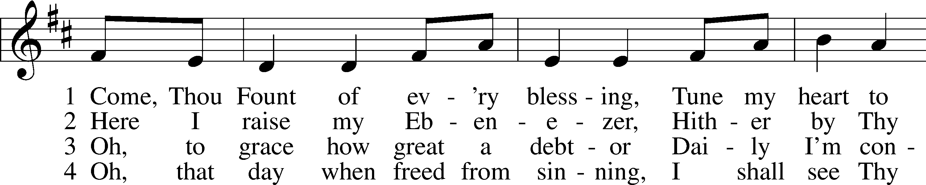
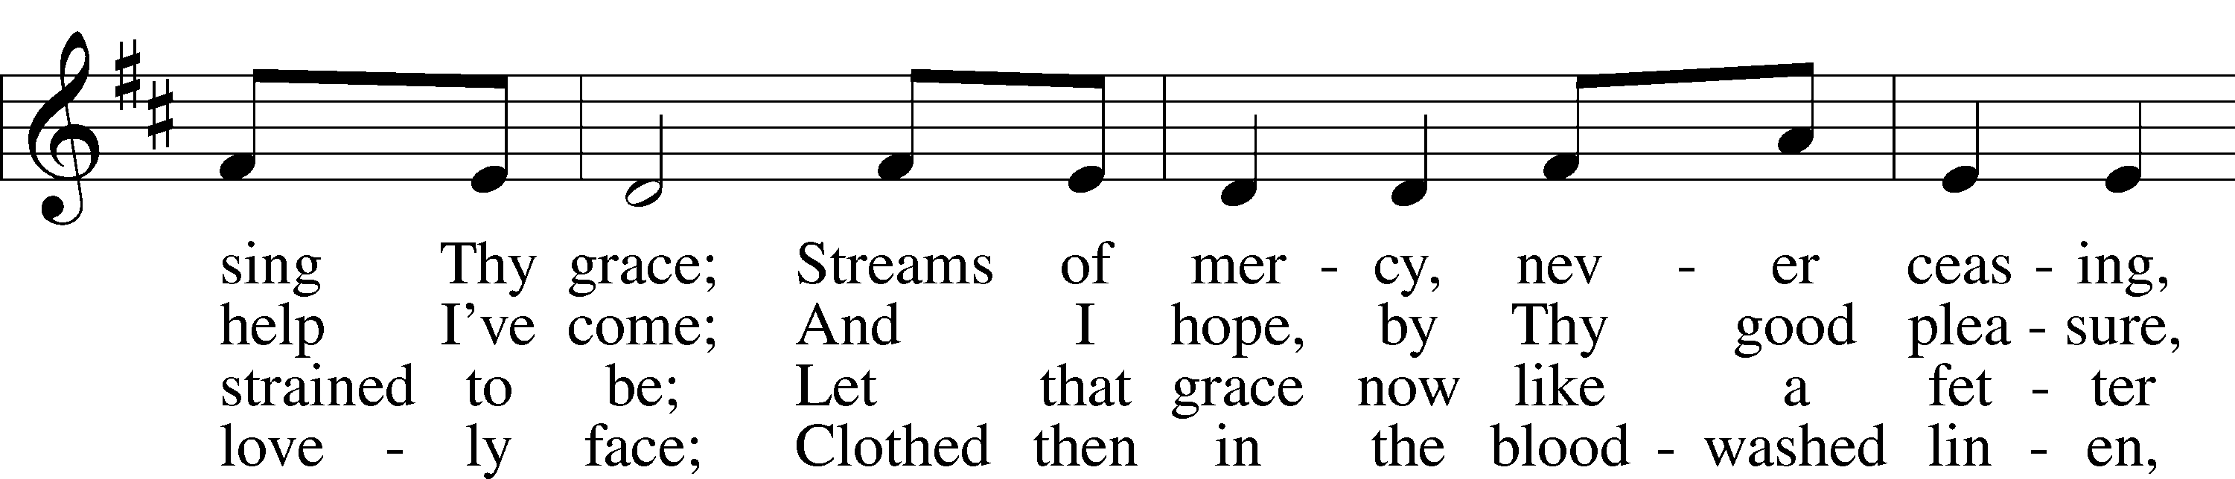
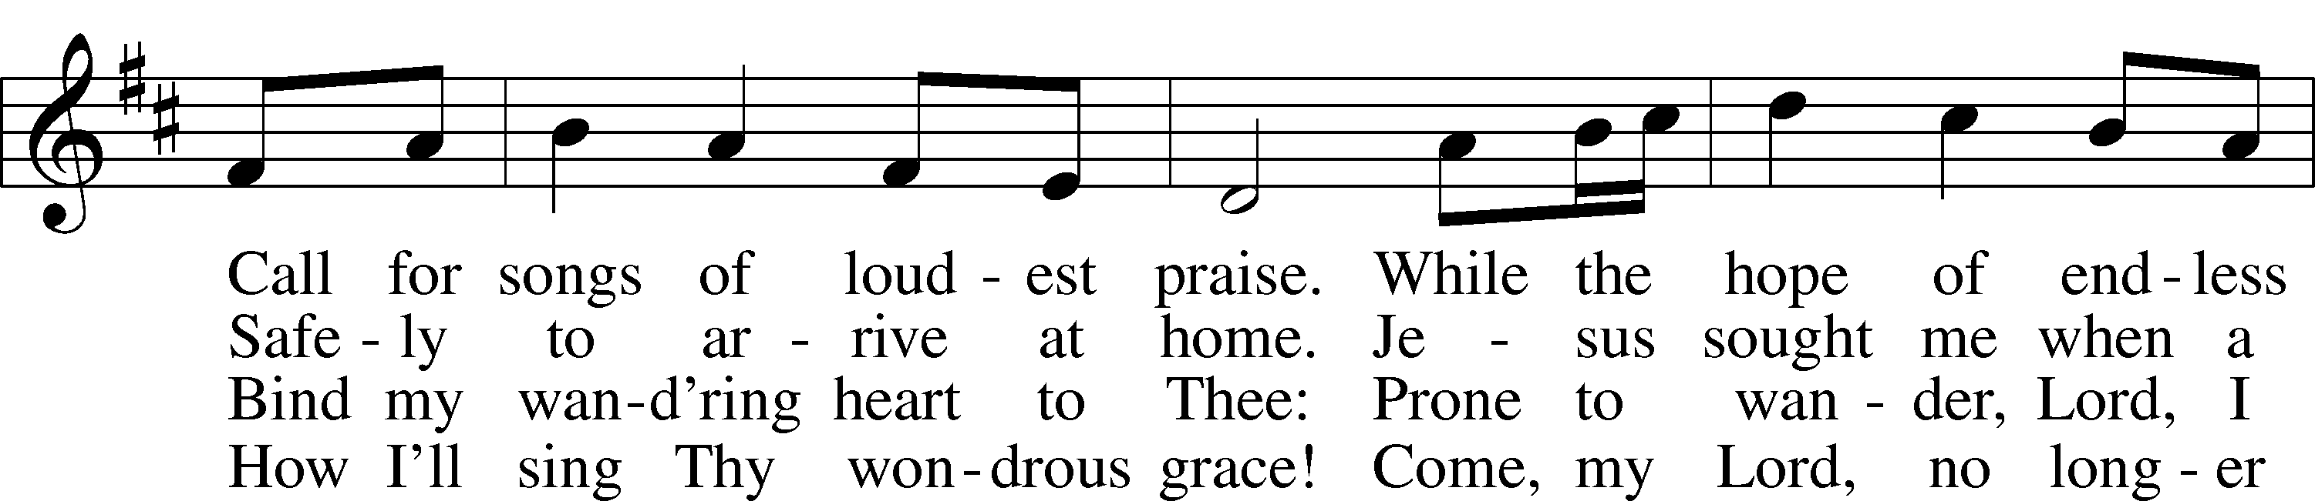
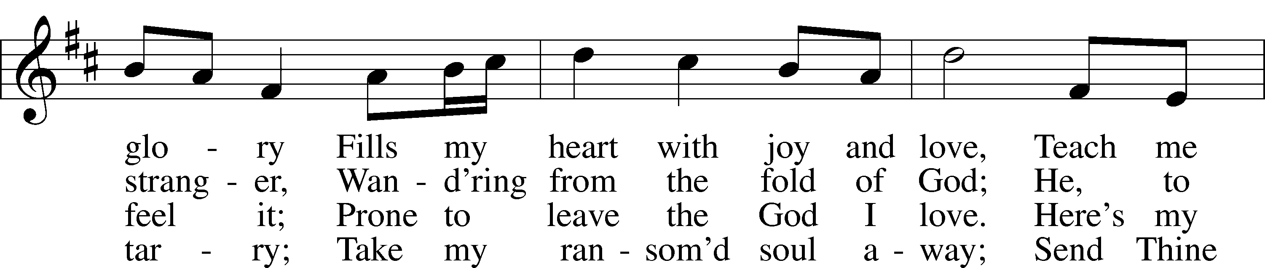
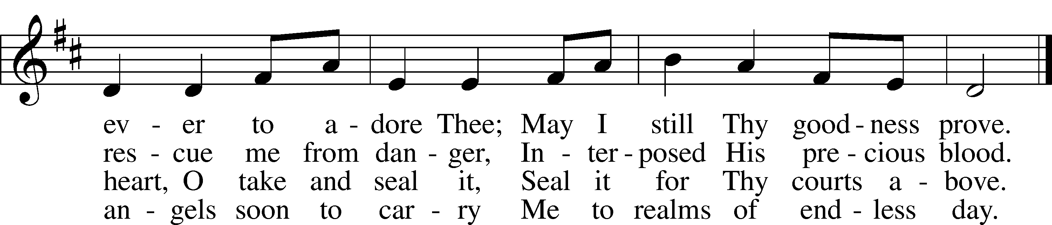
Text: Robert Robinson, 1735–90, alt.
Tune: Repository of Sacred Music, Part Second, 1813, Harrisburg
Text and tune: Public domain

Stand

The sign of the cross may be made by all in remembrance of their Baptism.

Invocation
P In the name of the Father and of the T Son and of the Holy Spirit.
C Amen.

Exhortation LSB 151
P If we say we have no sin, we deceive ourselves, and the truth is not in us.
C But if we confess our sins, God, who is faithful and just, will forgive our sins and cleanse us from all unrighteousness.

Kneel/Stand

Silence for reflection on God’s Word and for self-examination.

Confession of Sins LSB 151
P Let us then confess our sins to God our Father.
C Most merciful God, we confess that we are by nature sinful and unclean. We have sinned against You in thought, word, and deed, by what we have done and by what we have left undone. We have not loved You with our whole heart; we have not loved our neighbors as ourselves. We justly deserve Your present and eternal punishment. For the sake of Your Son, Jesus Christ, have mercy on us. Forgive us, renew us, and lead us, so that we may delight in Your will and walk in Your ways to the glory of Your holy name. Amen.

Absolution LSB 151
P Almighty God in His mercy has given His Son to die for you and for His sake forgives you all your sins. As a called and ordained servant of Christ, and by His authority, I therefore forgive you all your sins in the name of the Father and of the T Son and of the Holy Spirit.
C Amen.

Stand

Service of the Word

PSALM Psalm 23
1The Lord is my shepherd;
I shall not want.
2He makes me lie down in green pastures.
He leads me beside still waters.
3He restores my soul.
He leads me in paths of righteousness for his name’s sake.
4Even though I walk through the valley of the shadow of death,
I will fear no evil, for you are with me;
your rod and your staff, they comfort me.
5You prepare a table before me
in the presence of my enemies;
you anoint my head with oil;
my cup overflows.
6Surely goodness and mercy shall follow me
all the days of my life,
and I shall dwell in the house of the Lord forever.

Kyrie LSB 152
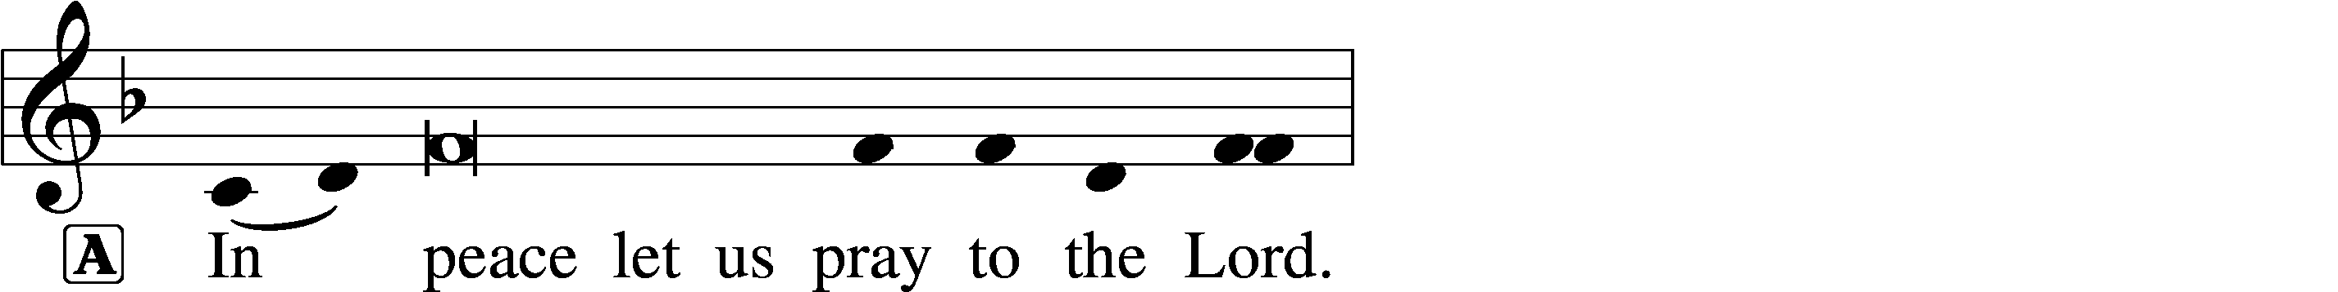
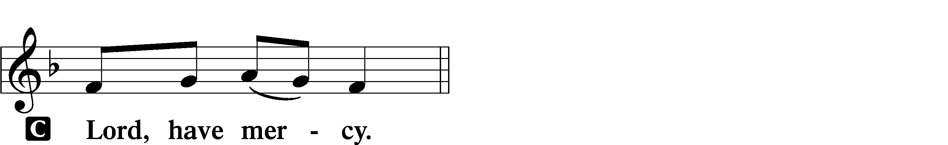

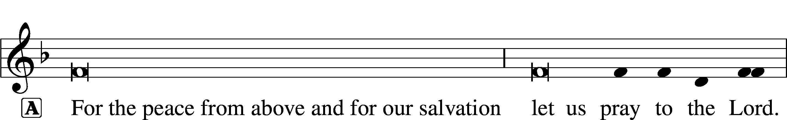
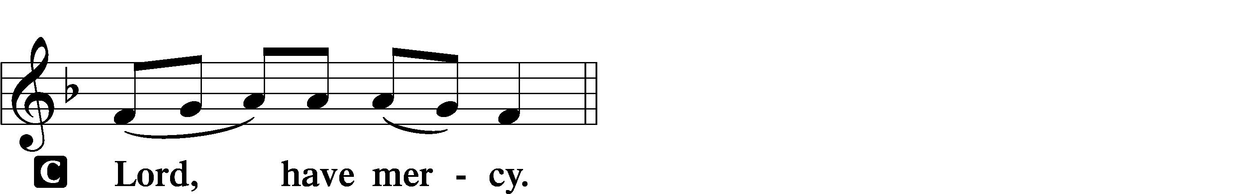

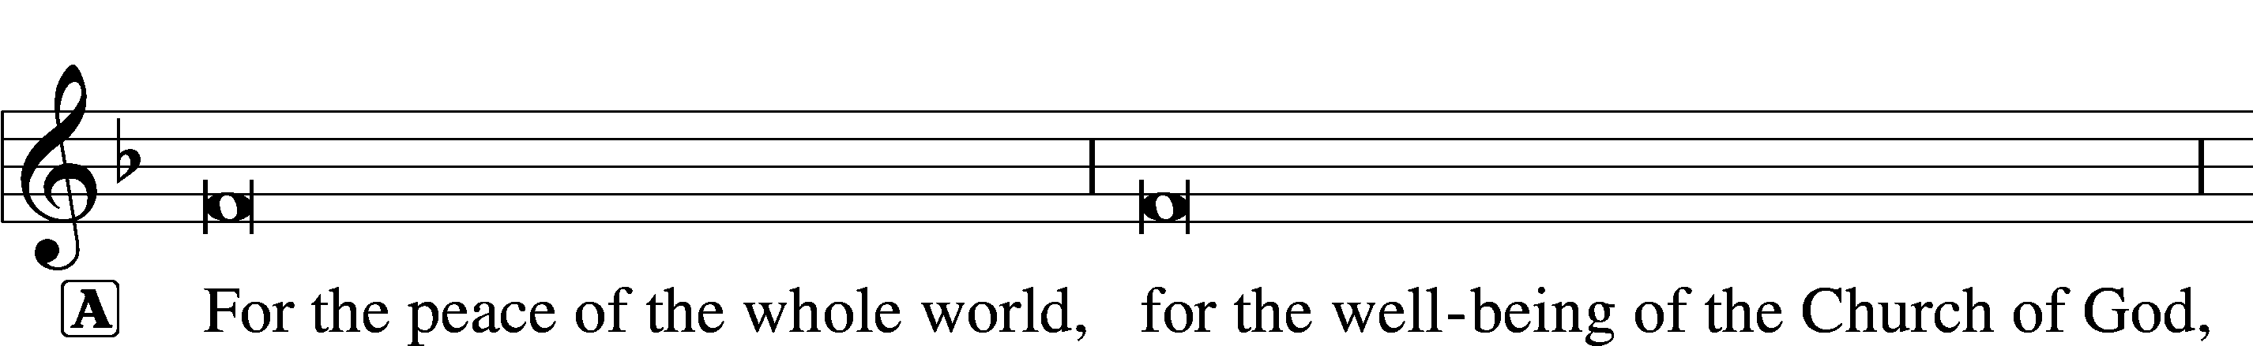
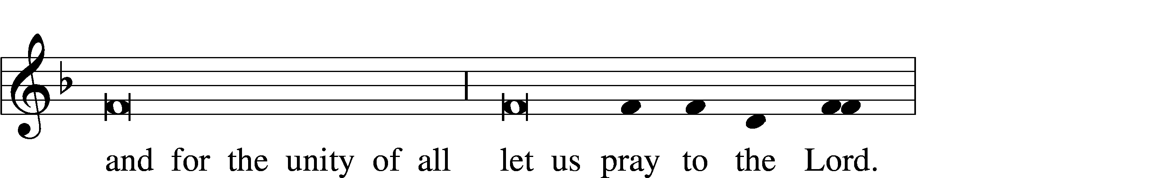
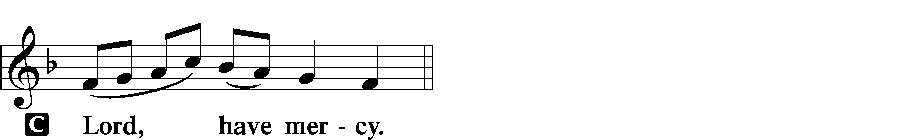

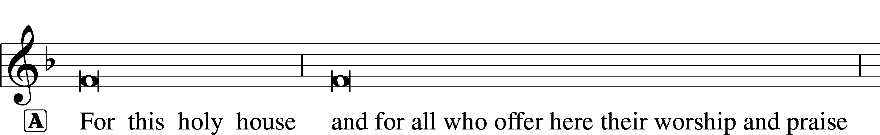
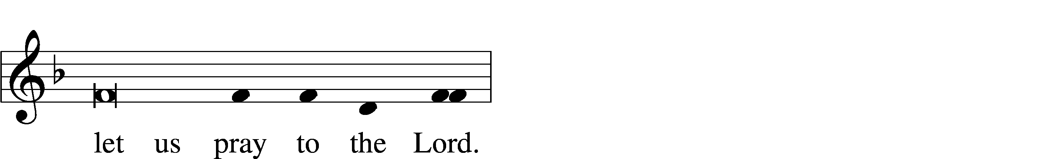
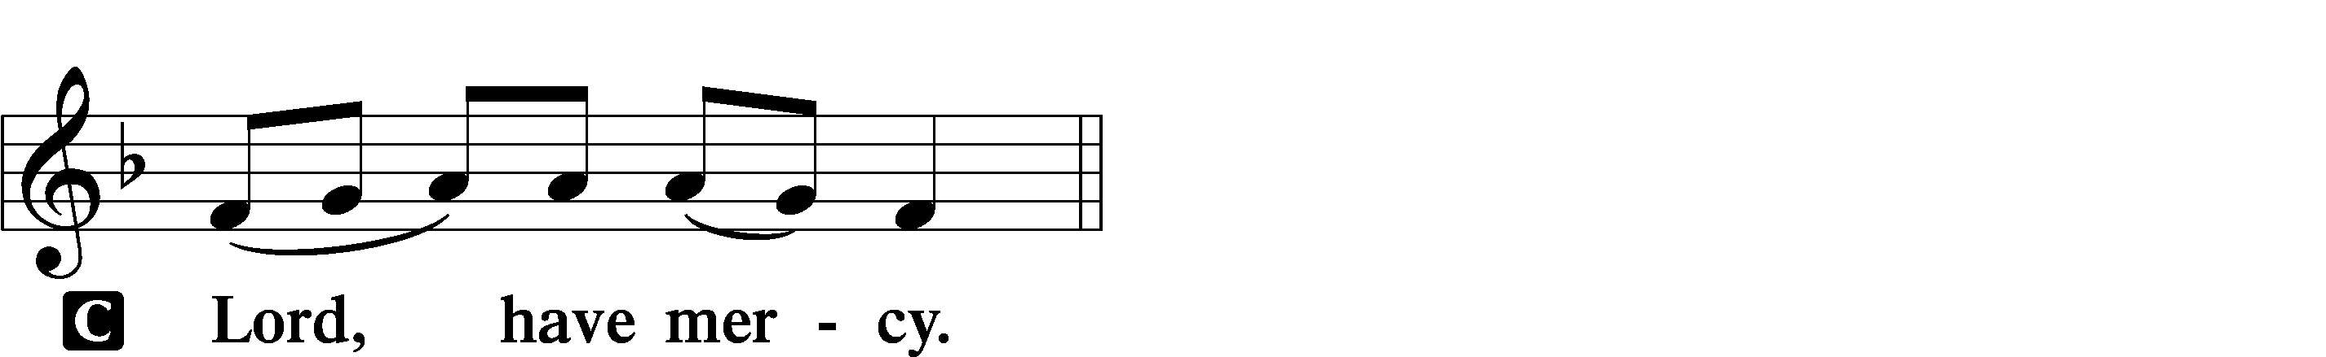

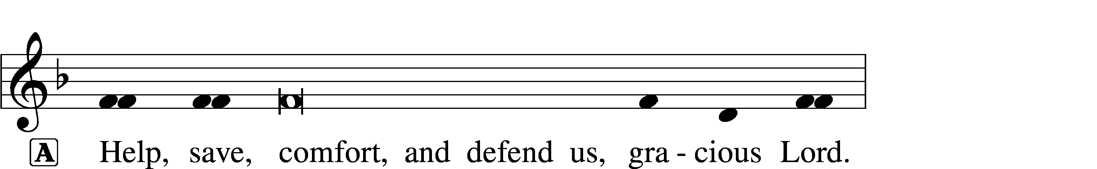

Gloria in Excelsis LSB 154
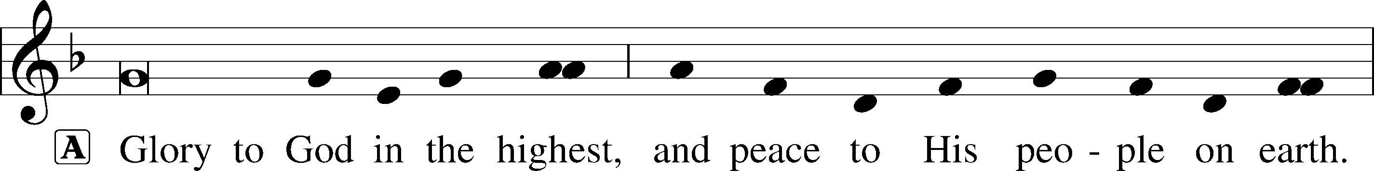
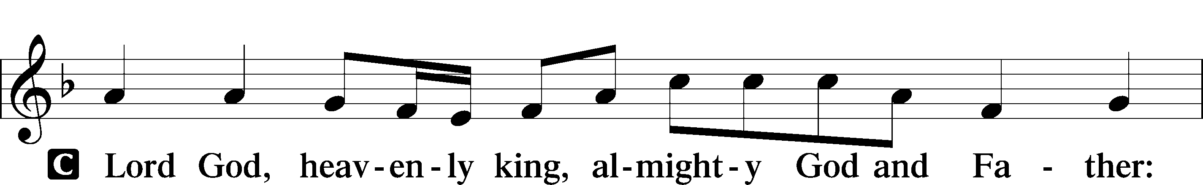
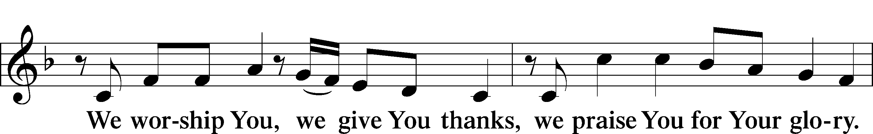
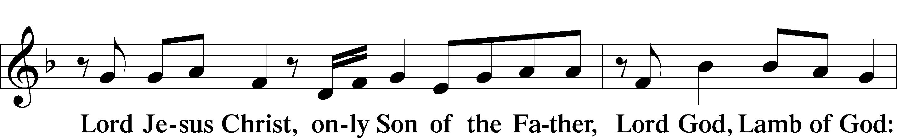
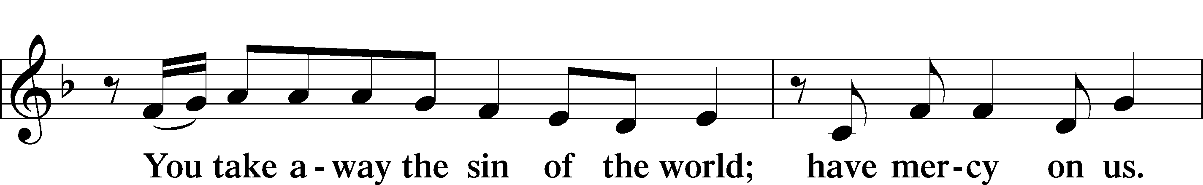
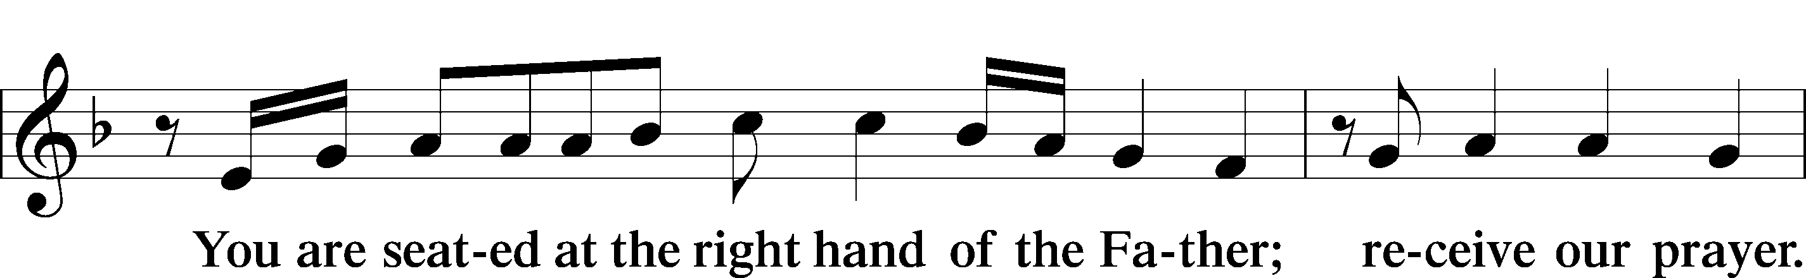
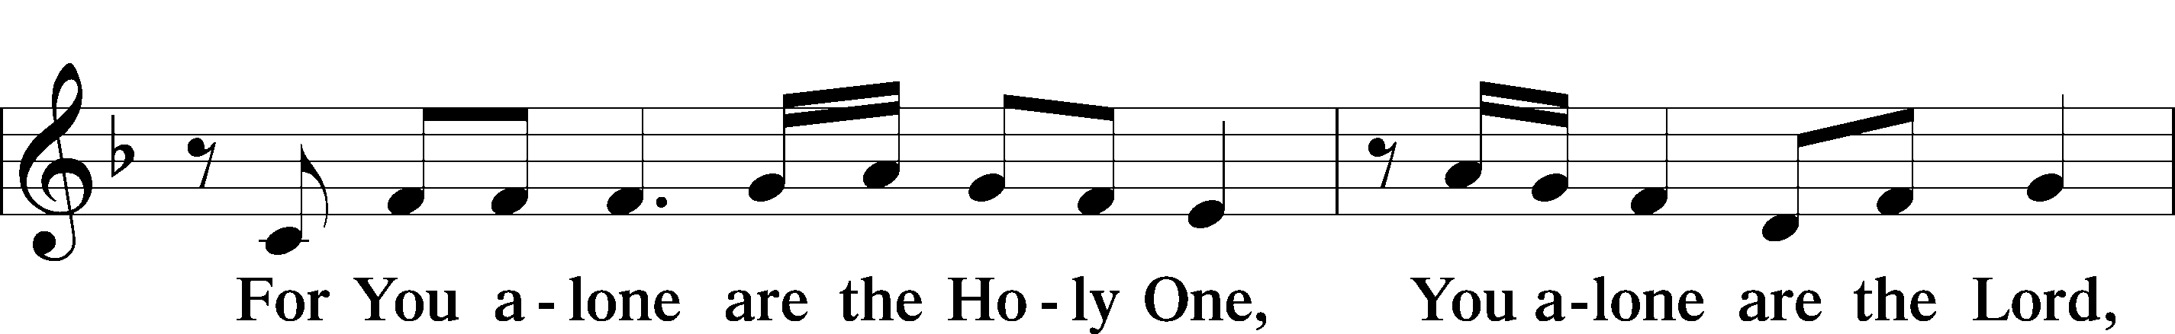
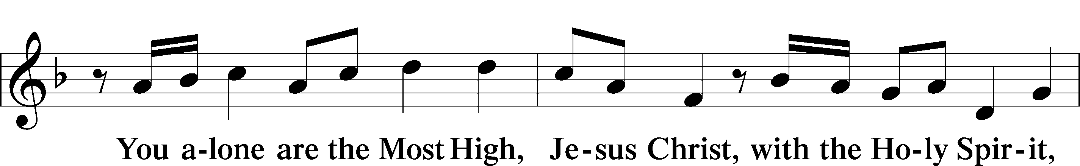
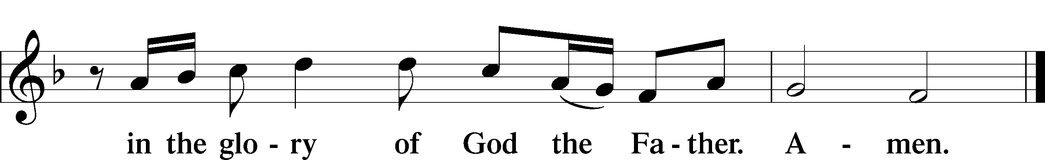

Salutation and Collect of the Day
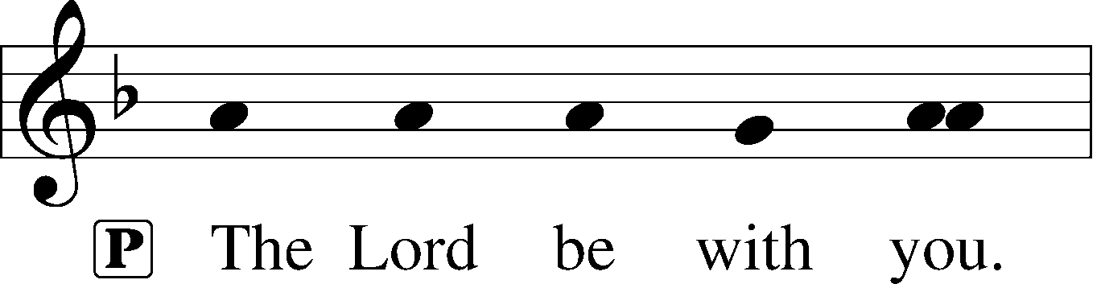
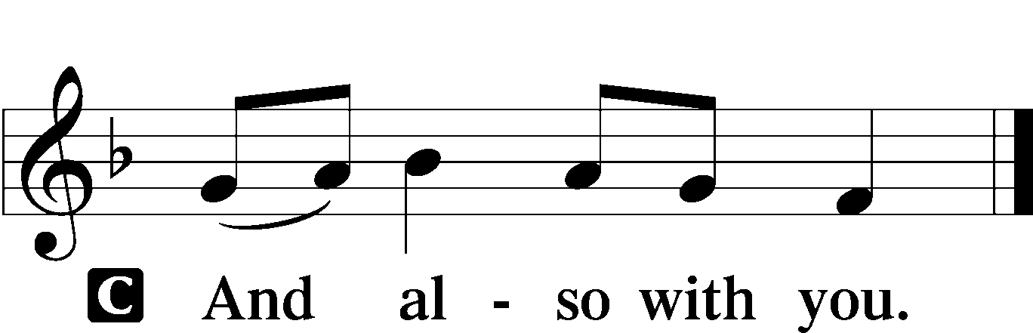

P Let us pray.
Almighty God, merciful Father, since You have wakened from death the Shepherd of Your sheep, grant us Your Holy Spirit that when we hear the voice of our Shepherd we may know Him who calls us each by name and follow where He leads; through the same Jesus Christ, Your Son, our Lord, who lives and reigns with You and the Holy Spirit, one God, now and forever.

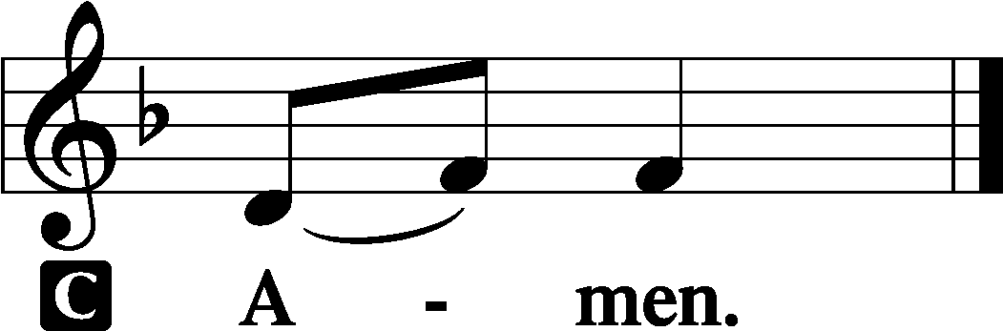

Sit

First Reading Acts 4:1–12
1As they were speaking to the people, the priests and the captain of the temple and the Sadducees came upon them, 2greatly annoyed because they were teaching the people and proclaiming in Jesus the resurrection from the dead. 3And they arrested them and put them in custody until the next day, for it was already evening. 4But many of those who had heard the word believed, and the number of the men came to about five thousand.
5On the next day their rulers and elders and scribes gathered together in Jerusalem, 6with Annas the high priest and Caiaphas and John and Alexander, and all who were of the high-priestly family. 7And when they had set them in the midst, they inquired, “By what power or by what name did you do this?” 8Then Peter, filled with the Holy Spirit, said to them, “Rulers of the people and elders, 9if we are being examined today concerning a good deed done to a crippled man, by what means this man has been healed, 10let it be known to all of you and to all the people of Israel that by the name of Jesus Christ of Nazareth, whom you crucified, whom God raised from the dead—by him this man is standing before you well. 11This Jesus is the stone that was rejected by you, the builders, which has become the cornerstone. 12And there is salvation in no one else, for there is no other name under heaven given among men by which we must be saved.”

A This is the Word of the Lord.
C Thanks be to God.

Epistle 1 John 3:16–24
16By this we know love, that he laid down his life for us, and we ought to lay down our lives for the brothers. 17But if anyone has the world’s goods and sees his brother in need, yet closes his heart against him, how does God’s love abide in him? 18Little children, let us not love in word or talk but in deed and in truth.
19By this we shall know that we are of the truth and reassure our heart before him; 20for whenever our heart condemns us, God is greater than our heart, and he knows everything. 21Beloved, if our heart does not condemn us, we have confidence before God; 22and whatever we ask we receive from him, because we keep his commandments and do what pleases him. 23And this is his commandment, that we believe in the name of his Son Jesus Christ and love one another, just as he has commanded us. 24Whoever keeps his commandments abides in him, and he in them. And by this we know that he abides in us, by the Spirit whom he has given us.

A This is the Word of the Lord.
C Thanks be to God.

Stand

Alleluia and Verse LSB 156
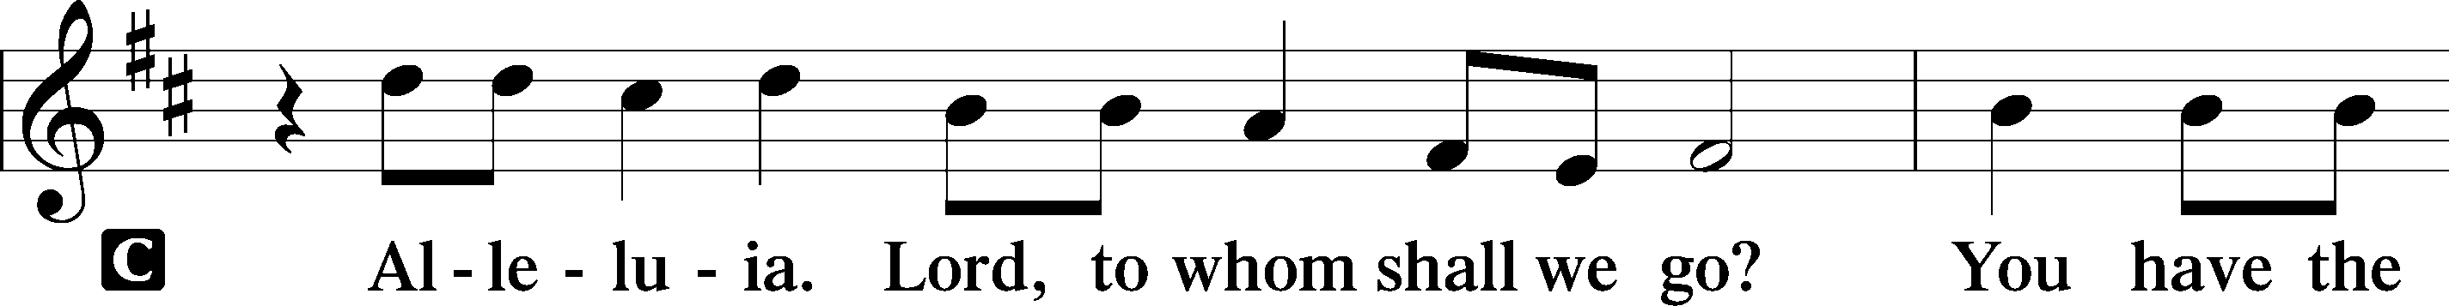
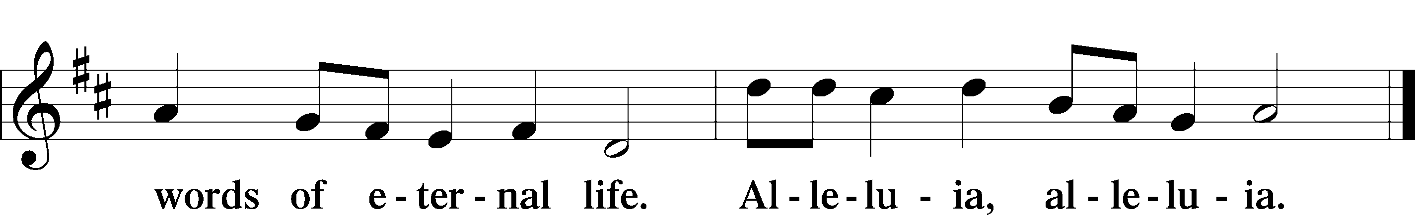

Holy Gospel John 10:11–18
P The Holy Gospel according to St. John, the tenth chapter.

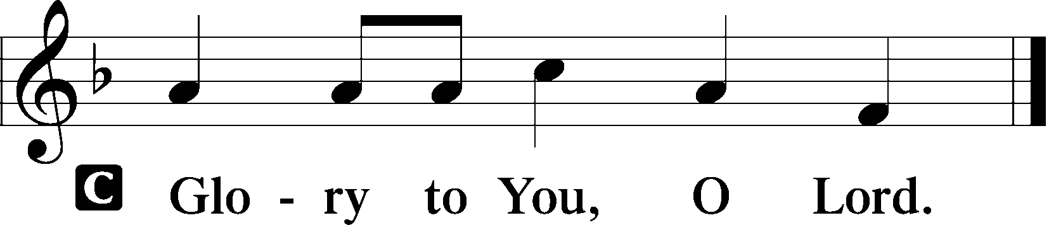

11[Jesus said:] “I am the good shepherd. The good shepherd lays down his life for the sheep. 12He who is a hired hand and not a shepherd, who does not own the sheep, sees the wolf coming and leaves the sheep and flees, and the wolf snatches them and scatters them. 13He flees because he is a hired hand and cares nothing for the sheep. 14I am the good shepherd. I know my own and my own know me, 15just as the Father knows me and I know the Father; and I lay down my life for the sheep. 16And I have other sheep that are not of this fold. I must bring them also, and they will listen to my voice. So there will be one flock, one shepherd. 17For this reason the Father loves me, because I lay down my life that I may take it up again. 18No one takes it from me, but I lay it down of my own accord. I have authority to lay it down, and I have authority to take it up again. This charge I have received from my Father.”

P This is the Gospel of the Lord.

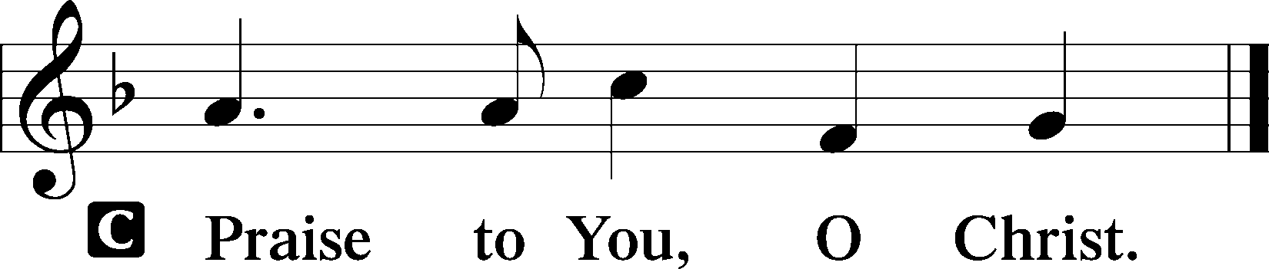

Sit

709 The King of Love My Shepherd Is
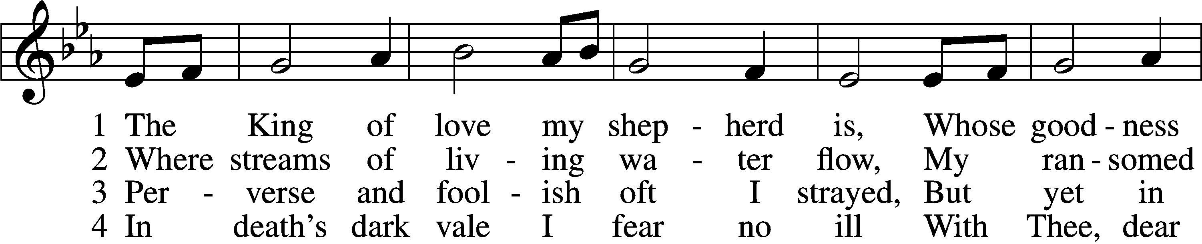
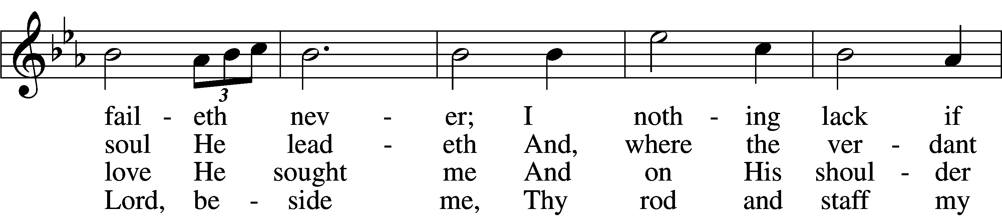
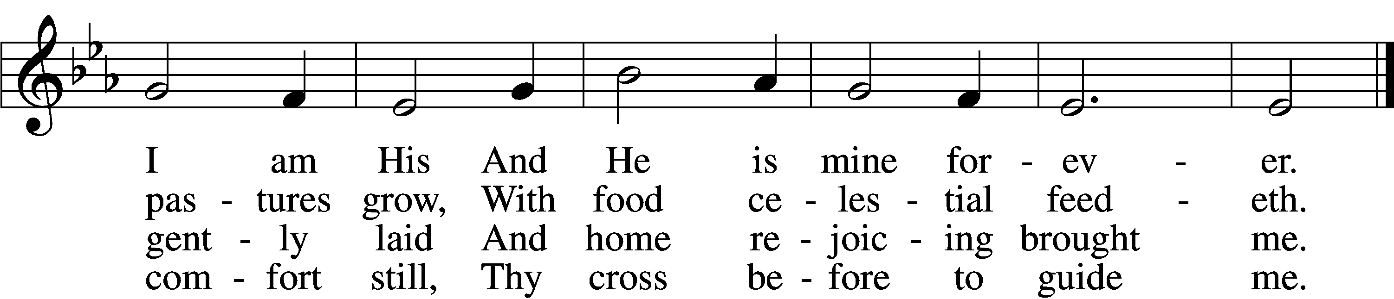

5 Thou spreadst a table in my sight;
Thine unction grace bestoweth;
And, oh, what transport of delight
From Thy pure chalice floweth!

6 And so through all the length of days
Thy goodness faileth never;
Good Shepherd, may I sing Thy praise
Within Thy house forever!
Text: Henry W. Baker, 1821–77
Tune: Irish, c. 18th cent.
Text and tune: Public domain

Children’s Sermon
Sermon

Stand

Nicene Creed
C I believe in one God,
the Father Almighty,
maker of heaven and earth
and of all things visible and invisible.

And in one Lord Jesus Christ,
the only-begotten Son of God,
begotten of His Father before all worlds,
God of God, Light of Light,
very God of very God,
begotten, not made,
being of one substance with the Father,
by whom all things were made;
who for us men and for our salvation came down from heaven
and was incarnate by the Holy Spirit of the virgin Mary
and was made man;
and was crucified also for us under Pontius Pilate.
He suffered and was buried.
And the third day He rose again according to the Scriptures
and ascended into heaven
and sits at the right hand of the Father.
And He will come again with glory to judge both the living and the dead,
whose kingdom will have no end.

And I believe in the Holy Spirit,
the Lord and giver of life,
who proceeds from the Father and the Son,
who with the Father and the Son together is worshiped and glorified,
who spoke by the prophets.
And I believe in one holy Christian and apostolic Church,
I acknowledge one Baptism for the remission of sins,
and I look for the resurrection of the dead
and the life T of the world to come. Amen.

Prayer of the Church
P Let us pray for the whole Church of God in Christ Jesus and for all people according to their needs.

Shepherd of Israel, in Your Son, Jesus Christ, You have sought out Your sheep and gathered us into Your flock. Keep us always in Your fold, and guard us from every wolf and snare. Lord, in Your mercy,
C hear our prayer.

P Heavenly Father, You alone gather us as Your sheep and send faithful shepherds to us. Call all who have wandered from Your flock, and bless the faithful shepherds who gather them through the voice of Your Word. Lord, in Your mercy,
C hear our prayer.

P Heavenly Father, Your Son has called us to love our brothers. Turn us in love toward the neighbors closest to us, especially within our own homes, that we may daily show our confidence in God by deed and truth, laying down our lives as Christ first did for us. Lord, in Your mercy,
C hear our prayer.

P Eternal Lord, through the Paschal Lamb You have wrought peace between man and God. By Your gift of good government, grant peace and good days also to our citizens and between the nations of the world, that we and all our neighbors may lead quiet lives in godly contentment. Lord, in Your mercy,
C hear our prayer.

P Heavenly Father, by the firstfruits of Christ’s life from the dead, You secured forgiveness for our troubled consciences. Bless also with temporal health and well-being those who suffer among us [especially _____________]. Grant them aid in this moment and, even more so, true, immortal health in the world to come. Lord, in Your mercy,
C hear our prayer.

P O Lord, our Shepherd, You calm all fears in this valley of the shadow of death, and You prepare the holy table of Your Son’s testament for us in the presence of our enemies. Grant us repentant and faithful hearts. In every tribulation or besetting sin, lead us to find comfort and strength in Your overflowing mercy given to us here in this Sacrament. Lord, in Your mercy,
C hear our prayer.

P Lord God, out of Your fatherly goodness You have remembered us poor, miserable sinners and given Your beloved Son to be our Shepherd — not only to nourish us by His Word, but also to defend us from sin, death and the devil. Grant us Your Holy Spirit, that even as this Shepherd knows us and helps in every affliction, we also may know Him, trust Him, seek help and comfort in Him, heartily obey His voice, and obtain eternal salvation; through the same Jesus Christ, Your Son, our Lord, who lives and reigns with You and the Holy Spirit, one God, now and forever.
C Amen.

Sit

Offering

Stand

Offertory LSB 159
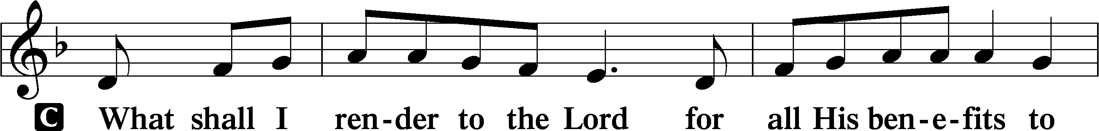
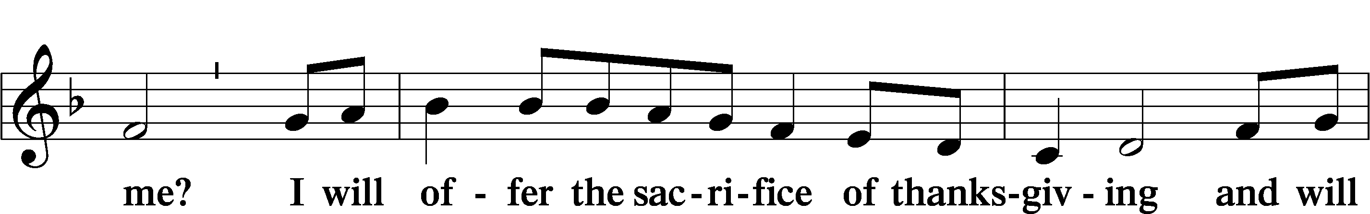
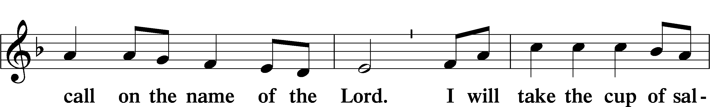
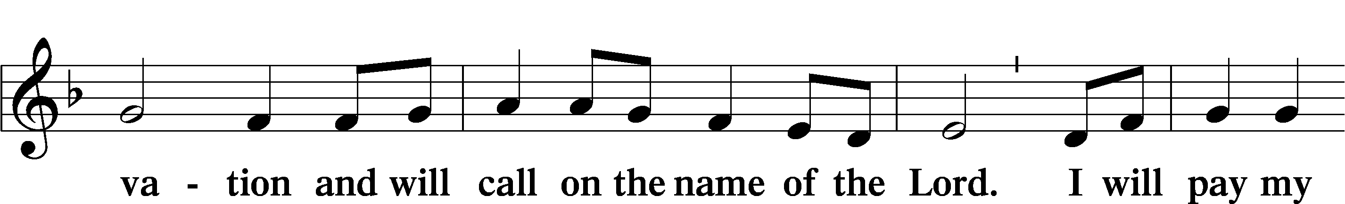
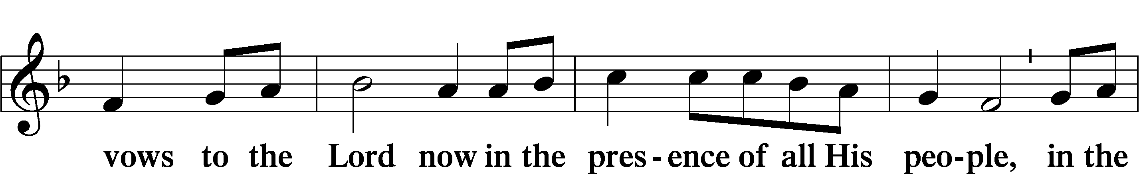
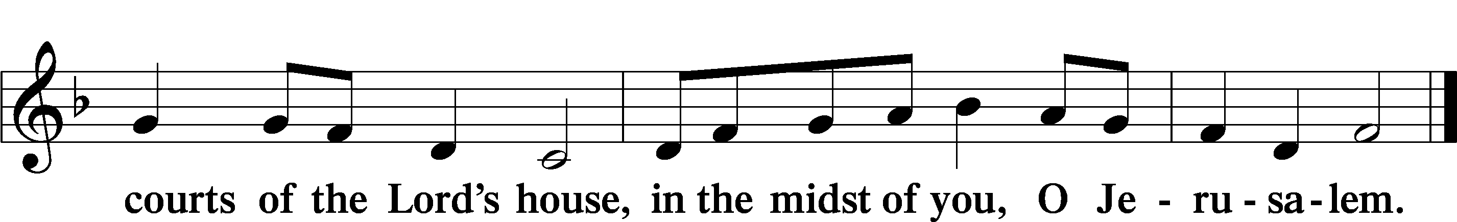

Service of the Sacrament

Preface LSB 160
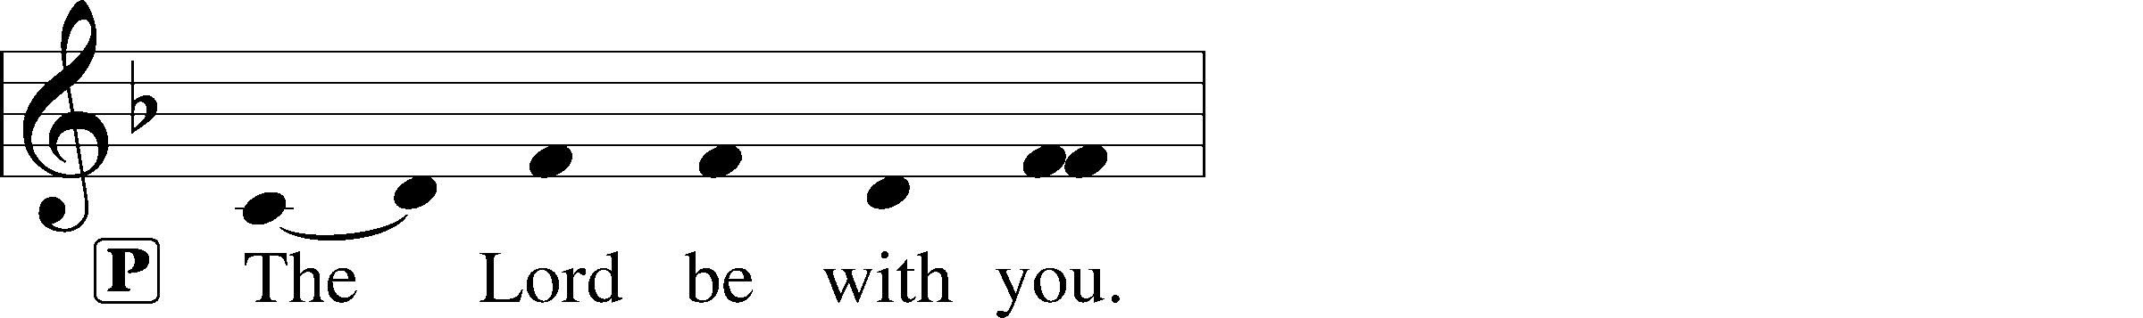
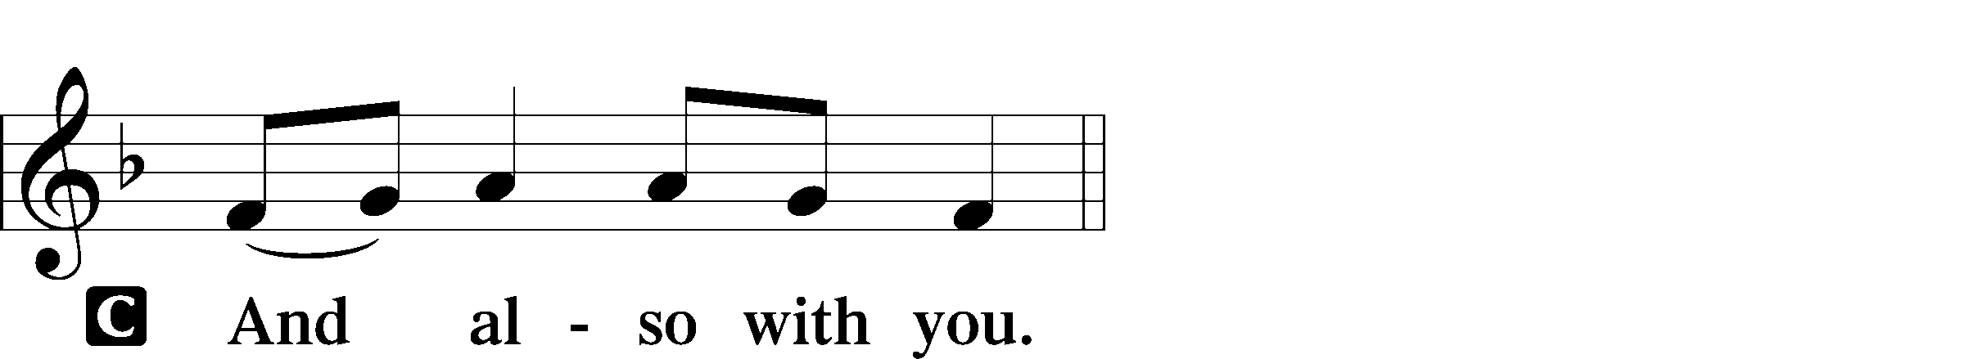
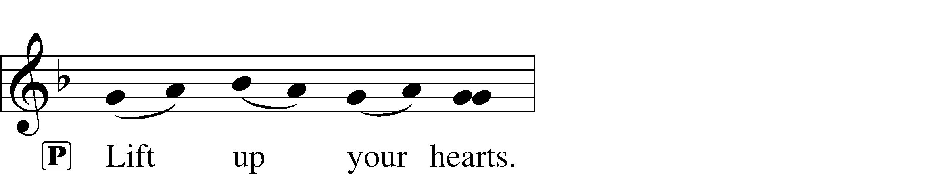
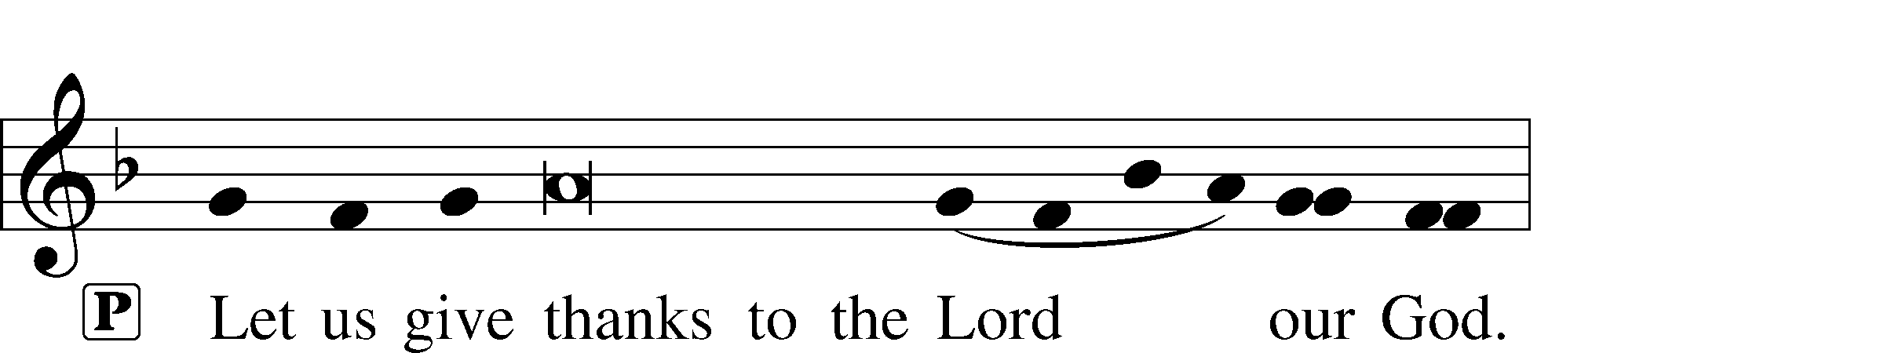
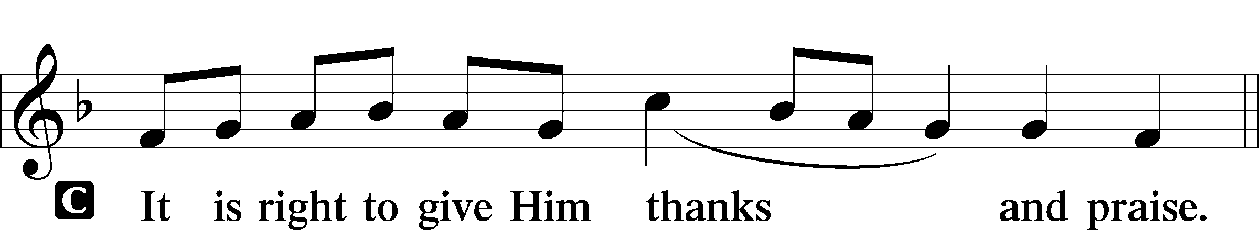

Proper Preface (Full)
P It is truly good, right, and salutary that we should at all times and in all places give thanks to You, holy Lord, almighty Father, everlasting God. And most especially are we bound to praise You on this day for the glorious resurrection of Your Son, Jesus Christ, the very Paschal Lamb, who was sacrificed for us and bore the sins of the world. By His dying He has destroyed death, and by His rising again He has restored to us everlasting life. Therefore with Mary Magdalene, Peter and John, and with all the witnesses of the resurrection, with angels and archangels, and with all the company of heaven we laud and magnify Your glorious name, evermore praising You and saying:

Sanctus LSB 161
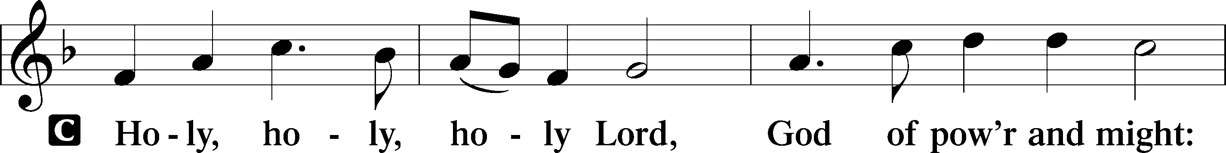
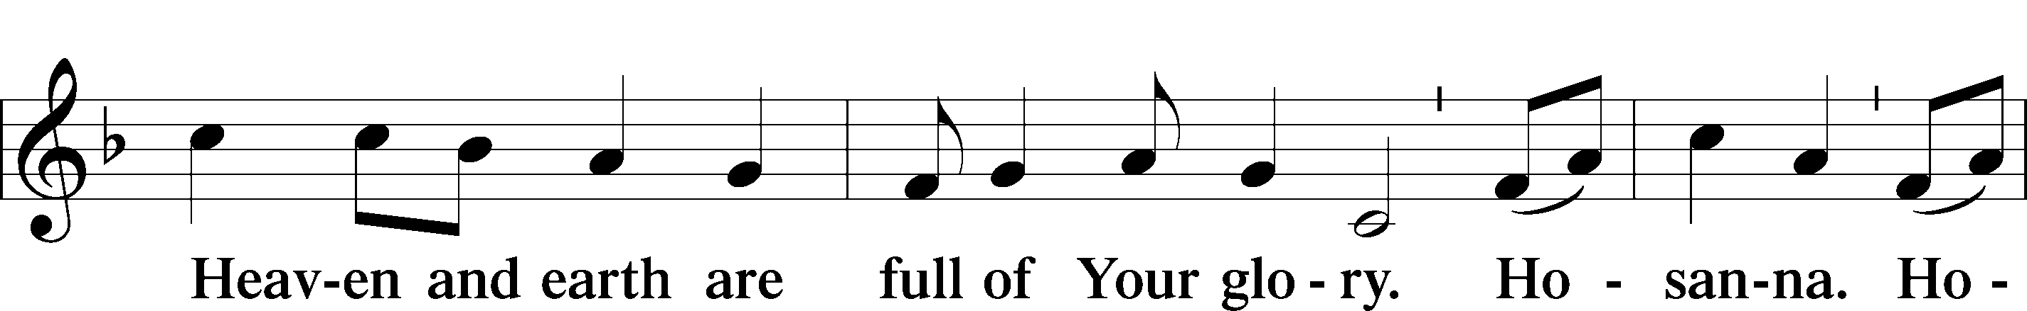
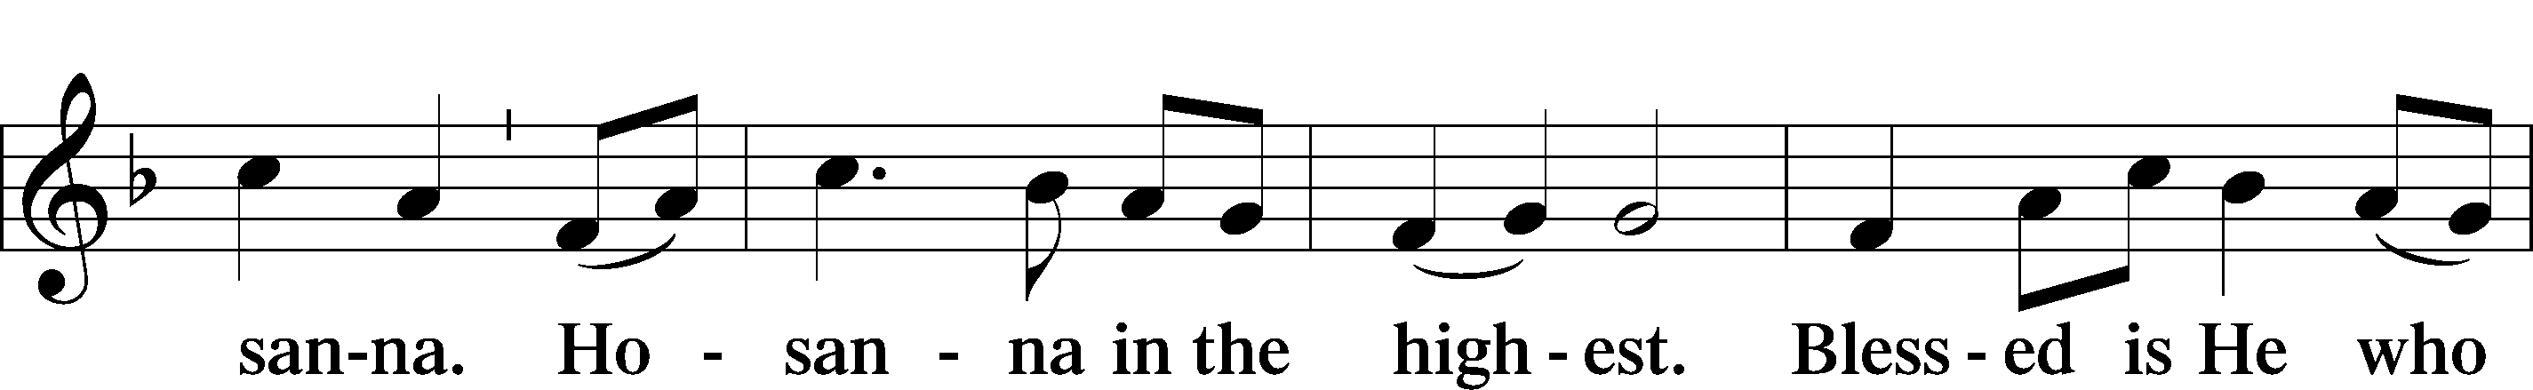
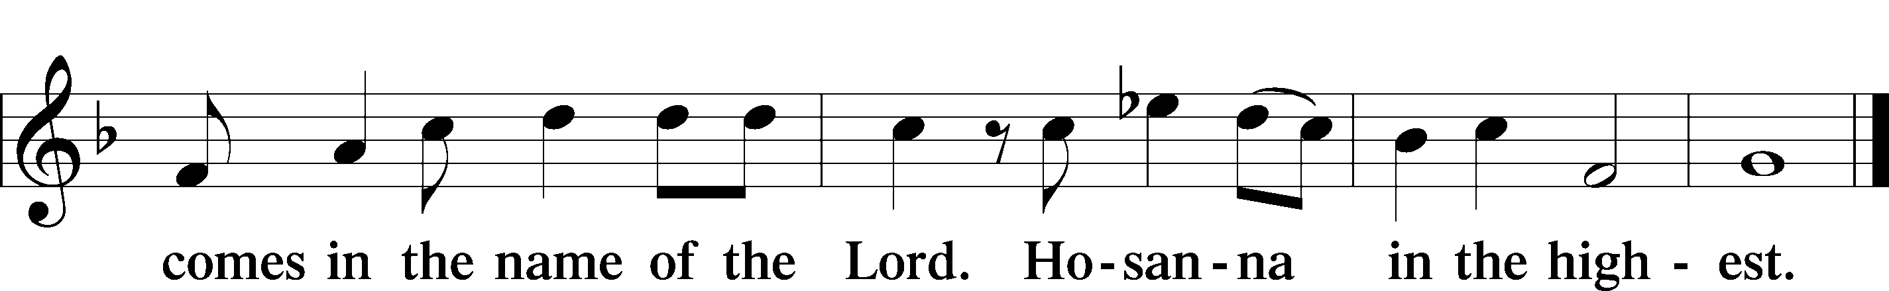

Prayer of Thanksgiving LSB 161
P Blessed are You, Lord of heaven and earth, for You have had mercy on those whom You created and sent Your only-begotten Son into our flesh to bear our sin and be our Savior. With repentant joy we receive the salvation accomplished for us by the all-availing sacrifice of His body and His blood on the cross.

Gathered in the name and the remembrance of Jesus, we beg You, O Lord, to forgive, renew, and strengthen us with Your Word and Spirit. Grant us faithfully to eat His body and drink His blood as He bids us do in His own testament. Gather us together, we pray, from the ends of the earth to celebrate with all the faithful the marriage feast of the Lamb in His kingdom, which has no end. Graciously receive our prayers; deliver and preserve us. To You alone, O Father, be all glory, honor, and worship, with the Son and the Holy Spirit, one God, now and forever.
C Amen.

Lord’s Prayer
C Our Father who art in heaven,
hallowed be Thy name,
Thy kingdom come,
Thy will be done on earth
as it is in heaven;
give us this day our daily bread;
and forgive us our trespasses
as we forgive those
who trespass against us;
and lead us not into temptation,
but deliver us from evil.
For Thine is the kingdom
and the power and the glory
forever and ever. Amen.
The Words of Our Lord
P Our Lord Jesus Christ, on the night when He was betrayed, took bread, and when He had given thanks, He broke it and gave it to the disciples and said: “Take, eat; this is My T body, which is given for you. This do in remembrance of Me.”

In the same way also He took the cup after supper, and when He had given thanks, He gave it to them, saying: “Drink of it, all of you; this cup is the new testament in My T blood, which is shed for you for the forgiveness of sins. This do, as often as you drink it, in remembrance of Me.”

Pax Domini LSB 163
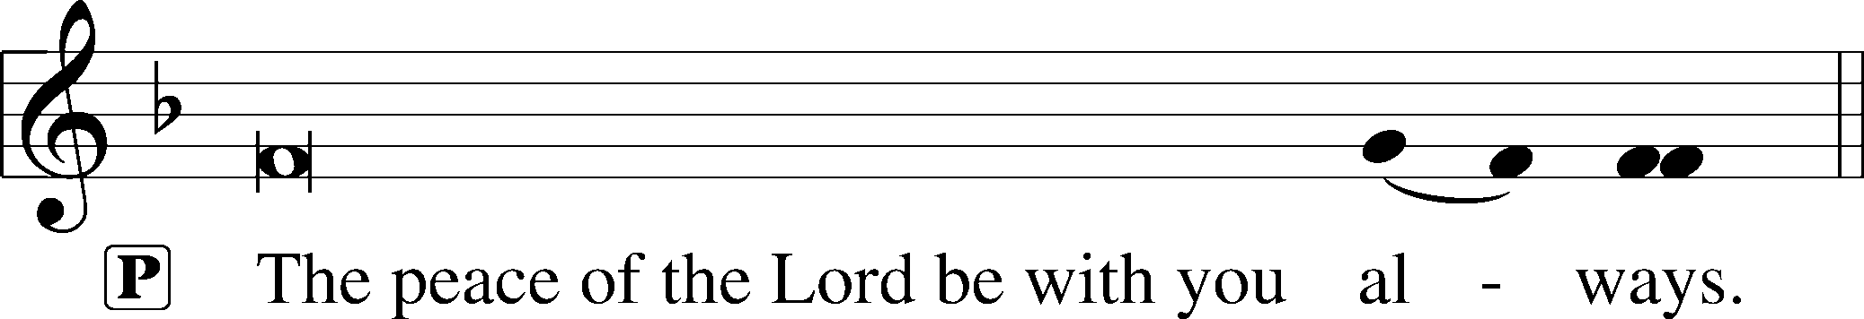

Agnus Dei LSB 163
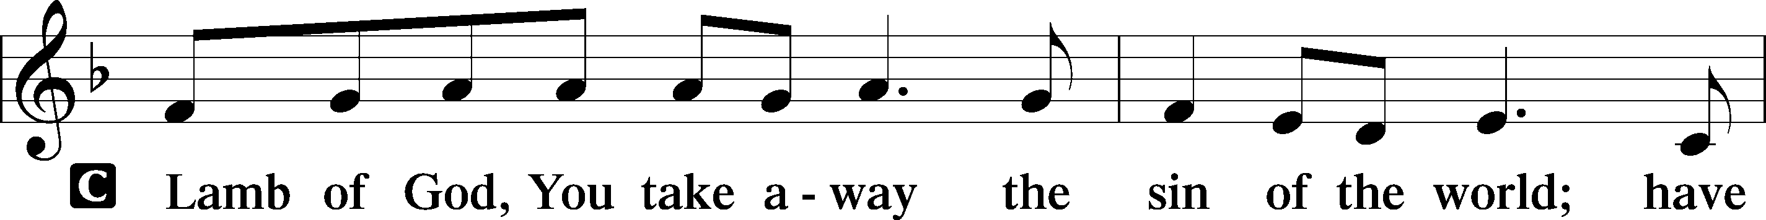
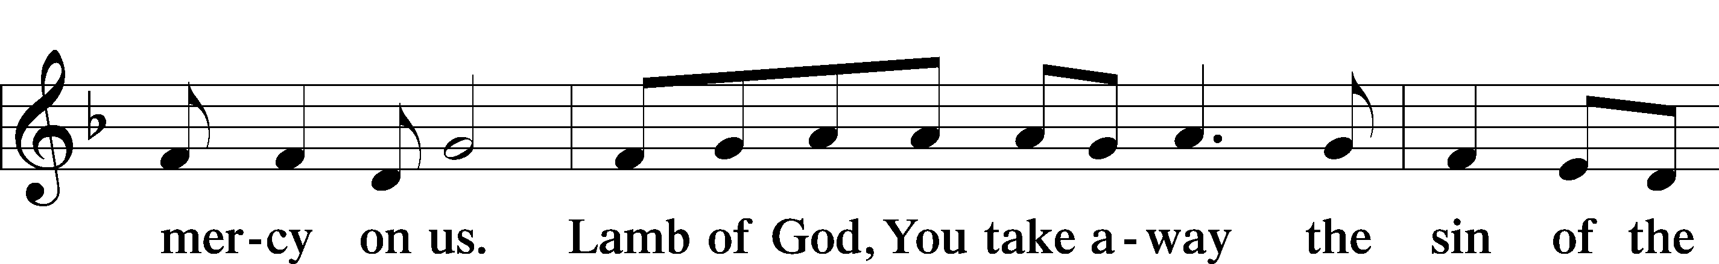
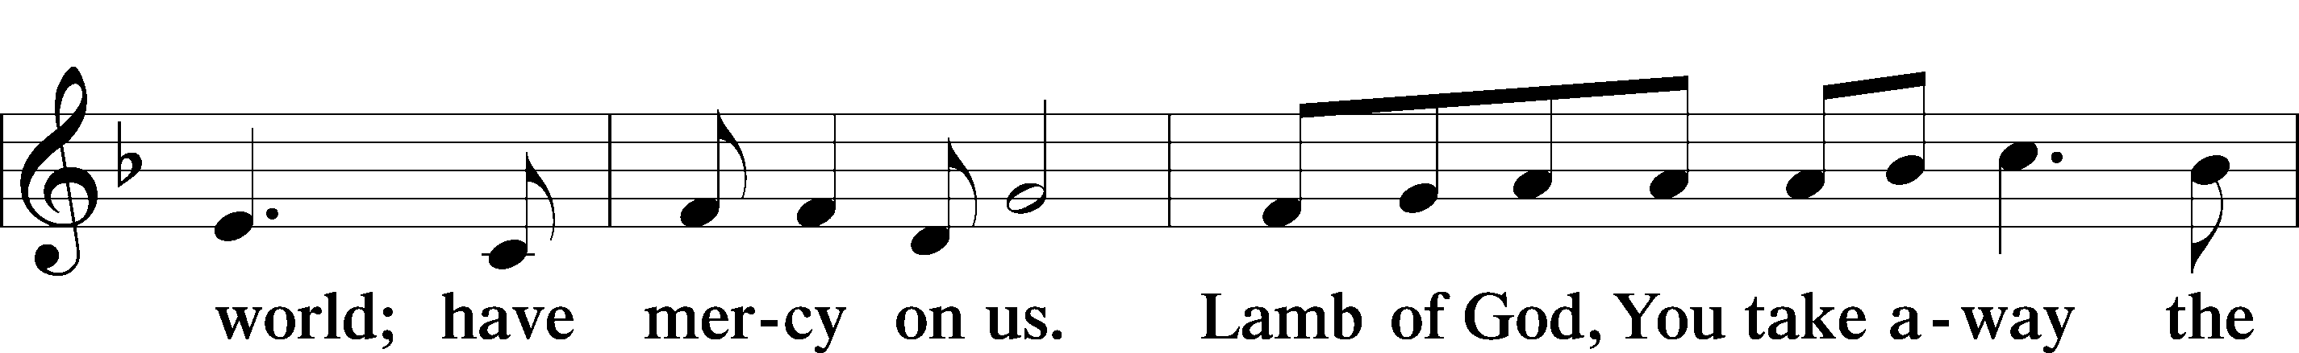
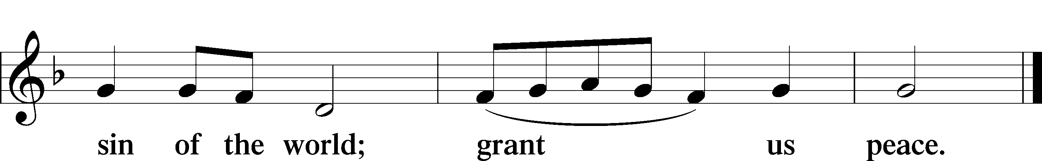

Sit

Distribution

740 I Am Jesus’ Little Lamb
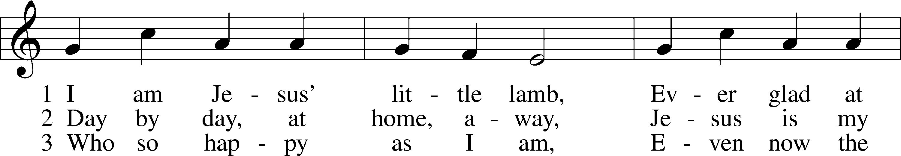
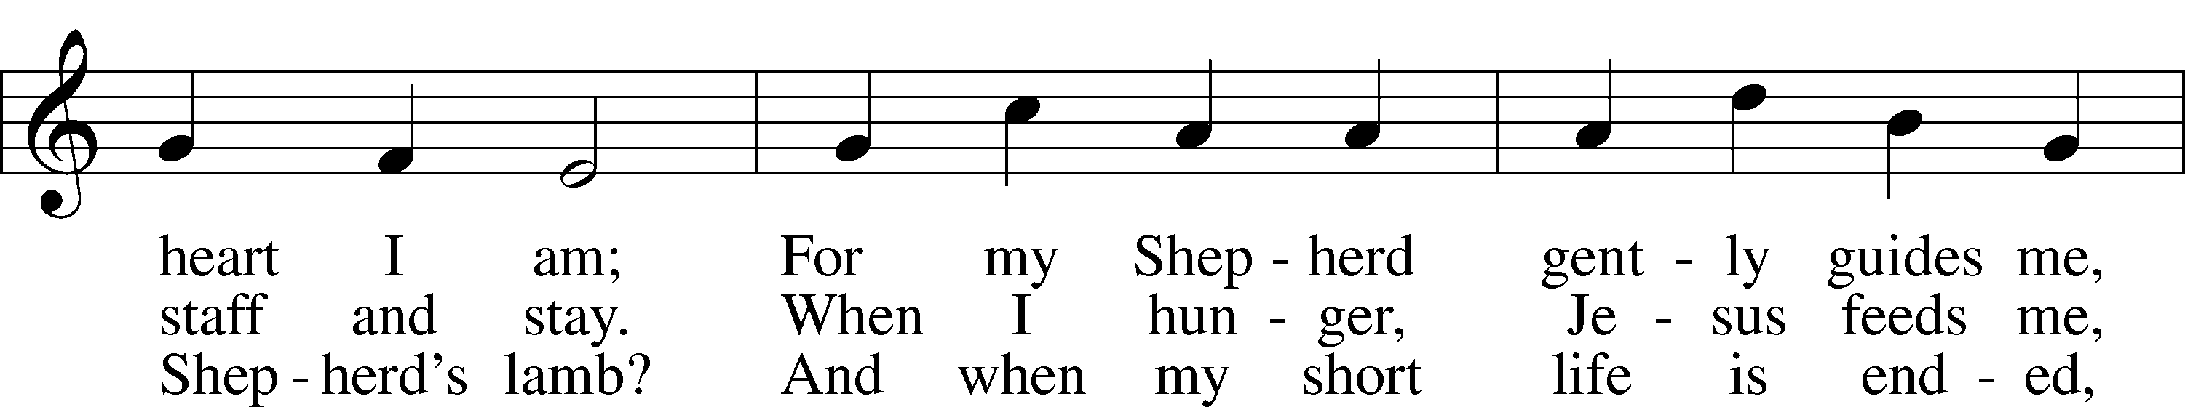
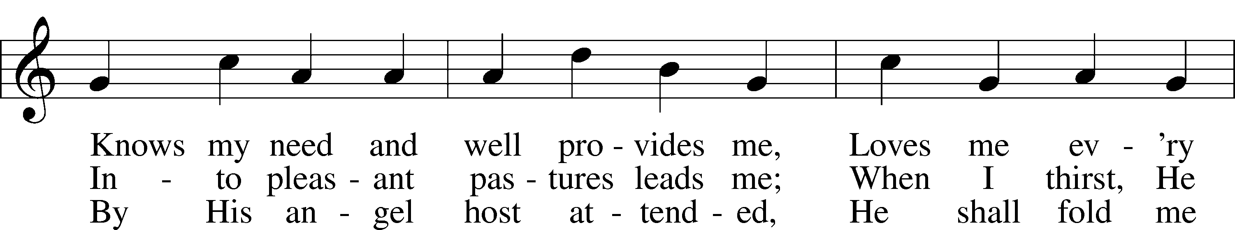
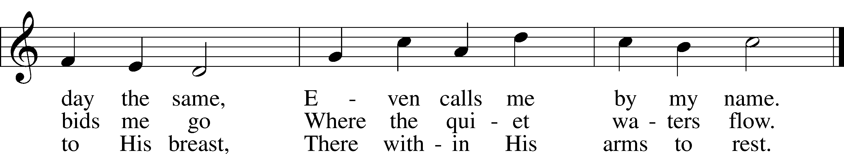
Text: Henrietta L. von Hayn, 1724–82; tr. The Lutheran Hymnal, 1941
Tune: Choral-Buch . . . Brüder-Gemeinen, 1784, Leipzig
Text and tune: Public domain

710 The Lord’s My Shepherd, I’ll Not Want
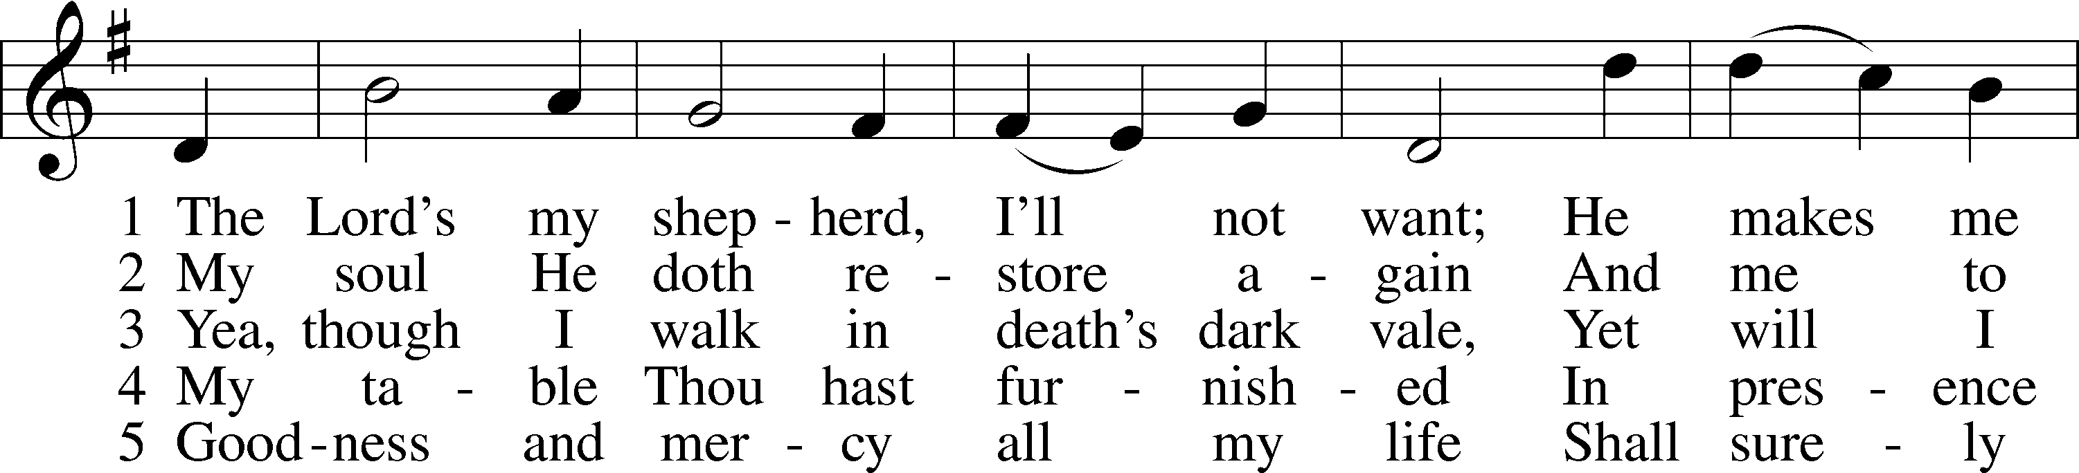
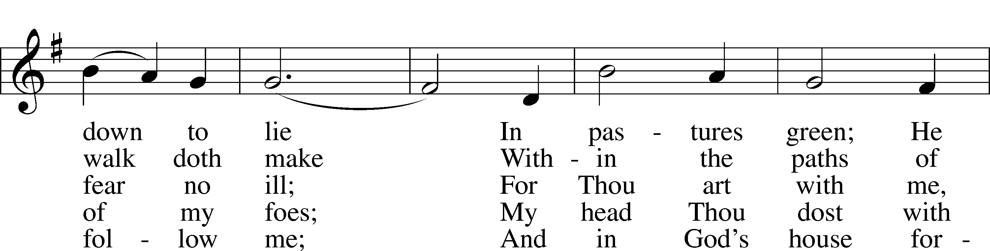
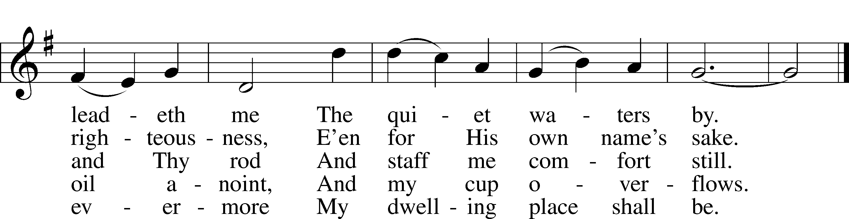
Text: The Psalms of David in Meeter, 1650, Edinburgh
Tune: William Gardiner, 1770–1853
Text and tune: Public domain

Stand

Thank the Lord LSB 164
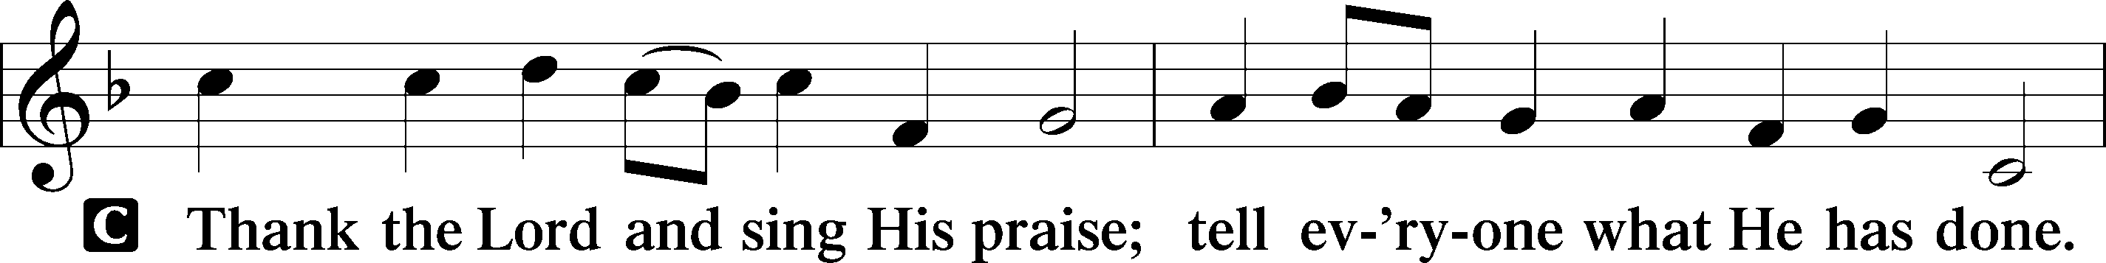
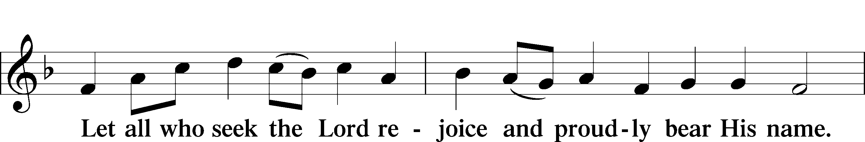
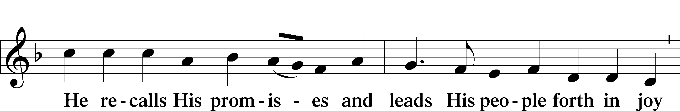
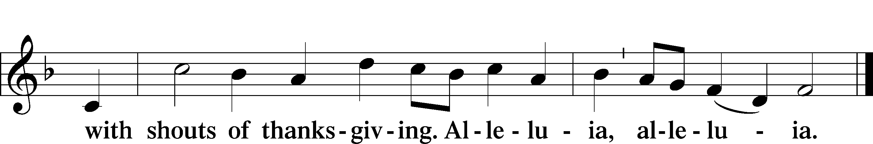

Post-Communion Collect
A Let us pray.
We give thanks to You, almighty God, that You have refreshed us through this salutary gift, and we implore You that of Your mercy You would strengthen us through the same in faith toward You and in fervent love toward one another; through Jesus Christ, Your Son, our Lord, who lives and reigns with You and the Holy Spirit, one God, now and forever.

Benediction LSB 166
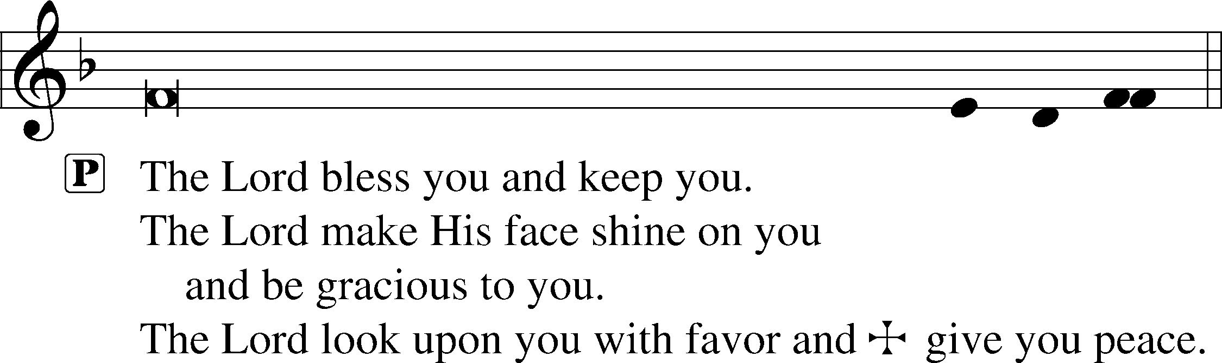

643 Sent Forth by God’s Blessing
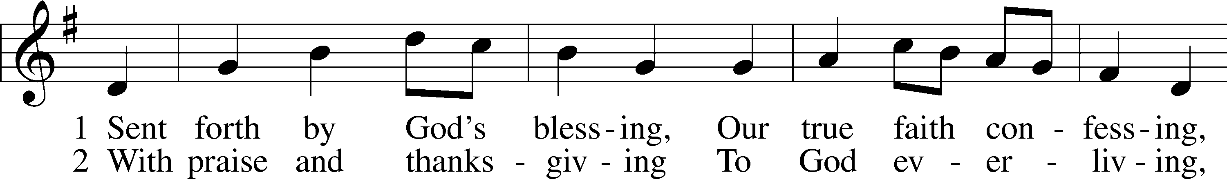
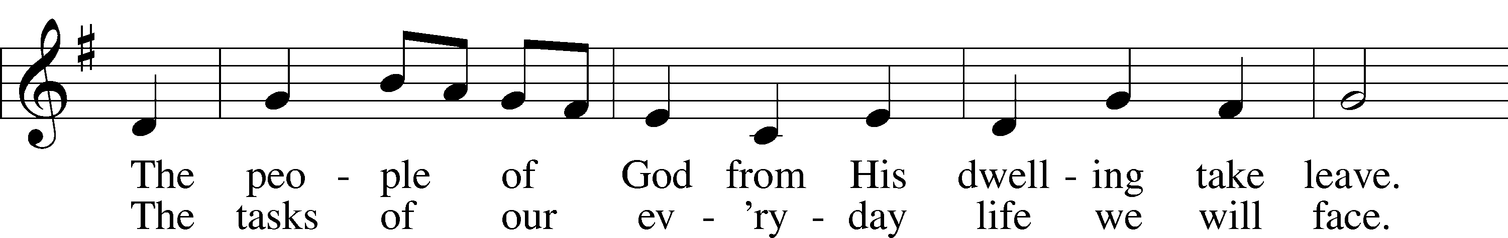
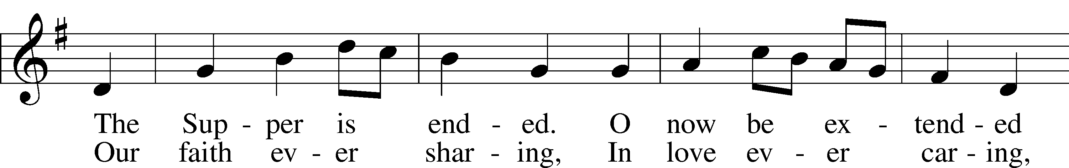
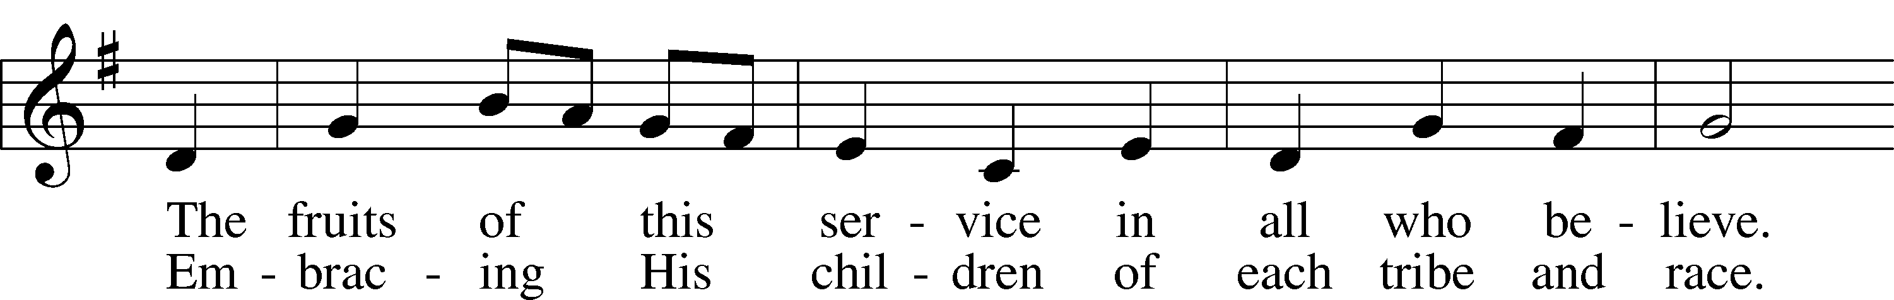
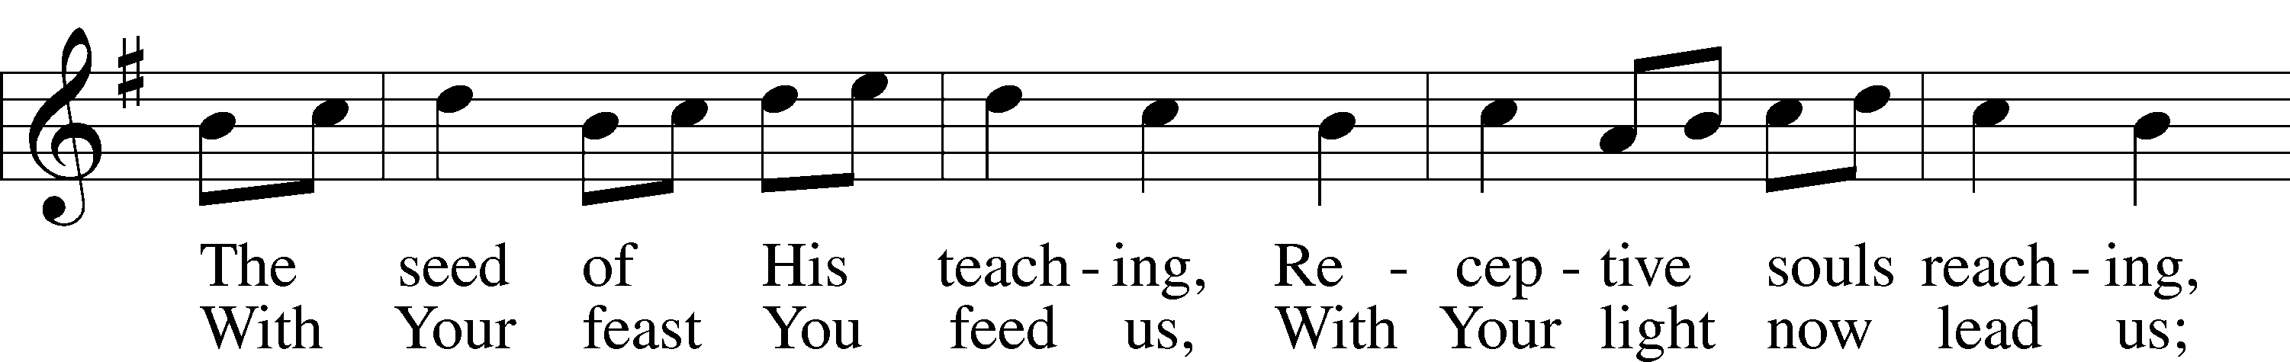
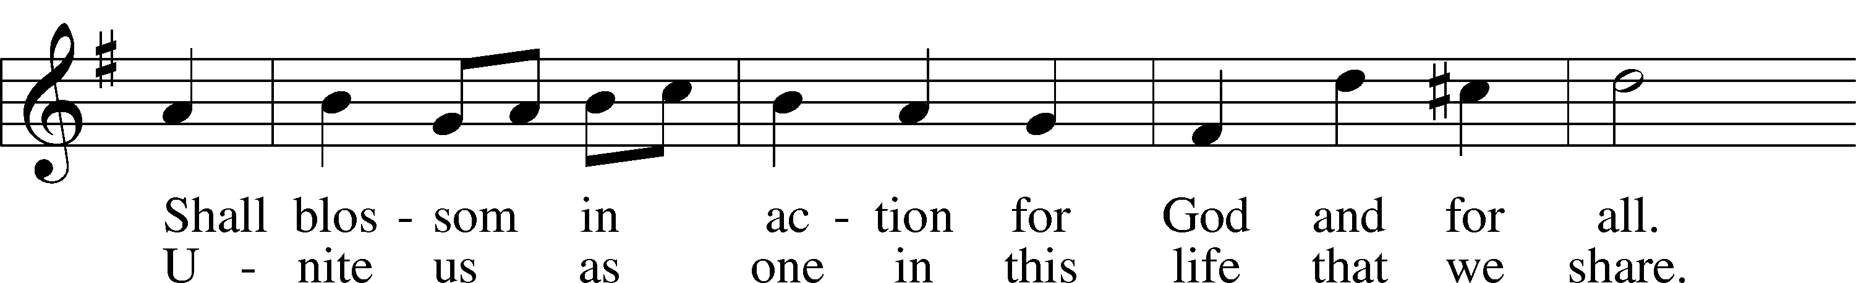
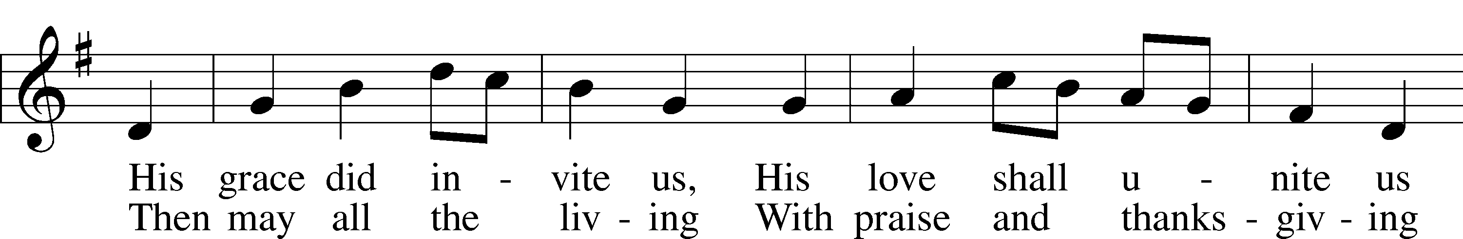
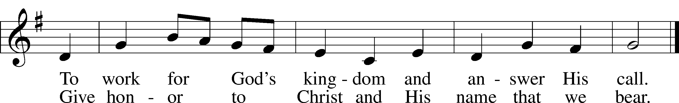
Text: Omer E. Westendorf, 1916–97, alt.
Tune: Welsh
Text: © 1964 World Library Publications. Used by permission: LSB Hymn License no. 110002831
Tune: Public domain

Acknowledgments
Unless otherwise indicated, Scripture quotations are from the ESV® Bible (The Holy Bible, English Standard Version®), copyright © 2001 by Crossway, a publishing ministry of Good News Publishers. Used by permission. All rights reserved.
Created by Lutheran Service Builder © 2024 Concordia Publishing House.

