Third Sunday of Easter
Prayer and Preaching
April 13 & 14, 2024
St. Paul Lutheran Church

594 God’s Own Child, I Gladly Say It
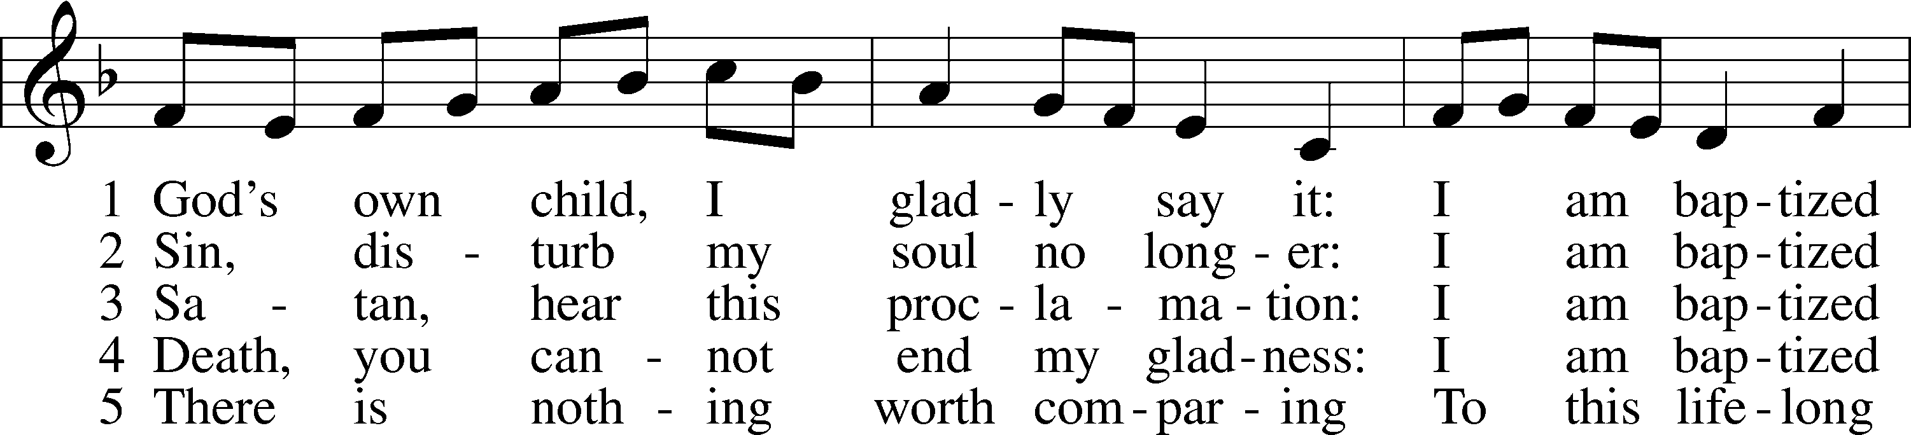
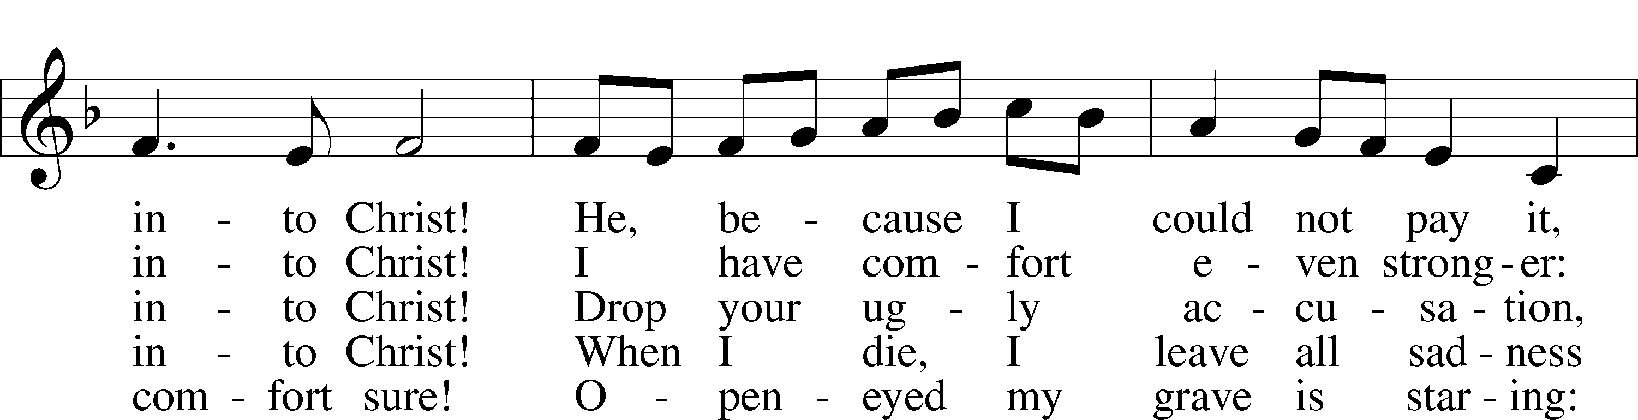
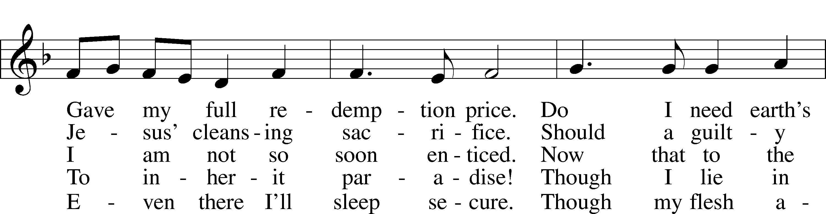
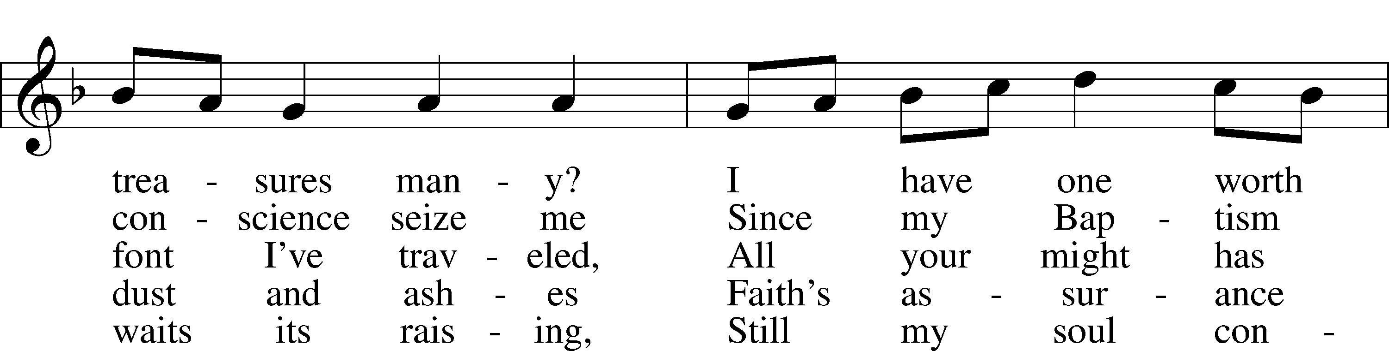
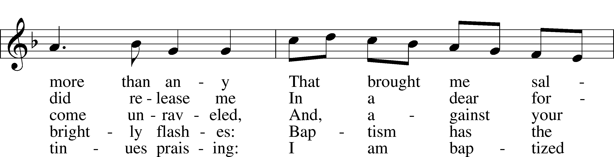
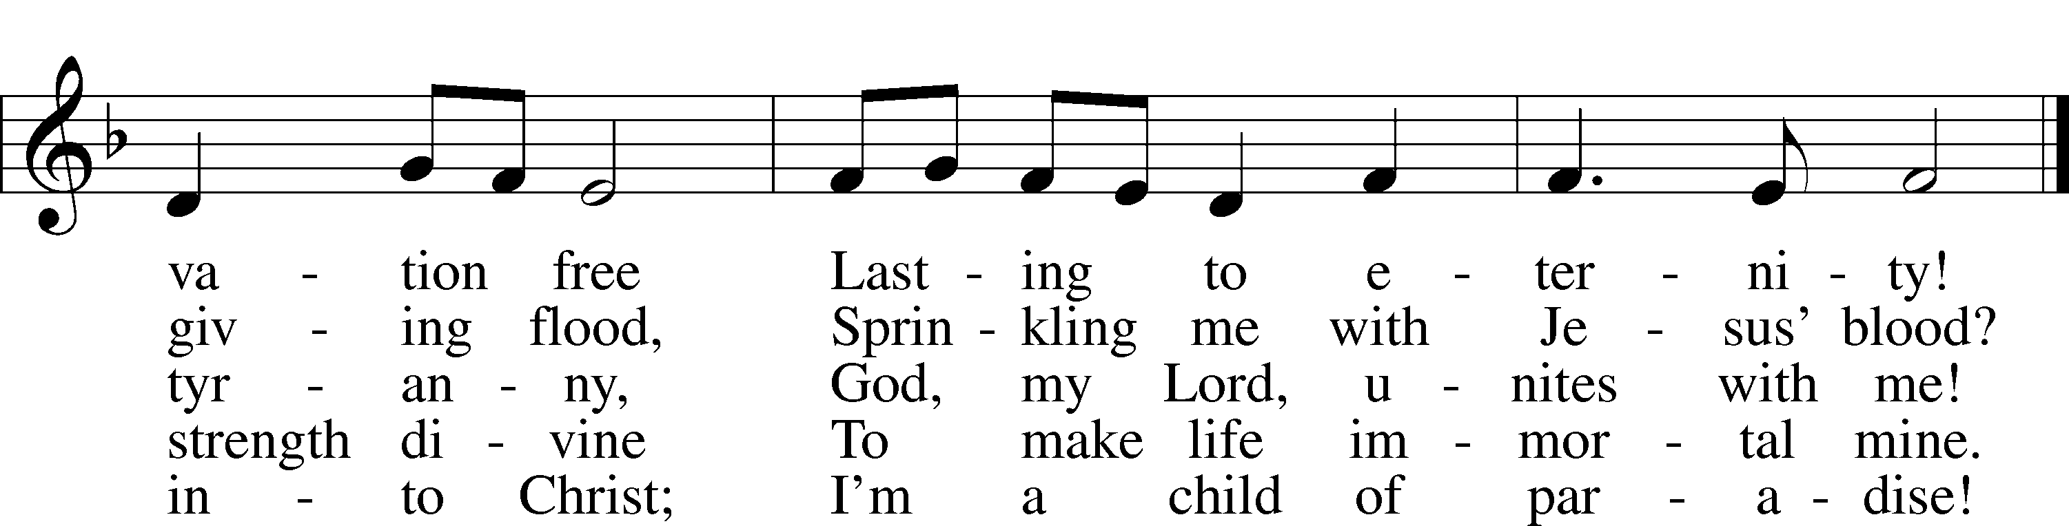
Text: Erdmann Neumeister, 1671–1756; tr. Robert E. Voelker, 1957
Tune: Johann Caspar Bachofen, 1695–1755, alt.
Text: © 1991 Robert E. Voelker. Used by permission: LSB Hymn License no. 110002831
Tune: Public domain

Stand

Opening Versicles

Common LSB 260
L This is the day which the Lord has made;
C let us rejoice and be glad in it.
L From the rising of the sun to its setting,
C the name of the Lord is to be praised.

L Better is one day in Your courts than a thousand elsewhere;
C I would rather be a doorkeeper in the house of my God than dwell in the tents of the wicked.
L Make me to know Your ways, O Lord.
C Teach me Your paths.
L Sanctify us in Your truth.
C Your Word is truth.

L From the rising of the sun to its setting,
C the name of the Lord is to be praised.

C Glory be to the Father and to the Son and to the Holy Spirit;
as it was in the beginning, is now, and will be forever. Amen.

Old Testament Canticle LSB 261
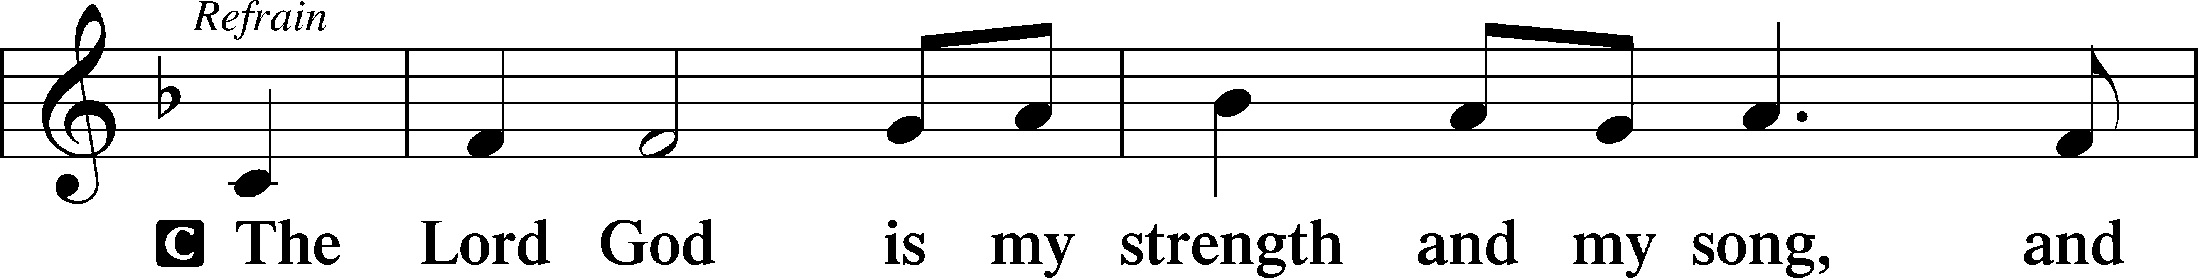
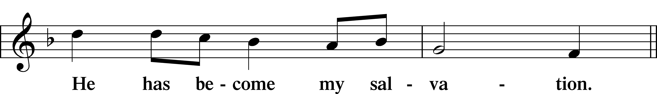
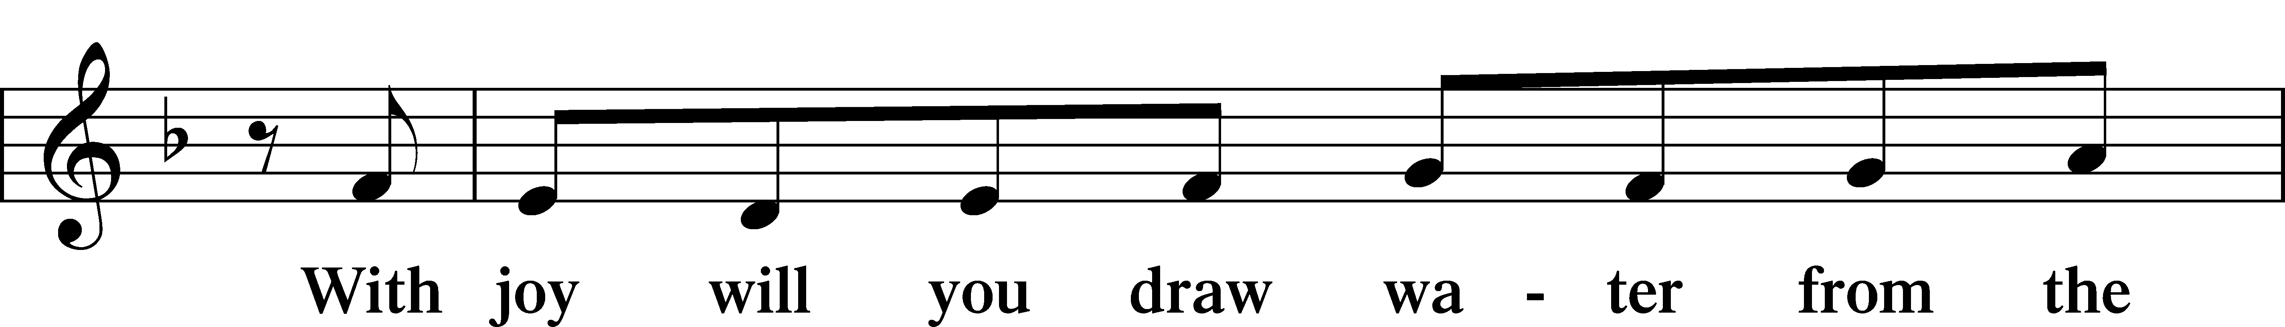
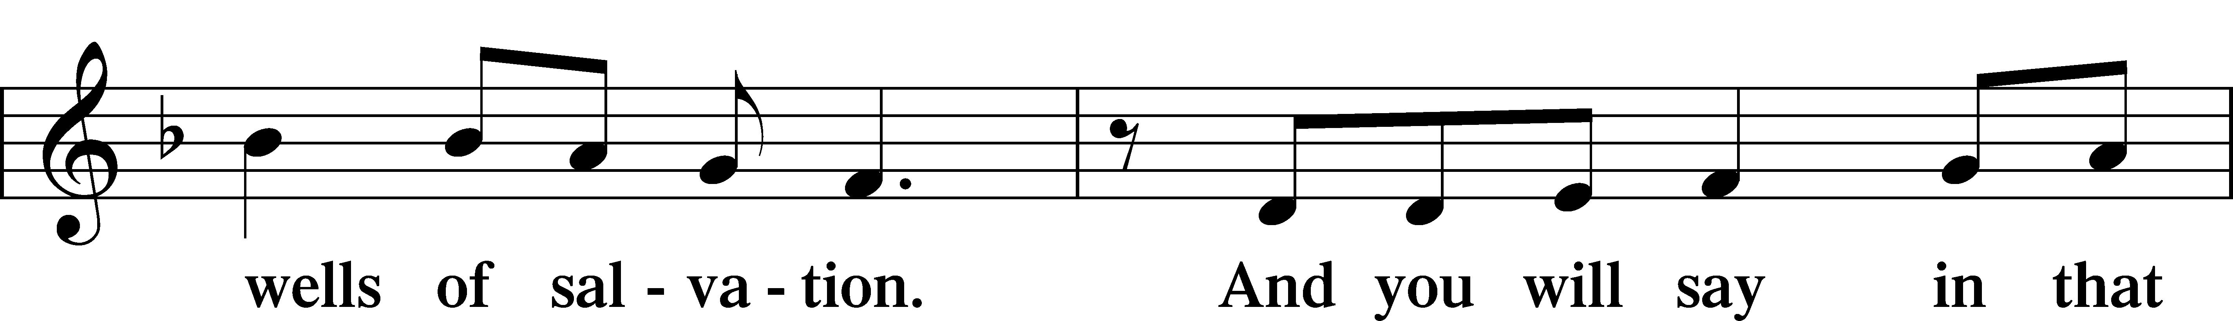
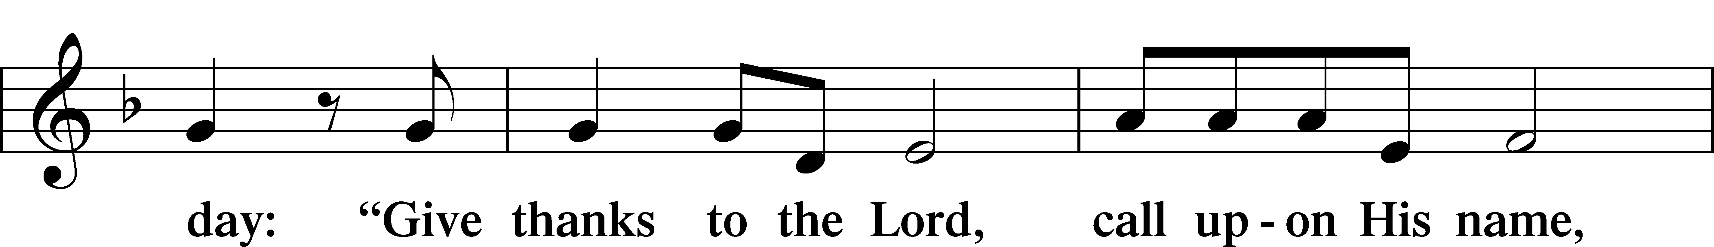
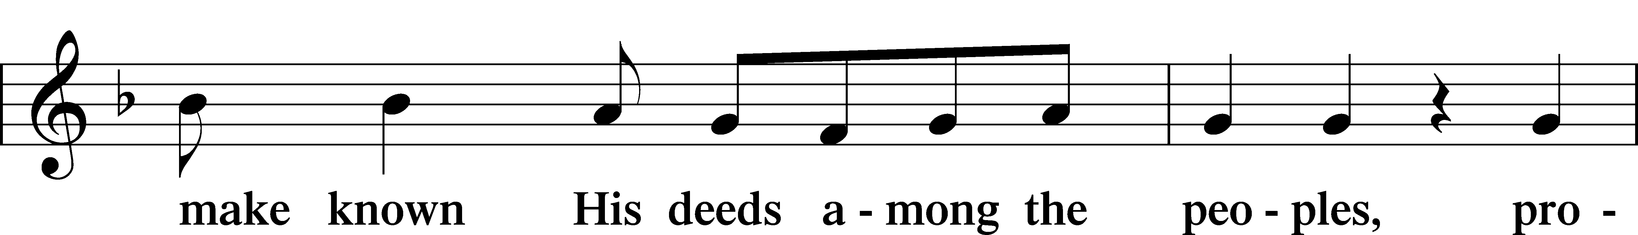
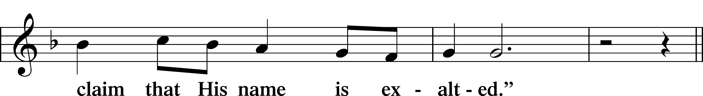
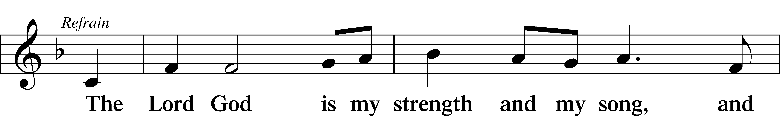
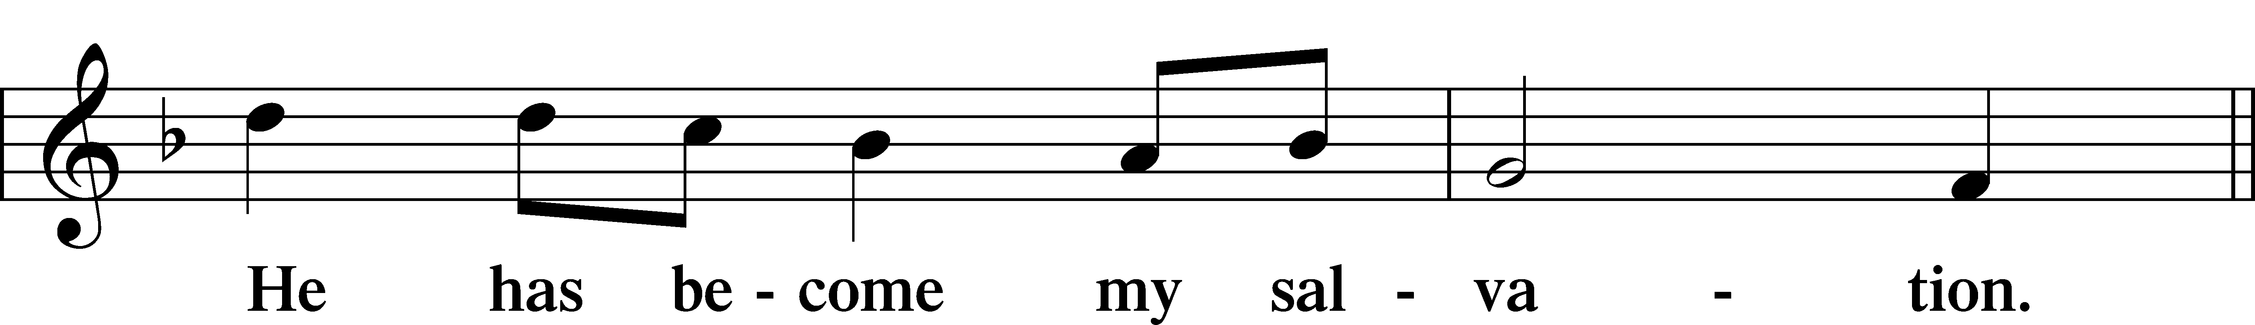
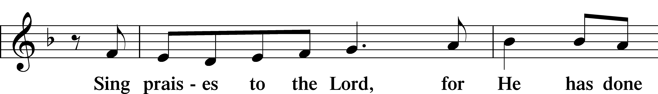
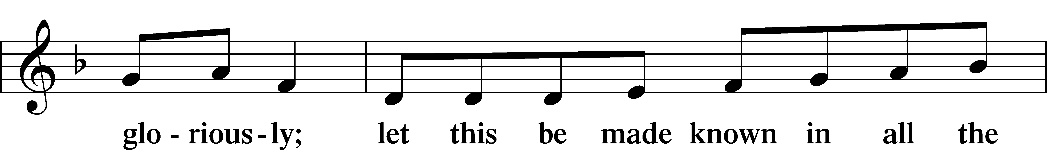
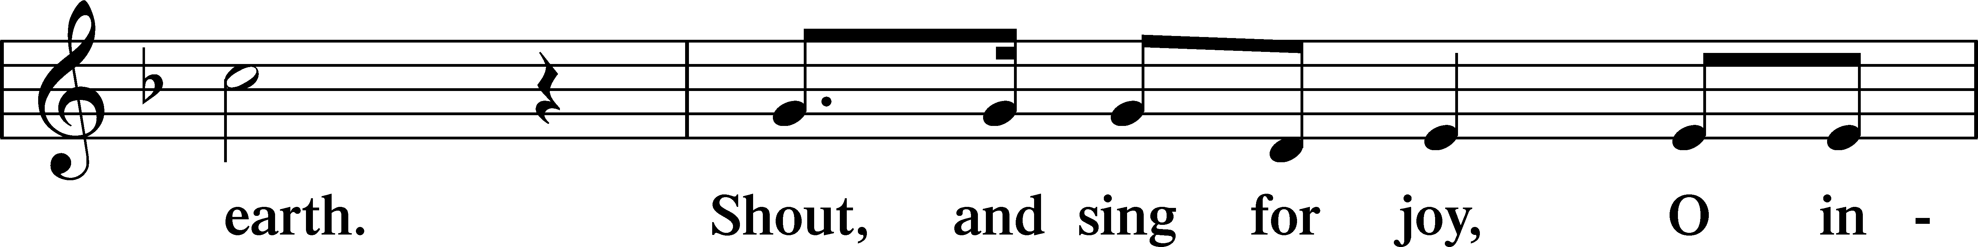
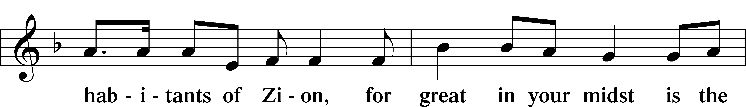
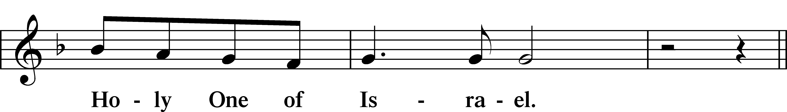
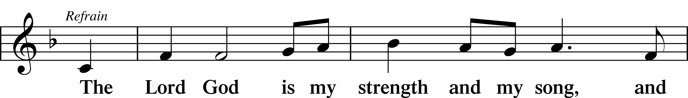
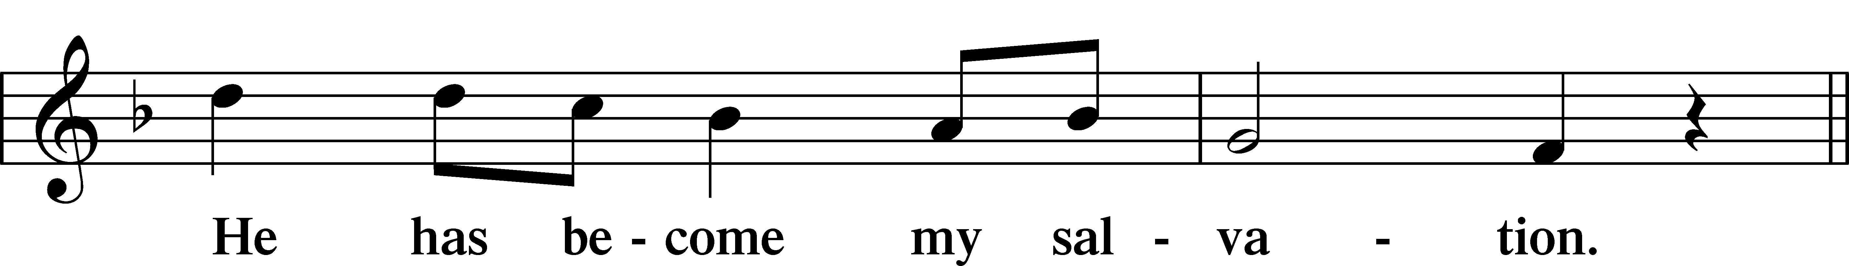
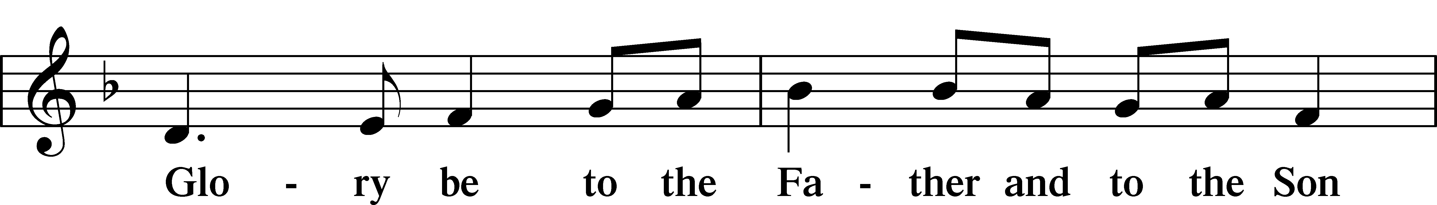
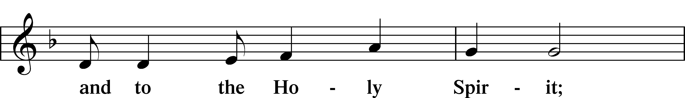
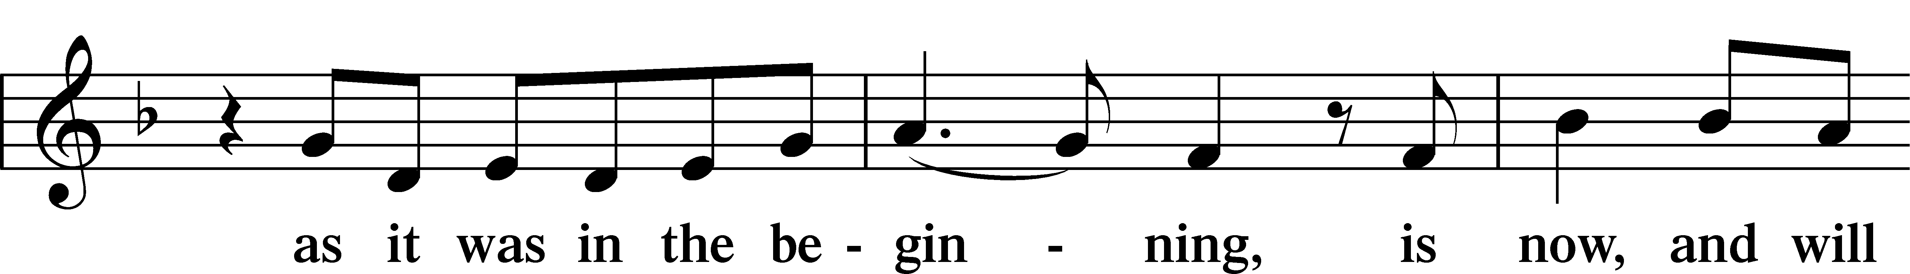
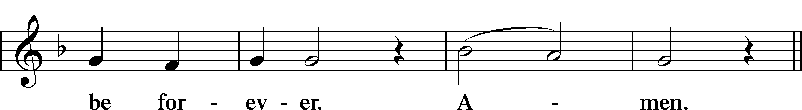
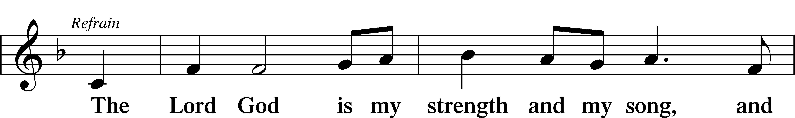
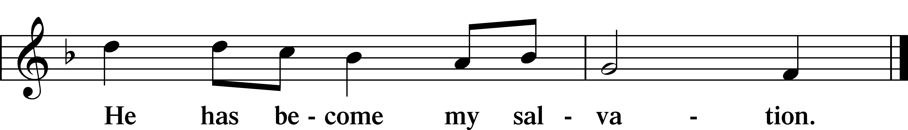

Sit

Readings From Holy Scripture

Reading Acts 3:11–21
L A reading from Acts, the third chapter.

11While [the lame man who was now healed] clung to Peter and John, all the people ran together to them in the portico called Solomon’s, astounded. 12And when Peter saw it he addressed the people: “Men of Israel, why do you wonder at this, or why do you stare at us, as though by our own power or piety we have made him walk? 13The God of Abraham, the God of Isaac, and the God of Jacob, the God of our fathers, glorified his servant Jesus, whom you delivered over and denied in the presence of Pilate, when he had decided to release him. 14But you denied the Holy and Righteous One, and asked for a murderer to be granted to you, 15and you killed the Author of life, whom God raised from the dead. To this we are witnesses. 16And his name—by faith in his name—has made this man strong whom you see and know, and the faith that is through Jesus has given the man this perfect health in the presence of you all.
17“And now, brothers, I know that you acted in ignorance, as did also your rulers. 18But what God foretold by the mouth of all the prophets, that his Christ would suffer, he thus fulfilled. 19Repent therefore, and turn again, that your sins may be blotted out, 20that times of refreshing may come from the presence of the Lord, and that he may send the Christ appointed for you, Jesus, 21whom heaven must receive until the time for restoring all the things about which God spoke by the mouth of his holy prophets long ago.”

L This is the Word of the Lord.
C Thanks be to God.

Reading 1 John 3:1–7
1See what kind of love the Father has given to us, that we should be called children of God; and so we are. The reason why the world does not know us is that it did not know him. 2Beloved, we are God’s children now, and what we will be has not yet appeared; but we know that when he appears we shall be like him, because we shall see him as he is. 3And everyone who thus hopes in him purifies himself as he is pure.
4Everyone who makes a practice of sinning also practices lawlessness; sin is lawlessness. 5You know that he appeared to take away sins, and in him there is no sin. 6No one who abides in him keeps on sinning; no one who keeps on sinning has either seen him or known him. 7Little children, let no one deceive you. Whoever practices righteousness is righteous, as he is righteous.

Reading Luke 24:36–49
36As they were talking about these things, Jesus himself stood among them, and said to them, “Peace to you!” 37But they were startled and frightened and thought they saw a spirit. 38And he said to them, “Why are you troubled, and why do doubts arise in your hearts? 39See my hands and my feet, that it is I myself. Touch me, and see. For a spirit does not have flesh and bones as you see that I have.” 40And when he had said this, he showed them his hands and his feet. 41And while they still disbelieved for joy and were marveling, he said to them, “Have you anything here to eat?” 42They gave him a piece of broiled fish, 43and he took it and ate before them.
44Then he said to them, “These are my words that I spoke to you while I was still with you, that everything written about me in the Law of Moses and the Prophets and the Psalms must be fulfilled.” 45Then he opened their minds to understand the Scriptures, 46and said to them, “Thus it is written, that the Christ should suffer and on the third day rise from the dead, 47and that repentance and forgiveness of sins should be proclaimed in his name to all nations, beginning from Jerusalem. 48You are witnesses of these things. 49And behold, I am sending the promise of my Father upon you. But stay in the city until you are clothed with power from on high.”

Responsory

Common LSB 263
L Forever, O Lord, Your Word is firmly set in the heavens.
C Lord, I love the habitation of Your house and the place where Your glory dwells.
L Blessed are those who hear the Word of God and keep it.
C Lord, I love the habitation of Your house and the place where Your glory dwells.
L Glory be to the Father and to the Son and to the Holy Spirit.
C Lord, I love the habitation of Your house and the place where Your glory dwells.

Stand

Ten Commandments
C You shall have no other gods.
You shall not misuse the name of the Lord your God.
Remember the Sabbath day by keeping it holy.
Honor your father and your mother.
You shall not murder.
You shall not commit adultery.
You shall not steal.
You shall not give false testimony against your neighbor.
You shall not covet your neighbor’s house.
You shall not covet your neighbor’s wife, or his manservant or maidservant, his ox or donkey, or anything that belongs to your neighbor.

Apostles’ Creed
C I believe in God, the Father Almighty,
maker of heaven and earth.

And in Jesus Christ, His only Son, our Lord,
who was conceived by the Holy Spirit,
born of the virgin Mary,
suffered under Pontius Pilate,
was crucified, died and was buried.
He descended into hell.
The third day He rose again from the dead.
He ascended into heaven
and sits at the right hand of God the Father Almighty.
From thence He will come to judge the living and the dead.

I believe in the Holy Spirit,
the holy Christian Church,
the communion of saints,
the forgiveness of sins,
the resurrection of the body,
and the life T everlasting. Amen.

Lord’s Prayer
C Our Father who art in heaven,
hallowed be Thy name,
Thy kingdom come,
Thy will be done on earth
as it is in heaven;
give us this day our daily bread;
and forgive us our trespasses
as we forgive those
who trespass against us;
and lead us not into temptation,
but deliver us from evil.
For Thine is the kingdom
and the power and the glory
forever and ever. Amen.

Sit
392 God Loves Me Dearly
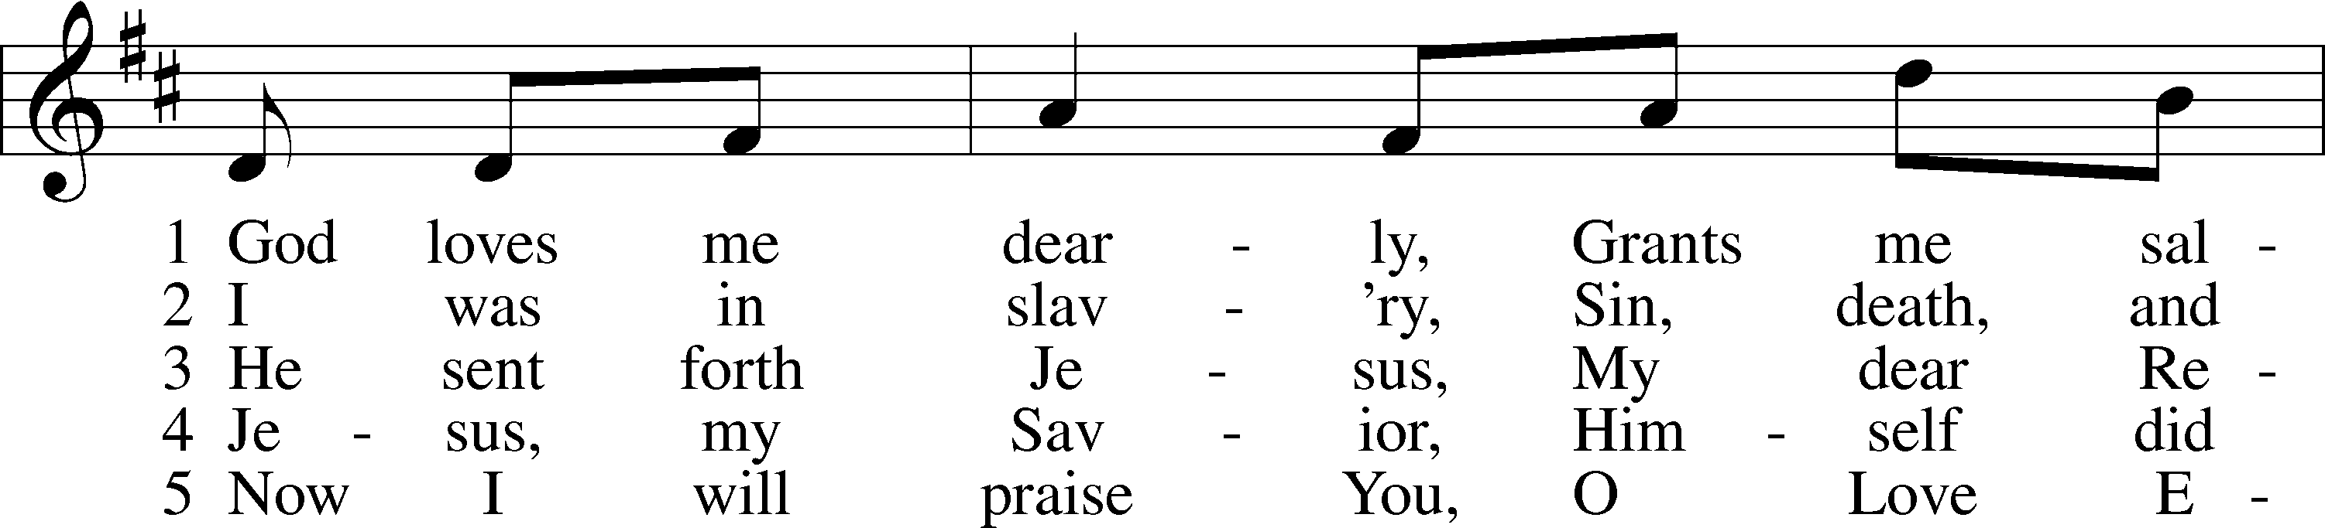
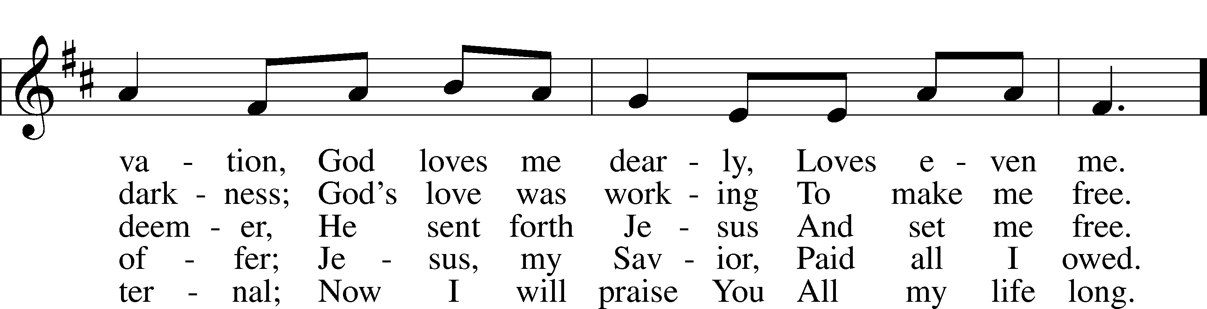
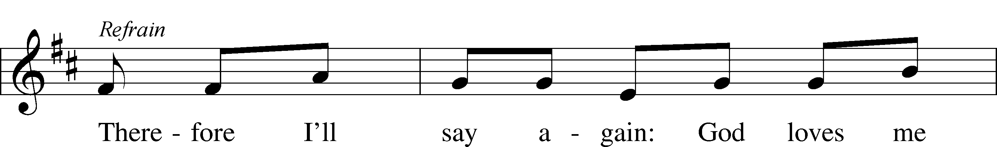
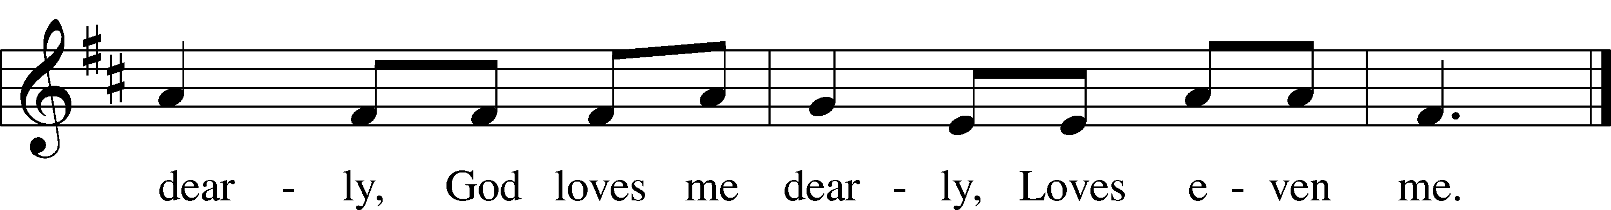
Text: August Rische, 1819–1906; tr. composite
Tune: German
Text and tune: Public domain

Children’s Sermon
Sermon

Offering

Stand

Prayer
L In peace let us pray to the Lord:
C Lord, have mercy.
L For the gift of divine peace and of pardon, with all our heart and with all our mind, let us pray to the Lord:
C Lord, have mercy.
L For the holy Christian Church, here and scattered throughout the world, and for the proclamation of the Gospel and the calling of all to faith, let us pray to the Lord:
C Lord, have mercy.
L For this nation, for our cities and communities, and for the common welfare of us all, let us pray to the Lord:
C Lord, have mercy.
L For seasonable weather and for the fruitfulness of the earth, let us pray to the Lord:
C Lord, have mercy.
L For those who labor, for those whose work is difficult or dangerous, and for all who travel, let us pray to the Lord:
C Lord, have mercy.
L For all those in need, for the hungry and homeless, for the widowed and orphaned, and for all those in prison, let us pray to the Lord:
C Lord, have mercy.
L For the sick and dying and for all those who care for them, let us pray to the Lord:
C Lord, have mercy.
L For . . . [additional bids for prayer may be inserted here] . . . let us pray to the Lord:
C Lord, have mercy.
L Finally, for these and for all our needs of body and soul, let us pray to the Lord:
C Lord, have mercy. Christ, have mercy. Lord, have mercy.

Collect of the Day
L O God, through the humiliation of Your Son You raised up the fallen world. Grant to Your faithful people, rescued from the peril of everlasting death, perpetual gladness and eternal joys; through Jesus Christ, our Lord, who lives and reigns with You and the Holy Spirit, one God, now and forever.
C Amen.

Collect for the Word
L Blessed Lord, You have caused all Holy Scriptures to be written for our learning. Grant that we may so hear them, read, mark, learn, and take them to heart that, by the patience and comfort of Your holy Word, we may embrace and ever hold fast the blessed hope of everlasting life; through Jesus Christ, Your Son, our Lord, who lives and reigns with You and the Holy Spirit, one God, now and forever.
C Amen.

Morning Prayer
C I thank You, my heavenly Father, through Jesus Christ, Your dear Son, that You have kept me this night from all harm and danger; and I pray that You would keep me this day also from sin and every evil, that all my doings and life may please You. For into Your hands I commend myself, my body and soul, and all things. Let Your holy angel be with me, that the evil foe may have no power over me.

EVENING PRAYER
C I thank You, my heavenly Father, through Jesus Christ, Your dear Son, that You have graciously kept me this day; and I pray that You would forgive me all my sins where I have done wrong, and graciously keep me this night. For into Your hands I commend myself, my body and soul, and all things. Let Your holy angel be with me, that the evil foe may have no power over me.

New Testament Canticle LSB 266
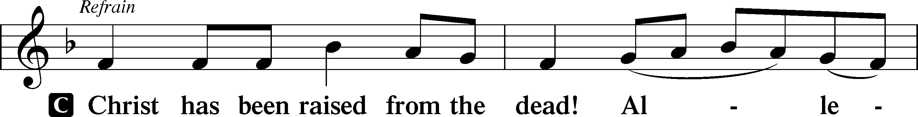
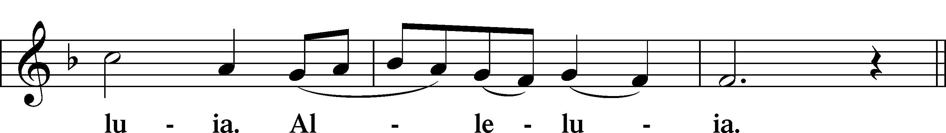
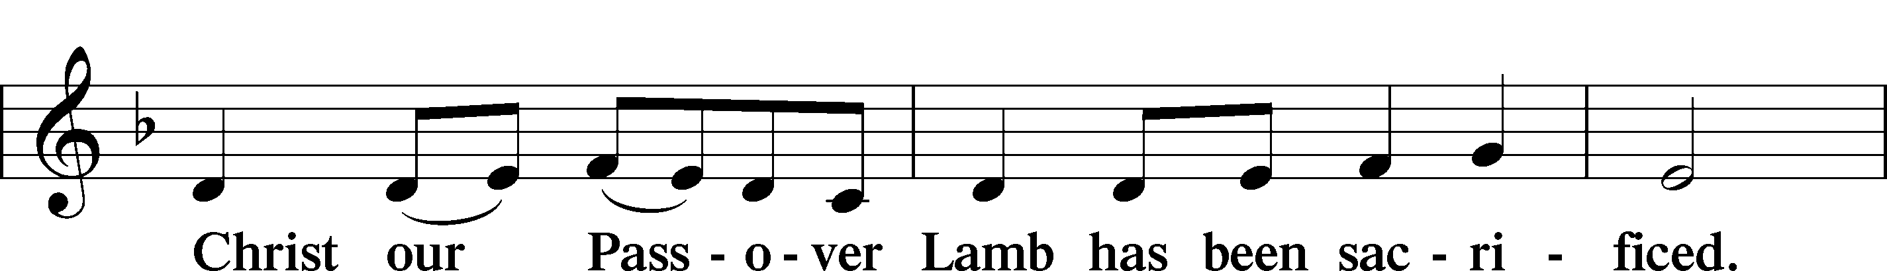
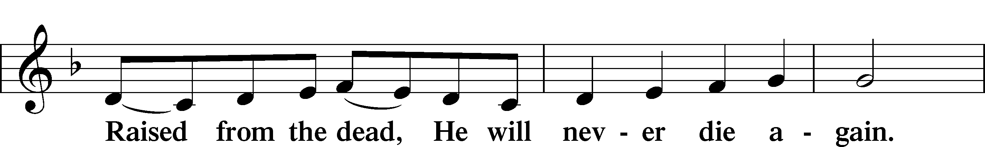
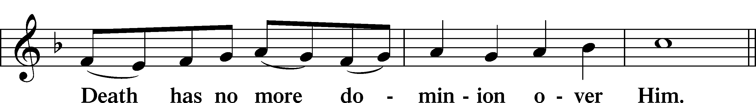
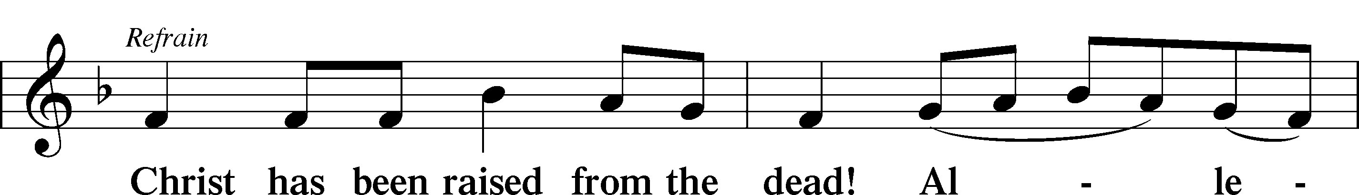
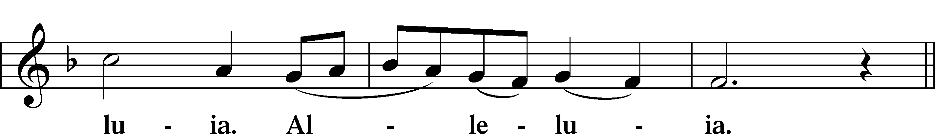
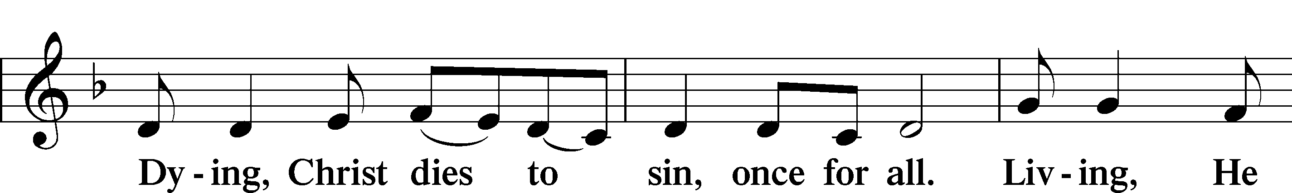
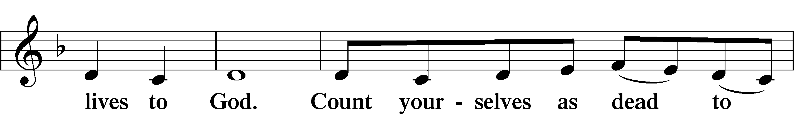
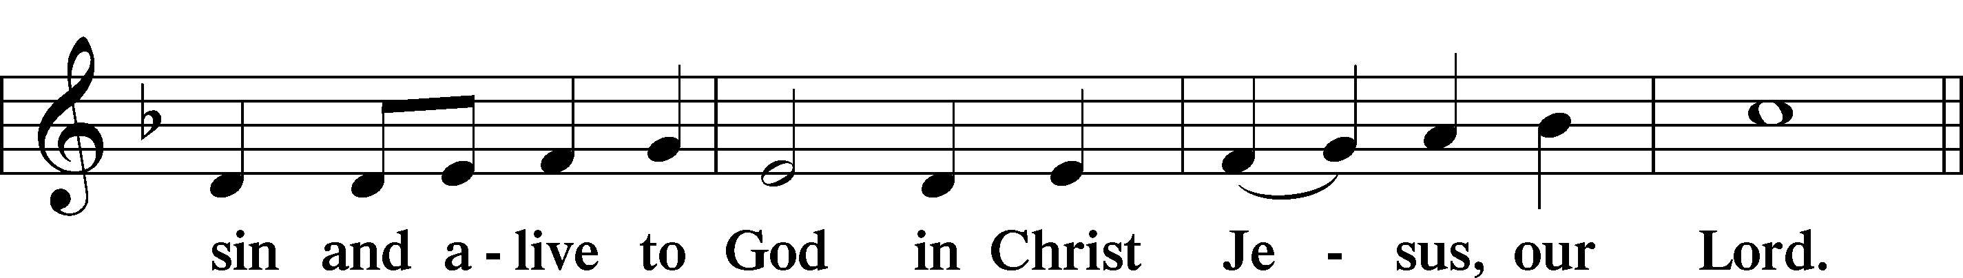
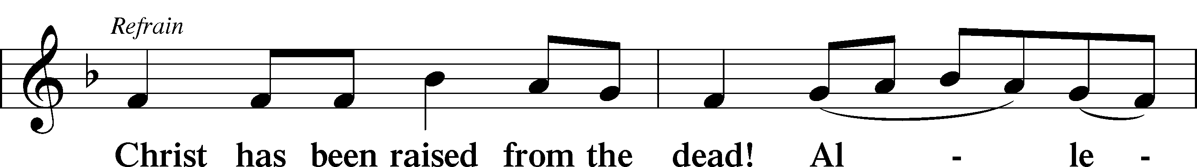
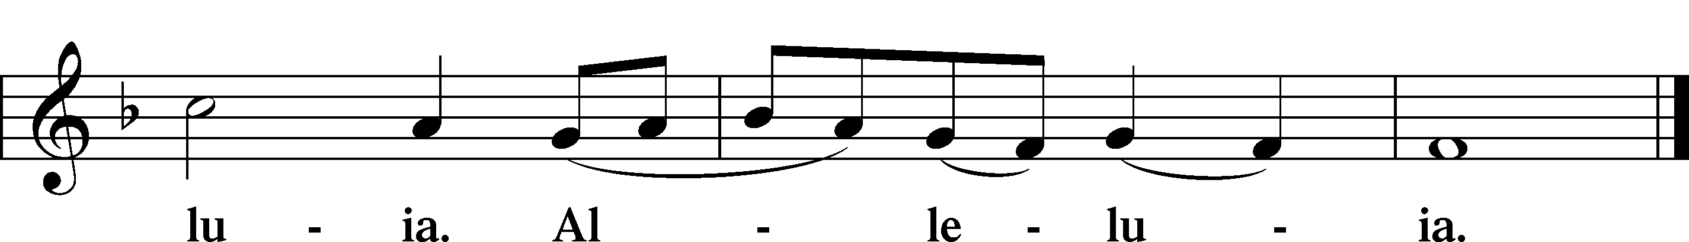

Blessing

Benedicamus LSB 267
L Let us bless the Lord.
C Thanks be to God.

Benediction LSB 267
P The almighty and merciful Lord, the Father, the T Son, and the Holy Spirit, bless and preserve you.
C Amen.

922 Go, My Children, with My Blessings
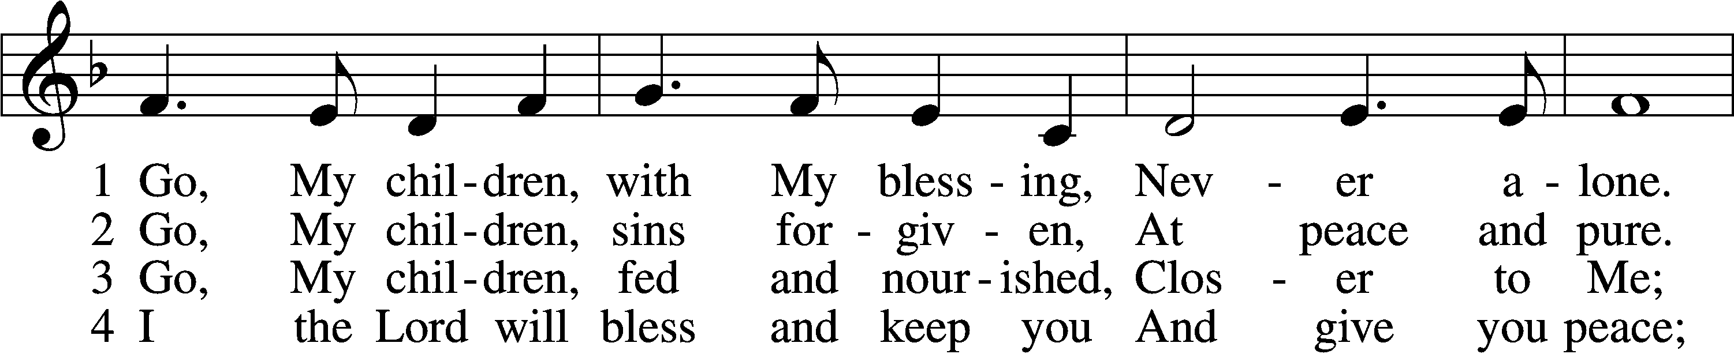
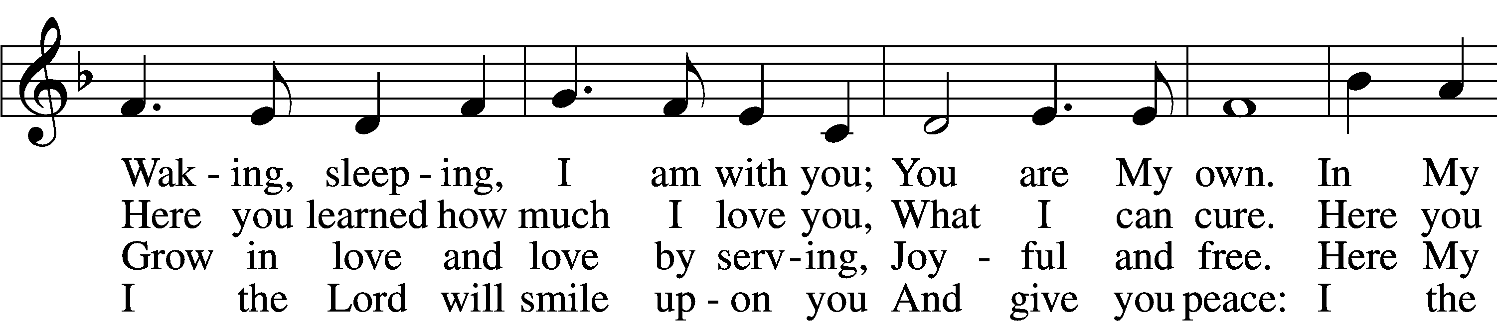
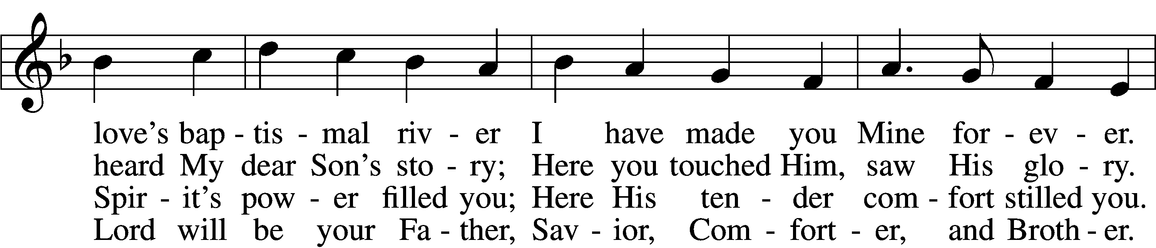
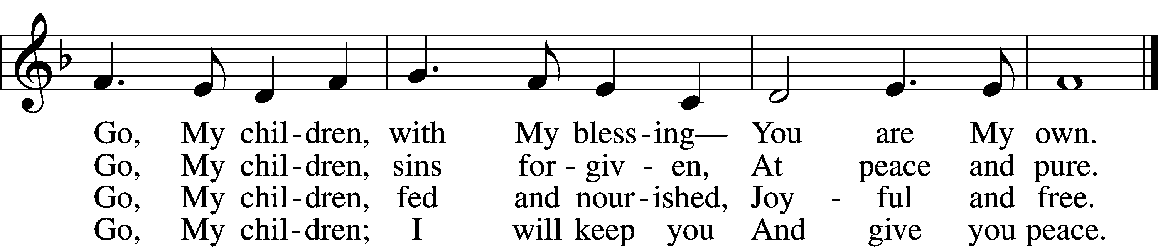
Text: Jaroslav J. Vajda, 1919–2008
Tune: Welsh, 18th cent.
Text: © 1983 Concordia Publishing House. Used by permission: LSB Hymn License no. 110002831
Tune: Public domain

Acknowledgments
Unless otherwise indicated, Scripture quotations are from the ESV® Bible (The Holy Bible, English Standard Version®), copyright © 2001 by Crossway, a publishing ministry of Good News Publishers. Used by permission. All rights reserved.
Created by Lutheran Service Builder © 2024 Concordia Publishing House.

