Second Sunday in Lent
Prayer and Preacher p. 260
February 24 & 25, 2024
St. Paul Lutheran Church

907 God Himself Is Present
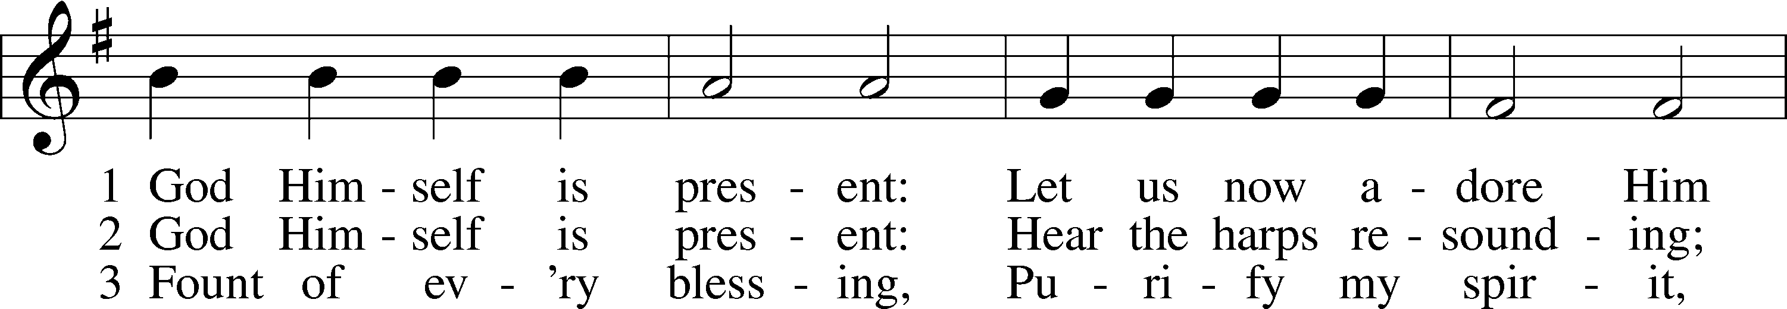
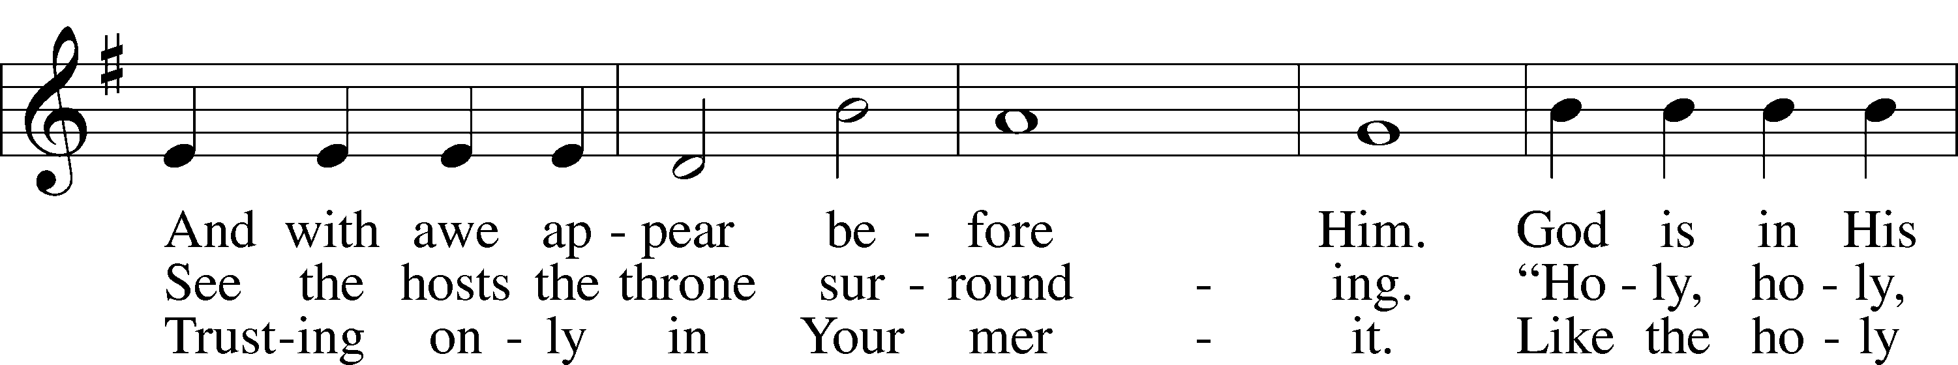
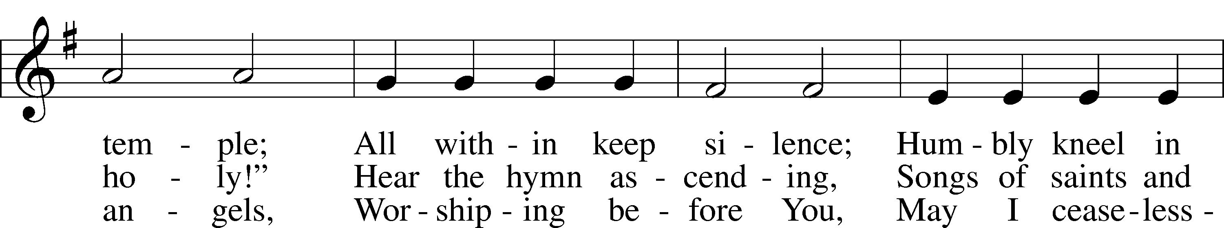
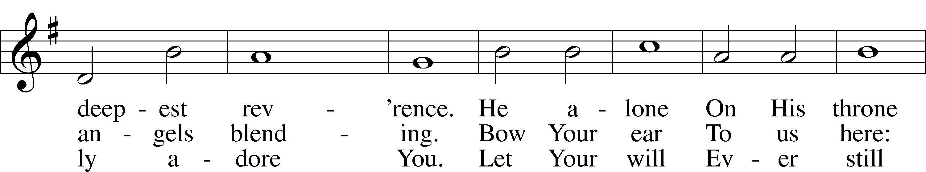
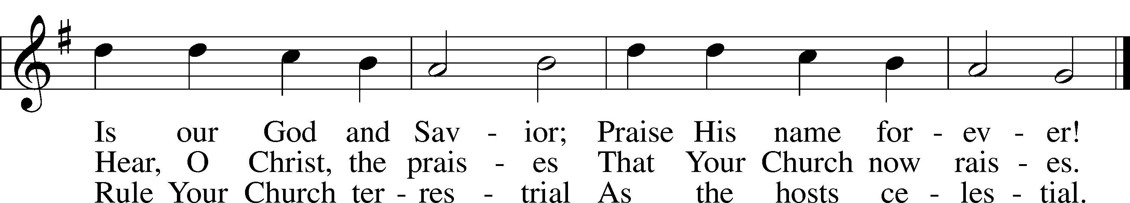
Text: Gerhard Tersteegen, 1697–1769, abr.; tr. Frederick W. Foster, 1760–1835, alt.; tr. John Miller, 1756–90, alt.
Tune: Joachim Neander, 1650–80
Text and tune: Public domain

Stand

Opening Versicles

Lent LSB 260
L This is the day which the Lord has made;
C let us rejoice and be glad in it.
L From the rising of the sun to its setting,
C the name of the Lord is to be praised.

L Return to the Lord, your God, for He is gracious and merciful,
C slow to anger, and abounding in steadfast love, and repents of evil.
L Jesus said: If any man would come after Me,
C let him deny himself and take up his cross and follow Me.
L Christ was wounded for our transgressions.
C He was bruised for our iniquities.

L From the rising of the sun to its setting,
C the name of the Lord is to be praised.

C Glory be to the Father and to the Son and to the Holy Spirit;
as it was in the beginning, is now, and will be forever. Amen.

Old Testament Canticle LSB 261
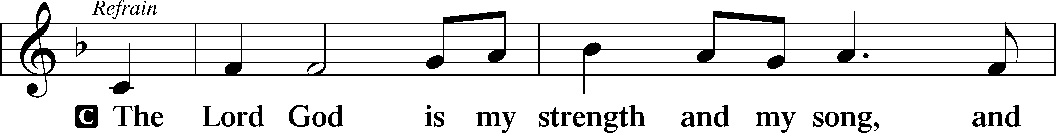
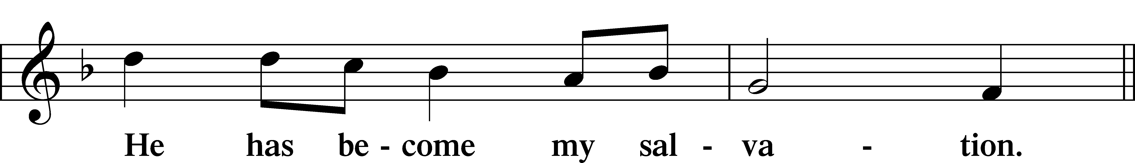
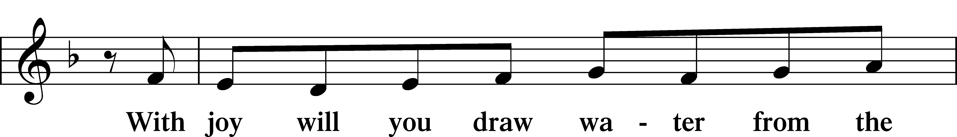
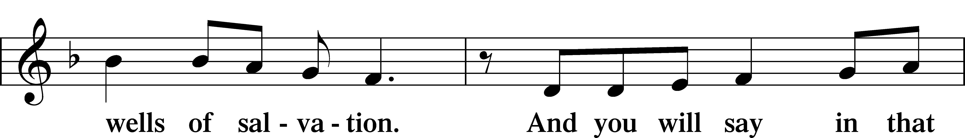
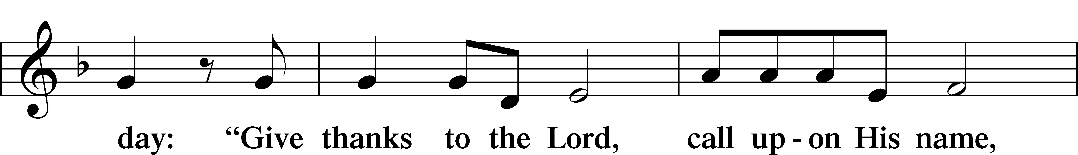
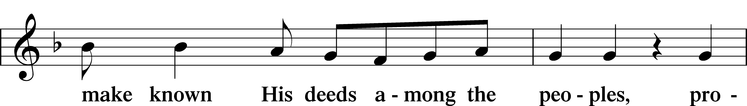
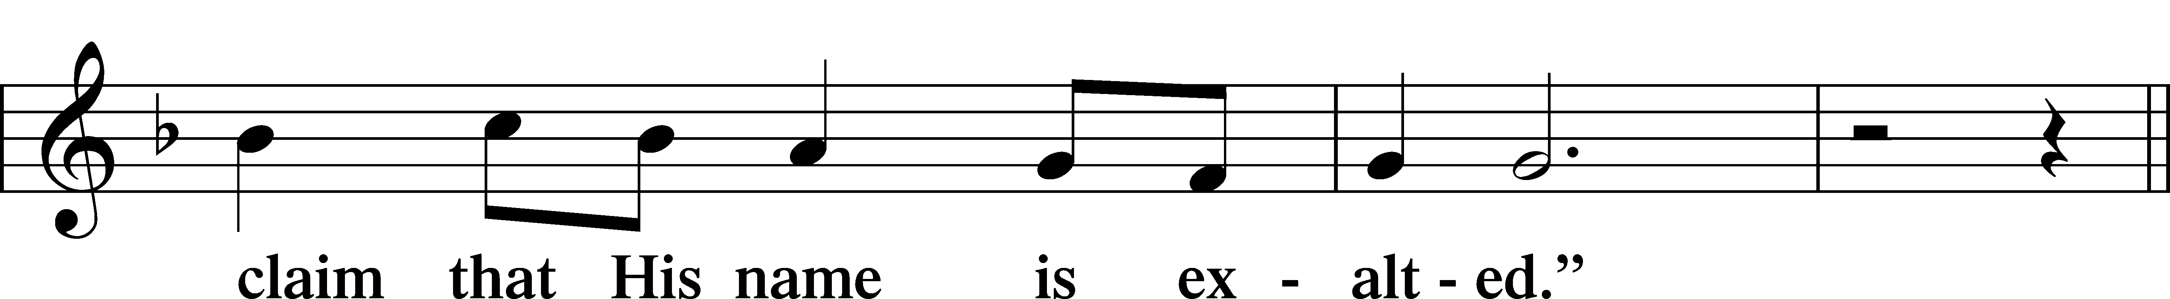
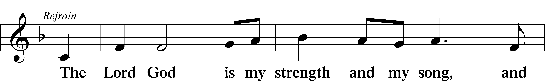
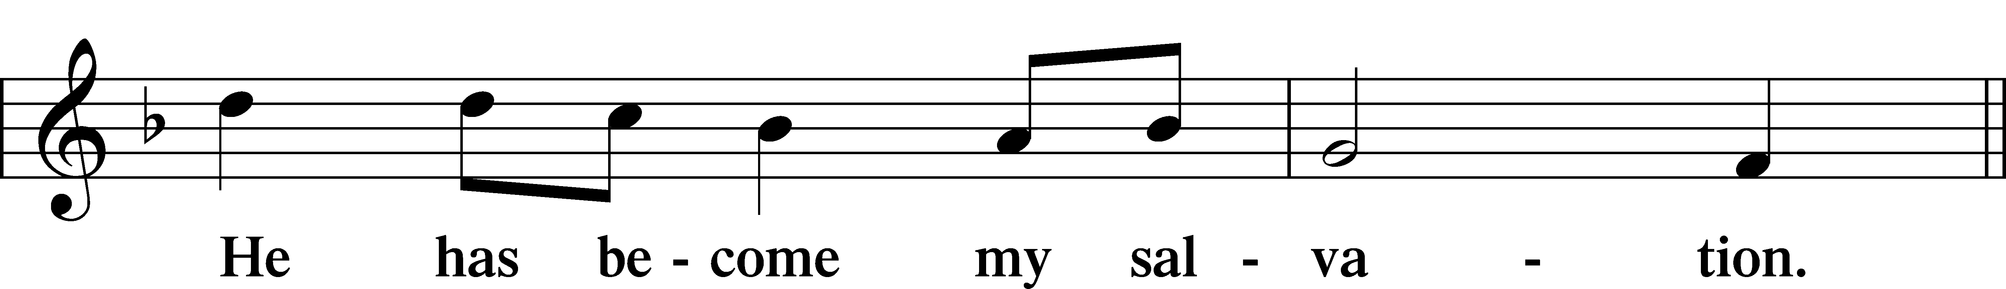
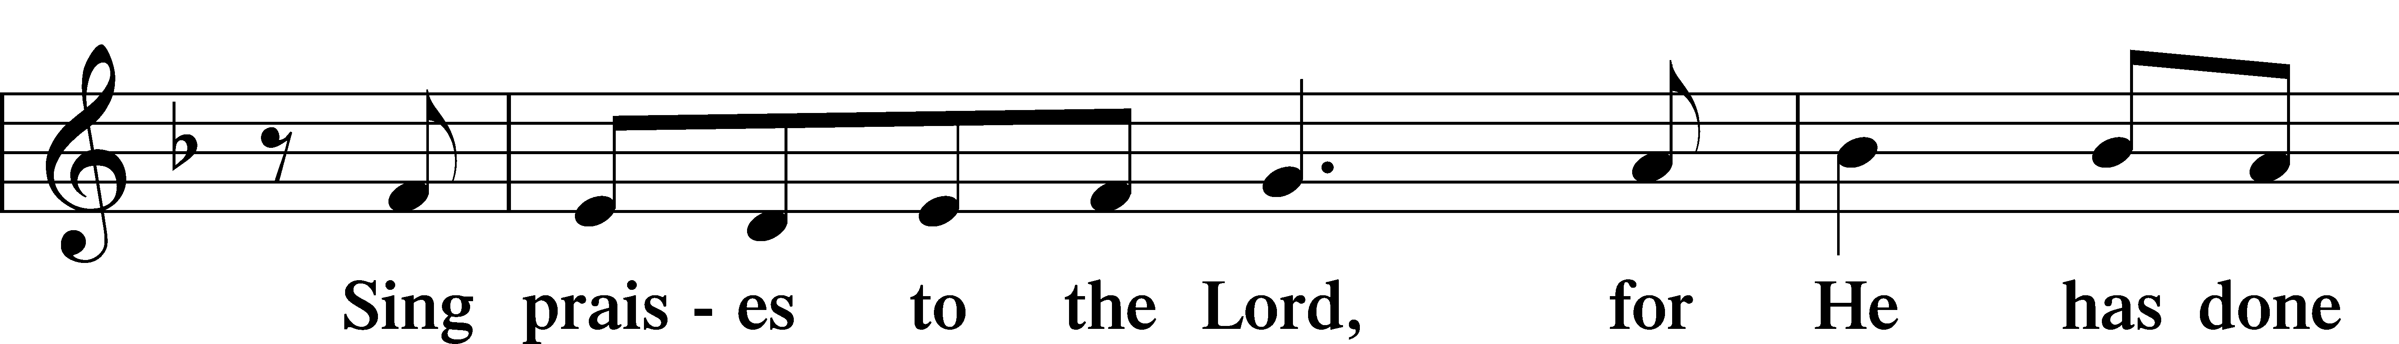
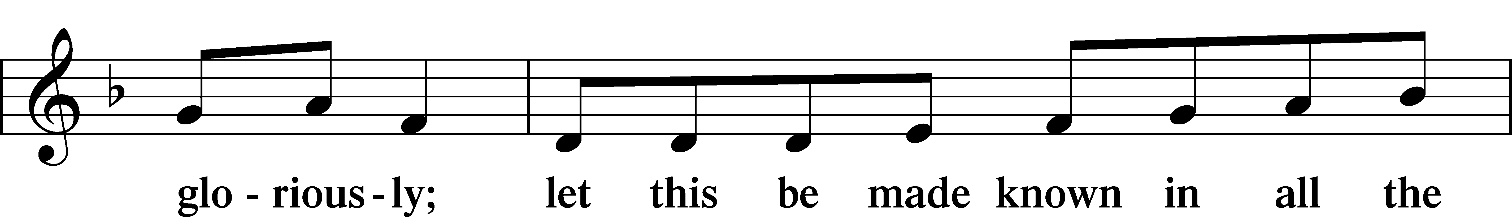
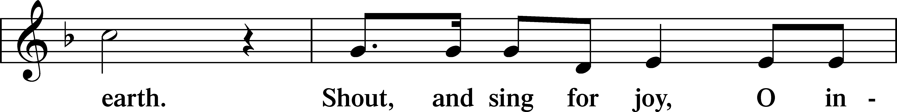
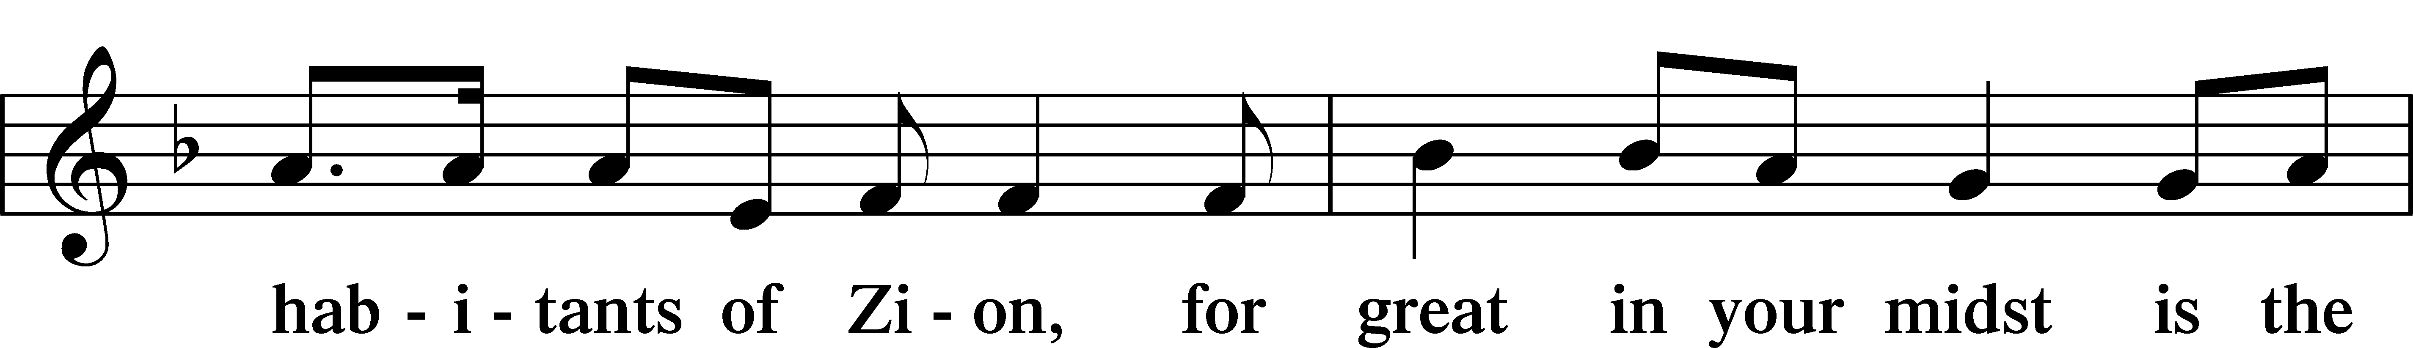
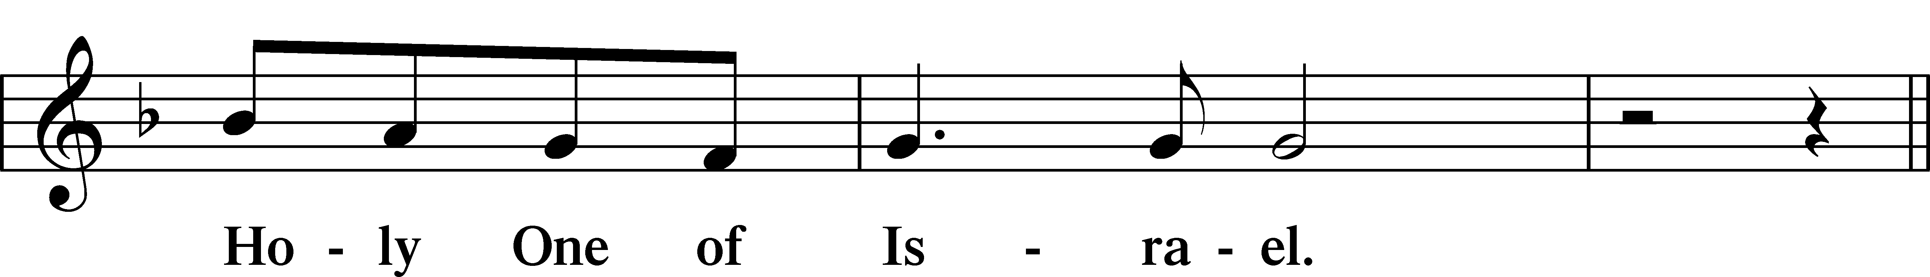
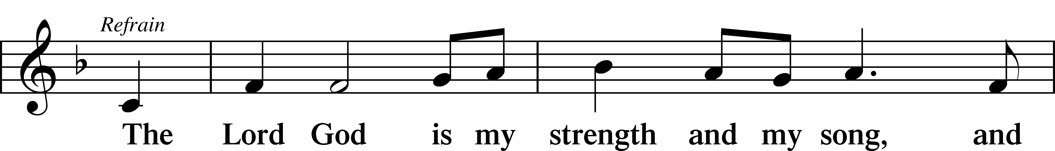
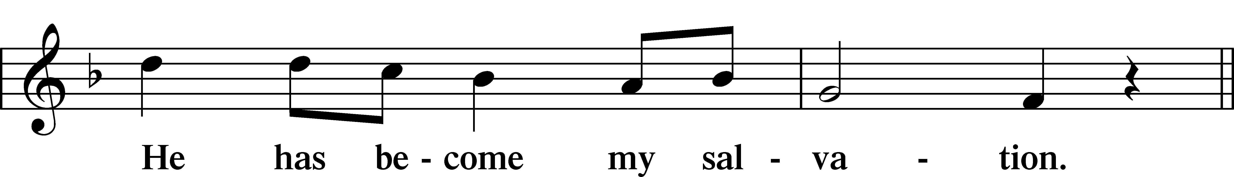
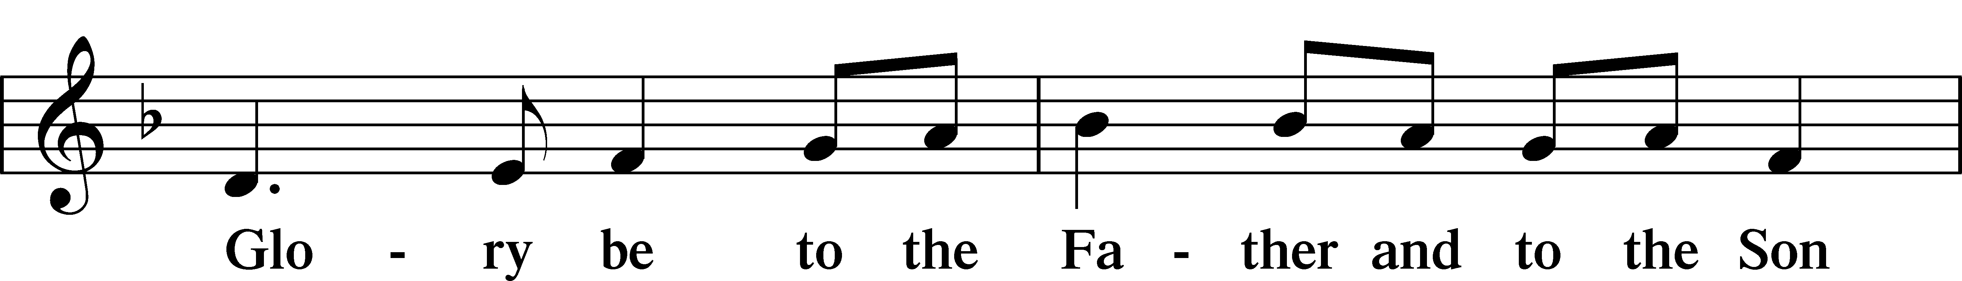
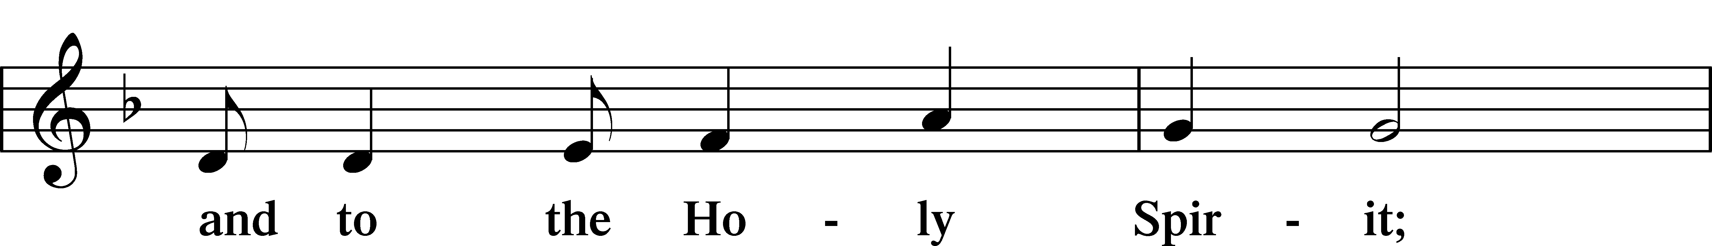
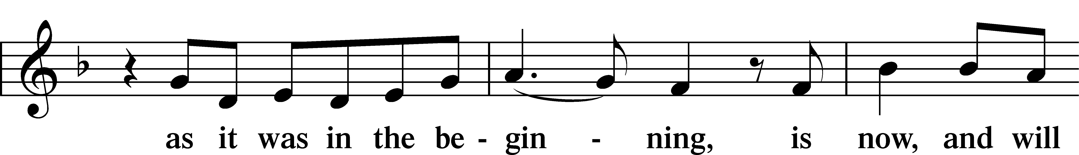
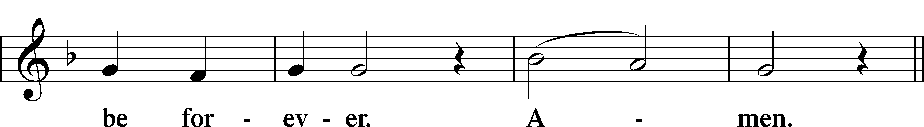
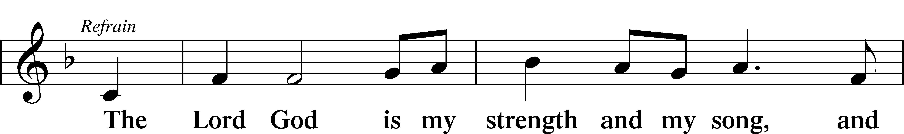
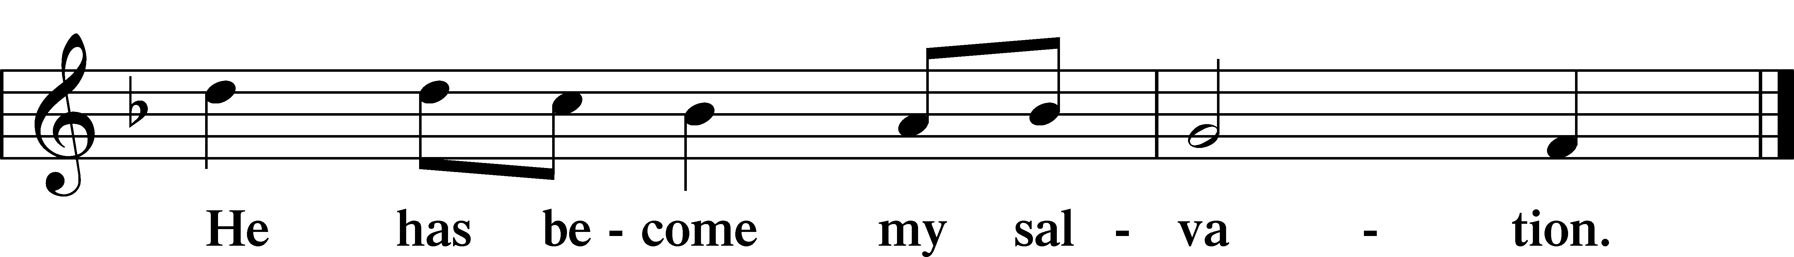

Sit

Readings From Holy Scripture

Reading Genesis 17:1–7, 15–16
L A reading from Genesis, the seventeenth chapter.

1When Abram was ninety-nine years old the Lord appeared to Abram and said to him, “I am God Almighty; walk before me, and be blameless, 2that I may make my covenant between me and you, and may multiply you greatly.” 3Then Abram fell on his face. And God said to him, 4“Behold, my covenant is with you, and you shall be the father of a multitude of nations. 5No longer shall your name be called Abram, but your name shall be Abraham, for I have made you the father of a multitude of nations. 6I will make you exceedingly fruitful, and I will make you into nations, and kings shall come from you. 7And I will establish my covenant between me and you and your offspring after you throughout their generations for an everlasting covenant, to be God to you and to your offspring after you. . . .
15And God said to Abraham, “As for Sarai your wife, you shall not call her name Sarai, but Sarah shall be her name. 16I will bless her, and moreover, I will give you a son by her. I will bless her, and she shall become nations; kings of peoples shall come from her.”

L This is the Word of the Lord.
C Thanks be to God.

Responsory

Lent LSB 263
L We have an advocate with the Father; Jesus Christ, the Righteous One.
C He was delivered up to death; He was delivered for the sins of the people.
L Blessed is the one whose transgression is forgiven, whose sin is covered.
C He was delivered up to death; He was delivered for the sins of the people.
L We have an advocate with the Father; Jesus Christ, the Righteous One.
C He was delivered up to death; He was delivered for the sins of the people.

Stand

Ten Commandments
C You shall have no other gods.
You shall not misuse the name of the Lord your God.
Remember the Sabbath day by keeping it holy.
Honor your father and your mother.
You shall not murder.
You shall not commit adultery.
You shall not steal.
You shall not give false testimony against your neighbor.
You shall not covet your neighbor’s house.
You shall not covet your neighbor’s wife, or his manservant or maidservant, his ox or donkey, or anything that belongs to your neighbor.

Apostles’ Creed
C I believe in God, the Father Almighty,
maker of heaven and earth.

And in Jesus Christ, His only Son, our Lord,
who was conceived by the Holy Spirit,
born of the virgin Mary,
suffered under Pontius Pilate,
was crucified, died and was buried.
He descended into hell.
The third day He rose again from the dead.
He ascended into heaven
and sits at the right hand of God the Father Almighty.
From thence He will come to judge the living and the dead.

I believe in the Holy Spirit,
the holy Christian Church,
the communion of saints,
the forgiveness of sins,
the resurrection of the body,
and the life T everlasting. Amen.

Lord’s Prayer
C Our Father who art in heaven,
hallowed be Thy name,
Thy kingdom come,
Thy will be done on earth
as it is in heaven;
give us this day our daily bread;
and forgive us our trespasses
as we forgive those
who trespass against us;
and lead us not into temptation,
but deliver us from evil.
For Thine is the kingdom
and the power and the glory
forever and ever. Amen.

Sit

430 My Song Is Love Unknown
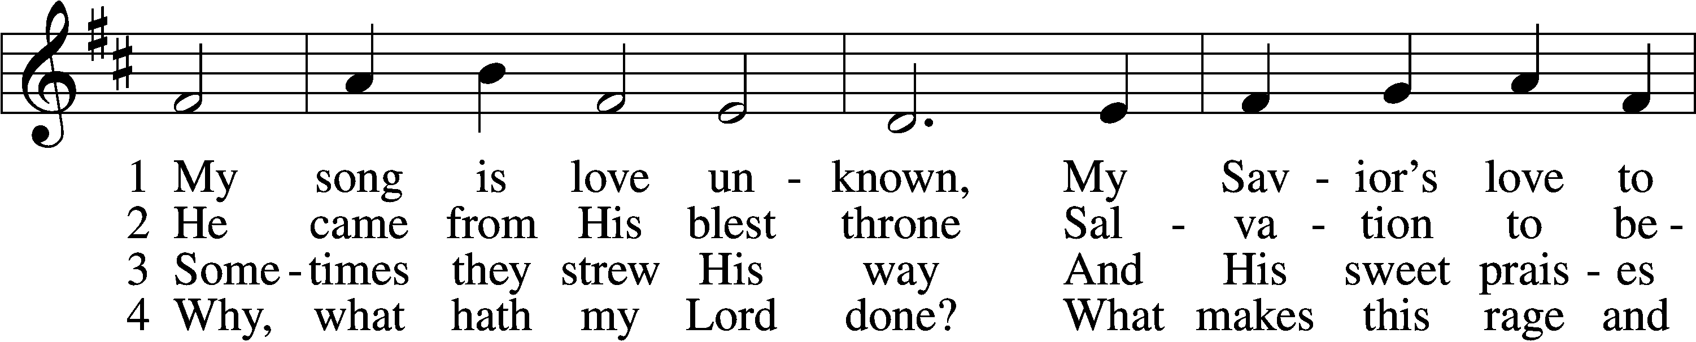
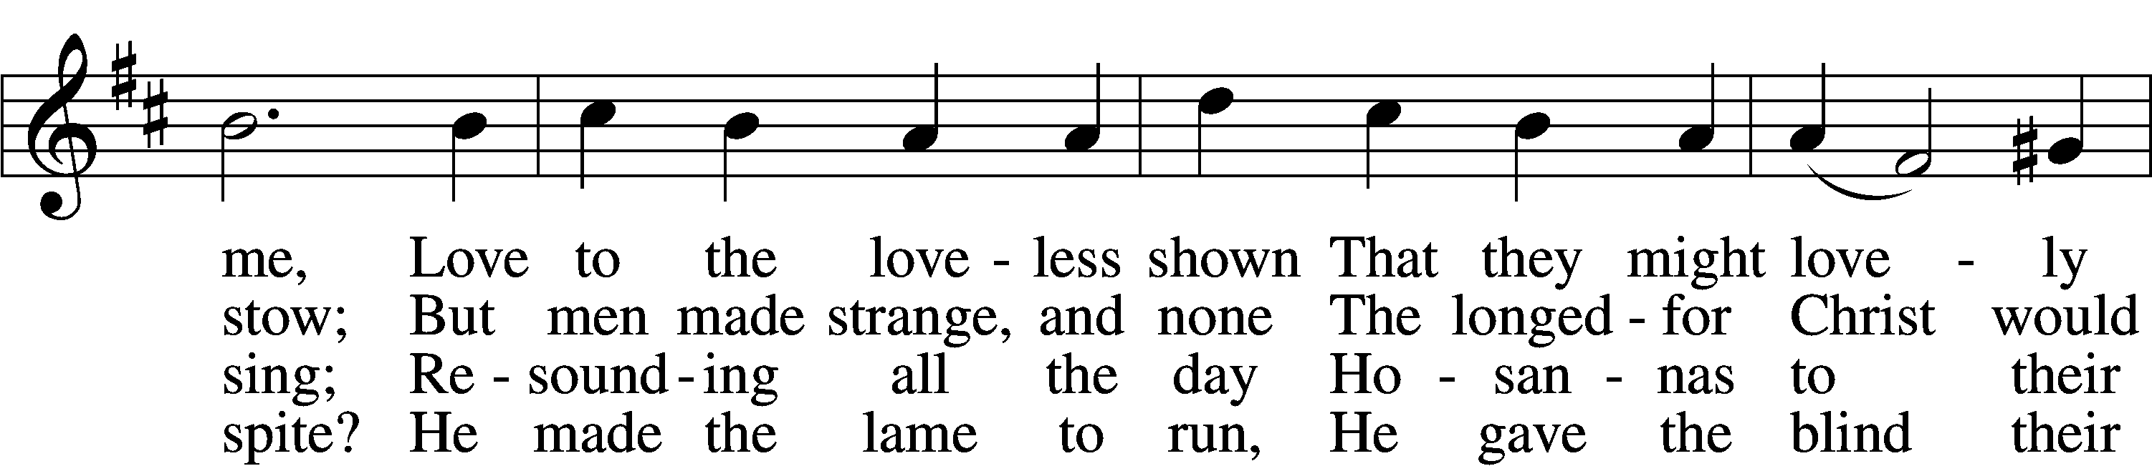
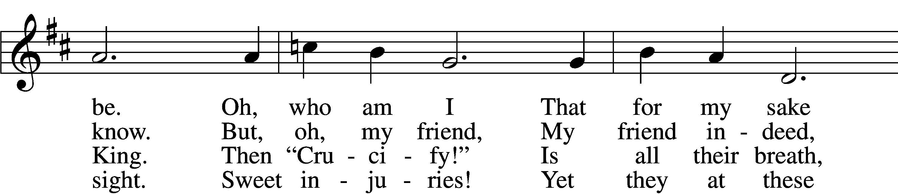
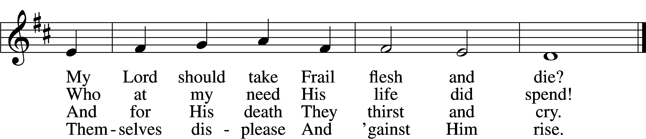

5 They rise and needs will have
My dear Lord made away;
A murderer they save,
The Prince of Life they slay.
Yet cheerful He
To suff’ring goes
That He His foes
From thence might free.

6 In life no house, no home
My Lord on earth might have;
In death no friendly tomb
But what a stranger gave.
What may I say?
Heav’n was His home
But mine the tomb
Wherein He lay.

7 Here might I stay and sing,
No story so divine!
Never was love, dear King,
Never was grief like Thine.
This is my friend,
In whose sweet praise
I all my days
Could gladly spend!
Text: Samuel Crossman, c. 1624–1683
Tune: John N. Ireland, 1879–1962
Text: Public domain
Tune: © John Ireland Trust. Used by permission: LSB Hymn License no. 110002831

Children’s Message
Sermon

Offering

Stand

Prayer
L In peace let us pray to the Lord:
C Lord, have mercy.
L For the gift of divine peace and of pardon, with all our heart and with all our mind, let us pray to the Lord:
C Lord, have mercy.
L For the holy Christian Church, here and scattered throughout the world, and for the proclamation of the Gospel and the calling of all to faith, let us pray to the Lord:
C Lord, have mercy.
L For this nation, for our cities and communities, and for the common welfare of us all, let us pray to the Lord:
C Lord, have mercy.
L For seasonable weather and for the fruitfulness of the earth, let us pray to the Lord:
C Lord, have mercy.
L For those who labor, for those whose work is difficult or dangerous, and for all who travel, let us pray to the Lord:
C Lord, have mercy.
L For all those in need, for the hungry and homeless, for the widowed and orphaned, and for all those in prison, let us pray to the Lord:
C Lord, have mercy.
L For the sick and dying and for all those who care for them, let us pray to the Lord:
C Lord, have mercy.
L For . . . [______] . . . let us pray to the Lord:
C Lord, have mercy.
L Finally, for these and for all our needs of body and soul, let us pray to the Lord:
C Lord, have mercy. Christ, have mercy. Lord, have mercy.

Collect of the Day
L O God, You see that of ourselves we have no strength. By Your mighty power defend us from all adversities that may happen to the body and from all evil thoughts that may assault and hurt the soul; through Jesus Christ, Your Son, our Lord, who lives and reigns with You and the Holy Spirit, one God, now and forever.
C Amen.

Collect for the Word
L Blessed Lord, You have caused all Holy Scriptures to be written for our learning. Grant that we may so hear them, read, mark, learn, and take them to heart that, by the patience and comfort of Your holy Word, we may embrace and ever hold fast the blessed hope of everlasting life; through Jesus Christ, Your Son, our Lord, who lives and reigns with You and the Holy Spirit, one God, now and forever.
C Amen.

Morning Prayer
C I thank You, my heavenly Father, through Jesus Christ, Your dear Son, that You have kept me this night from all harm and danger; and I pray that You would keep me this day also from sin and every evil, that all my doings and life may please You. For into Your hands I commend myself, my body and soul, and all things. Let Your holy angel be with me, that the evil foe may have no power over me.

Evening Prayer
C I thank You, my heavenly Father, through Jesus Christ, Your dear Son, that You have graciously kept me this day; and I pray that You would forgive me all my sins where I have done wrong, and graciously keep me this night. For into Your hands I commend myself, my body and soul, and all things. Let Your holy angel be with me, that the evil foe may have no power over me.

940 Holy God, We Praise Thy Name sts. 1–5
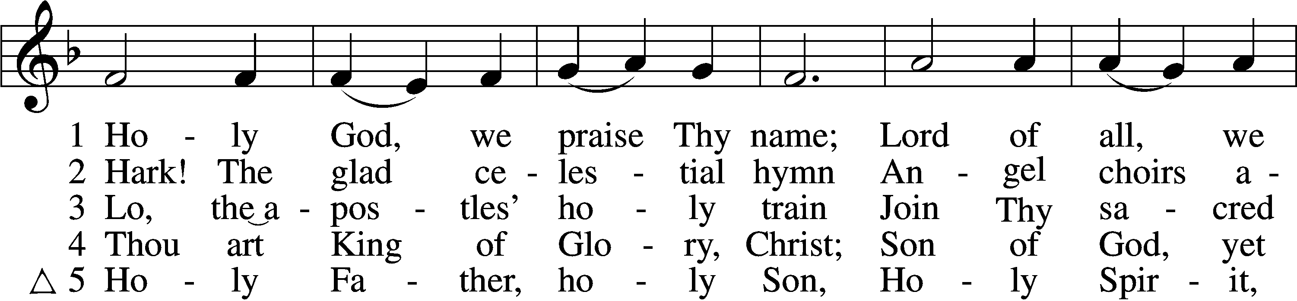
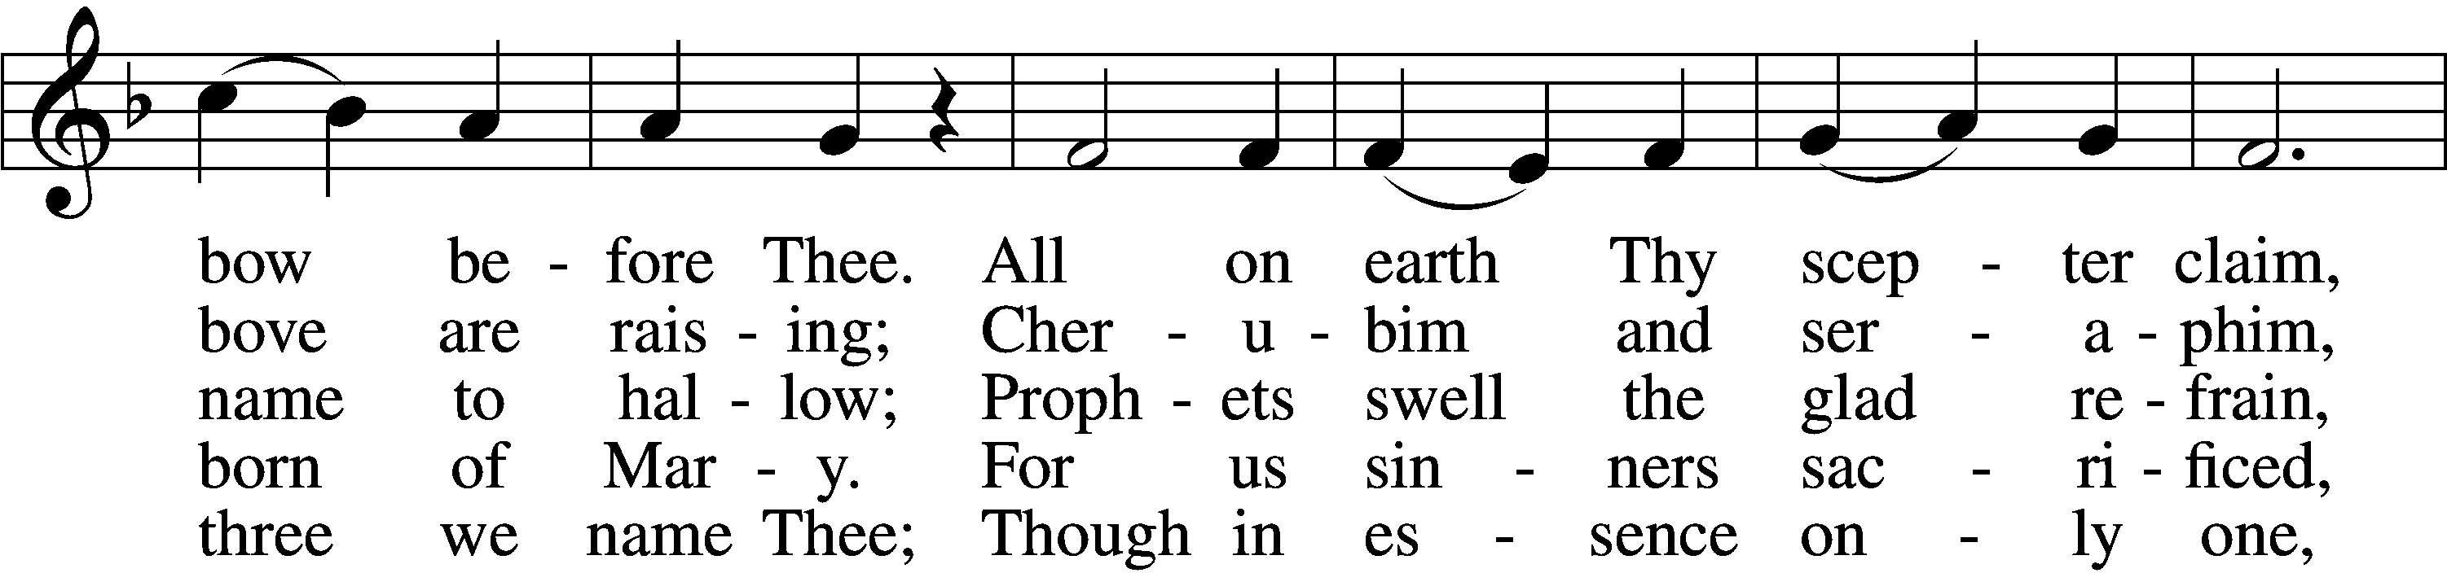
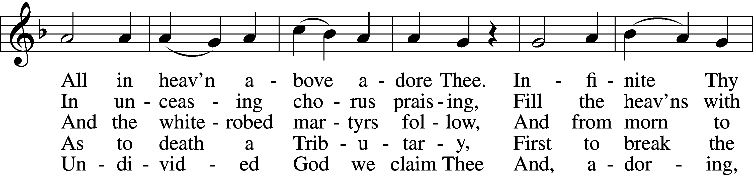
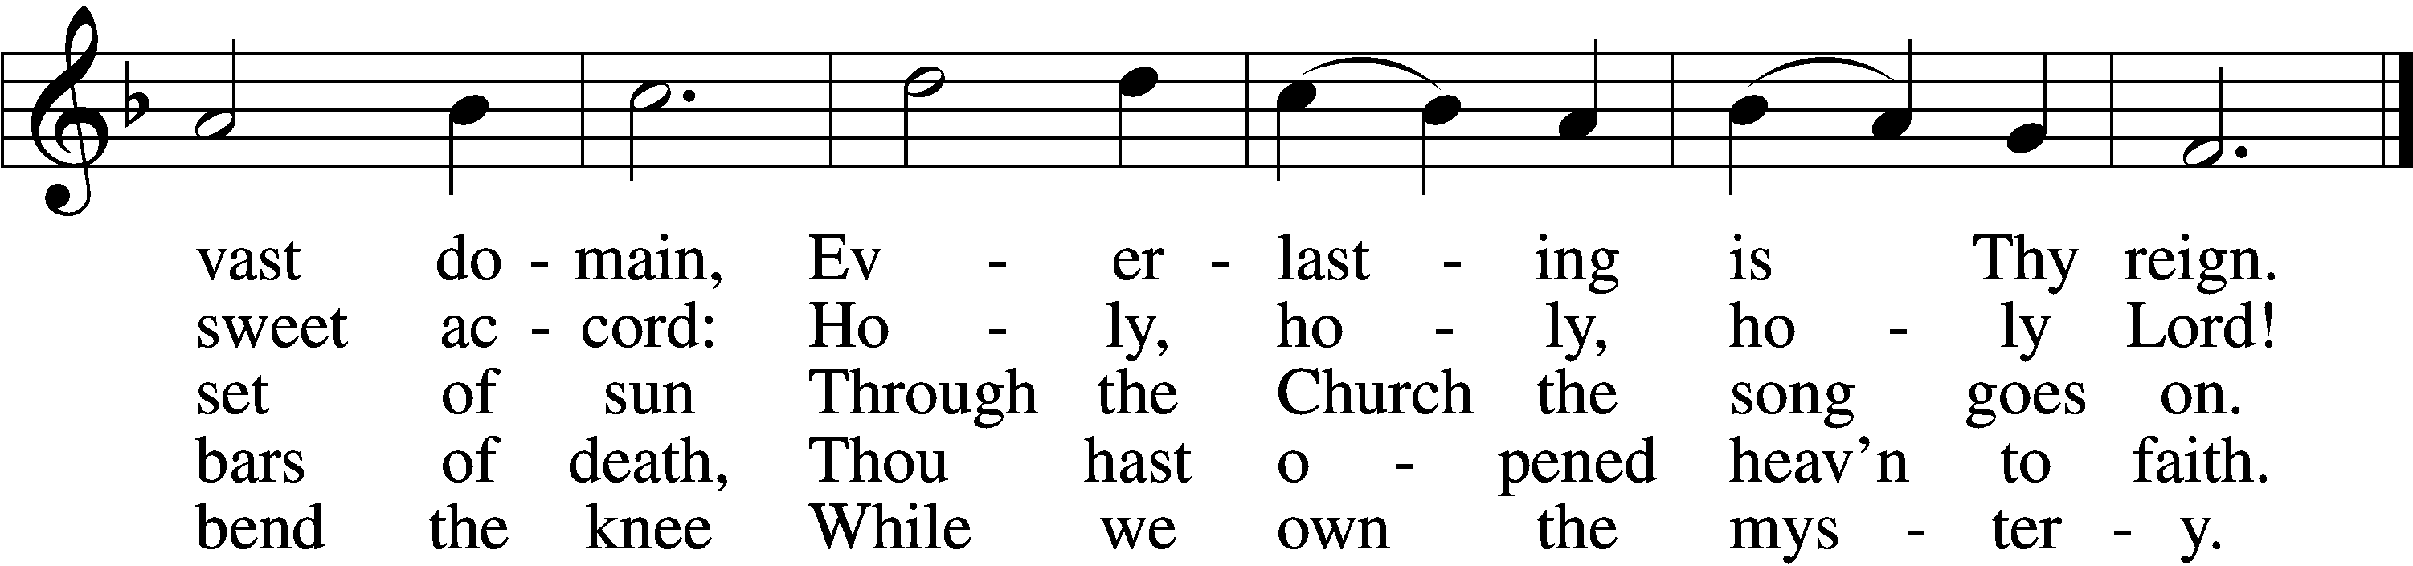
Text: Latin, c. 4th cent.; German version Katholisches Gesangbuch, 1774, Vienna; tr. Clarence A. Walworth, 1820–1900, alt.
Tune: Katholisches Gesangbuch, 1774, Vienna
Text and tune: Public domain

Blessing

Benedicamus LSB 267
L Let us bless the Lord.
C Thanks be to God.

Benediction LSB 267
L The almighty and merciful Lord, the Father, the T Son, and the Holy Spirit, bless and preserve us.
C Amen.

837 Lift High the Cross sts. ref–6
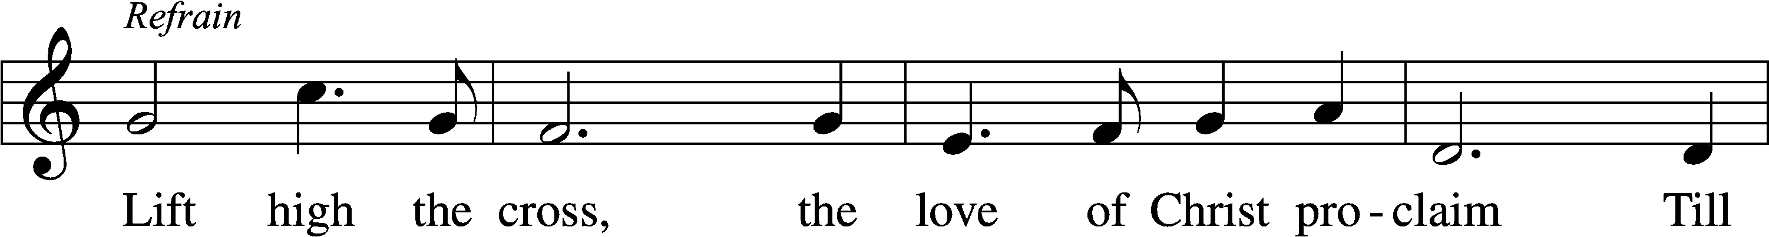
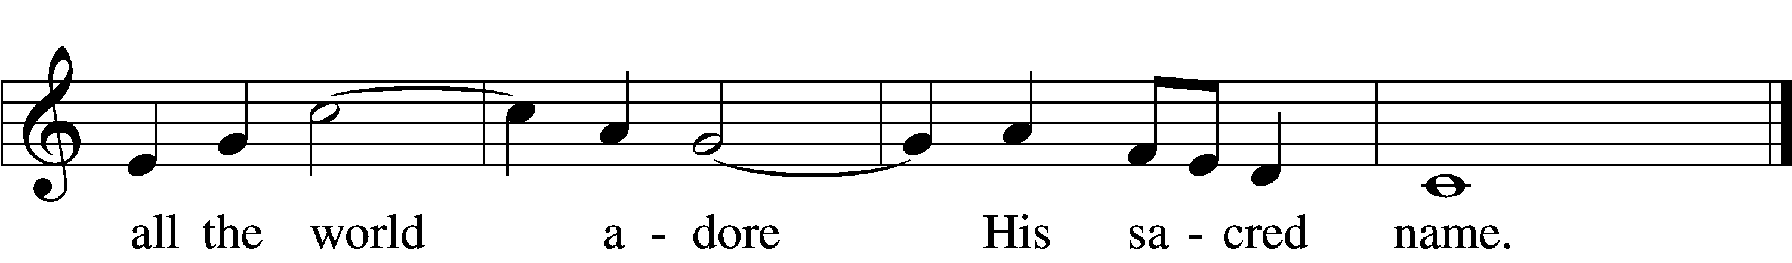
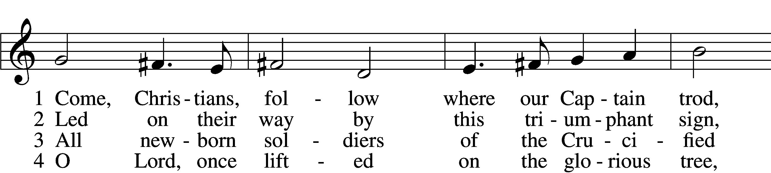
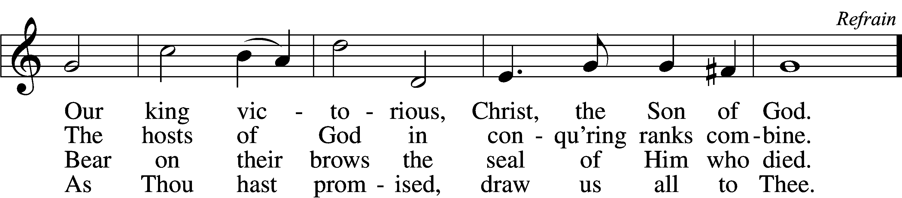

5 Let ev’ry race and ev’ry language tell
Of Him who saves our lives from death and hell. Refrain

6 So shall our song of triumph ever be:
Praise to the Crucified for victory! Refrain
Text: George W. Kitchin, 1827–1912; rev. Michael R. Newbolt, 1874–1956, alt.
Tune: Sydney H. Nicholson, 1875–1947
Text and tune: © 1974 Hope Publishing Co. Used by permission: LSB Hymn License no. 110002831

Acknowledgments
Unless otherwise indicated, Scripture quotations are from the ESV® Bible (The Holy Bible, English Standard Version®), copyright © 2001 by Crossway, a publishing ministry of Good News Publishers. Used by permission. All rights reserved.
Created by Lutheran Service Builder © 2024 Concordia Publishing House.

