Fourth Sunday after Epiphany
Prayer and Preaching p. 260
January 27 & 28, 2024
St. Paul Lutheran Church

528 Oh, for a Thousand Tongues to Sing
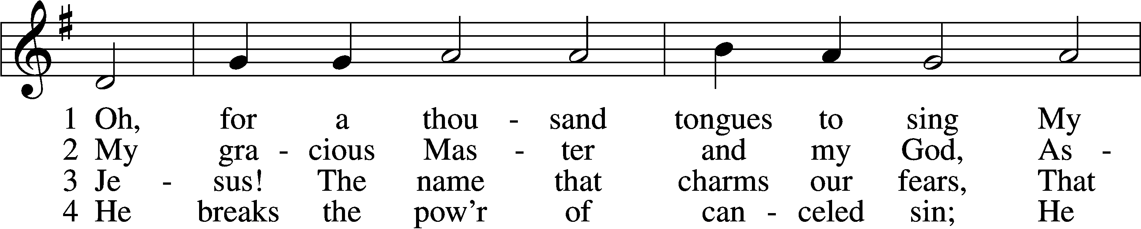
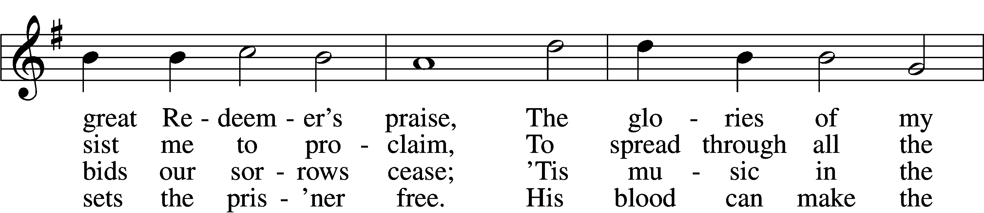
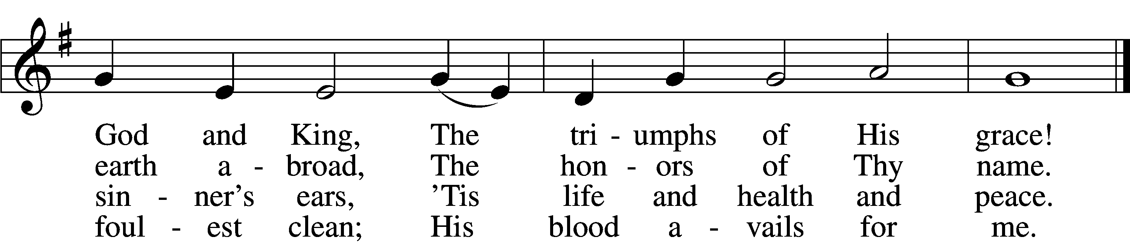

5 Look unto Him, ye nations; own
Your God, ye fallen race.
Look and be saved through faith alone,
Be justified by grace.

6 See all your sins on Jesus laid;
The Lamb of God was slain.
His soul was once an off’ring made
For ev’ry soul of man.

7 To God all glory, praise, and love
Be now and ever giv’n
By saints below and saints above,
The Church in earth and heav’n.
Text: Charles Wesley, 1707–88, alt.
Tune: Carl G. Gläser, 1784–1829
Text and tune: Public domain

Stand

Opening Versicles

Common LSB 260
L This is the day which the Lord has made;
C let us rejoice and be glad in it.
L From the rising of the sun to its setting,
C the name of the Lord is to be praised.

L Better is one day in Your courts than a thousand elsewhere;
C I would rather be a doorkeeper in the house of my God than dwell in the tents of the wicked.
L Make me to know Your ways, O Lord.
C Teach me Your paths.
L Sanctify us in Your truth.
C Your Word is truth.

L From the rising of the sun to its setting,
C the name of the Lord is to be praised.

C Glory be to the Father and to the Son and to the Holy Spirit;
as it was in the beginning, is now, and will be forever. Amen.

Old Testament Canticle LSB 261
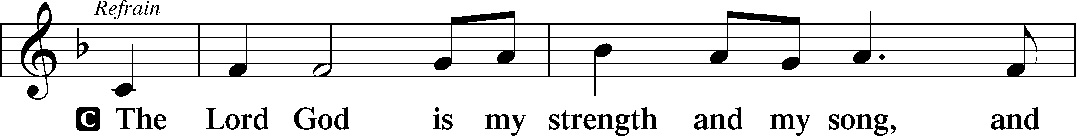
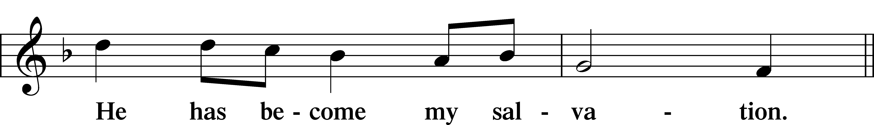
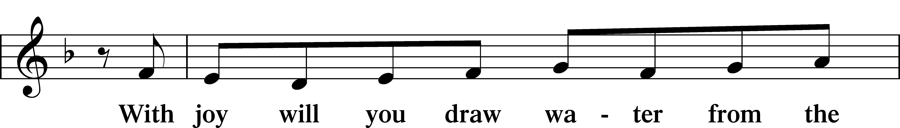
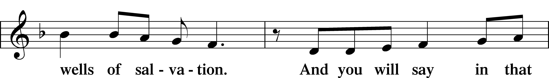
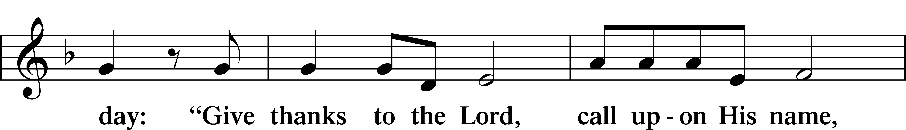
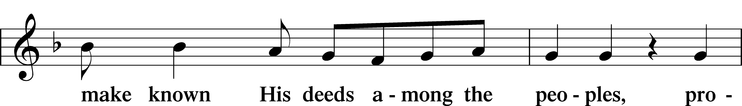
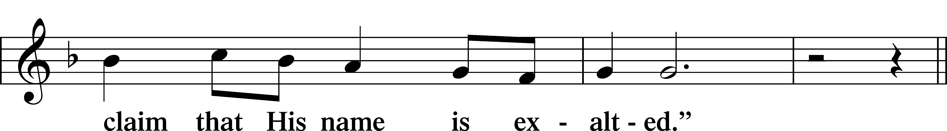
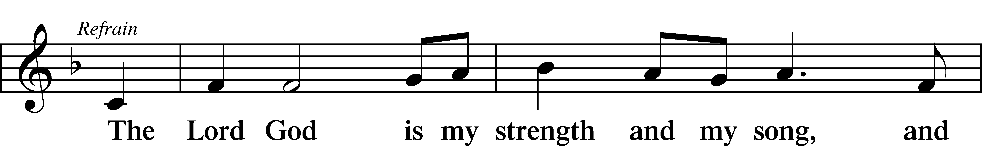
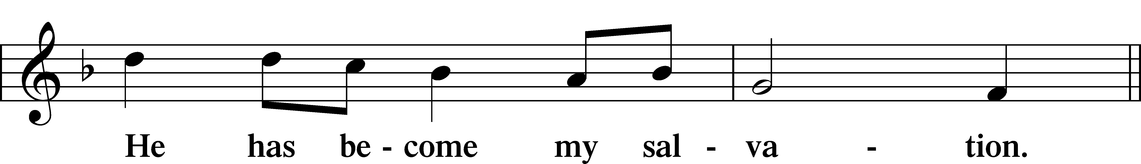
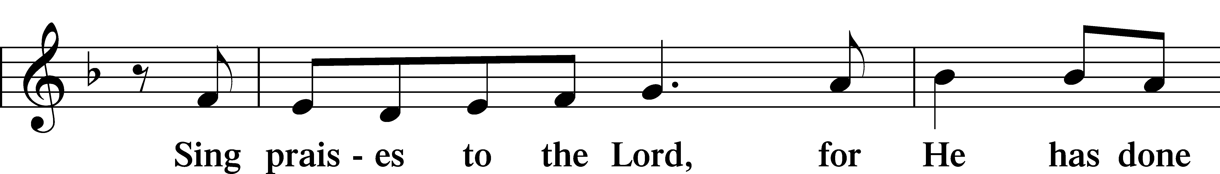
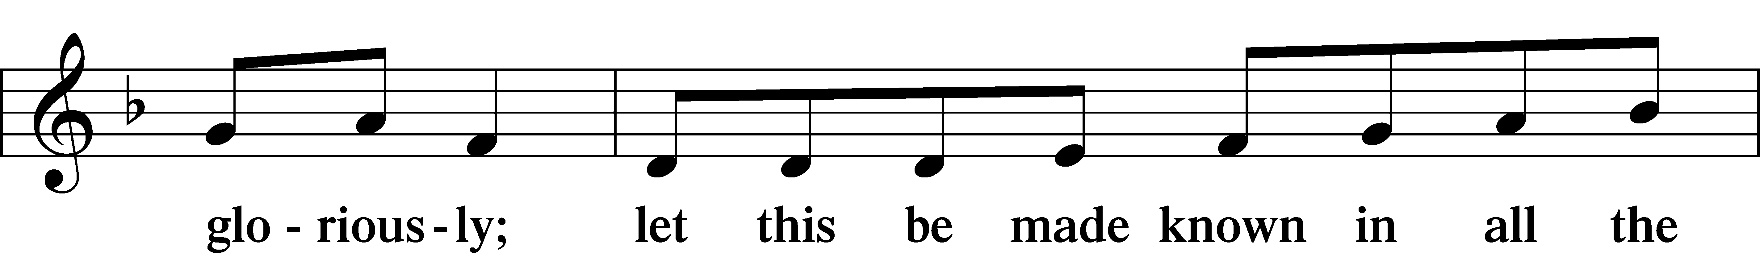
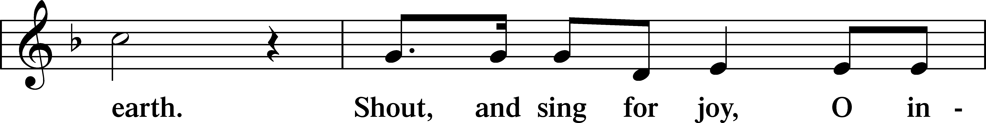
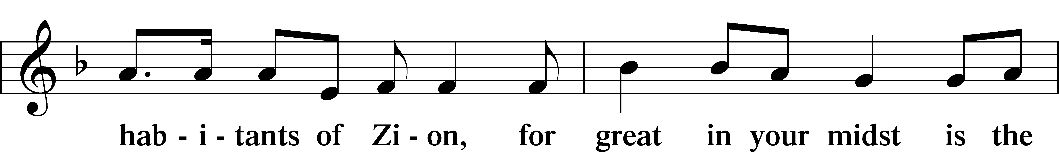
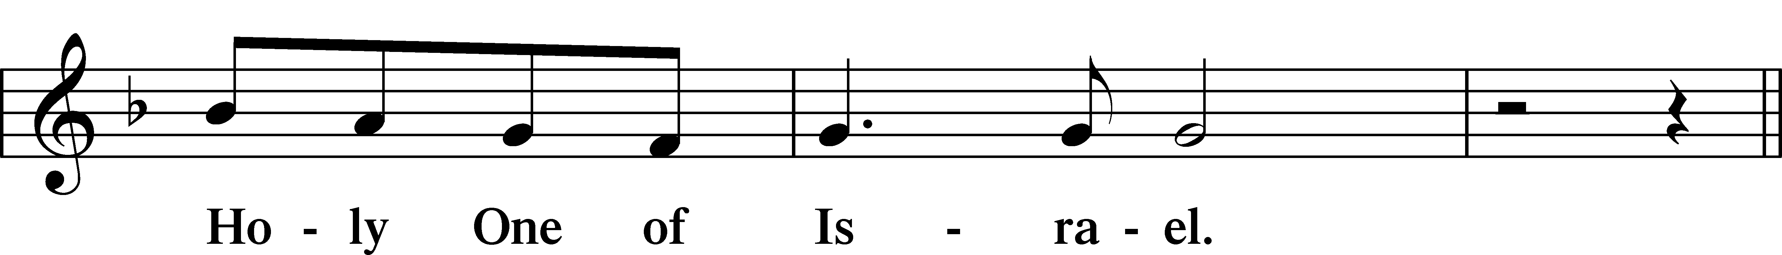
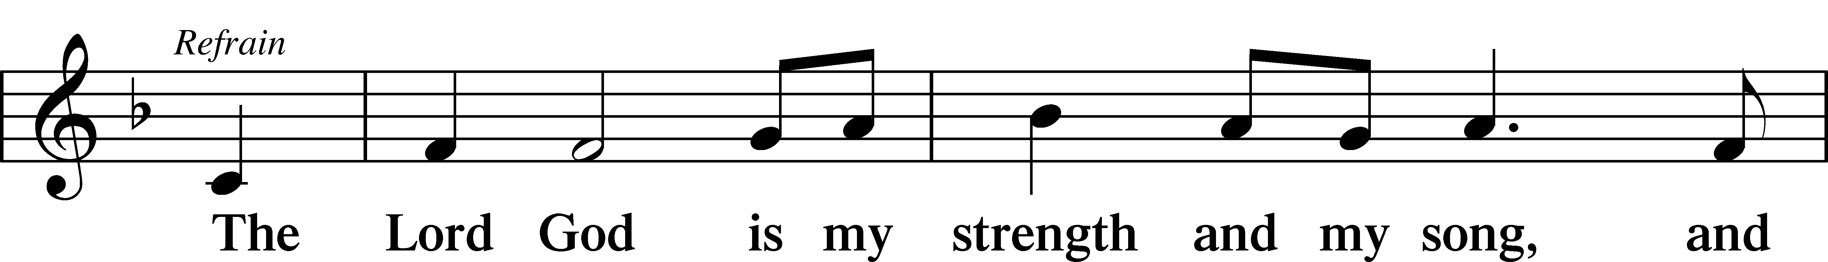
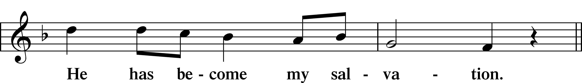
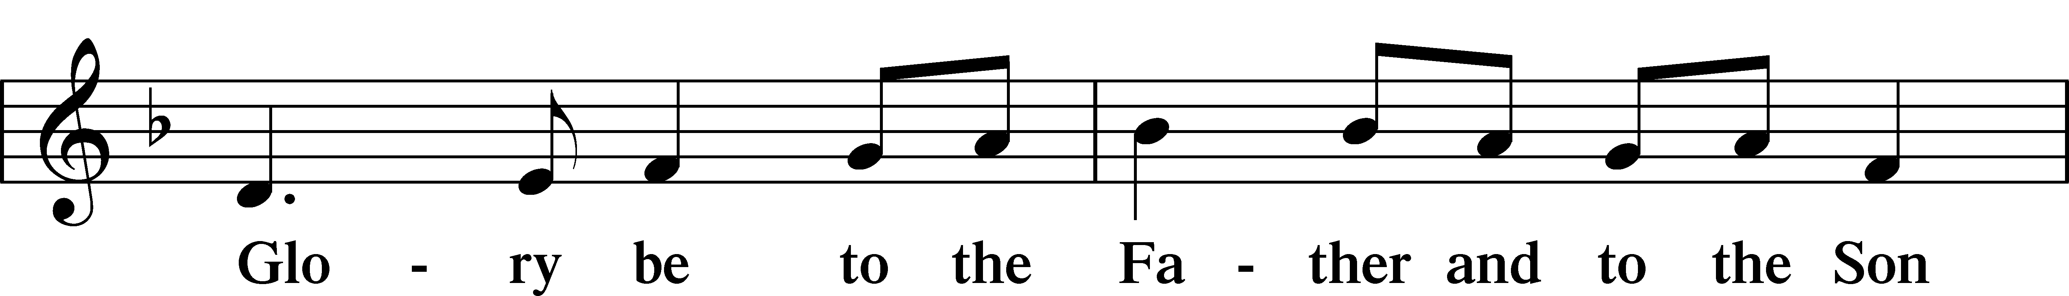
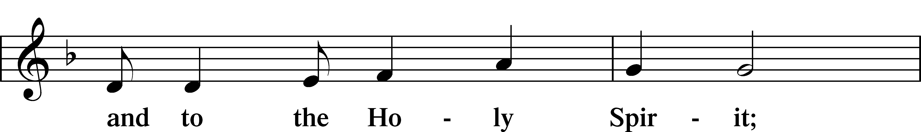
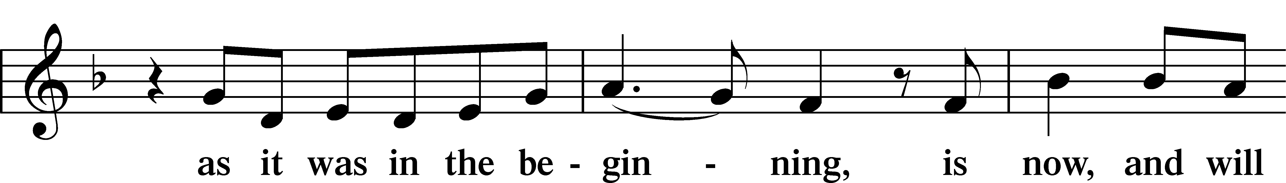
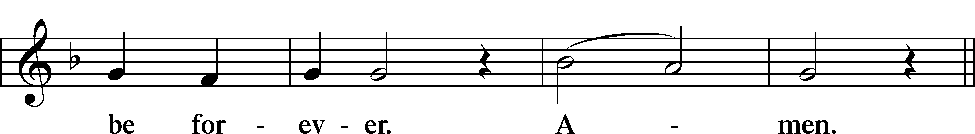
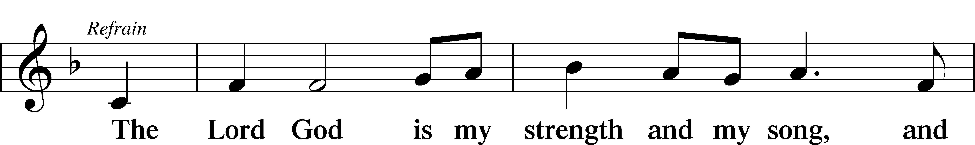
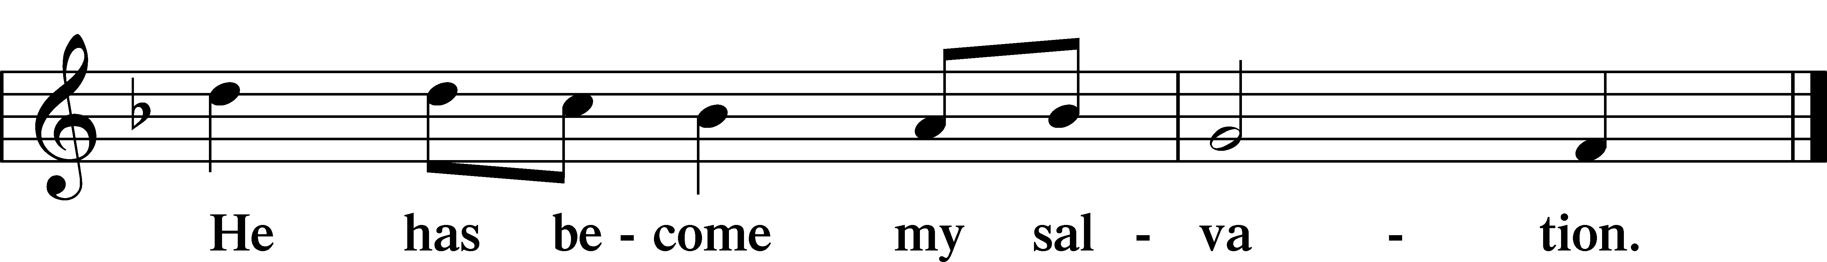

Sit

Readings From Holy Scripture

Reading Deuteronomy 18:15–20
L A reading from Deuteronomy, the eighteenth chapter.

15“The Lord your God will raise up for you a prophet like me from among you, from your brothers—it is to him you shall listen— 16just as you desired of the Lord your God at Horeb on the day of the assembly, when you said, ‘Let me not hear again the voice of the Lord my God or see this great fire any more, lest I die.’ 17And the Lord said to me, ‘They are right in what they have spoken. 18I will raise up for them a prophet like you from among their brothers. And I will put my words in his mouth, and he shall speak to them all that I command him. 19And whoever will not listen to my words that he shall speak in my name, I myself will require it of him. 20But the prophet who presumes to speak a word in my name that I have not commanded him to speak, or who speaks in the name of other gods, that same prophet shall die.’”

L This is the Word of the Lord.
C Thanks be to God.

Psalms, hymns, or choral music may be sung between the readings.

Responsory

Common LSB 263
L Forever, O Lord, Your Word is firmly set in the heavens.
C Lord, I love the habitation of Your house and the place where Your glory dwells.
L Blessed are those who hear the Word of God and keep it.
C Lord, I love the habitation of Your house and the place where Your glory dwells.
L Glory be to the Father and to the Son and to the Holy Spirit.
C Lord, I love the habitation of Your house and the place where Your glory dwells.

Stand

Ten Commandments
C You shall have no other gods.
You shall not misuse the name of the Lord your God.
Remember the Sabbath day by keeping it holy.
Honor your father and your mother.
You shall not murder.
You shall not commit adultery.
You shall not steal.
You shall not give false testimony against your neighbor.
You shall not covet your neighbor’s house.
You shall not covet your neighbor’s wife, or his manservant or maidservant, his ox or donkey, or anything that belongs to your neighbor.

Apostles’ Creed
C I believe in God, the Father Almighty,
maker of heaven and earth.

And in Jesus Christ, His only Son, our Lord,
who was conceived by the Holy Spirit,
born of the virgin Mary,
suffered under Pontius Pilate,
was crucified, died and was buried.
He descended into hell.
The third day He rose again from the dead.
He ascended into heaven
and sits at the right hand of God the Father Almighty.
From thence He will come to judge the living and the dead.

I believe in the Holy Spirit,
the holy Christian Church,
the communion of saints,
the forgiveness of sins,
the resurrection of the body,
and the life T everlasting. Amen.

Lord’s Prayer
C Our Father who art in heaven,
hallowed be Thy name,
Thy kingdom come,
Thy will be done on earth
as it is in heaven;
give us this day our daily bread;
and forgive us our trespasses
as we forgive those
who trespass against us;
and lead us not into temptation,
but deliver us from evil.
For Thine is the kingdom
and the power and the glory
forever and ever. Amen.

Sit

Sermon

842 Son of God, Eternal Savior
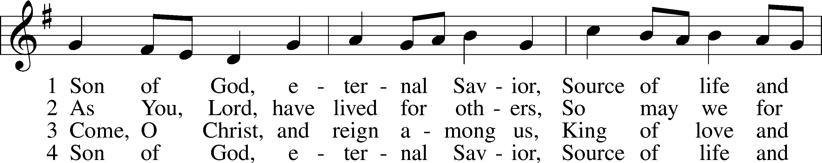
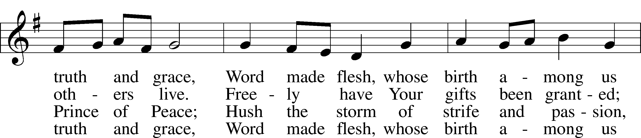
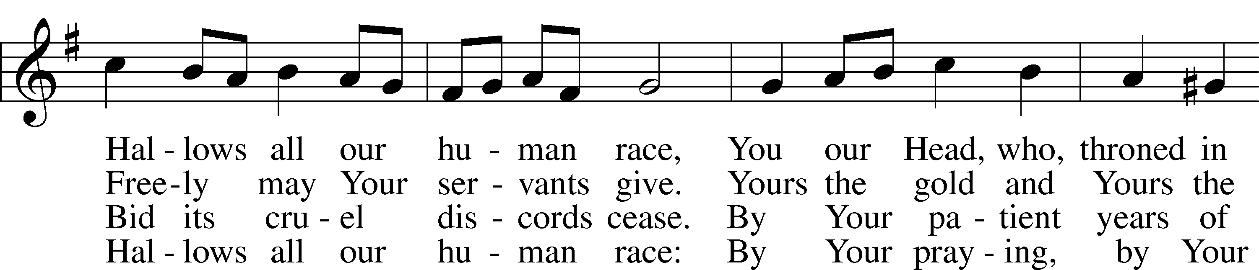
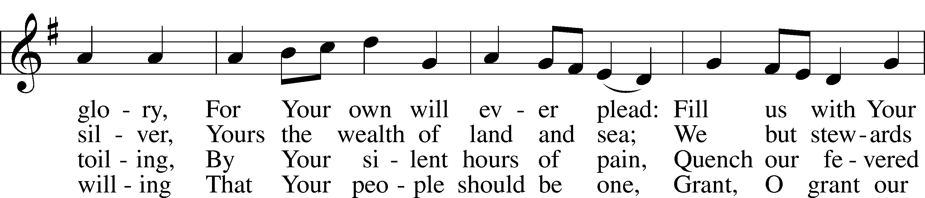
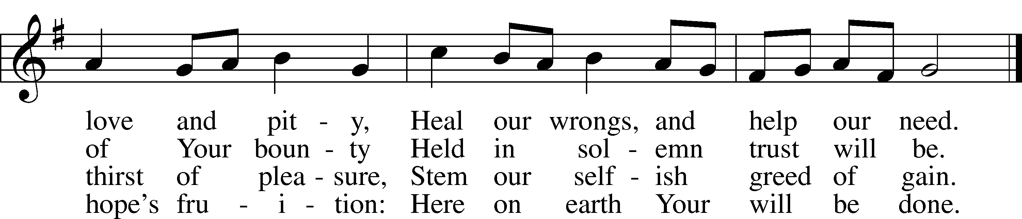
Text: Somerset T. C. Lowry, 1855–1932, alt.
Tune: Oude en Nieuwe Hollantse . . . Contradanseu, c. 1710, Amsterdam
Text and tune: Public domain

Offering

Stand

Prayer
L In peace let us pray to the Lord:
C Lord, have mercy.
L For the gift of divine peace and of pardon, with all our heart and with all our mind, let us pray to the Lord:
C Lord, have mercy.
L For the holy Christian Church, here and scattered throughout the world, and for the proclamation of the Gospel and the calling of all to faith, let us pray to the Lord:
C Lord, have mercy.
L For this nation, for our cities and communities, and for the common welfare of us all, let us pray to the Lord:
C Lord, have mercy.
L For seasonable weather and for the fruitfulness of the earth, let us pray to the Lord:
C Lord, have mercy.
L For those who labor, for those whose work is difficult or dangerous, and for all who travel, let us pray to the Lord:
C Lord, have mercy.
L For all those in need, for the hungry and homeless, for the widowed and orphaned, and for all those in prison, let us pray to the Lord:
C Lord, have mercy.
L For the sick and dying and for all those who care for them, let us pray to the Lord:
C Lord, have mercy.
L For . . . [additional bids for prayer may be inserted here] . . . let us pray to the Lord:
C Lord, have mercy.
L Finally, for these and for all our needs of body and soul, let us pray to the Lord:
C Lord, have mercy. Christ, have mercy. Lord, have mercy.

Collect of the Day
L Almighty God, You know we live in the midst of so many dangers that in our frailty we cannot stand upright. Grant strength and protection to support us in all dangers and carry us through all temptations; through Jesus Christ, Your Son, our Lord, who lives and reigns with You and the Holy Spirit, one God, now and forever.
C Amen.

Collect for the Word
L Blessed Lord, You have caused all Holy Scriptures to be written for our learning. Grant that we may so hear them, read, mark, learn, and take them to heart that, by the patience and comfort of Your holy Word, we may embrace and ever hold fast the blessed hope of everlasting life; through Jesus Christ, Your Son, our Lord, who lives and reigns with You and the Holy Spirit, one God, now and forever.
C Amen.

Morning Prayer
C I thank You, my heavenly Father, through Jesus Christ, Your dear Son, that You have kept me this night from all harm and danger; and I pray that You would keep me this day also from sin and every evil, that all my doings and life may please You. For into Your hands I commend myself, my body and soul, and all things. Let Your holy angel be with me, that the evil foe may have no power over me.

EVENING PRAYER
C I thank You, my heavenly Father, through Jesus Christ, Your dear Son, that You have graciously kept me this day; and I pray that You would forgive me all my sins where I have done wrong, and graciously keep me this night. For into Your hands I commend myself, my body and soul, and all things. Let Your holy angel be with me, that the evil foe may have no power over me.

New Testament Canticle LSB 266
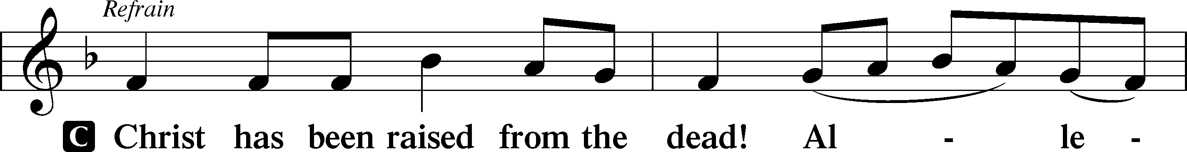
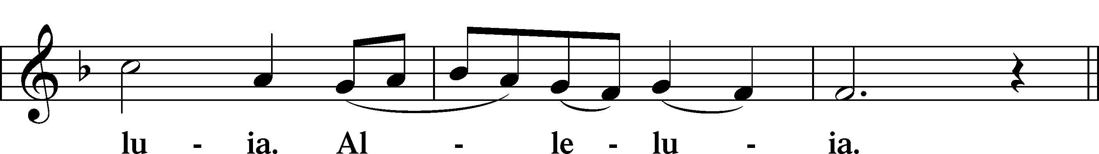
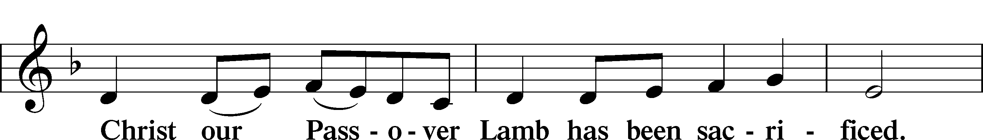
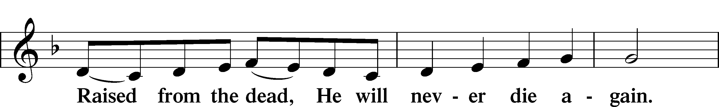
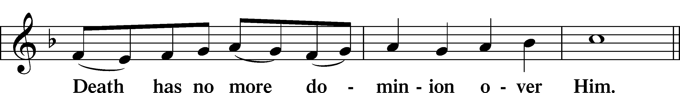
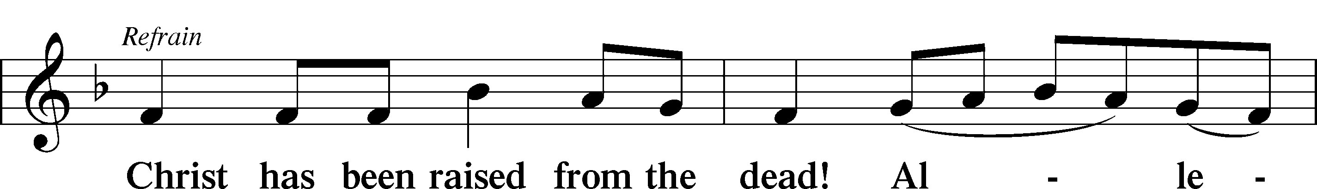
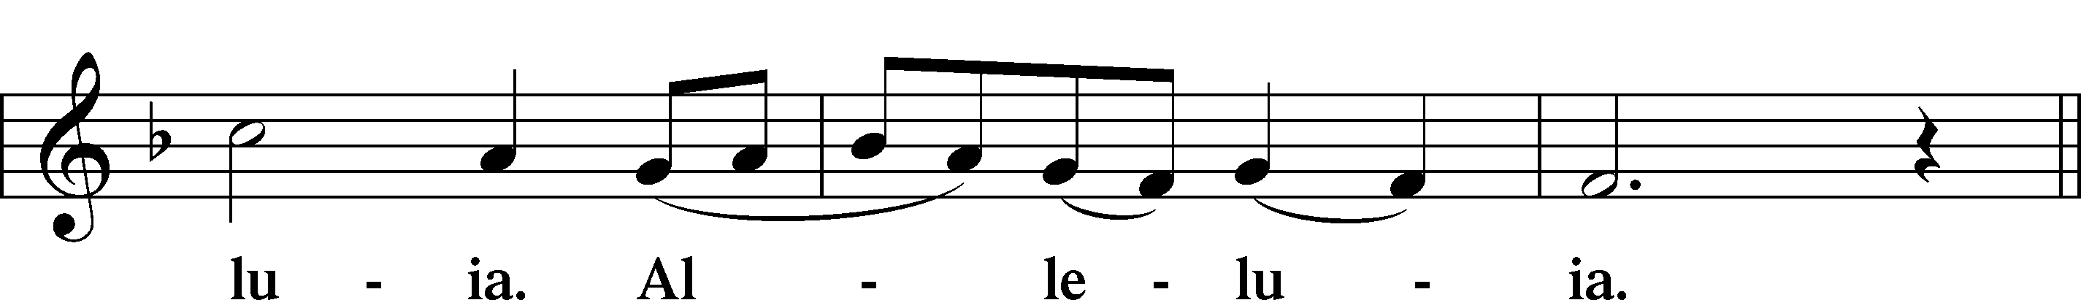
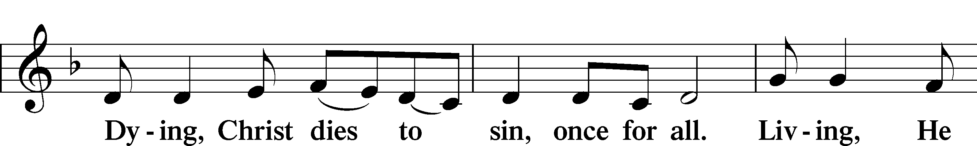
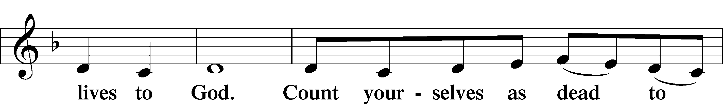
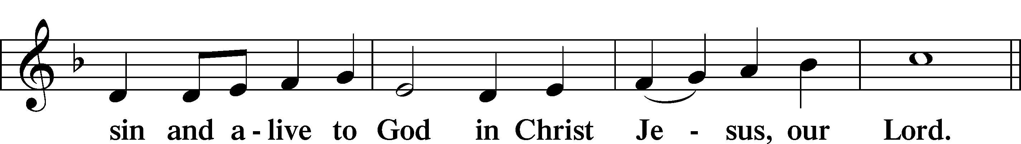
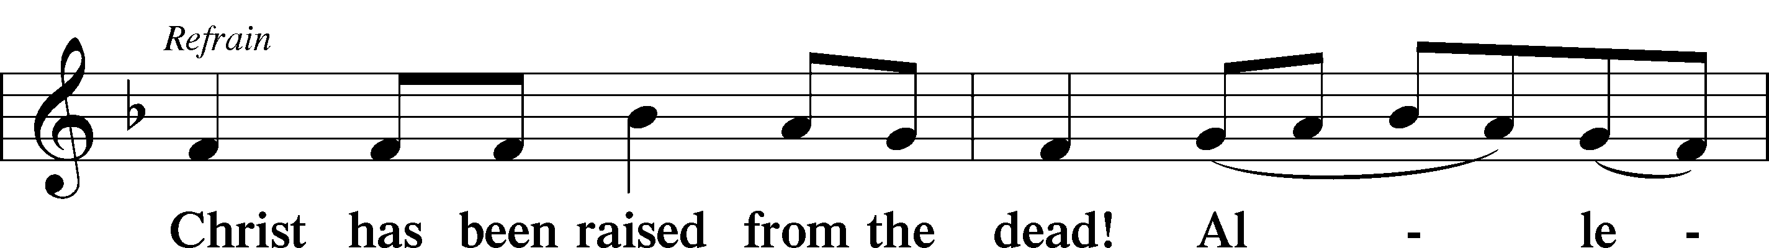
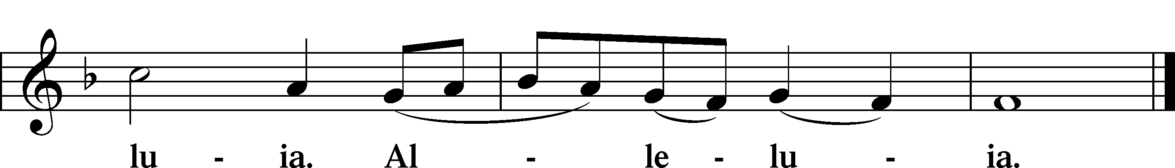

Blessing

Benedicamus LSB 267
L Let us bless the Lord.
C Thanks be to God.

Benediction LSB 267
L The almighty and merciful Lord, the Father, the T Son, and the Holy Spirit, bless and preserve us.
C Amen.

394 Songs of Thankfulness and Praise
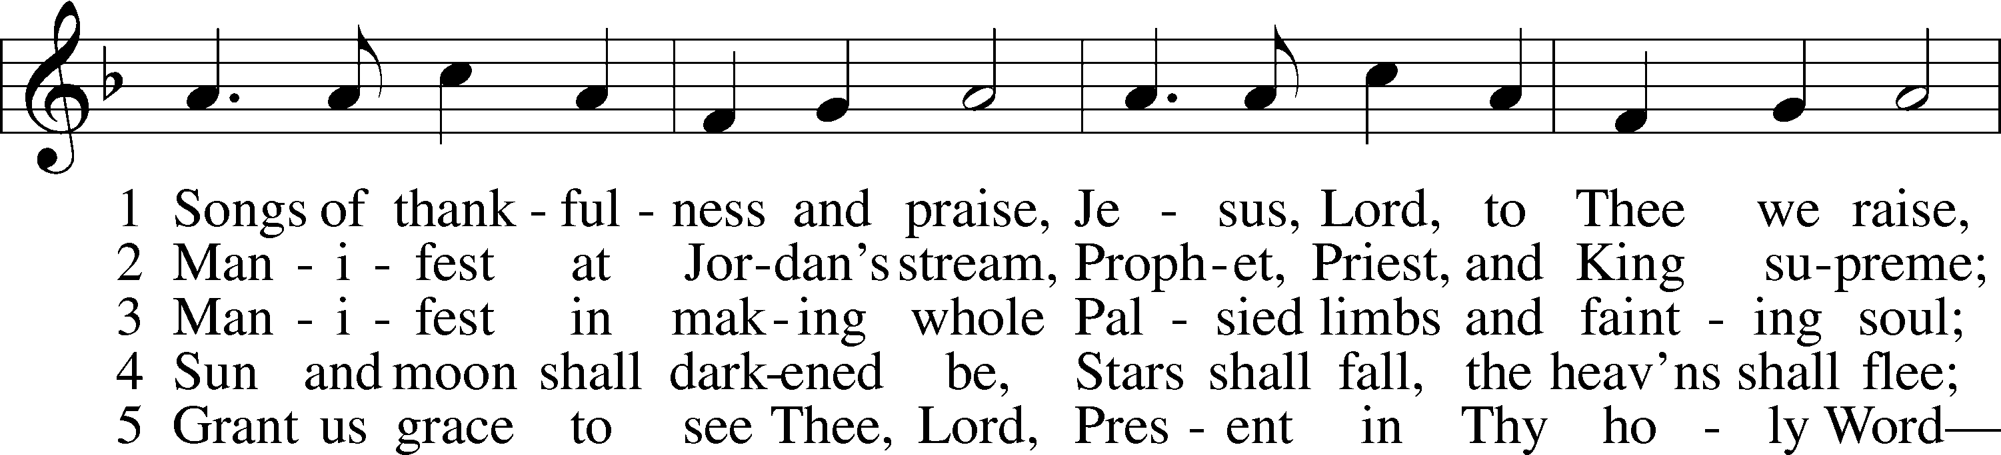
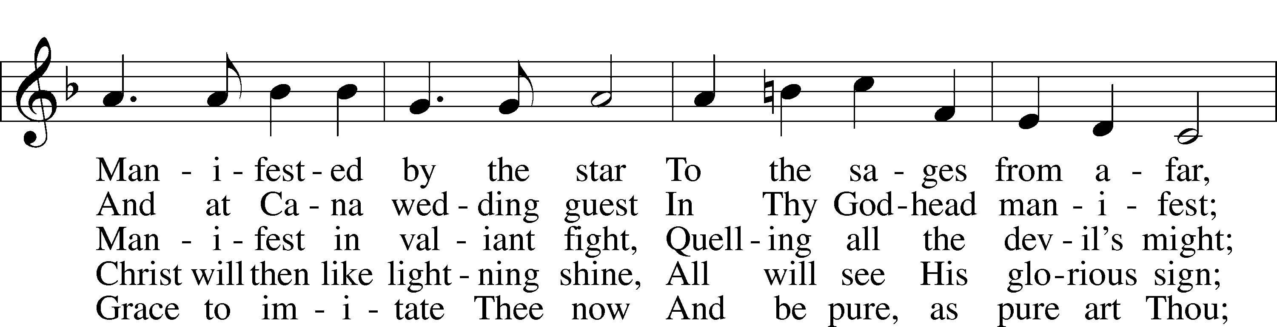
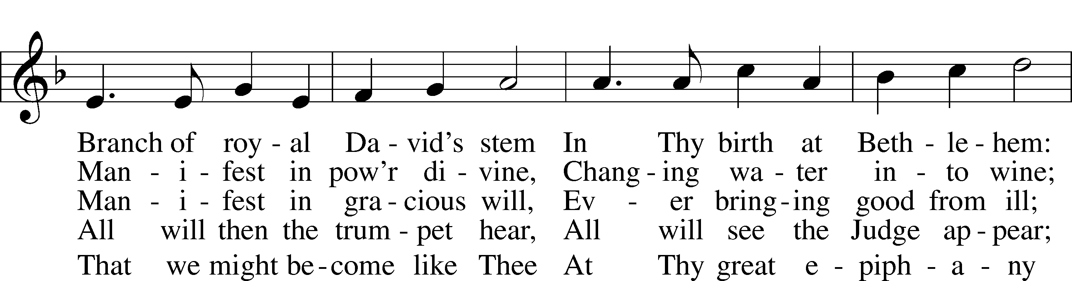
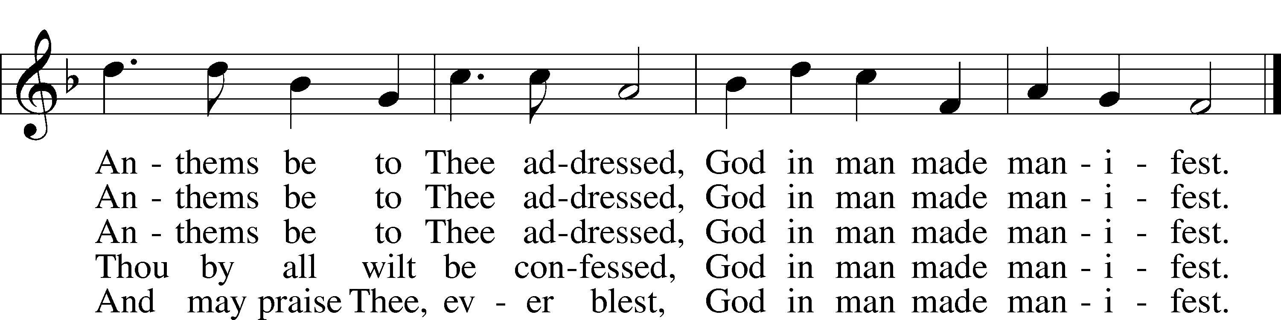
Text: Christopher Wordsworth, 1807–85, alt.
Tune: George J. Elvey, 1816–93
Text and tune: Public domain

Acknowledgments
Unless otherwise indicated, Scripture quotations are from the ESV® Bible (The Holy Bible, English Standard Version®), copyright © 2001 by Crossway, a publishing ministry of Good News Publishers. Used by permission. All rights reserved.
Created by Lutheran Service Builder © 2024 Concordia Publishing House.

