Fifth Sunday in Lent
Divine Service 4 p. 203
March 16 & 17, 2024
St. Paul Lutheran Church

Confession and Absolution

594 God’s Own Child, I Gladly Say It
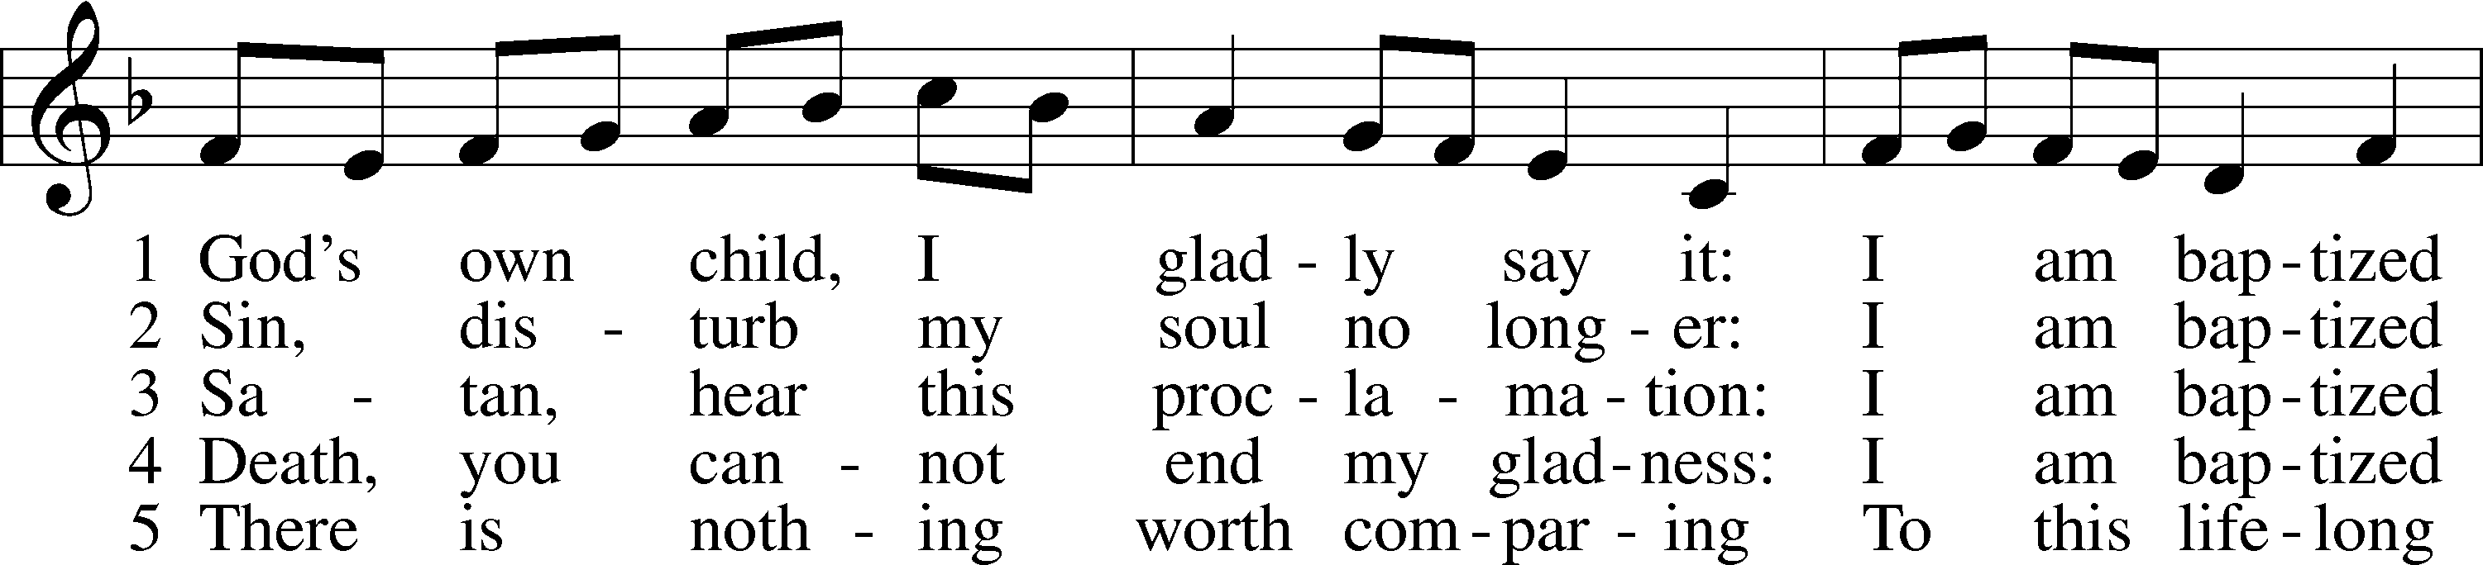
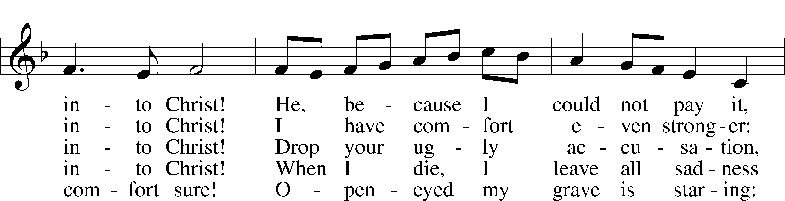
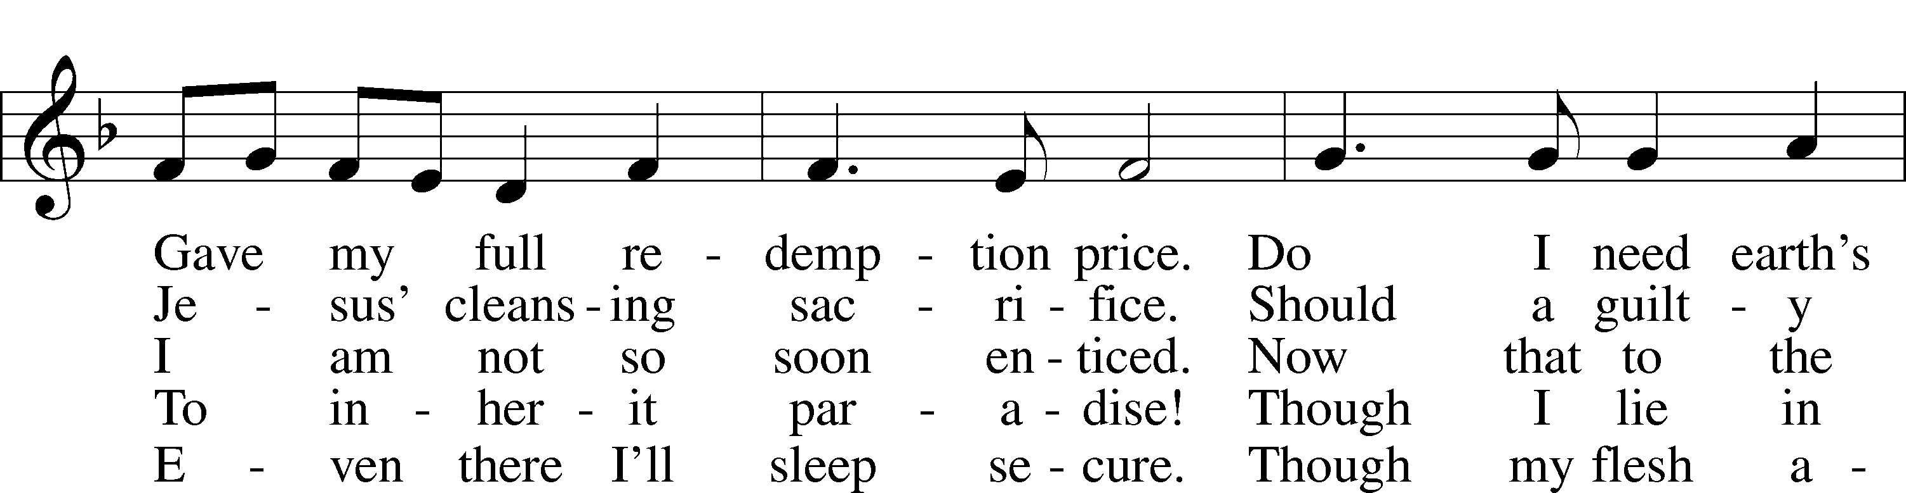
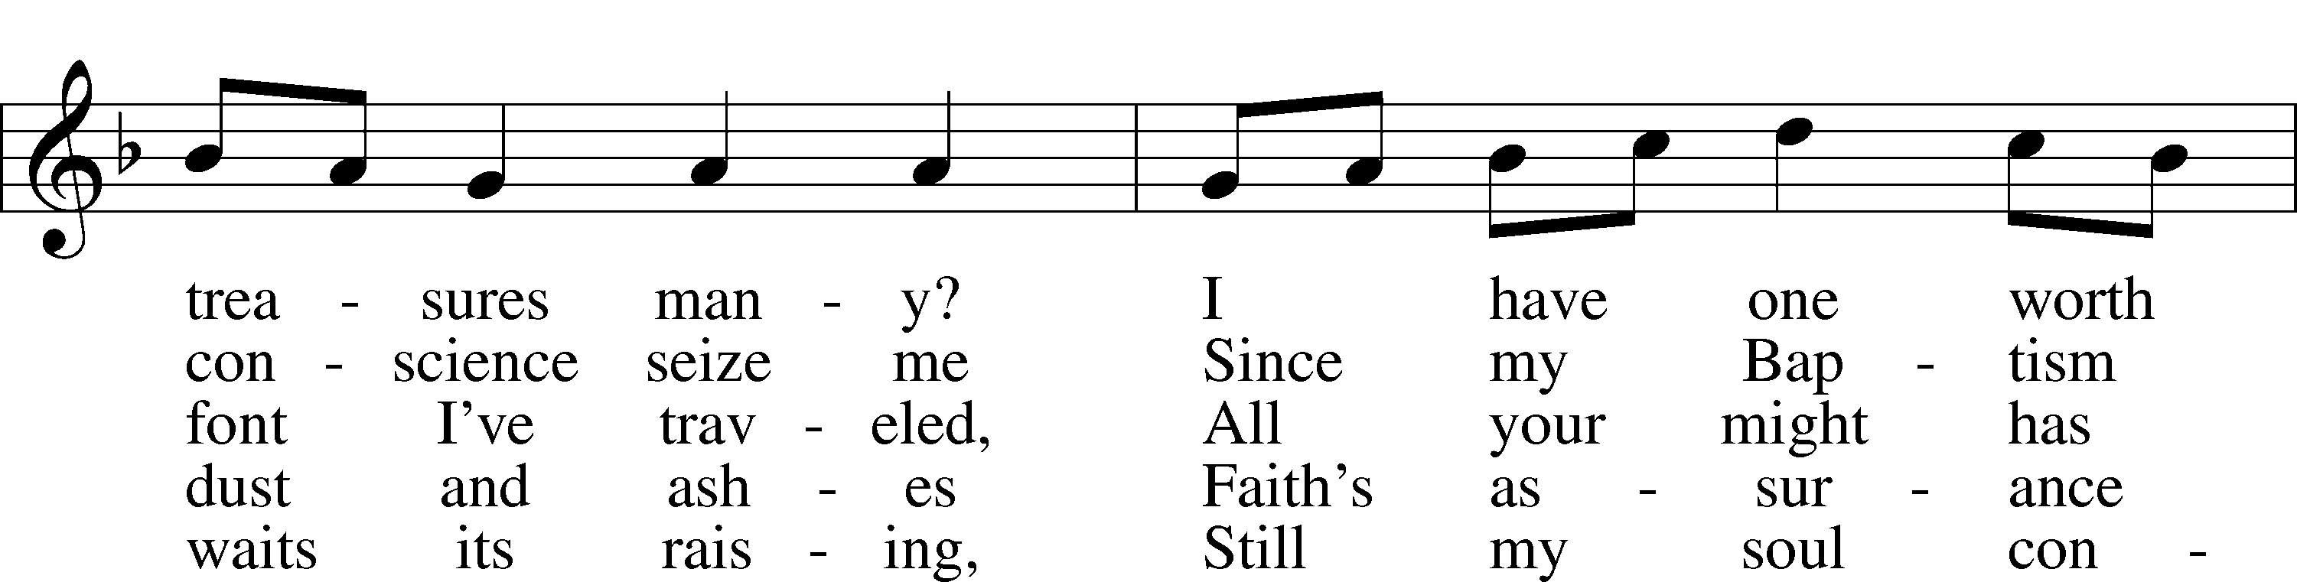
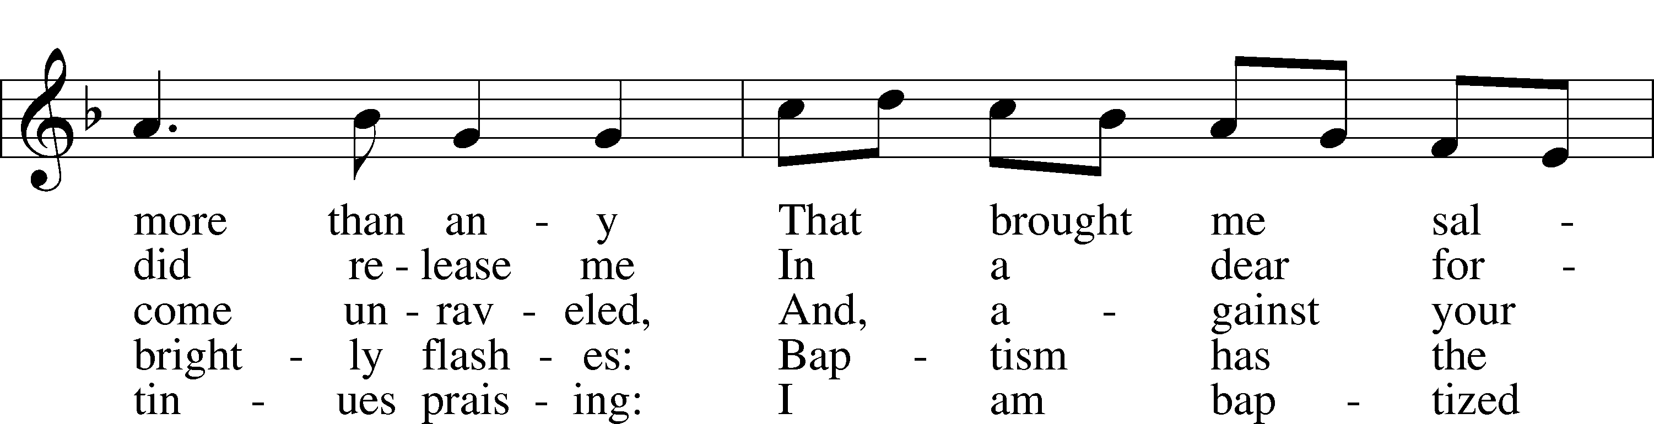
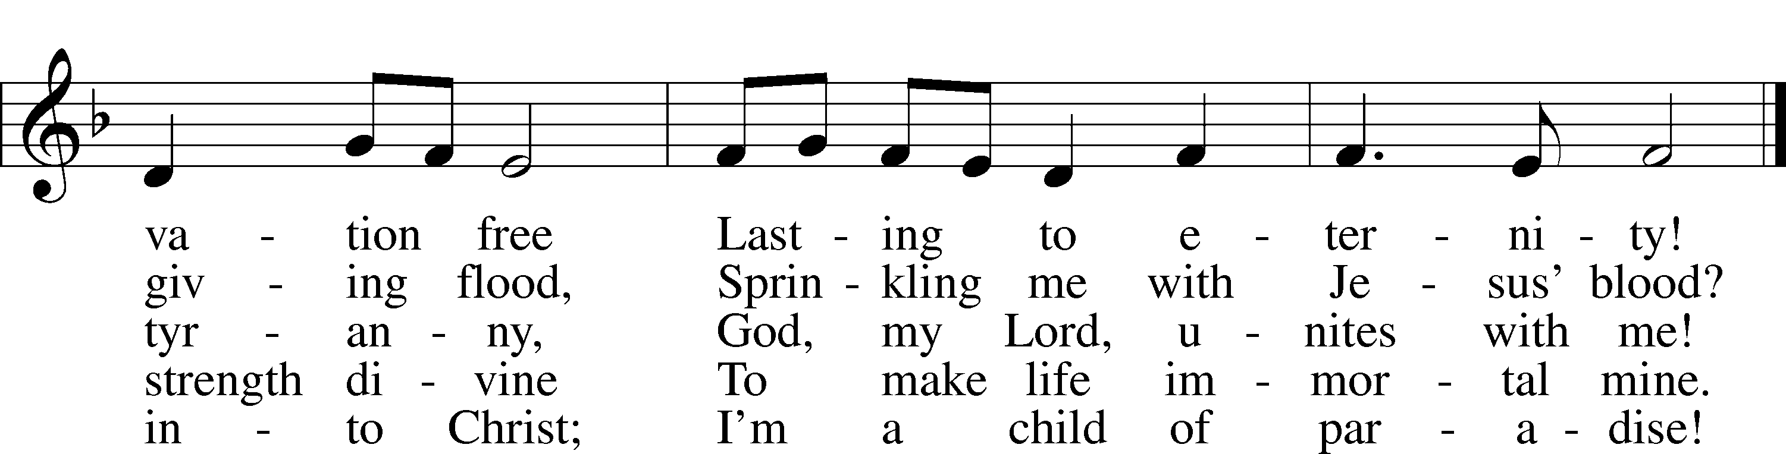
Text: Erdmann Neumeister, 1671–1756; tr. Robert E. Voelker, 1957
Tune: Johann Caspar Bachofen, 1695–1755, alt.
Text: © 1991 Robert E. Voelker. Used by permission: LSB Hymn License no. 110002831
Tune: Public domain

Stand

The sign of the cross may be made by all in remembrance of their Baptism.

Invocation
P In the name of the Father and of the T Son and of the Holy Spirit.
C Amen.

Exhortation LSB 203
P Our help is in the name of the Lord,
C who made heaven and earth.

P If You, O Lord, kept a record of sins, O Lord, who could stand?
C But with You there is forgiveness; therefore You are feared.

P Since we are gathered to hear God’s Word, call upon Him in prayer and praise, and receive the body and blood of our Lord Jesus Christ in the fellowship of this altar, let us first consider our unworthiness and confess before God and one another that we have sinned in thought, word, and deed, and that we cannot free ourselves from our sinful condition. Together as His people let us take refuge in the infinite mercy of God, our heavenly Father, seeking His grace for the sake of Christ, and saying: God, be merciful to me, a sinner.

Kneel/Stand

Confession of Sins LSB 203
C Almighty God, have mercy upon us, forgive us our sins, and lead us to everlasting life. Amen.

Prayer for Forgiveness
P Almighty God, merciful Father, in Holy Baptism You declared us to be Your children and gathered us into Your one, holy Church, in which You daily and richly forgive us our sins and grant us new life through Your Spirit. Be in our midst, enliven our faith, and graciously receive our prayer and praise; through Your Son, Jesus Christ, our Lord.
C Amen.

Stand

Service of the Word

PSALM Psalm 119:9–16
9How can a young man keep his way pure?
By guarding it according to your word.
10With my whole heart I seek you;
let me not wander from your commandments!
11I have stored up your word in my heart,
that I might not sin against you.
12Blessèd are you, O Lord;
teach me your statutes!
13With my lips I declare
all the just decrees of your mouth.
14In the way of your testimonies I delight
as much as in all riches.
15I will meditate on your precepts
and fix my eyes on your ways.
16I will delight in your statutes;
I will not forget your word.
Kyrie LSB 204
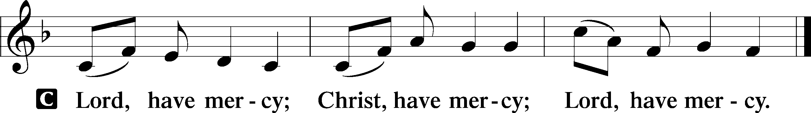

Salutation and Collect of the Day
P The Lord be with you.
C And also with you.

P Let us pray.
Almighty God, by Your great goodness mercifully look upon Your people that we may be governed and preserved evermore in body and soul; through Jesus Christ, Your Son, our Lord, who lives and reigns with You and the Holy Spirit, one God, now and forever.

C Amen.

Sit

Old Testament Reading Jeremiah 31:31–34
31“Behold, the days are coming, declares the Lord, when I will make a new covenant with the house of Israel and the house of Judah, 32not like the covenant that I made with their fathers on the day when I took them by the hand to bring them out of the land of Egypt, my covenant that they broke, though I was their husband, declares the Lord. 33But this is the covenant that I will make with the house of Israel after those days, declares the Lord: I will put my law within them, and I will write it on their hearts. And I will be their God, and they shall be my people. 34And no longer shall each one teach his neighbor and each his brother, saying, ‘Know the Lord,’ for they shall all know me, from the least of them to the greatest, declares the Lord. For I will forgive their iniquity, and I will remember their sin no more.”

A This is the Word of the Lord.
C Thanks be to God.

Epistle Hebrews 5:1–10
1Every high priest chosen from among men is appointed to act on behalf of men in relation to God, to offer gifts and sacrifices for sins. 2He can deal gently with the ignorant and wayward, since he himself is beset with weakness. 3Because of this he is obligated to offer sacrifice for his own sins just as he does for those of the people. 4And no one takes this honor for himself, but only when called by God, just as Aaron was.
5So also Christ did not exalt himself to be made a high priest, but was appointed by him who said to him,
“You are my Son,
today I have begotten you”;
6as he says also in another place,
“You are a priest forever,
after the order of Melchizedek.”
7In the days of his flesh, Jesus offered up prayers and supplications, with loud cries and tears, to him who was able to save him from death, and he was heard because of his reverence. 8Although he was a son, he learned obedience through what he suffered. 9And being made perfect, he became the source of eternal salvation to all who obey him, 10being designated by God a high priest after the order of Melchizedek.

A This is the Word of the Lord.
C Thanks be to God.

Stand

Alleluia and Verse

Verse LSB 205
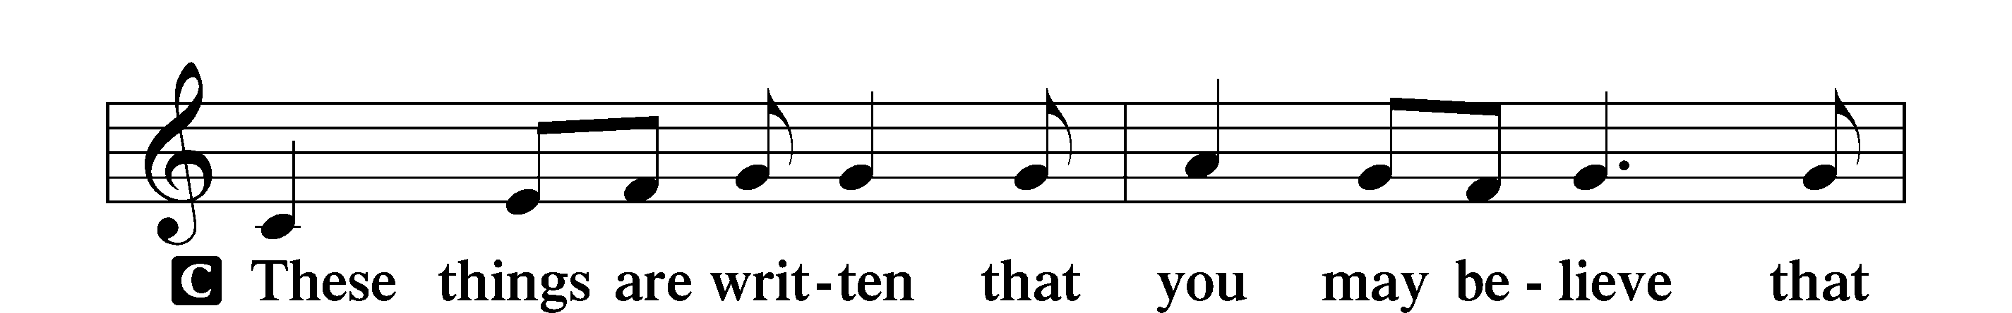
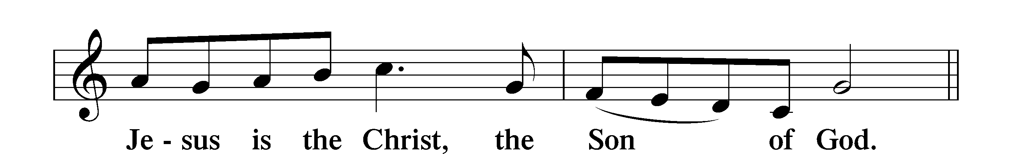

Alleluia LSB 205
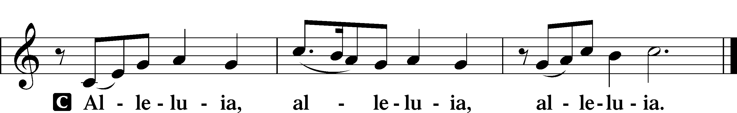

Holy Gospel Mark 10:32–45
P The Holy Gospel according to St. Mark, the tenth chapter.
C Glory to You, O Lord.

32And they were on the road, going up to Jerusalem, and Jesus was walking ahead of them. And they were amazed, and those who followed were afraid. And taking the twelve again, he began to tell them what was to happen to him, 33saying, “See, we are going up to Jerusalem, and the Son of Man will be delivered over to the chief priests and the scribes, and they will condemn him to death and deliver him over to the Gentiles. 34And they will mock him and spit on him, and flog him and kill him. And after three days he will rise.”
35And James and John, the sons of Zebedee, came up to him and said to him, “Teacher, we want you to do for us whatever we ask of you.” 36And he said to them, “What do you want me to do for you?” 37And they said to him, “Grant us to sit, one at your right hand and one at your left, in your glory.” 38Jesus said to them, “You do not know what you are asking. Are you able to drink the cup that I drink, or to be baptized with the baptism with which I am baptized?” 39And they said to him, “We are able.” And Jesus said to them, “The cup that I drink you will drink, and with the baptism with which I am baptized, you will be baptized, 40but to sit at my right hand or at my left is not mine to grant, but it is for those for whom it has been prepared.” 41And when the ten heard it, they began to be indignant at James and John. 42And Jesus called them to him and said to them, “You know that those who are considered rulers of the Gentiles lord it over them, and their great ones exercise authority over them. 43But it shall not be so among you. But whoever would be great among you must be your servant, 44and whoever would be first among you must be slave of all. 45For even the Son of Man came not to be served but to serve, and to give his life as a ransom for many.”

P This is the Gospel of the Lord.
C Praise to You, O Christ.

Nicene Creed
C I believe in one God,
the Father Almighty,
maker of heaven and earth
and of all things visible and invisible.

And in one Lord Jesus Christ,
the only-begotten Son of God,
begotten of His Father before all worlds,
God of God, Light of Light,
very God of very God,
begotten, not made,
being of one substance with the Father,
by whom all things were made;
who for us men and for our salvation came down from heaven
and was incarnate by the Holy Spirit of the virgin Mary
and was made man;
and was crucified also for us under Pontius Pilate.
He suffered and was buried.
And the third day He rose again according to the Scriptures
and ascended into heaven
and sits at the right hand of the Father.
And He will come again with glory to judge both the living and the dead,
whose kingdom will have no end.

And I believe in the Holy Spirit,
the Lord and giver of life,
who proceeds from the Father and the Son,
who with the Father and the Son together is worshiped and glorified,
who spoke by the prophets.
And I believe in one holy Christian and apostolic Church,
I acknowledge one Baptism for the remission of sins,
and I look for the resurrection of the dead
and the life T of the world to come. Amen.

Sit

430 My Song Is Love Unknown
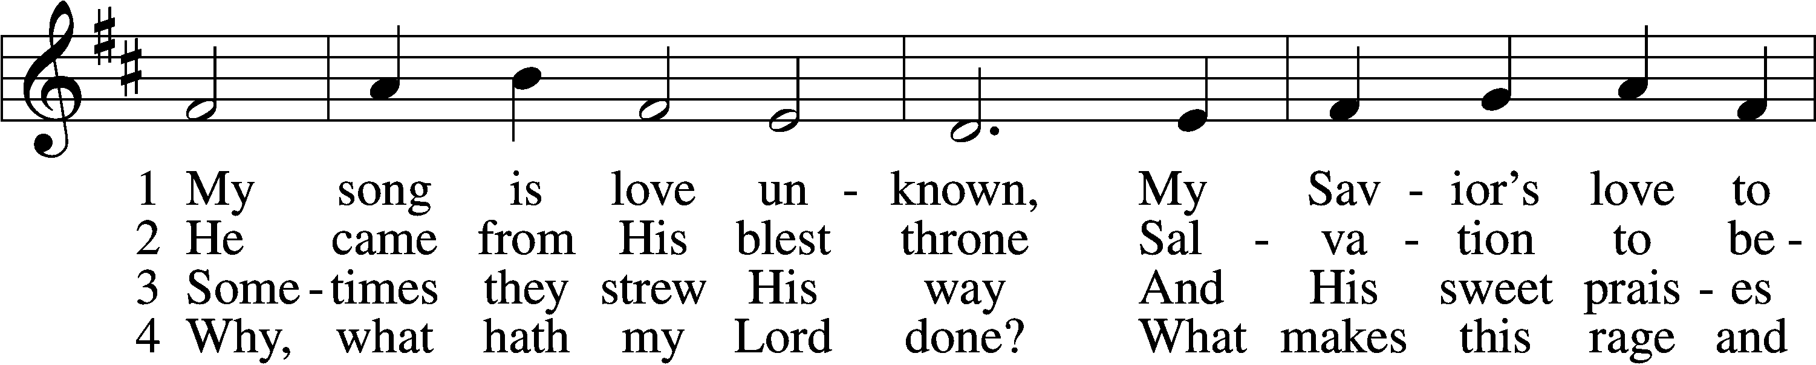
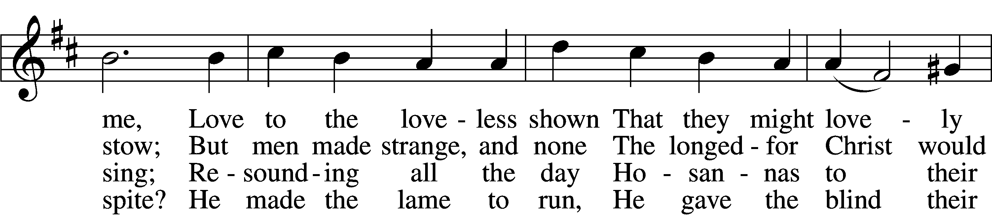
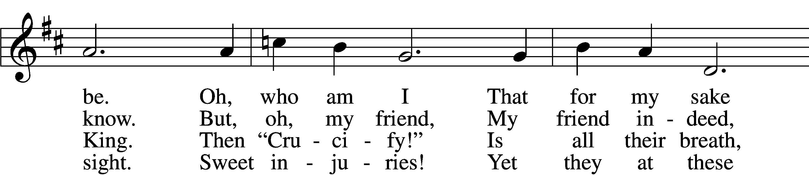
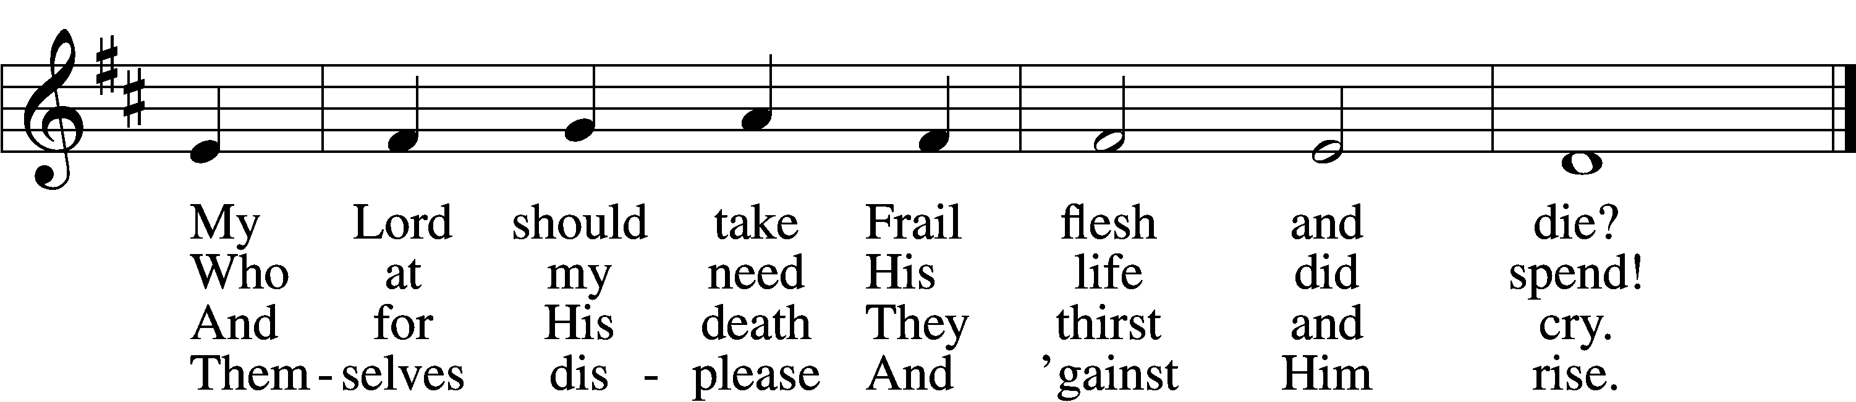

5 They rise and needs will have
My dear Lord made away;
A murderer they save,
The Prince of Life they slay.
Yet cheerful He
To suff’ring goes
That He His foes
From thence might free.

6 In life no house, no home
My Lord on earth might have;
In death no friendly tomb
But what a stranger gave.
What may I say?
Heav’n was His home
But mine the tomb
Wherein He lay.

7 Here might I stay and sing,
No story so divine!
Never was love, dear King,
Never was grief like Thine.
This is my friend,
In whose sweet praise
I all my days
Could gladly spend!
Text: Samuel Crossman, c. 1624–1683
Tune: John N. Ireland, 1879–1962
Text: Public domain
Tune: © John Ireland Trust. Used by permission: LSB Hymn License no. 110002831

Children’s Sermon
Sermon

Stand

Prayer of the Church
P In peace, let us pray to the Lord:
C Lord, have mercy.

P For the gift of the Holy Spirit, that our heavenly Father would write His Word on our hearts and lead us to know Him as the God who forgives our iniquities and remembers our sins no more, let us pray to the Lord:
C Lord, have mercy.

P For Matthew, our Synod president; _____________, our district president; _____________, our circuit visitor; and our pastor(s), who like all flesh are beset with weakness, that they may deal gently with us and be preserved faithful to proclaim God’s Word, let us pray to the Lord:
C Lord, have mercy.

P For humility, that after the example of Christ, we would not lord authority over one another but serve each other in our homes, communities and congregation, let us pray to the Lord:
C Lord, have mercy.

P For all earthly authorities, that they may be guarded from the temptation to wield such power improperly, and be committed instead to good and faithful service, let us pray to the Lord:
C Lord, have mercy.

P For _____________ and all who walk the way of the cross among us, that as Christ learned obedience through His suffering, they also may be instructed in His ways, sustained by His blessings and, in His time, receive relief from His Fatherly hand, let us pray to the Lord:
C Lord, have mercy.

P For all who come to the holy altar, that God would prepare our hearts by His Spirit worthily to receive the body and blood of Christ, who was sacrificed for us on the cross; and that we would believe in His promise of the forgiveness of sins, let us pray to the Lord:
C Lord, have mercy.

P Hear us, heavenly Father, for the sake of Christ Jesus, our Lord, who lives and reigns with You and the Holy Spirit, one God, now and forever.
C Amen.

Offering

Service of the Sacrament

Stand

Preface LSB 208
P The Lord be with you.
C And also with you.

P Lift up your hearts.
C We lift them to the Lord.

P Let us give thanks to the Lord our God.
C It is right to give Him thanks and praise.

P It is truly good, right, and salutary that we should at all times and in all places give thanks to You, O Lord, holy Father, almighty and everlasting God, for the countless blessings You so freely bestow on us and all creation. Above all, we give thanks for Your boundless love shown to us when You sent Your only-begotten Son, Jesus Christ, into our flesh and laid on Him our sin, giving Him into death that we might not die eternally. Because He is now risen from the dead and lives and reigns to all eternity, all who believe in Him will overcome sin and death and will rise again to new life. Therefore with angels and archangels and with all the company of heaven we laud and magnify Your glorious name, evermore praising You and saying:

Sanctus LSB 208
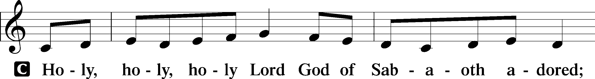
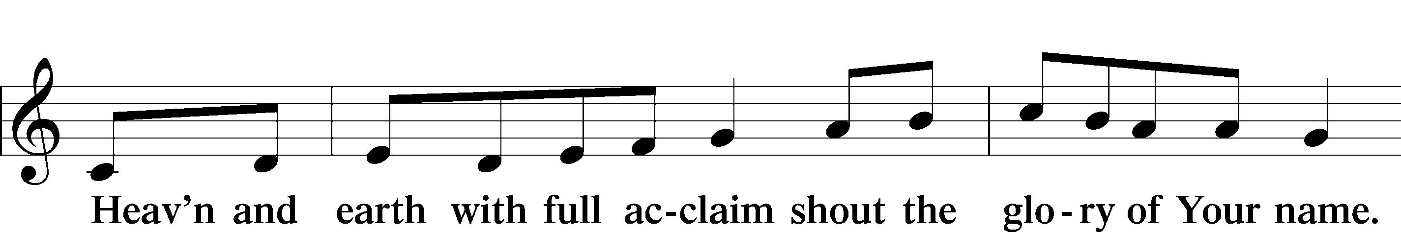
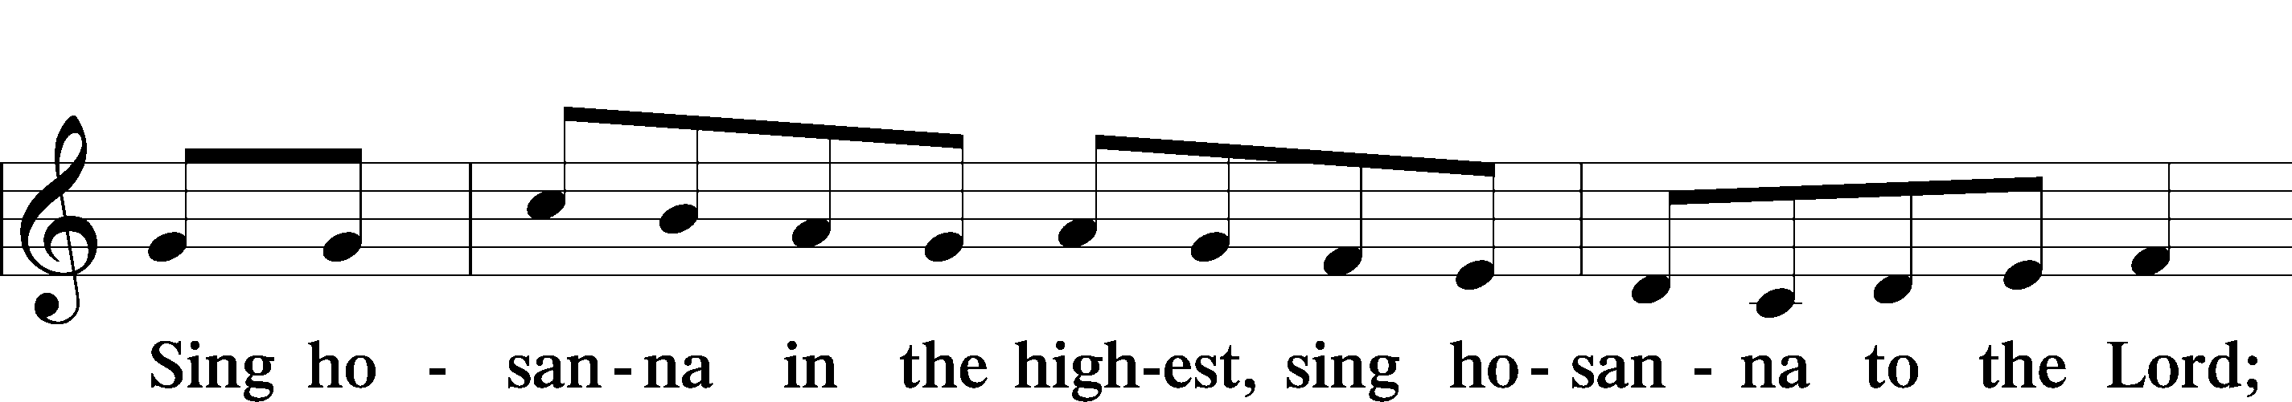
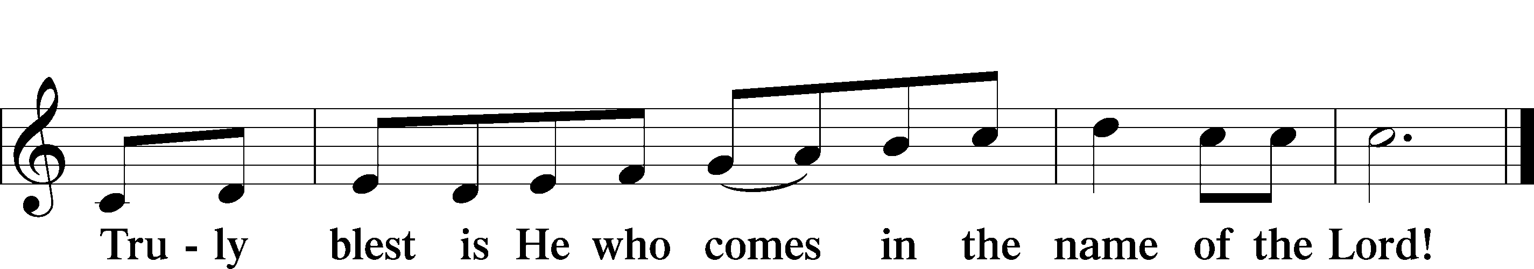
Text: Stephen P. Starke

Prayer of Thanksgiving
P Blessed are You, O Lord our God, king of all creation, for You have had mercy on us and given Your only-begotten Son that whoever believes in Him should not perish but have eternal life.

At Your command, Abraham prepared to offer his son Isaac as a sacrifice on the mountain; yet, in mercy You provided a ram as a substitute. We give You thanks that on Calvary You spared not Your only Son but sent Him to offer His life as a ransom for many.

As we eat and drink His body and blood, grant us, like Abraham our father, to trust in Your promise now fulfilled in Christ, the Lamb of God, who takes away the sin of the world.

Hear us as we pray in His name and as He has taught us:

Lord’s Prayer
C Our Father who art in heaven,
hallowed be Thy name,
Thy kingdom come,
Thy will be done on earth
as it is in heaven;
give us this day our daily bread;
and forgive us our trespasses
as we forgive those
who trespass against us;
and lead us not into temptation,
but deliver us from evil.
For Thine is the kingdom
and the power and the glory
forever and ever. Amen.

The Words of Our Lord
P Our Lord Jesus Christ, on the night when He was betrayed, took bread, and when He had given thanks, He broke it and gave it to the disciples and said: “Take, eat; this is My T body, which is given for you. This do in remembrance of Me.”

In the same way also He took the cup after supper, and when He had given thanks, He gave it to them, saying: “Drink of it, all of you; this cup is the new testament in My T blood, which is shed for you for the forgiveness of sins. This do, as often as you drink it, in remembrance of Me.”

Pax Domini
P The peace of the Lord be with you always.
C Amen.

Agnus Dei LSB 210
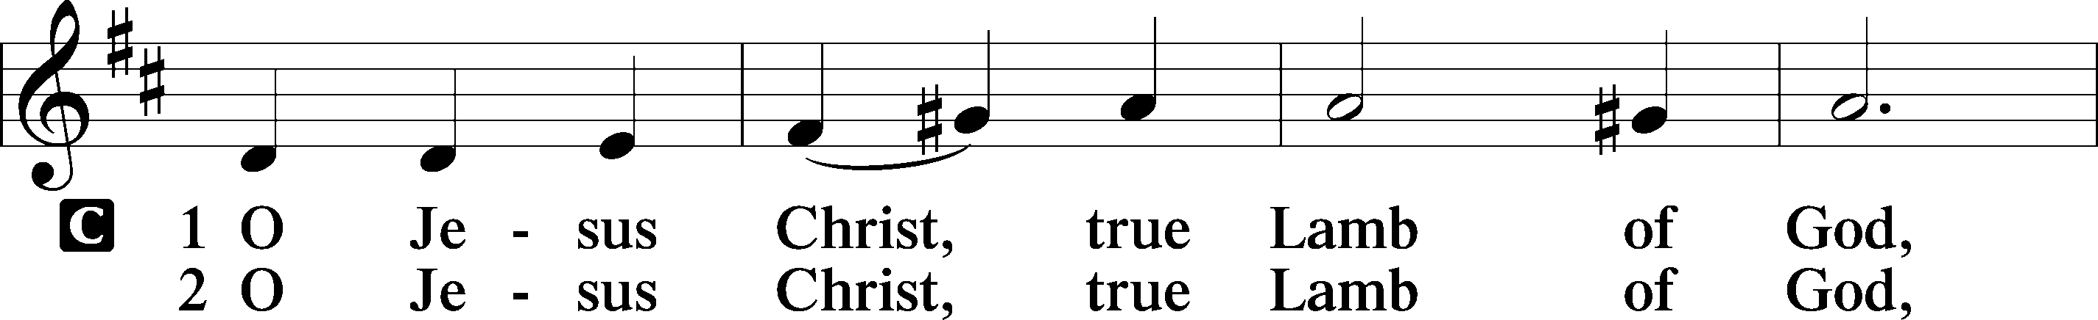
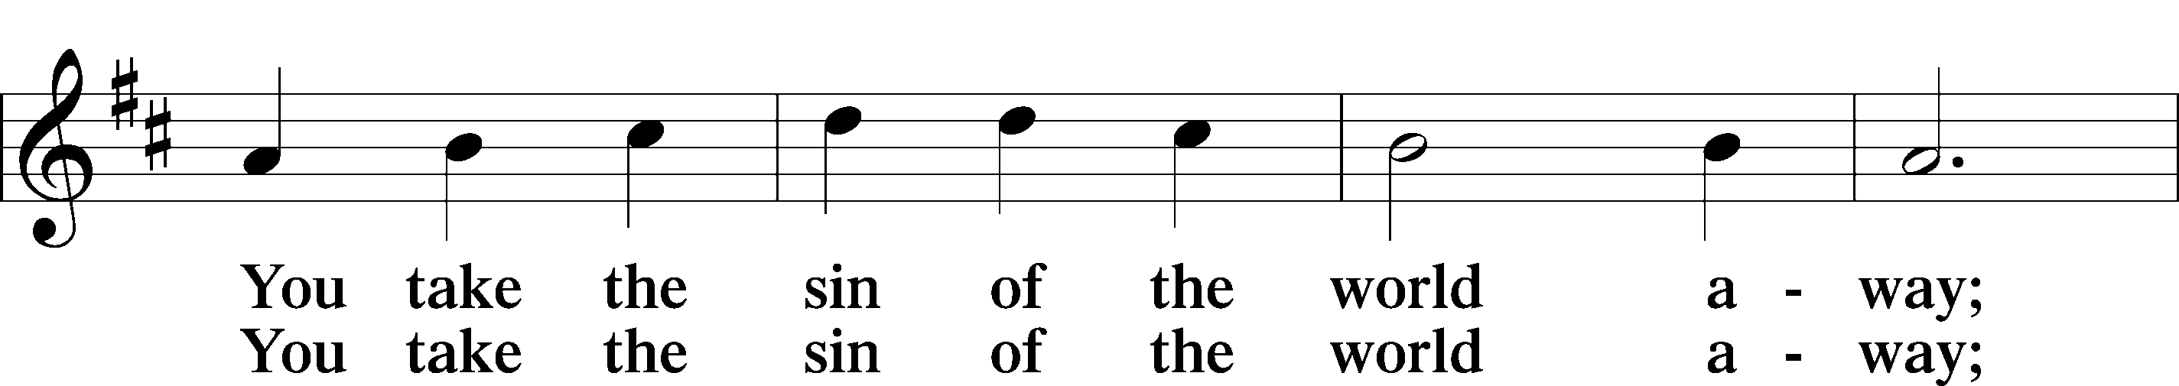
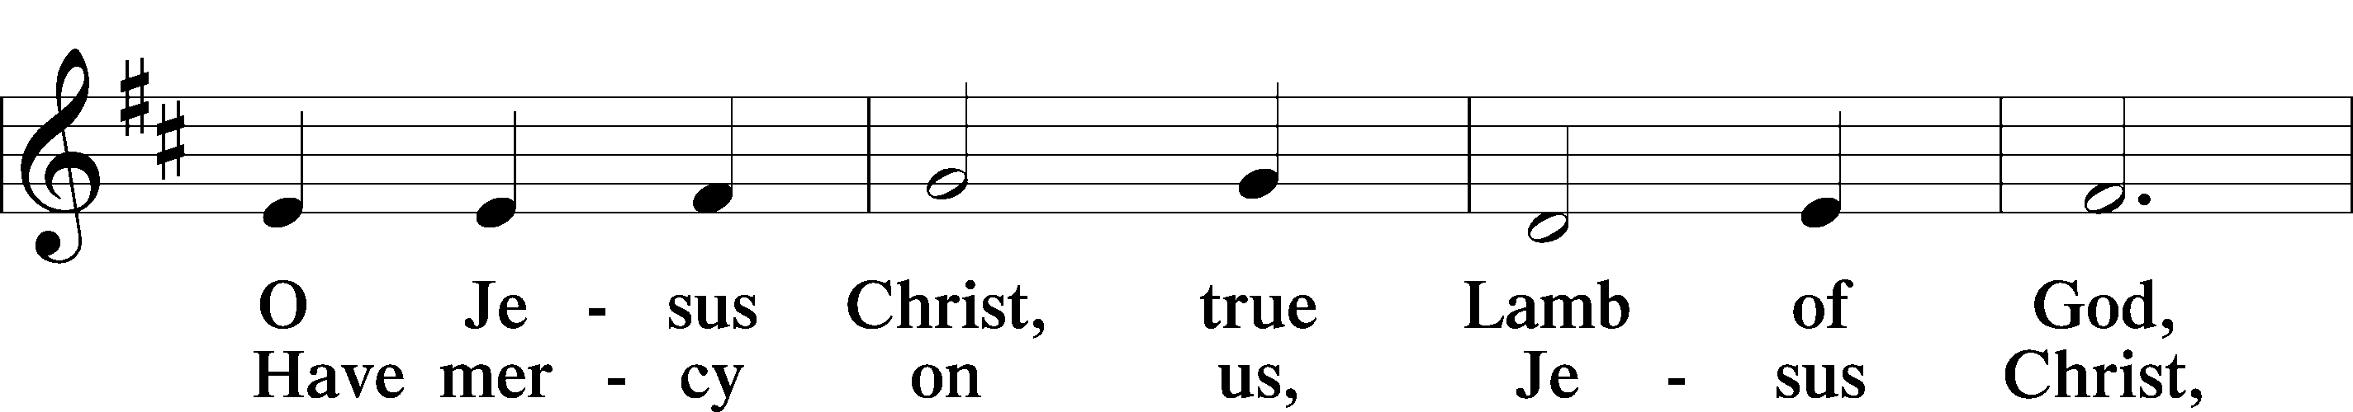
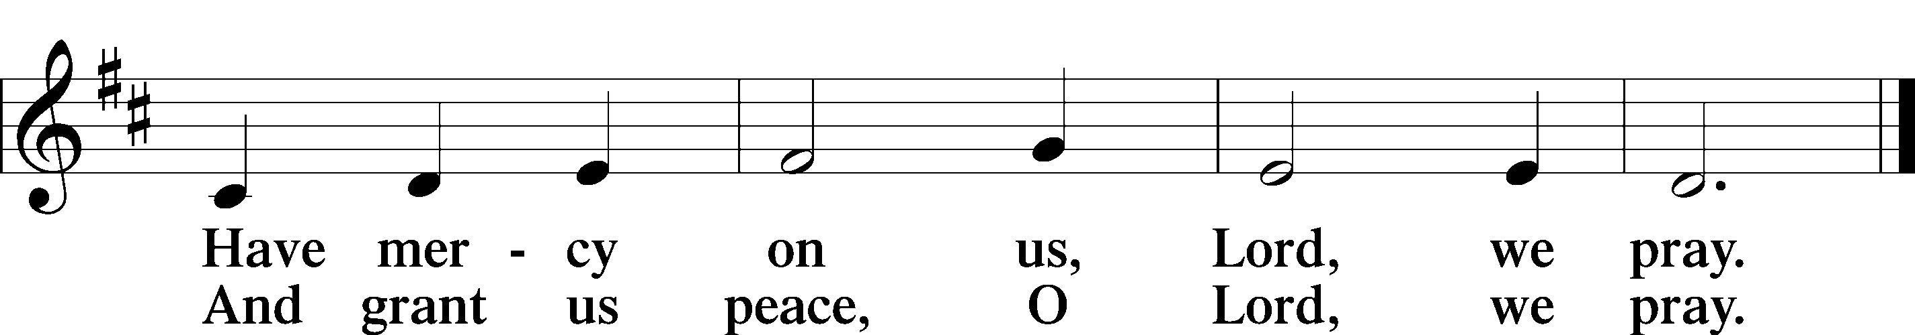
Text: Stephen P. Starke

Sit
Distribution

560 Drawn to the Cross, Which Thou Hast Blessed
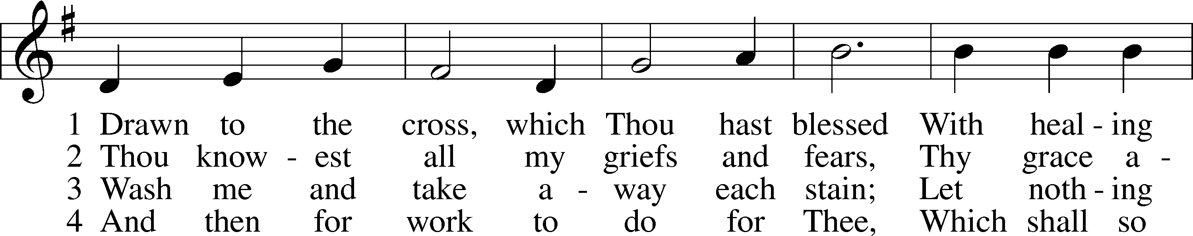
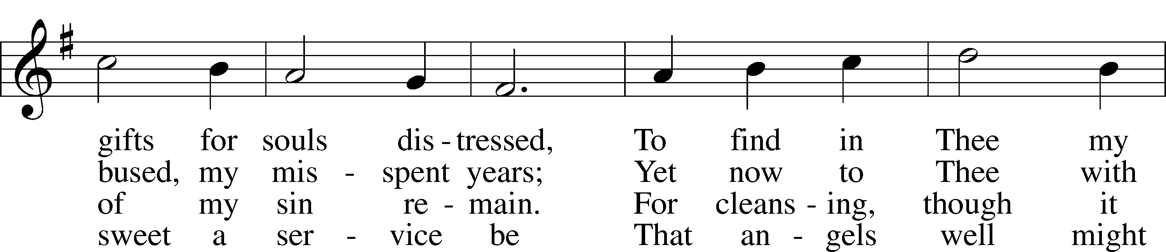
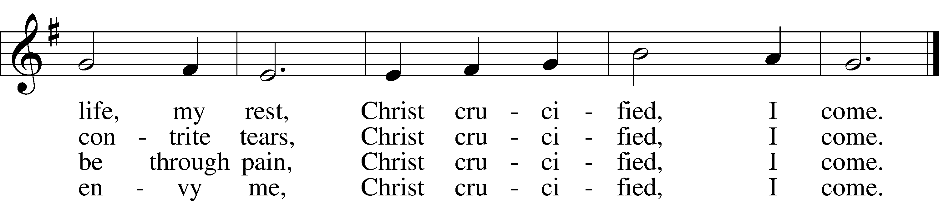
Text: Genevieve M. Irons, 1855–1928
Tune: Joseph Barnby, 1838–96
Text and tune: Public domain

435 Come to Calvary’s Holy Mountain
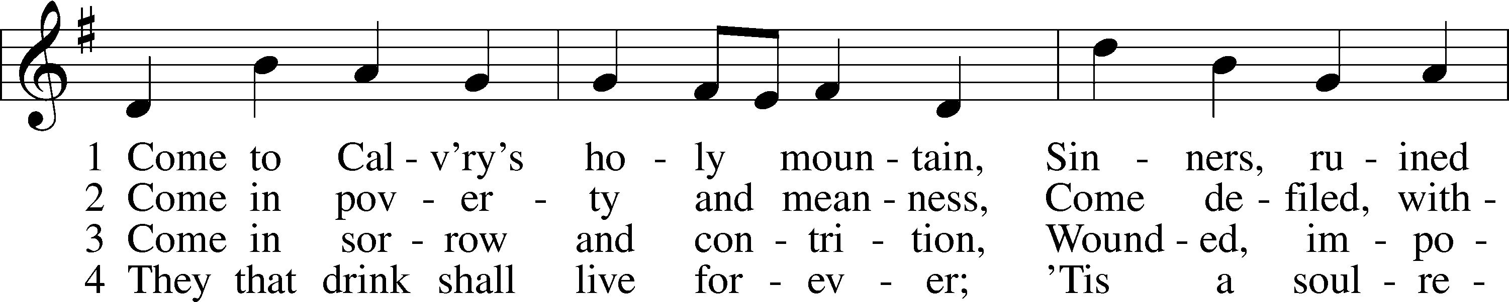
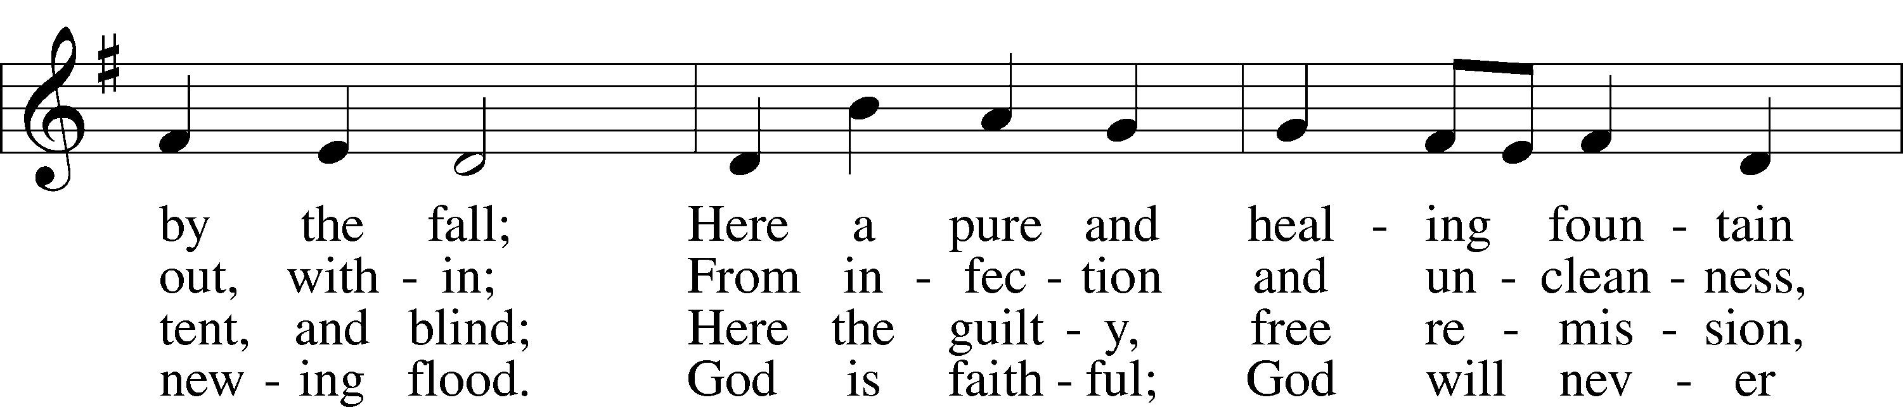
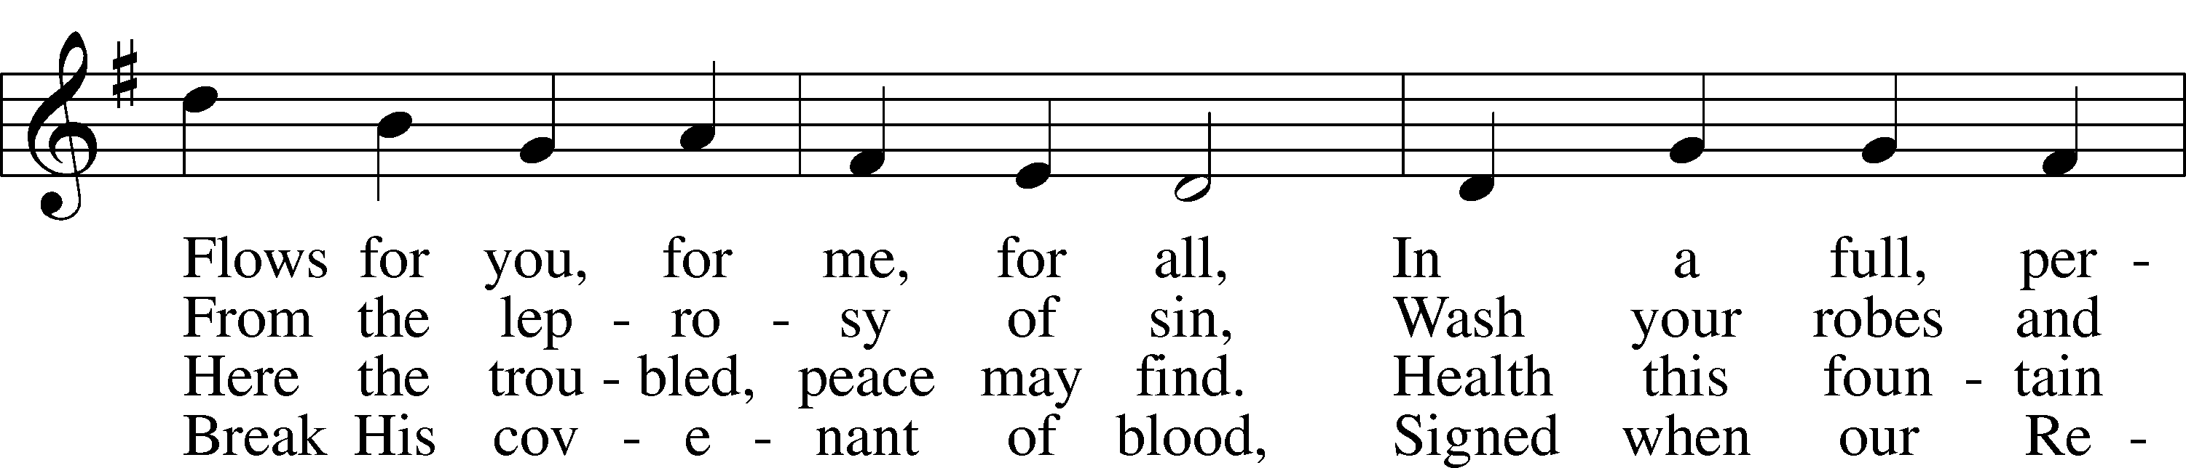
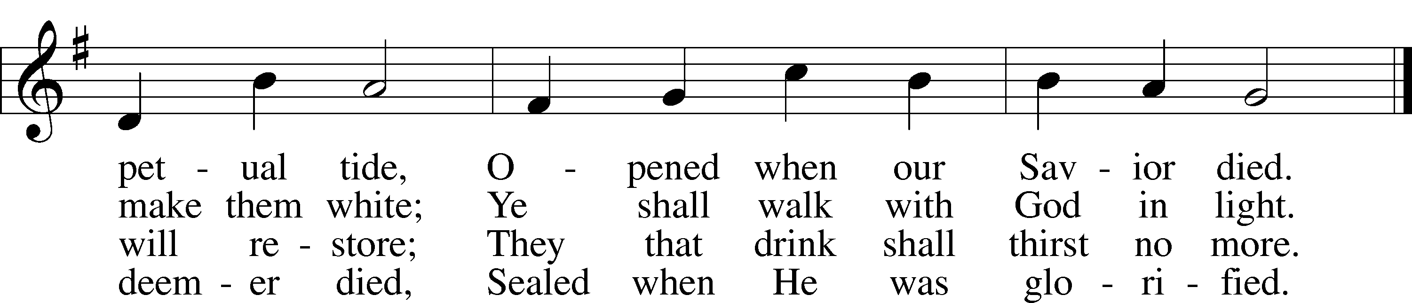
Text: James Montgomery, 1771–1854, alt.
Tune: Ludvig M. Lindeman, 1812–87
Text and tune: Public domain

427 In the Cross of Christ I Glory
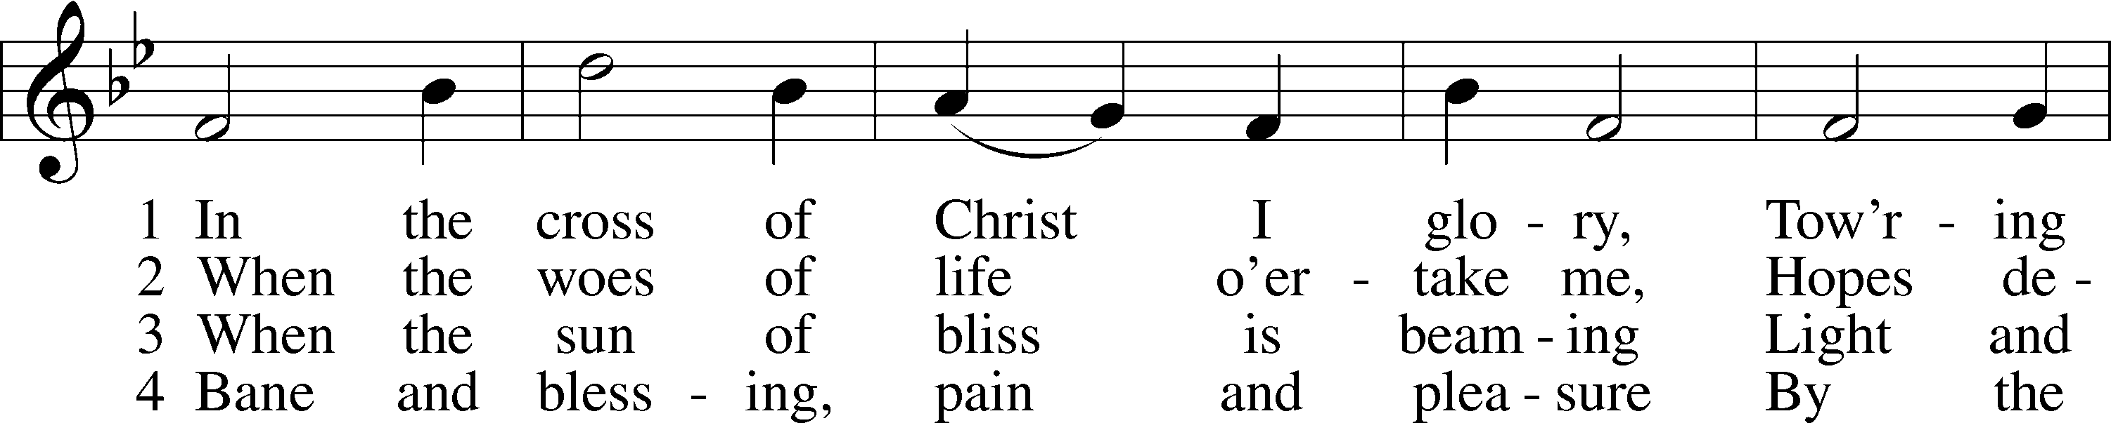
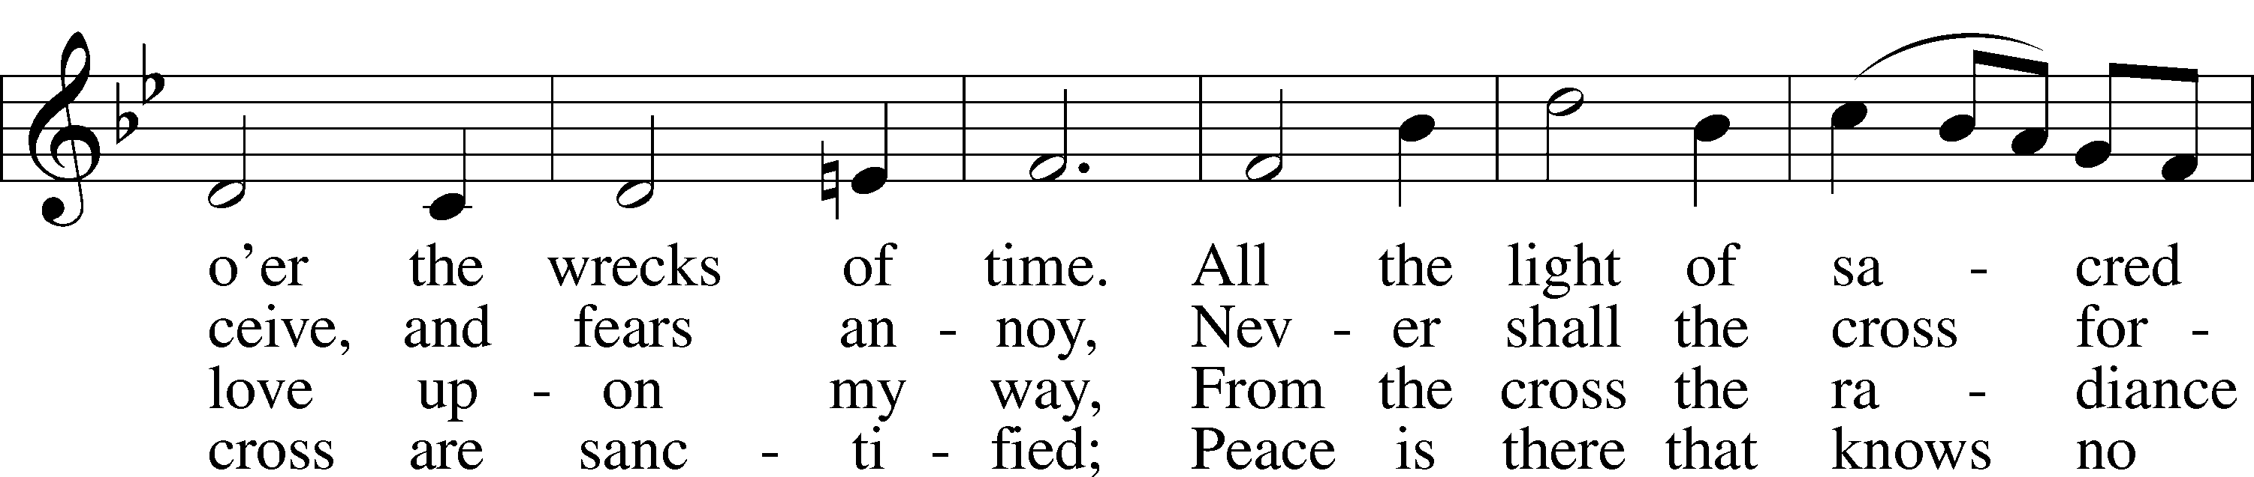
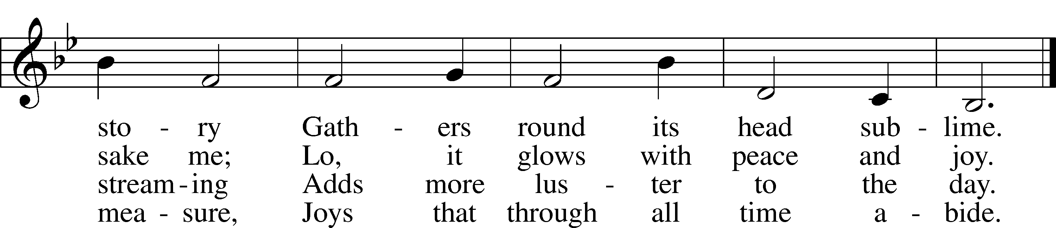
Stand

Nunc Dimittis LSB 211
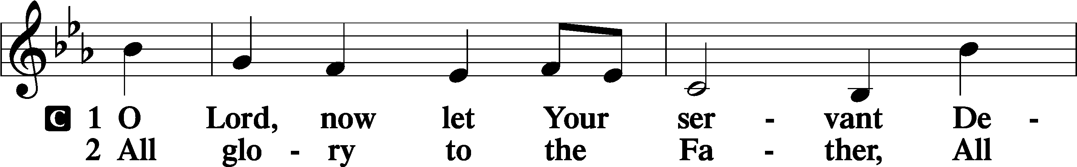
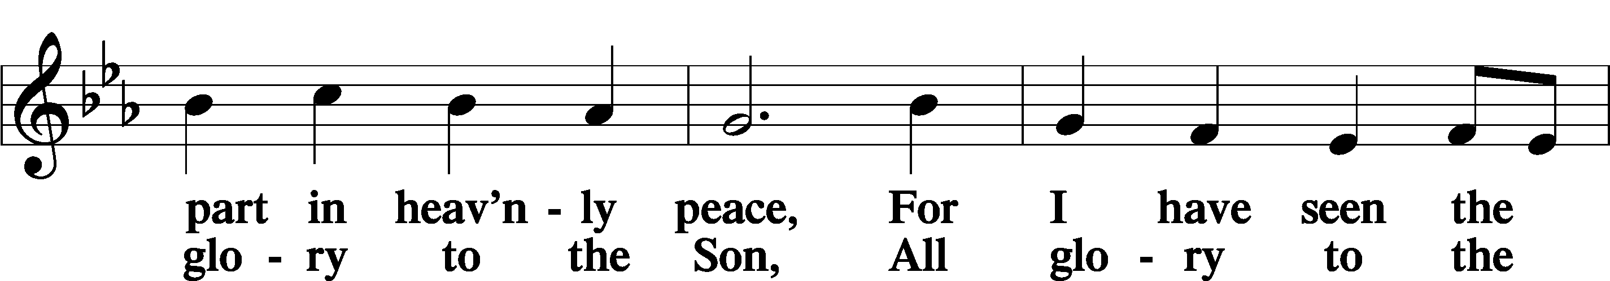
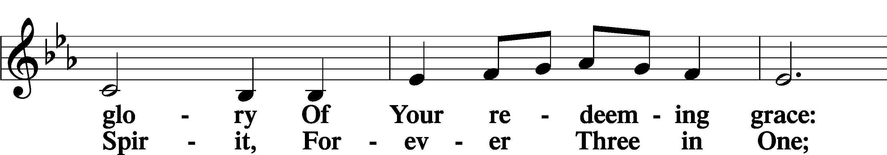
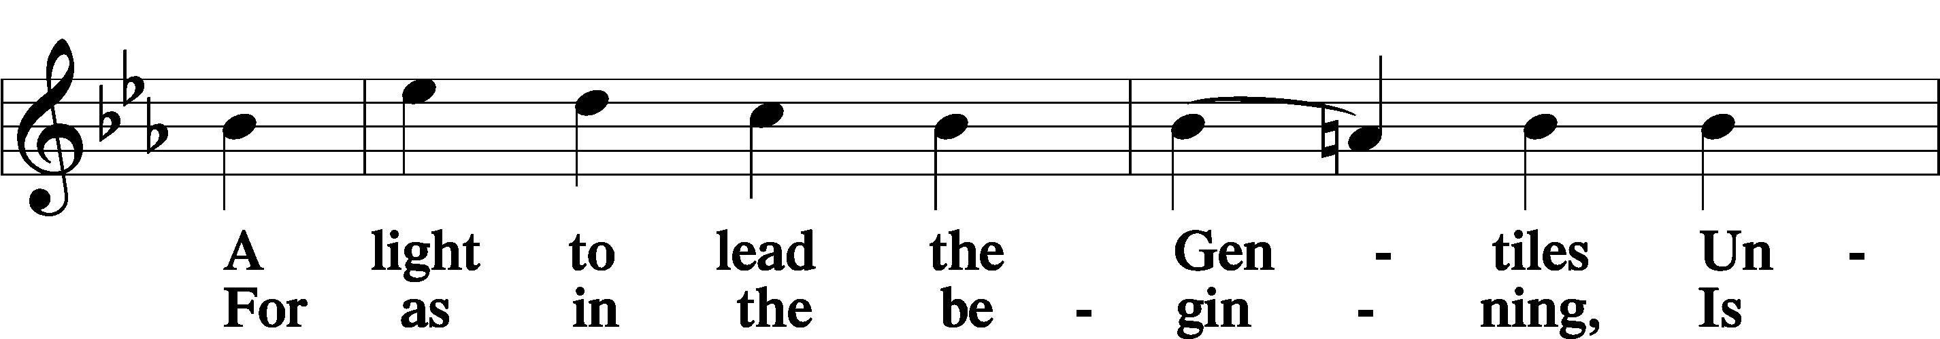
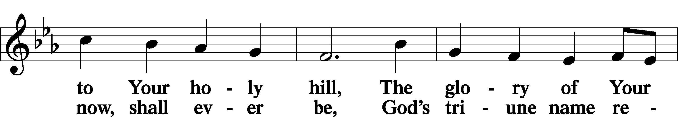
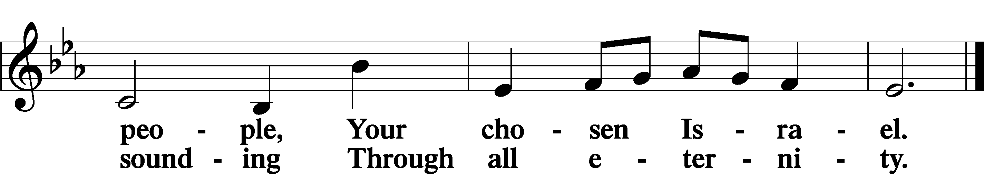

Post-Communion Collect
A Let us pray.
We give thanks to You, almighty God, that You have refreshed us through this salutary gift, and we implore You that of Your mercy You would strengthen us through the same in faith toward You and in fervent love toward one another; through Jesus Christ, Your Son, our Lord, who lives and reigns with You and the Holy Spirit, one God, now and forever.
C Amen.

Benedicamus LSB 212
A Let us bless the Lord.
C Thanks be to God.

Benediction
P The Lord bless you and keep you.
The Lord make His face shine on you and be gracious to you.
The Lord look upon you with favor and T give you peace.
C Amen.

632 O Jesus, Blessed Lord, to Thee
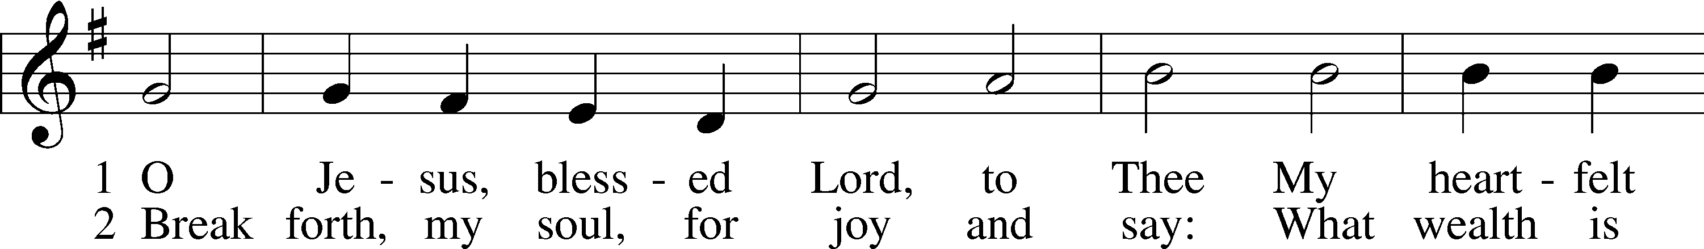
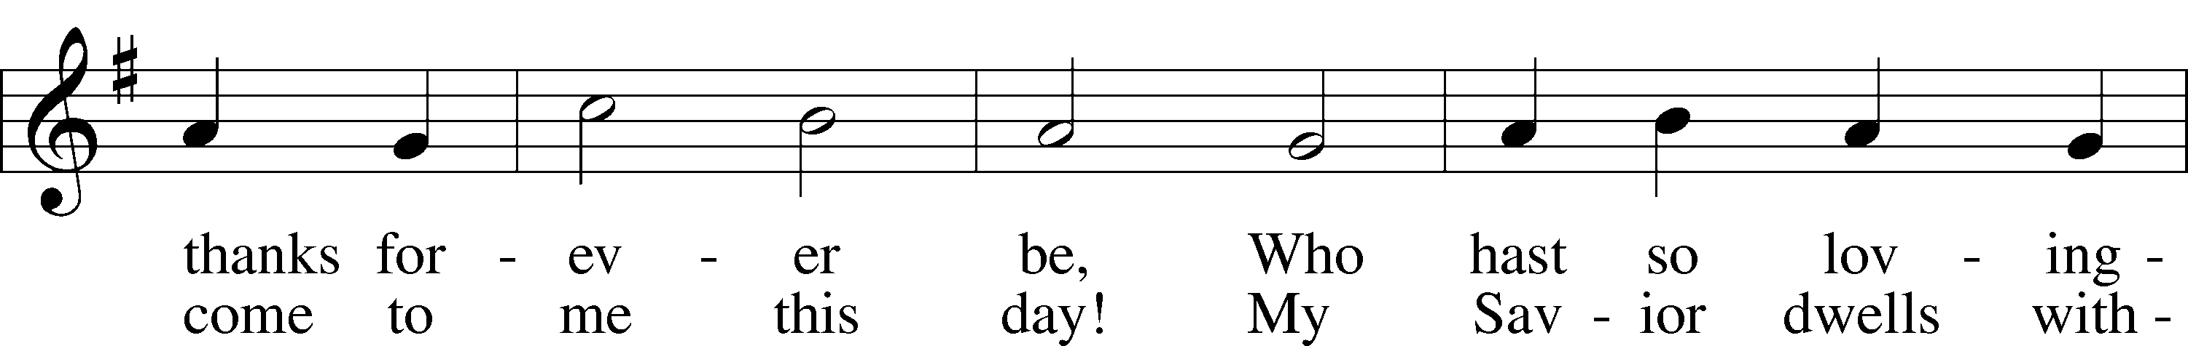
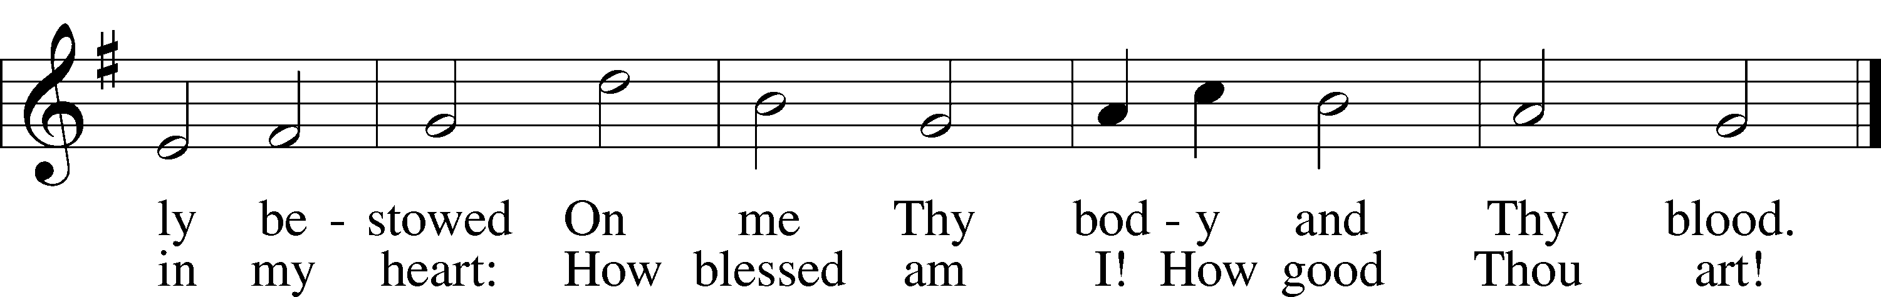
Text: Thomas Hansen Kingo, 1634–1703; tr. Arthur J. Mason, 1851–1928
Tune: Trente quatre Pseaumes de David, 1551, Geneva, ed. Louis Bourgeois
Text and tune: Public domain

Acknowledgments
Unless otherwise indicated, Scripture quotations are from the ESV® Bible (The Holy Bible, English Standard Version®), copyright © 2001 by Crossway, a publishing ministry of Good News Publishers. Used by permission. All rights reserved.
Created by Lutheran Service Builder © 2024 Concordia Publishing House.

