First Sunday in Lent
Divine Service 3 p. 184
February 17 & 18, 2024
St. Paul Lutheran Church

Confession and Absolution

657 A Mighty Fortress Is Our God sts. 1–4
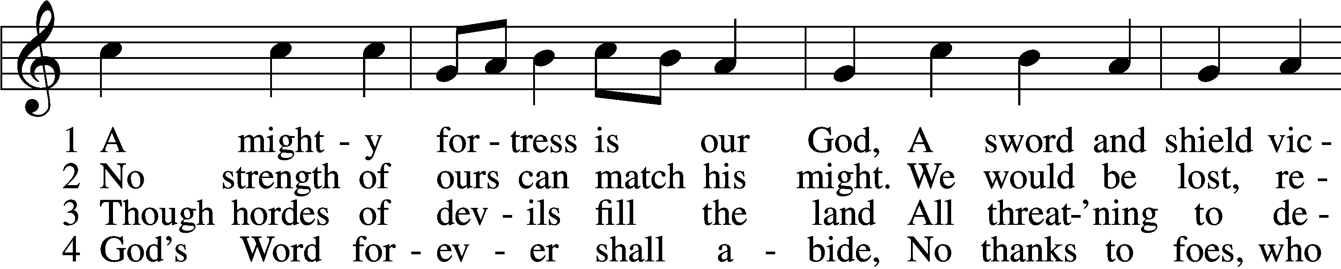
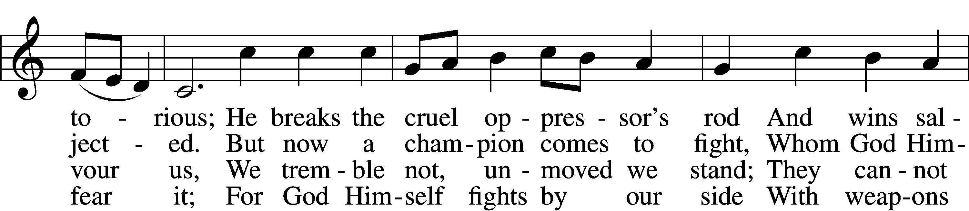
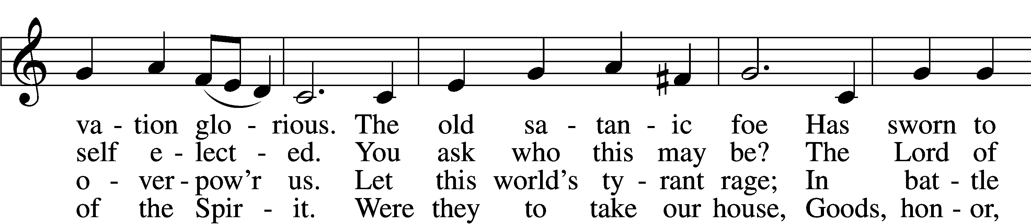
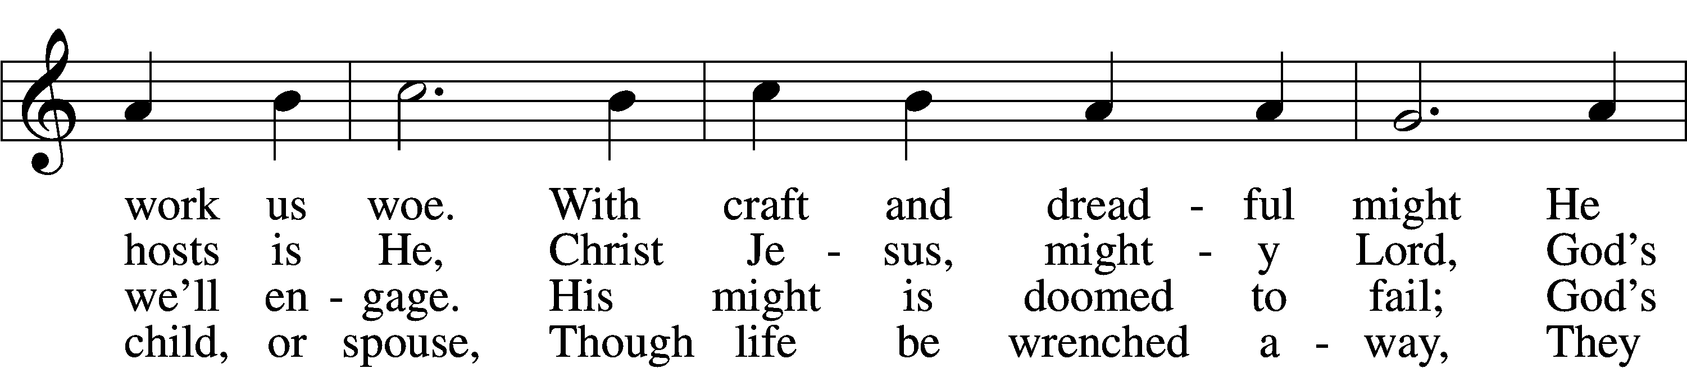
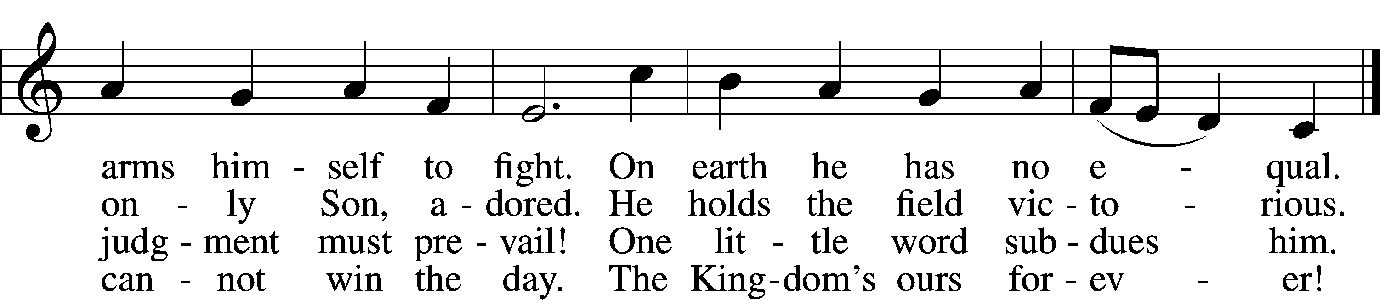
Text: tr. Lutheran Book of Worship, 1978
Text and tune: Martin Luther, 1483–1546
Text: © 1978 Lutheran Book of Worship. Used by permission: LSB Hymn License no. 110002831
Tune: Public domain

Stand

The sign of the cross may be made by all in remembrance of their Baptism.

Invocation
P In the name of the Father and of the T Son and of the Holy Spirit.
C Amen.

Exhortation LSB 184
P Beloved in the Lord! Let us draw near with a true heart and confess our sins unto God our Father, beseeching Him in the name of our Lord Jesus Christ to grant us forgiveness.

P Our help is in the name of the Lord,
C who made heaven and earth.
P I said, I will confess my transgressions unto the Lord,
C and You forgave the iniquity of my sin.

Kneel/Stand

Silence for reflection on God’s Word and for self-examination.

Confession of Sins LSB 184
P O almighty God, merciful Father,
C I, a poor, miserable sinner, confess unto You all my sins and iniquities with which I have ever offended You and justly deserved Your temporal and eternal punishment. But I am heartily sorry for them and sincerely repent of them, and I pray You of Your boundless mercy and for the sake of the holy, innocent, bitter sufferings and death of Your beloved Son, Jesus Christ, to be gracious and merciful to me, a poor, sinful being.

Absolution LSB 185
P Upon this your confession, I, by virtue of my office, as a called and ordained servant of the Word, announce the grace of God unto all of you, and in the stead and by the command of my Lord Jesus Christ I forgive you all your sins in the name of the Father and of the T Son and of the Holy Spirit.
C Amen.

Stand

Service of the Word

PSALM Psalm 25:1–10
1To you, O Lord,
I lift up my soul.
2O my God, in you I trust;
let me not be put to shame;
let not my enemies exult over me.
3Indeed, none who wait for you shall be put to shame;
they shall be ashamed who are wantonly treacherous.
4Make me to know your ways, O Lord;
teach me your paths.
5Lead me in your truth and teach me,
for you are the God of my salvation;
for you I wait all the day long.
6Remember your mercy, O Lord, and your steadfast love,
for they have been from of old.
7Remember not the sins of my youth or my transgressions;
according to your steadfast love remember me,
for the sake of your goodness, O Lord!
8Good and upright is the Lord;
therefore he instructs sinners in the way.
9He leads the humble in what is right,
and teaches the humble his way.
10All the paths of the Lord are steadfast love and faithfulness,
for those who keep his covenant and his testimonies.

Gloria Patri LSB 186
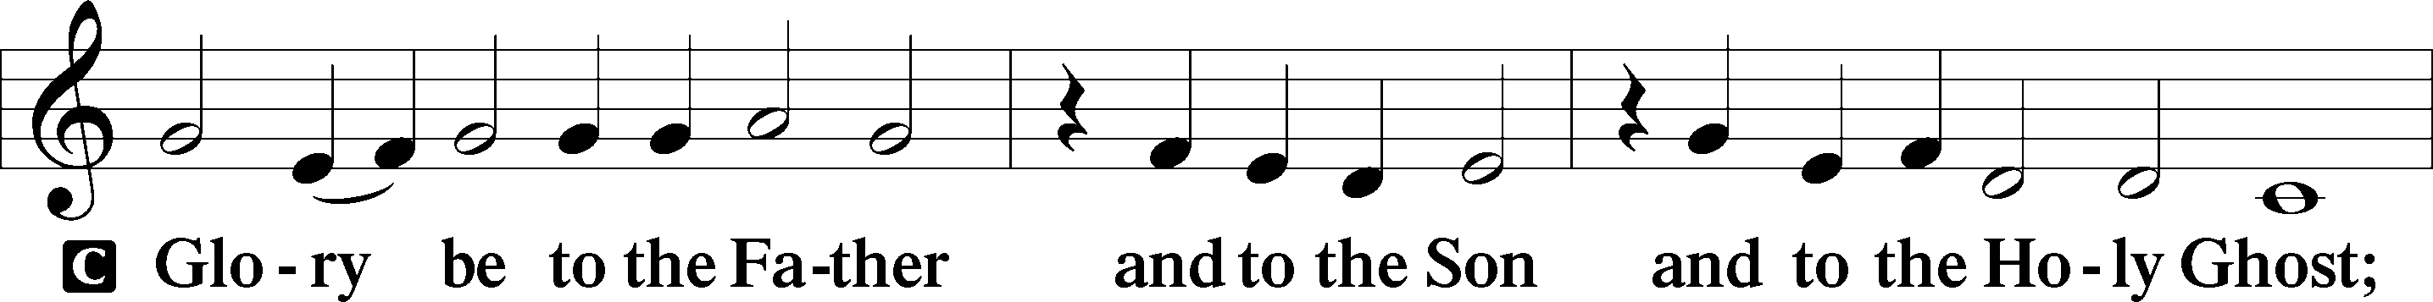
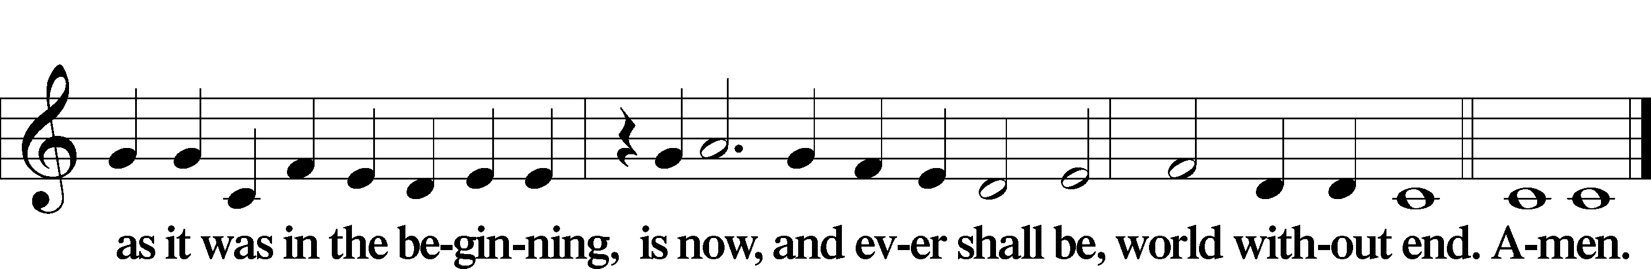

Kyrie LSB 186
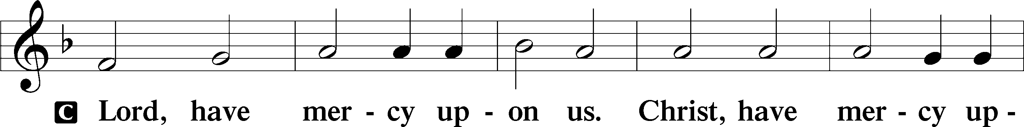
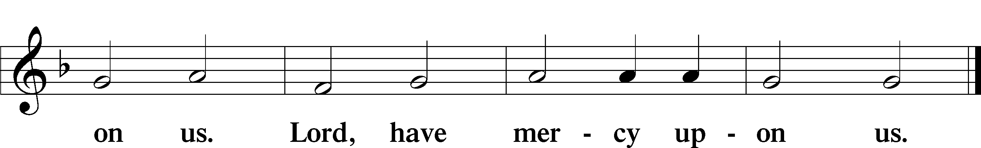

Salutation and Collect of the Day
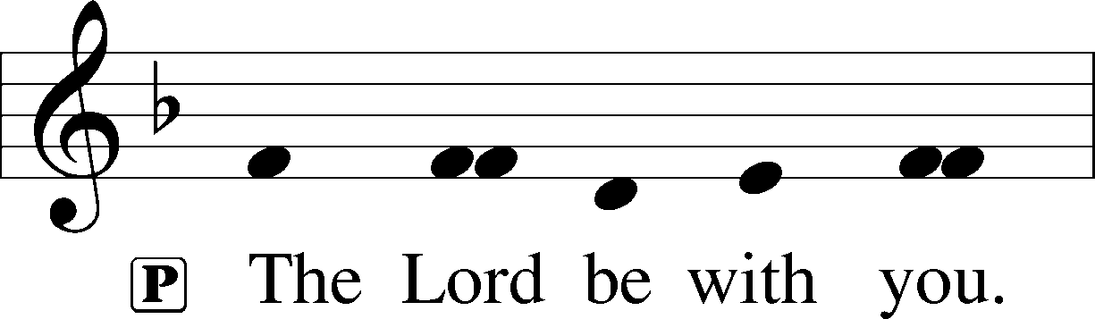
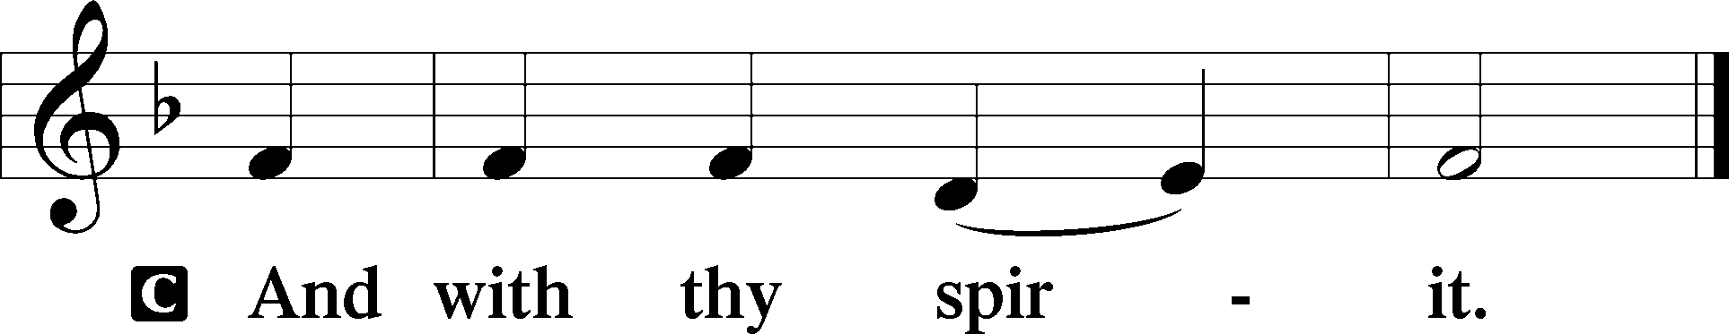

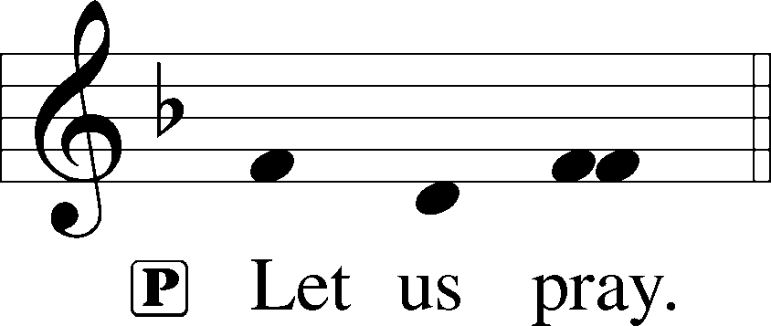

P O Lord God, You led Your ancient people through the wilderness and brought them to the promised land. Guide the people of Your Church that following our Savior we may walk through the wilderness of this world toward the glory of the world to come; through Jesus Christ, Your Son, our Lord, who lives and reigns with You and the Holy Spirit, one God, now and forever.

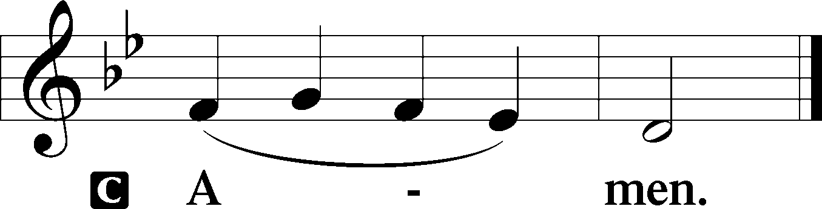

Sit

Old Testament Reading Genesis 22:1–18
1After these things God tested Abraham and said to him, “Abraham!” And he said, “Here am I.” 2He said, “Take your son, your only son Isaac, whom you love, and go to the land of Moriah, and offer him there as a burnt offering on one of the mountains of which I shall tell you.” 3So Abraham rose early in the morning, saddled his donkey, and took two of his young men with him, and his son Isaac. And he cut the wood for the burnt offering and arose and went to the place of which God had told him. 4On the third day Abraham lifted up his eyes and saw the place from afar. 5Then Abraham said to his young men, “Stay here with the donkey; I and the boy will go over there and worship and come again to you.” 6And Abraham took the wood of the burnt offering and laid it on Isaac his son. And he took in his hand the fire and the knife. So they went both of them together. 7And Isaac said to his father Abraham, “My father!” And he said, “Here am I, my son.” He said, “Behold, the fire and the wood, but where is the lamb for a burnt offering?” 8Abraham said, “God will provide for himself the lamb for a burnt offering, my son.” So they went both of them together.
9When they came to the place of which God had told him, Abraham built the altar there and laid the wood in order and bound Isaac his son and laid him on the altar, on top of the wood. 10Then Abraham reached out his hand and took the knife to slaughter his son. 11But the angel of the Lord called to him from heaven and said, “Abraham, Abraham!” And he said, “Here am I.” 12He said, “Do not lay your hand on the boy or do anything to him, for now I know that you fear God, seeing you have not withheld your son, your only son, from me.” 13And Abraham lifted up his eyes and looked, and behold, behind him was a ram, caught in a thicket by his horns. And Abraham went and took the ram and offered it up as a burnt offering instead of his son. 14So Abraham called the name of that place, “The Lord will provide”; as it is said to this day, “On the mount of the Lord it shall be provided.”
15And the angel of the Lord called to Abraham a second time from heaven 16and said, “By myself I have sworn, declares the Lord, because you have done this and have not withheld your son, your only son, 17I will surely bless you, and I will surely multiply your offspring as the stars of heaven and as the sand that is on the seashore. And your offspring shall possess the gate of his enemies, 18and in your offspring shall all the nations of the earth be blessed, because you have obeyed my voice.”

A This is the Word of the Lord.
C Thanks be to God.

Epistle James 1:12–18
12Blessed is the man who remains steadfast under trial, for when he has stood the test he will receive the crown of life, which God has promised to those who love him. 13Let no one say when he is tempted, “I am being tempted by God,” for God cannot be tempted with evil, and he himself tempts no one. 14But each person is tempted when he is lured and enticed by his own desire. 15Then desire when it has conceived gives birth to sin, and sin when it is fully grown brings forth death.
16Do not be deceived, my beloved brothers. 17Every good gift and every perfect gift is from above, coming down from the Father of lights with whom there is no variation or shadow due to change. 18Of his own will he brought us forth by the word of truth, that we should be a kind of firstfruits of his creatures.

A This is the Word of the Lord.
C Thanks be to God.

Stand

Holy Gospel Mark 1:9–15
P The Holy Gospel according to St. Mark, the first chapter.

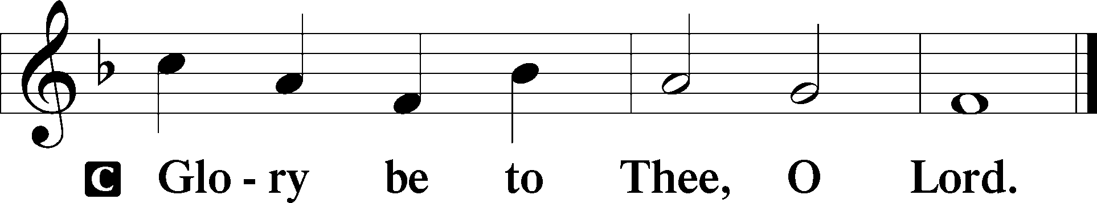

9In those days Jesus came from Nazareth of Galilee and was baptized by John in the Jordan. 10And when he came up out of the water, immediately he saw the heavens opening and the Spirit descending on him like a dove. 11And a voice came from heaven, “You are my beloved Son; with you I am well pleased.”
12The Spirit immediately drove him out into the wilderness. 13And he was in the wilderness forty days, being tempted by Satan. And he was with the wild animals, and the angels were ministering to him.
14Now after John was arrested, Jesus came into Galilee, proclaiming the gospel of God, 15and saying, “The time is fulfilled, and the kingdom of God is at hand; repent and believe in the gospel.”

P This is the Gospel of the Lord.

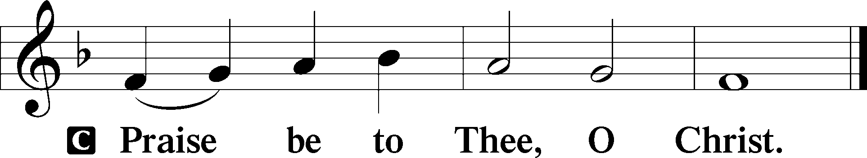

Nicene Creed
C I believe in one God,
the Father Almighty,
maker of heaven and earth
and of all things visible and invisible.

And in one Lord Jesus Christ,
the only-begotten Son of God,
begotten of His Father before all worlds,
God of God, Light of Light,
very God of very God,
begotten, not made,
being of one substance with the Father,
by whom all things were made;
who for us men and for our salvation came down from heaven
and was incarnate by the Holy Spirit of the virgin Mary
and was made man;
and was crucified also for us under Pontius Pilate.
He suffered and was buried.
And the third day He rose again according to the Scriptures
and ascended into heaven
and sits at the right hand of the Father.
And He will come again with glory to judge both the living and the dead,
whose kingdom will have no end.

And I believe in the Holy Spirit,
the Lord and giver of life,
who proceeds from the Father and the Son,
who with the Father and the Son together is worshiped and glorified,
who spoke by the prophets.
And I believe in one holy Christian and apostolic Church,
I acknowledge one Baptism for the remission of sins,
and I look for the resurrection of the dead
and the life T of the world to come. Amen.

Sit

718 Jesus, Lead Thou On
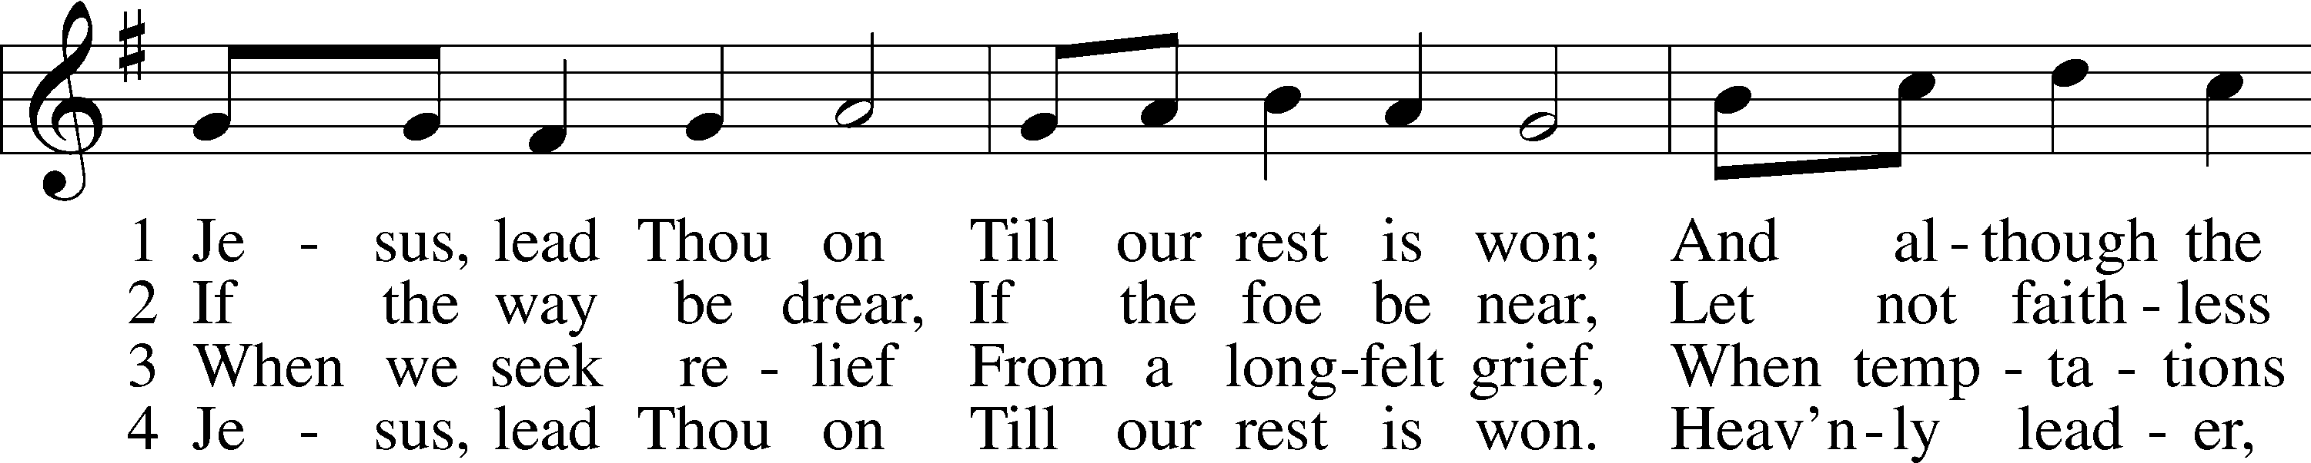
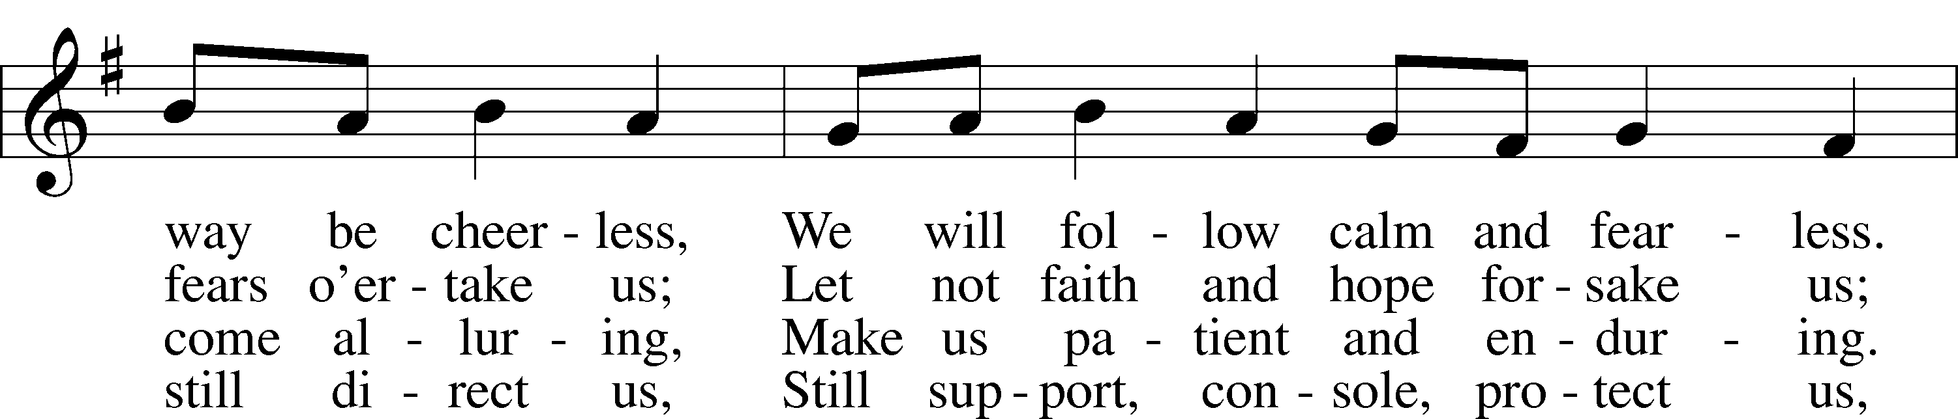
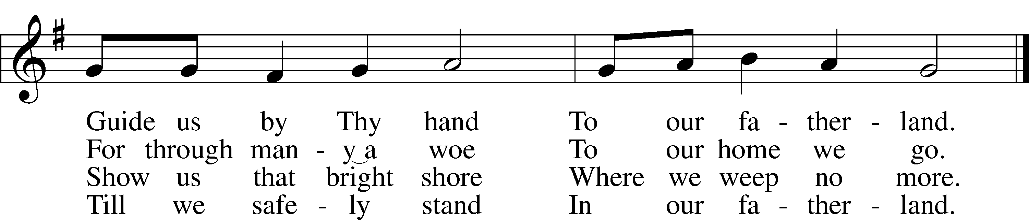
Text: Nicolaus Ludwig von Zinzendorf, 1700–60; tr. Jane L. Borthwick, 1813–97, alt.Tune: Adam Drese, 1620–1701Text and tune: Public domain

Children’s Message
Sermon

Stand

Offertory LSB 192
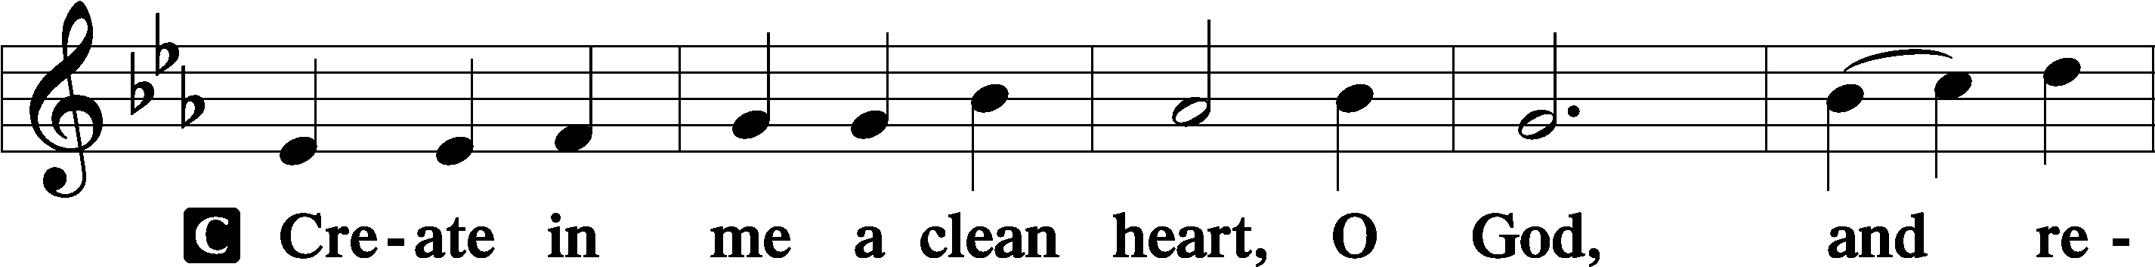
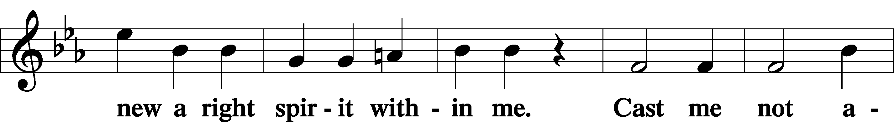
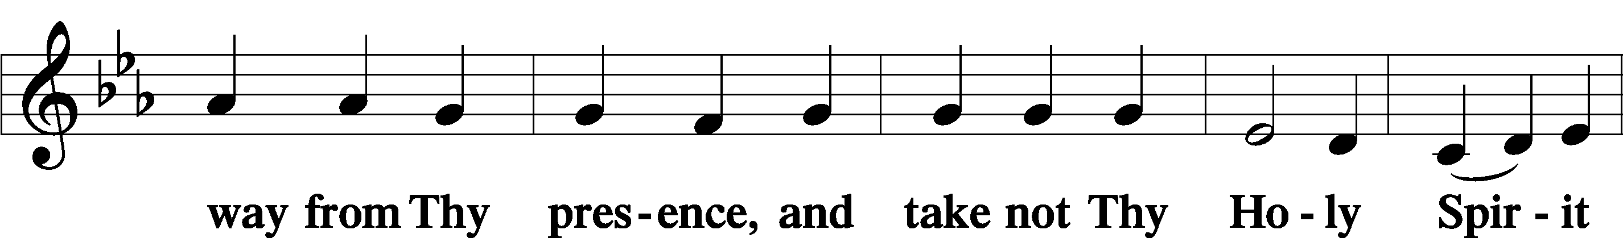
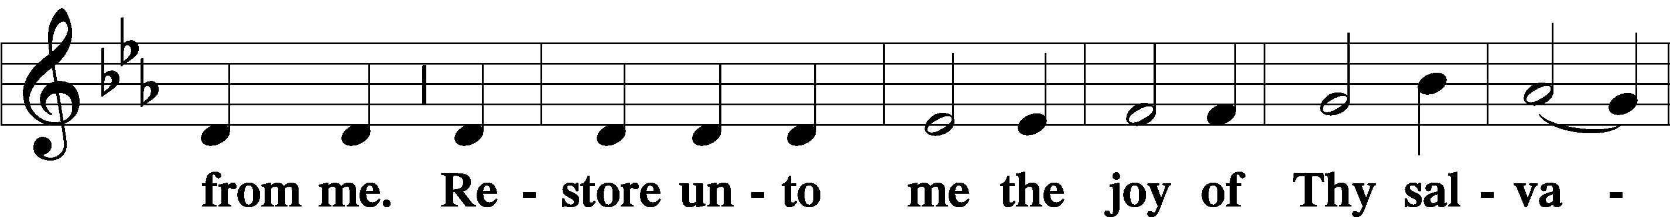
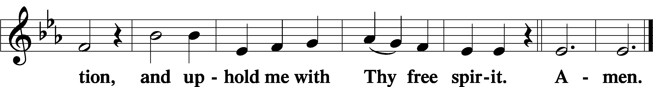
Sit

Offering

Stand

Prayer of the Church
P In peace, let us pray to the Lord:
C Lord, have mercy.

P For faith to follow our Lord Jesus and resist temptation, that we would come through this fallen world to dwell with Him forever, let us pray to the Lord:
C Lord, have mercy.

P For the Church of God, guarded by the Lord who bore the wood of the cross, that her ministers and people may be certain that the gates of hell cannot prevail against us; and for boldness of faith, that we may trample every power of the enemy underfoot, let us pray to the Lord:
C Lord, have mercy.

P For all catechumens and their teachers, all children and their parents, and every Christian home, that God would preserve them from the assaults of the evil one and, as Christ overcame Satan in the desert by the Word of God, give them the victory through Him and His Word, let us pray to the Lord:
C Lord, have mercy.

P To the Father of lights, from whom every good and perfect gift comes, that He would keep us from all sinful desires and misuse of His gifts; for His help to use them in service to our neighbor; and that He would bless Joseph and all leaders to govern wisely for the good of this and future generations, let us pray to the Lord:
C Lord, have mercy.

P For our brothers and sisters and all who suffer in our midst, [________,] that God Most High, our refuge in every trouble, would command His angels to keep them from every evil of body, mind or soul, let us pray to the Lord:
C Lord, have mercy.

P For those who commune, that in the blessed Sacrament they would acknowledge the time fulfilled and the kingdom at hand in Christ Jesus, receiving His body and blood with repentance and faith, let us pray to the Lord:
C Lord, have mercy.

P Lord God, heavenly Father, see how the adversary continually afflicts us and walks about as a roaring lion seeking to devour us. We implore You for the sake of the suffering and death of Your Son, Jesus Christ, to help us by the grace of the Holy Spirit and to strengthen our hearts by Your Word, that our enemy would not prevail over us, but instead that we may abide evermore in Your grace and be preserved to life everlasting; through the same Jesus Christ, Your Son, our Lord, who lives and reigns with You and the Holy Spirit, one God, now and forever.
C Amen.

Service of the Sacrament

Preface LSB 194
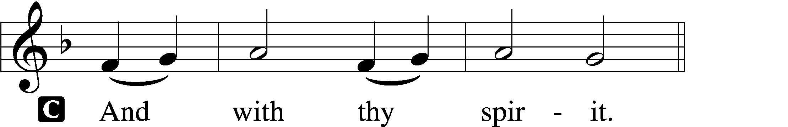

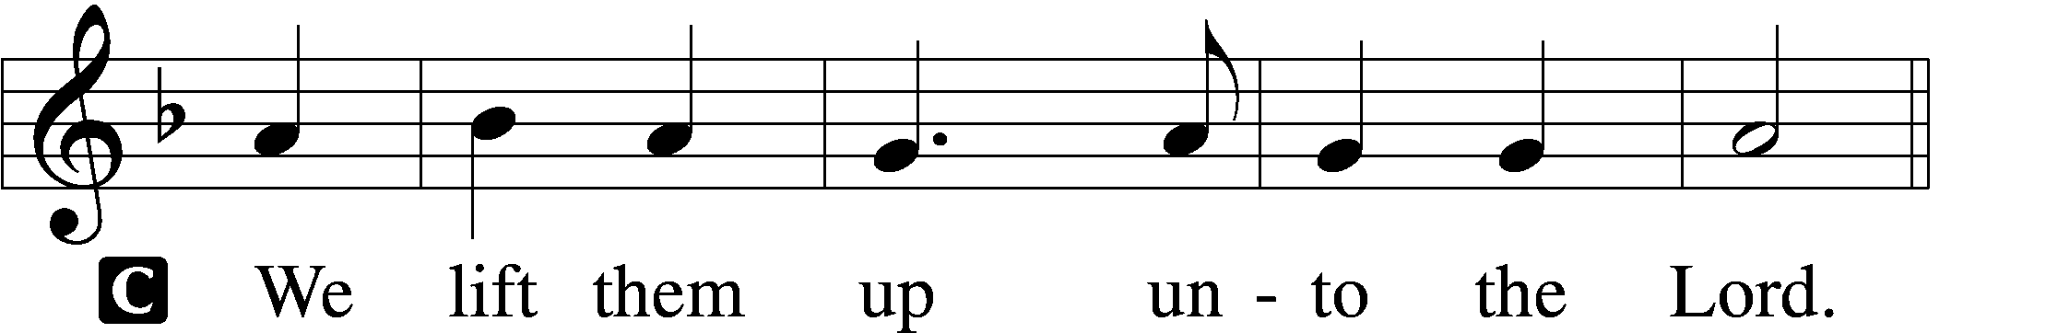

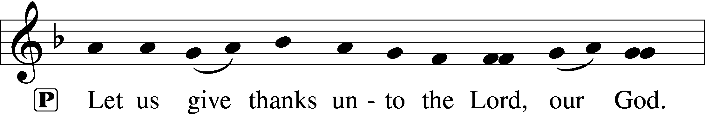
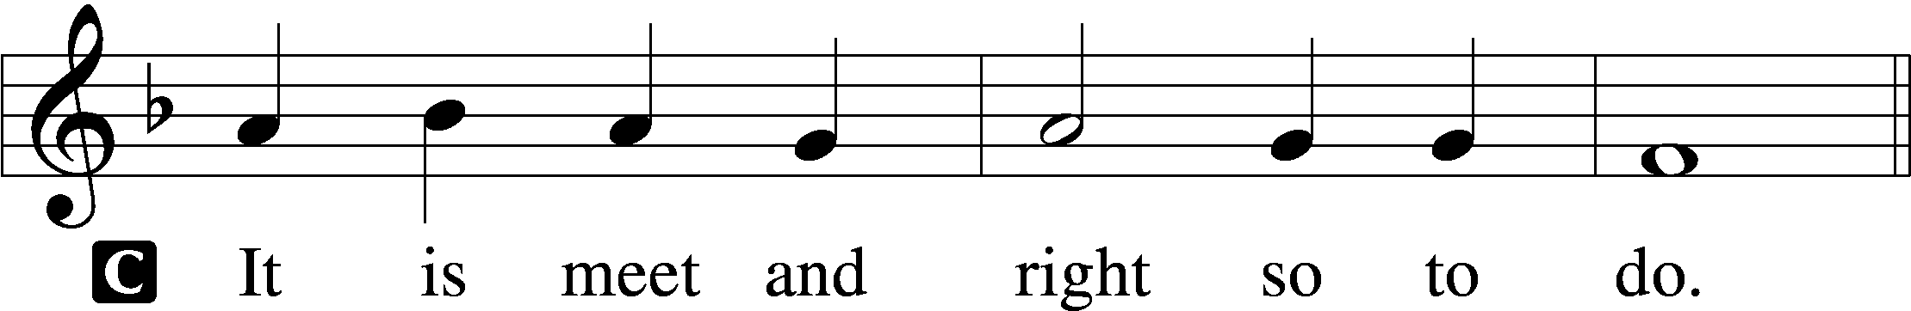

Proper Preface
P It is truly meet, right, and salutary that we should at all times and in all places give thanks to You, holy Lord, almighty Father, everlasting God, through Jesus Christ, our Lord, who overcame the assaults of the devil and gave His life as a ransom for many that with cleansed hearts we might be prepared joyfully to celebrate the paschal feast in sincerity and truth. Therefore with angels and archangels and with all the company of heaven we laud and magnify Your glorious name, evermore praising You and saying:

Sanctus LSB 195
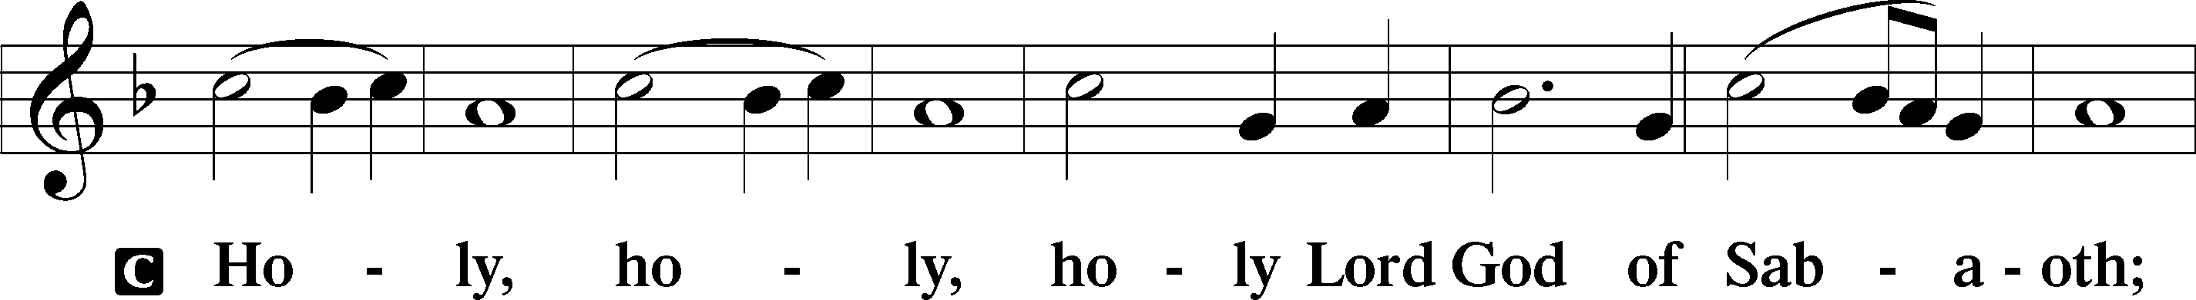
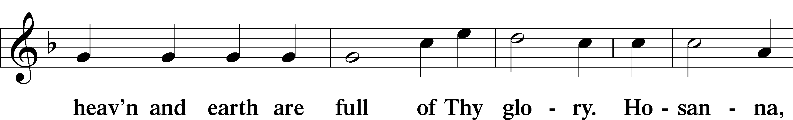
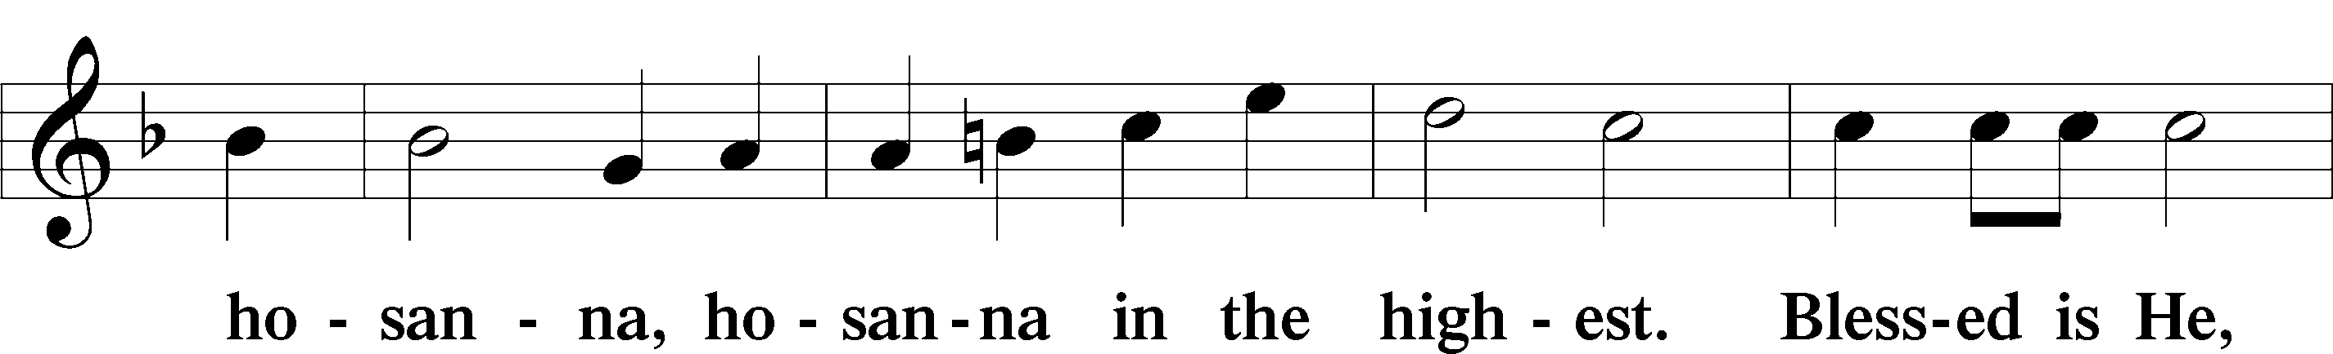
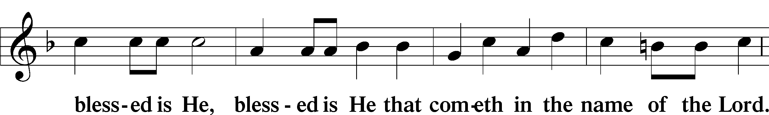
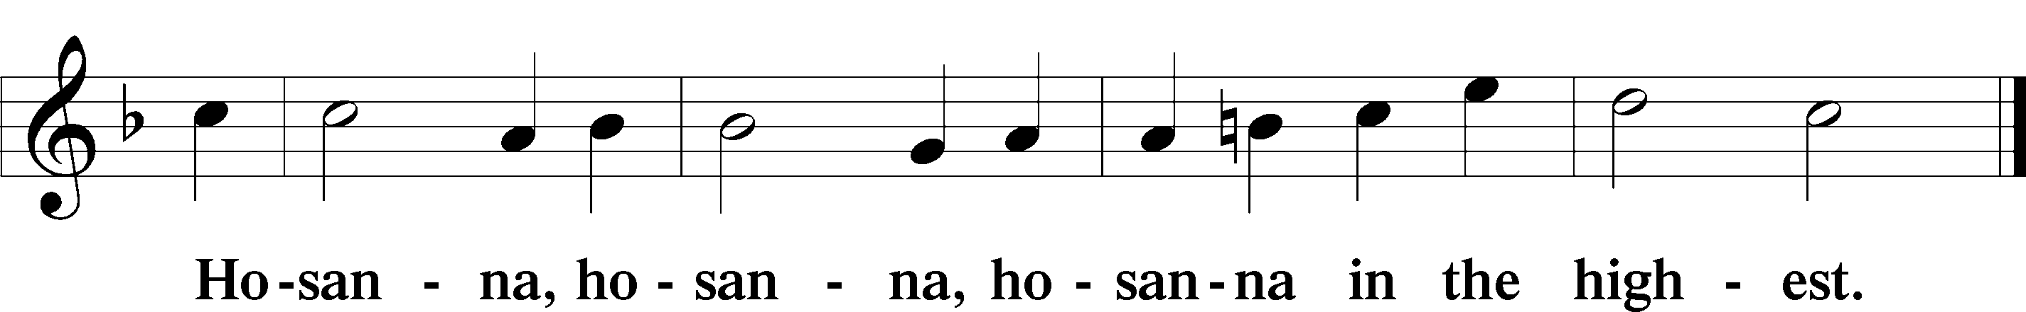

Lord’s Prayer LSB 196
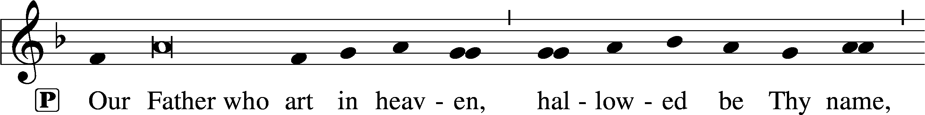
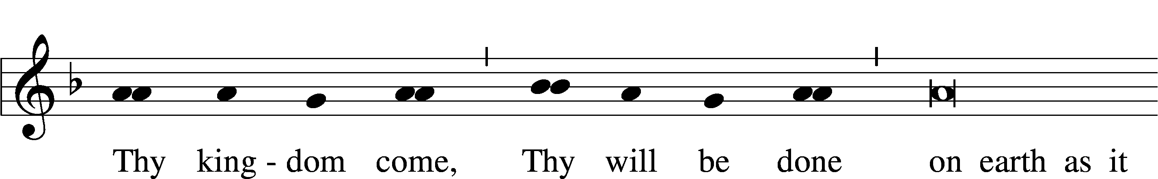
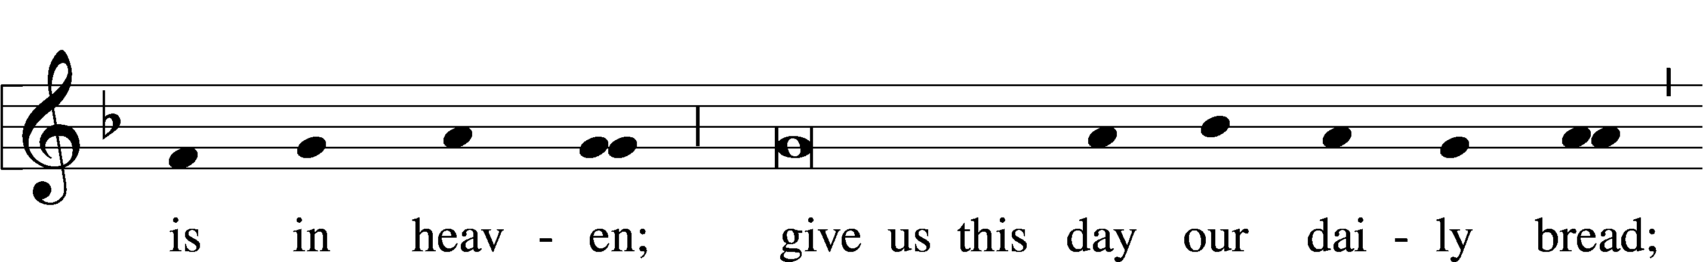
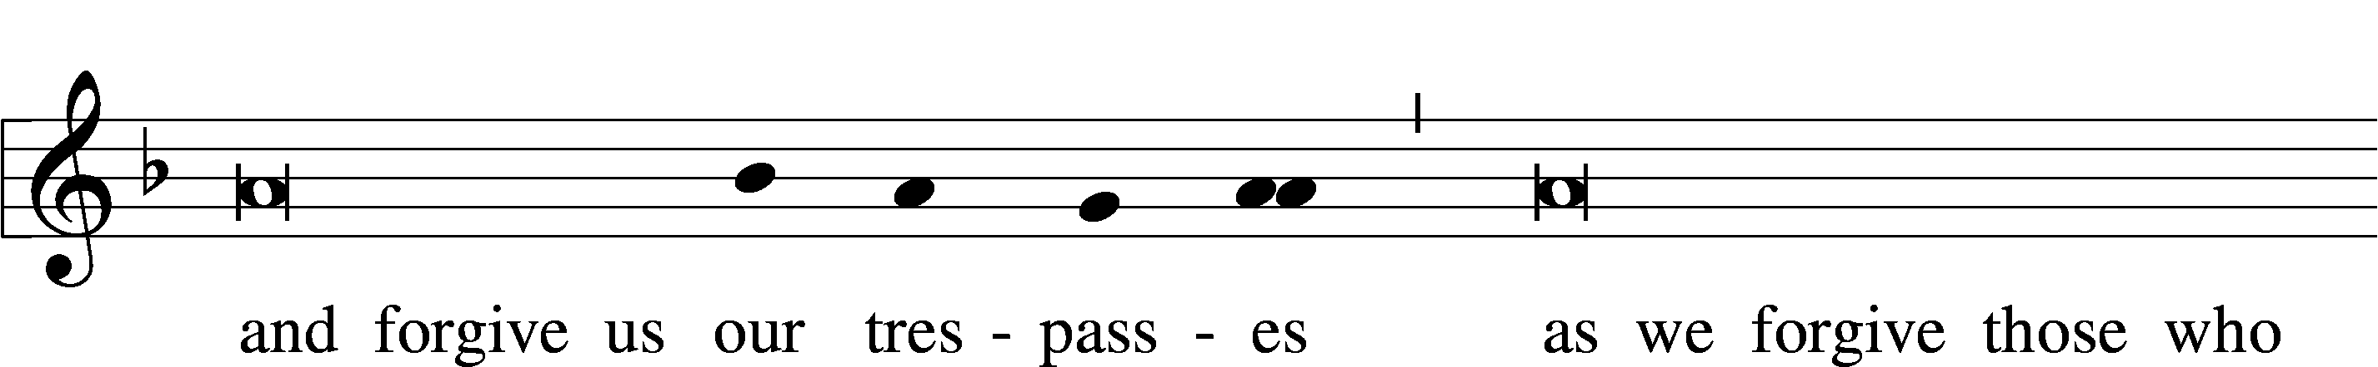
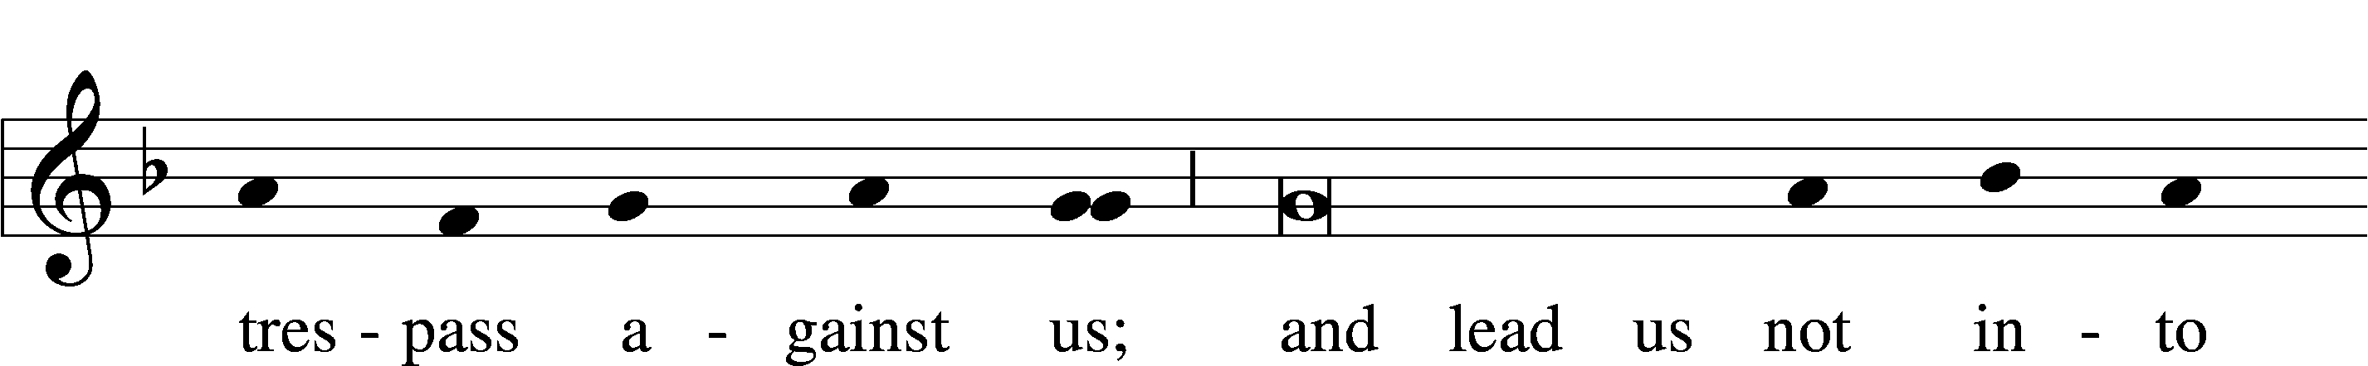
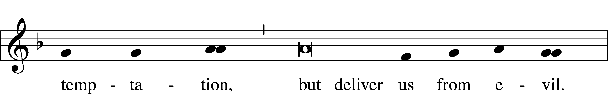

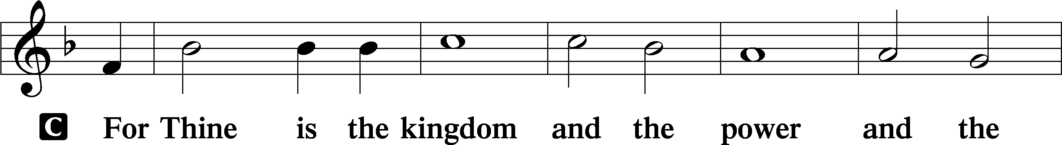
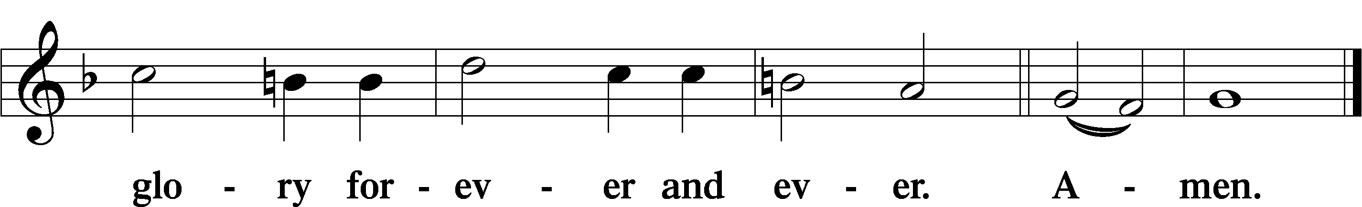

The Words of Our Lord LSB 197
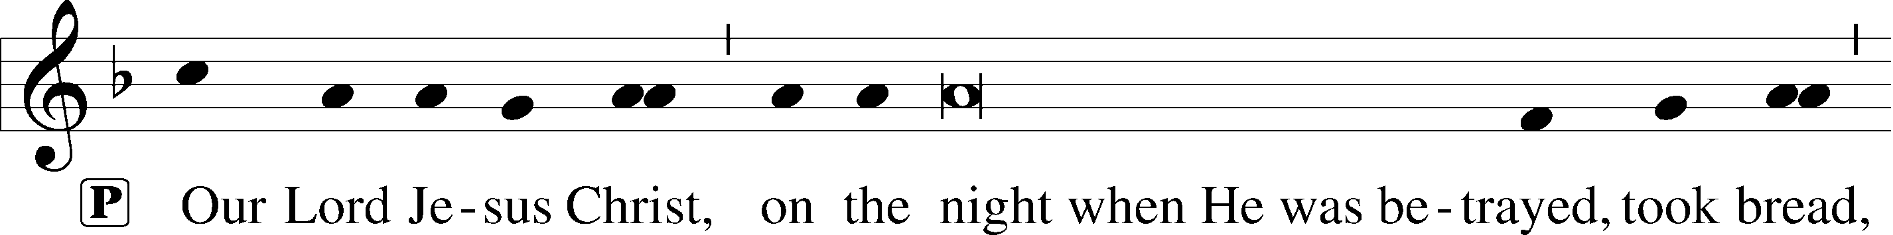
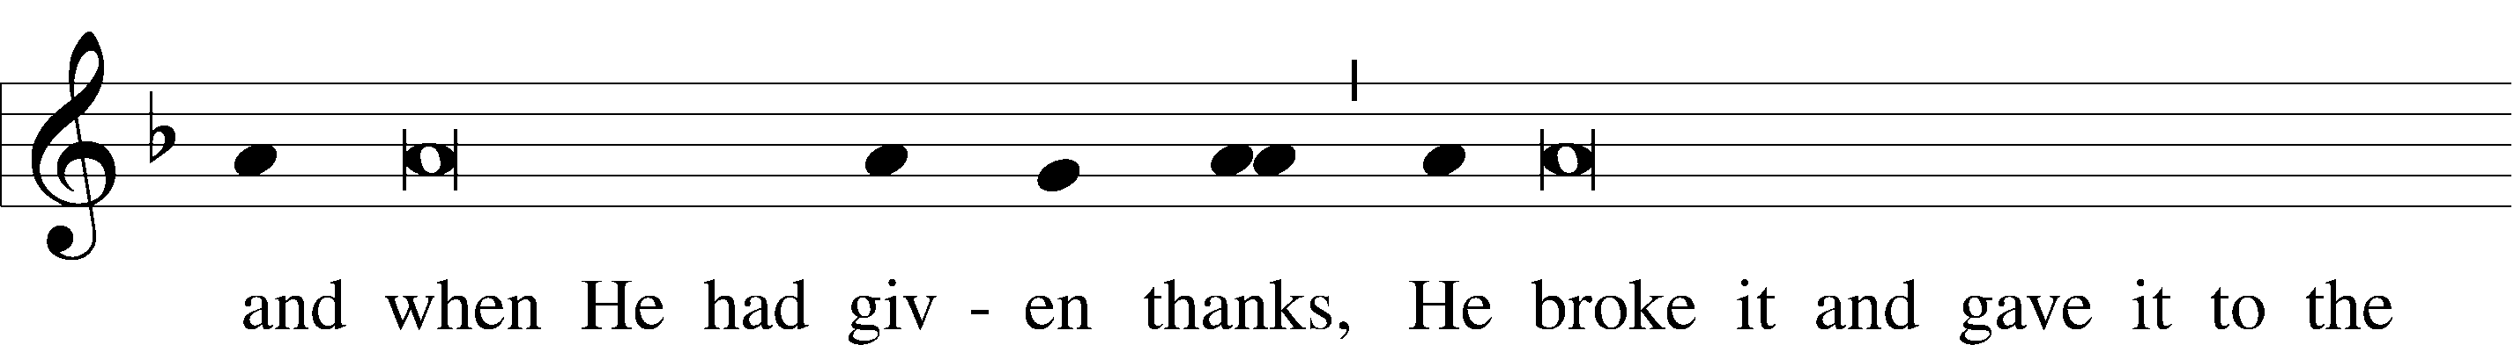
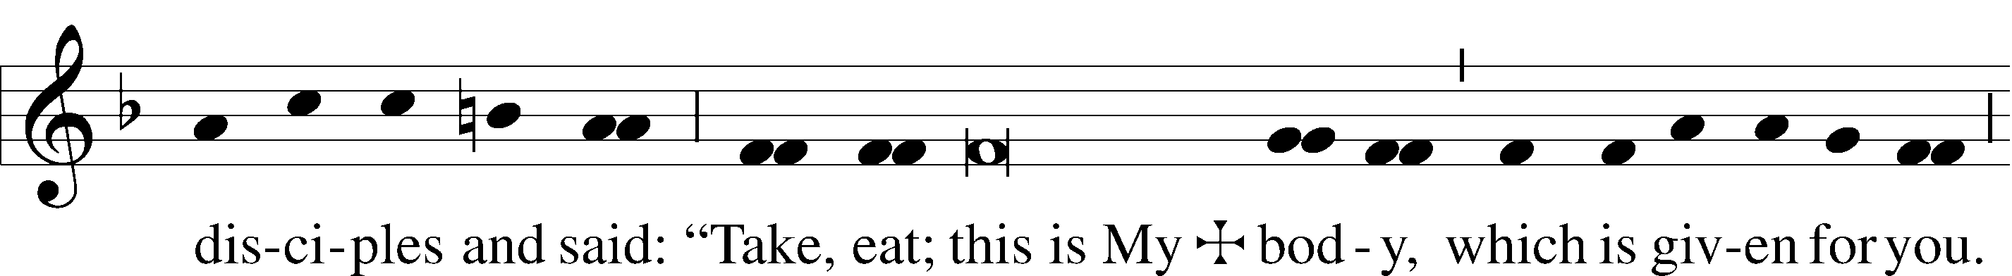
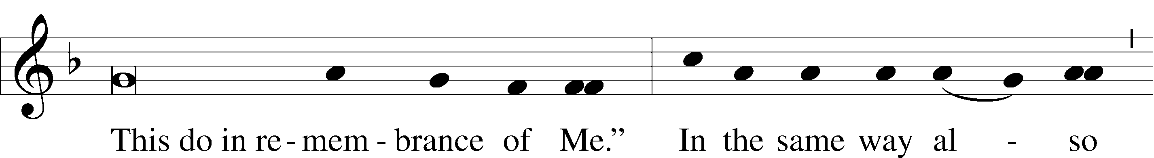
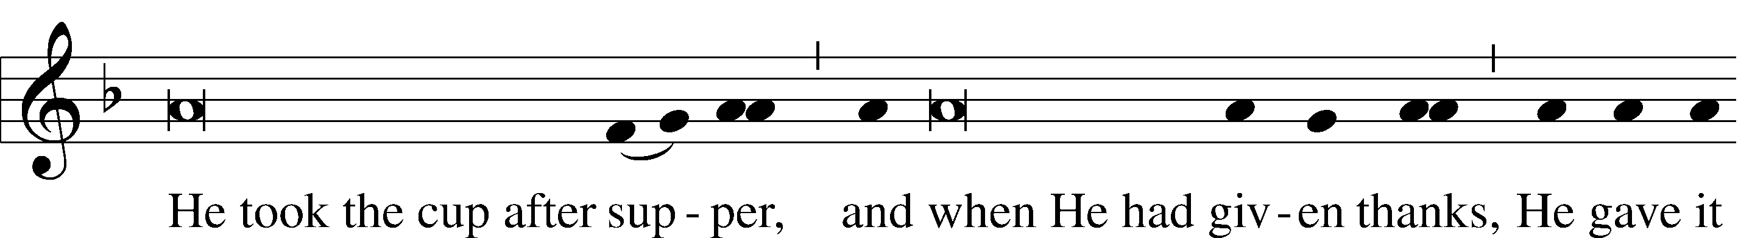
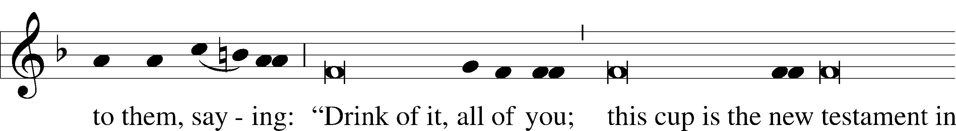
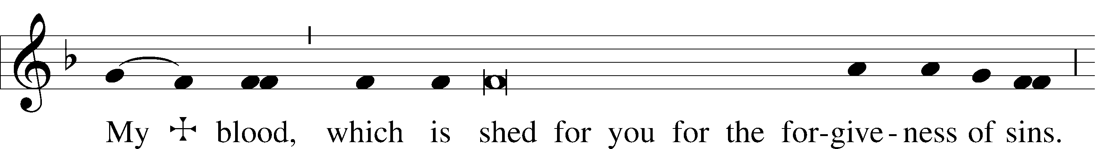
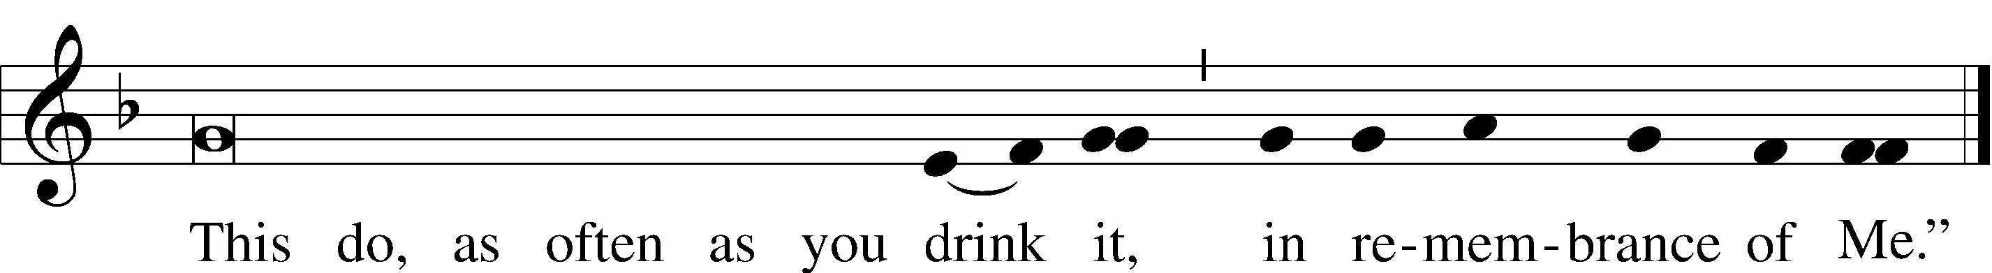

Pax Domini LSB 197
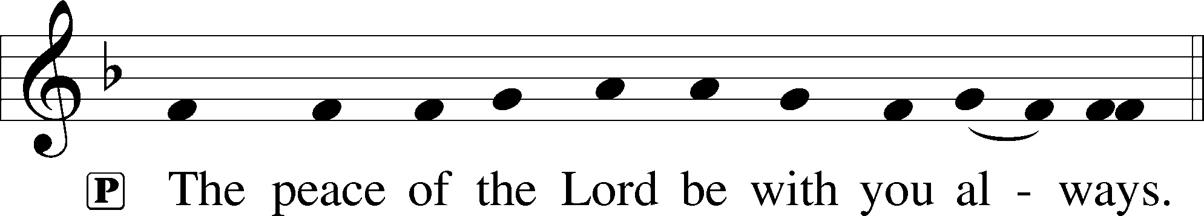

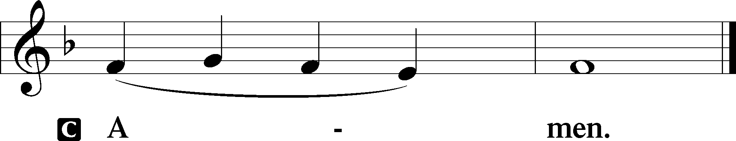

Agnus Dei LSB 198
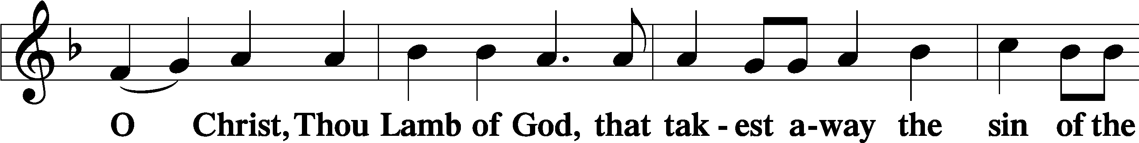
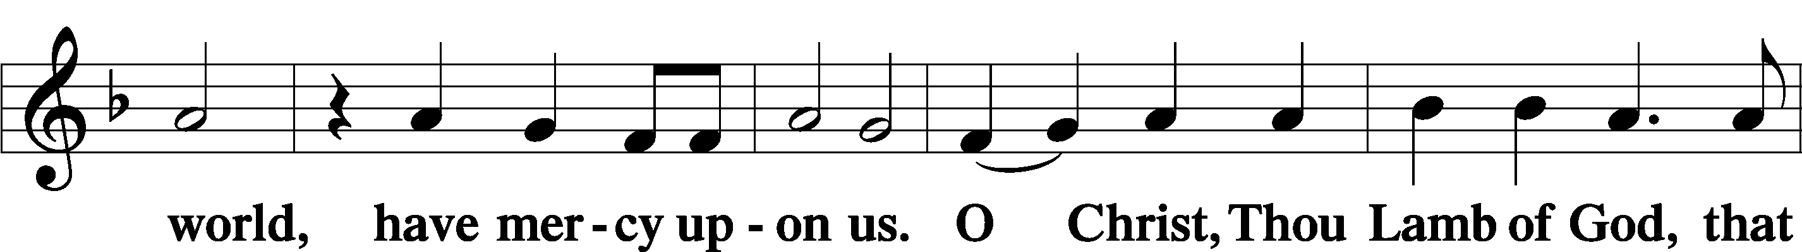
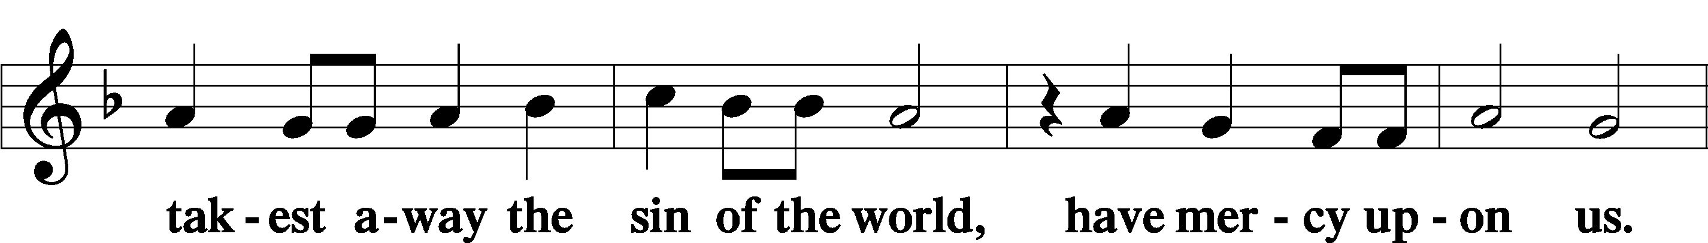
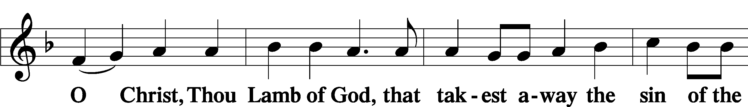
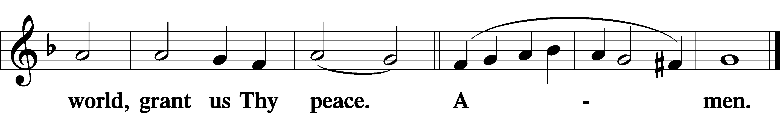

Sit
Distribution
547 The Lamb
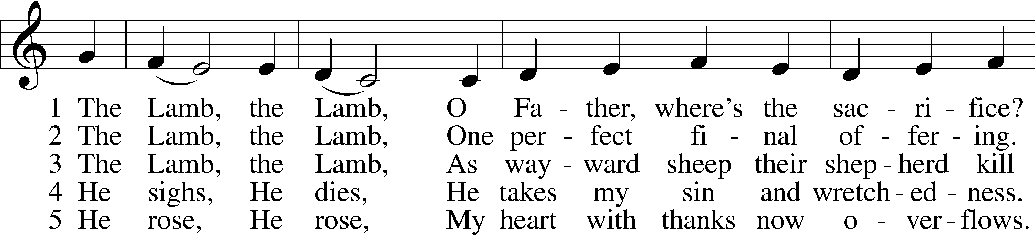
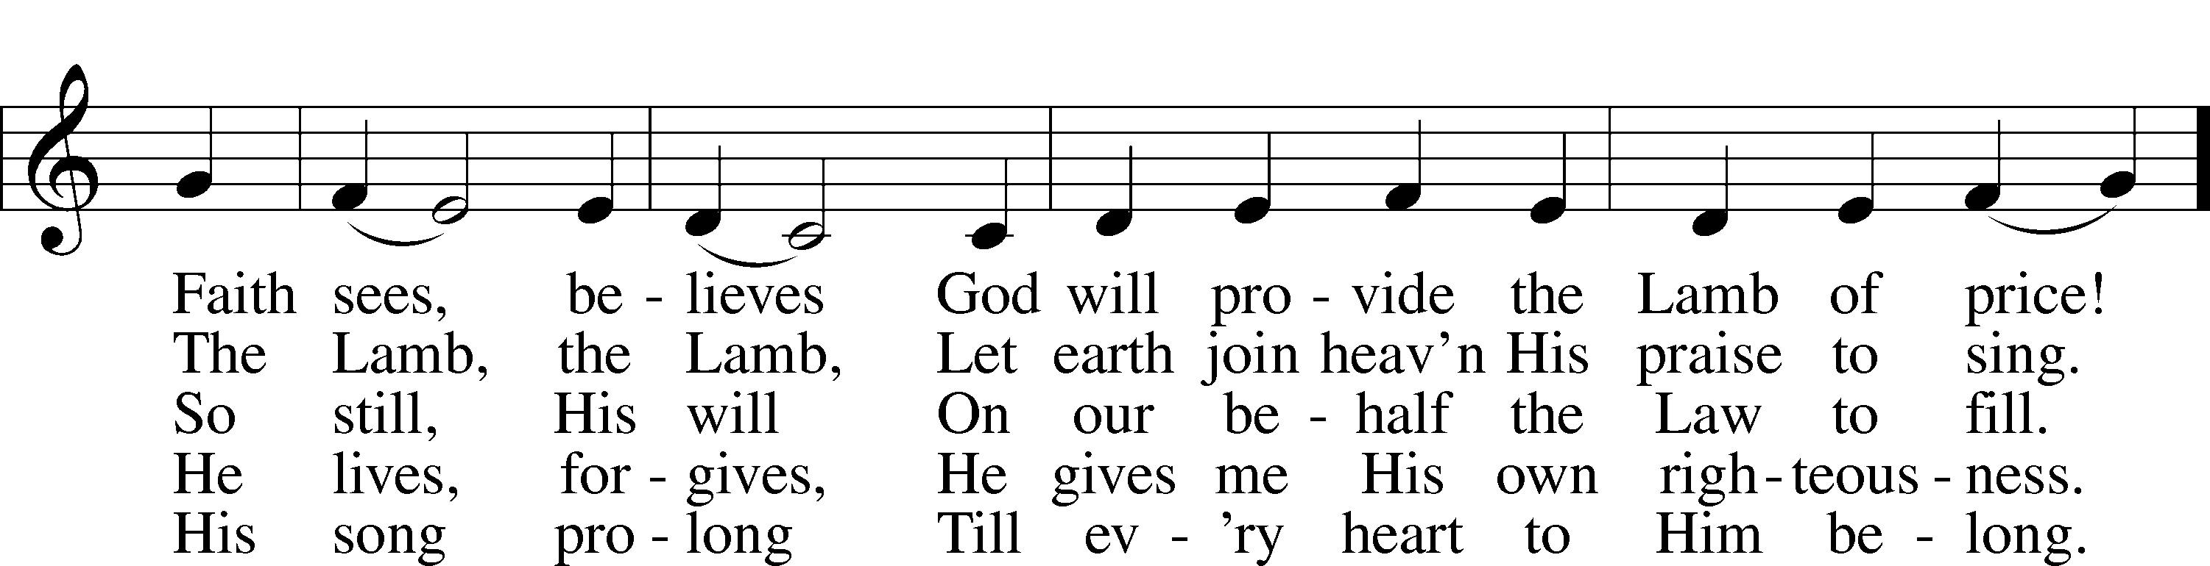
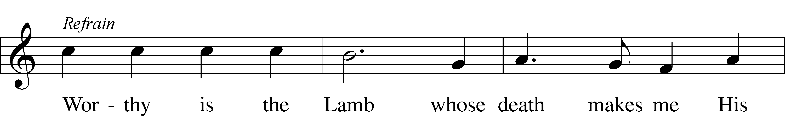
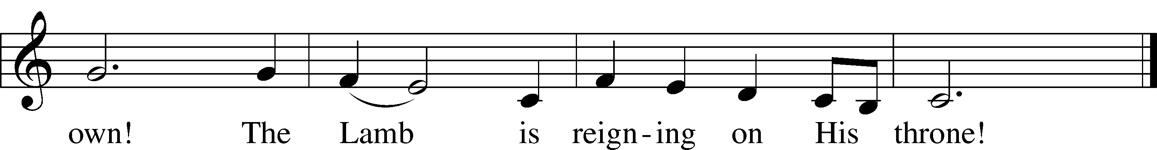
570 Just as I Am, without One Plea
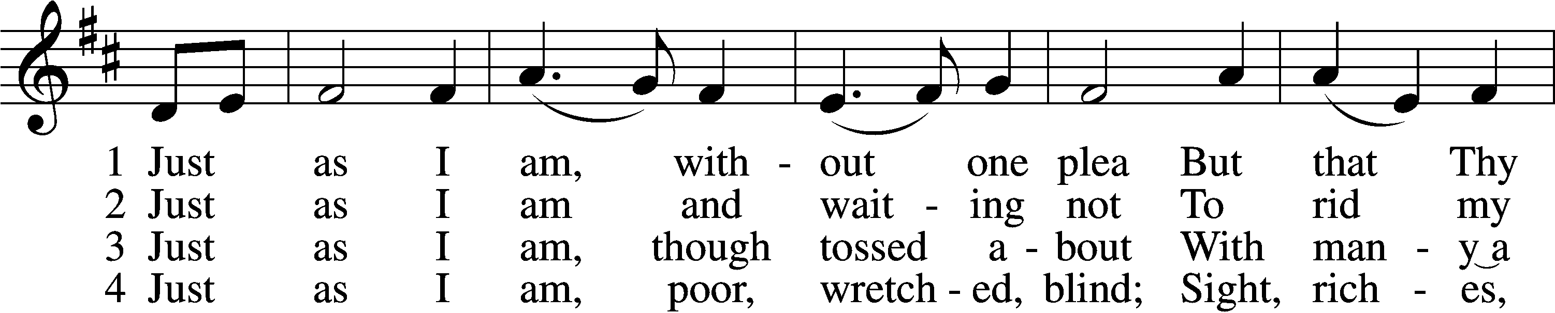
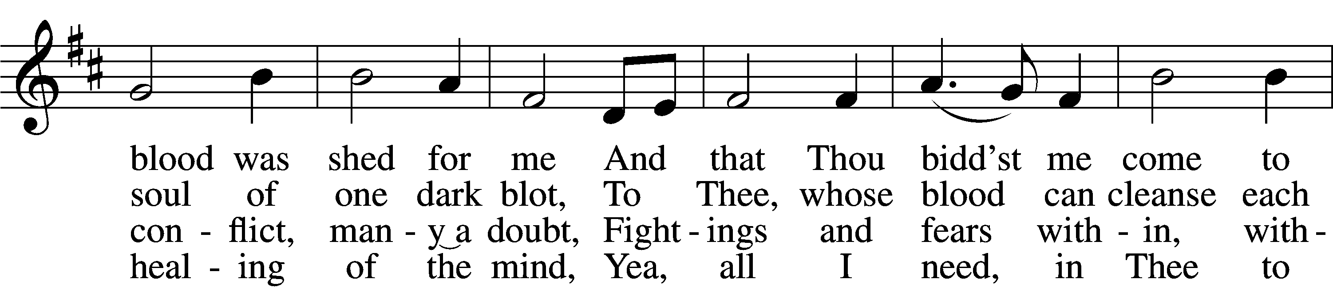
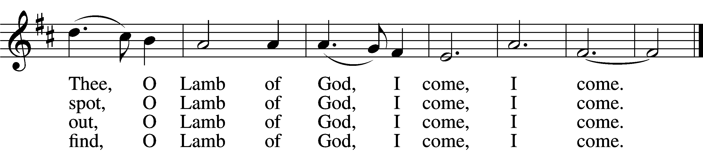

5 Just as I am, Thou wilt receive,
Wilt welcome, pardon, cleanse, relieve;
Because Thy promise I believe,
O Lamb of God, I come, I come.

6 Just as I am; Thy love unknown
Has broken ev’ry barrier down;
Now to be Thine, yea, Thine alone,
O Lamb of God, I come, I come.
Text: Charlotte Elliott, 1789–1871
Tune: William B. Bradbury, 1816–68
Text and tune: Public domain

606 I Lay My Sins on Jesus
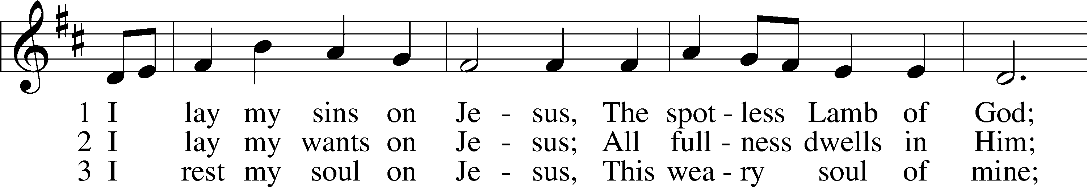
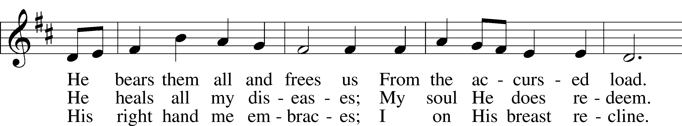
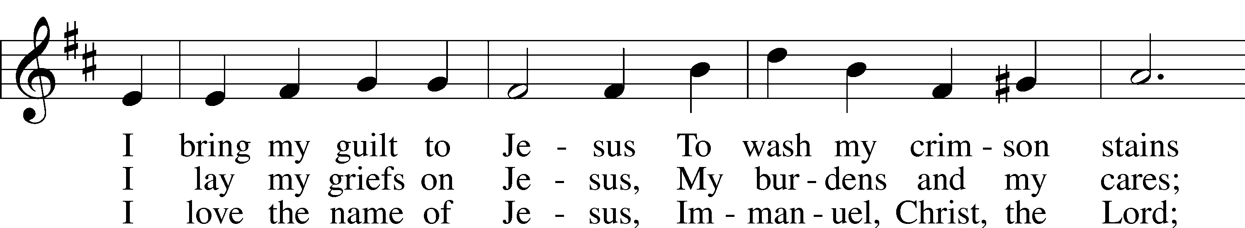
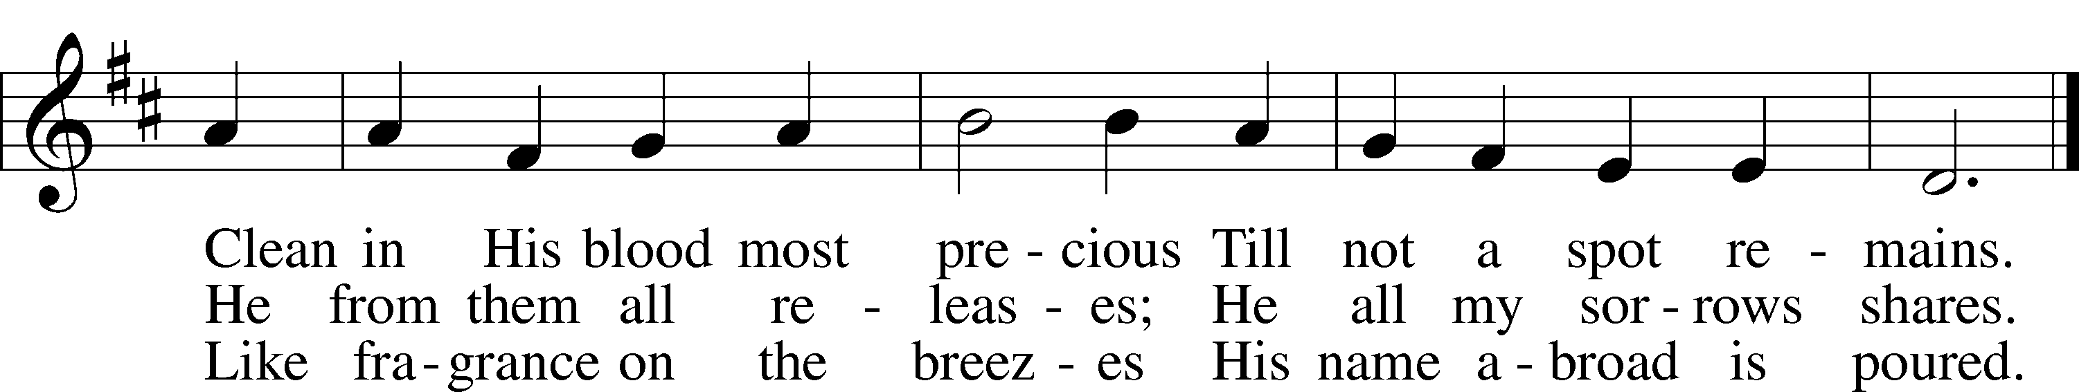
Text: Horatius Bonar, 1808–89
Tune: Neu-vermehrtes . . . Gesangbuch, 1693, 3rd ed., Meiningen
Text and tune: Public domain

Stand

Nunc Dimittis LSB 199
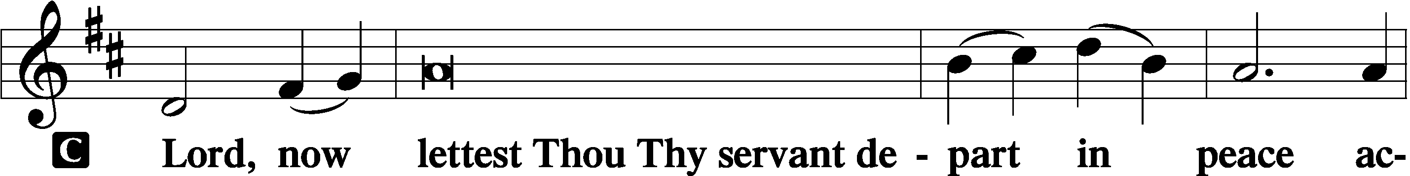

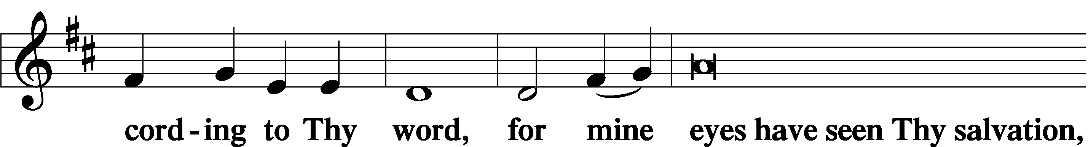

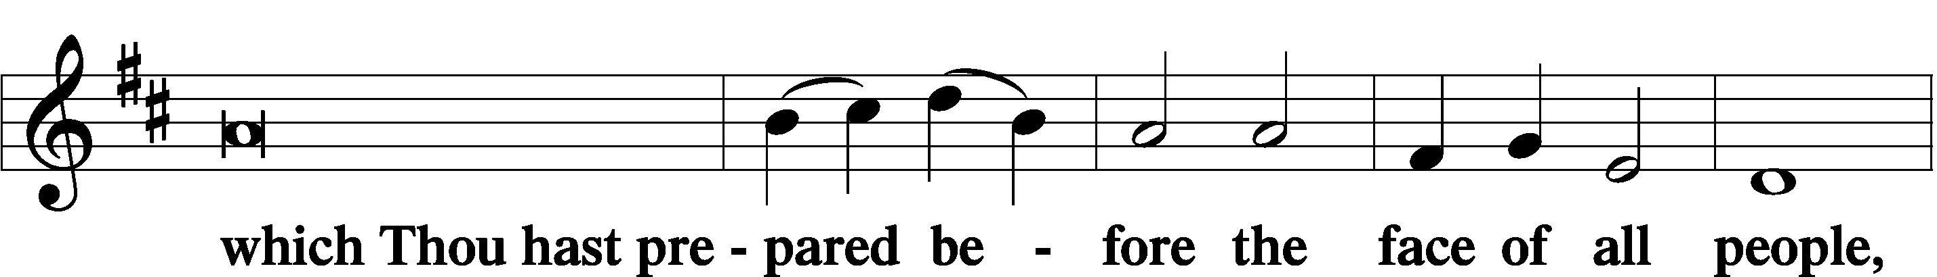

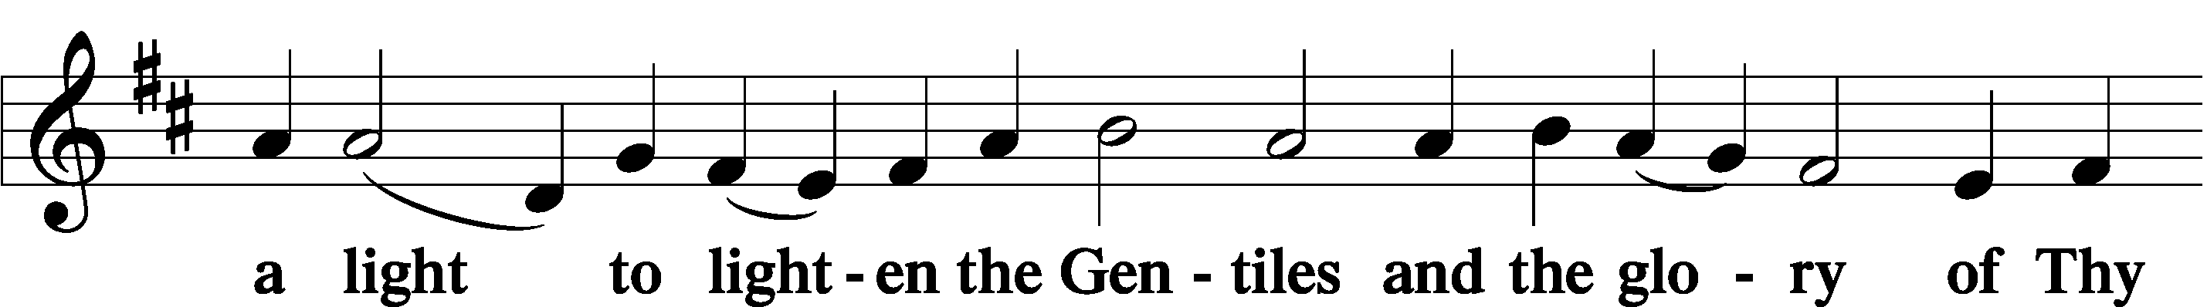

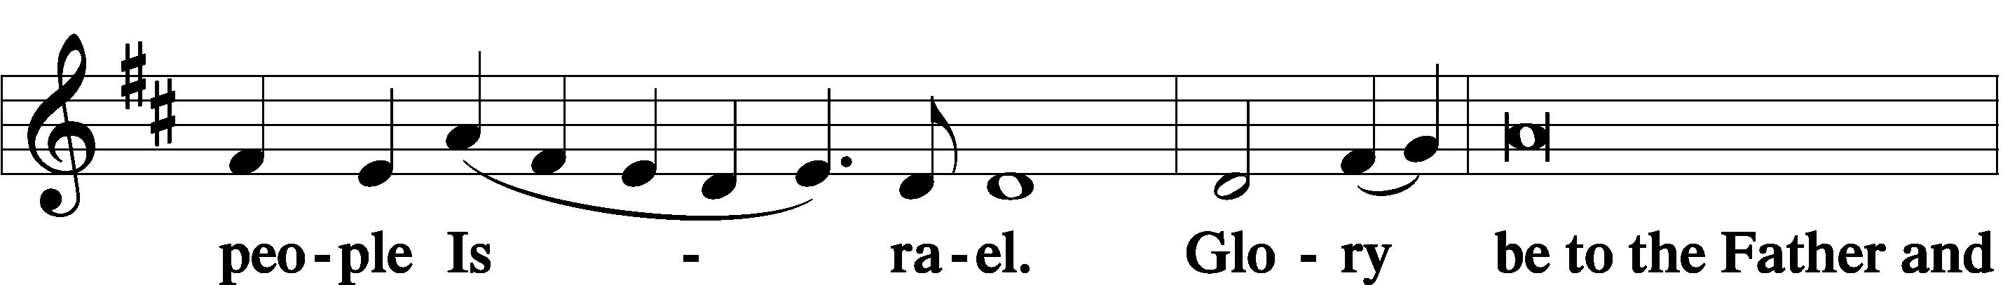

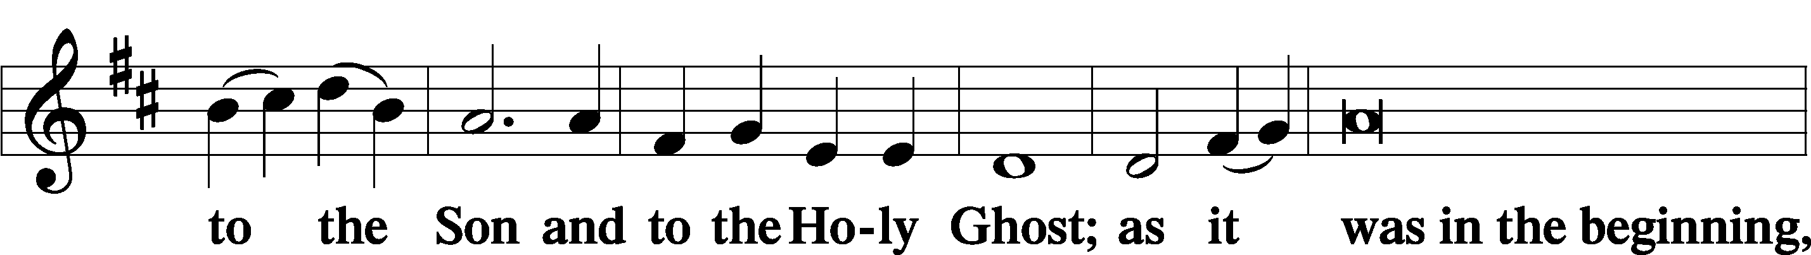

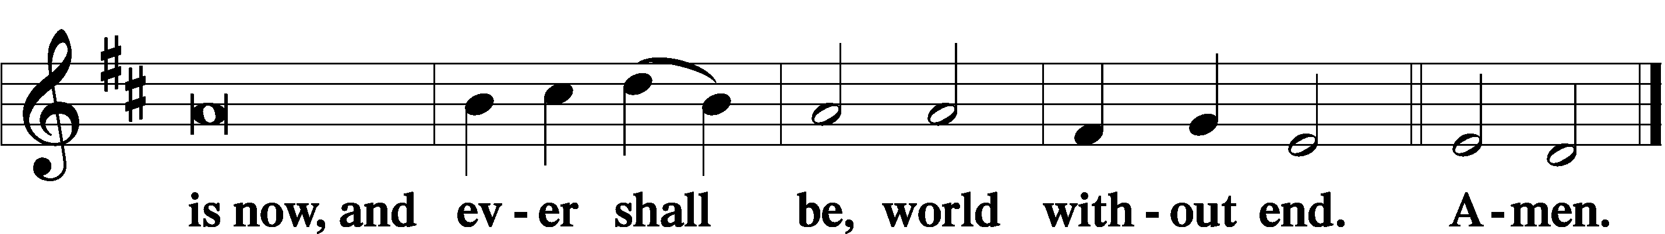

Thanksgiving LSB 200
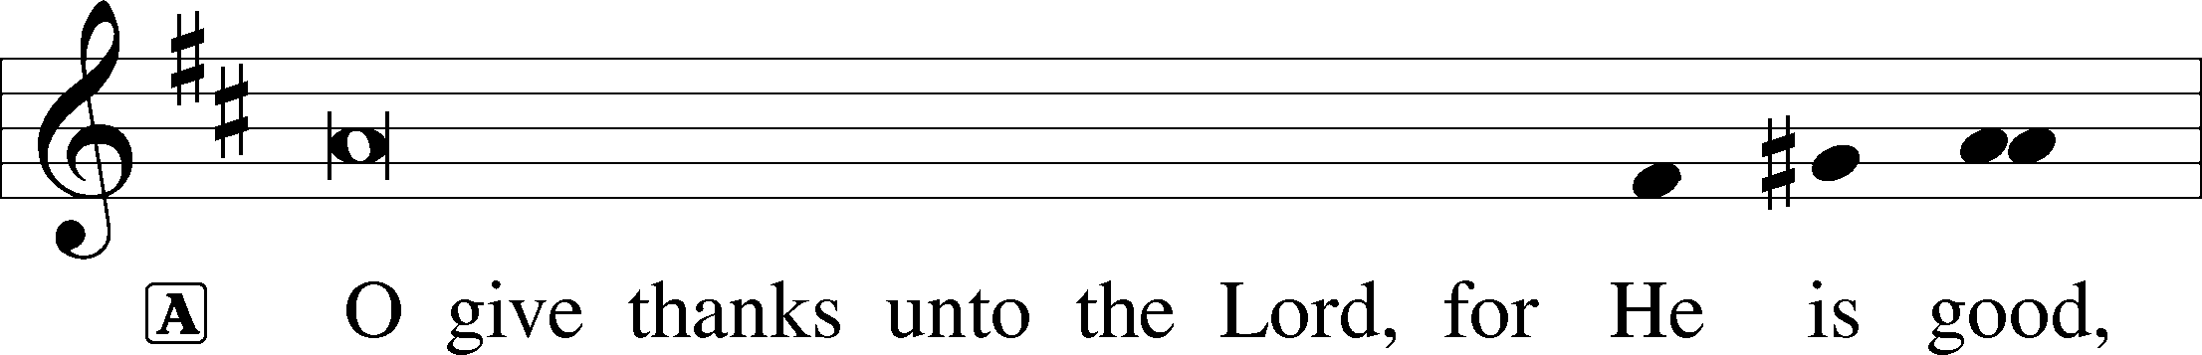

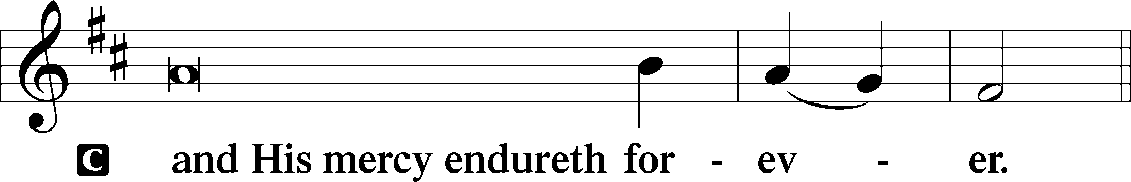

Post-Communion Collect
A Let us pray.
We give thanks to You, almighty God, that You have refreshed us through this salutary gift, and we implore You that of Your mercy You would strengthen us through the same in faith toward You and in fervent love toward one another; through Jesus Christ, Your Son, our Lord, who lives and reigns with You and the Holy Spirit, one God, now and forever.

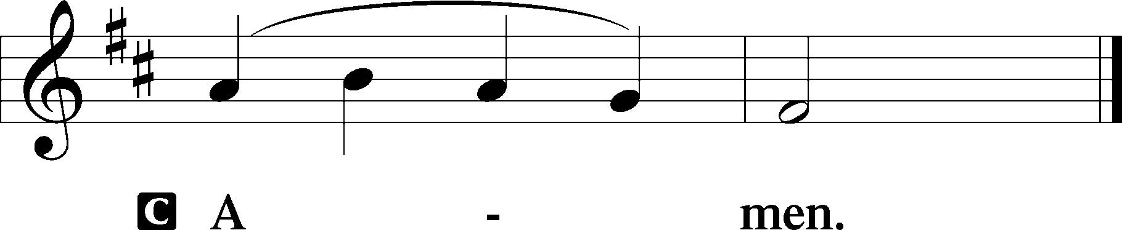

Salutation LSB 201
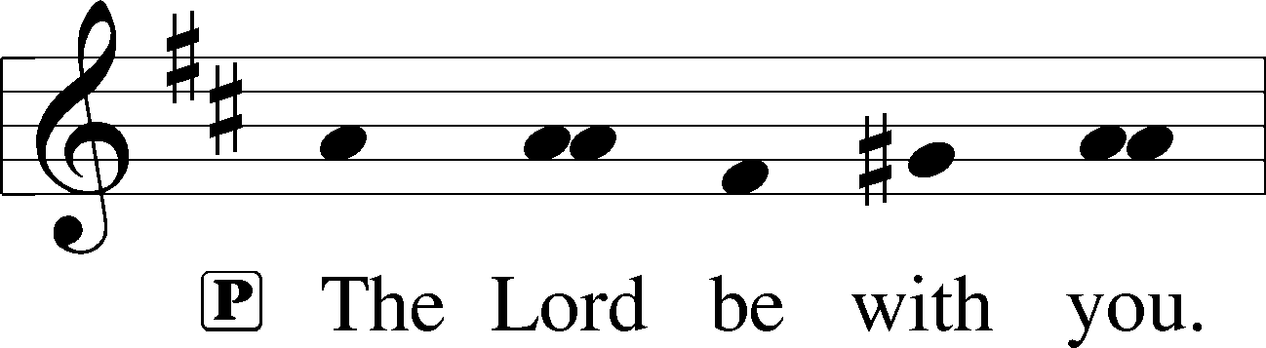

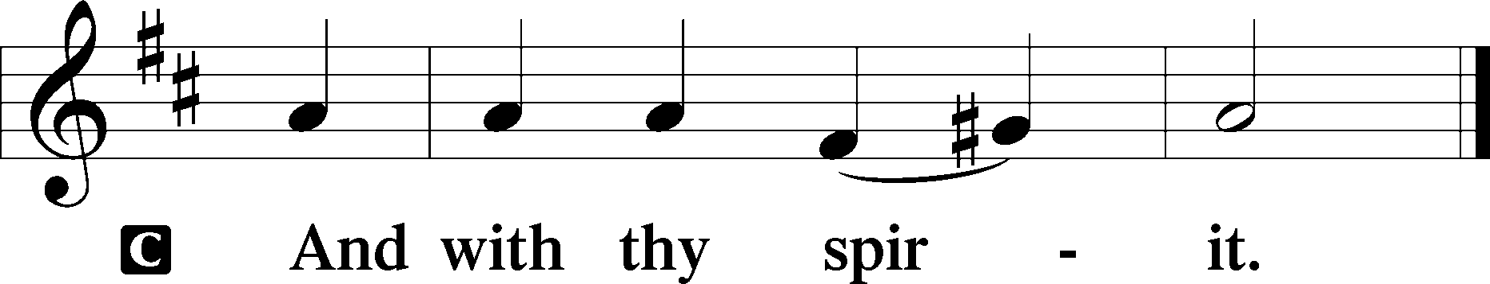

Benedicamus LSB 202
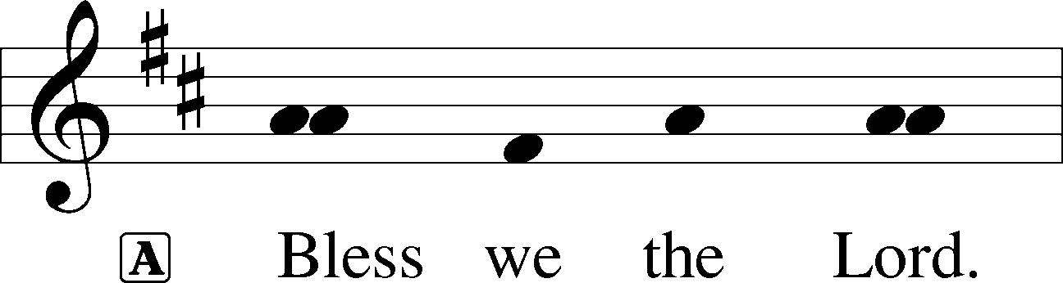

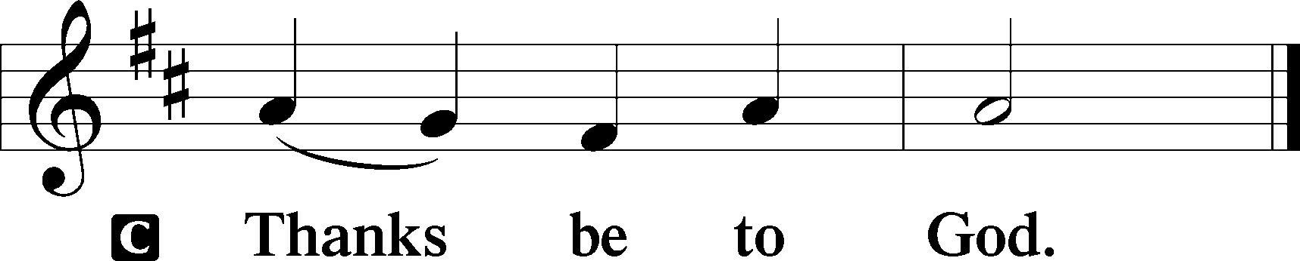

Benediction LSB 202
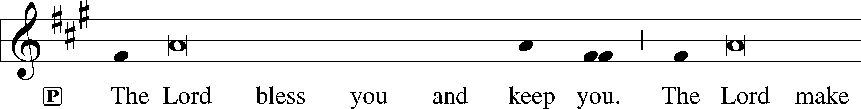
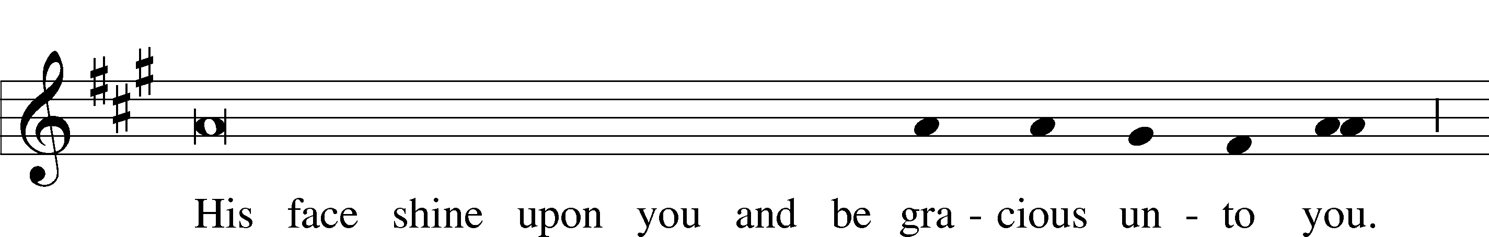
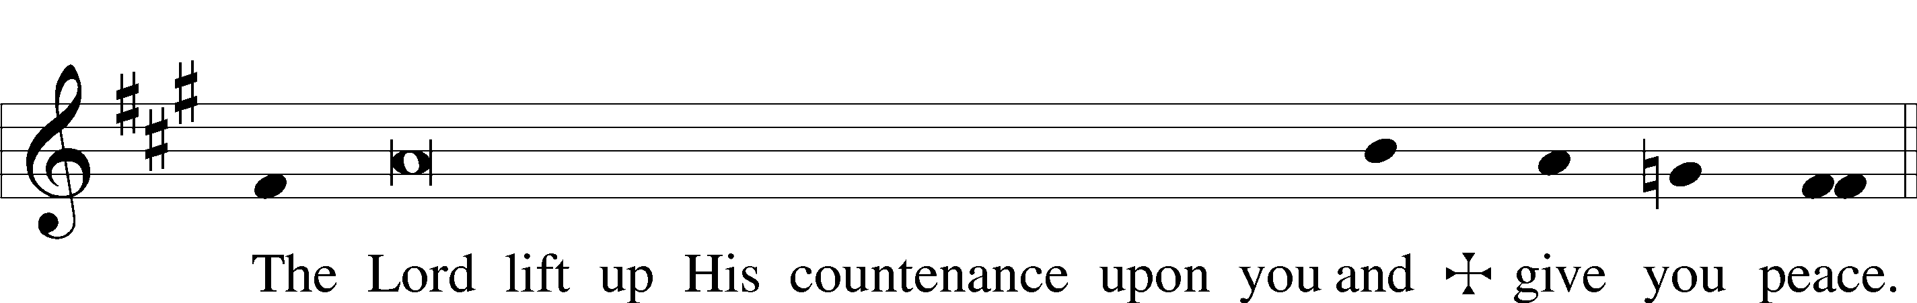

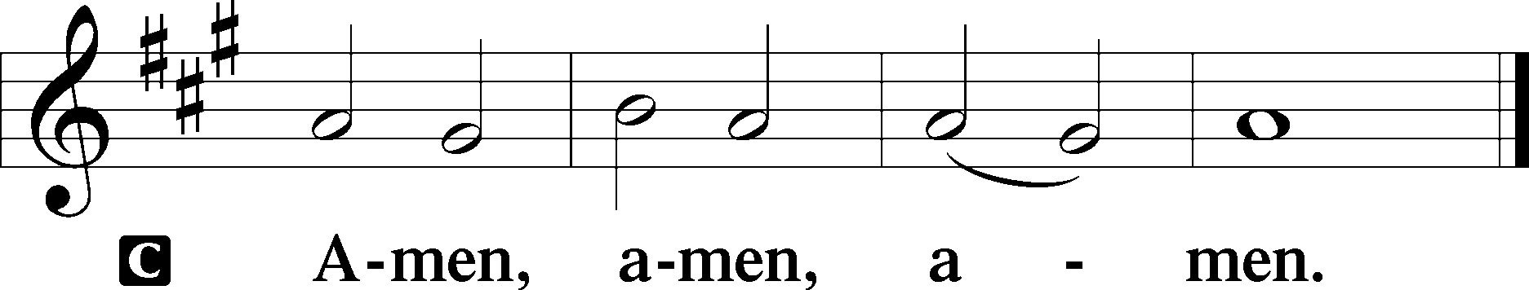

861 Christ Be My Leader
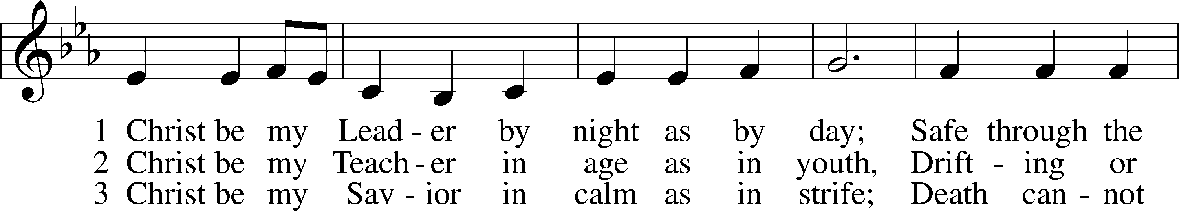
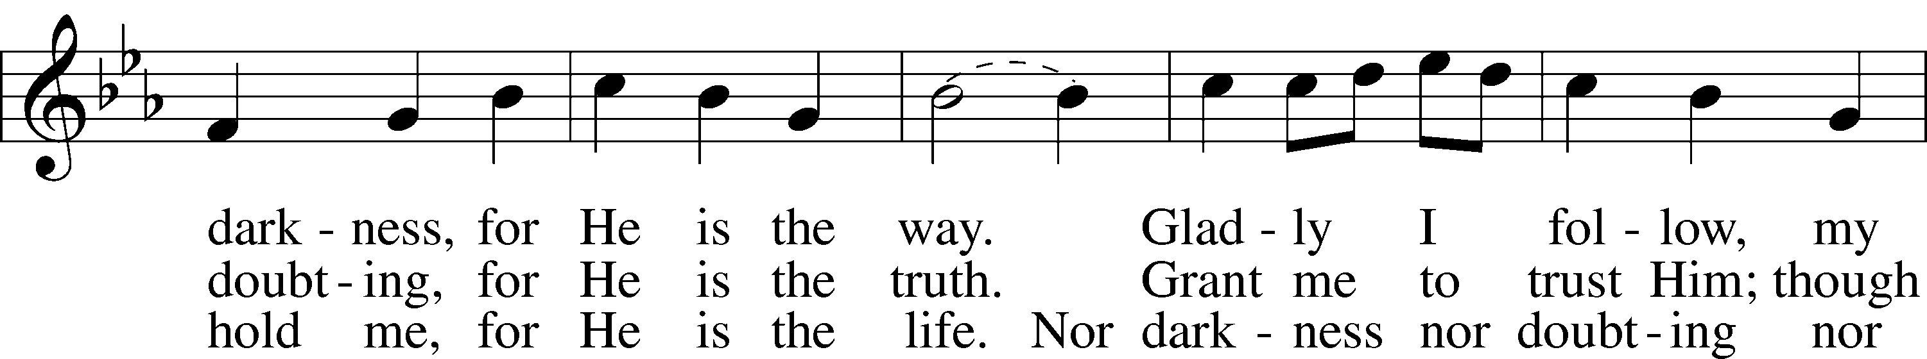
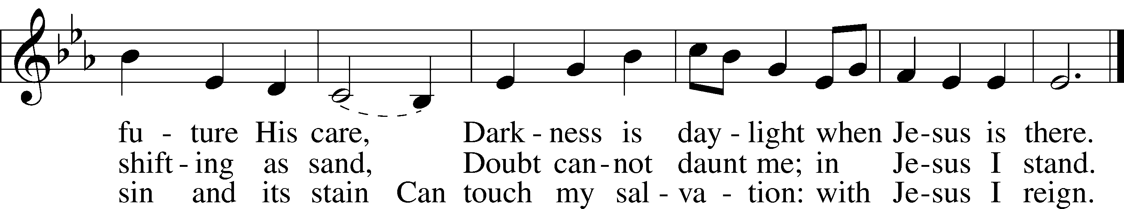
Text: Timothy Dudley-Smith, 1926
Tune: Irish
Text: © 1964, renewed 1992 Hope Publishing Co. Used by permission: LSB Hymn License no. 110002831
Tune: Public domain

Acknowledgments
Unless otherwise indicated, Scripture quotations are from the ESV® Bible (The Holy Bible, English Standard Version®), copyright © 2001 by Crossway, a publishing ministry of Good News Publishers. Used by permission. All rights reserved.
Created by Lutheran Service Builder © 2024 Concordia Publishing House.

