Third Sunday after Epiphany
Divine Service 1
January 20 & 21, 2024
St. Paul Lutheran Church

Confession and Absolution

825 Rise, Shine, You People
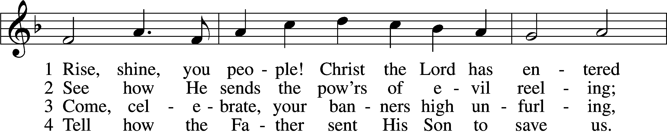
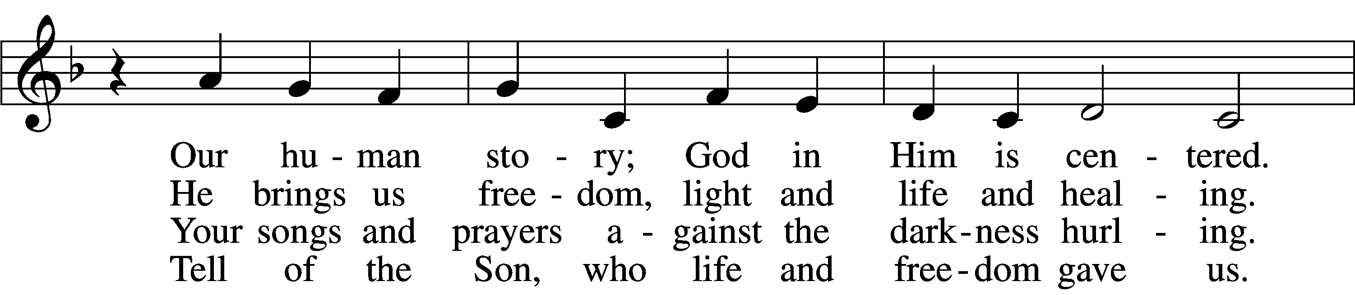
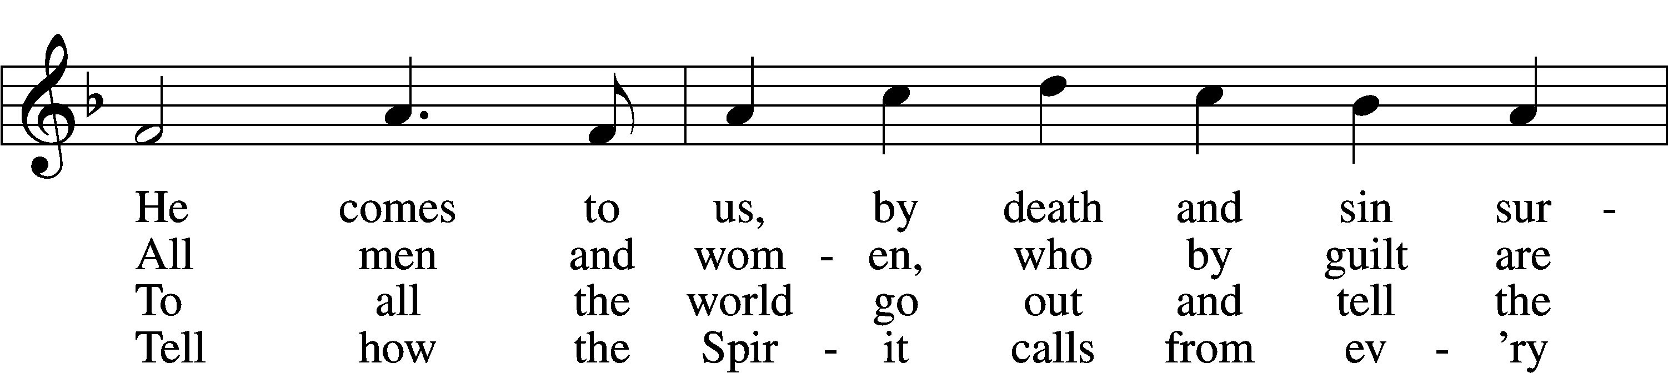
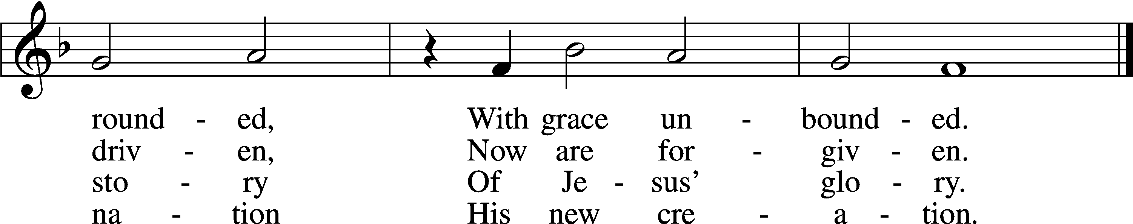
Text: Ronald A. Klug, 1939, alt.
Tune: Dale Wood, 1934–2003
Text and tune: © 1974 Augsburg Publishing House, admin. Augsburg Fortress. Used by permission: LSB Hymn License no. 110002831

Stand

The sign of the cross may be made by all in remembrance of their Baptism.

Invocation
P In the name of the Father and of the T Son and of the Holy Spirit.
C Amen.

Exhortation LSB 151
P If we say we have no sin, we deceive ourselves, and the truth is not in us.
C But if we confess our sins, God, who is faithful and just, will forgive our sins and cleanse us from all unrighteousness.

Kneel/Stand

Silence for reflection on God’s Word and for self-examination.

Confession of Sins LSB 151
P Let us then confess our sins to God our Father.
C Most merciful God, we confess that we are by nature sinful and unclean. We have sinned against You in thought, word, and deed, by what we have done and by what we have left undone. We have not loved You with our whole heart; we have not loved our neighbors as ourselves. We justly deserve Your present and eternal punishment. For the sake of Your Son, Jesus Christ, have mercy on us. Forgive us, renew us, and lead us, so that we may delight in Your will and walk in Your ways to the glory of Your holy name. Amen.

Absolution LSB 151
P Almighty God in His mercy has given His Son to die for you and for His sake forgives you all your sins. As a called and ordained servant of Christ, and by His authority, I therefore forgive you all your sins in the name of the Father and of the T Son and of the Holy Spirit.
C Amen.

Stand

Service of the Word

PSALM Psalm 62
1For God alone my soul waits in silence;
from him comes my salvation.
2He only is my rock and my salvation,
my fortress;
I shall not be greatly shaken.
3How long will all of you attack a man
to batter him,
like a leaning wall, a tottering fence?
4They only plan to thrust him down from his high position.
They take pleasure in falsehood.
They bless with their mouths,
but inwardly they curse.
5For God alone, O my soul, wait in silence,
for my hope is from him.
6He only is my rock and my salvation,
my fortress;
I shall not be shaken.
7On God rests my salvation and my glory;
my mighty rock, my refuge is God.
8Trust in him at all times, O people;
pour out your heart before him;
God is a refuge for us.
9Those of low estate are but a breath;
those of high estate are a delusion;
in the balances they go up;
they are together lighter than a breath.
10Put no trust in extortion;
set no vain hopes on robbery;
if riches increase, set not your heart on them.
11Once God has spoken;
twice have I heard this:
that power belongs to God,
12and that to you, O Lord, belongs steadfast love.
For you will render to a man
according to his work.

Kyrie LSB 152
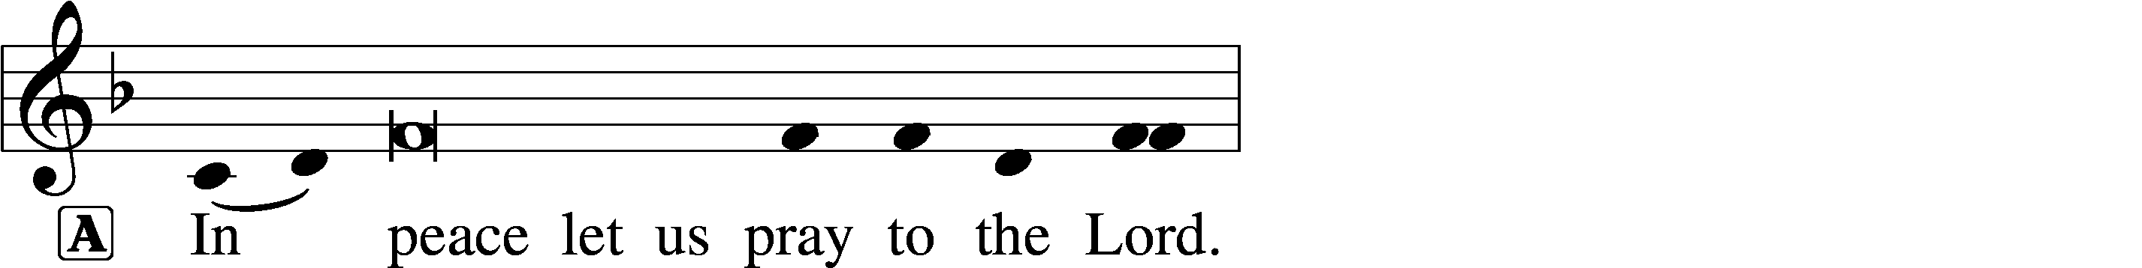
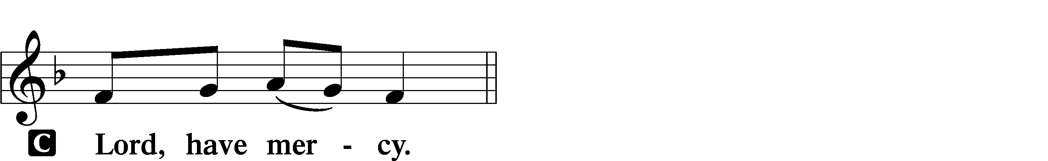

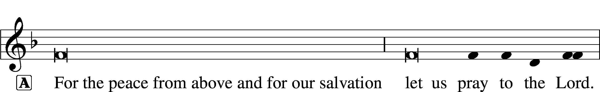
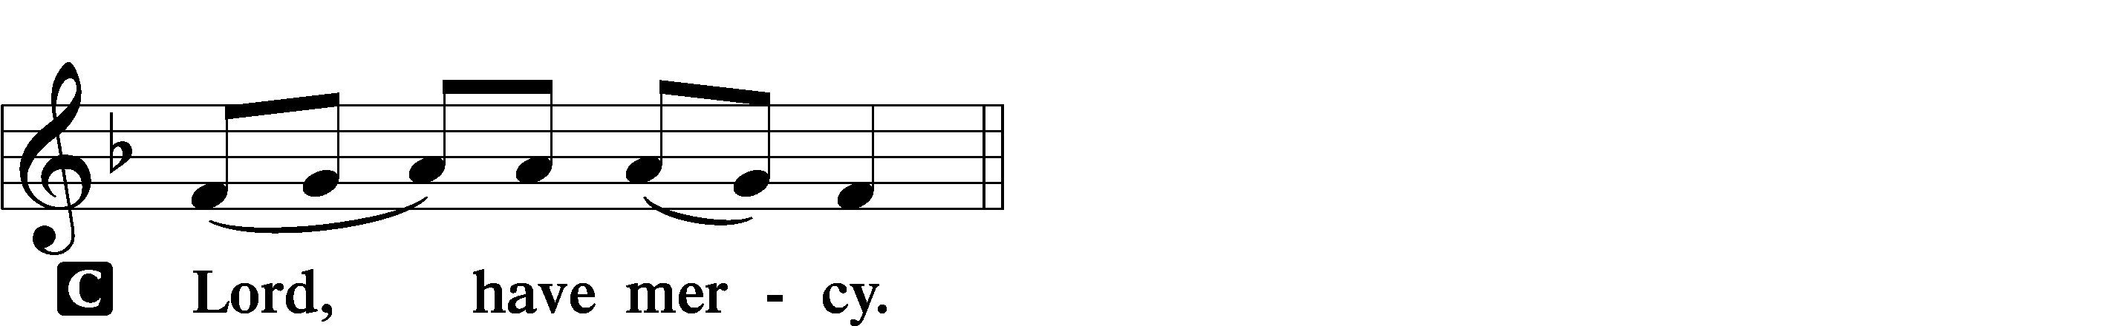

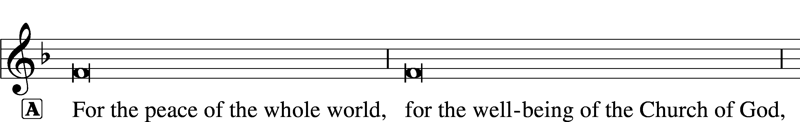
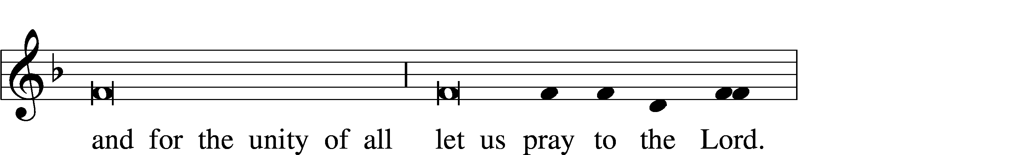
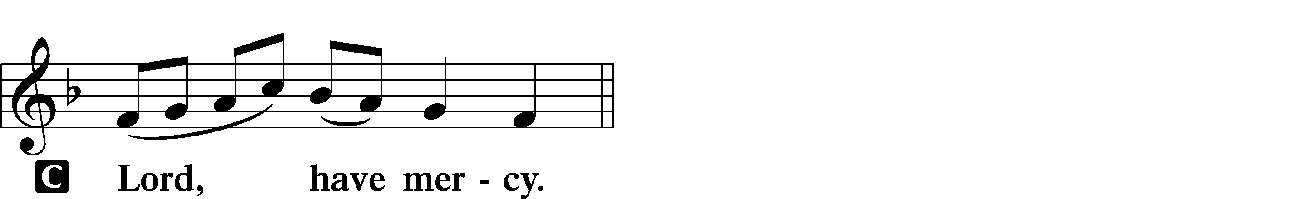

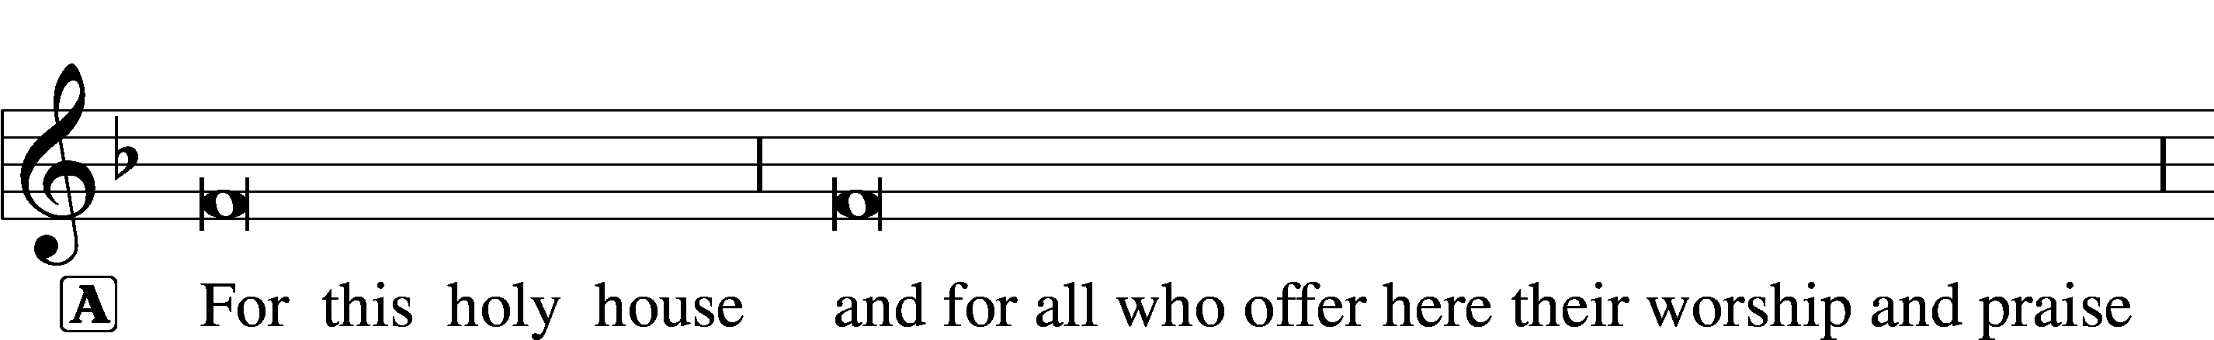
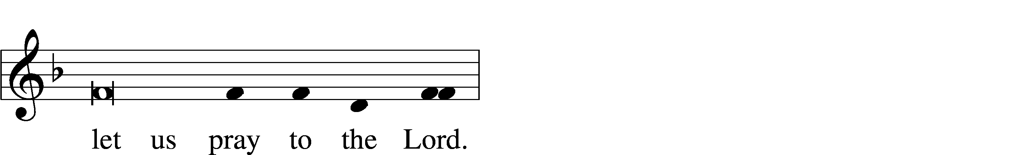
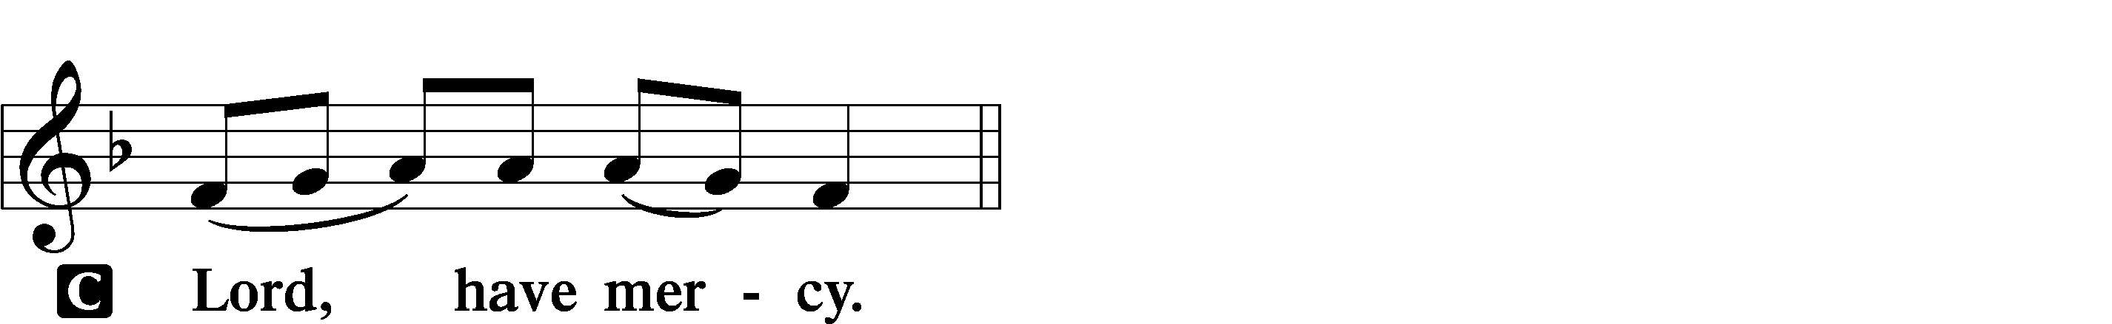

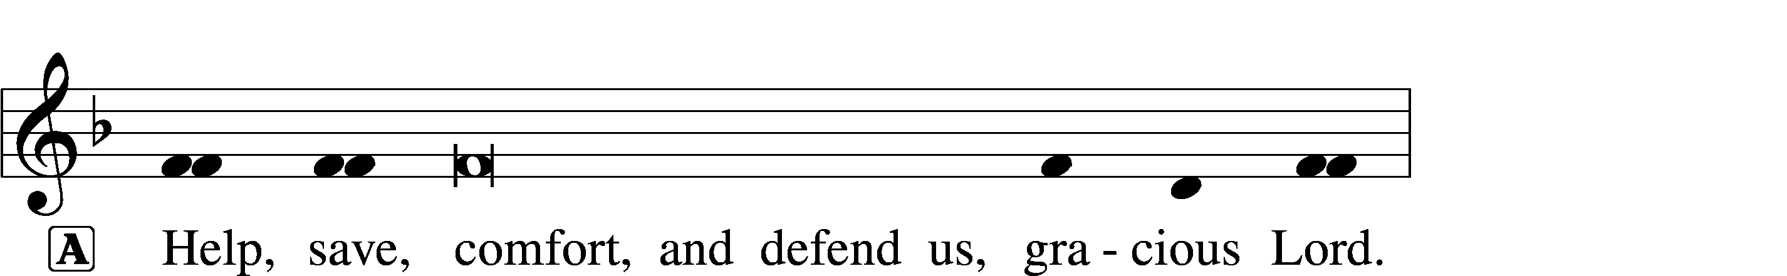
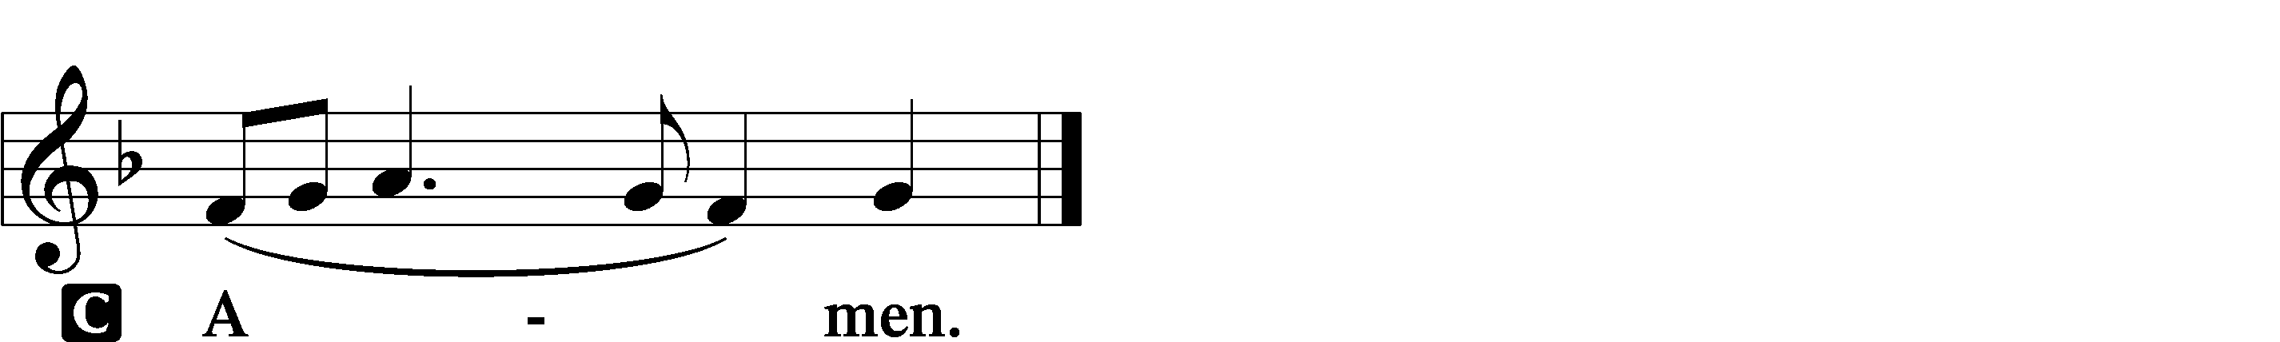

Salutation and Collect of the Day
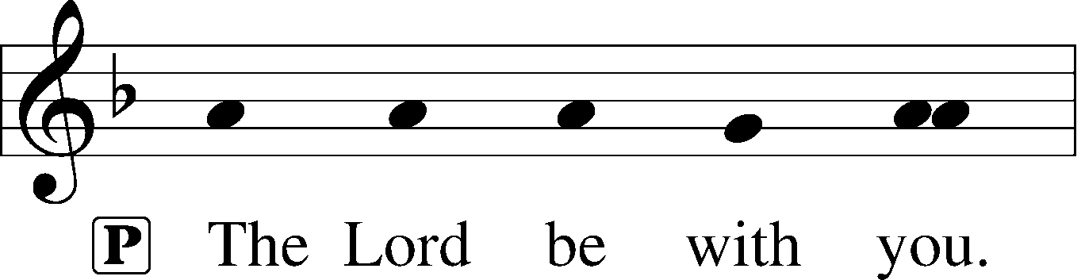
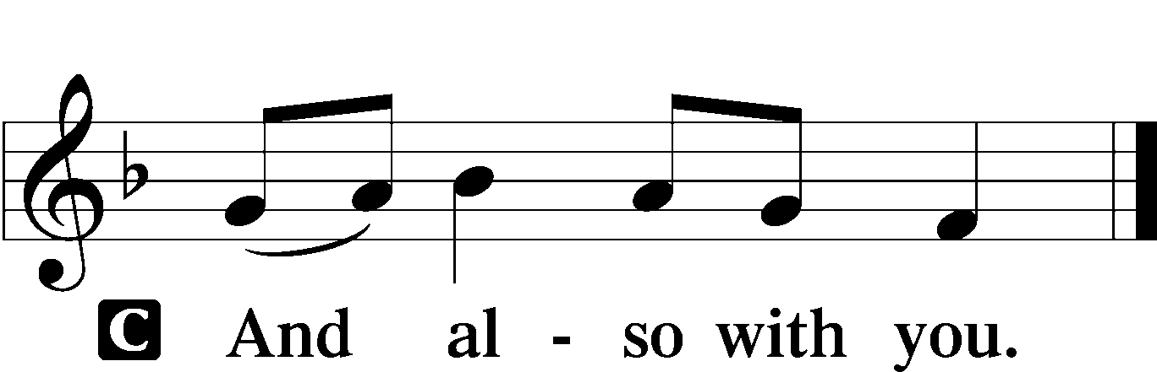

P Let us pray.
Almighty and everlasting God, mercifully look upon our infirmities and stretch forth the hand of Your majesty to heal and defend us; through Jesus Christ, Your Son, our Lord, who lives and reigns with You and the Holy Spirit, one God, now and forever.

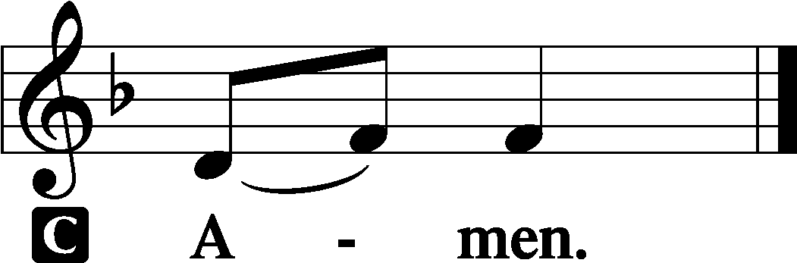

Sit

Old Testament Reading Jonah 3:1–5, 10
1Then the word of the Lord came to Jonah the second time, saying, 2“Arise, go to Nineveh, that great city, and call out against it the message that I tell you.” 3So Jonah arose and went to Nineveh, according to the word of the Lord. Now Nineveh was an exceedingly great city, three days’ journey in breadth. 4Jonah began to go into the city, going a day’s journey. And he called out, “Yet forty days, and Nineveh shall be overthrown!” 5And the people of Nineveh believed God. They called for a fast and put on sackcloth, from the greatest of them to the least of them. . . .
10When God saw what they did, how they turned from their evil way, God relented of the disaster that he had said he would do to them, and he did not do it.

A This is the Word of the Lord.
C Thanks be to God.

Epistle 1 Corinthians 7:29–35
29This is what I mean, brothers: the appointed time has grown very short. From now on, let those who have wives live as though they had none, 30and those who mourn as though they were not mourning, and those who rejoice as though they were not rejoicing, and those who buy as though they had no goods, 31and those who deal with the world as though they had no dealings with it. For the present form of this world is passing away.
32I want you to be free from anxieties. The unmarried man is anxious about the things of the Lord, how to please the Lord. 33But the married man is anxious about worldly things, how to please his wife, 34and his interests are divided. And the unmarried or betrothed woman is anxious about the things of the Lord, how to be holy in body and spirit. But the married woman is anxious about worldly things, how to please her husband. 35I say this for your own benefit, not to lay any restraint upon you, but to promote good order and to secure your undivided devotion to the Lord.

A This is the Word of the Lord.
C Thanks be to God.

Stand

Alleluia and Verse LSB 156
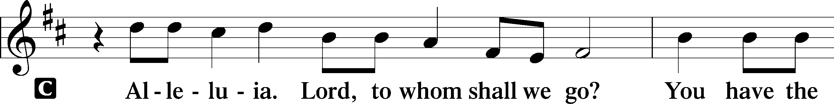
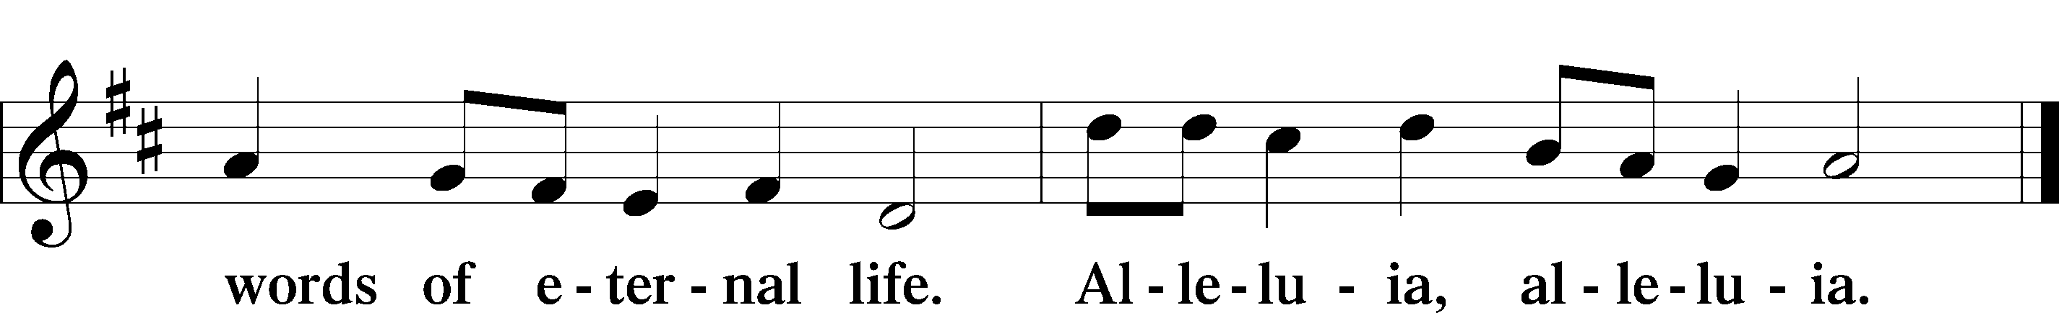

Holy Gospel Mark 1:14–20
P The Holy Gospel according to St. Mark, the first chapter.

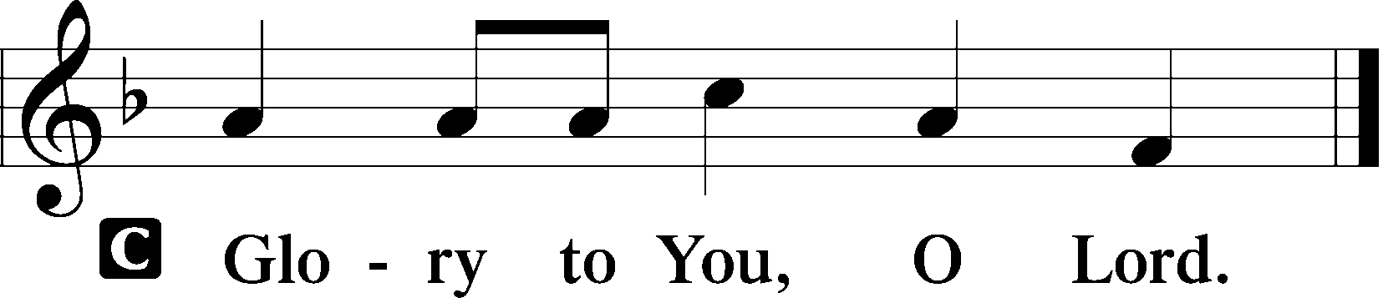

14After John was arrested, Jesus came into Galilee, proclaiming the gospel of God, 15and saying, “The time is fulfilled, and the kingdom of God is at hand; repent and believe in the gospel.”
16Passing alongside the Sea of Galilee, he saw Simon and Andrew the brother of Simon casting a net into the sea, for they were fishermen. 17And Jesus said to them, “Follow me, and I will make you become fishers of men.” 18And immediately they left their nets and followed him. 19And going on a little farther, he saw James the son of Zebedee and John his brother, who were in their boat mending the nets. 20And immediately he called them, and they left their father Zebedee in the boat with the hired servants and followed him.

P This is the Gospel of the Lord.

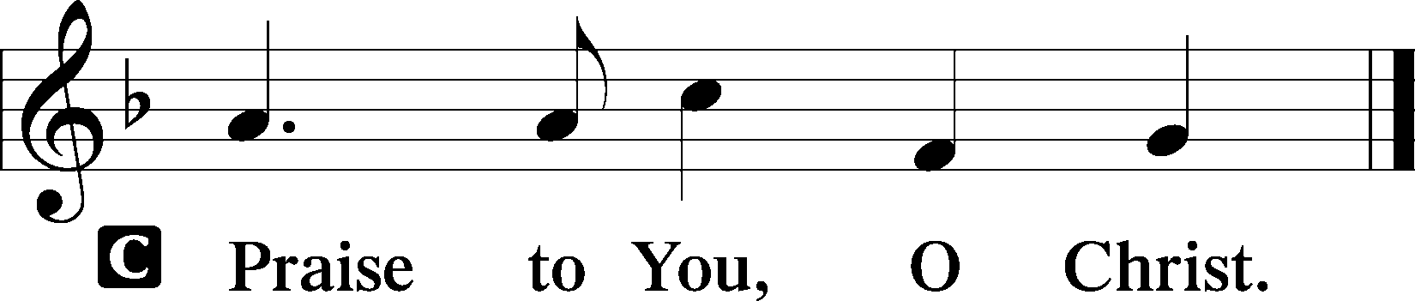

Sit

593 See This Wonder in the Making
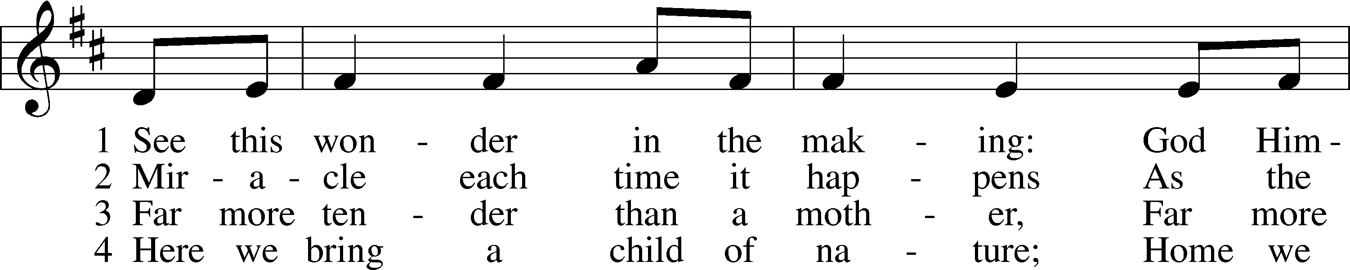
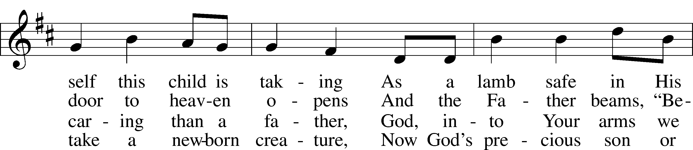
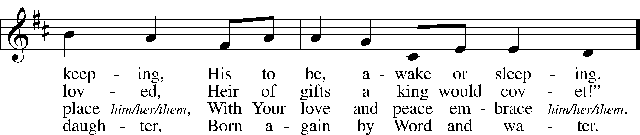
Text: Jaroslav J. Vajda, 1919–2008
Tune: Lofsånger och andeliga wisor, 1873, Sweden
Text: © 1984 Concordia Publishing House. Used by permission: LSB Hymn License no. 110002831
Tune: Public domain

Rite of Holy Baptism for Delia Bell pg. 268
Children’s Message
Sermon

Stand

Prayer of the Church
P In peace, let us pray to the Lord:
C Lord, have mercy.

P For faithfulness and urgency in the Church, that as this world passes away, we may be bold to proclaim the kingdom of God come near in Christ Jesus, who does not desire the death of a sinner but that all would repent and believe the Gospel, let us pray to the Lord:
C Lord, have mercy.

P For the Church’s mission, that as Christ called Peter and Andrew, James and John to follow Him and made them fishers of men, He would send faithful preachers also in our time; and for those who generously support the missionaries, seminaries, colleges and other institutions of our Church for the spread of the Gospel and the service of God’s people, let us pray to the Lord:
C Lord, have mercy.

P For Christians in every home, that they may have constancy and contentment in their God-given stations despite every current distress as the present form of this world passes away; for the married, that God would give them comfort and faithfulness, strengthening them also to pass on the faith to the next generation; and for the unmarried, that assured of the holiness of their place in life, they would live freed from anxiety and attend to holiness in body and spirit with undivided devotion to Christ, let us pray to the Lord:
C Lord, have mercy.

P For our nation with its rulers, that God would spare Joseph, our president; _____________, our governor; and all who serve for the good of this people; that God would call to repentance those who have forgotten Him; and that He would not let disaster befall us, but preserve us in peace and quietness, let us pray to the Lord:
C Lord, have mercy.

P For all of us, that our merciful Father would turn us from every distracting anxiety and the dealings of this world that would draw our hearts away from His blessed Gospel and its end, eternal life; for confidence in the resurrection and the peace of a clean conscience by the forgiveness of sins in Jesus’ name; and that God would graciously behold and help those for whom we pray, [____________,] let us pray to the Lord:
C Lord, have mercy.

P For all who come to the Holy Sacrament, that the Holy Spirit would work repentance and faith in us, united in a sincere confession of His divine truth at this altar, let us pray to the Lord:
C Lord, have mercy.

P Hear us, heavenly Father, for the sake of Christ Jesus, our Lord, who lives and reigns with You and the Holy Spirit, one God, now and forever.
C Amen.

Sit
Offering
Stand
Offertory LSB 159
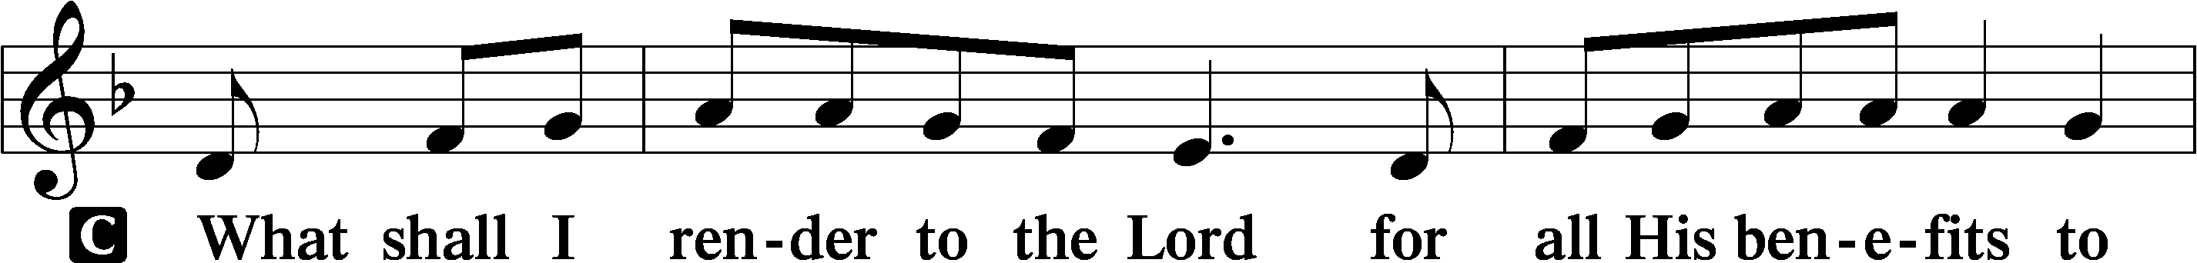
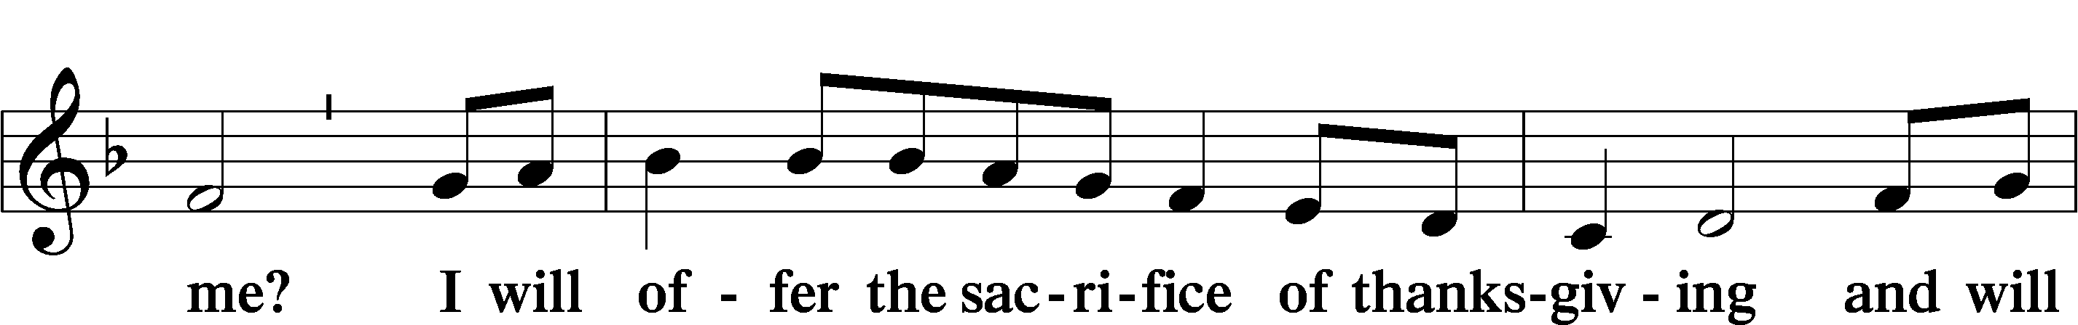
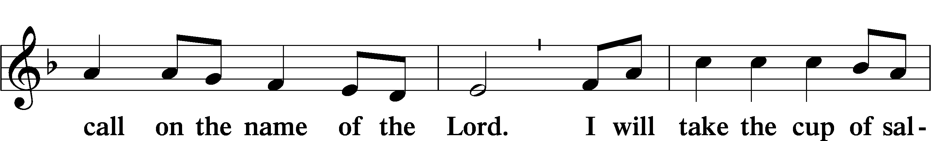
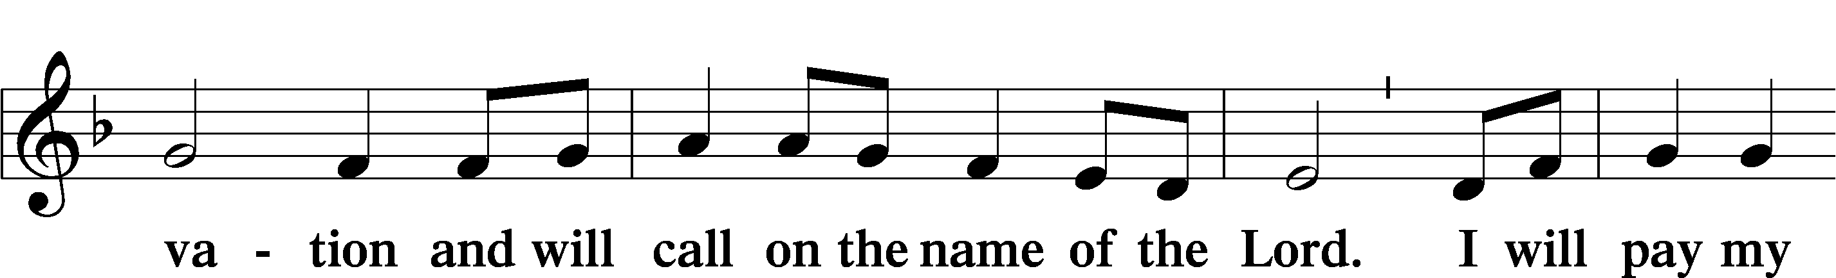
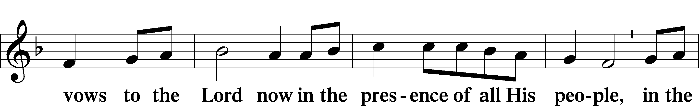
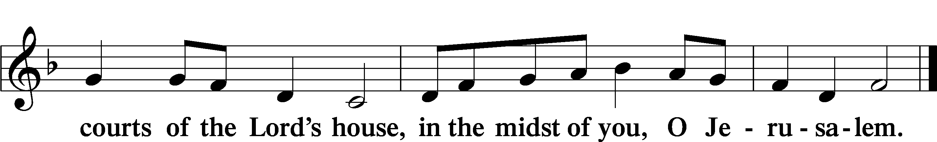

Service of the Sacrament

Preface LSB 160
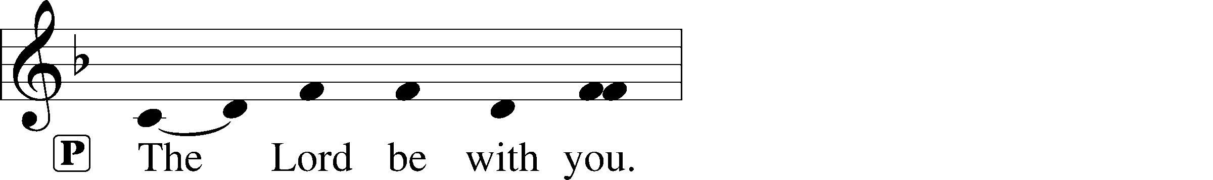
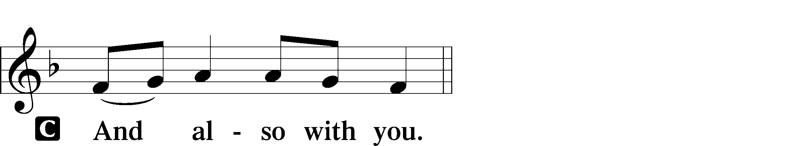
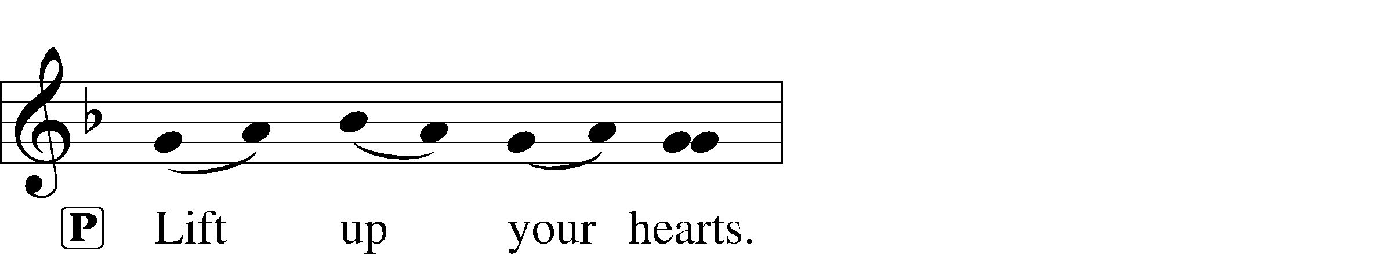
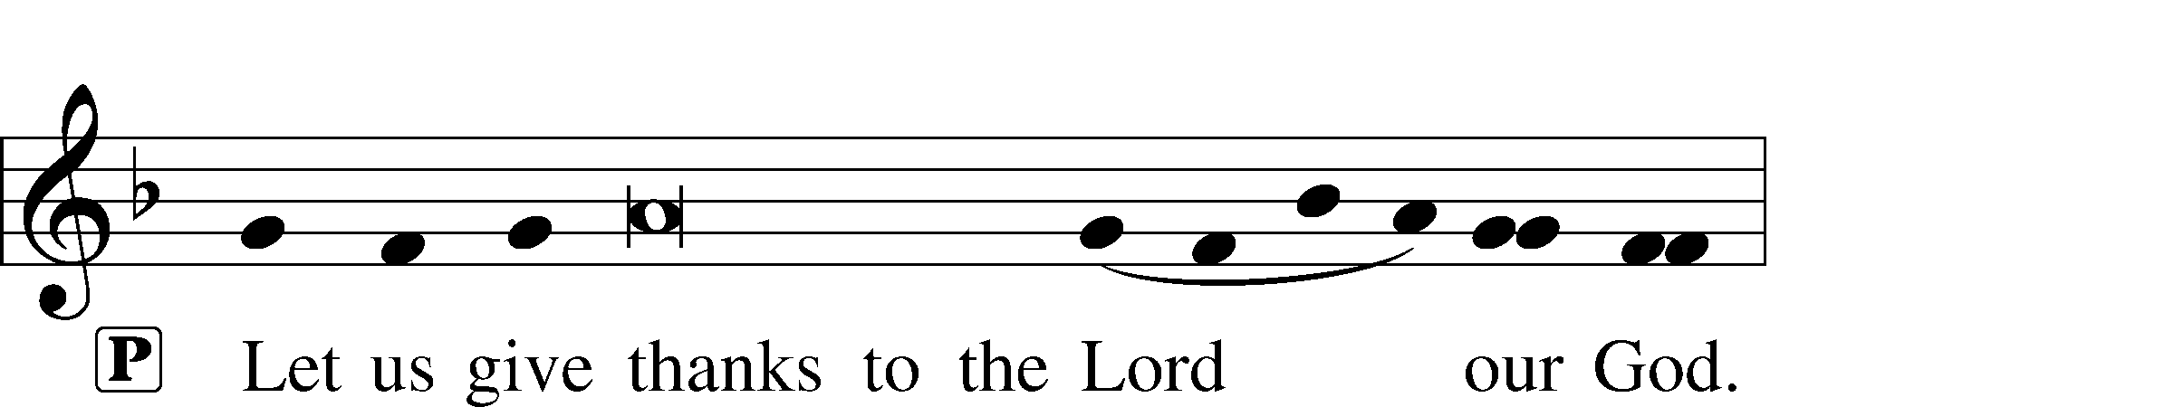
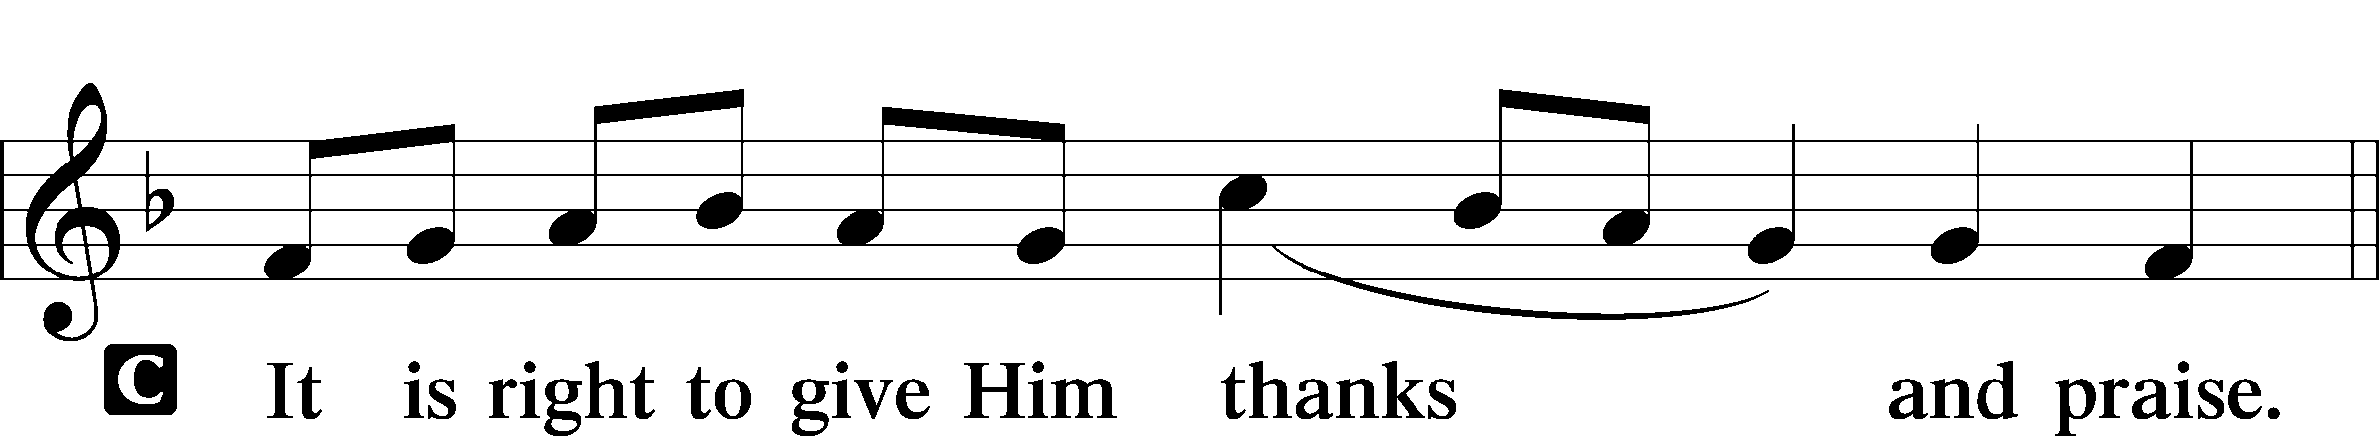

Proper Preface
P It is truly good, right, and salutary that we should at all times and in all places give thanks to You, holy Lord, almighty Father, everlasting God, through Jesus Christ, our Lord; for what had been hidden from before the foundation of the world You have made known to the nations in Your Son. In Him, being found in the substance of our mortal nature, You have manifested the fullness of Your glory. Therefore with angels and archangels and with all the company of heaven we laud and magnify Your glorious name, evermore praising You and saying:

Sanctus LSB 161
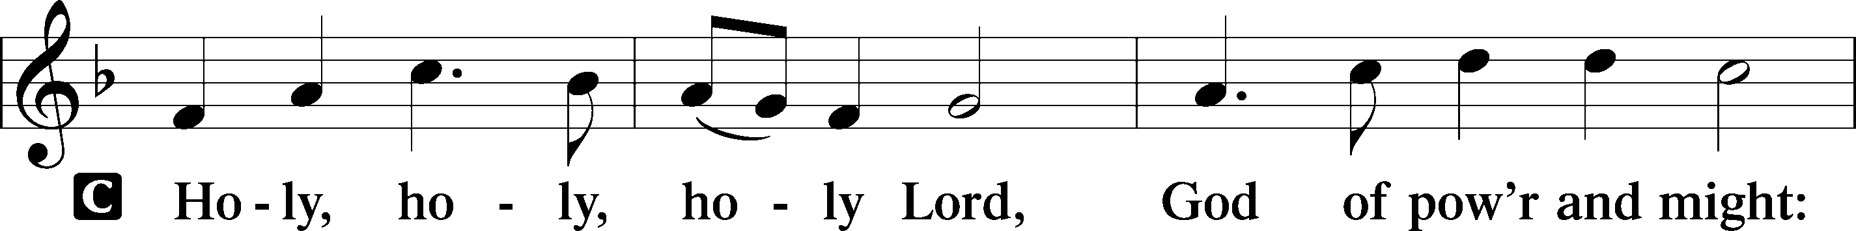
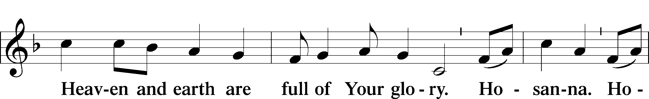
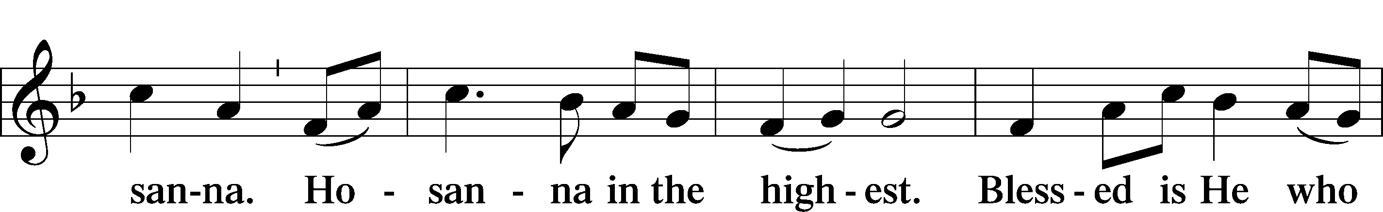
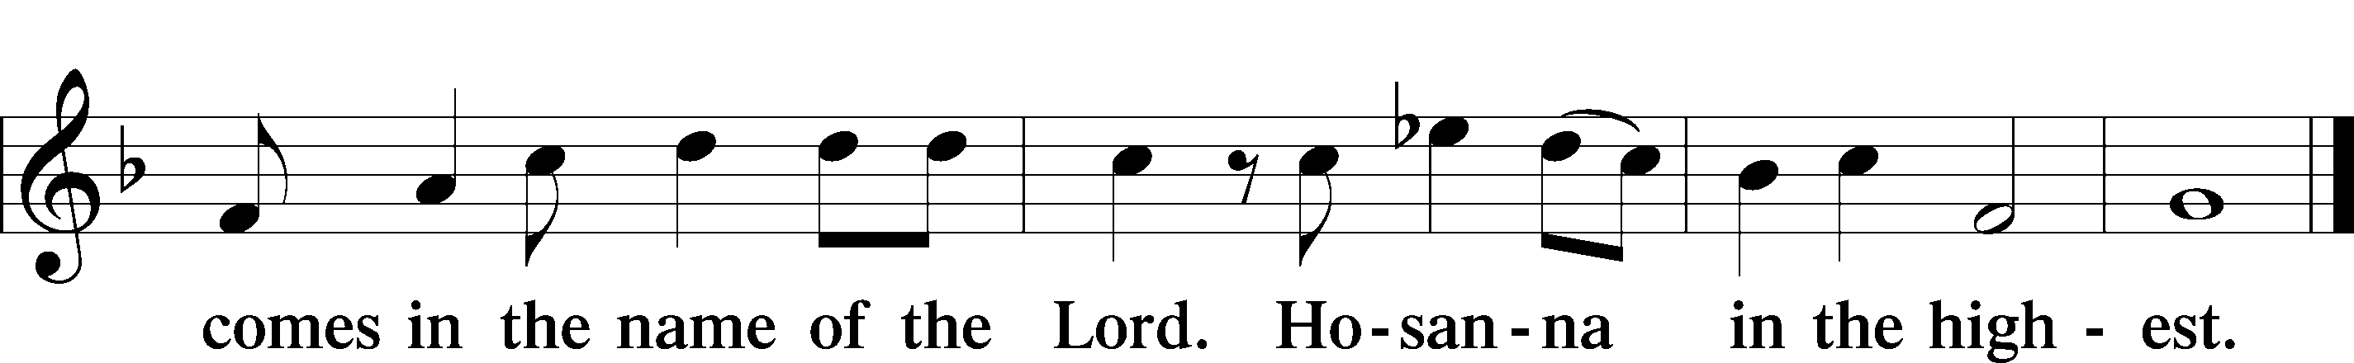

Prayer of Thanksgiving LSB 161
P Blessed are You, Lord of heaven and earth, for You have had mercy on those whom You created and sent Your only-begotten Son into our flesh to bear our sin and be our Savior. With repentant joy we receive the salvation accomplished for us by the all-availing sacrifice of His body and His blood on the cross.

Gathered in the name and the remembrance of Jesus, we beg You, O Lord, to forgive, renew, and strengthen us with Your Word and Spirit. Grant us faithfully to eat His body and drink His blood as He bids us do in His own testament. Gather us together, we pray, from the ends of the earth to celebrate with all the faithful the marriage feast of the Lamb in His kingdom, which has no end. Graciously receive our prayers; deliver and preserve us. To You alone, O Father, be all glory, honor, and worship, with the Son and the Holy Spirit, one God, now and forever.
C Amen.

The Words of Our Lord
P Our Lord Jesus Christ, on the night when He was betrayed, took bread, and when He had given thanks, He broke it and gave it to the disciples and said: “Take, eat; this is My T body, which is given for you. This do in remembrance of Me.”

In the same way also He took the cup after supper, and when He had given thanks, He gave it to them, saying: “Drink of it, all of you; this cup is the new testament in My T blood, which is shed for you for the forgiveness of sins. This do, as often as you drink it, in remembrance of Me.”

Proclamation of Christ
P As often as we eat this bread and drink this cup, we proclaim the Lord’s death until He comes.
C Amen. Come, Lord Jesus.

P O Lord Jesus Christ, only Son of the Father, in giving us Your body and blood to eat and to drink, You lead us to remember and confess Your holy cross and passion, Your blessed death, Your rest in the tomb, Your resurrection from the dead, Your ascension into heaven, and Your coming for the final judgment. So remember us in Your kingdom and teach us to pray:

Lord’s Prayer
C Our Father who art in heaven,
hallowed be Thy name,
Thy kingdom come,
Thy will be done on earth
as it is in heaven;
give us this day our daily bread;
and forgive us our trespasses
as we forgive those
who trespass against us;
and lead us not into temptation,
but deliver us from evil.
For Thine is the kingdom
and the power and the glory
forever and ever. Amen.

Pax Domini LSB 163
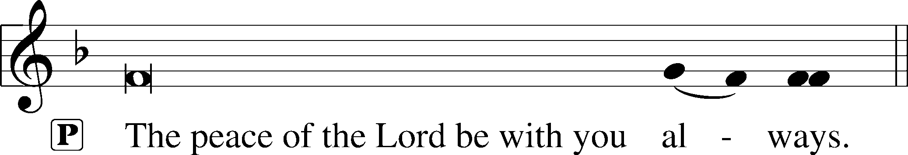
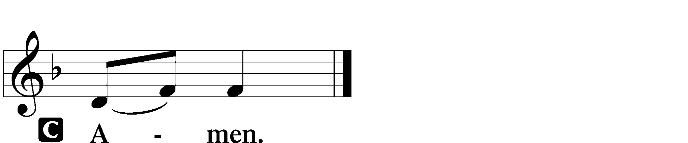

Agnus Dei LSB 163
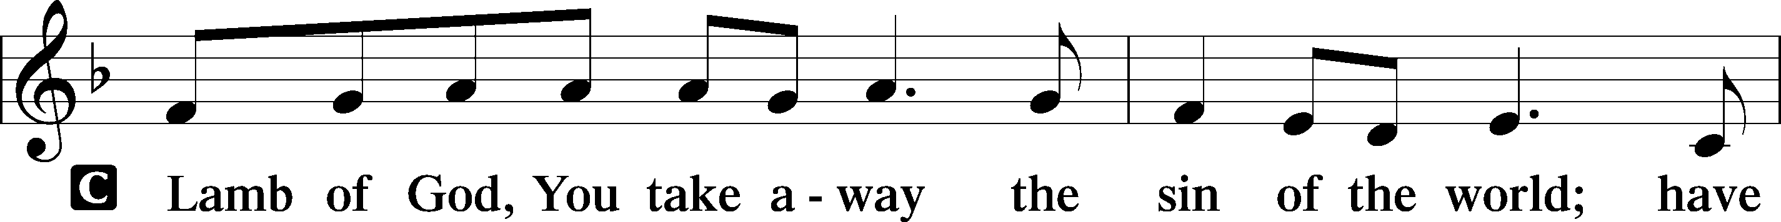
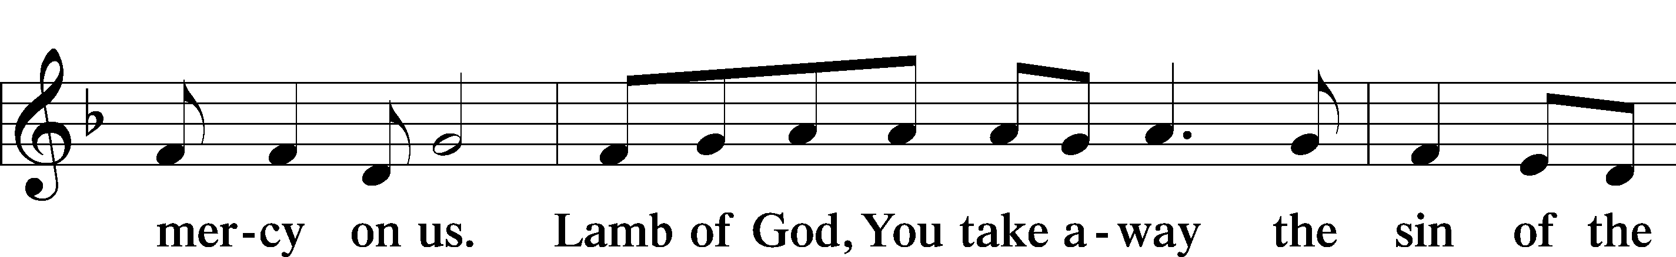
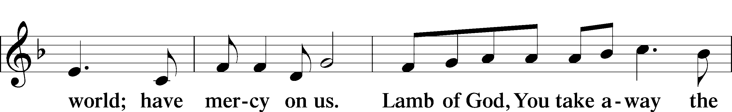
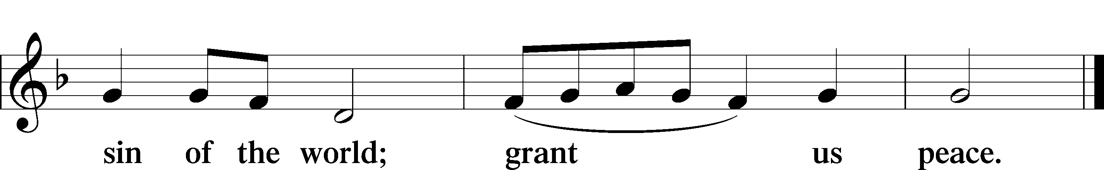

Sit

Distribution

907 God Himself Is Present
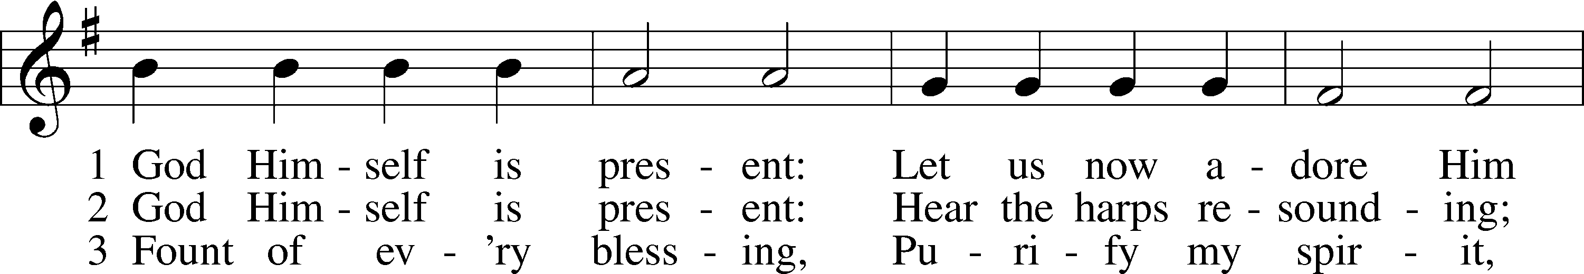
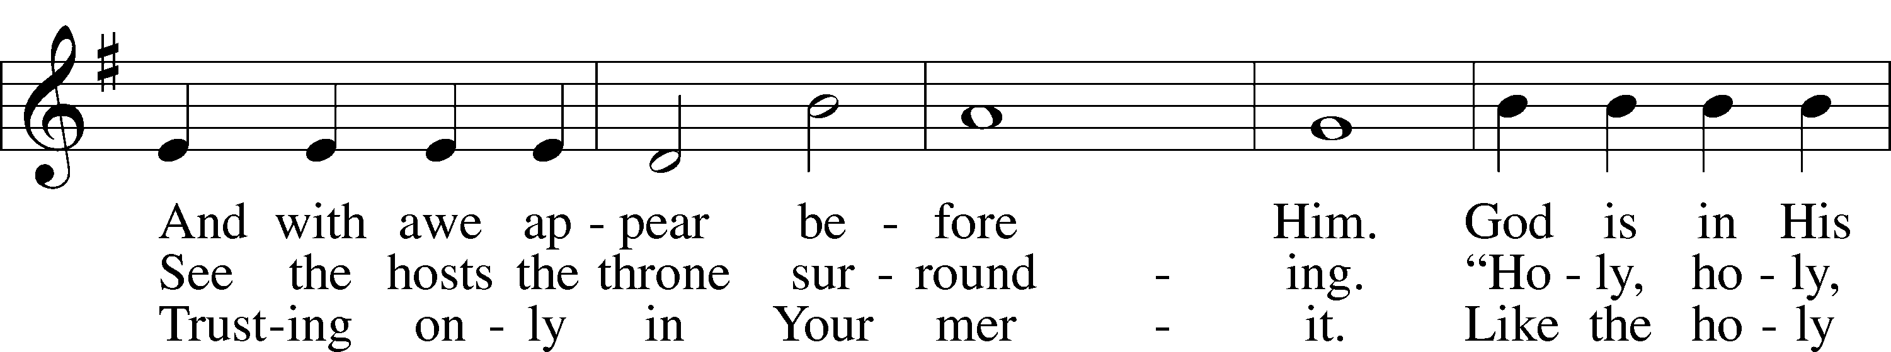
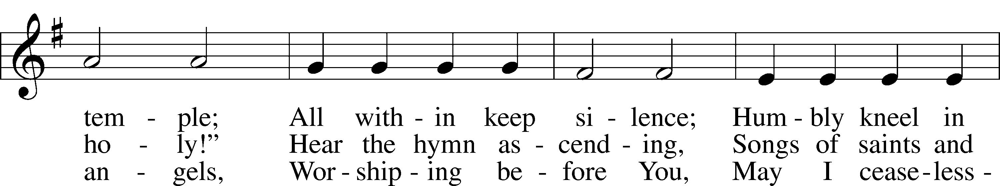
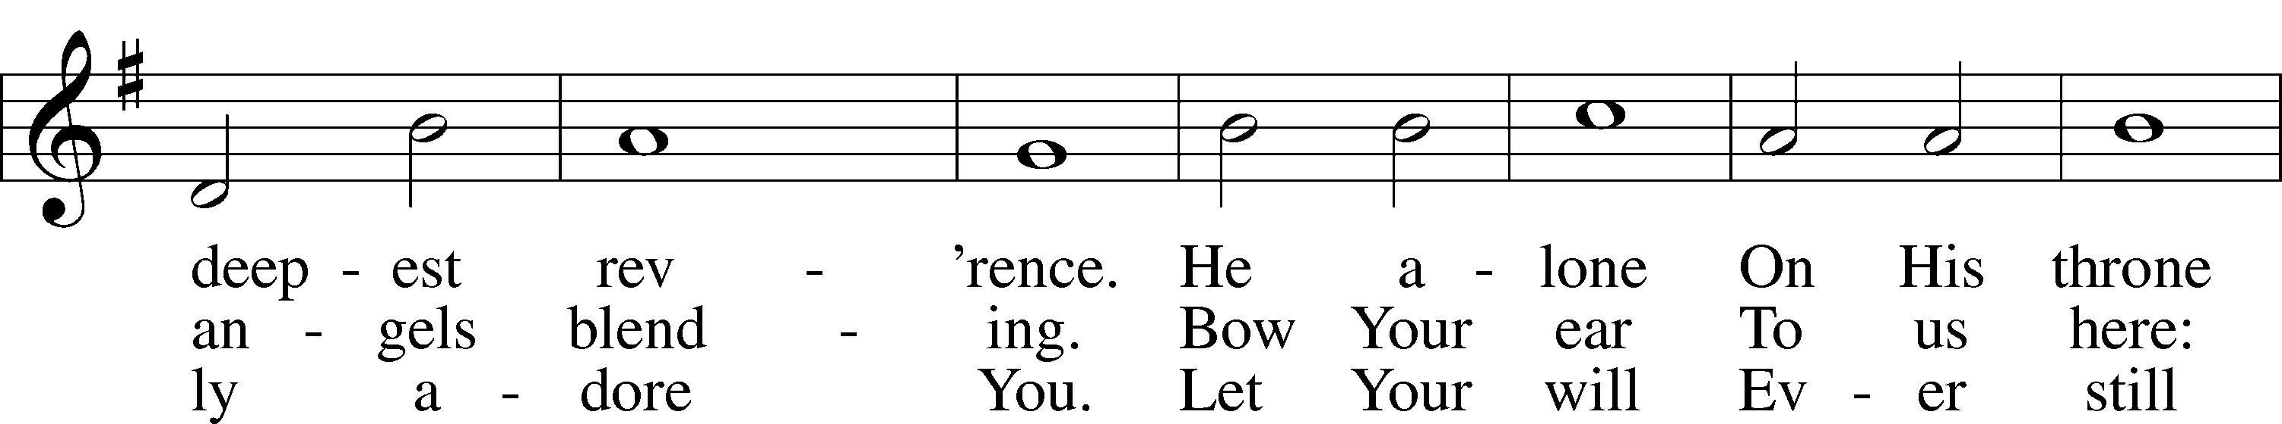
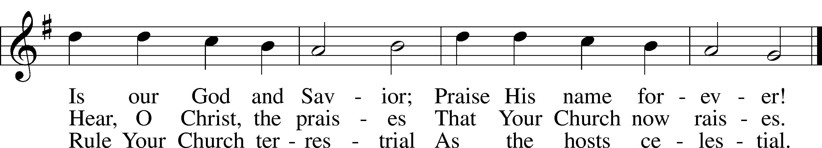
Text: Gerhard Tersteegen, 1697–1769, abr.; tr. Frederick W. Foster, 1760–1835, alt.; tr. John Miller, 1756–90, alt.
Tune: Joachim Neander, 1650–80
Text and tune: Public domain

628 Your Table I Approach
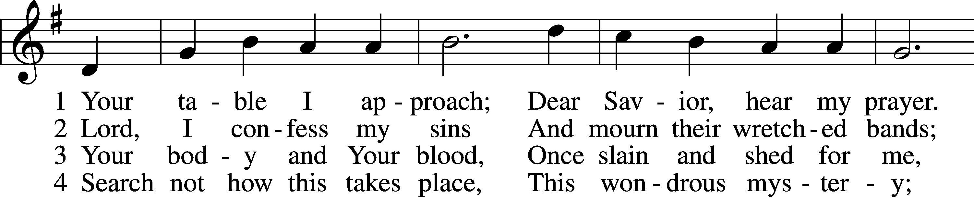
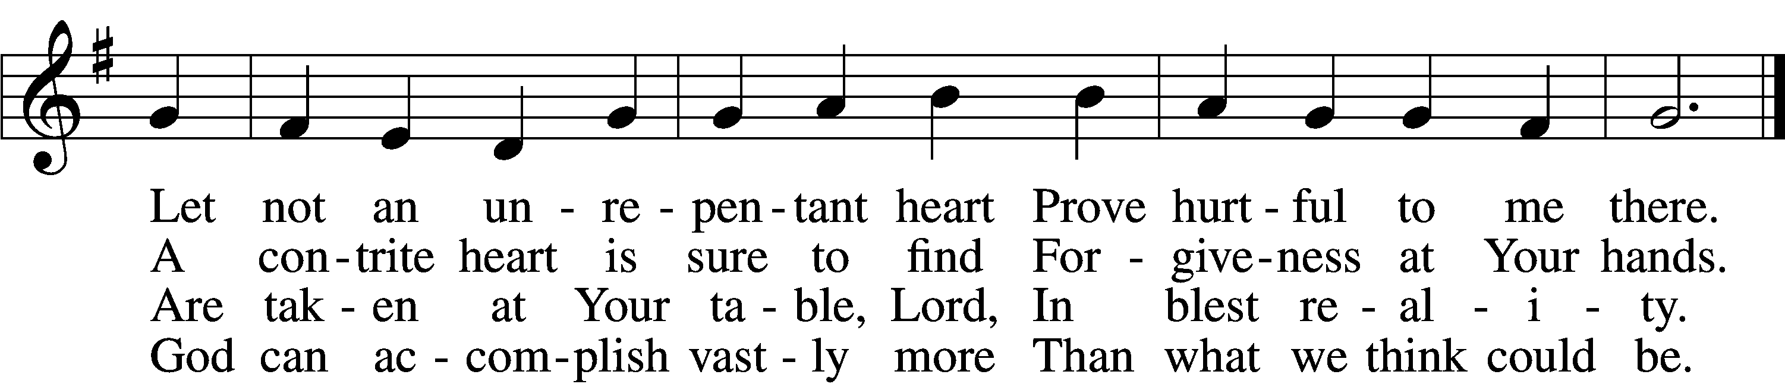

5 O grant, most blessèd Lord,
That earth and hell combined
May not about this sacrament
Raise doubt within my mind.

6 Oh, may I never fail
To thank You day and night
For Your true body and true blood,
O God, my peace and light.
Text: Gerhard Wolter Molanus, 1633–1722; tr. Matthias Loy, 1828–1915, alt.
Tune: Trente quatre Pseaumes de David, 1551, Geneva, ed. Louis Bourgeois
Text and tune: Public domain

606 I Lay My Sins on Jesus
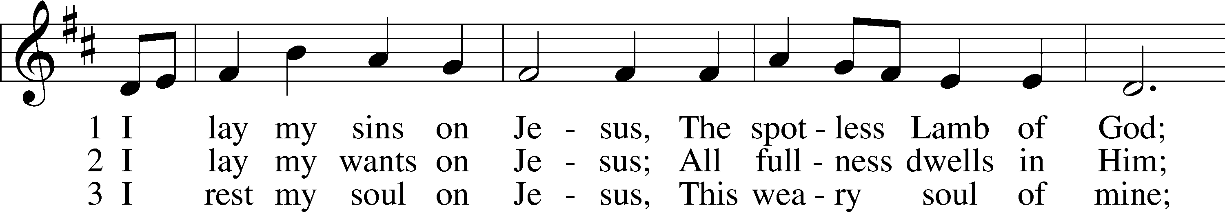
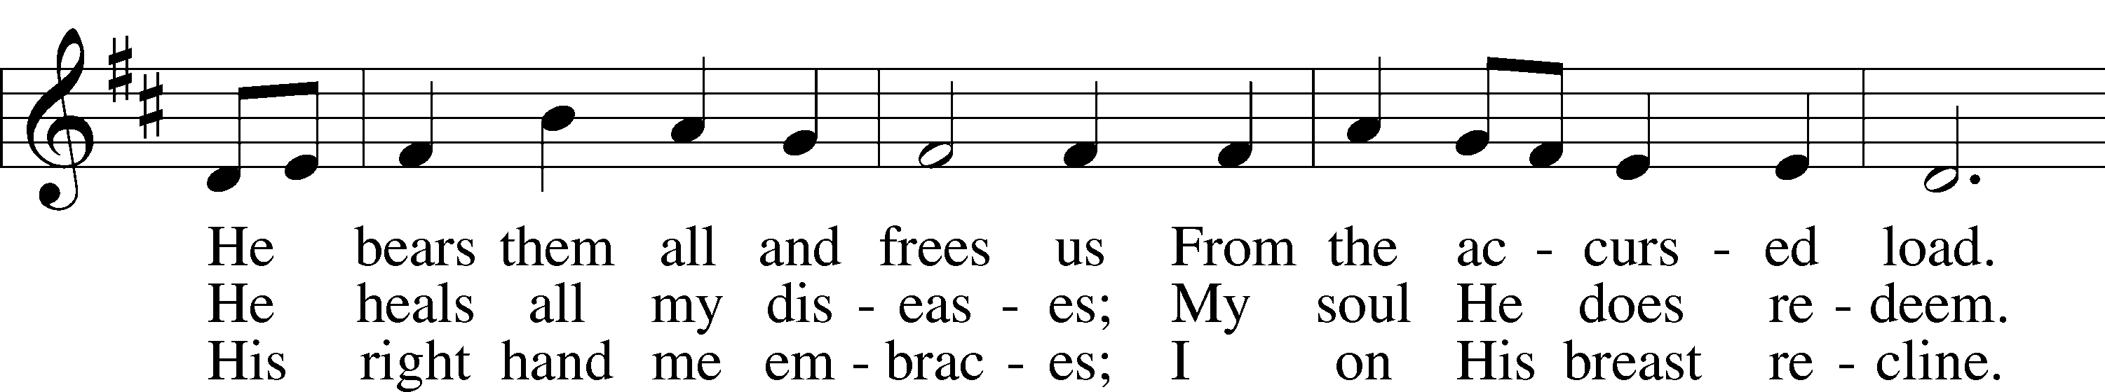
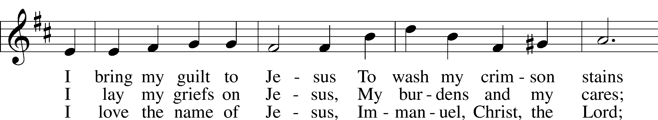
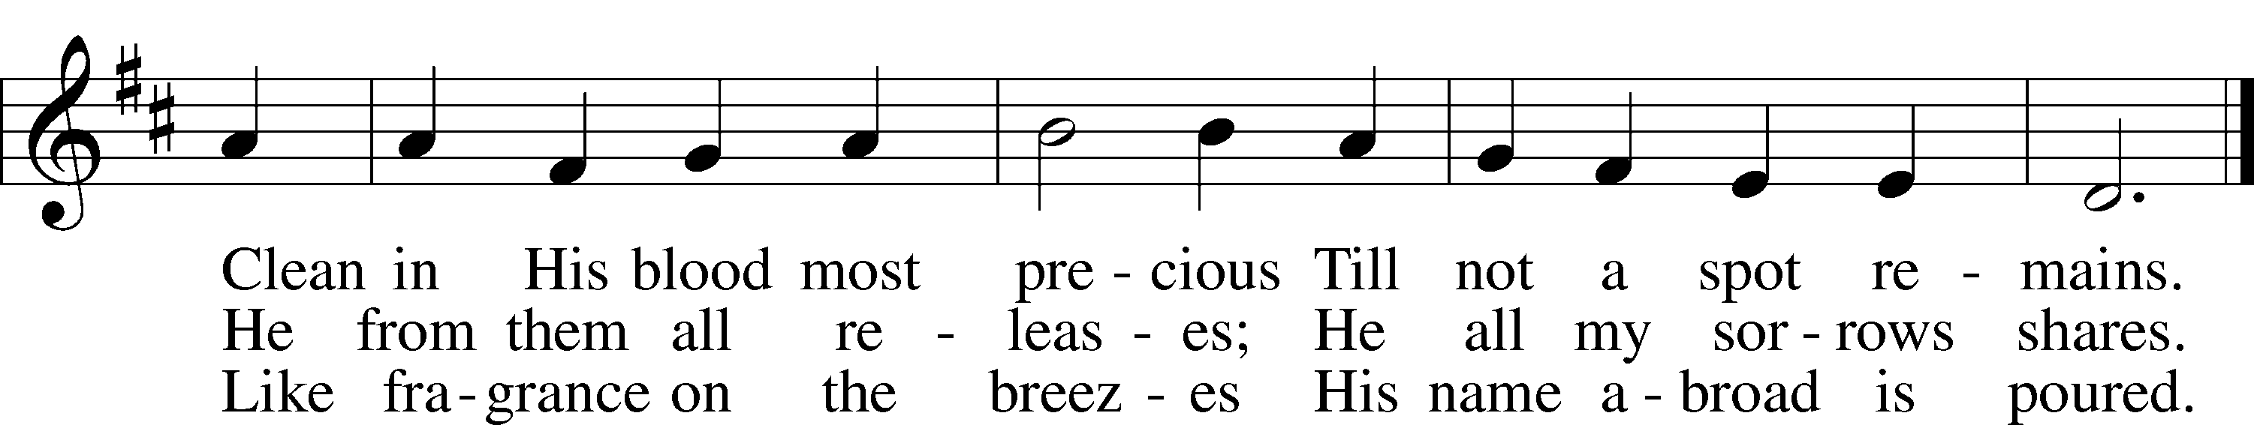
Text: Horatius Bonar, 1808–89
Tune: Neu-vermehrtes . . . Gesangbuch, 1693, 3rd ed., Meiningen
Text and tune: Public domain

Stand

Thank the Lord LSB 164
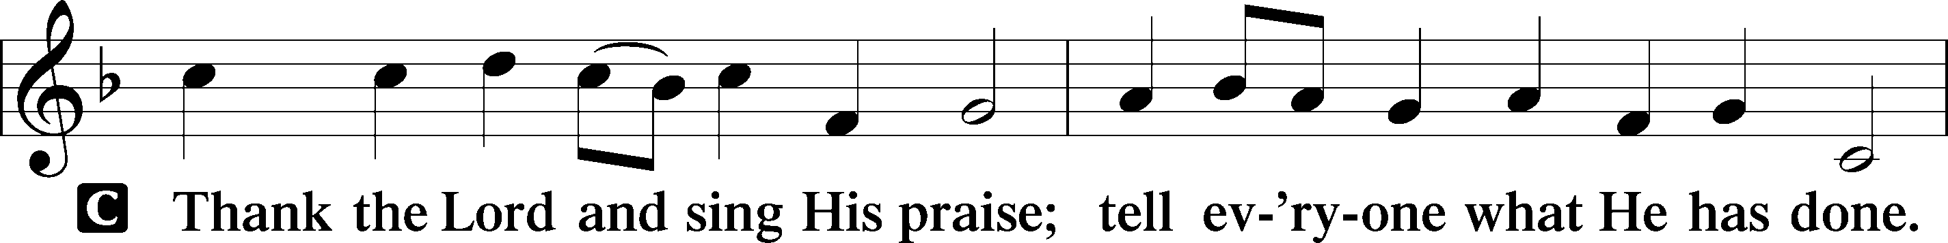
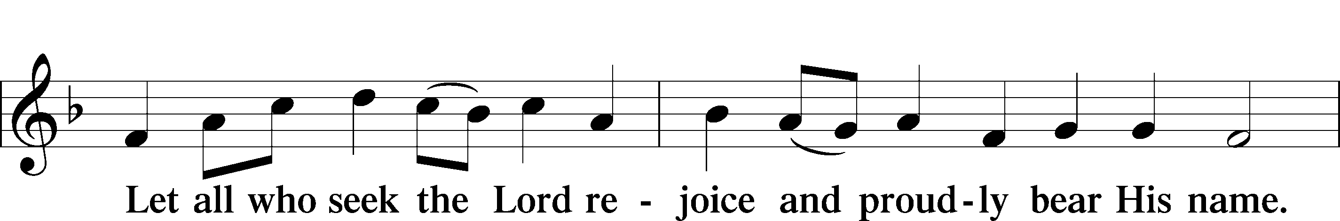
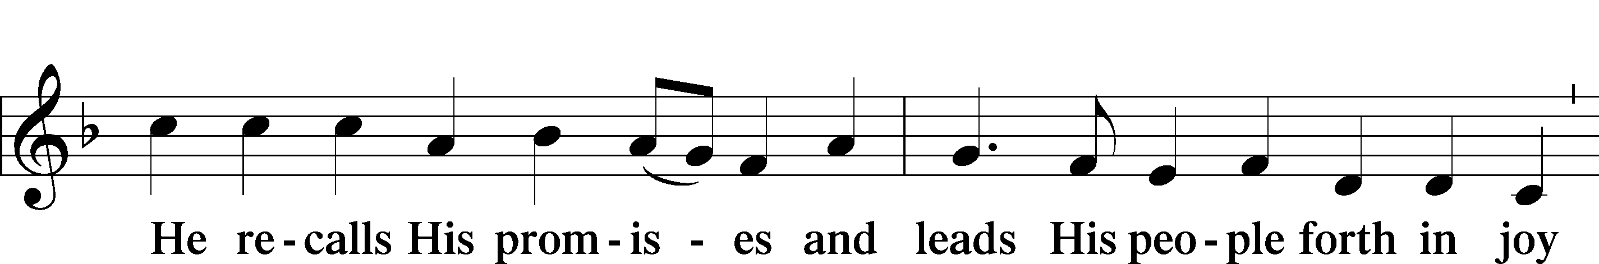
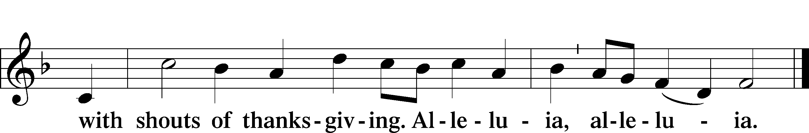

Post-Communion Collect
A Let us pray.
We give thanks to You, almighty God, that You have refreshed us through this salutary gift, and we implore You that of Your mercy You would strengthen us through the same in faith toward You and in fervent love toward one another; through Jesus Christ, Your Son, our Lord, who lives and reigns with You and the Holy Spirit, one God, now and forever.

Benediction LSB 166
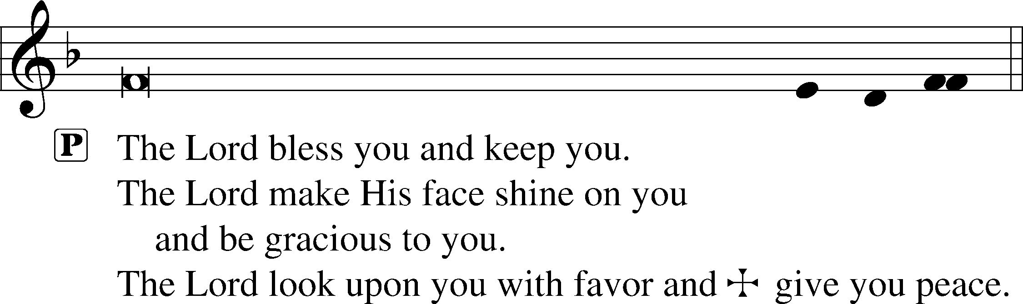
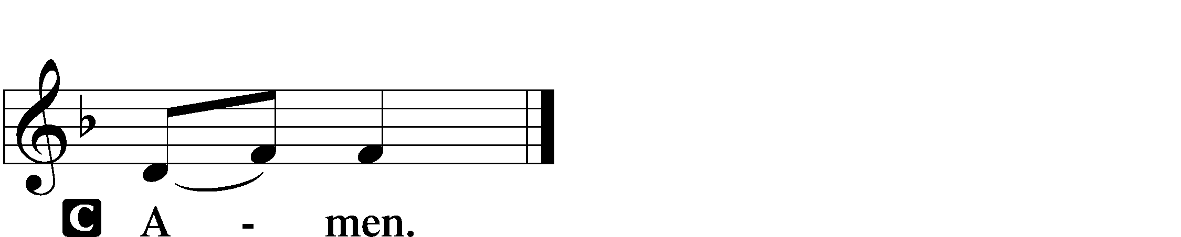

849 Praise the One Who Breaks the Darkness
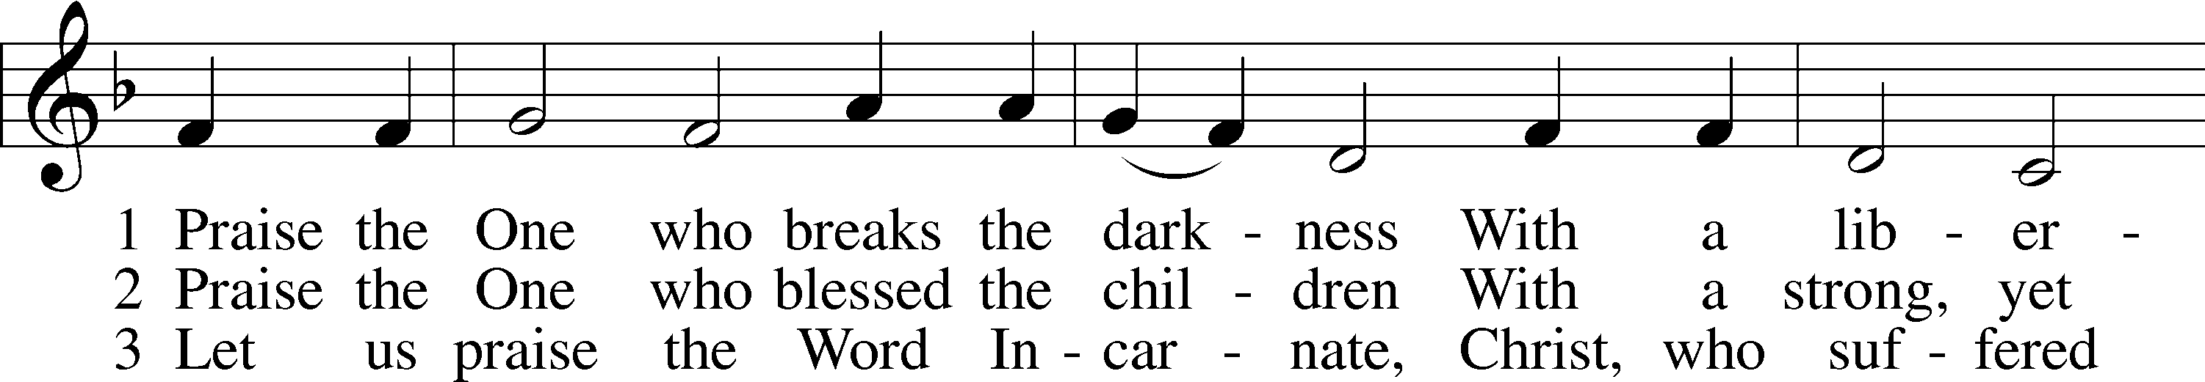
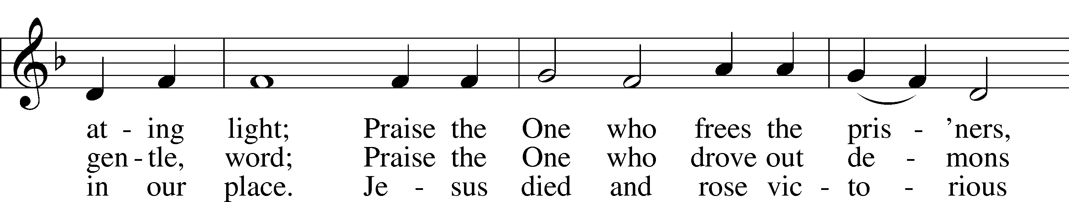
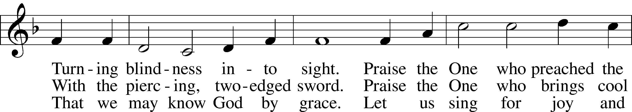
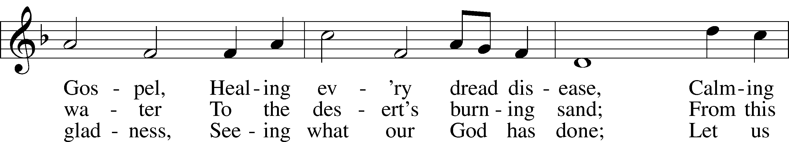
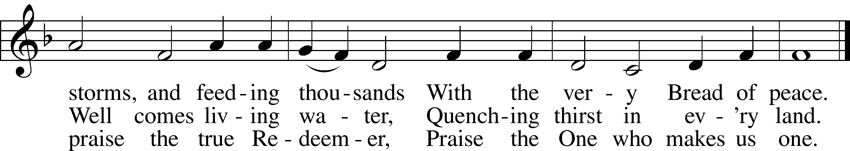
Text: Rusty Edwards, 1955
Tune: The Sacred Harp, 1844, Philadelphia
Text: © 1987 Hope Publishing Co. Used by permission: LSB Hymn License no. 110002831
Tune: Public domain

Acknowledgments
Unless otherwise indicated, Scripture quotations are from the ESV® Bible (The Holy Bible, English Standard Version®), copyright © 2001 by Crossway, a publishing ministry of Good News Publishers. Used by permission. All rights reserved.
Created by Lutheran Service Builder © 2024 Concordia Publishing House.

