Sixth Sunday of Easter
Divine Service 1 p. 151
May 4 & 5, 2024
St. Paul Lutheran Church

Confession and Absolution

791 All People That on Earth Do Dwell
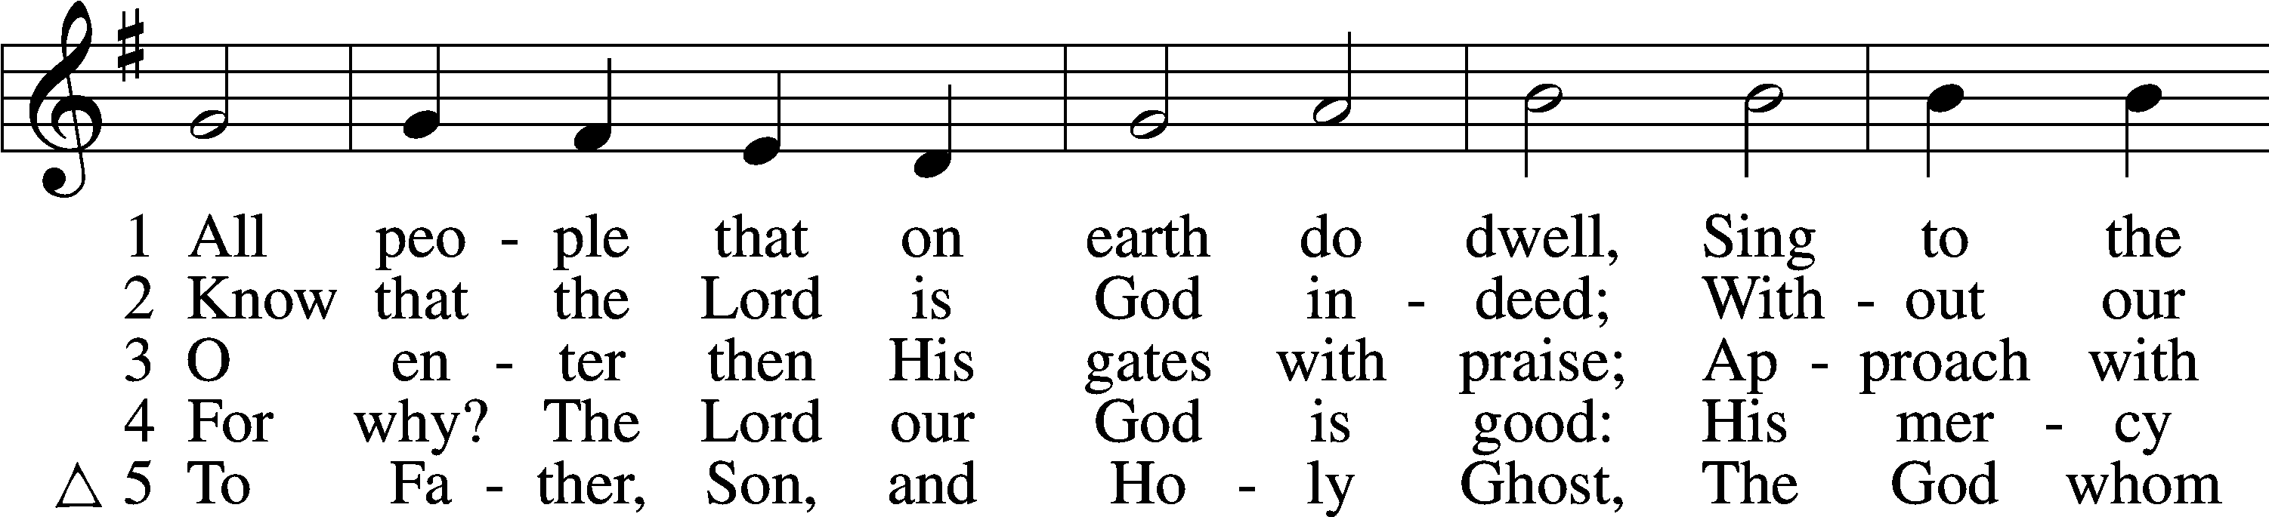
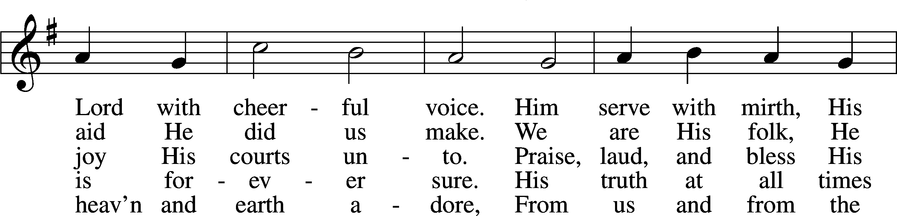
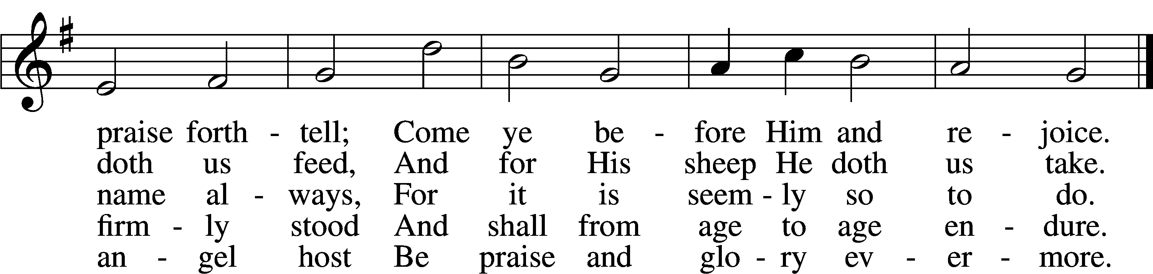
Text: William Kethe, d. c. 1593, alt.
Tune: Trente quatre Pseaumes de David, 1551, Geneva, ed. Louis Bourgeois
Text and tune: Public domain

Stand

The sign of the cross may be made by all in remembrance of their Baptism.

Invocation
P In the name of the Father and of the T Son and of the Holy Spirit.
C Amen.

Exhortation LSB 151
P If we say we have no sin, we deceive ourselves, and the truth is not in us.
C But if we confess our sins, God, who is faithful and just, will forgive our sins and cleanse us from all unrighteousness.

Kneel/Stand

Silence for reflection on God’s Word and for self-examination.

Confession of Sins LSB 151
P Let us then confess our sins to God our Father.
C Most merciful God, we confess that we are by nature sinful and unclean. We have sinned against You in thought, word, and deed, by what we have done and by what we have left undone. We have not loved You with our whole heart; we have not loved our neighbors as ourselves. We justly deserve Your present and eternal punishment. For the sake of Your Son, Jesus Christ, have mercy on us. Forgive us, renew us, and lead us, so that we may delight in Your will and walk in Your ways to the glory of Your holy name. Amen.

Absolution LSB 151
P Almighty God in His mercy has given His Son to die for you and for His sake forgives you all your sins. As a called and ordained servant of Christ, and by His authority, I therefore forgive you all your sins in the name of the Father and of the T Son and of the Holy Spirit.
C Amen.

Stand

Service of the Word

PSALM Psalm 98
1Oh sing to the Lord a new song,
for he has done marvelous things!
His right hand and his holy arm
have worked salvation for him.
2The Lord has made known his salvation;
he has revealed his righteousness in the sight of the nations.
3He has remembered his steadfast love and faithfulness
to the house of Israel.
All the ends of the earth have seen
the salvation of our God.
4Make a joyful noise to the Lord, all the earth;
break forth into joyous song and sing praises!
5Sing praises to the Lord with the lyre,
with the lyre and the sound of melody!
6With trumpets and the sound of the horn
make a joyful noise before the King, the Lord!
7Let the sea roar, and all that fills it;
the world and those who dwell in it!
8Let the rivers clap their hands;
let the hills sing for joy together
9before the Lord, for he comes
to judge the earth.
He will judge the world with righteousness,
and the peoples with equity.

Kyrie LSB 152
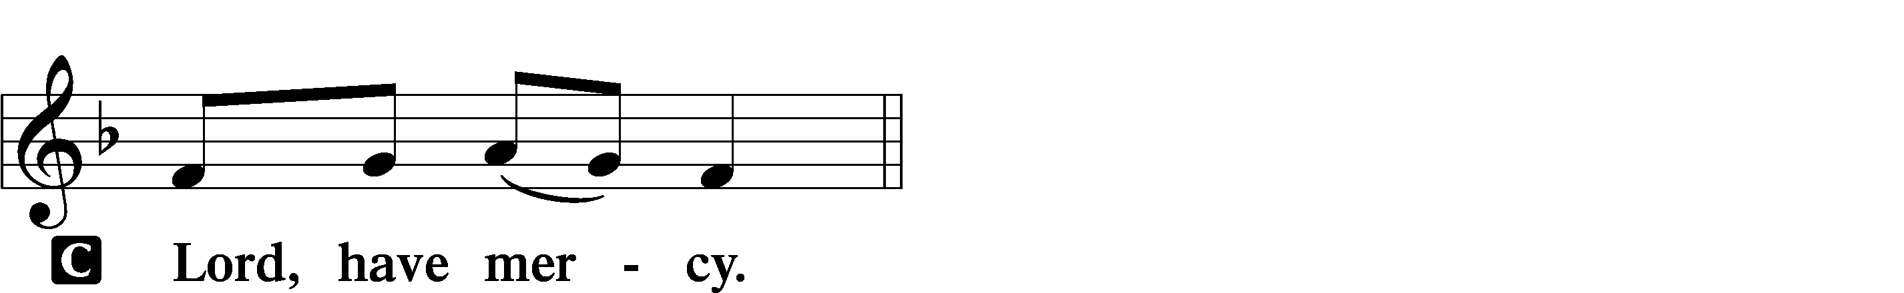

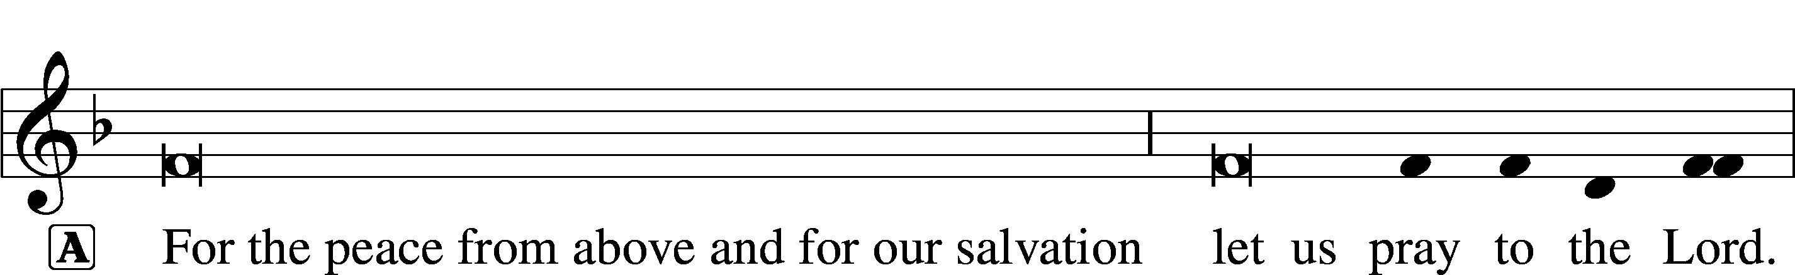
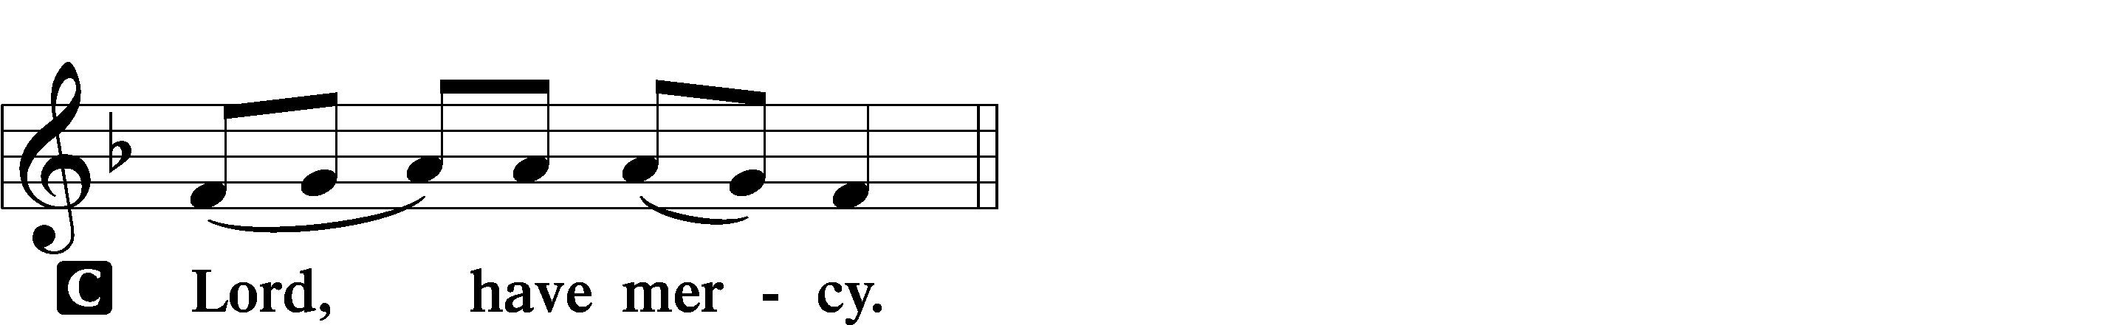

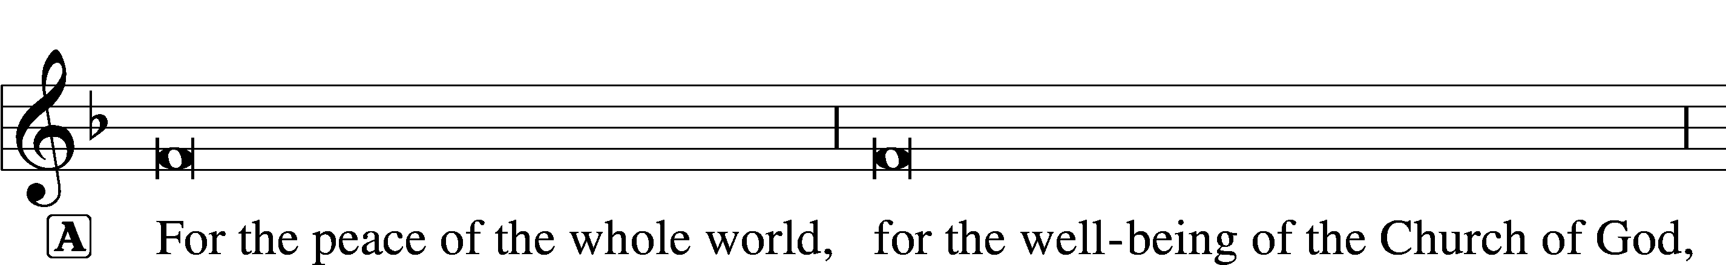
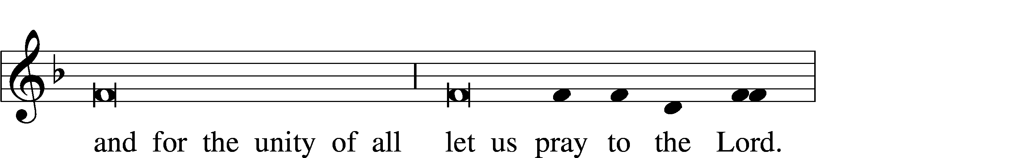
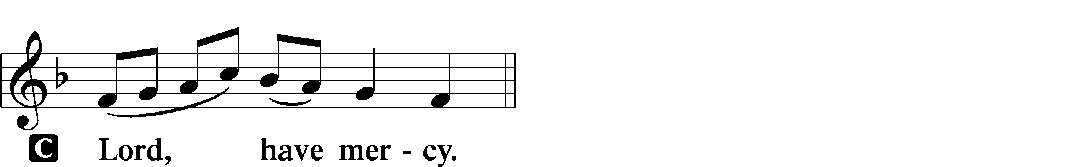

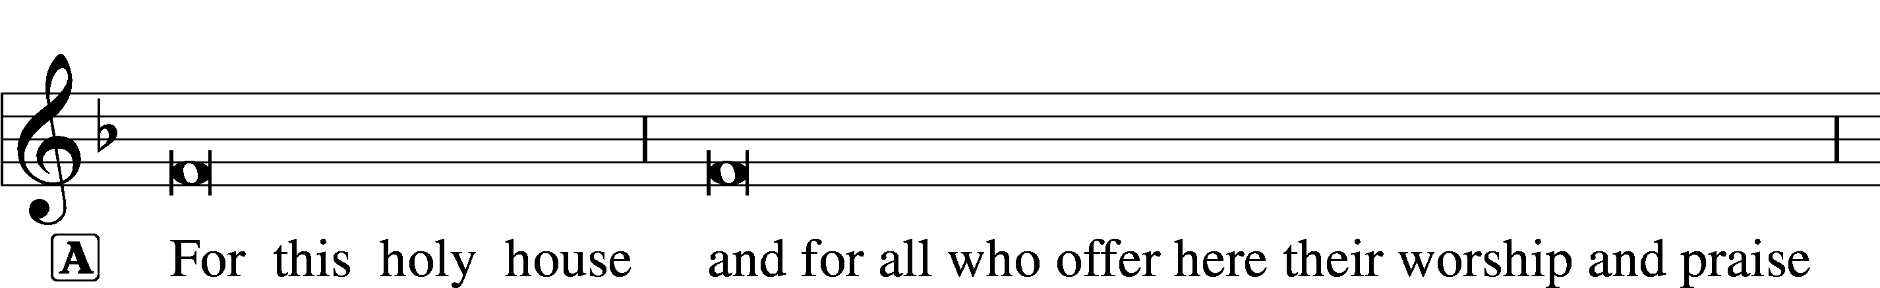
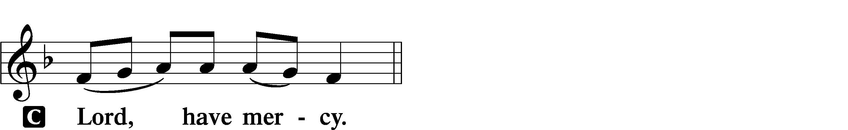

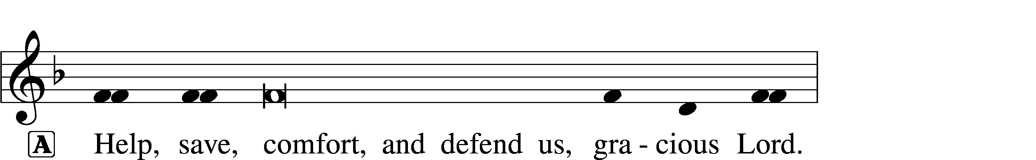

This Is the Feast LSB 155
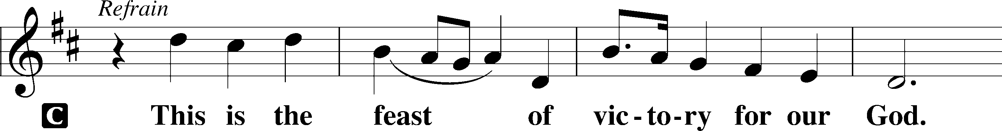
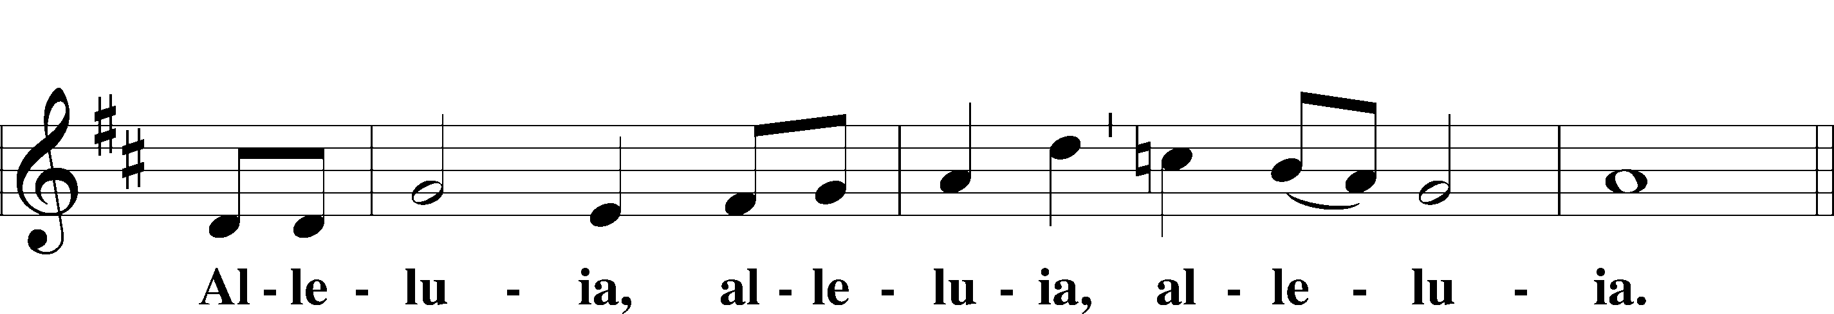
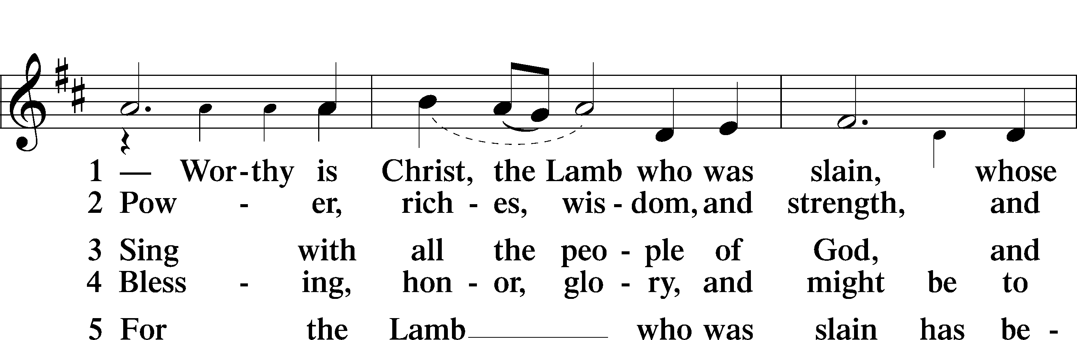
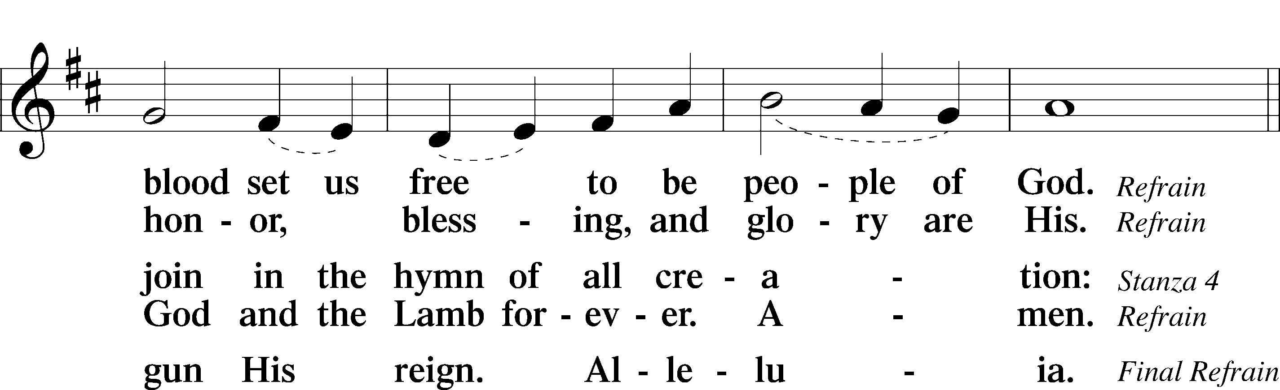
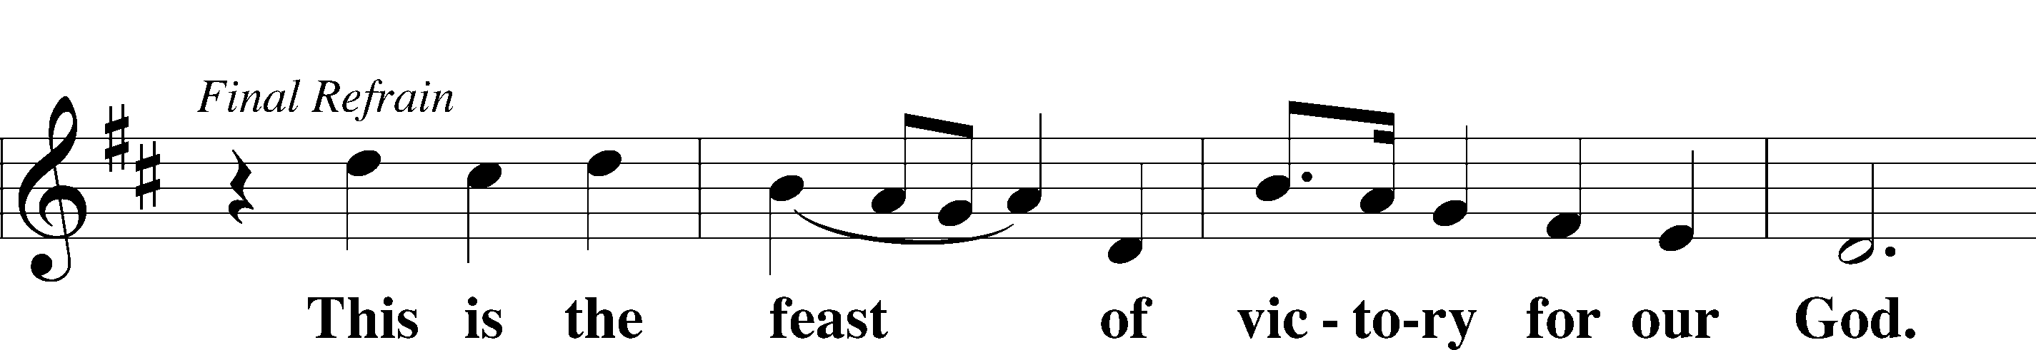
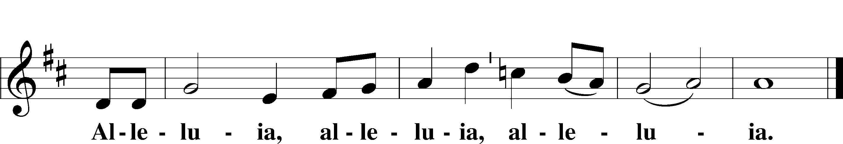

Salutation and Collect of the Day
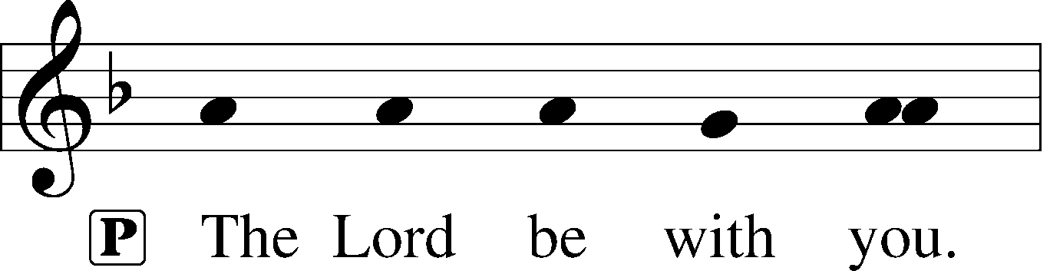
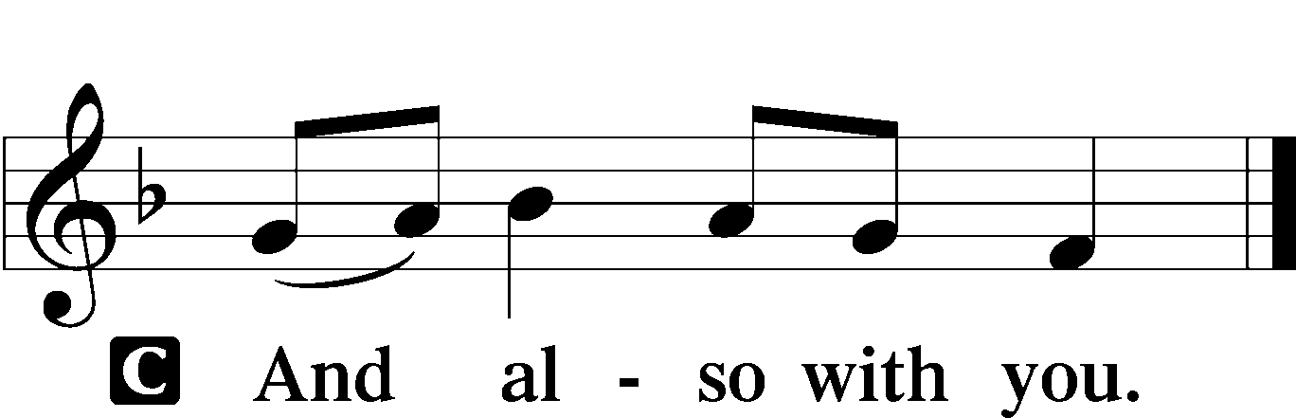

P Let us pray.
O God, the giver of all that is good, by Your holy inspiration grant that we may think those things that are right and by Your merciful guiding accomplish them; through Jesus Christ, Your Son, our Lord, who lives and reigns with You and the Holy Spirit, one God, now and forever.

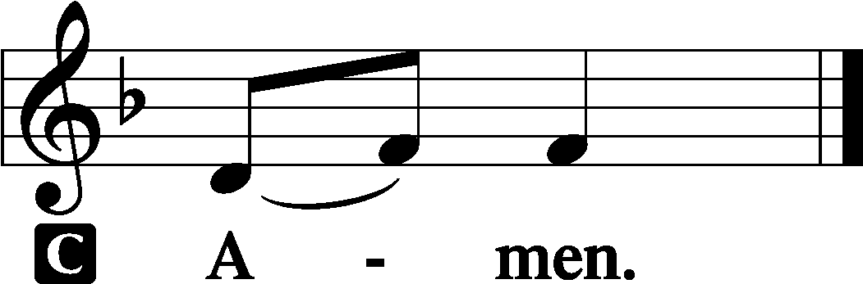

Sit
First Reading Acts 10:34–48
34Peter opened his mouth and said: “Truly I understand that God shows no partiality, 35but in every nation anyone who fears him and does what is right is acceptable to him. 36As for the word that he sent to Israel, preaching good news of peace through Jesus Christ (he is Lord of all), 37you yourselves know what happened throughout all Judea, beginning from Galilee after the baptism that John proclaimed: 38how God anointed Jesus of Nazareth with the Holy Spirit and with power. He went about doing good and healing all who were oppressed by the devil, for God was with him. 39And we are witnesses of all that he did both in the country of the Jews and in Jerusalem. They put him to death by hanging him on a tree, 40but God raised him on the third day and made him to appear, 41not to all the people but to us who had been chosen by God as witnesses, who ate and drank with him after he rose from the dead. 42And he commanded us to preach to the people and to testify that he is the one appointed by God to be judge of the living and the dead. 43To him all the prophets bear witness that everyone who believes in him receives forgiveness of sins through his name.”
44While Peter was still saying these things, the Holy Spirit fell on all who heard the word. 45And the believers from among the circumcised who had come with Peter were amazed, because the gift of the Holy Spirit was poured out even on the Gentiles. 46For they were hearing them speaking in tongues and extolling God. Then Peter declared, 47“Can anyone withhold water for baptizing these people, who have received the Holy Spirit just as we have?” 48And he commanded them to be baptized in the name of Jesus Christ. Then they asked him to remain for some days.

A This is the Word of the Lord.
C Thanks be to God.

Epistle 1 John 5:1–8
1Everyone who believes that Jesus is the Christ has been born of God, and everyone who loves the Father loves whoever has been born of him. 2By this we know that we love the children of God, when we love God and obey his commandments. 3For this is the love of God, that we keep his commandments. And his commandments are not burdensome. 4For everyone who has been born of God overcomes the world. And this is the victory that has overcome the world—our faith. 5Who is it that overcomes the world except the one who believes that Jesus is the Son of God?
6This is he who came by water and blood—Jesus Christ; not by the water only but by the water and the blood. And the Spirit is the one who testifies, because the Spirit is the truth. 7For there are three that testify: 8the Spirit and the water and the blood; and these three agree.

A This is the Word of the Lord.
C Thanks be to God.

Stand

Alleluia and Verse LSB 156
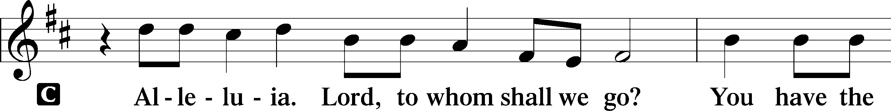
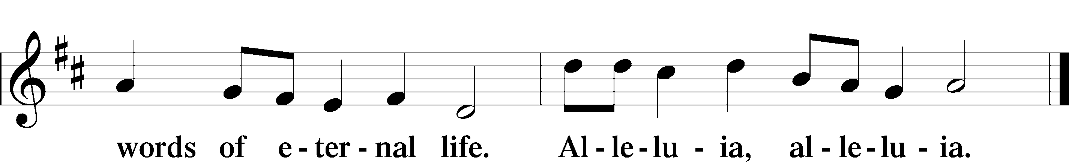

Holy Gospel John 15:9–17
P The Holy Gospel according to St. John, the fifteenth chapter.

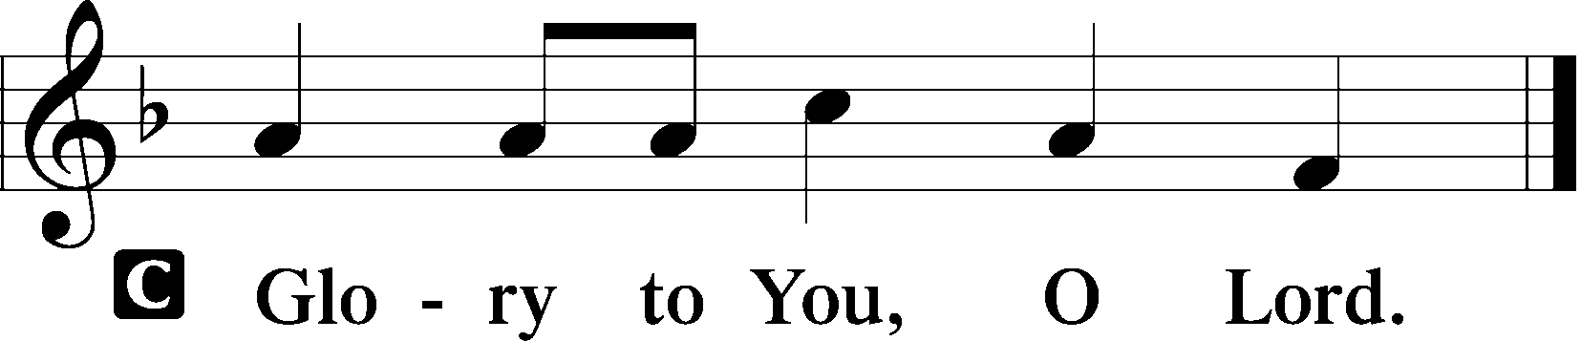

9[Jesus said:] “As the Father has loved me, so have I loved you. Abide in my love. 10If you keep my commandments, you will abide in my love, just as I have kept my Father’s commandments and abide in his love. 11These things I have spoken to you, that my joy may be in you, and that your joy may be full.
12“This is my commandment, that you love one another as I have loved you. 13Greater love has no one than this, that someone lays down his life for his friends. 14You are my friends if you do what I command you. 15No longer do I call you servants, for the servant does not know what his master is doing; but I have called you friends, for all that I have heard from my Father I have made known to you. 16You did not choose me, but I chose you and appointed you that you should go and bear fruit and that your fruit should abide, so that whatever you ask the Father in my name, he may give it to you. 17These things I command you, so that you will love one another.”

P This is the Gospel of the Lord.

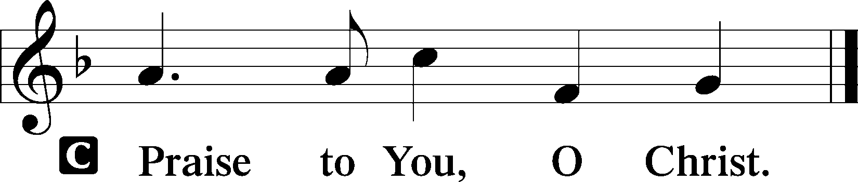

Sit

770 What a Friend We Have in Jesus
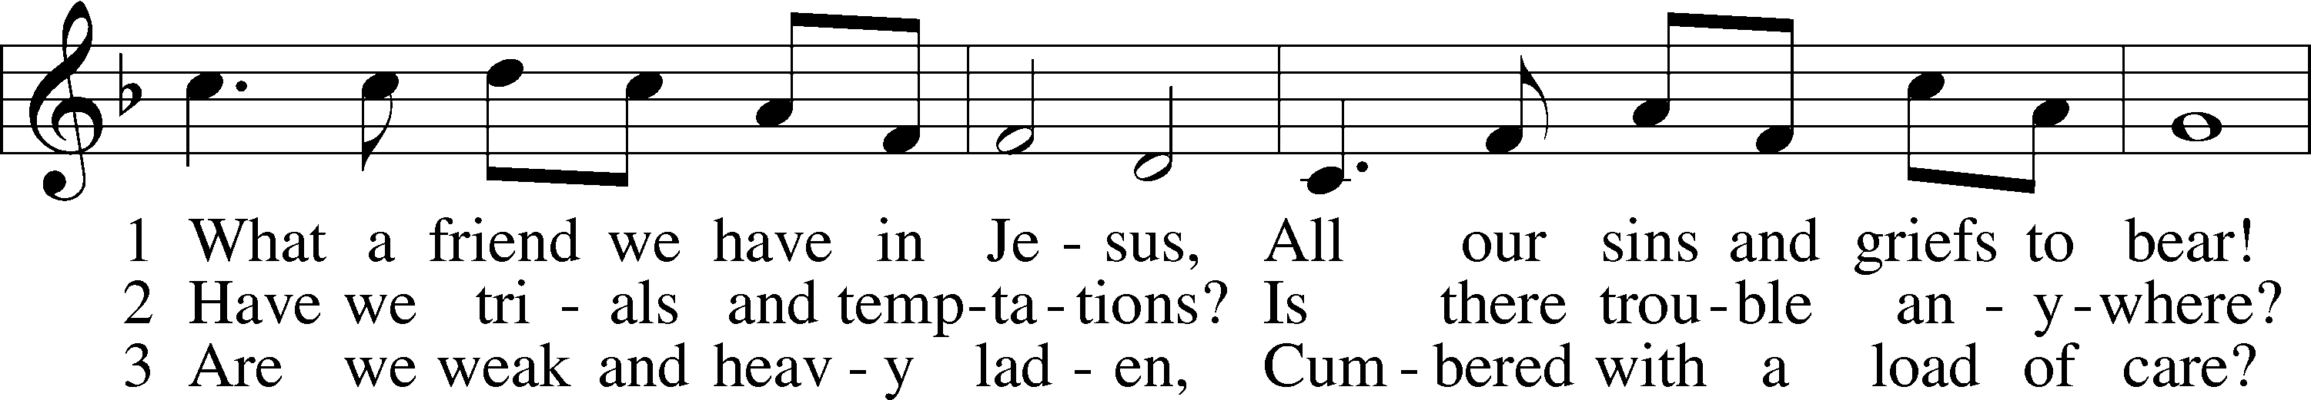
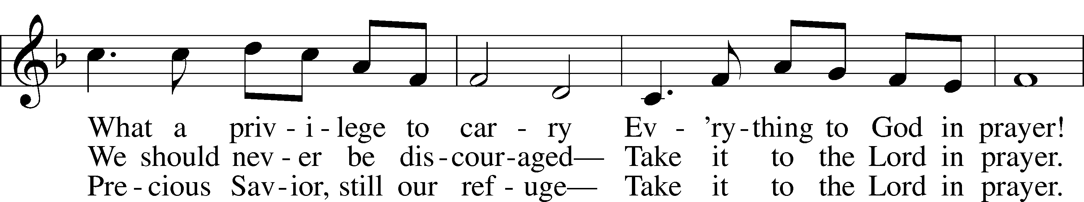
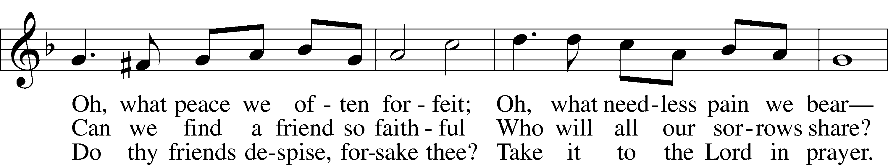
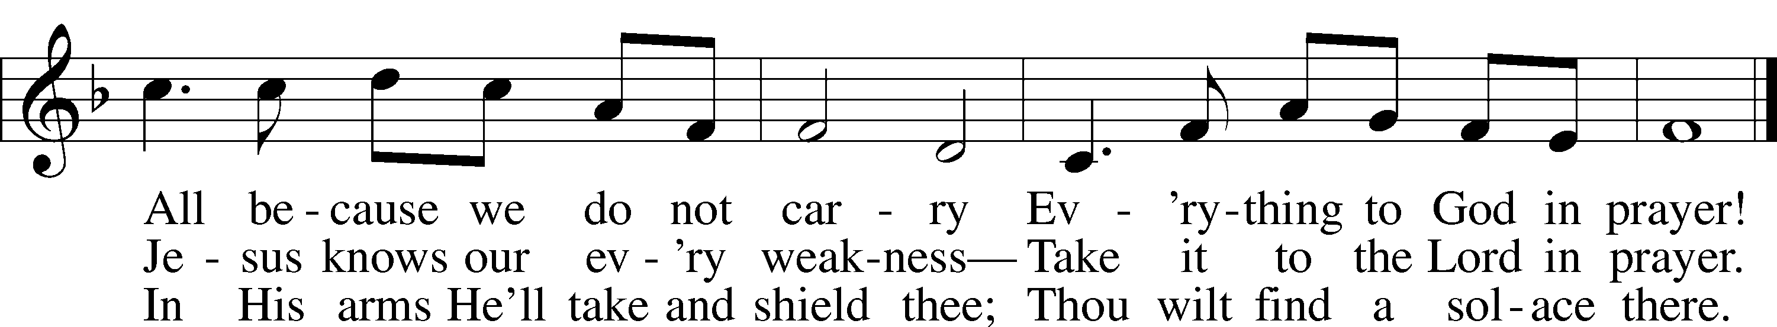
Text: Joseph M. Scriven, 1819–86
Tune: Charles C. Converse, 1832–1918
Text and tune: Public domain

Sermon

Stand

Nicene Creed
C I believe in one God,
the Father Almighty,
maker of heaven and earth
and of all things visible and invisible.

And in one Lord Jesus Christ,
the only-begotten Son of God,
begotten of His Father before all worlds,
God of God, Light of Light,
very God of very God,
begotten, not made,
being of one substance with the Father,
by whom all things were made;
who for us men and for our salvation came down from heaven
and was incarnate by the Holy Spirit of the virgin Mary
and was made man;
and was crucified also for us under Pontius Pilate.
He suffered and was buried.
And the third day He rose again according to the Scriptures
and ascended into heaven
and sits at the right hand of the Father.
And He will come again with glory to judge both the living and the dead,
whose kingdom will have no end.

And I believe in the Holy Spirit,
the Lord and giver of life,
who proceeds from the Father and the Son,
who with the Father and the Son together is worshiped and glorified,
who spoke by the prophets.
And I believe in one holy Christian and apostolic Church,
I acknowledge one Baptism for the remission of sins,
and I look for the resurrection of the dead
and the life T of the world to come. Amen.

Prayer of the Church
P In peace, let us pray to the Lord:
C Lord, have mercy.

P For all who come and hear God’s Word, that they would rightly fear God and learn what He has done for their souls, let us pray to the Lord:
C Lord, have mercy.

P For the work of our missionaries, that in every nation there would be people who fear God, do what is right and, believing in Jesus, receive forgiveness of sins through His name, let us pray to the Lord:
C Lord, have mercy.

P For the people of God, that like our Lord Jesus who loved the world and laid down His life for all, they also may lay down their lives for others in love, let us pray to the Lord:
C Lord, have mercy.

P For our nation’s leaders, that God would cause them to serve wisely for our good in accord with His revealed order; and though we do not always know what the Master is doing by the authorities He gives, that we would make ample use of the freedom Jesus has given in His name to ask the Father for everything as friends and fellow sons, let us pray to the Lord:
C Lord, have mercy.

P For all who are in sorrow or need, sickness or adversity, [especially _____________,] that they would receive from God all His good gifts of healing for the body, grace to bear the cross, and finally a blessed end and the gift of eternal life in His kingdom, let us pray to the Lord:
C Lord, have mercy.

P For all who come to the Holy Supper, that having received the testimony of God in the water of Baptism, they may also receive it in the body and blood of Jesus and so overcome the world by faith in Him, let us pray to the Lord:
C Lord, have mercy.

P O Lord, heavenly Father, we gratefully remember the sufferings and death of Your dear Son, Jesus Christ, for our salvation. Rejoicing in His victorious resurrection from the dead, we draw strength from His ascension before You, where He ever stands for us as our own High Priest. Gather us together from the ends of the earth to celebrate with all the faithful the marriage feast of the Lamb in His kingdom, which has no end. Graciously receive our prayers, deliver and preserve us, for to You alone we give all glory, honor and worship, Father, Son and Holy Spirit, one God, now and forever.
C Amen.

Sit

Offering

Stand

Offertory LSB 159
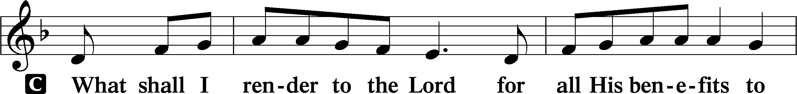
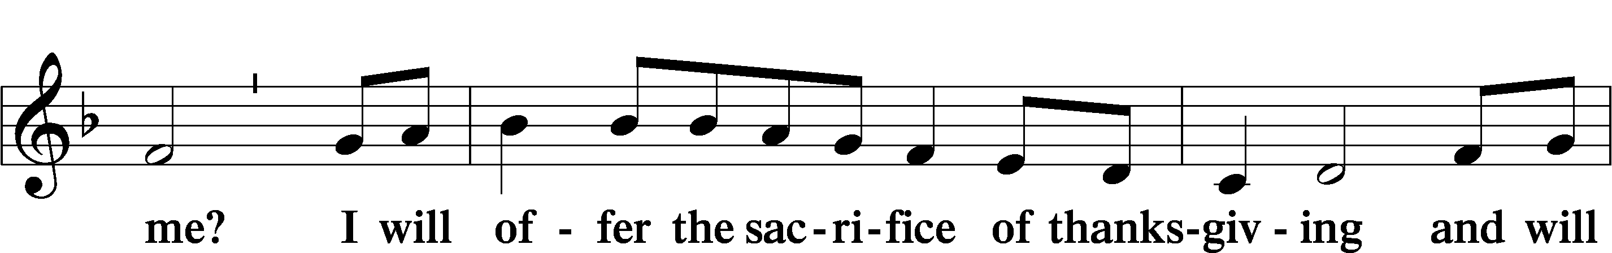
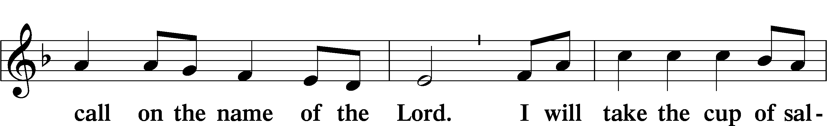
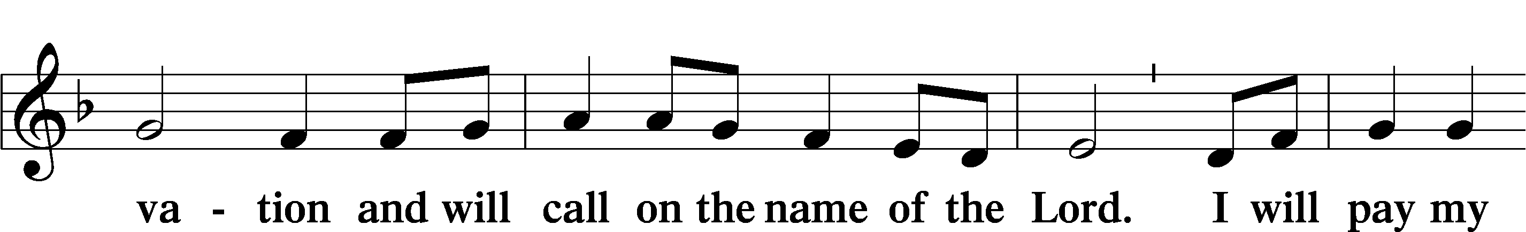
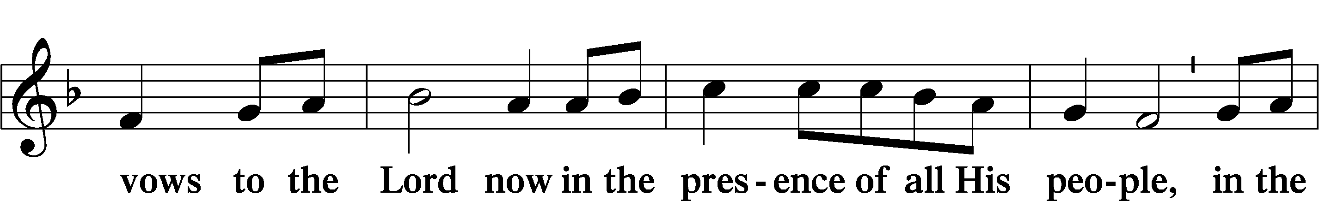
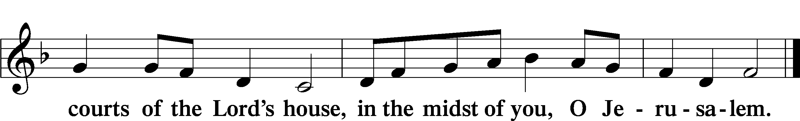

Service of the Sacrament

Preface LSB 160
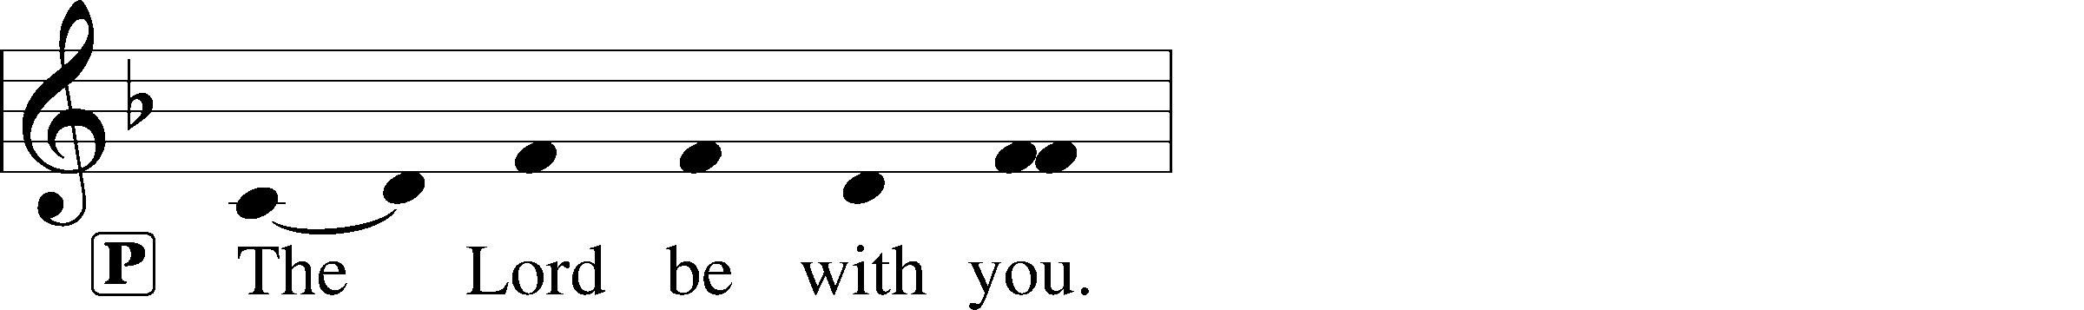
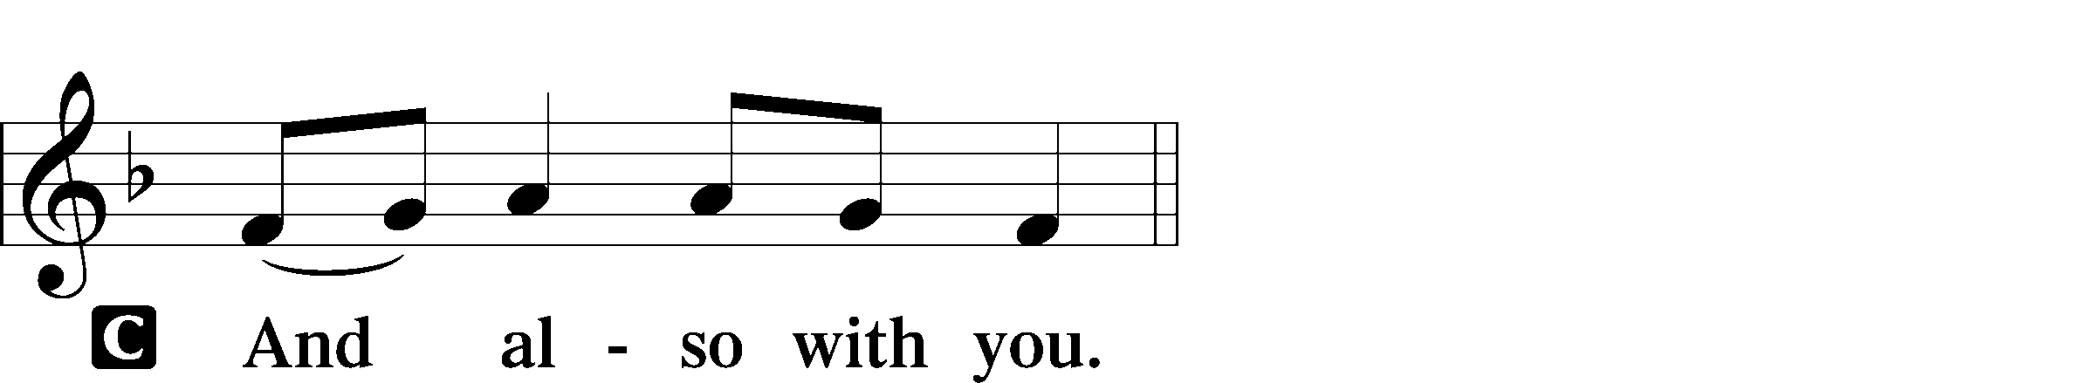
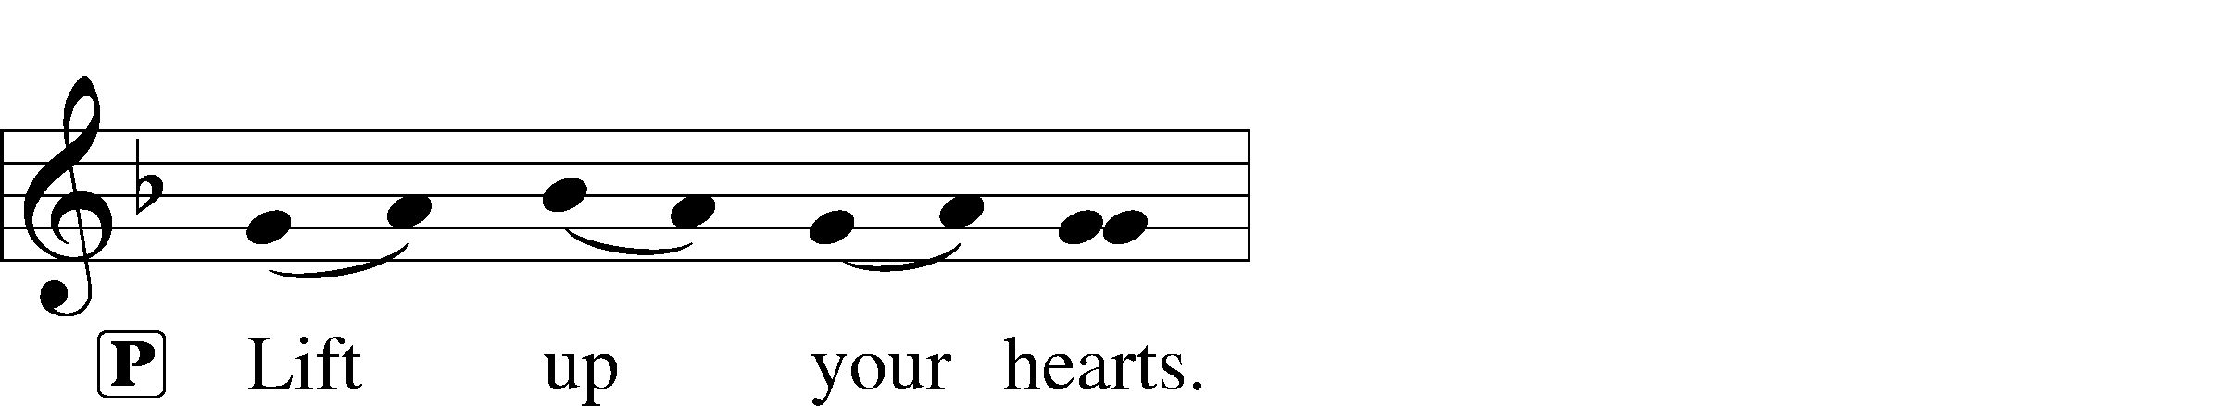
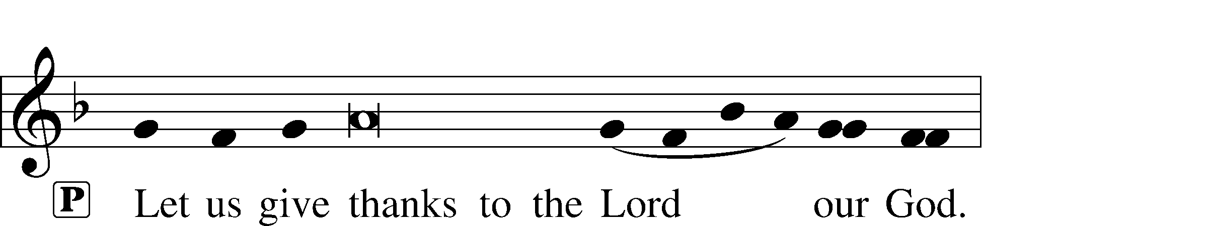
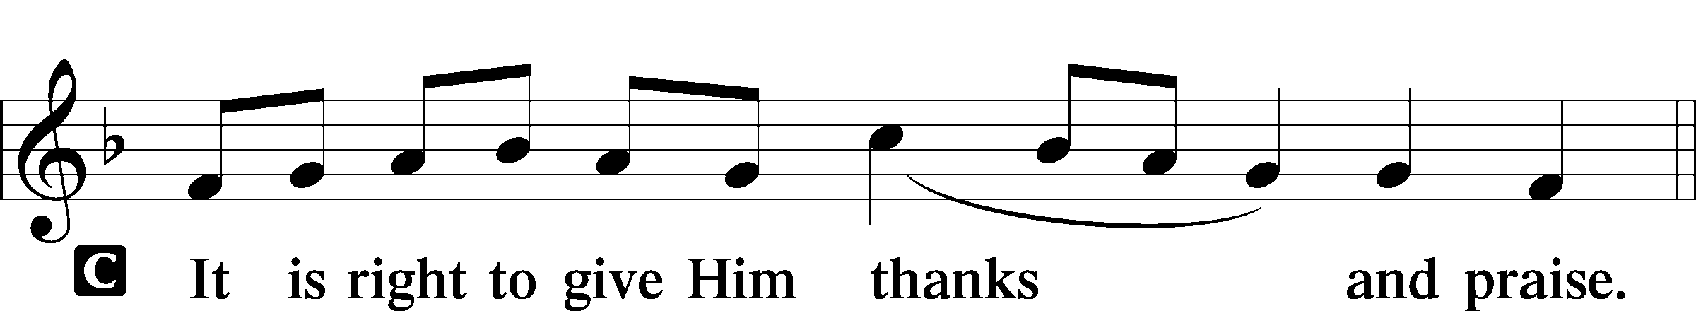

Proper Preface (Full)
P It is truly good, right, and salutary that we should at all times and in all places give thanks to You, holy Lord, almighty Father, everlasting God. And most especially are we bound to praise You on this day for the glorious resurrection of Your Son, Jesus Christ, the very Paschal Lamb, who was sacrificed for us and bore the sins of the world. By His dying He has destroyed death, and by His rising again He has restored to us everlasting life. Therefore with Mary Magdalene, Peter and John, and with all the witnesses of the resurrection, with angels and archangels, and with all the company of heaven we laud and magnify Your glorious name, evermore praising You and saying:

Sanctus LSB 161
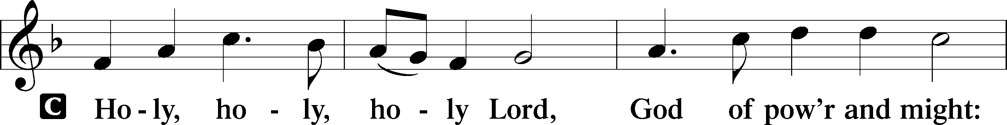
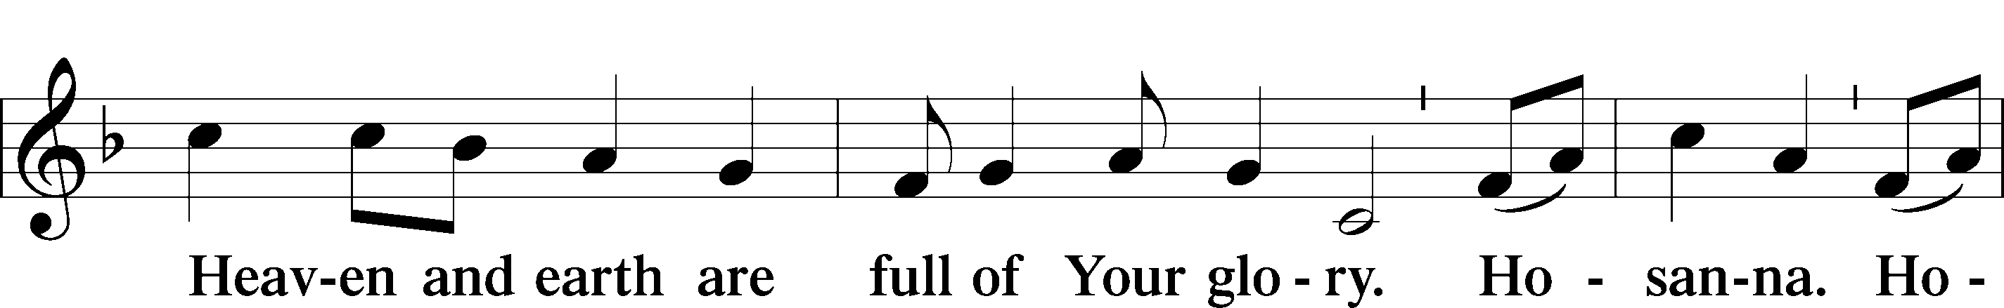
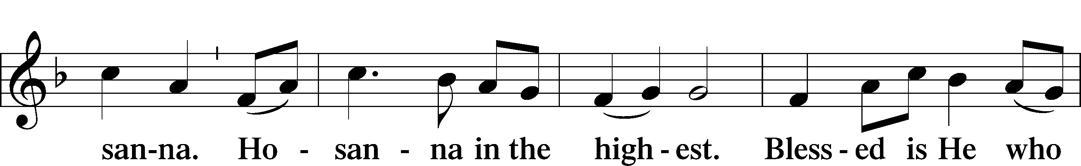
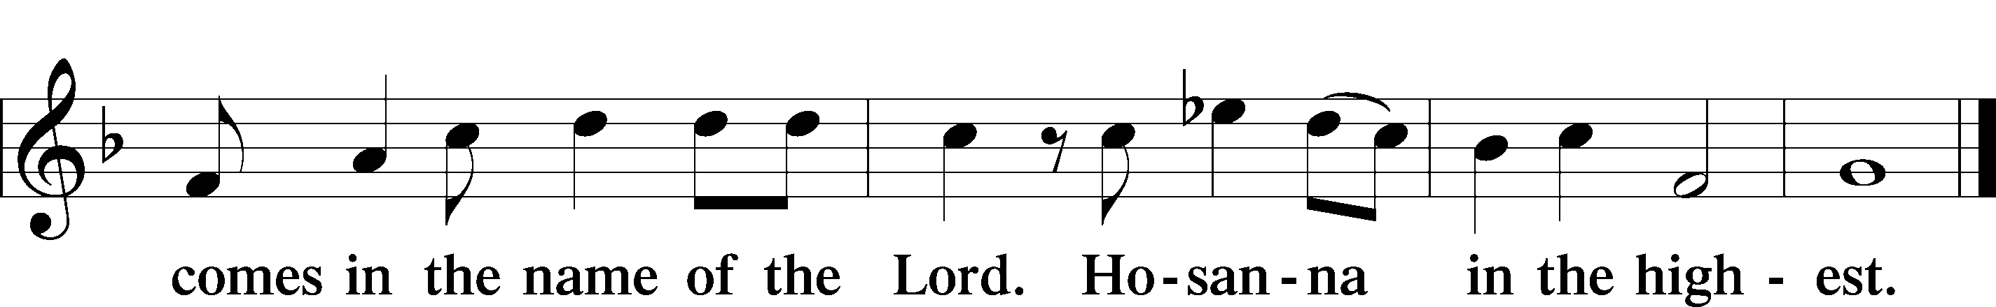

Prayer of Thanksgiving LSB 161
P Blessed are You, Lord of heaven and earth, for You have had mercy on those whom You created and sent Your only-begotten Son into our flesh to bear our sin and be our Savior. With repentant joy we receive the salvation accomplished for us by the all-availing sacrifice of His body and His blood on the cross.

Gathered in the name and the remembrance of Jesus, we beg You, O Lord, to forgive, renew, and strengthen us with Your Word and Spirit. Grant us faithfully to eat His body and drink His blood as He bids us do in His own testament. Gather us together, we pray, from the ends of the earth to celebrate with all the faithful the marriage feast of the Lamb in His kingdom, which has no end. Graciously receive our prayers; deliver and preserve us. To You alone, O Father, be all glory, honor, and worship, with the Son and the Holy Spirit, one God, now and forever.
C Amen.

P Lord, remember us in Your kingdom and teach us to pray:

Lord’s Prayer
C Our Father who art in heaven,
hallowed be Thy name,
Thy kingdom come,
Thy will be done on earth
as it is in heaven;
give us this day our daily bread;
and forgive us our trespasses
as we forgive those
who trespass against us;
and lead us not into temptation,
but deliver us from evil.
For Thine is the kingdom
and the power and the glory
forever and ever. Amen.

The Words of Our Lord
P Our Lord Jesus Christ, on the night when He was betrayed, took bread, and when He had given thanks, He broke it and gave it to the disciples and said: “Take, eat; this is My T body, which is given for you. This do in remembrance of Me.”

In the same way also He took the cup after supper, and when He had given thanks, He gave it to them, saying: “Drink of it, all of you; this cup is the new testament in My T blood, which is shed for you for the forgiveness of sins. This do, as often as you drink it, in remembrance of Me.”

Pax Domini LSB 163
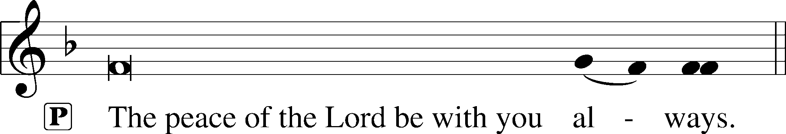
Agnus Dei LSB 163
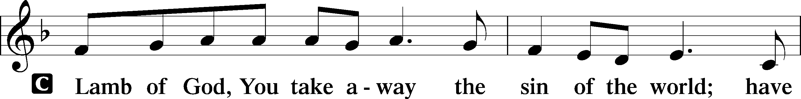
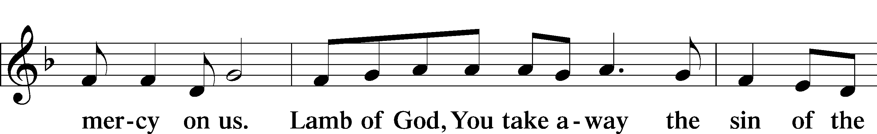
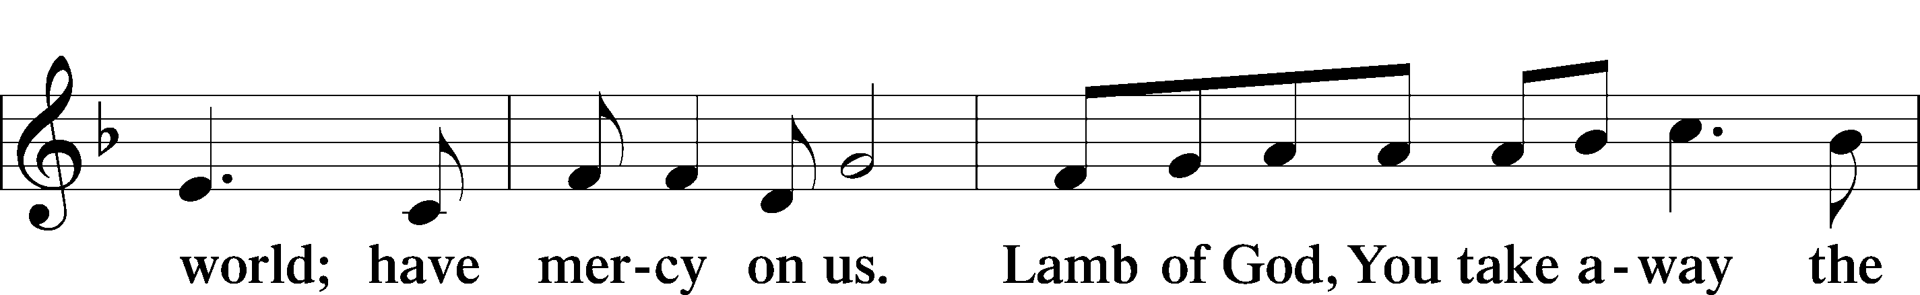
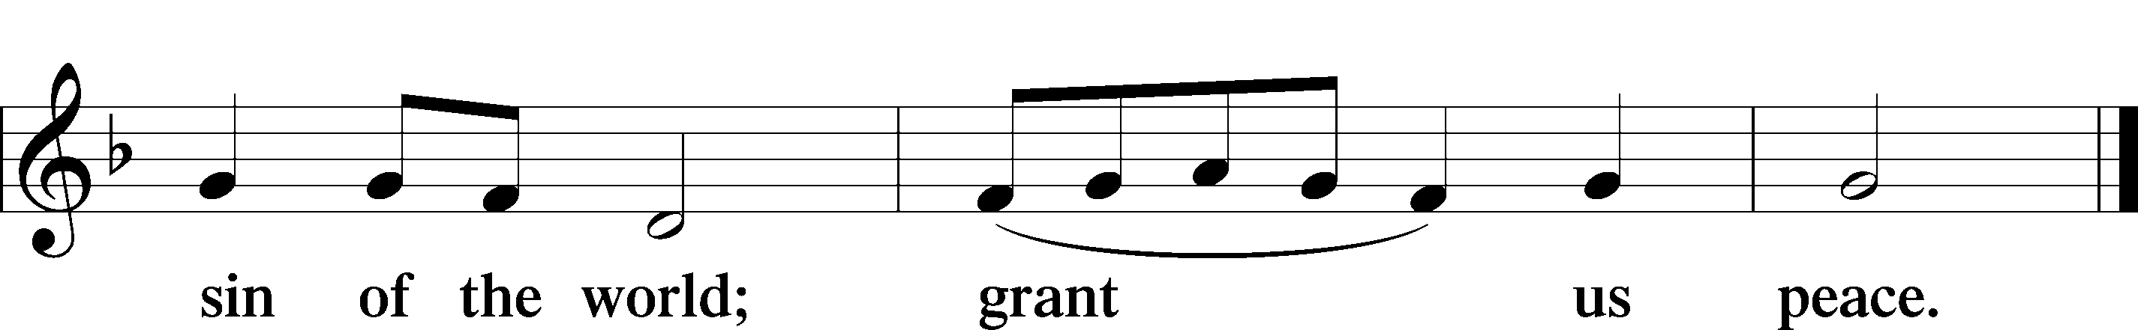

Distribution

543 What Wondrous Love Is This
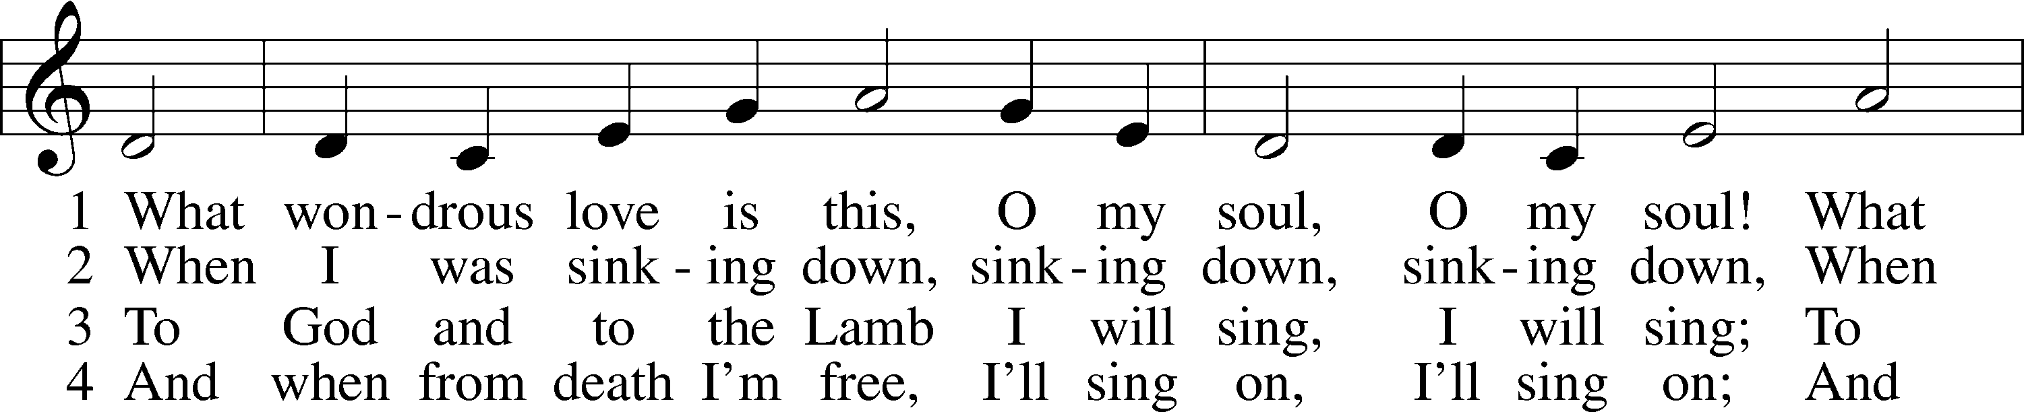
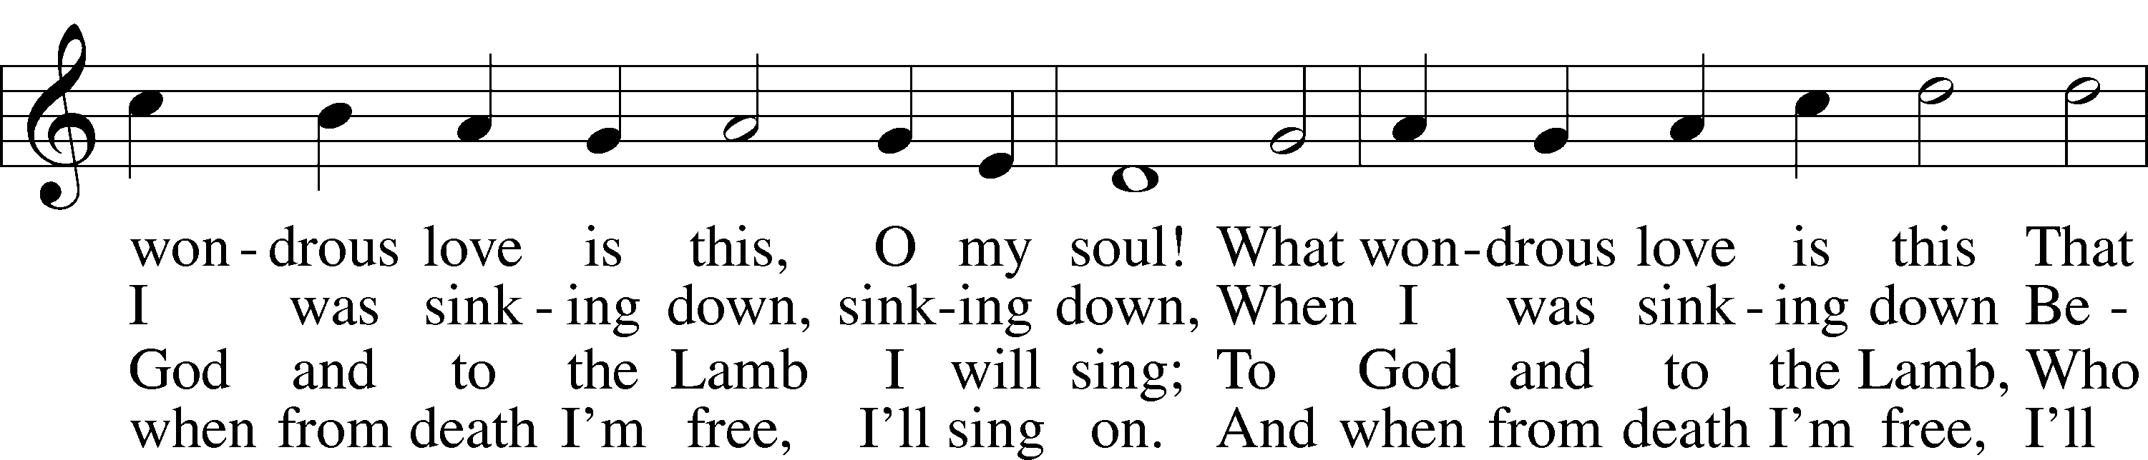
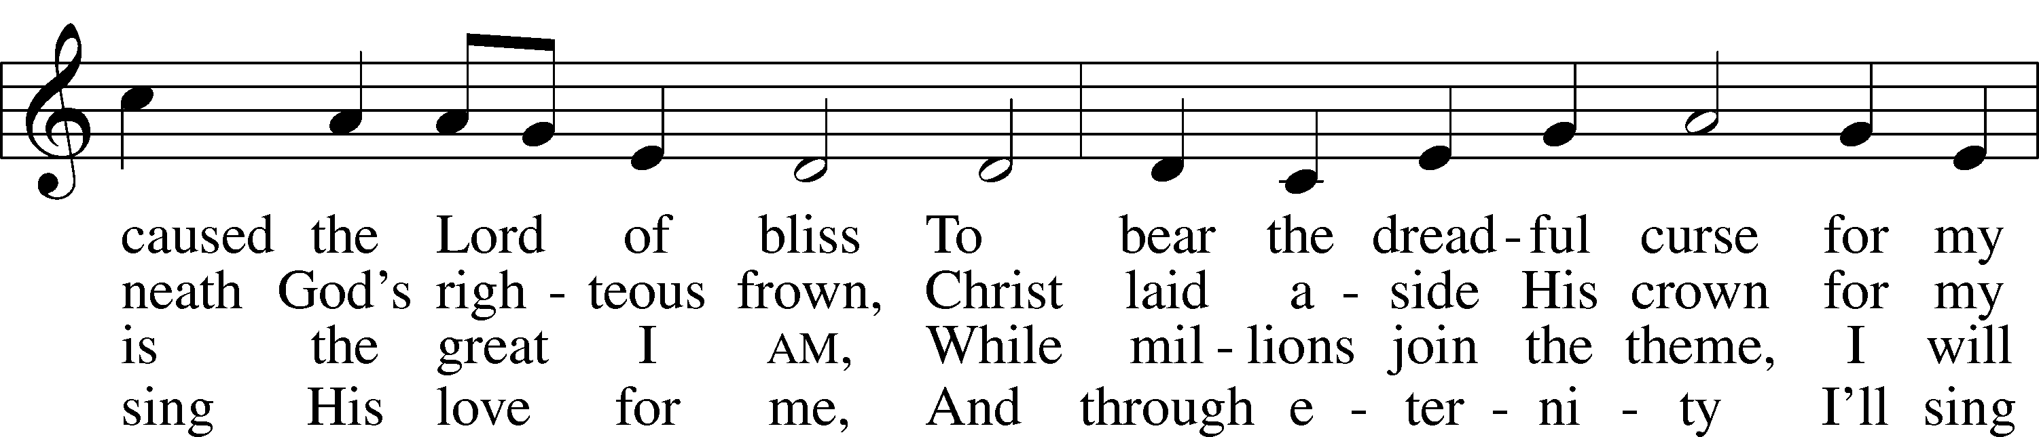
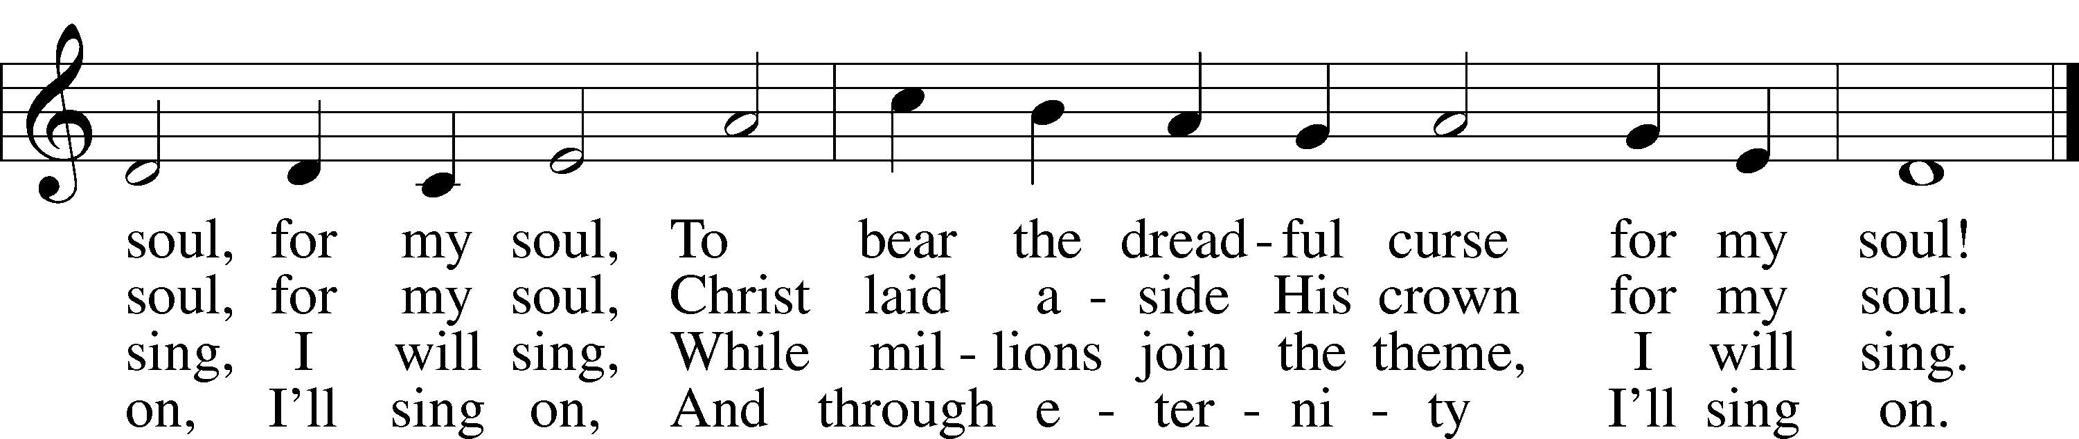
563 Jesus, Thy Blood and Righteousness
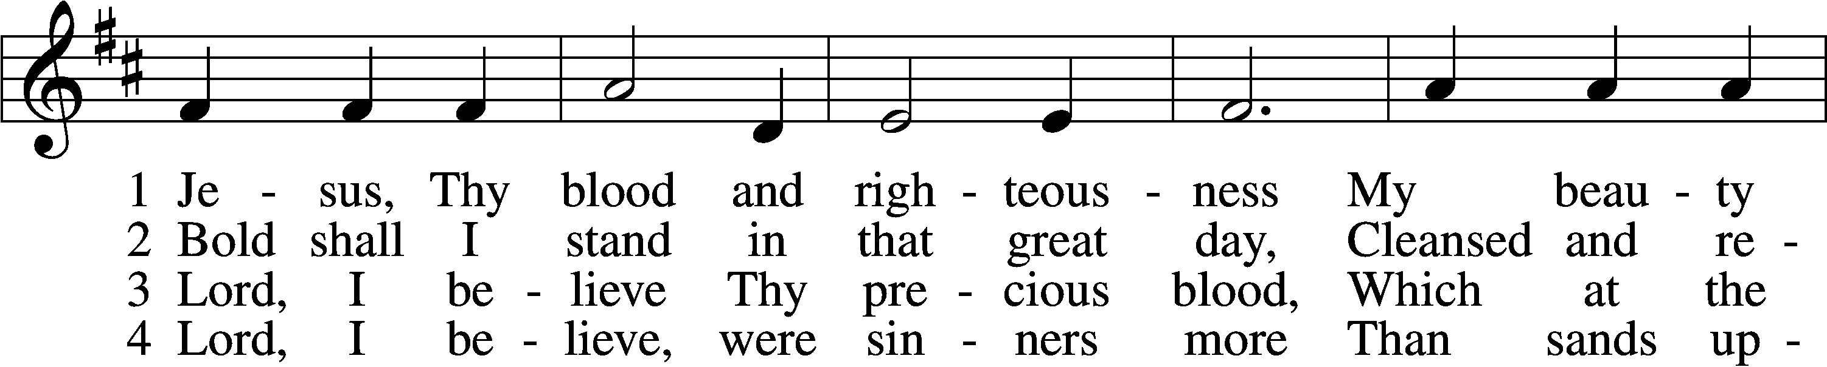
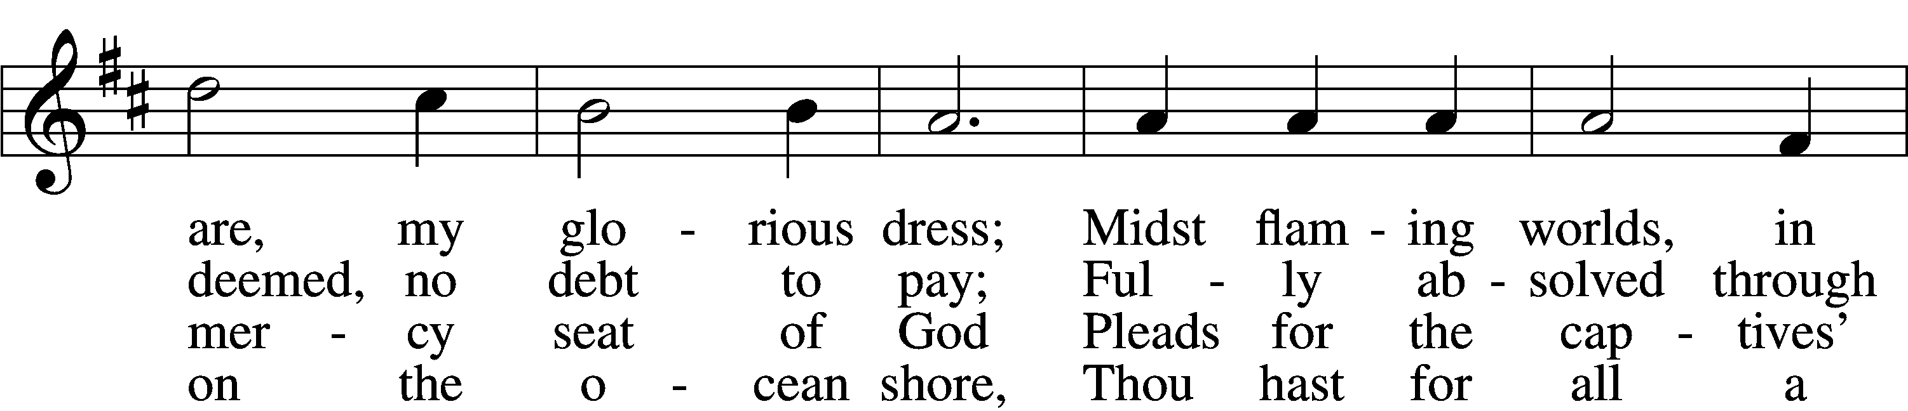
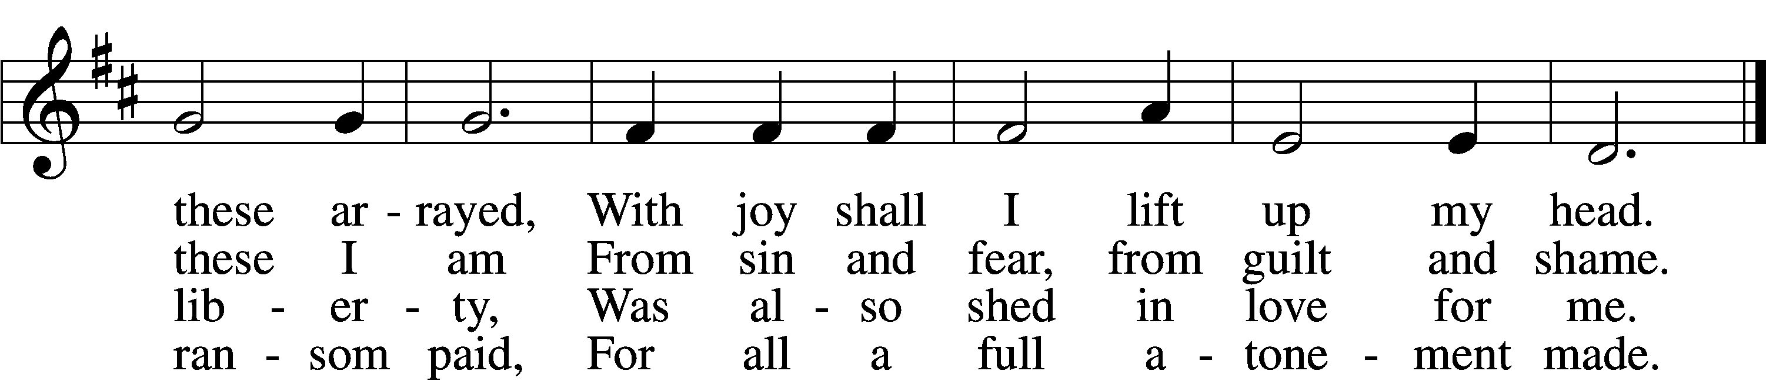

5 When from the dust of death I rise
To claim my mansion in the skies,
This then shall be my only plea:
Jesus hath lived and died for me.

6 Jesus, be endless praise to Thee,
Whose boundless mercy hath for me,
For me, and all Thy hands have made,
An everlasting ransom paid.
Text: Nicolaus Ludwig von Zinzendorf, 1700–60; tr. John B. Wesley, 1703–91, alt.
Tune: George J. Elvey, 1816–93
Text and tune: Public domain

700 Love Divine, All Loves Excelling
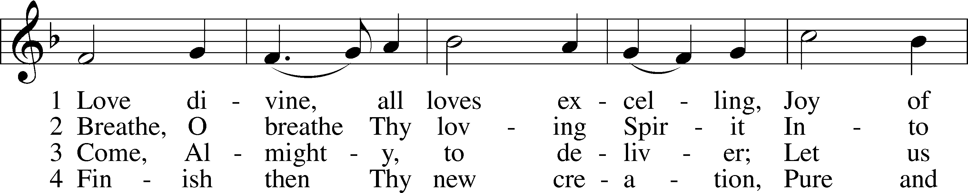
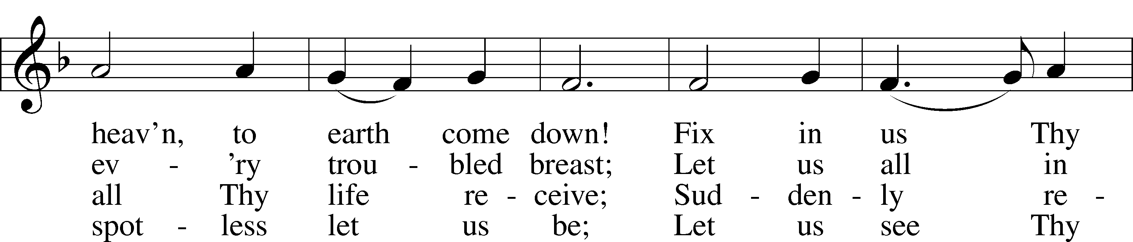
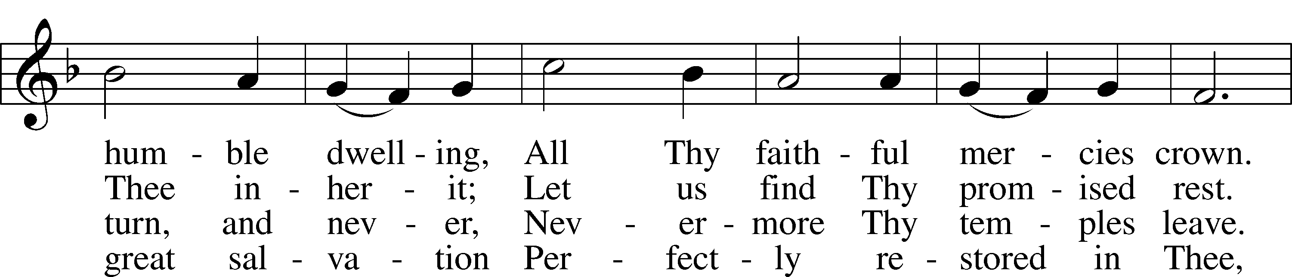
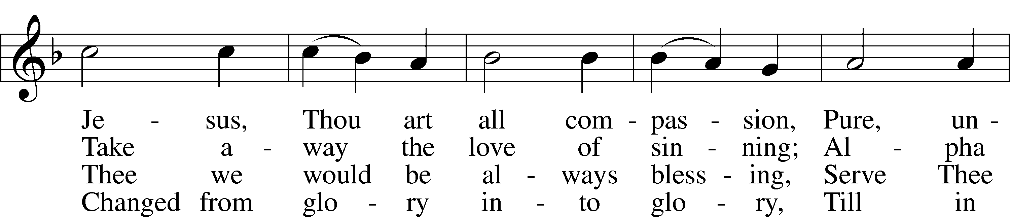
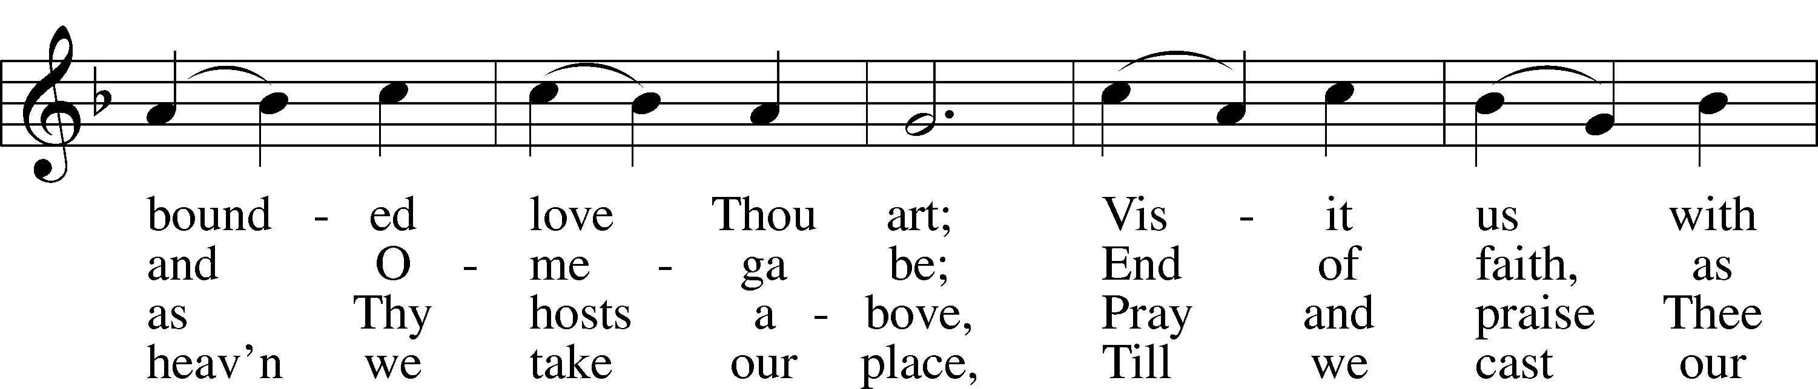
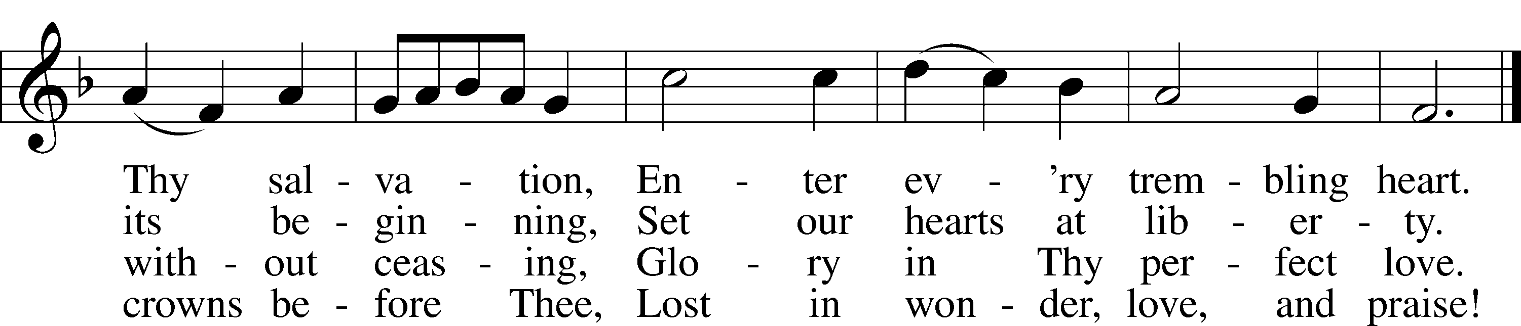
Text: Charles Wesley, 1707–88
Tune: Rowland H. Prichard, 1811–87
Text and tune: Public domain

Stand

Thank the Lord LSB 164
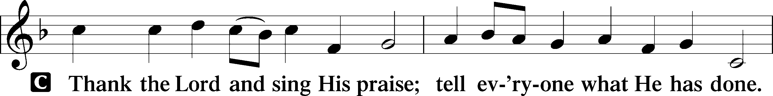
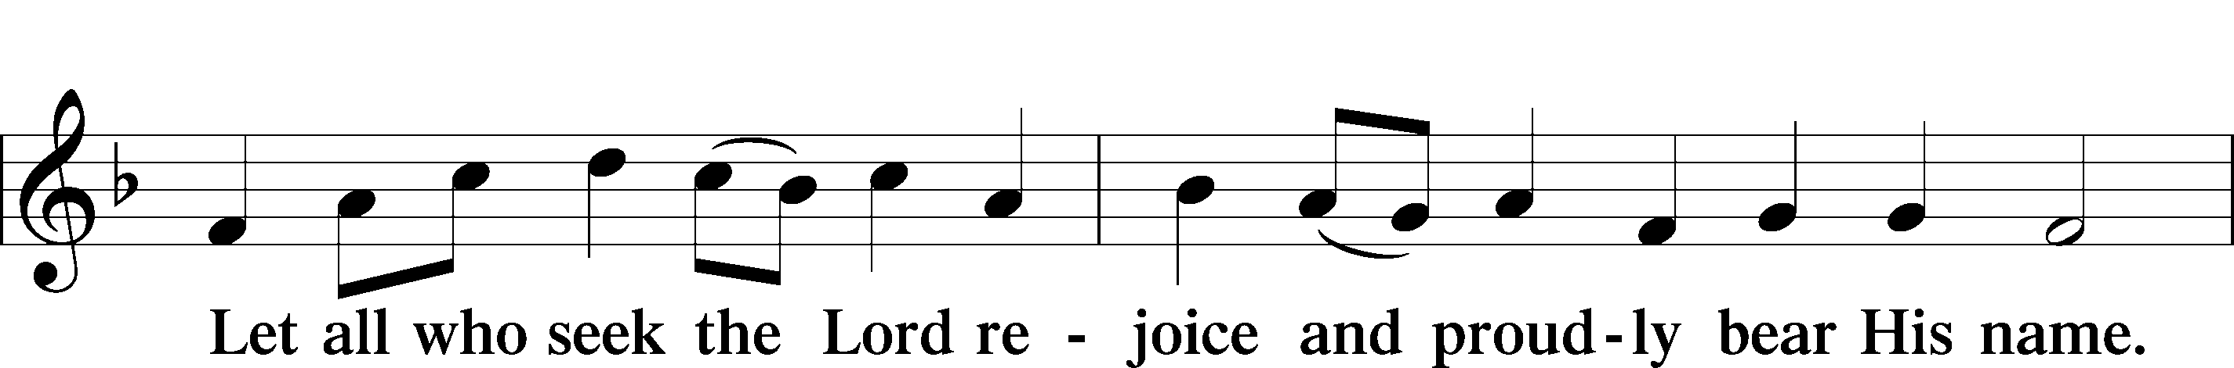
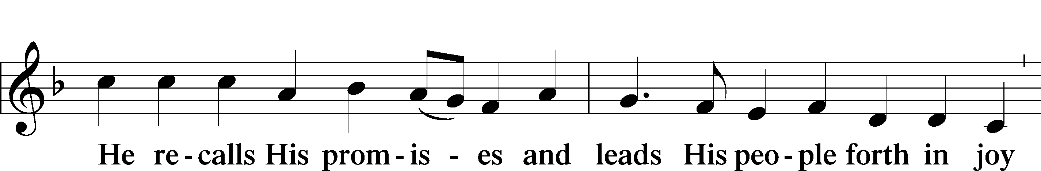
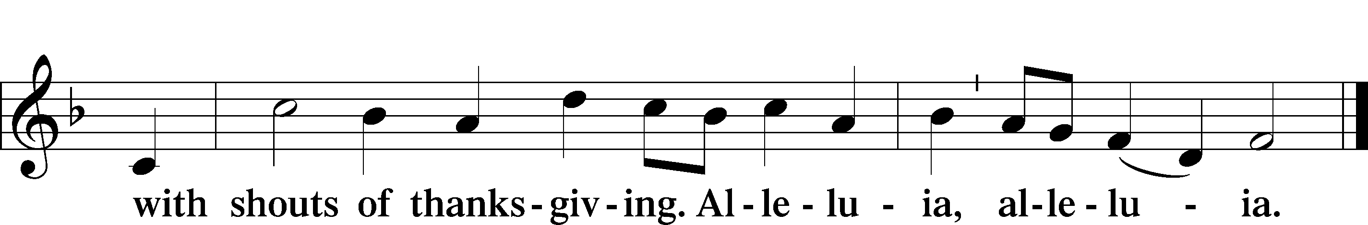

Post-Communion Collect
A Let us pray.
We give thanks to You, almighty God, that You have refreshed us through this salutary gift, and we implore You that of Your mercy You would strengthen us through the same in faith toward You and in fervent love toward one another; through Jesus Christ, Your Son, our Lord, who lives and reigns with You and the Holy Spirit, one God, now and forever.

Benediction LSB 166
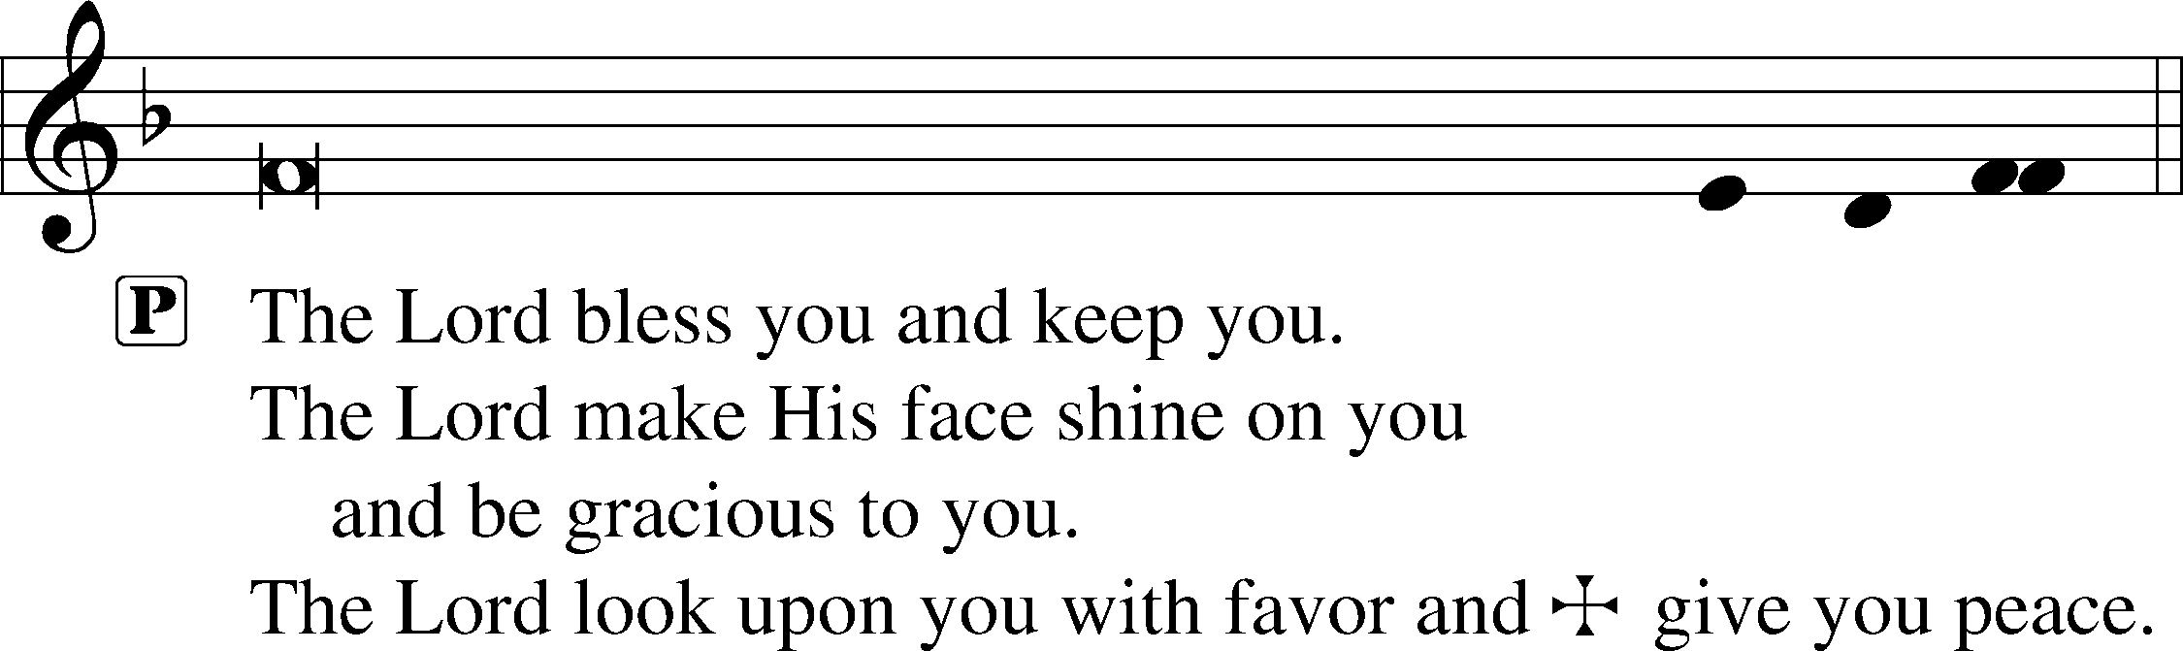

922 Go, My Children, with My Blessing sts. 1–4
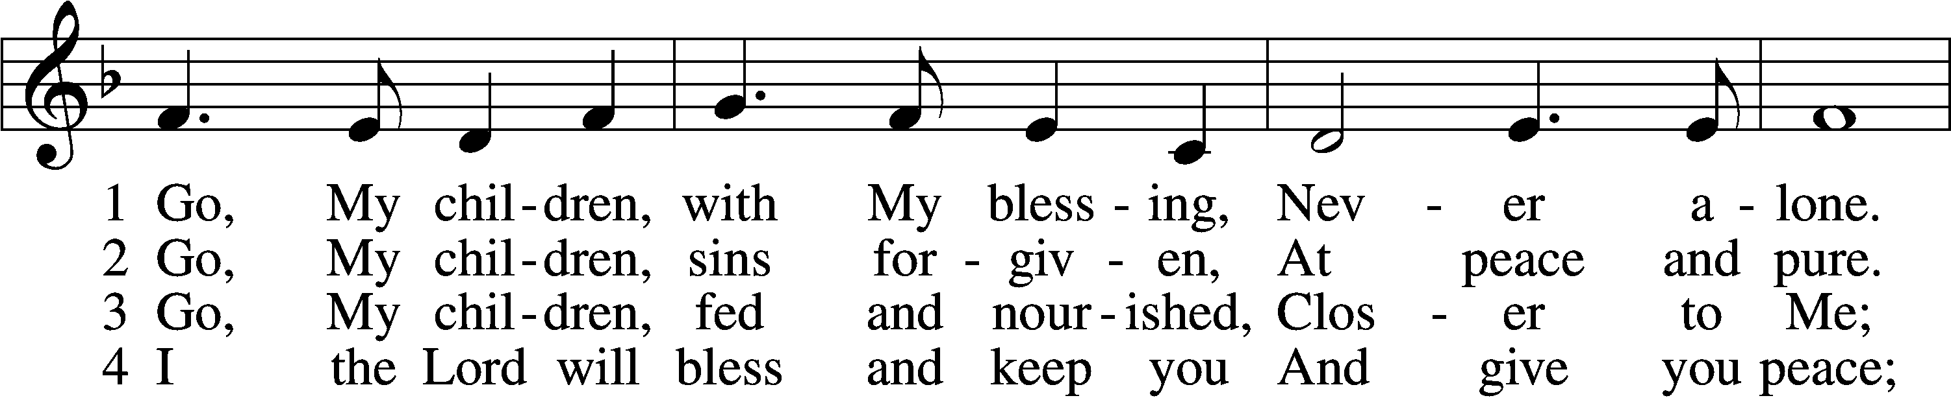
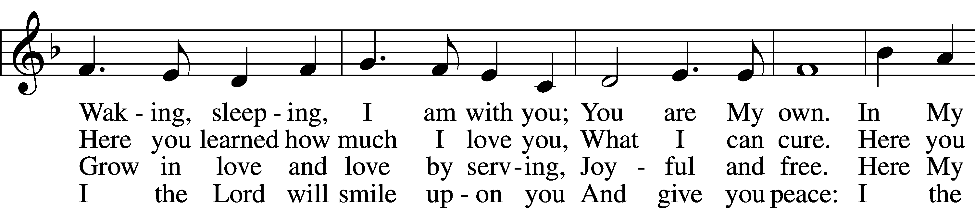
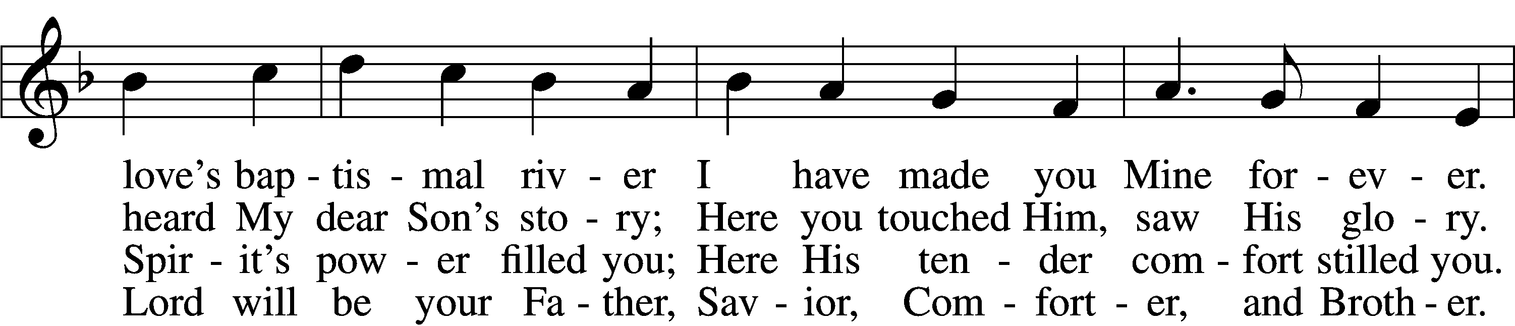
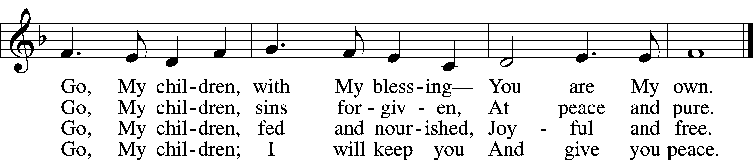
Text: Jaroslav J. Vajda, 1919–2008
Tune: Welsh, 18th cent.
Text: © 1983 Concordia Publishing House. Used by permission: LSB Hymn License no. 110002831
Tune: Public domain

Acknowledgments
Unless otherwise indicated, Scripture quotations are from the ESV® Bible (The Holy Bible, English Standard Version®), copyright © 2001 by Crossway, a publishing ministry of Good News Publishers. Used by permission. All rights reserved.
Created by Lutheran Service Builder © 2024 Concordia Publishing House.

