Second Sunday of Easter
Divine Service 4 p. 203
April 6 & 7, 2024
St. Paul Lutheran Church

Confession and Absolution

940 Holy God, We Praise Thy Name sts. 1–5
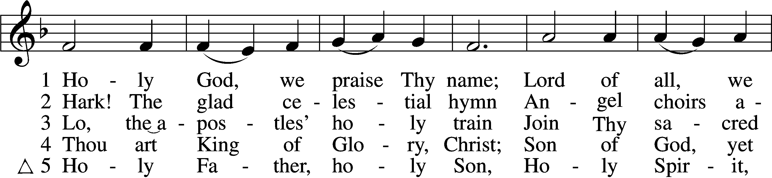
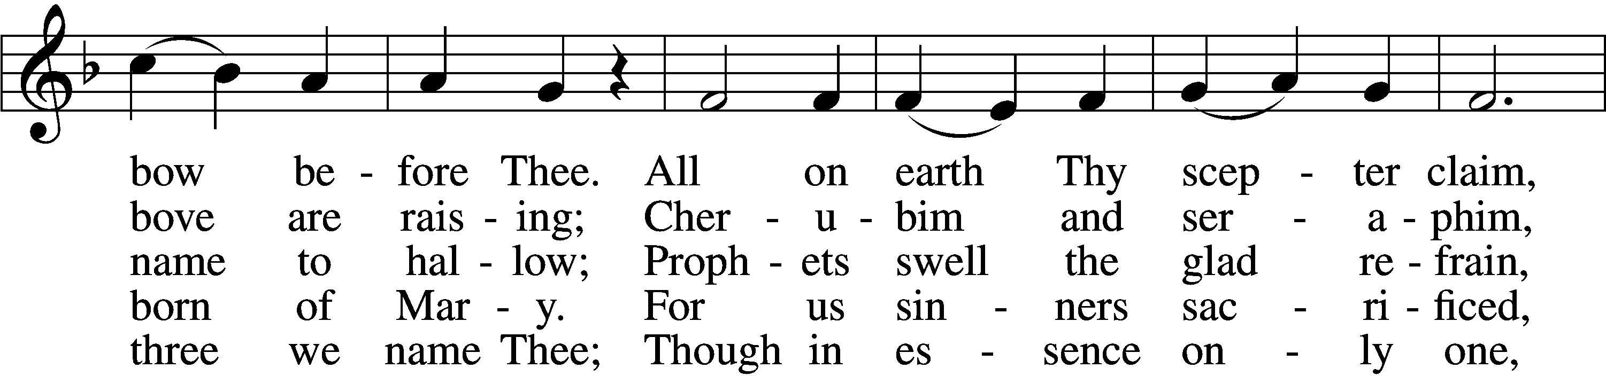
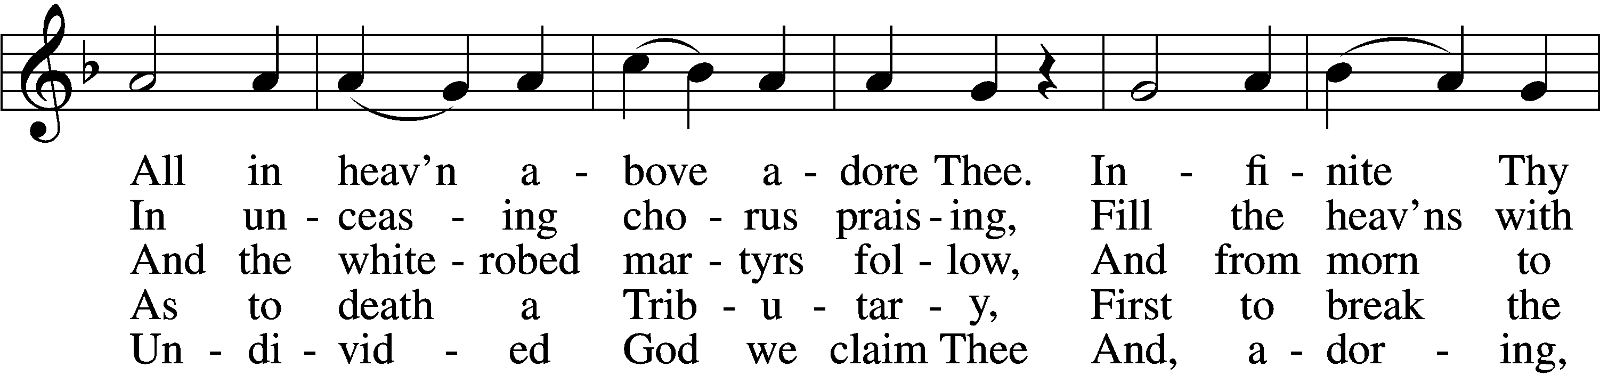
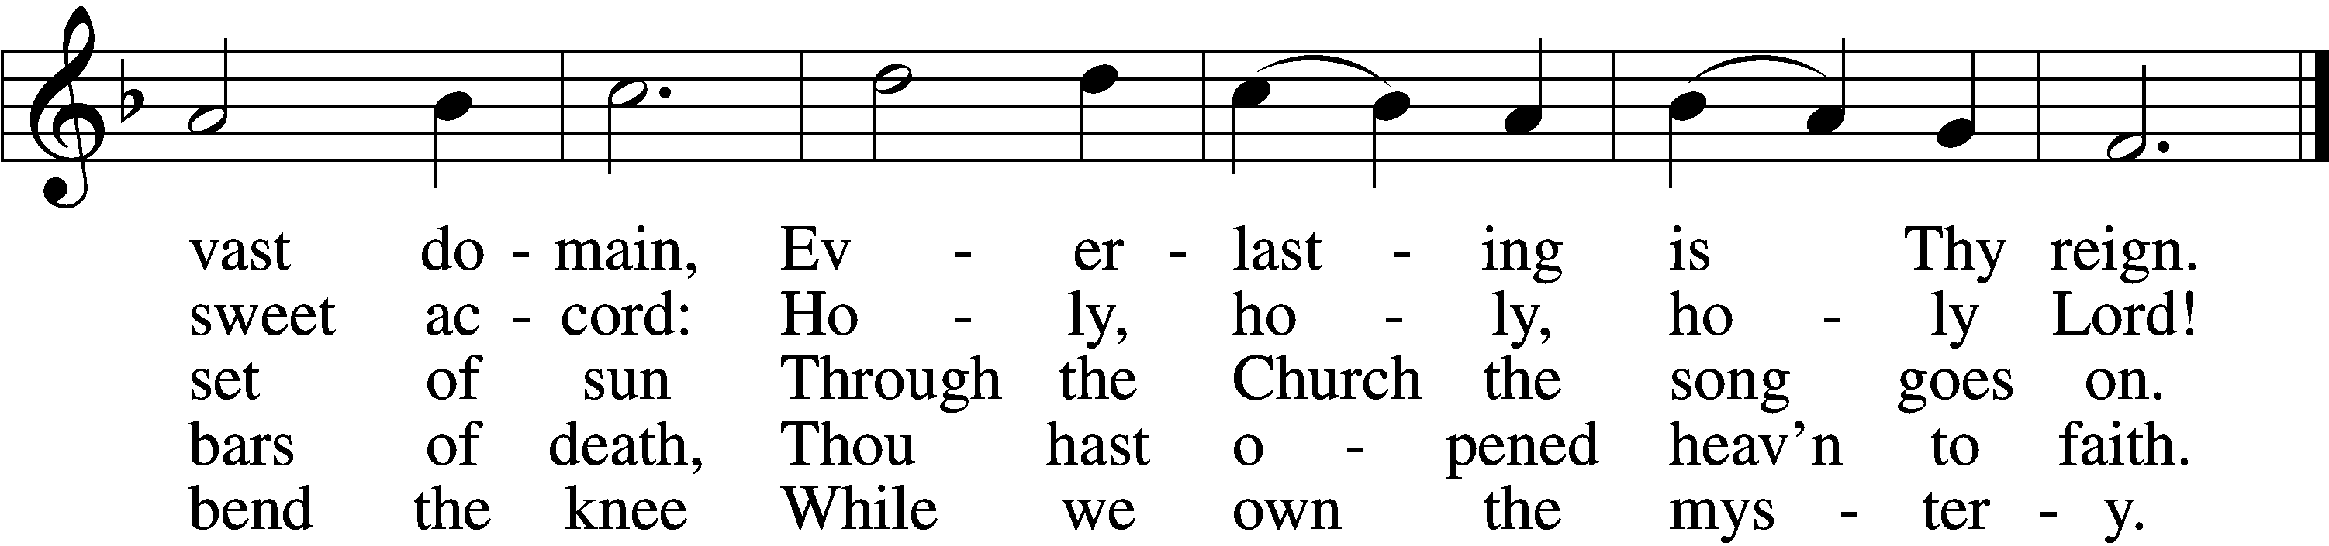
Text: Latin, c. 4th cent.; German version Katholisches Gesangbuch, 1774, Vienna; tr. Clarence A. Walworth, 1820–1900, alt.
Tune: Katholisches Gesangbuch, 1774, Vienna
Text and tune: Public domain

Stand

The sign of the cross may be made by all in remembrance of their Baptism.

Invocation
P In the name of the Father and of the T Son and of the Holy Spirit.
C Amen.

Exhortation LSB 203
P Our help is in the name of the Lord,
C who made heaven and earth.

P If You, O Lord, kept a record of sins, O Lord, who could stand?
C But with You there is forgiveness; therefore You are feared.

P Since we are gathered to hear God’s Word, call upon Him in prayer and praise, and receive the body and blood of our Lord Jesus Christ in the fellowship of this altar, let us first consider our unworthiness and confess before God and one another that we have sinned in thought, word, and deed, and that we cannot free ourselves from our sinful condition. Together as His people let us take refuge in the infinite mercy of God, our heavenly Father, seeking His grace for the sake of Christ, and saying: God, be merciful to me, a sinner.

Kneel/Stand

Confession of Sins LSB 203
C Almighty God, have mercy upon us, forgive us our sins, and lead us to everlasting life. Amen.

Prayer for Forgiveness
P Almighty God, merciful Father, in Holy Baptism You declared us to be Your children and gathered us into Your one, holy Church, in which You daily and richly forgive us our sins and grant us new life through Your Spirit. Be in our midst, enliven our faith, and graciously receive our prayer and praise; through Your Son, Jesus Christ, our Lord.
C Amen.

Stand

Service of the Word

PSALM Psalm 148
1Praise the Lord!
Praise the Lord from the heavens;
praise him in the heights!
2Praise him, all his angels;
praise him, all his hosts!
3Praise him, sun and moon,
praise him, all you shining stars!
4Praise him, you highest heavens,
and you waters above the heavens!
5Let them praise the name of the Lord!
For he commanded and they were created.
6And he established them forever and ever;
he gave a decree, and it shall not pass away.
7Praise the Lord from the earth,
you great sea creatures and all deeps,
8fire and hail, snow and mist,
stormy wind fulfilling his word!
9Mountains and all hills,
fruit trees and all cedars!
10Beasts and all livestock,
creeping things and flying birds!
11Kings of the earth and all peoples,
princes and all rulers of the earth!
12Young men and maidens together,
old men and children!
13Let them praise the name of the Lord,
for his name alone is exalted;
his majesty is above earth and heaven.
14He has raised up a horn for his people,
praise for all his saints,
for the people of Israel who are near to him. Praise the Lord!

Kyrie LSB 204
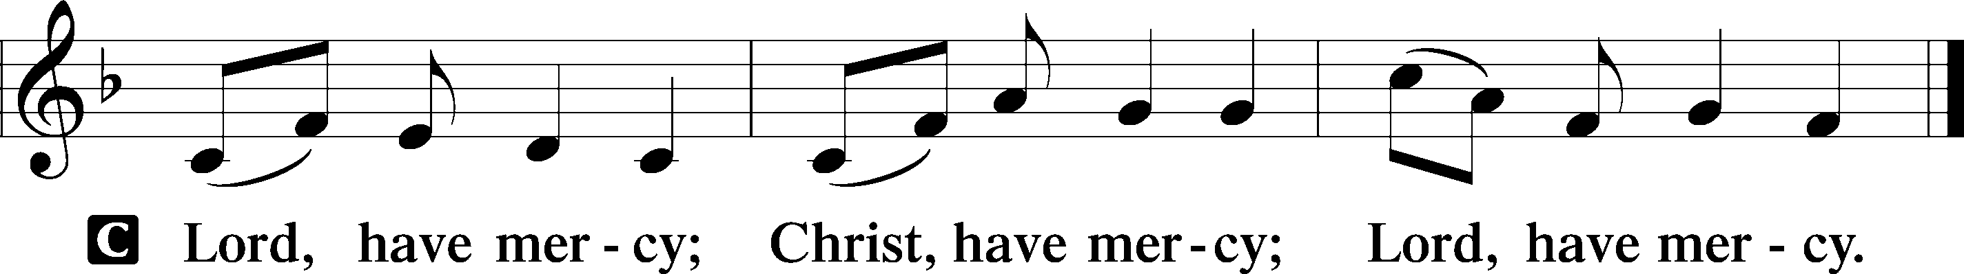

Gloria in Excelsis LSB 204
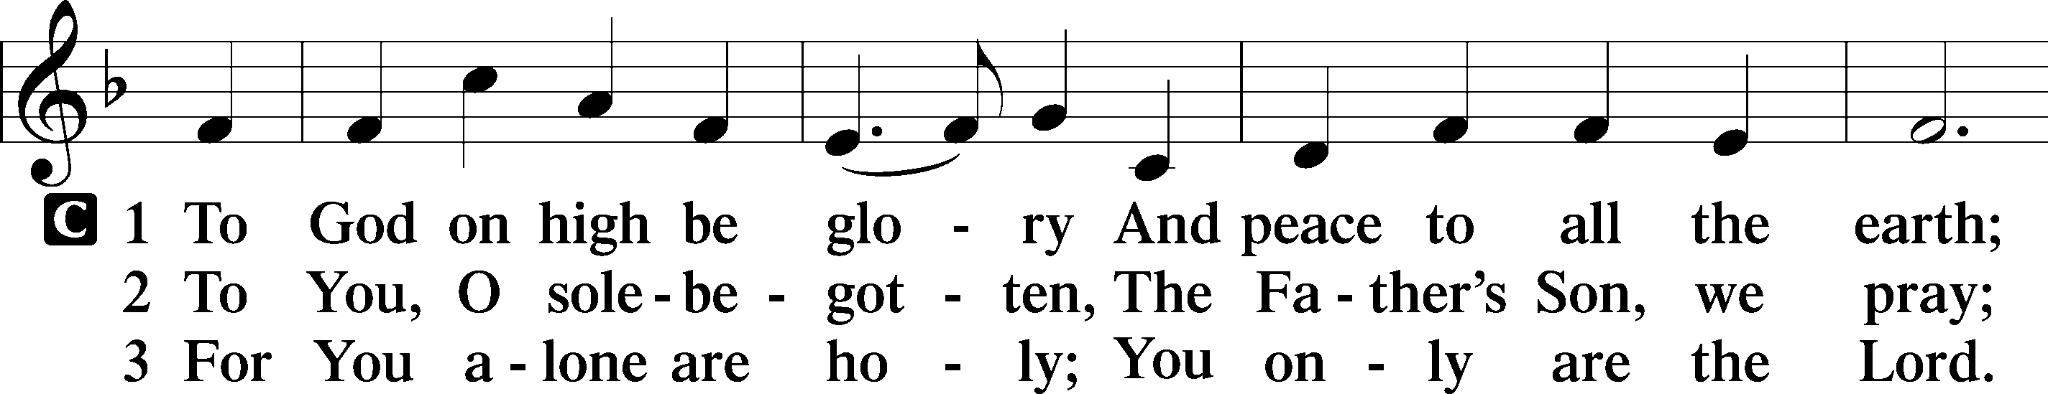
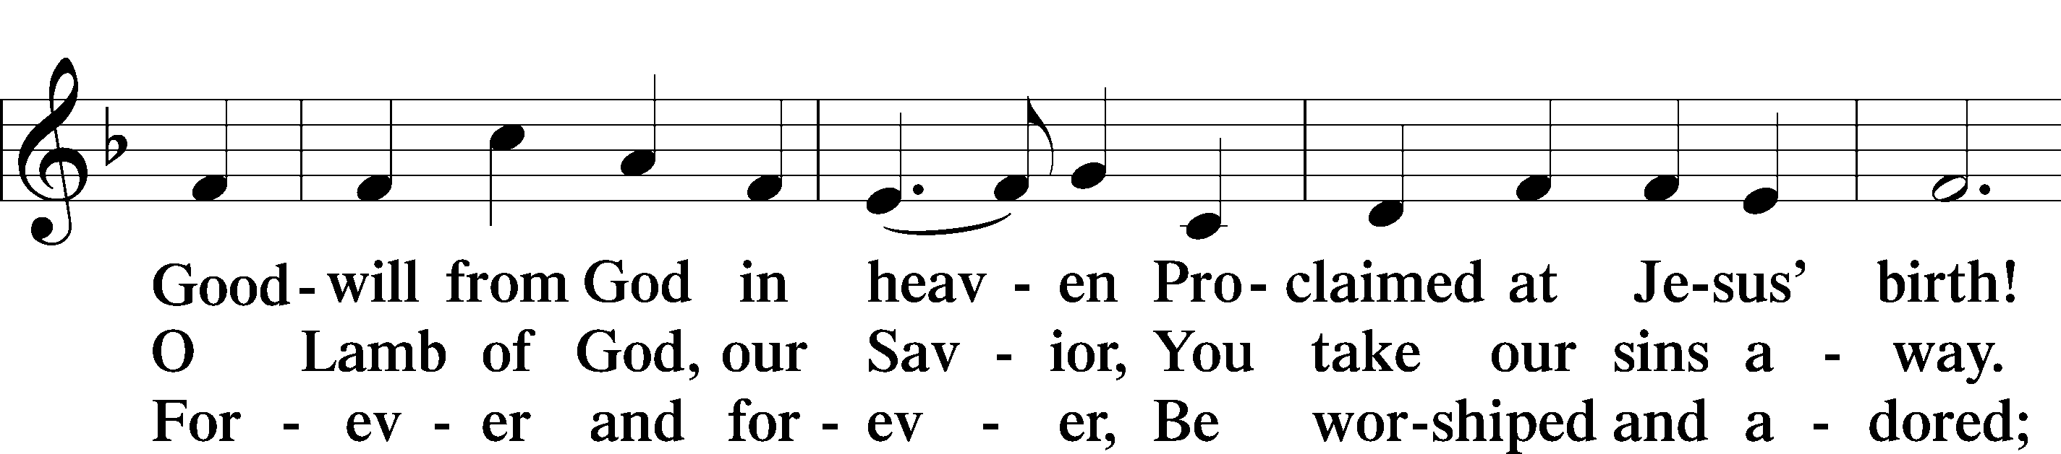
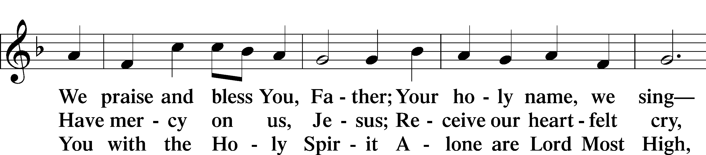
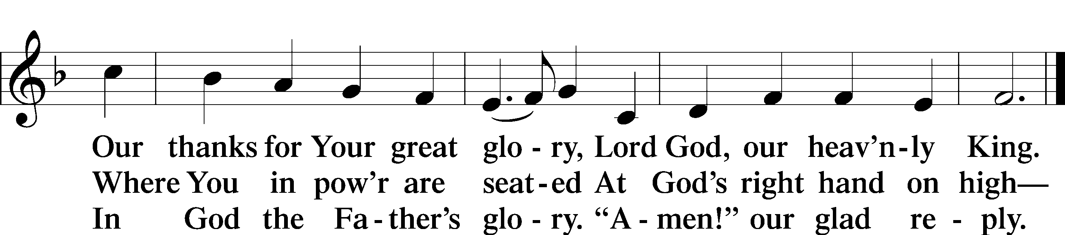
Text: Stephen P. Starke

Salutation and Collect of the Day
P The Lord be with you.
C And also with you.

P Let us pray.
Almighty God, grant that we who have celebrated the Lord’s resurrection may by Your grace confess in our life and conversation that Jesus is Lord and God; through the same Jesus Christ, Your Son, who lives and reigns with You and the Holy Spirit, one God, now and forever.

C Amen.

Sit

First Reading Acts 4:32–35
32The full number of those who believed were of one heart and soul, and no one said that any of the things that belonged to him was his own, but they had everything in common. 33And with great power the apostles were giving their testimony to the resurrection of the Lord Jesus, and great grace was upon them all. 34There was not a needy person among them, for as many as were owners of lands or houses sold them and brought the proceeds of what was sold 35and laid it at the apostles’ feet, and it was distributed to each as any had need.

A This is the Word of the Lord.
C Thanks be to God.

Epistle 1 John 1:1—2:2
1That which was from the beginning, which we have heard, which we have seen with our eyes, which we looked upon and have touched with our hands, concerning the word of life— 2the life was made manifest, and we have seen it, and testify to it and proclaim to you the eternal life, which was with the Father and was made manifest to us— 3that which we have seen and heard we proclaim also to you, so that you too may have fellowship with us; and indeed our fellowship is with the Father and with his Son Jesus Christ. 4And we are writing these things so that our joy may be complete.
5This is the message we have heard from him and proclaim to you, that God is light, and in him is no darkness at all. 6If we say we have fellowship with him while we walk in darkness, we lie and do not practice the truth. 7But if we walk in the light, as he is in the light, we have fellowship with one another, and the blood of Jesus his Son cleanses us from all sin. 8If we say we have no sin, we deceive ourselves, and the truth is not in us. 9If we confess our sins, he is faithful and just to forgive us our sins and to cleanse us from all unrighteousness. 10If we say we have not sinned, we make him a liar, and his word is not in us.
1My little children, I am writing these things to you so that you may not sin. But if anyone does sin, we have an advocate with the Father, Jesus Christ the righteous. 2He is the propitiation for our sins, and not for ours only but also for the sins of the whole world.

A This is the Word of the Lord.
C Thanks be to God.

Stand

Alleluia and Verse

Alleluia LSB 205
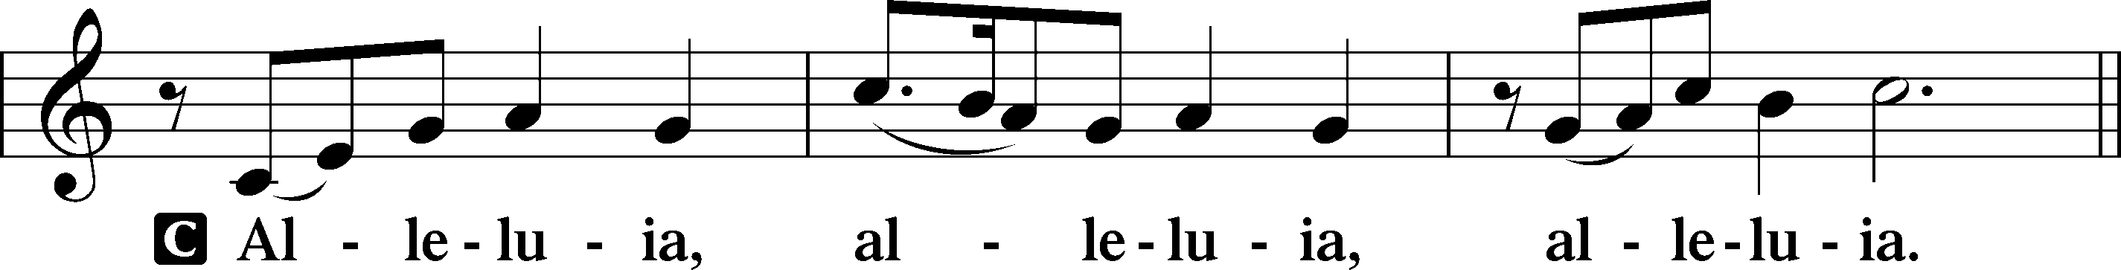

Verse LSB 205
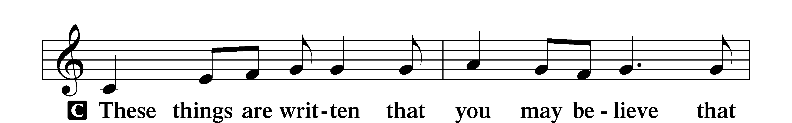
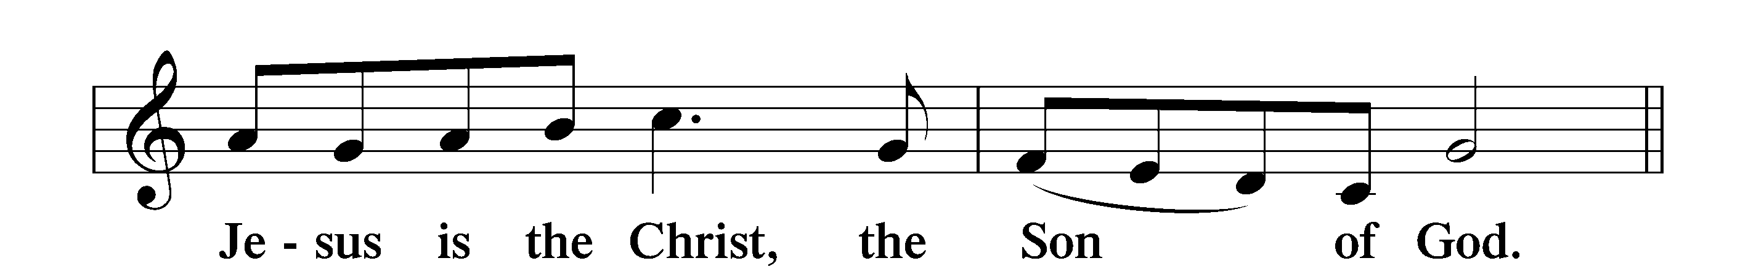

Alleluia LSB 205
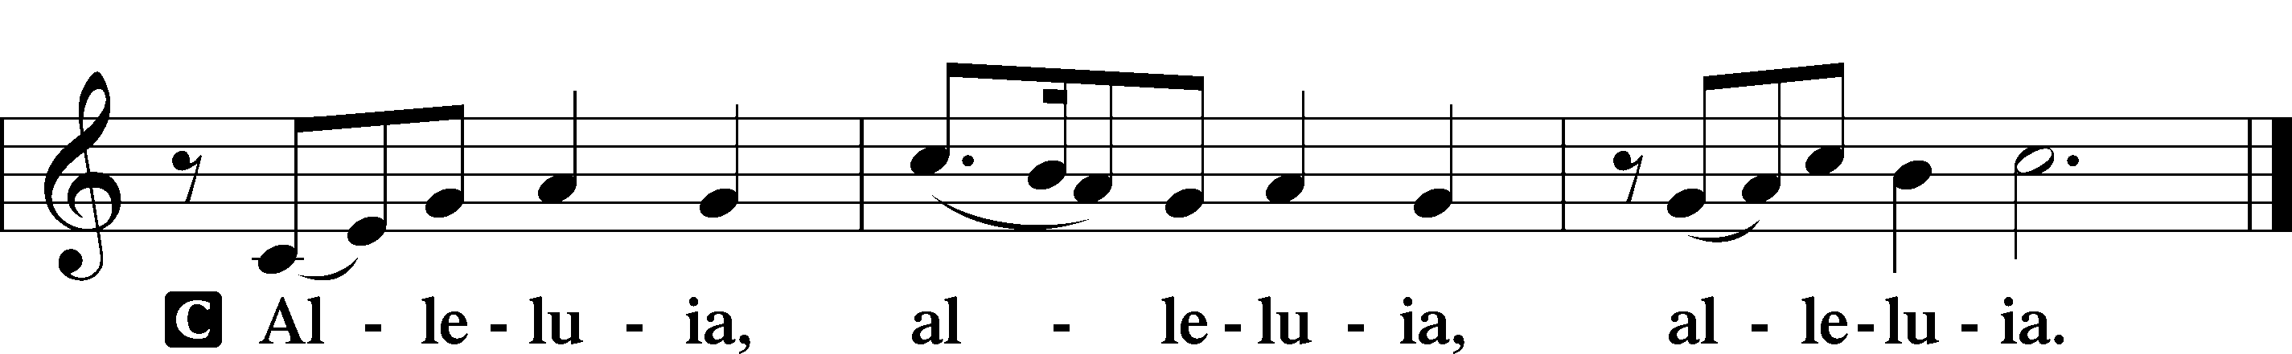

Holy Gospel John 20:19–31
P The Holy Gospel according to St. John, the twentieth chapter.
C Glory to You, O Lord.

19On the evening of that day, the first day of the week, the doors being locked where the disciples were for fear of the Jews, Jesus came and stood among them and said to them, “Peace be with you.” 20When he had said this, he showed them his hands and his side. Then the disciples were glad when they saw the Lord. 21Jesus said to them again, “Peace be with you. As the Father has sent me, even so I am sending you.” 22And when he had said this, he breathed on them and said to them, “Receive the Holy Spirit. 23If you forgive the sins of anyone, they are forgiven; if you withhold forgiveness from anyone, it is withheld.”
24Now Thomas, one of the Twelve, called the Twin, was not with them when Jesus came. 25So the other disciples told him, “We have seen the Lord.” But he said to them, “Unless I see in his hands the mark of the nails, and place my finger into the mark of the nails, and place my hand into his side, I will never believe.”
26Eight days later, his disciples were inside again, and Thomas was with them. Although the doors were locked, Jesus came and stood among them and said, “Peace be with you.” 27Then he said to Thomas, “Put your finger here, and see my hands; and put out your hand, and place it in my side. Do not disbelieve, but believe.” 28Thomas answered him, “My Lord and my God!” 29Jesus said to him, “Have you believed because you have seen me? Blessed are those who have not seen and yet have believed.”
30Now Jesus did many other signs in the presence of the disciples, which are not written in this book; 31but these are written so that you may believe that Jesus is the Christ, the Son of God, and that by believing you may have life in his name.

P This is the Gospel of the Lord.
C Praise to You, O Christ.

Nicene Creed
C I believe in one God,
the Father Almighty,
maker of heaven and earth
and of all things visible and invisible.

And in one Lord Jesus Christ,
the only-begotten Son of God,
begotten of His Father before all worlds,
God of God, Light of Light,
very God of very God,
begotten, not made,
being of one substance with the Father,
by whom all things were made;
who for us men and for our salvation came down from heaven
and was incarnate by the Holy Spirit of the virgin Mary
and was made man;
and was crucified also for us under Pontius Pilate.
He suffered and was buried.
And the third day He rose again according to the Scriptures
and ascended into heaven
and sits at the right hand of the Father.
And He will come again with glory to judge both the living and the dead,
whose kingdom will have no end.

And I believe in the Holy Spirit,
the Lord and giver of life,
who proceeds from the Father and the Son,
who with the Father and the Son together is worshiped and glorified,
who spoke by the prophets.
And I believe in one holy Christian and apostolic Church,
I acknowledge one Baptism for the remission of sins,
and I look for the resurrection of the dead
and the life T of the world to come. Amen.

Sit

527 O Savior, Precious Savior
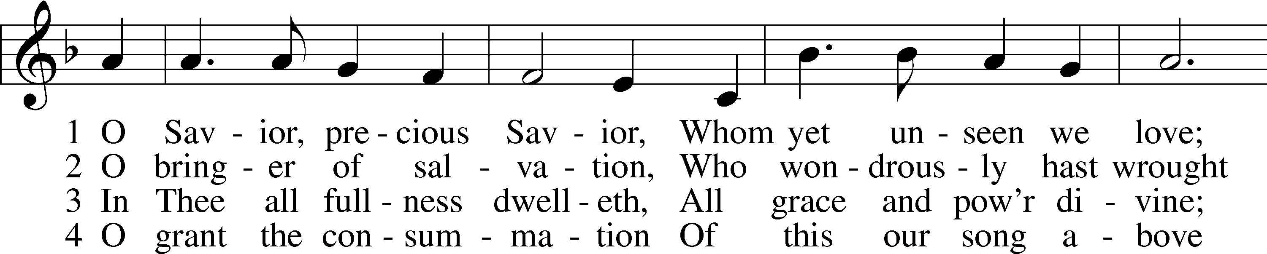
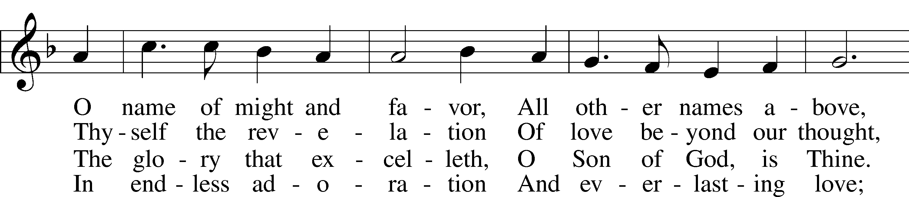
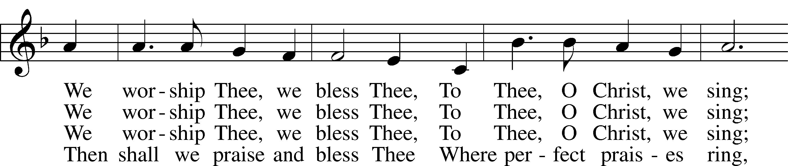
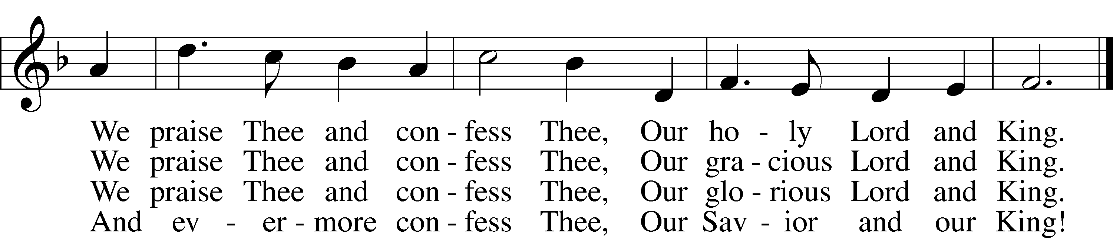
Text: Frances R. Havergal, 1836–79
Tune: Arthur H. Mann, 1850–1929
Text and tune: Public domain

Children’s Sermon
Sermon

Stand

Prayer of the Church
P Let us pray for the whole Church of God in Christ Jesus and for all people according to their needs.
Heavenly Father, Your Son is the firstborn from the dead. In Him, we have been reborn into a new and living hope. Nurture us with the pure milk of Your Word, that we may grow to maturity of faith and have everlasting life. Lord, in Your mercy,
C hear our prayer.

P Grant to those ordained for Your service the gift of the Spirit, wisdom that comes down from above, and grace to faithfully fulfill their holy calling where You have placed them. Lord, in Your mercy,
C hear our prayer.

P As Your people are united in the common life and love of our Savior, grant that we would share that life and love with those in need. Lord, in Your mercy,
C hear our prayer.

P Build up the households of Your people, that Your holy children, begotten in Baptism, may grow in Your grace and share together in Your forgiveness and life. Lord, in Your mercy,
C hear our prayer.

P You have instituted authorities to carry out Your justice. Bless all who make, administer and judge the laws of our land. Give them wisdom, integrity and honor to serve according to Your good will. Lord, in Your mercy,
C hear our prayer.

P As Your Son’s wounds brought gladness and peace to the troubled disciples, give Your presence and comfort to the troubled in our midst [especially _________]. Comfort also those who weep [especially _________] with the blessed joy of Easter morning. Lord, in Your mercy,
C hear our prayer.

P Father of the risen Christ, You give us the crucified and risen body and blood of our Lord in this Holy Supper. Let us taste that the Lord is good and continually grow up unto salvation. Lord, in Your mercy,
C hear our prayer.

P Lord God, heavenly Father, we thank You that out of Your indescribable grace, for the sake of Your Son, You have given us the Holy Gospel and instituted the blessed Sacraments, that through them we may have comfort and the forgiveness of sin. Grant us Your Holy Spirit, that we may heartily believe Your Word, and through the Holy Sacraments establish our faith day by day, until at last we obtain eternal salvation; through the same Jesus Christ, Your Son, our Lord, who lives and reigns with You and the Holy Spirit, one God, now and forever.
C Amen.

Sit

Offering

Service of the Sacrament

Stand

Preface LSB 208
P The Lord be with you.
C And also with you.

P Lift up your hearts.
C We lift them to the Lord.

P Let us give thanks to the Lord our God.
C It is right to give Him thanks and praise.

P It is truly good, right, and salutary that we should at all times and in all places give thanks to You, O Lord, holy Father, almighty and everlasting God, for the countless blessings You so freely bestow on us and all creation. Above all, we give thanks for Your boundless love shown to us when You sent Your only-begotten Son, Jesus Christ, into our flesh and laid on Him our sin, giving Him into death that we might not die eternally. Because He is now risen from the dead and lives and reigns to all eternity, all who believe in Him will overcome sin and death and will rise again to new life. Therefore with angels and archangels and with all the company of heaven we laud and magnify Your glorious name, evermore praising You and saying:

Sanctus LSB 208
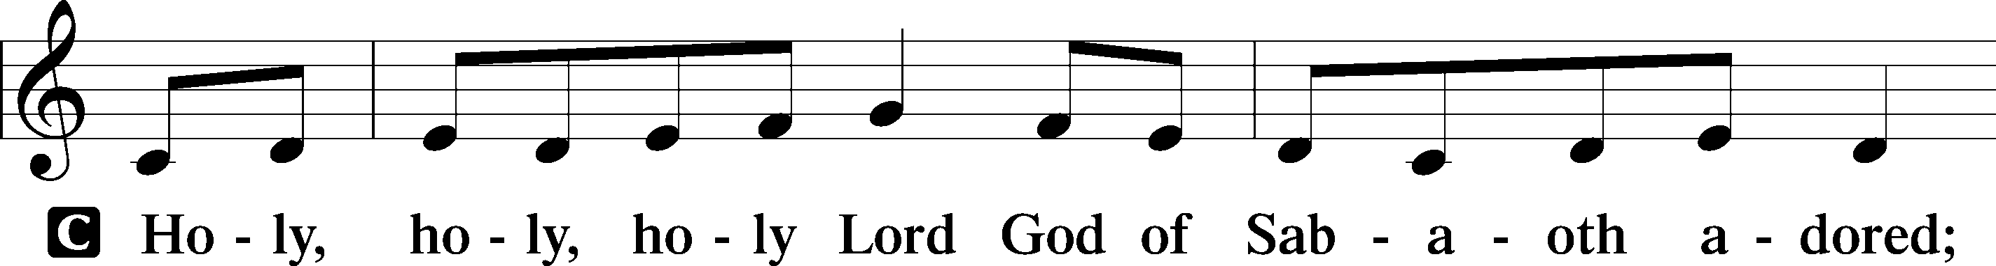
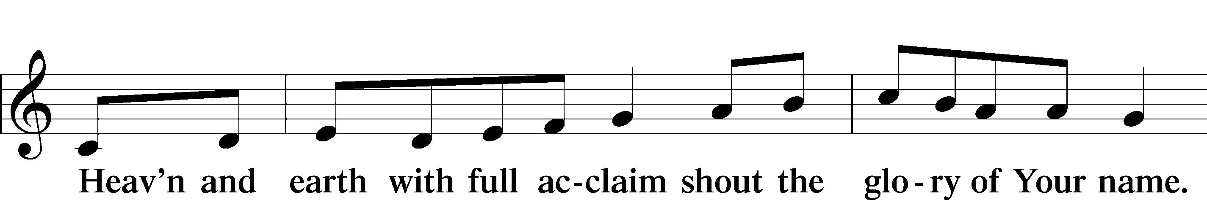
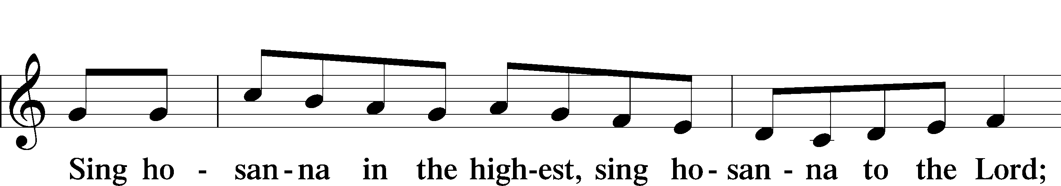
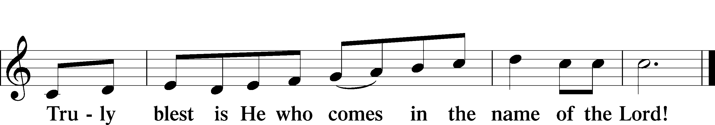
Text: Stephen P. Starke

Prayer of Thanksgiving
P Blessed are You, O Lord our God, king of all creation, for You have had mercy on us and given Your only-begotten Son that whoever believes in Him should not perish but have eternal life.

For Christ, our Passover Lamb, has been sacrificed. By His death, He has redeemed us from bondage to sin and death, and by His resurrection, He has delivered us into new life in Him.

Grant us to keep the Feast in sincerity and truth, faithfully eating His body given into death and drinking His life’s blood poured out for our salvation until we pass through death to the promised land of life eternal.

Hear us as we pray in His name and as He has taught us:

Lord’s Prayer
C Our Father who art in heaven,
hallowed be Thy name,
Thy kingdom come,
Thy will be done on earth
as it is in heaven;
give us this day our daily bread;
and forgive us our trespasses
as we forgive those
who trespass against us;
and lead us not into temptation,
but deliver us from evil.
For Thine is the kingdom
and the power and the glory
forever and ever. Amen.

The Words of Our Lord
P Our Lord Jesus Christ, on the night when He was betrayed, took bread, and when He had given thanks, He broke it and gave it to the disciples and said: “Take, eat; this is My T body, which is given for you. This do in remembrance of Me.”

In the same way also He took the cup after supper, and when He had given thanks, He gave it to them, saying: “Drink of it, all of you; this cup is the new testament in My T blood, which is shed for you for the forgiveness of sins. This do, as often as you drink it, in remembrance of Me.”

Pax Domini
P The peace of the Lord be with you always.
C Amen.

Agnus Dei LSB 210
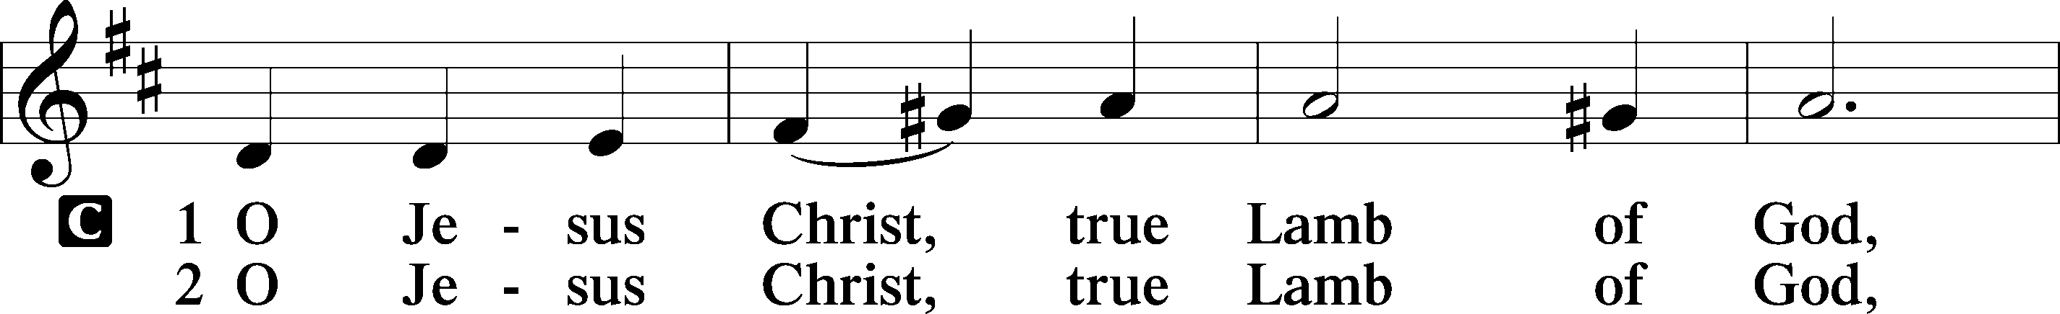
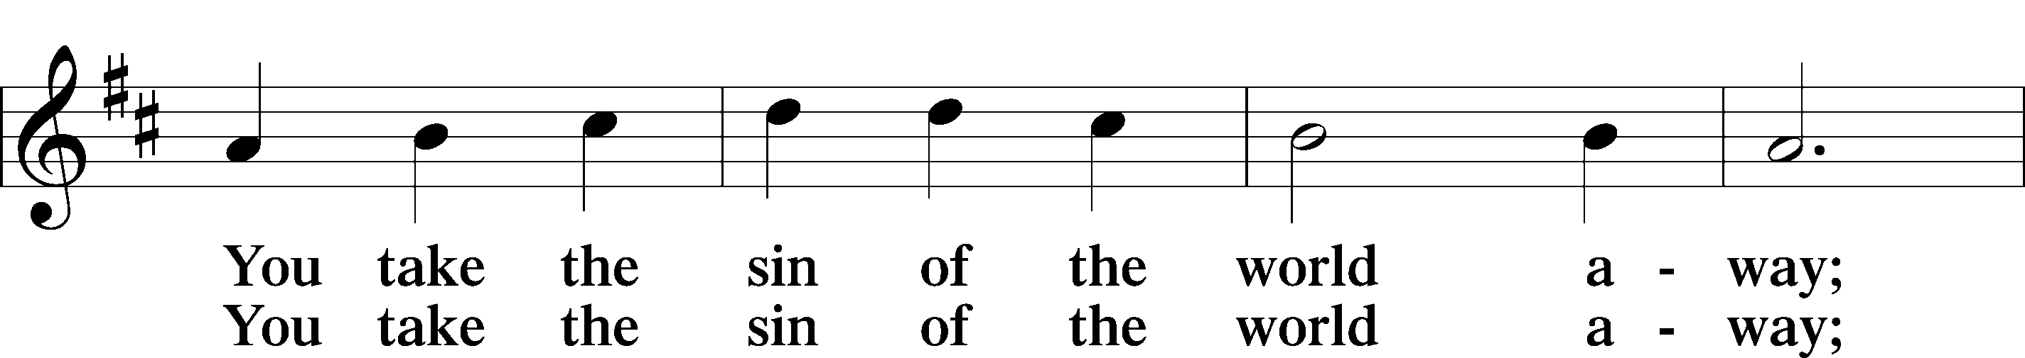
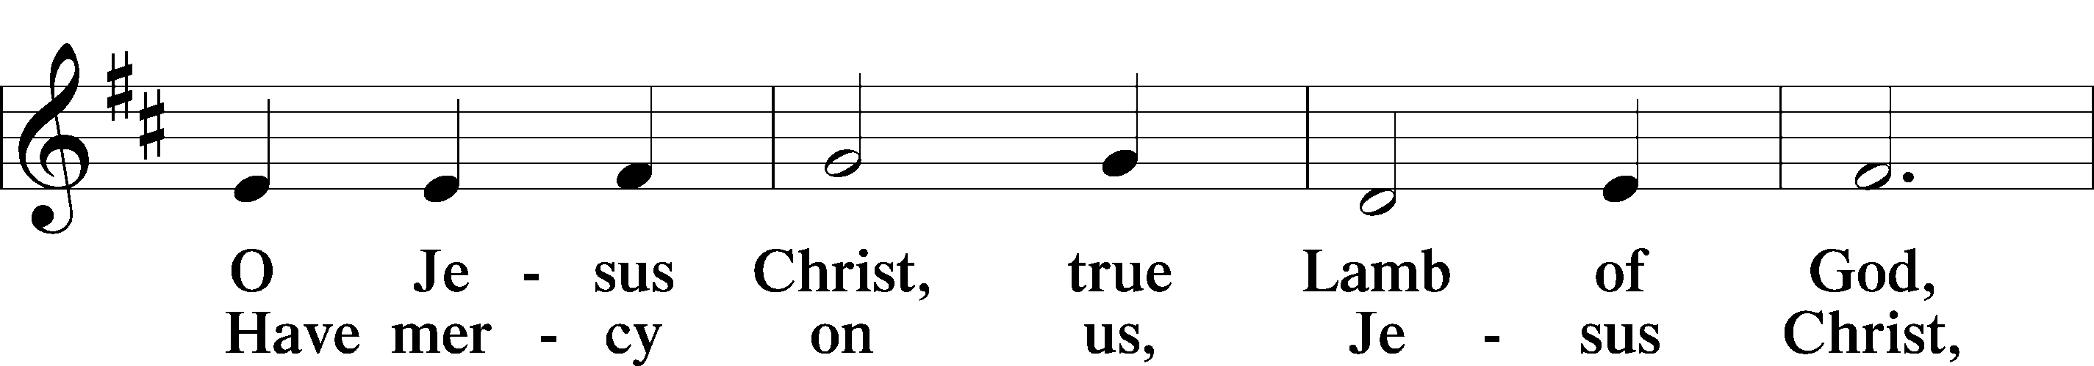
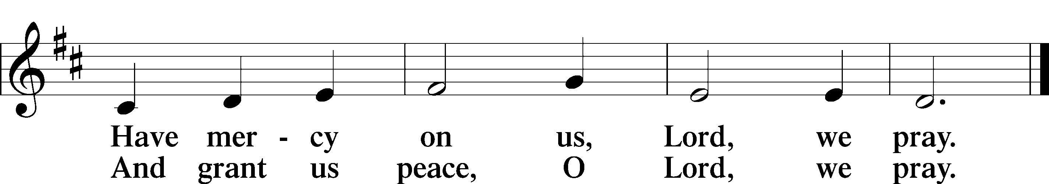
Text: Stephen P. Starke

Sit

Distribution

907 God Himself Is Present
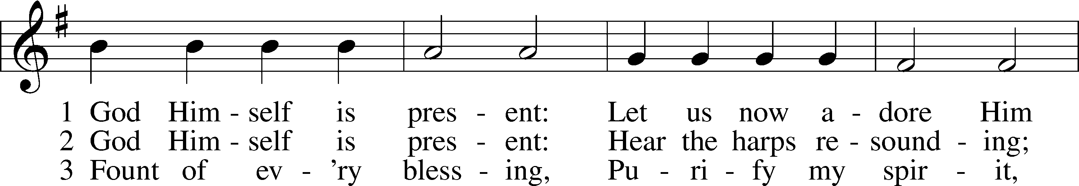
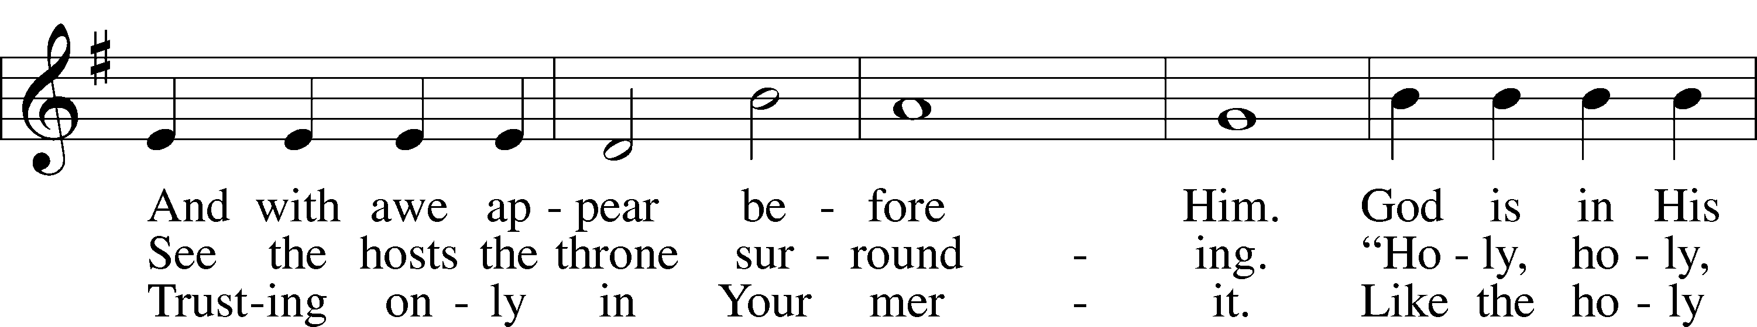
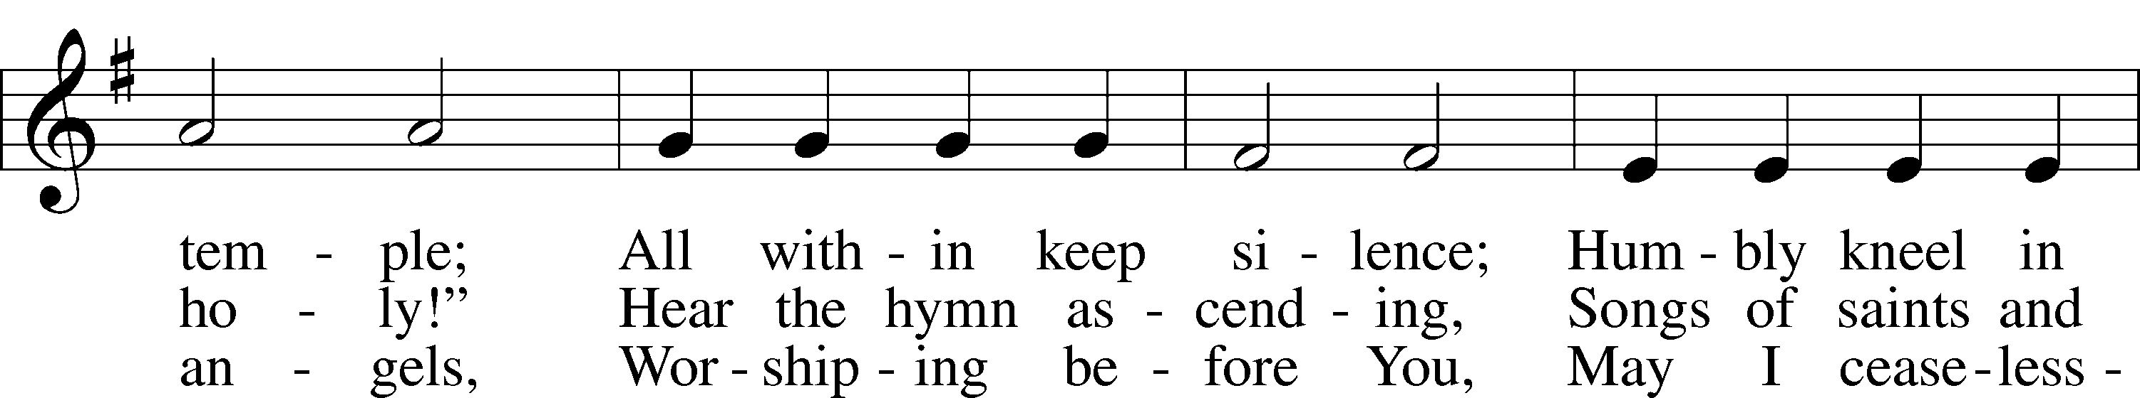
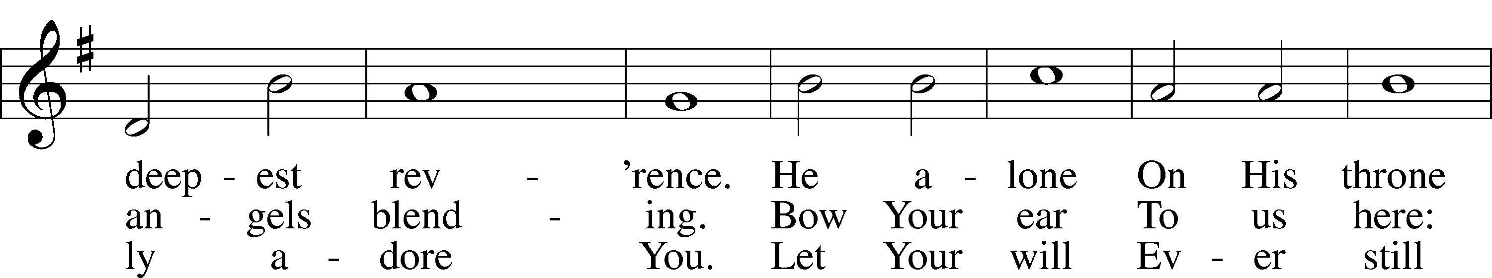
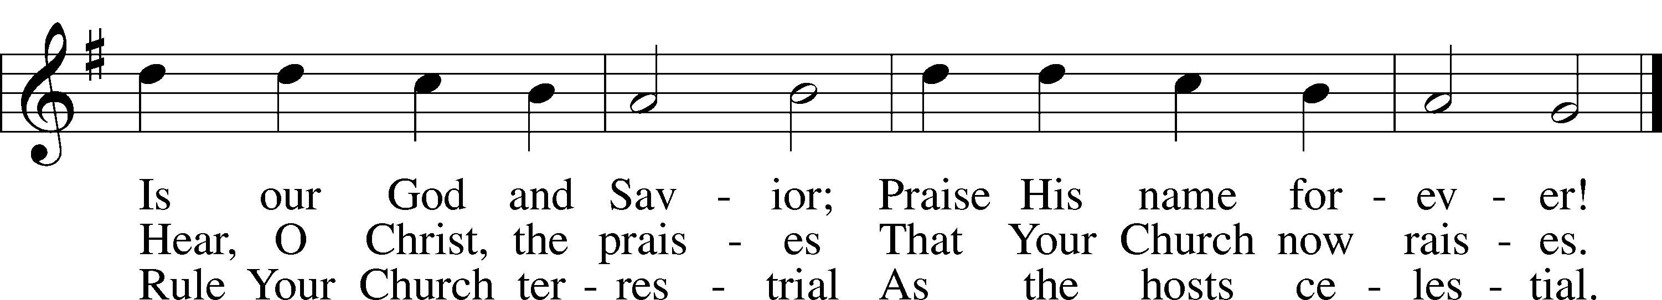
Text: Gerhard Tersteegen, 1697–1769, abr.; tr. Frederick W. Foster, 1760–1835, alt.; tr. John Miller, 1756–90, alt.
Tune: Joachim Neander, 1650–80
Text and tune: Public domain

563 Jesus, Thy Blood and Righteousness
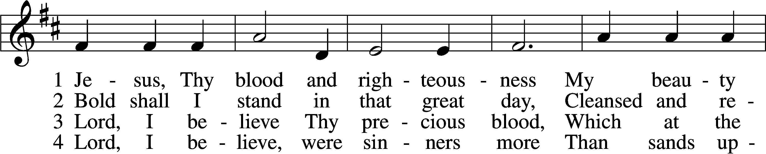
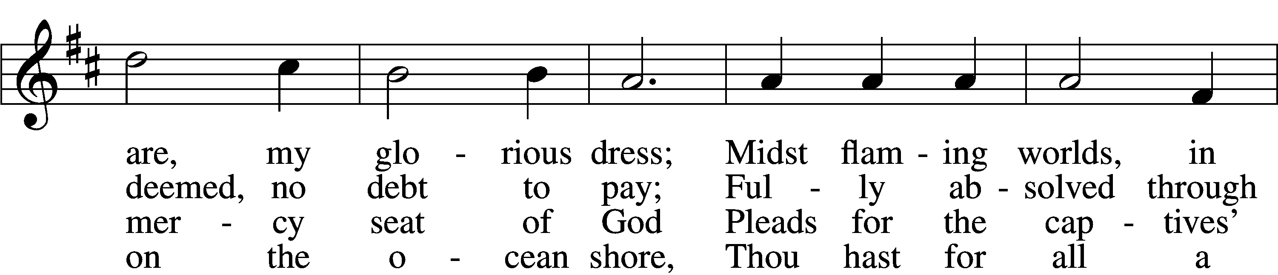
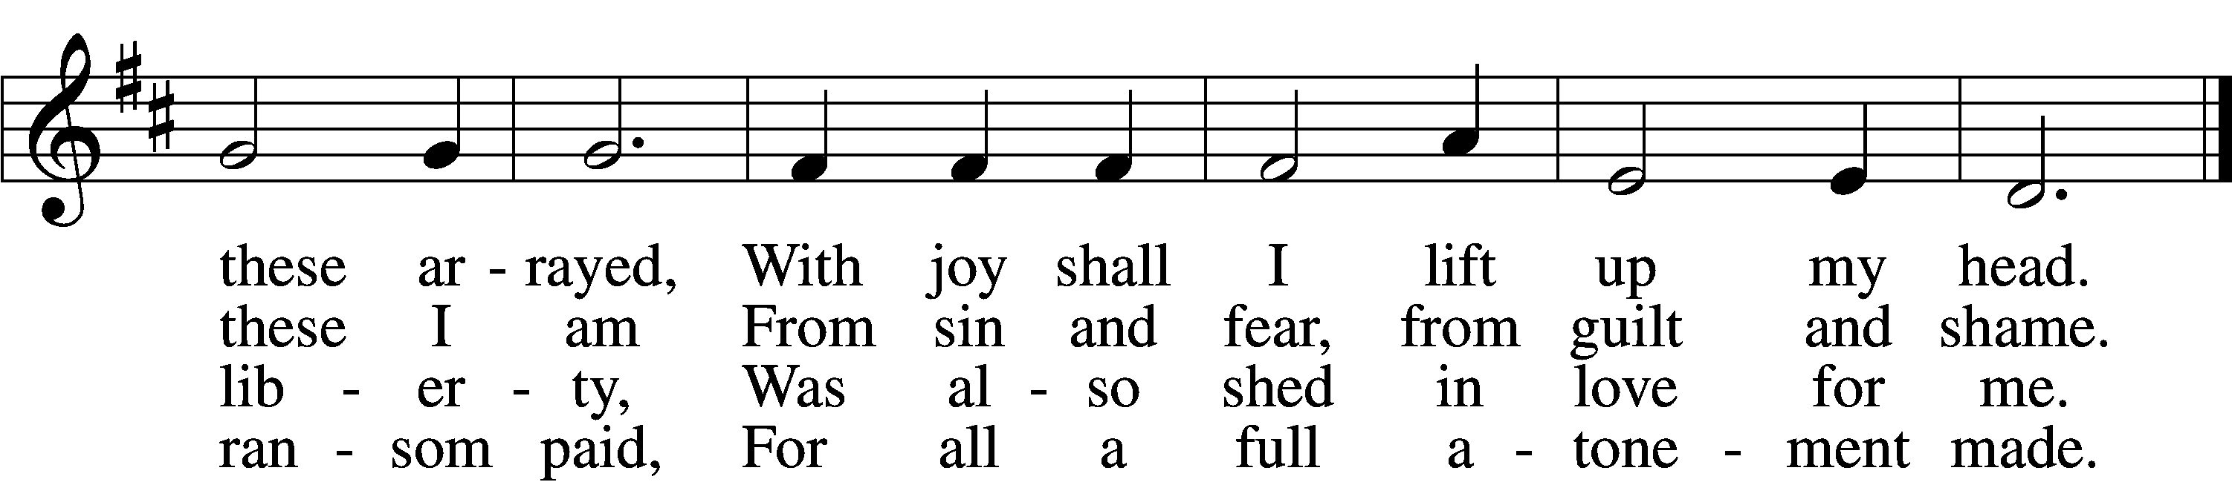

5 When from the dust of death I rise
To claim my mansion in the skies,
This then shall be my only plea:
Jesus hath lived and died for me.

6 Jesus, be endless praise to Thee,
Whose boundless mercy hath for me,
For me, and all Thy hands have made,
An everlasting ransom paid.
Text: Nicolaus Ludwig von Zinzendorf, 1700–60; tr. John B. Wesley, 1703–91, alt.
Tune: George J. Elvey, 1816–93
Text and tune: Public domain

606 I Lay My Sins on Jesus
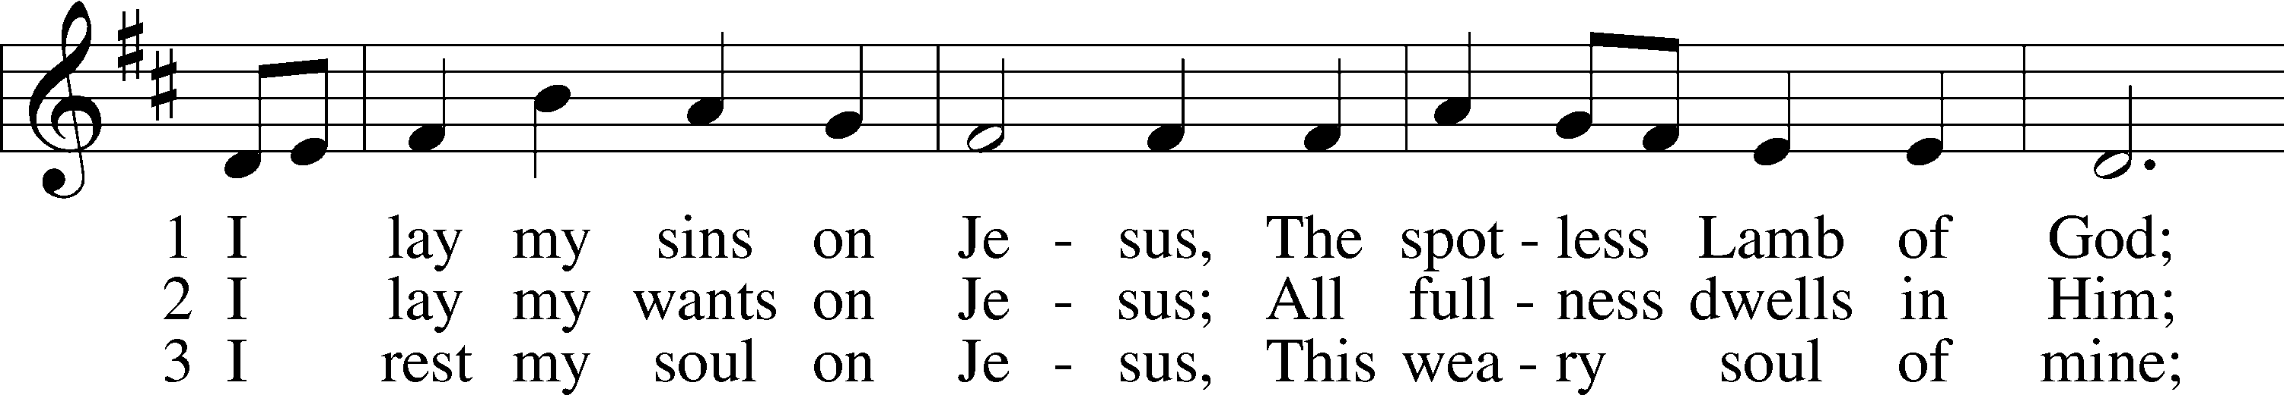
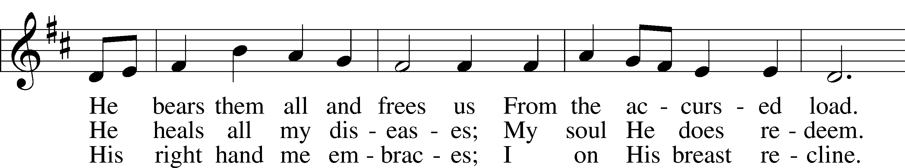
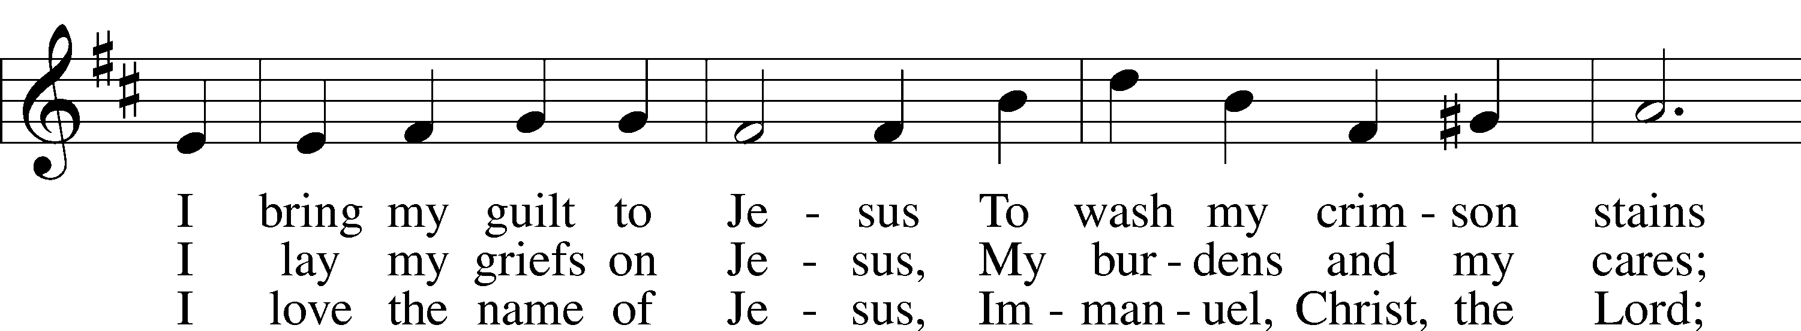
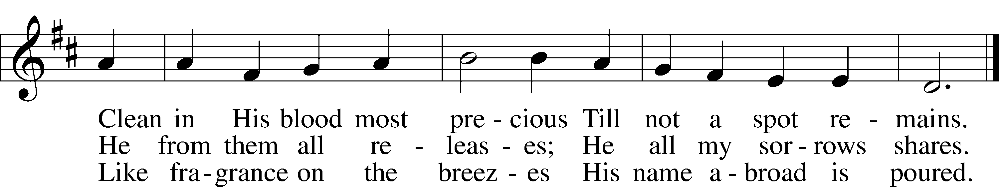
Text: Horatius Bonar, 1808–89
Tune: Neu-vermehrtes . . . Gesangbuch, 1693, 3rd ed., Meiningen
Text and tune: Public domain

Stand

Nunc Dimittis LSB 211
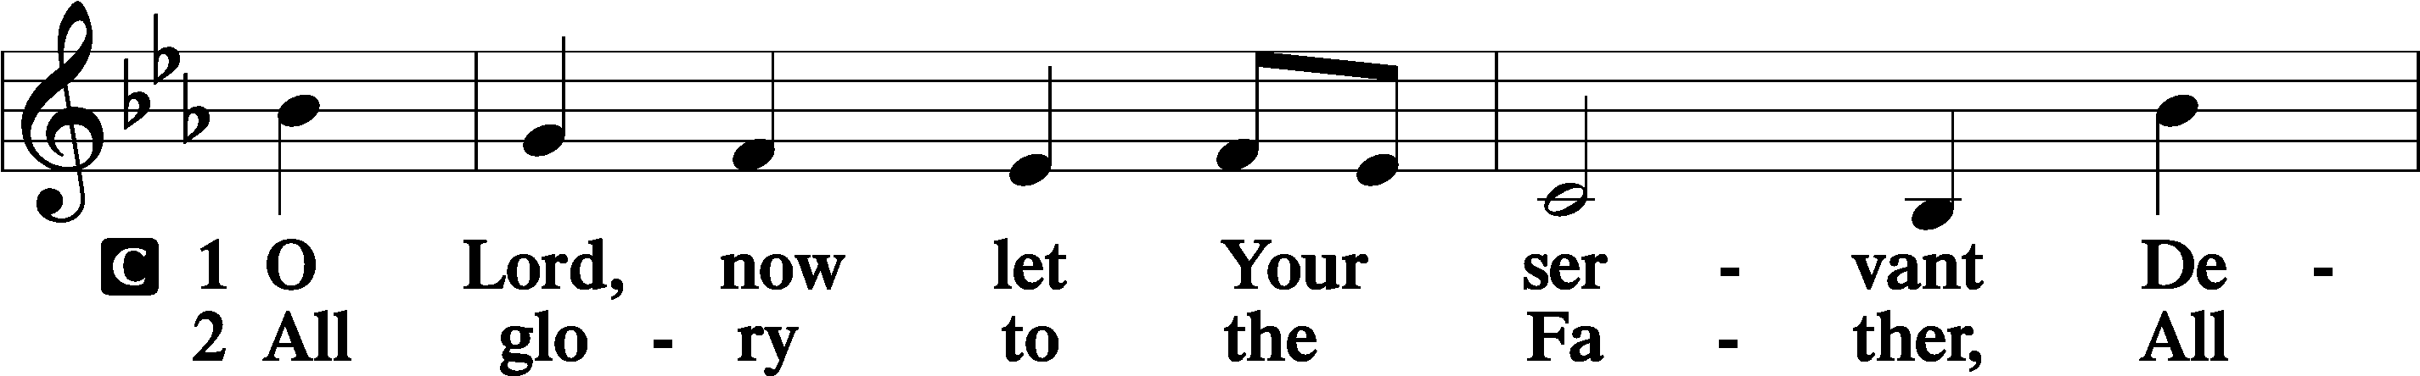
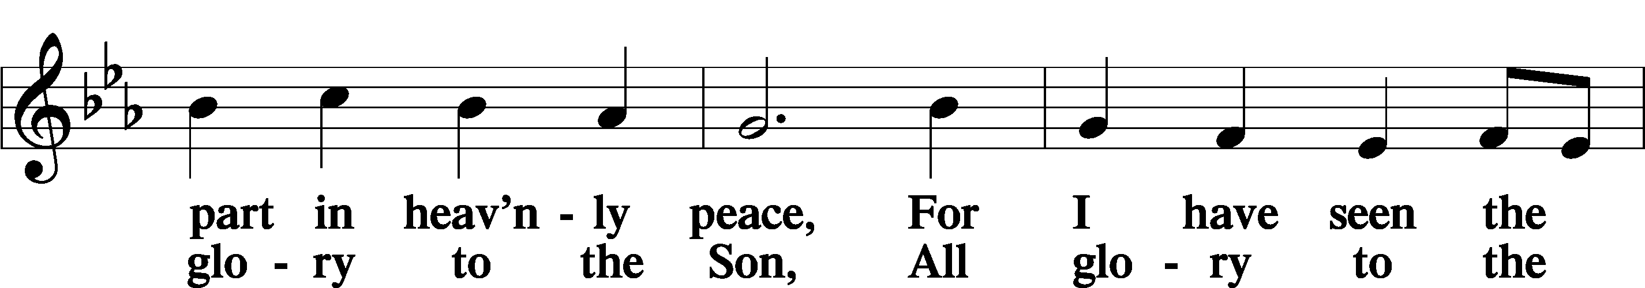
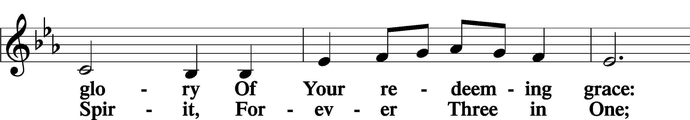
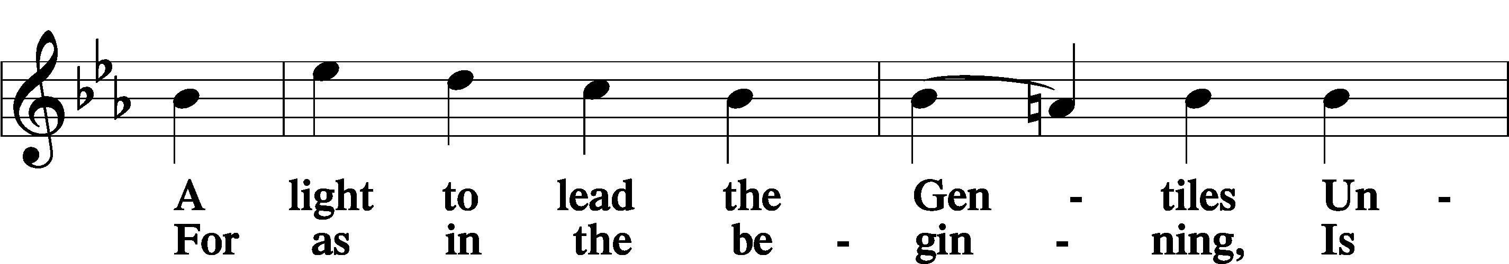
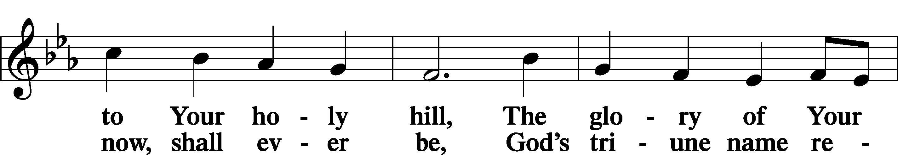
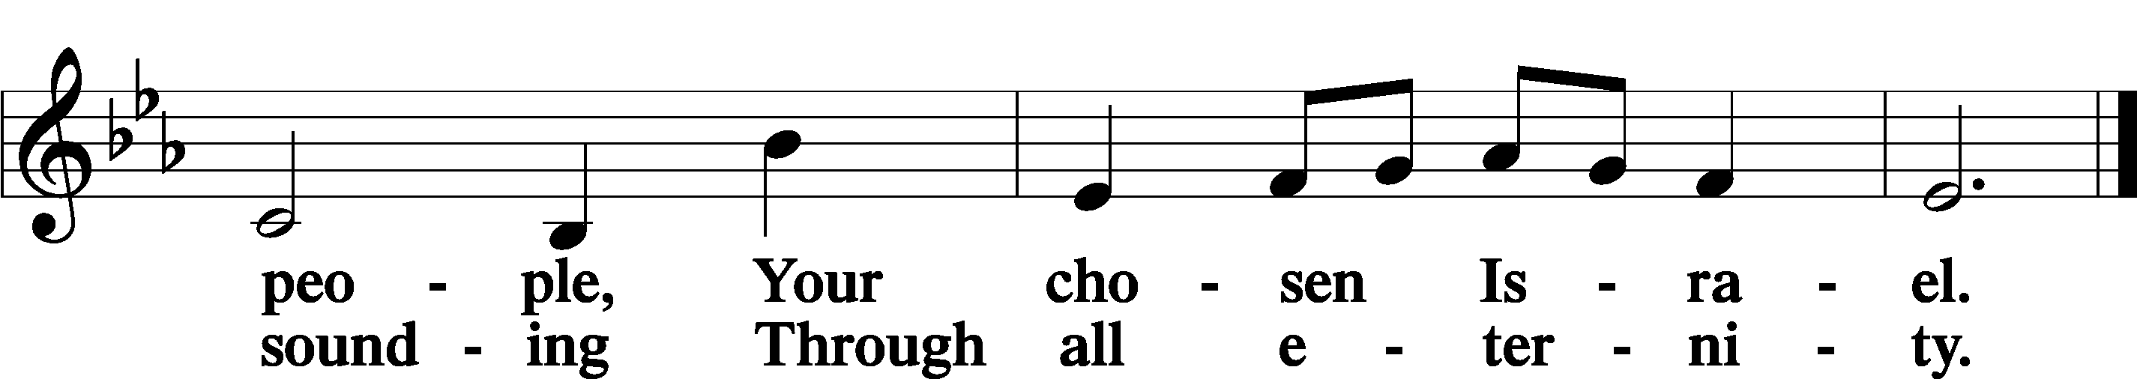

Post-Communion Collect
A Let us pray.
We give thanks to You, almighty God, that You have refreshed us through this salutary gift, and we implore You that of Your mercy You would strengthen us through the same in faith toward You and in fervent love toward one another; through Jesus Christ, Your Son, our Lord, who lives and reigns with You and the Holy Spirit, one God, now and forever.
C Amen.

Benedicamus LSB 212
A Let us bless the Lord.
C Thanks be to God.

Benediction
P The Lord bless you and keep you.
The Lord make His face shine on you and be gracious to you.
The Lord look upon you with favor and T give you peace.
C Amen.

632 O Jesus, Blessed Lord, to Thee
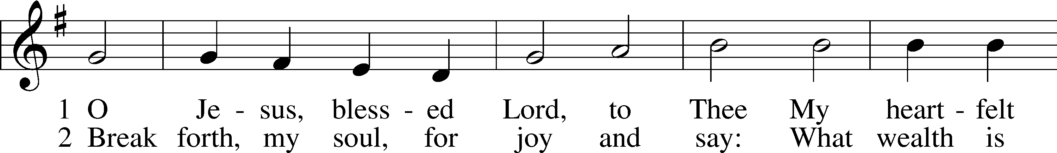
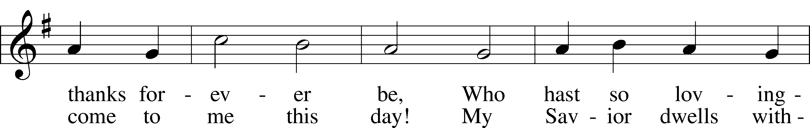
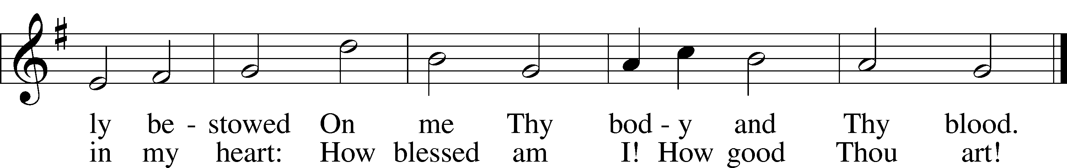
Text: Thomas Hansen Kingo, 1634–1703; tr. Arthur J. Mason, 1851–1928
Tune: Trente quatre Pseaumes de David, 1551, Geneva, ed. Louis Bourgeois
Text and tune: Public domain

Acknowledgments
Unless otherwise indicated, Scripture quotations are from the ESV® Bible (The Holy Bible, English Standard Version®), copyright © 2001 by Crossway, a publishing ministry of Good News Publishers. Used by permission. All rights reserved.
Created by Lutheran Service Builder © 2024 Concordia Publishing House.

