Fifth Sunday of Easter
Prayer and Preaching p. 260
April 27 & 28, 2024
St. Paul Lutheran Church

807 When Morning Gilds the Skies
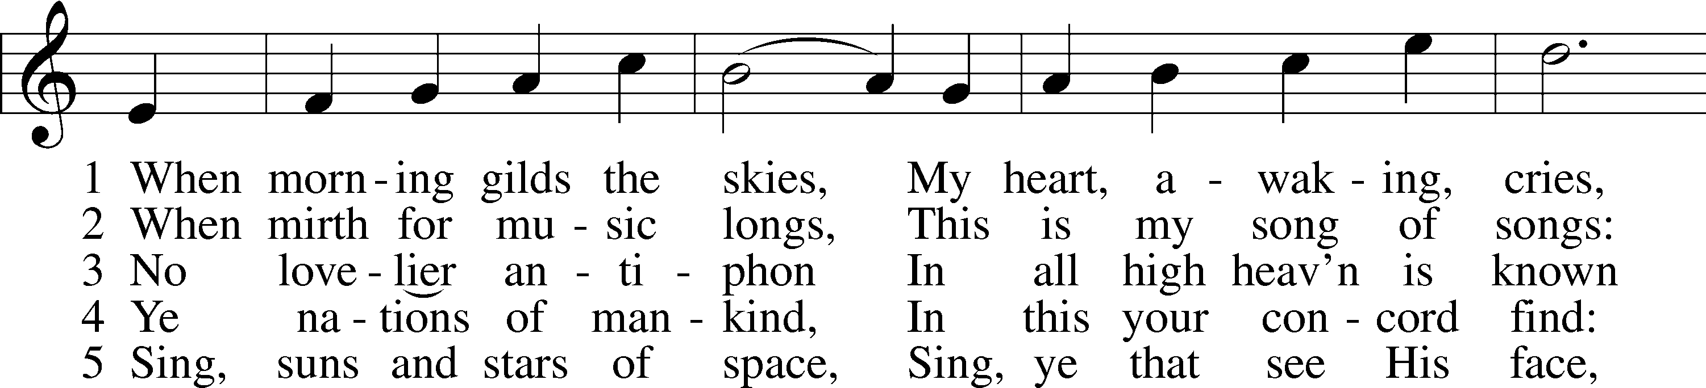
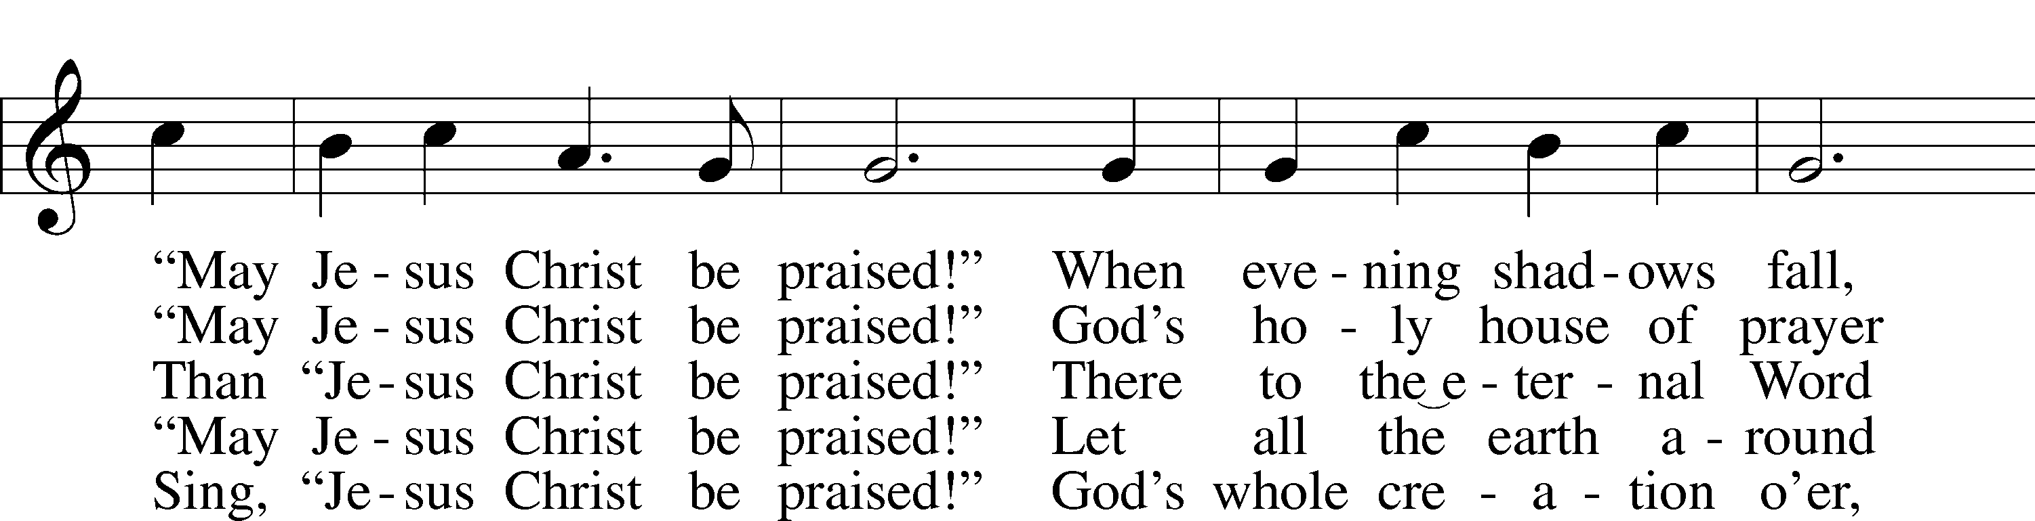
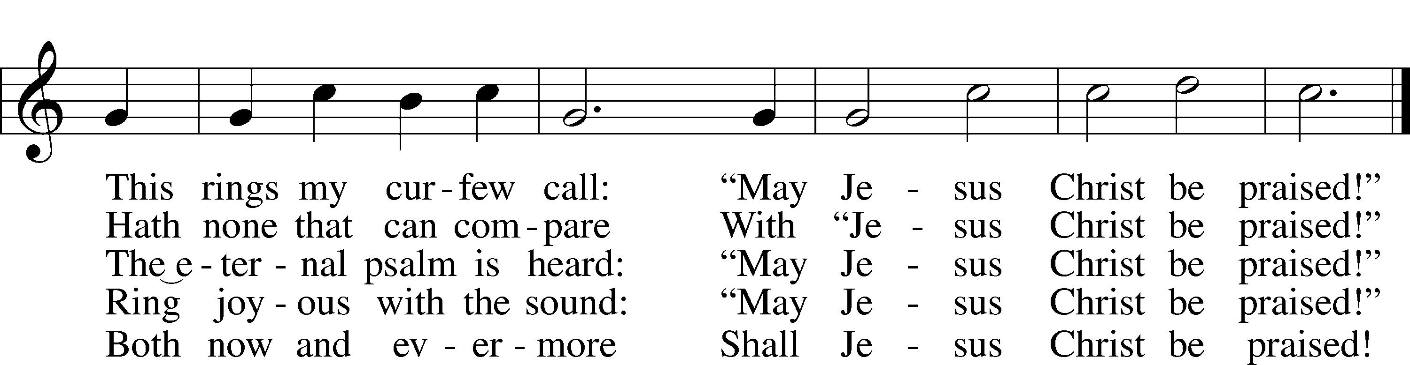
Text: Katholisches Gesangbuch, 1828, Würzburg; tr. Robert S. Bridges, 1844–1930, alt.
Tune: Joseph Barnby, 1838–96
Text and tune: Public domain

Stand

Opening Versicles

Common LSB 260
L This is the day which the Lord has made;
C let us rejoice and be glad in it.
L From the rising of the sun to its setting,
C the name of the Lord is to be praised.

L Better is one day in Your courts than a thousand elsewhere;
C I would rather be a doorkeeper in the house of my God than dwell in the tents of the wicked.
L Make me to know Your ways, O Lord.
C Teach me Your paths.
L Sanctify us in Your truth.
C Your Word is truth.

L From the rising of the sun to its setting,
C the name of the Lord is to be praised.

C Glory be to the Father and to the Son and to the Holy Spirit;
as it was in the beginning, is now, and will be forever. Amen.

Old Testament Canticle LSB 261
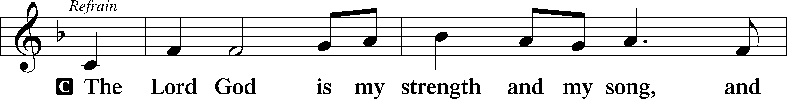
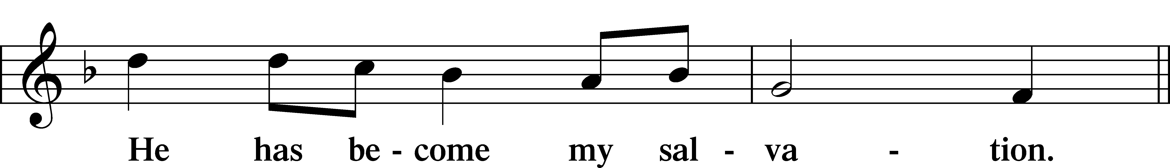
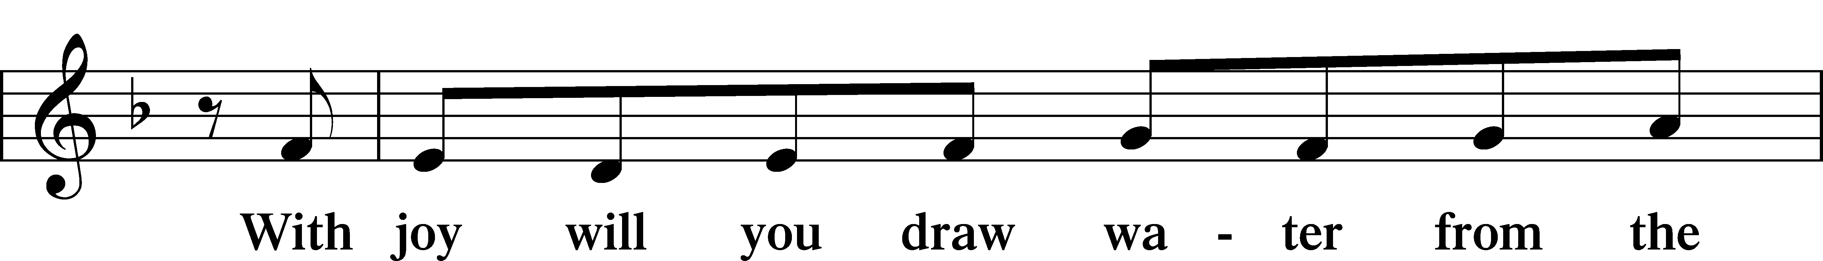
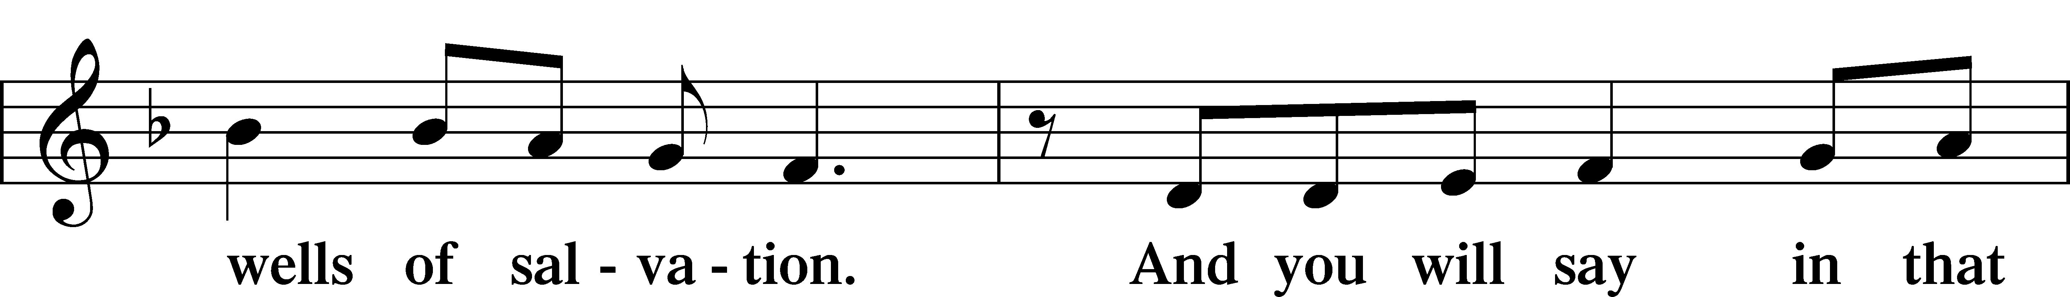
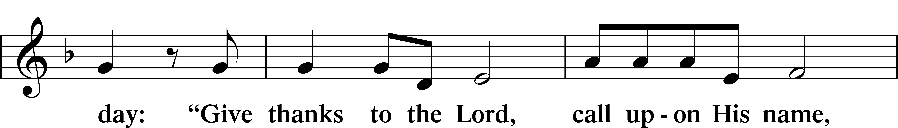
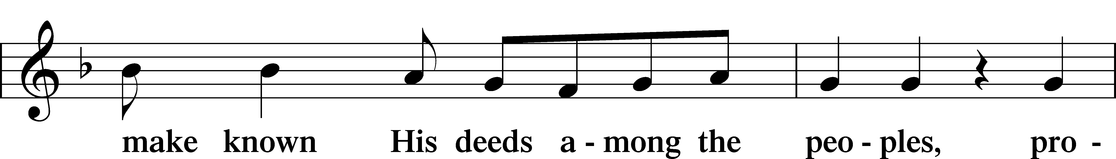
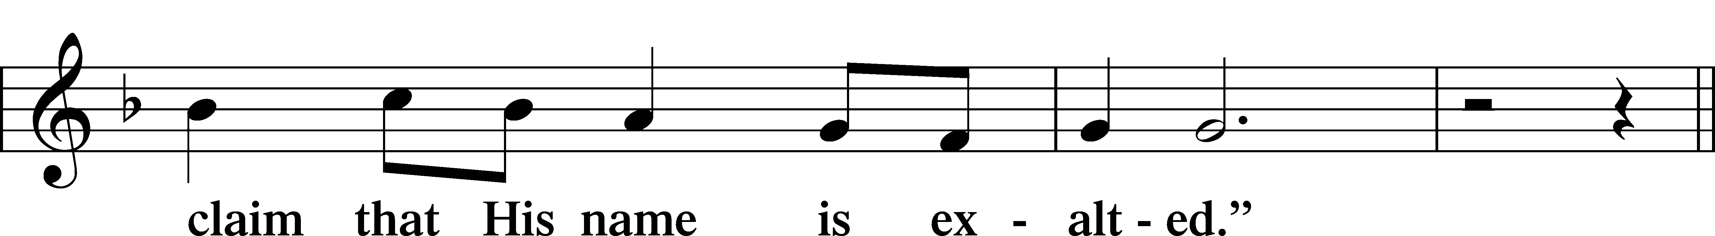
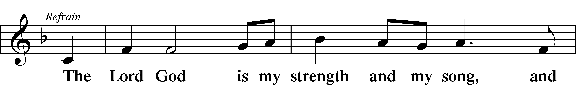
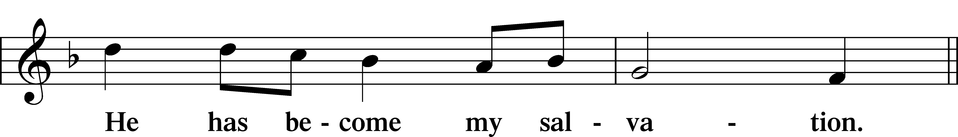
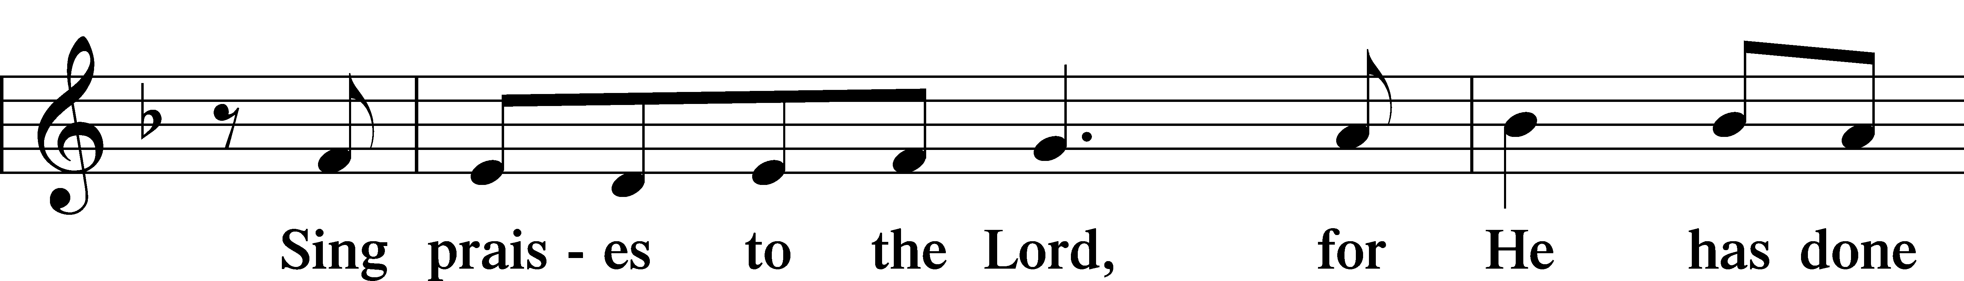
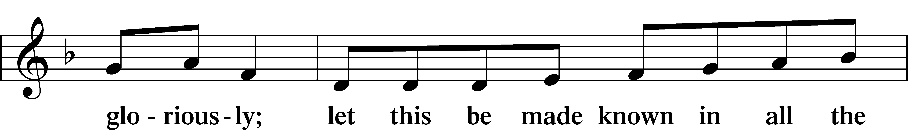
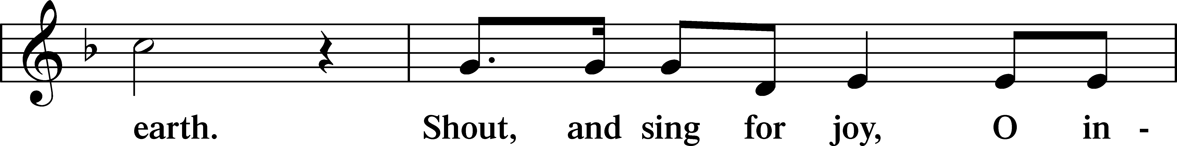
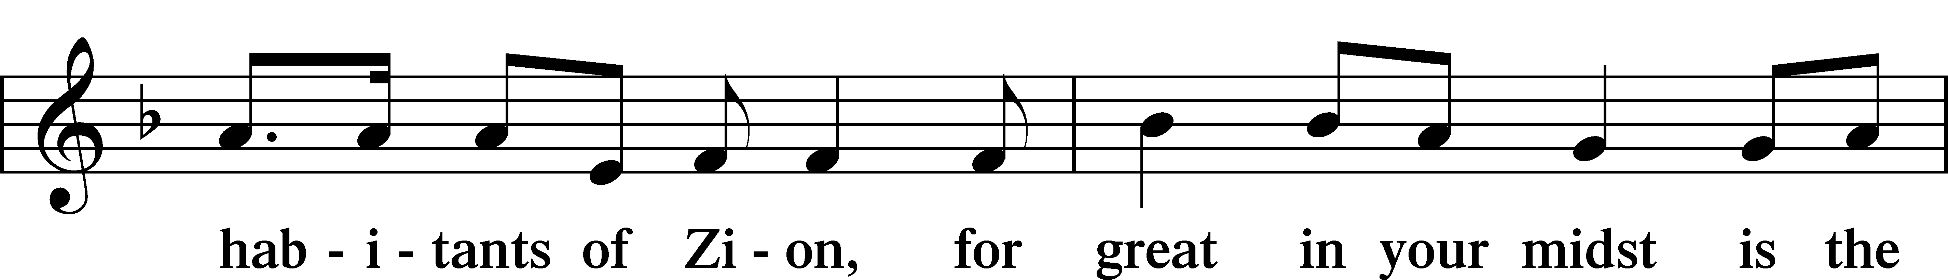
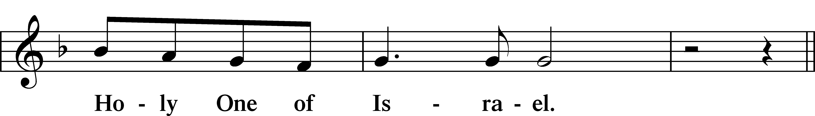
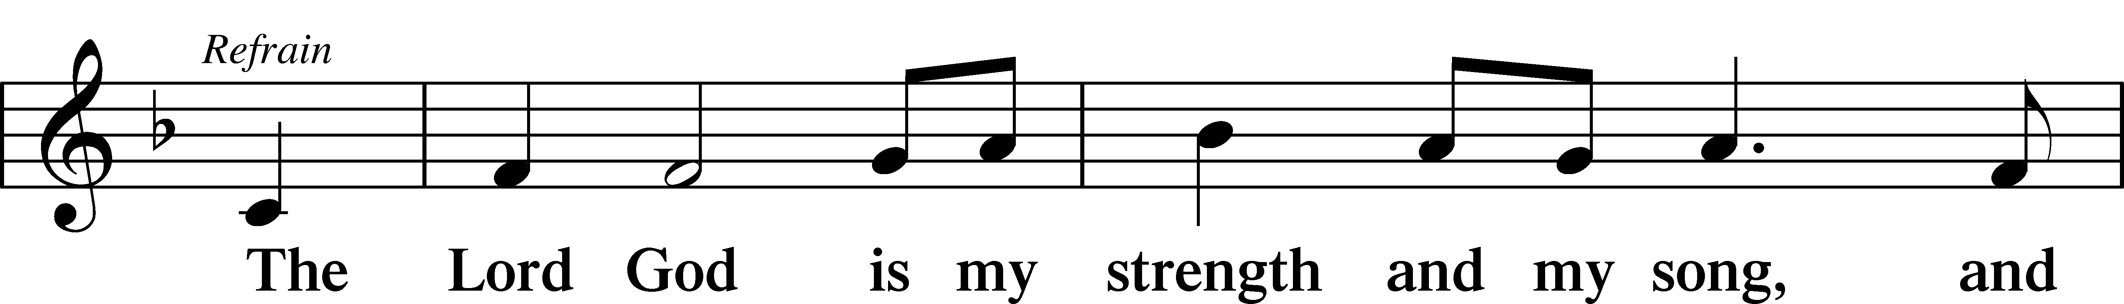
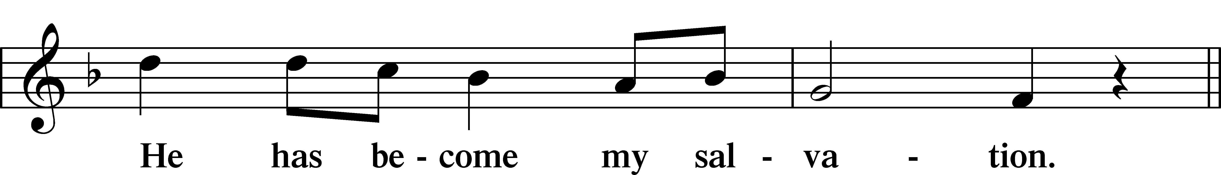
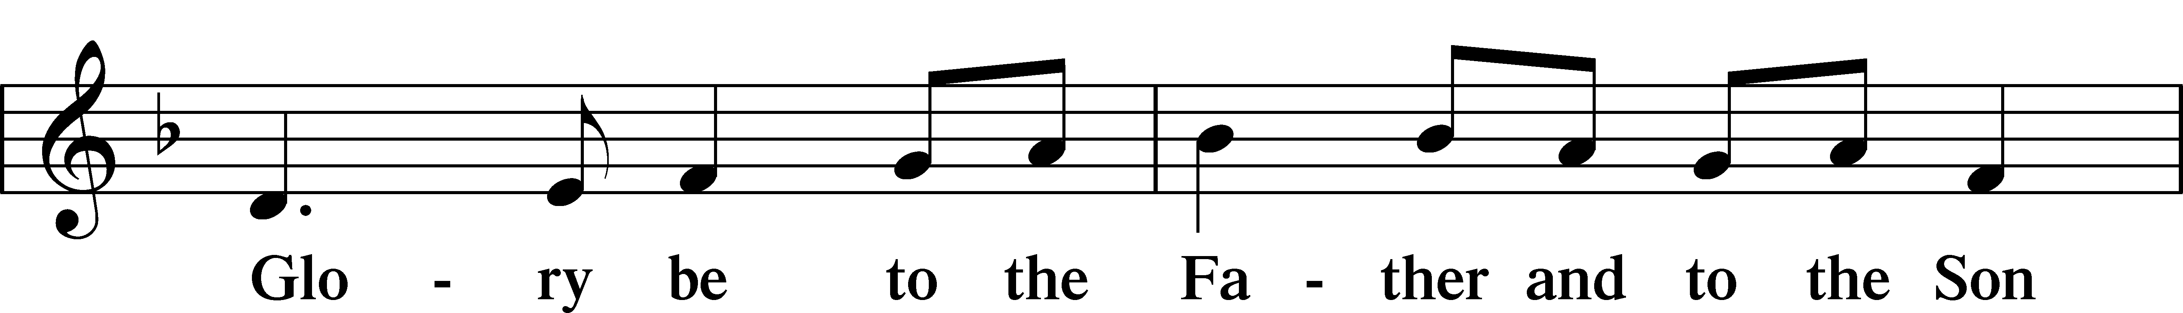
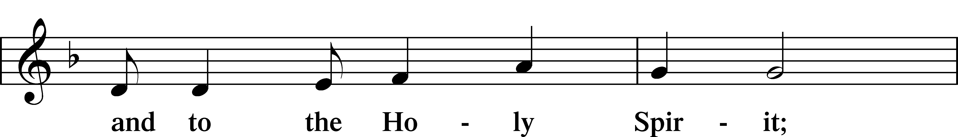
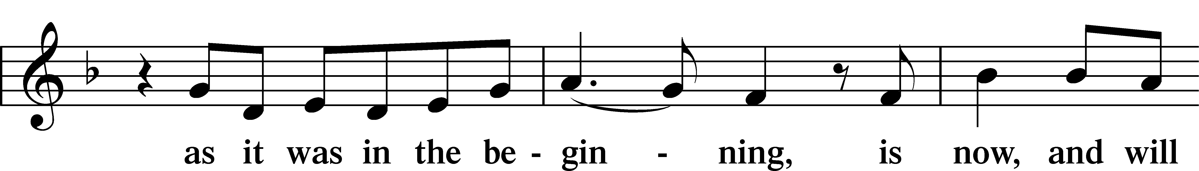
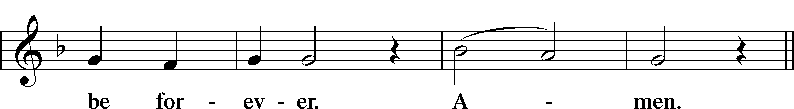
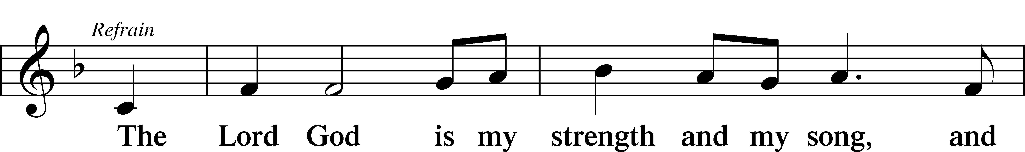
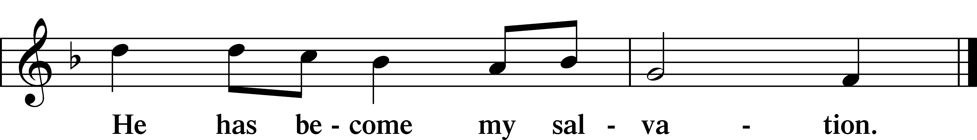

Sit

Readings From Holy Scripture

Reading Acts 8:26–40
L A reading from Acts, the eighth chapter.

26An angel of the Lord said to Philip, “Rise and go toward the south to the road that goes down from Jerusalem to Gaza.” This is a desert place. 27And he rose and went. And there was an Ethiopian, a eunuch, a court official of Candace, queen of the Ethiopians, who was in charge of all her treasure. He had come to Jerusalem to worship 28and was returning, seated in his chariot, and he was reading the prophet Isaiah. 29And the Spirit said to Philip, “Go over and join this chariot.” 30So Philip ran to him and heard him reading Isaiah the prophet and asked, “Do you understand what you are reading?” 31And he said, “How can I, unless someone guides me?” And he invited Philip to come up and sit with him. 32Now the passage of the Scripture that he was reading was this:
“Like a sheep he was led to the slaughter
and like a lamb before its shearer is silent,
so he opens not his mouth.
33In his humiliation justice was denied him.
Who can describe his generation?
For his life is taken away from the earth.”
34And the eunuch said to Philip, “About whom, I ask you, does the prophet say this, about himself or about someone else?” 35Then Philip opened his mouth, and beginning with this Scripture he told him the good news about Jesus. 36And as they were going along the road they came to some water, and the eunuch said, “See, here is water! What prevents me from being baptized?” 38And he commanded the chariot to stop, and they both went down into the water, Philip and the eunuch, and he baptized him. 39And when they came up out of the water, the Spirit of the Lord carried Philip away, and the eunuch saw him no more, and went on his way rejoicing. 40But Philip found himself at Azotus, and as he passed through he preached the gospel to all the towns until he came to Caesarea.

L This is the Word of the Lord.
C Thanks be to God.

Reading 1 John 4:1–11
¹Beloved, do not believe every spirit, but test the spirits to see whether they are from God, for many false prophets have gone out into the world. ²By this you know the Spirit of God: every spirit that confesses that Jesus Christ has come in the flesh is from God, ³and every spirit that does not confess Jesus is not from God. This is the spirit of the antichrist, which you heard was coming and now is in the world already. ⁴Little children, you are from God and have overcome them, for he who is in you is greater than he who is in the world. ⁵They are from the world; therefore they speak from the world, and the world listens to them. ⁶We are from God. Whoever knows God listens to us; whoever is not from God does not listen to us. By this we know the Spirit of truth and the spirit of error.
⁷Beloved, let us love one another, for love is from God, and whoever loves has been born of God and knows God. ⁸Anyone who does not love does not know God, because God is love. ⁹In this the love of God was made manifest among us, that God sent his only Son into the world, so that we might live through him. ¹⁰In this is love, not that we have loved God but that he loved us and sent his Son to be the propitiation for our sins. ¹¹Beloved, if God so loved us, we also ought to love one another.
L This is the Word of the Lord.
C Thanks be to God.

Reading John 15:1–8
¹[Jesus said:] “I am the true vine, and my Father is the vinedresser. ²Every branch of mine that does not bear fruit he takes away, and every branch that does bear fruit he prunes, that it may bear more fruit. ³Already you are clean because of the word that I have spoken to you. ⁴Abide in me, and I in you. As the branch cannot bear fruit by itself, unless it abides in the vine, neither can you, unless you abide in me. ⁵I am the vine; you are the branches. Whoever abides in me and I in him, he it is that bears much fruit, for apart from me you can do nothing. ⁶If anyone does not abide in me he is thrown away like a branch and withers; and the branches are gathered, thrown into the fire, and burned. ⁷If you abide in me, and my words abide in you, ask whatever you wish, and it will be done for you. ⁸By this my Father is glorified, that you bear much fruit and so prove to be my disciples.”
L This is the Word of the Lord.
C Thanks be to God.

Responsory
Common LSB 263
L Forever, O Lord, Your Word is firmly set in the heavens.
C Lord, I love the habitation of Your house and the place where Your glory dwells.
L Blessed are those who hear the Word of God and keep it.
C Lord, I love the habitation of Your house and the place where Your glory dwells.
L Glory be to the Father and to the Son and to the Holy Spirit.
C Lord, I love the habitation of Your house and the place where Your glory dwells.

Stand

Ten Commandments
C You shall have no other gods.
You shall not misuse the name of the Lord your God.
Remember the Sabbath day by keeping it holy.
Honor your father and your mother.
You shall not murder.
You shall not commit adultery.
You shall not steal.
You shall not give false testimony against your neighbor.
You shall not covet your neighbor’s house.
You shall not covet your neighbor’s wife, or his manservant or maidservant, his ox or donkey, or anything that belongs to your neighbor.

Apostles’ Creed
C I believe in God, the Father Almighty,
maker of heaven and earth.

And in Jesus Christ, His only Son, our Lord,
who was conceived by the Holy Spirit,
born of the virgin Mary,
suffered under Pontius Pilate,
was crucified, died and was buried.
He descended into hell.
The third day He rose again from the dead.
He ascended into heaven
and sits at the right hand of God the Father Almighty.
From thence He will come to judge the living and the dead.

I believe in the Holy Spirit,
the holy Christian Church,
the communion of saints,
the forgiveness of sins,
the resurrection of the body,
and the life T everlasting. Amen.

Lord’s Prayer
C Our Father who art in heaven,
hallowed be Thy name,
Thy kingdom come,
Thy will be done on earth
as it is in heaven;
give us this day our daily bread;
and forgive us our trespasses
as we forgive those
who trespass against us;
and lead us not into temptation,
but deliver us from evil.
For Thine is the kingdom
and the power and the glory
forever and ever. Amen.

Sit

595 O Blessed Spring
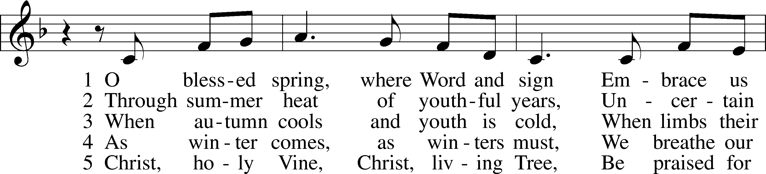
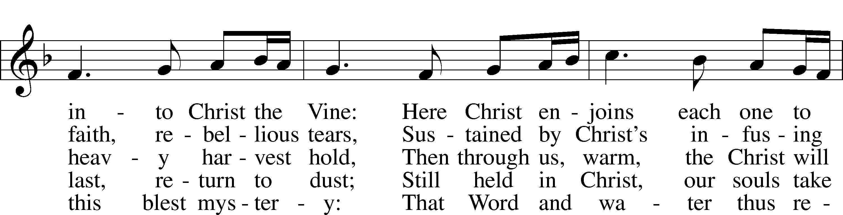
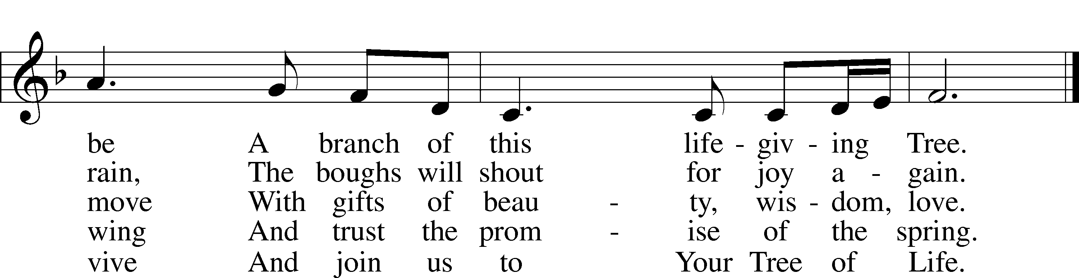
Text: Susan Palo Cherwien, 1953
Tune: English
Text: © 1993 Susan Palo Cherwien, admin. Augsburg Fortress. Used by permission: LSB Hymn License no. 110002831
Tune: Public domain

Children’s Sermon
Sermon

Offering

Stand

Prayer
L In peace let us pray to the Lord:
C Lord, have mercy.
L For the gift of divine peace and of pardon, with all our heart and with all our mind, let us pray to the Lord:
C Lord, have mercy.
L For the holy Christian Church, here and scattered throughout the world, and for the proclamation of the Gospel and the calling of all to faith, let us pray to the Lord:
C Lord, have mercy.
L For this nation, for our cities and communities, and for the common welfare of us all, let us pray to the Lord:
C Lord, have mercy.
L For seasonable weather and for the fruitfulness of the earth, let us pray to the Lord:
C Lord, have mercy.
L For those who labor, for those whose work is difficult or dangerous, and for all who travel, let us pray to the Lord:
C Lord, have mercy.
L For all those in need, for the hungry and homeless, for the widowed and orphaned, and for all those in prison, let us pray to the Lord:
C Lord, have mercy.
L For the sick and dying and for all those who care for them, let us pray to the Lord:
C Lord, have mercy.
L For . . . [additional bids for prayer may be inserted here] . . . let us pray to the Lord:
C Lord, have mercy.
L Finally, for these and for all our needs of body and soul, let us pray to the Lord:
C Lord, have mercy. Christ, have mercy. Lord, have mercy.

Collect of the Day
L O God, You make the minds of Your faithful to be of one will. Grant that we may love what You have commanded and desire what You promise, that among the many changes of this world our hearts may be fixed where true joys are found; through Jesus Christ, Your Son, our Lord, who lives and reigns with You and the Holy Spirit, one God, now and forever.
C Amen.

Collect for the Word
L Blessed Lord, You have caused all Holy Scriptures to be written for our learning. Grant that we may so hear them, read, mark, learn, and take them to heart that, by the patience and comfort of Your holy Word, we may embrace and ever hold fast the blessed hope of everlasting life; through Jesus Christ, Your Son, our Lord, who lives and reigns with You and the Holy Spirit, one God, now and forever.
C Amen.

Morning Prayer
C I thank You, my heavenly Father, through Jesus Christ, Your dear Son, that You have kept me this night from all harm and danger; and I pray that You would keep me this day also from sin and every evil, that all my doings and life may please You. For into Your hands I commend myself, my body and soul, and all things. Let Your holy angel be with me, that the evil foe may have no power over me.

Evening Prayer
C I thank You, my heavenly Father, through Jesus Christ, Your dear Son, that You have graciously kept me this day; and I pray that You would forgive me all my sins where I have done wrong, and graciously keep me this night. For into Your hands I commend myself, my body and soul, and all things. Let Your holy angel be with me, that the evil foe may have no power over me.

New Testament Canticle LSB 266
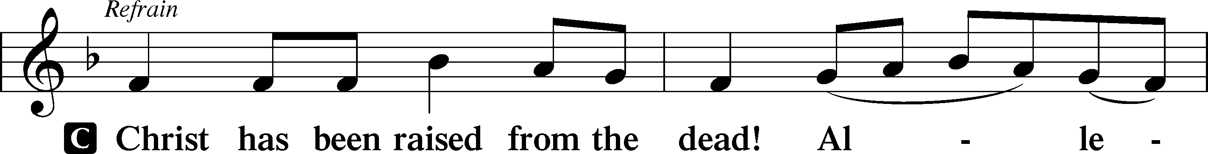
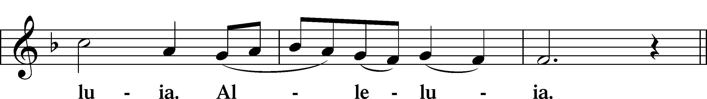
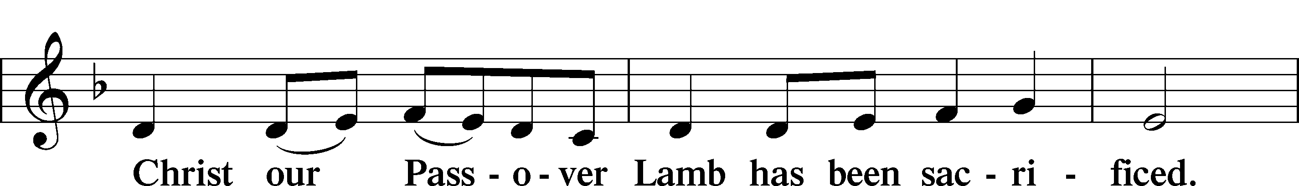
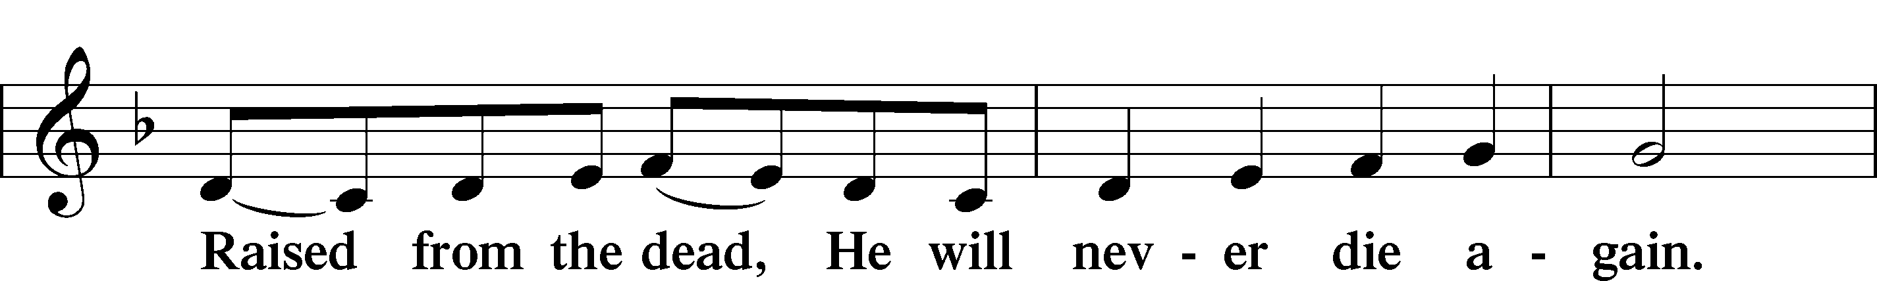
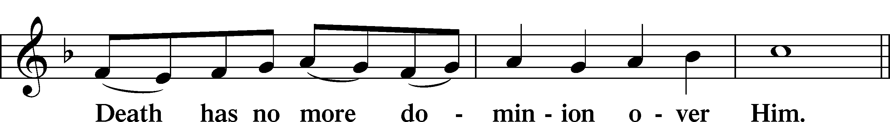
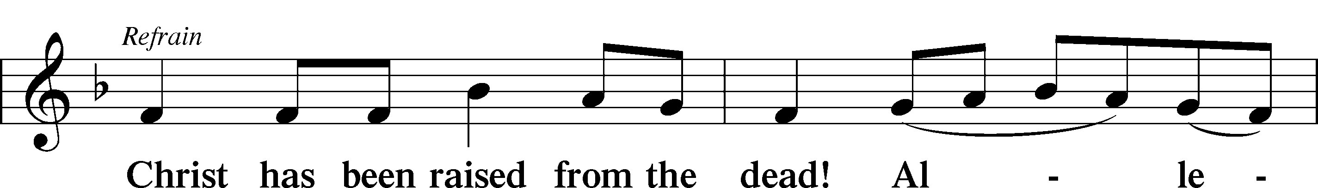
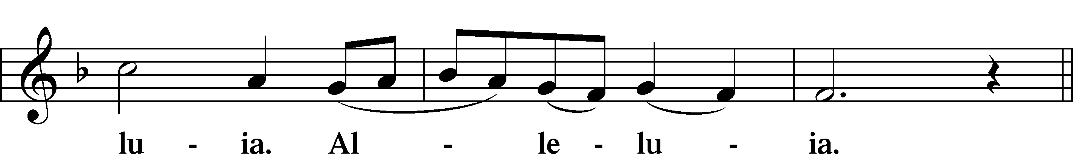
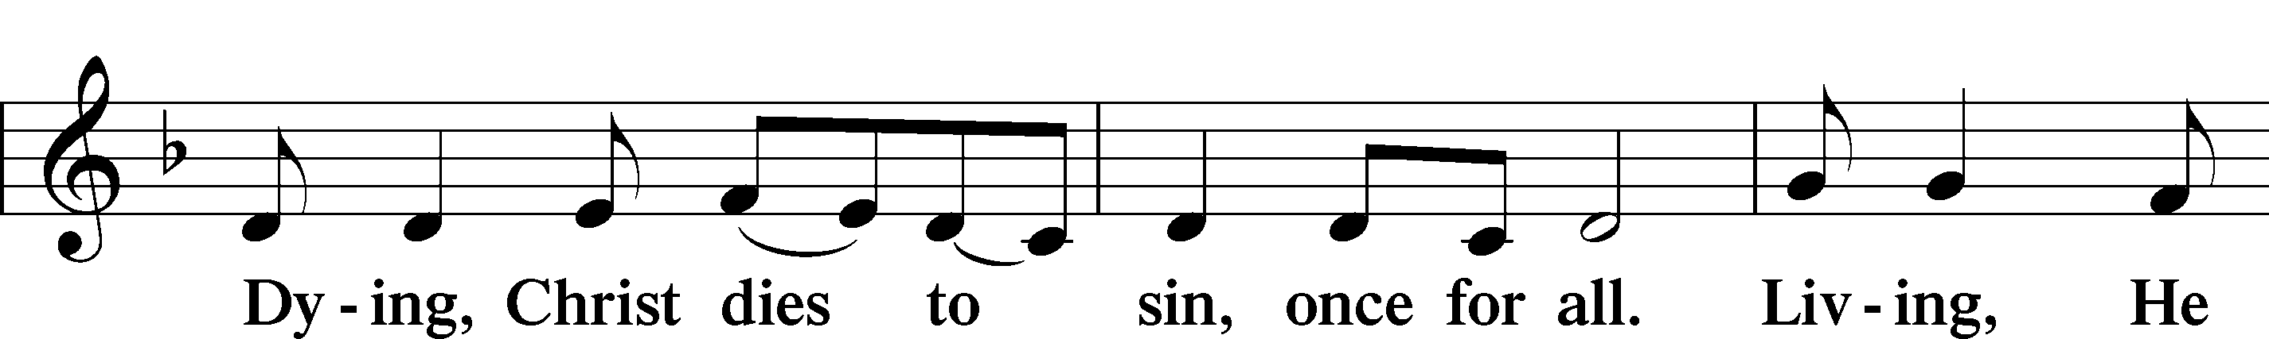
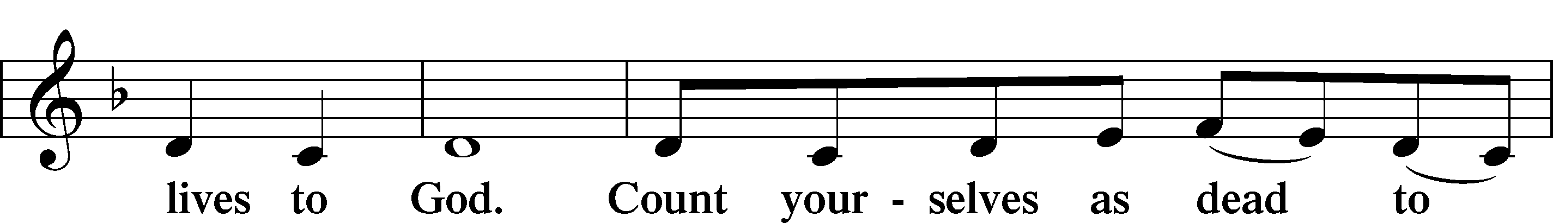
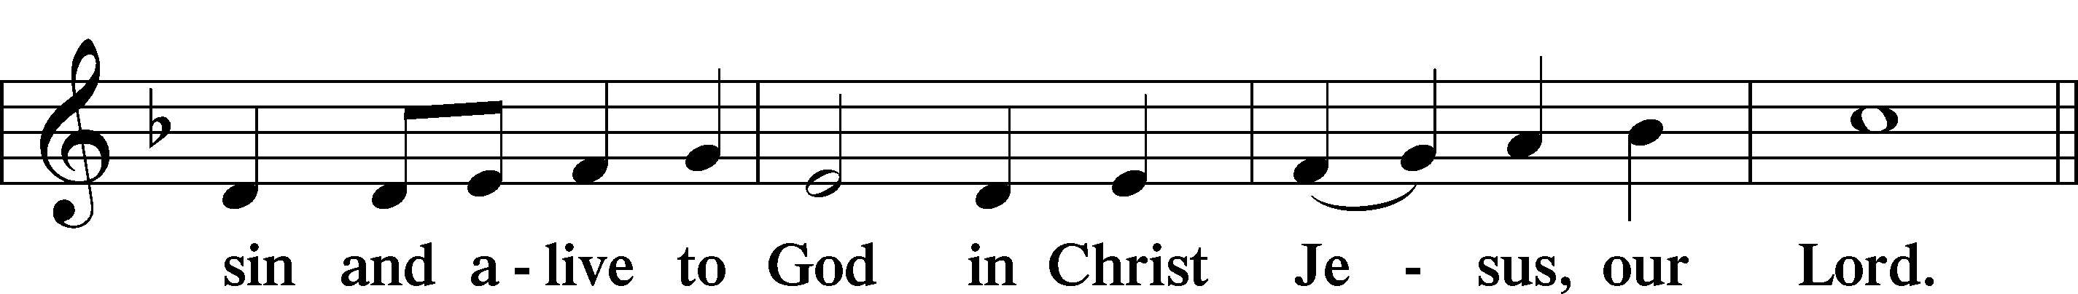
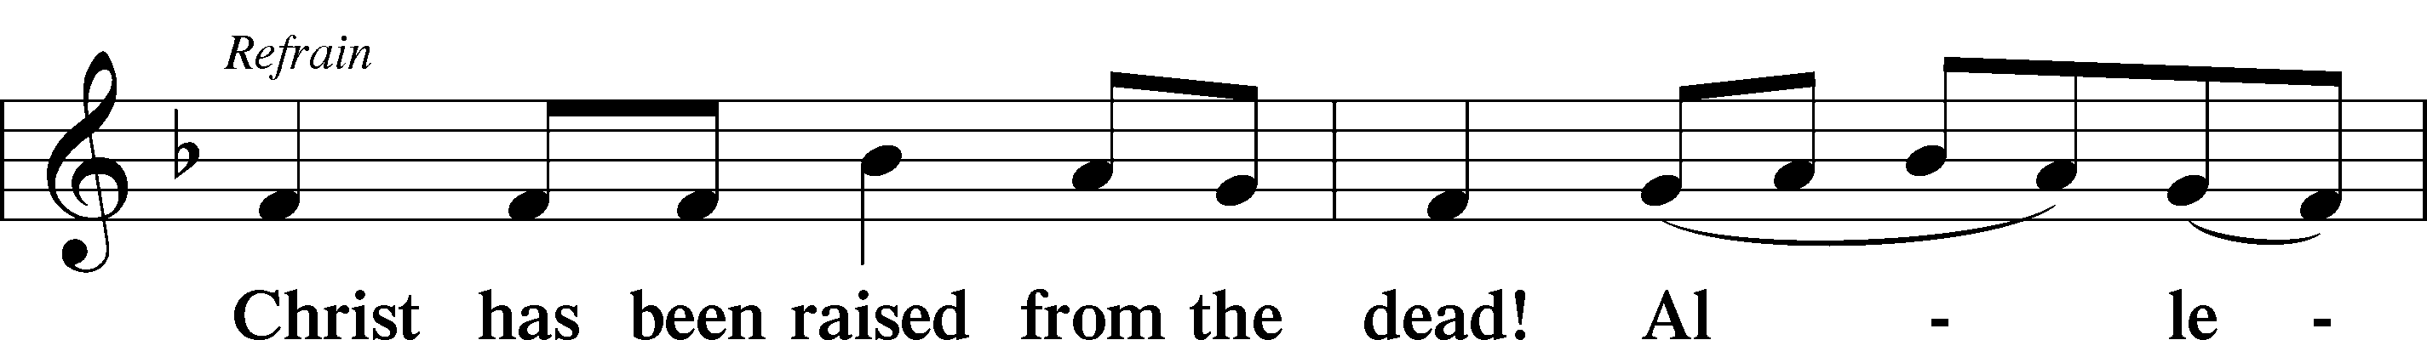
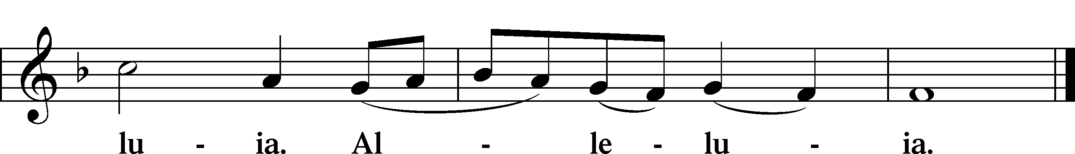

Blessing

Benedicamus LSB 267
L Let us bless the Lord.
C Thanks be to God.

Benediction LSB 267
L The almighty and merciful Lord, the Father, the T Son, and the Holy Spirit, bless and preserve us.
C Amen.

474 Alleluia! Jesus Is Risen
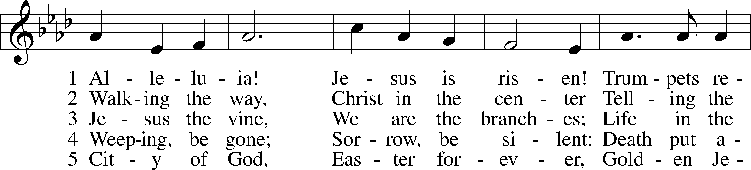
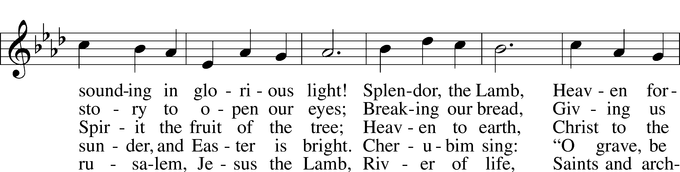
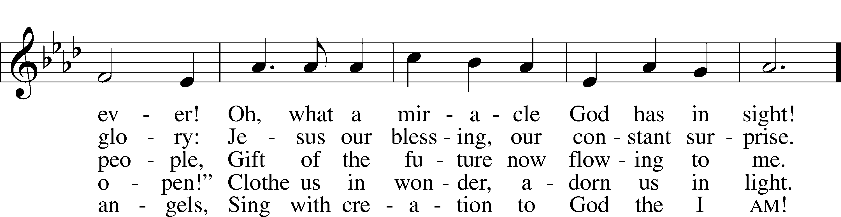
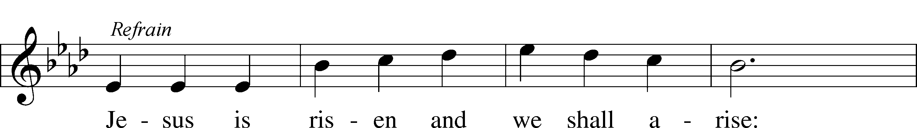
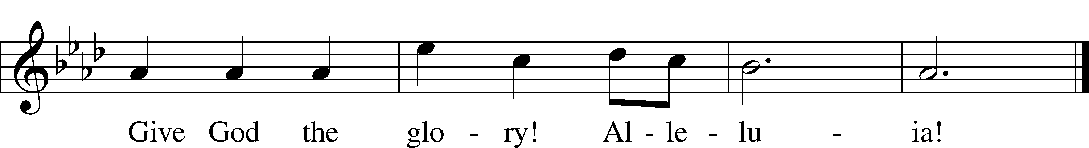
Text: Herbert F. Brokering, 1926–2009
Tune: David N. Johnson, 1922–87
Text: © 1995 Augsburg Fortress. Used by permission: LSB Hymn License no. 110002831
Tune: © 1968 Augsburg Publishing House. Used by permission: LSB Hymn License no. 110002831

Acknowledgments
Unless otherwise indicated, Scripture quotations are from the ESV® Bible (The Holy Bible, English Standard Version®), copyright © 2001 by Crossway, a publishing ministry of Good News Publishers. Used by permission. All rights reserved.
Created by Lutheran Service Builder © 2024 Concordia Publishing House.

