The Resurrection of Our Lord
Divine Service 1 p. 151
March 31, 2024
St. Paul Lutheran Church

Confession and Absolution

457 Jesus Christ Is Risen Today
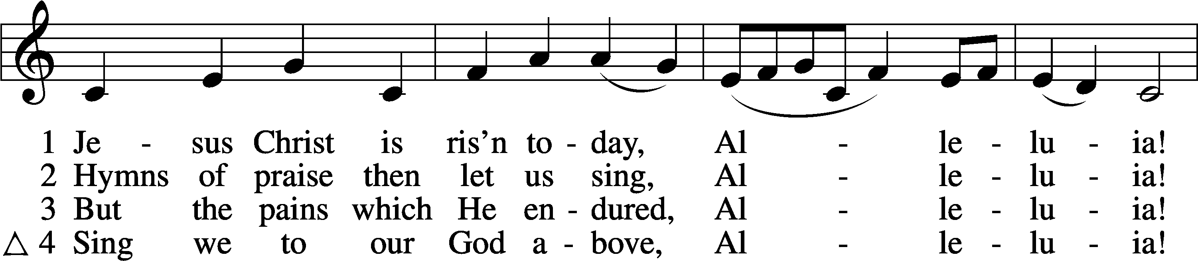
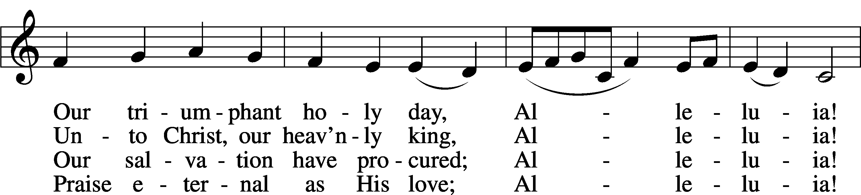
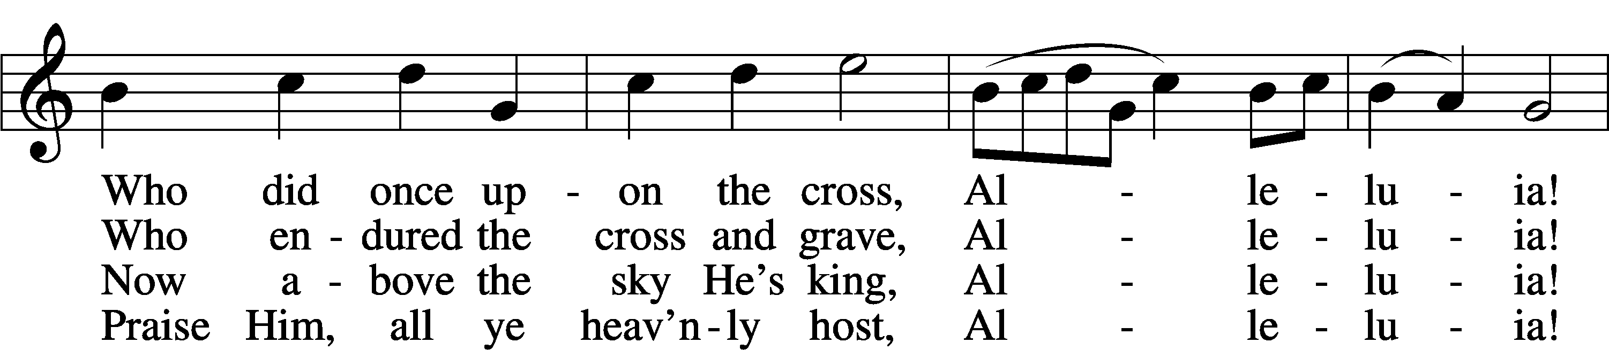
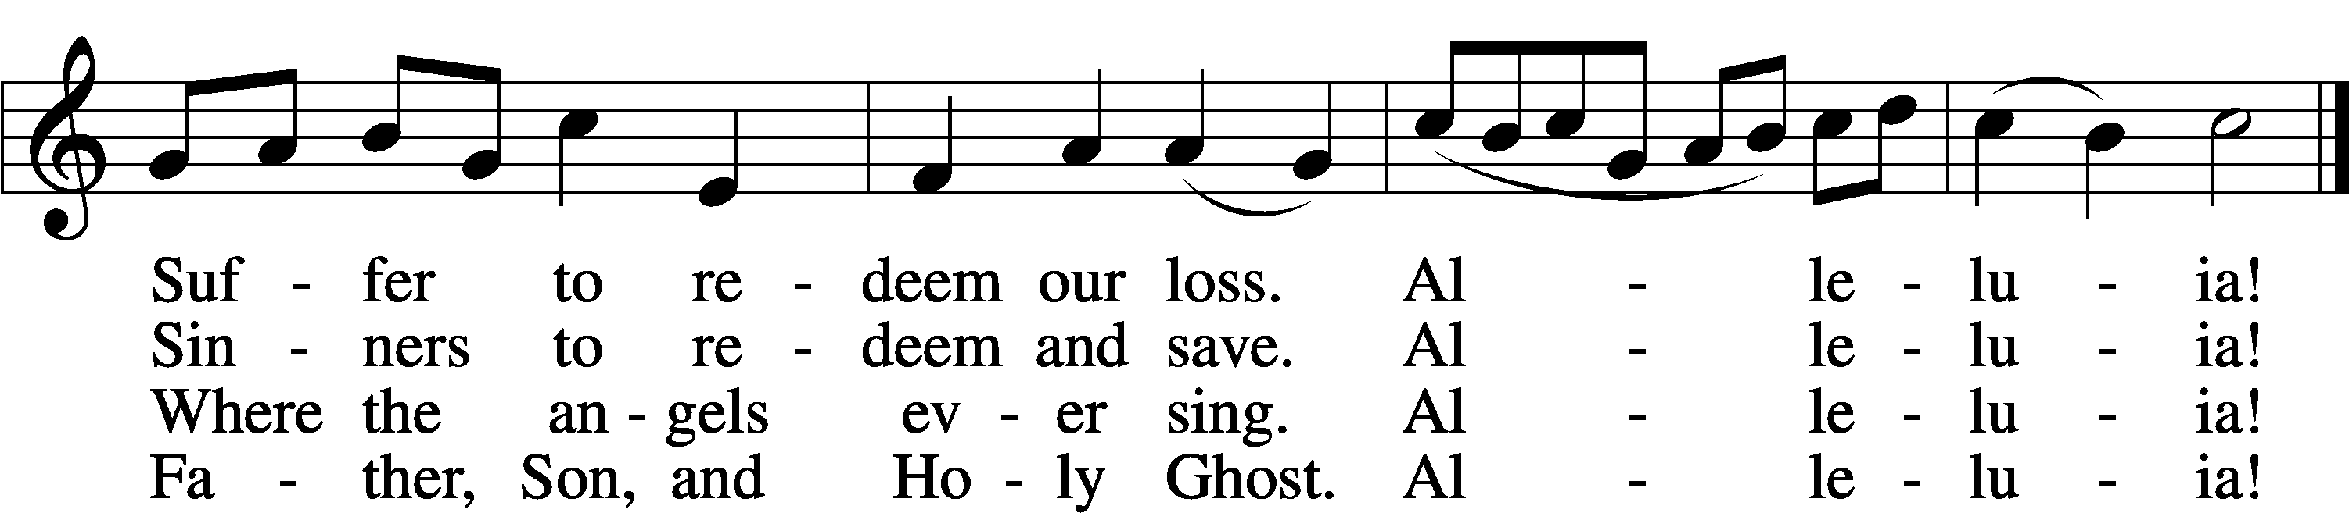
Text: tr. Lyra Davidica, 1708, London, alt.; (sts. 1–3): Latin, 14th cent.; (st. 4): Charles Wesley, 1707–88
Tune: Lyra Davidica, 1708, London
Text and tune: Public domain

Stand

The sign of the cross may be made by all in remembrance of their Baptism.

Invocation
P In the name of the Father and of the T Son and of the Holy Spirit.
C Amen.

Exhortation LSB 151
P If we say we have no sin, we deceive ourselves, and the truth is not in us.
C But if we confess our sins, God, who is faithful and just, will forgive our sins and cleanse us from all unrighteousness.

Kneel/Stand

Silence for reflection on God’s Word and for self-examination.

Confession of Sins LSB 151
P Let us then confess our sins to God our Father.
C Most merciful God, we confess that we are by nature sinful and unclean. We have sinned against You in thought, word, and deed, by what we have done and by what we have left undone. We have not loved You with our whole heart; we have not loved our neighbors as ourselves. We justly deserve Your present and eternal punishment. For the sake of Your Son, Jesus Christ, have mercy on us. Forgive us, renew us, and lead us, so that we may delight in Your will and walk in Your ways to the glory of Your holy name. Amen.

Absolution LSB 151
P Almighty God in His mercy has given His Son to die for you and for His sake forgives you all your sins. As a called and ordained servant of Christ, and by His authority, I therefore forgive you all your sins in the name of the Father and of the T Son and of the Holy Spirit.
C Amen.

Stand

Service of the Word

Psalm Psalm 16; antiphon: v. 10
1Preserve me, O God,
for in you I take refuge.
2I say to the Lord, “You are my Lord;
I have no good apart from you.”
3As for the saints in the land,
they are the excellent ones,
in whom is all my delight.
4The sorrows of those who run after another god shall multiply;
their drink offerings of blood I will not pour out
or take their names on my lips.
5The Lord is my chosen portion and my cup;
you hold my lot.
6The lines have fallen for me in pleasant places;
indeed, I have a beautiful inheritance.
7I bless the Lord who gives me counsel;
in the night also my heart instructs me.
8I have set the Lord always before me;
because he is at my right hand, I shall not be shaken.
9Therefore my heart is glad, and my whole being rejoices;
my flesh also dwells secure.
10For you will not abandon my soul to Sheol,
or let your holy one see corruption.
11You make known to me the path of life;
in your presence there is fullness of joy;
at your right hand are pleasures forevermore.

Kyrie LSB 152
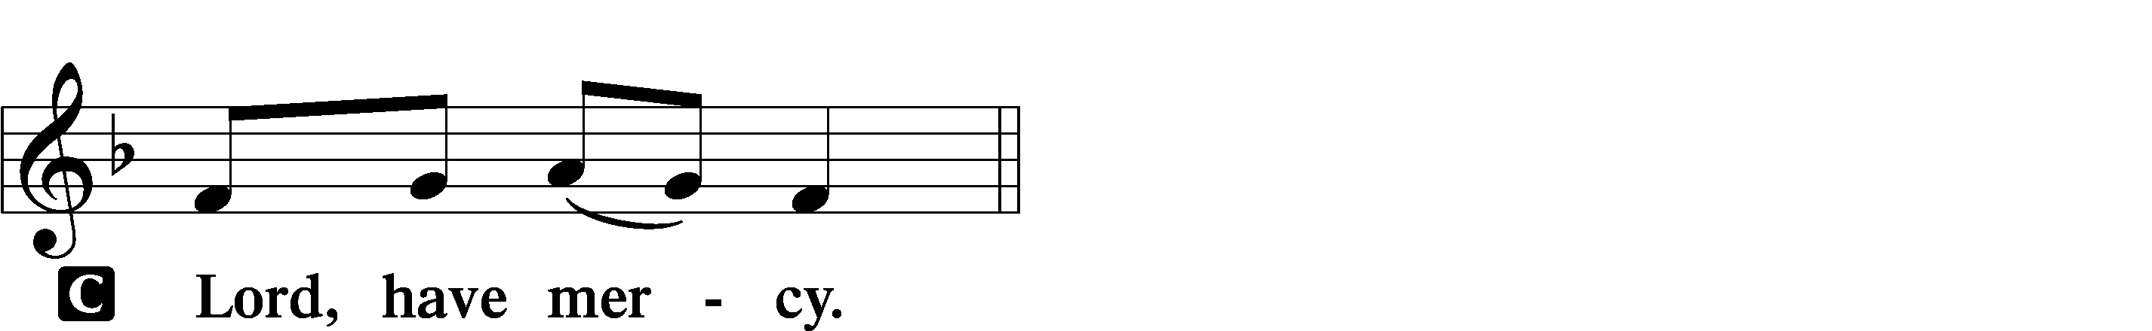

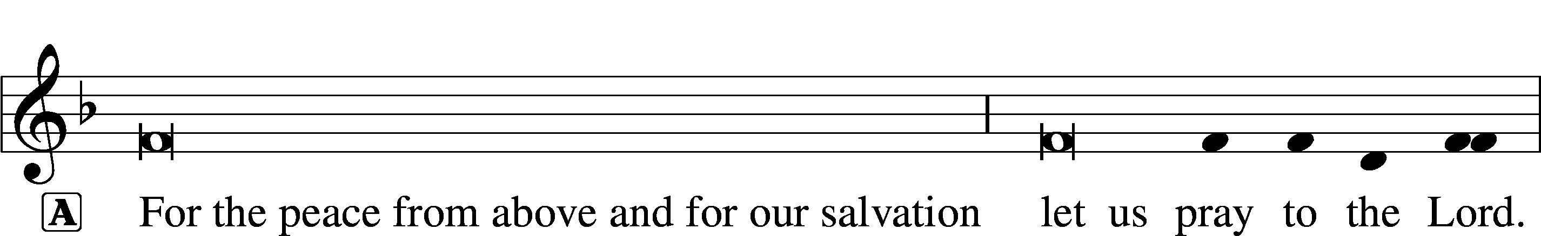
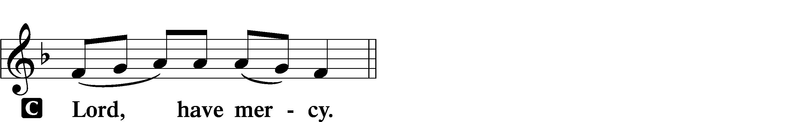

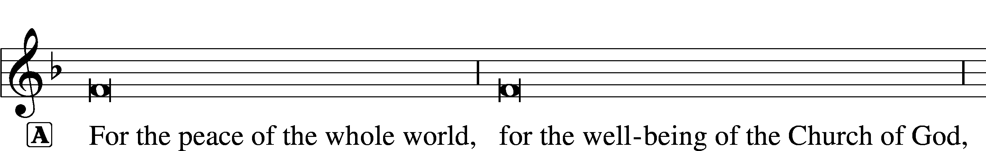
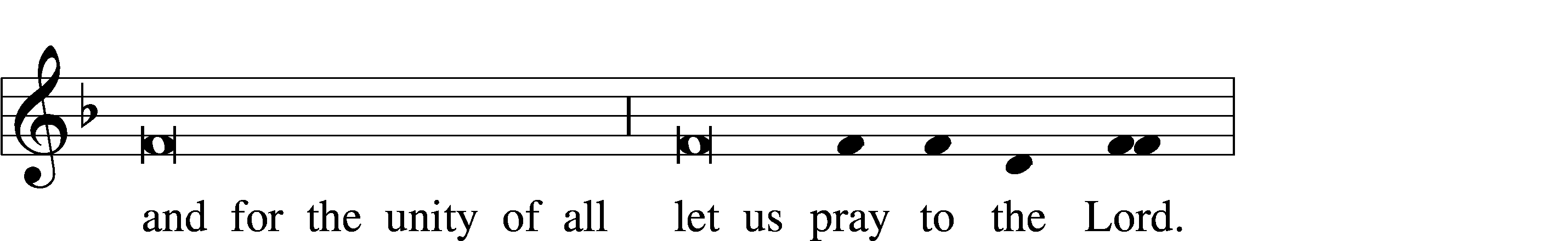
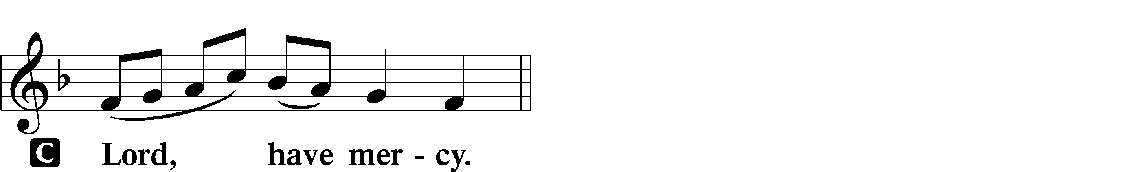

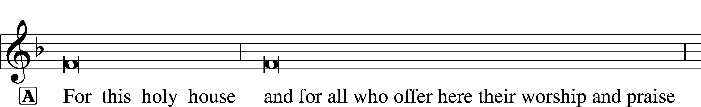
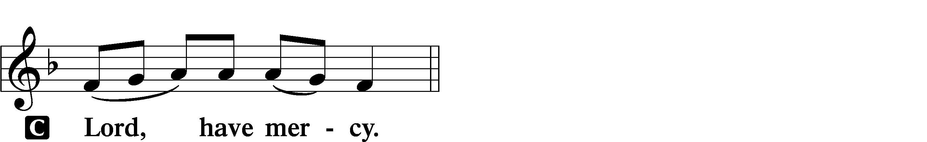

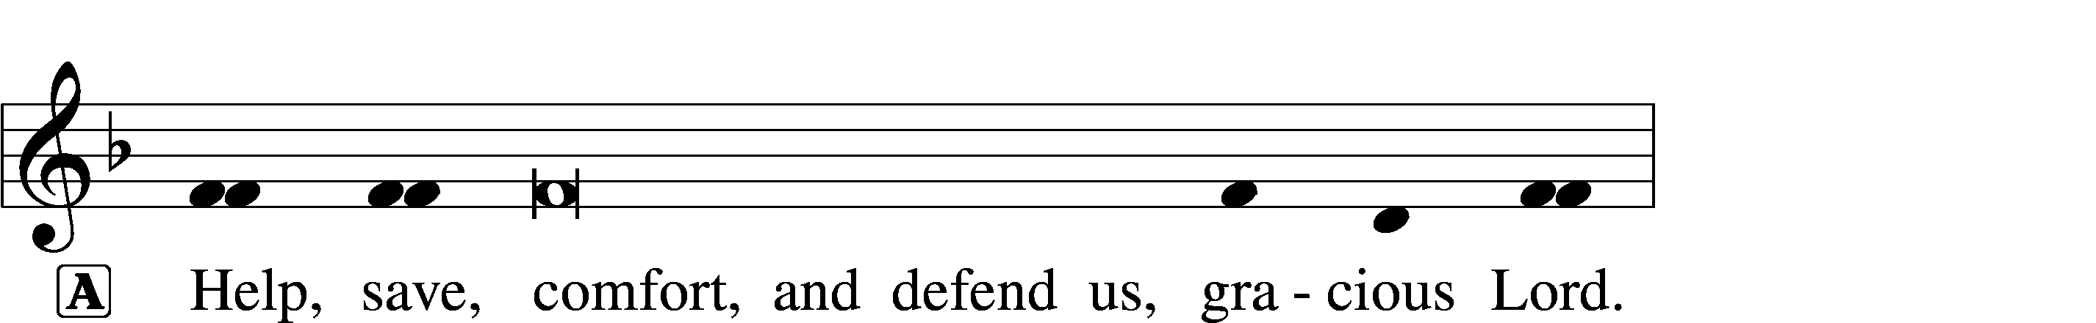

Gloria in Excelsis LSB 154
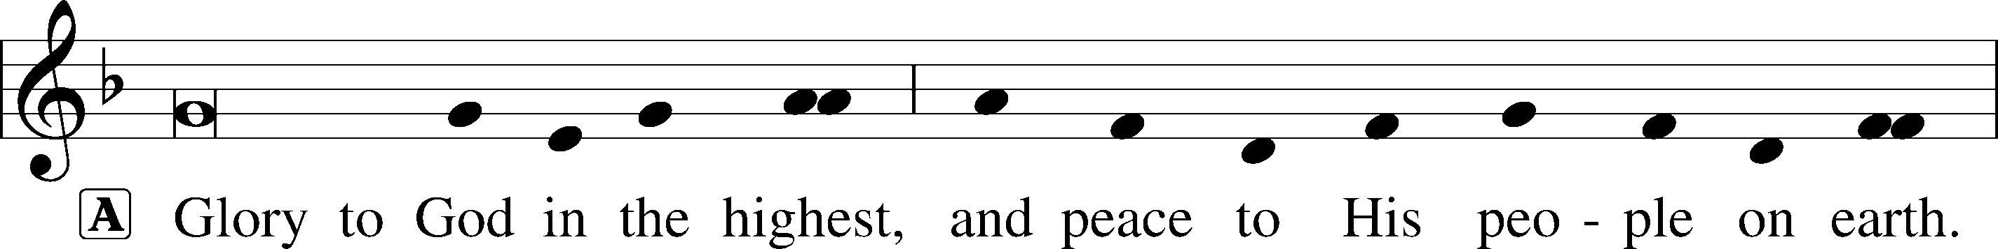
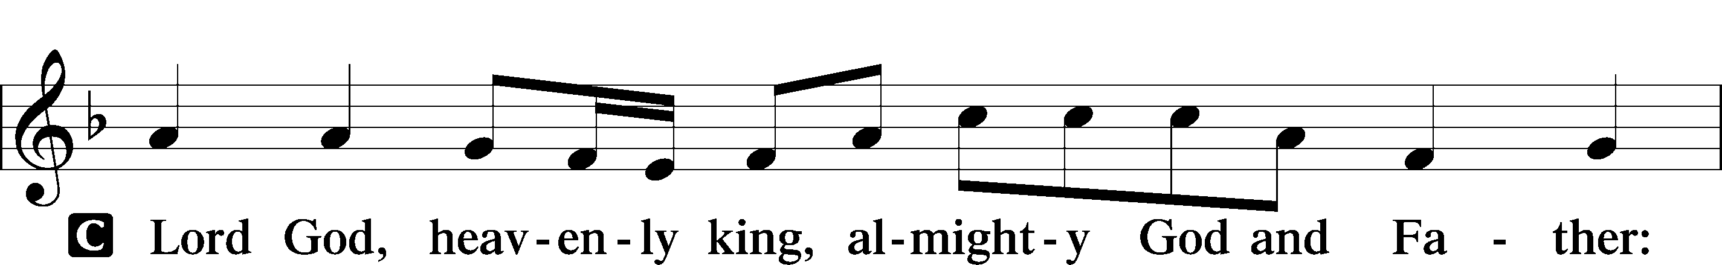
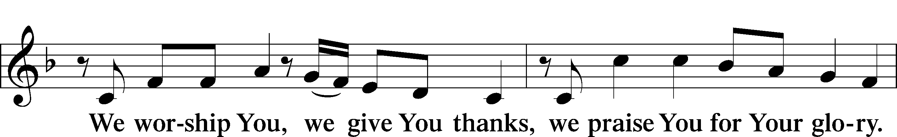
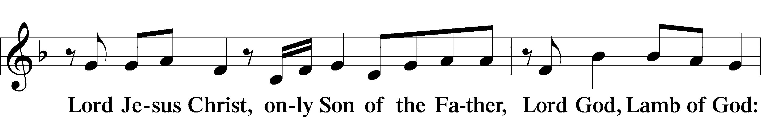
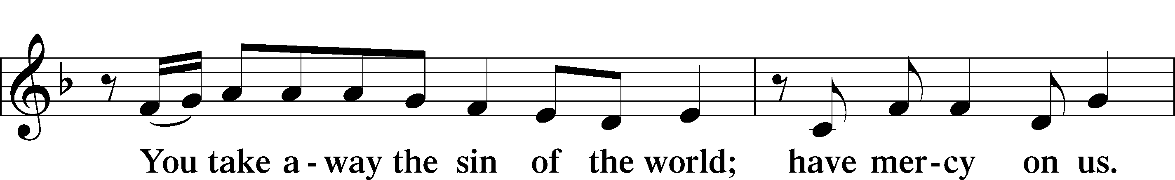
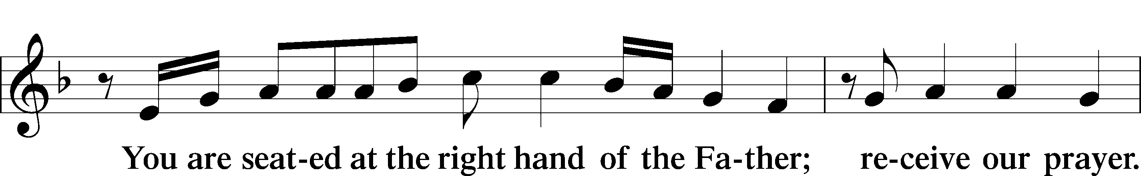
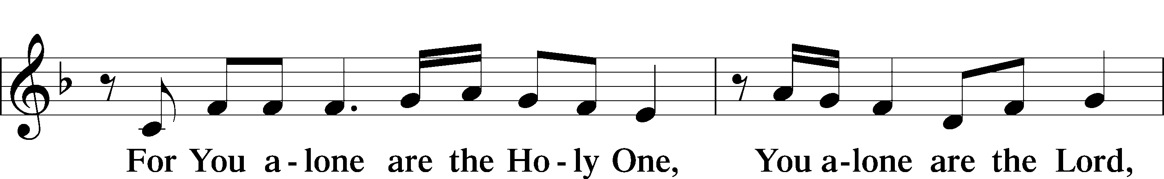
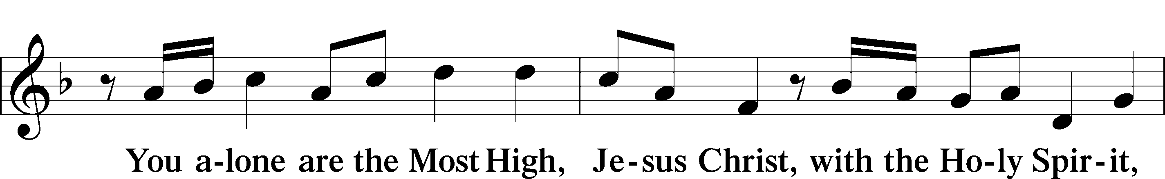
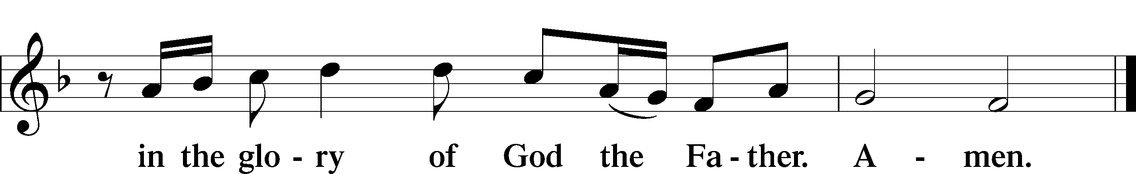

Salutation and Collect of the Day
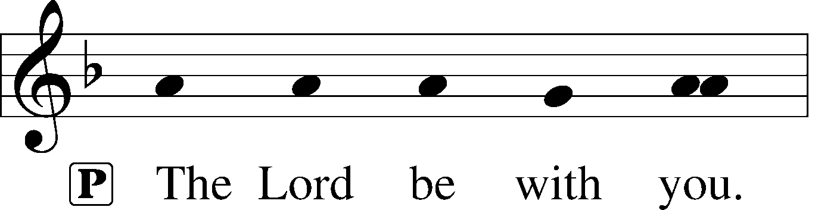
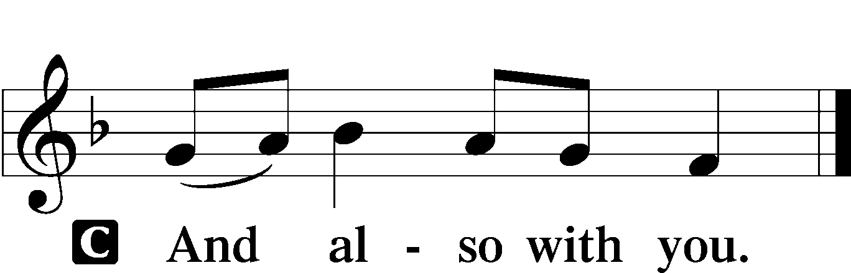

P Let us pray.
Almighty God the Father, through Your only-begotten Son, Jesus Christ, You have overcome death and opened the gate of everlasting life to us. Grant that we, who celebrate with joy the day of our Lord’s resurrection, may be raised from the death of sin by Your life-giving Spirit; through Jesus Christ, our Lord, who lives and reigns with You and the Holy Spirit, one God, now and forever.

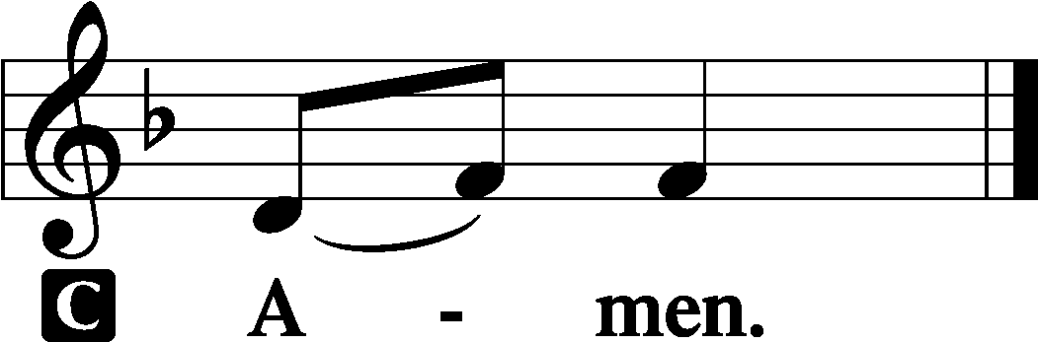

Sit
Old Testament Reading Isaiah 25:6–9
6On this mountain the Lord of hosts will make for all peoples
a feast of rich food, a feast of well-aged wine,
of rich food full of marrow, of aged wine well refined.
7And he will swallow up on this mountain
the covering that is cast over all peoples,
the veil that is spread over all nations.
8He will swallow up death forever;
and the Lord God will wipe away tears from all faces,
and the reproach of his people he will take away from all the earth,
for the Lord has spoken.
9It will be said on that day,
“Behold, this is our God; we have waited for him, that he might save us.
This is the Lord; we have waited for him;
let us be glad and rejoice in his salvation.”
A This is the Word of the Lord.
C Thanks be to God.

Epistle 1 Corinthians 15:1–11
1Now I would remind you, brothers, of the gospel I preached to you, which you received, in which you stand, 2and by which you are being saved, if you hold fast to the word I preached to you—unless you believed in vain.
3For I delivered to you as of first importance what I also received: that Christ died for our sins in accordance with the Scriptures, 4that he was buried, that he was raised on the third day in accordance with the Scriptures, 5and that he appeared to Cephas, then to the twelve. 6Then he appeared to more than five hundred brothers at one time, most of whom are still alive, though some have fallen asleep. 7Then he appeared to James, then to all the apostles. 8Last of all, as to one untimely born, he appeared also to me. 9For I am the least of the apostles, unworthy to be called an apostle, because I persecuted the church of God. 10But by the grace of God I am what I am, and his grace toward me was not in vain. On the contrary, I worked harder than any of them, though it was not I, but the grace of God that is with me. 11Whether then it was I or they, so we preach and so you believed.
A This is the Word of the Lord.
C Thanks be to God.
Stand

Alleluia and Verse LSB 156
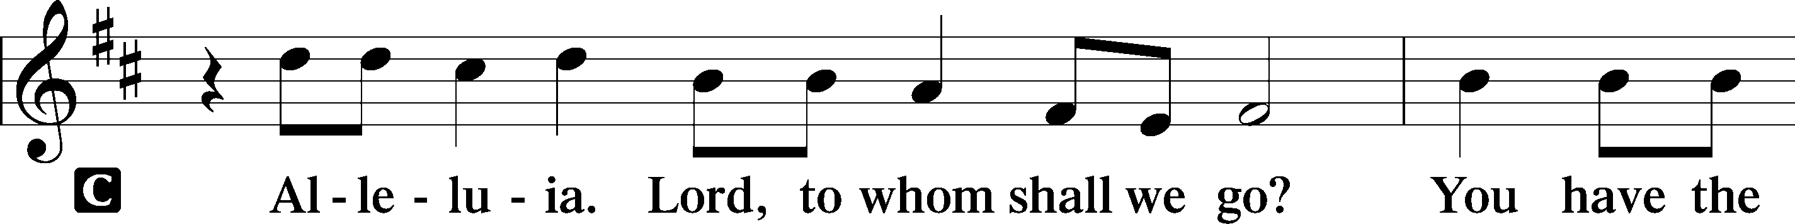
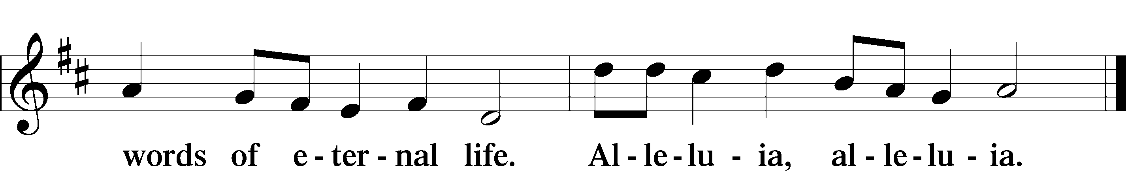

Holy Gospel Mark 16:1–8
P The Holy Gospel according to St. Mark, the sixteenth chapter.

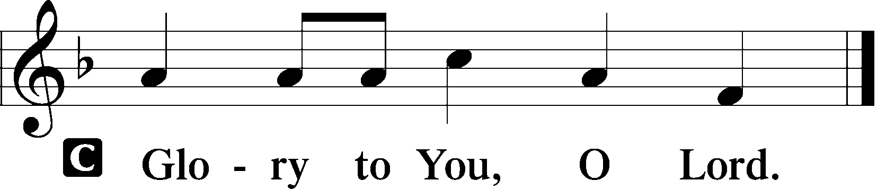

1When the Sabbath was past, Mary Magdalene and Mary the mother of James and Salome bought spices, so that they might go and anoint him. 2And very early on the first day of the week, when the sun had risen, they went to the tomb. 3And they were saying to one another, “Who will roll away the stone for us from the entrance of the tomb?” 4And looking up, they saw that the stone had been rolled back—it was very large. 5And entering the tomb, they saw a young man sitting on the right side, dressed in a white robe, and they were alarmed. 6And he said to them, “Do not be alarmed. You seek Jesus of Nazareth, who was crucified. He has risen; he is not here. See the place where they laid him. 7But go, tell his disciples and Peter that he is going before you to Galilee. There you will see him, just as he told you.” 8And they went out and fled from the tomb, for trembling and astonishment had seized them, and they said nothing to anyone, for they were afraid.

P This is the Gospel of the Lord.

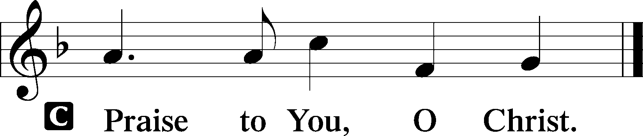

Sit

461 I Know That My Redeemer Lives
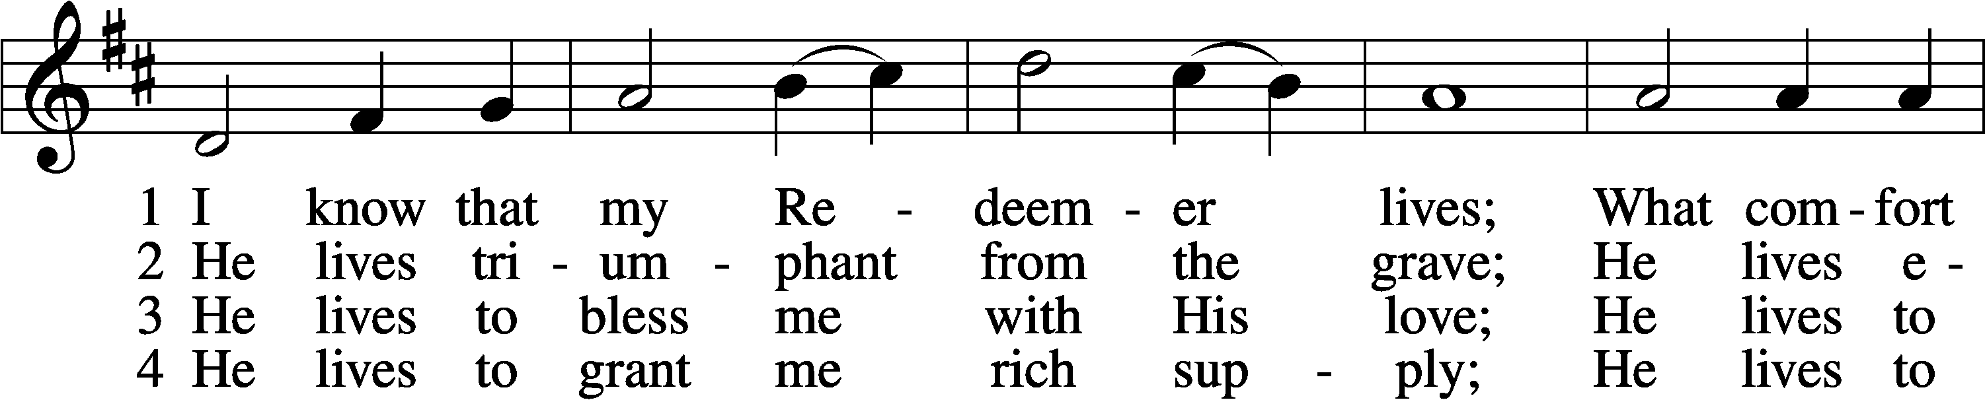
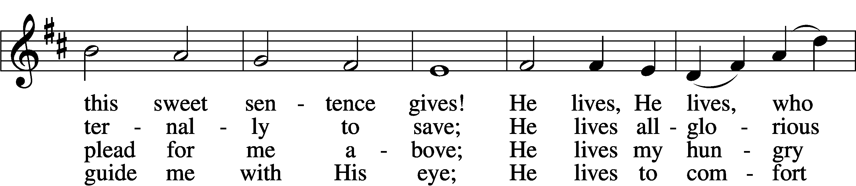
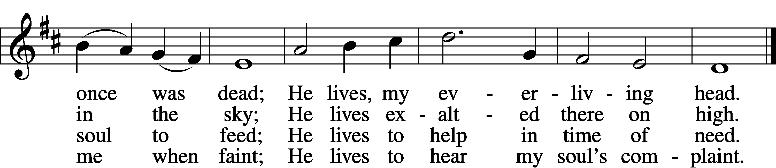

5 He lives to silence all my fears;
He lives to wipe away my tears;
He lives to calm my troubled heart;
He lives all blessings to impart.

6 He lives, my kind, wise, heav’nly friend;
He lives and loves me to the end;
He lives, and while He lives, I’ll sing;
He lives, my Prophet, Priest, and King.

7 He lives and grants me daily breath;
He lives, and I shall conquer death;
He lives my mansion to prepare;
He lives to bring me safely there.

8 He lives, all glory to His name!
He lives, my Jesus, still the same;
Oh, the sweet joy this sentence gives:
I know that my Redeemer lives!
Text: Samuel Medley, 1738–99, abr.
Tune: attr. John C. Hatton, d. 1793
Text and tune: Public domain

Children’s Sermon
Sermon

Stand

Nicene Creed
C I believe in one God,
the Father Almighty,
maker of heaven and earth
and of all things visible and invisible.

And in one Lord Jesus Christ,
the only-begotten Son of God,
begotten of His Father before all worlds,
God of God, Light of Light,
very God of very God,
begotten, not made,
being of one substance with the Father,
by whom all things were made;
who for us men and for our salvation came down from heaven
and was incarnate by the Holy Spirit of the virgin Mary
and was made man;
and was crucified also for us under Pontius Pilate.
He suffered and was buried.
And the third day He rose again according to the Scriptures
and ascended into heaven
and sits at the right hand of the Father.
And He will come again with glory to judge both the living and the dead,
whose kingdom will have no end.

And I believe in the Holy Spirit,
the Lord and giver of life,
who proceeds from the Father and the Son,
who with the Father and the Son together is worshiped and glorified,
who spoke by the prophets.
And I believe in one holy Christian and apostolic Church,
I acknowledge one Baptism for the remission of sins,
and I look for the resurrection of the dead
and the life T of the world to come. Amen.

Prayer of the Church
P Let us pray for the whole Church of God in Christ Jesus and for all people according to their needs.
Almighty God, You kept Your promise and delivered up Your own Son to be our Savior. By His sacrificial death, our sins are forgiven, and by His rising again, we have the hope of everlasting life. Keep us in this holy joy throughout the Easter season and all our daily lives, that we may not fear our enemies nor give in to the temptation of despair in our days of trouble. Lord, in Your mercy,
C hear our prayer.

P Be with Matthew, our Synod president; __________, our district president; and all our pastors. Keep them faithful to deliver to Your people the apostolic Gospel of Your Son’s death, burial and resurrection. Lord, in Your mercy,
C hear our prayer.

P Let us hold fast to the Word preached to us, that receiving it with joy we may take our stand in it and be saved by it. Hinder all who would sow doubt into our hearts, and grant us courage to confess its truth in our life and conversation. Lord, in Your mercy,
C hear our prayer.

P Bless Joseph, our president, and all who make and administer our laws. Frustrate the forces of evil, and do not let our leaders cooperate with them or further their goals. Guard our armed forces as they stand watch for us at home and abroad. Let them serve with honor and integrity. Lord, in Your mercy,
C hear our prayer.

P Have mercy on the sick and those in any need [________]. Let the dawning light of the new creation in Christ sustain them in faith. In accord with Your will, grant them renewed health — a foretaste of their eternal healing in Him. Lord, in Your mercy,
C hear our prayer.

P Give us joy in Your Son’s great victory feast as He shares it with us from this altar. In the eating of His true body and the drinking of His precious blood in faith, overcome our sin by His forgiveness and swallow up our death in His life, that we may be glad and rejoice in His salvation. Lord, in Your mercy,
C hear our prayer.

P We praise Your holy name, O Lord, for all Your servants who have departed this life in faith. We pray that You will not abandon us to Sheol but that, when we awake in the resurrection of all flesh, Your presence will give us joy. Lord, in Your mercy,
C hear our prayer.

P We join today in singing eternal alleluias with innumerable angels in festal gathering, with the assembly of the firstborn enrolled in heaven and with the spirits of the righteous made perfect, and we bring these petitions before You, dear Father, trusting in Your mercy; through Jesus Christ, Your Son, our Lord, who lives and reigns with You and the Holy Spirit, one God, now and forever.
C Amen.

Sit

Offering

Stand

Offertory LSB 159
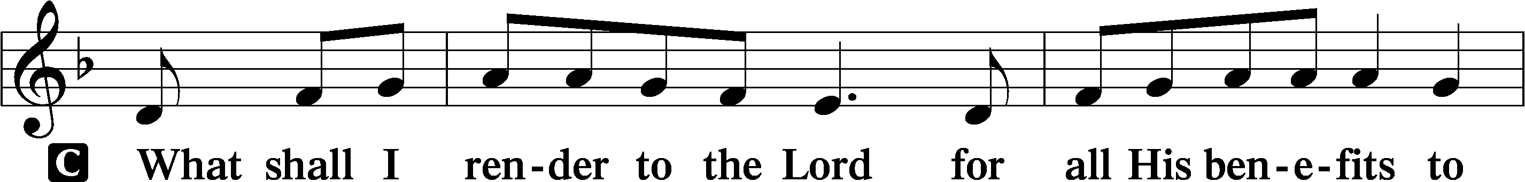
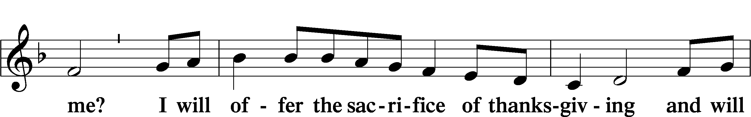
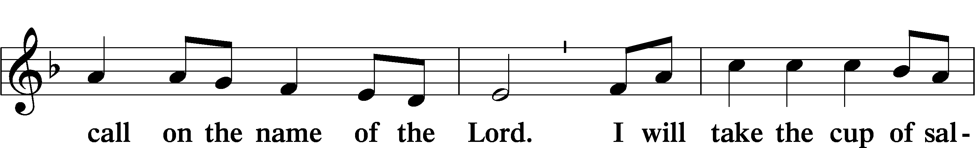
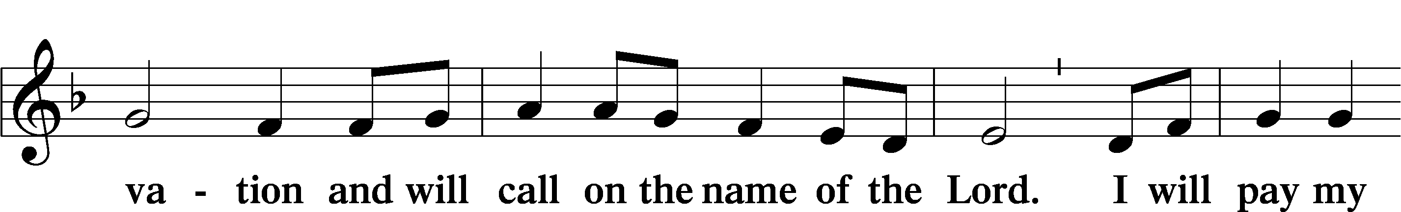
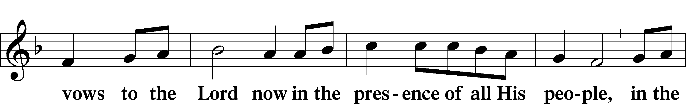
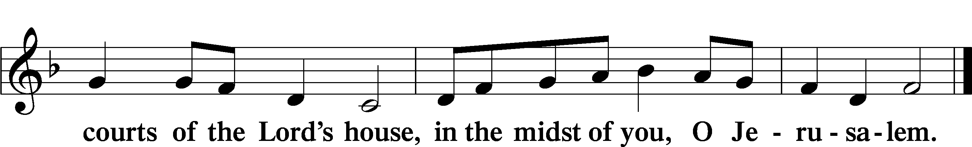

Service of the Sacrament

Preface LSB 160
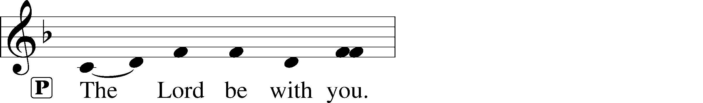
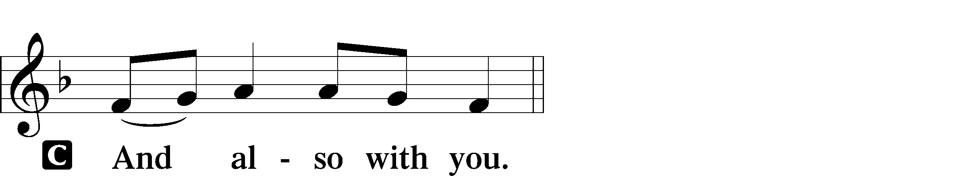
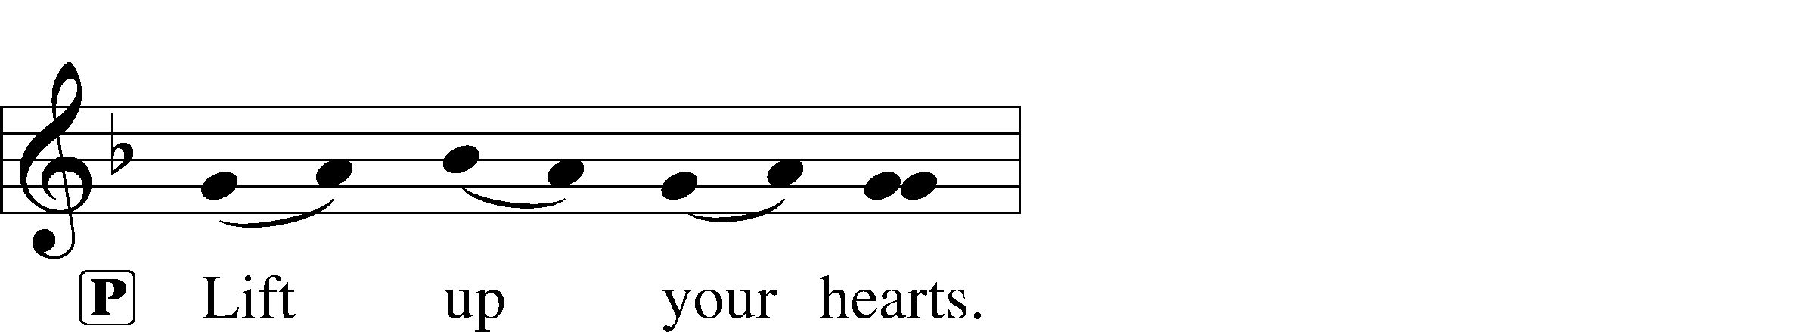
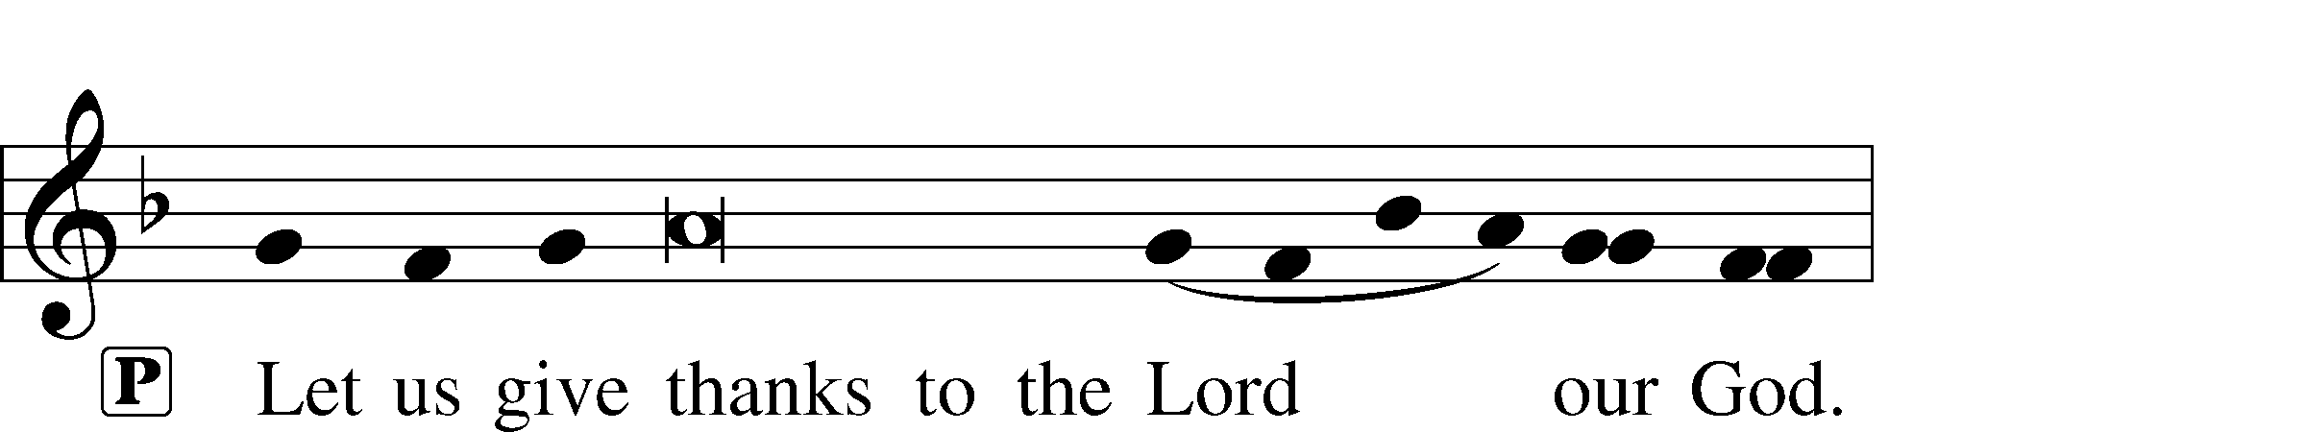
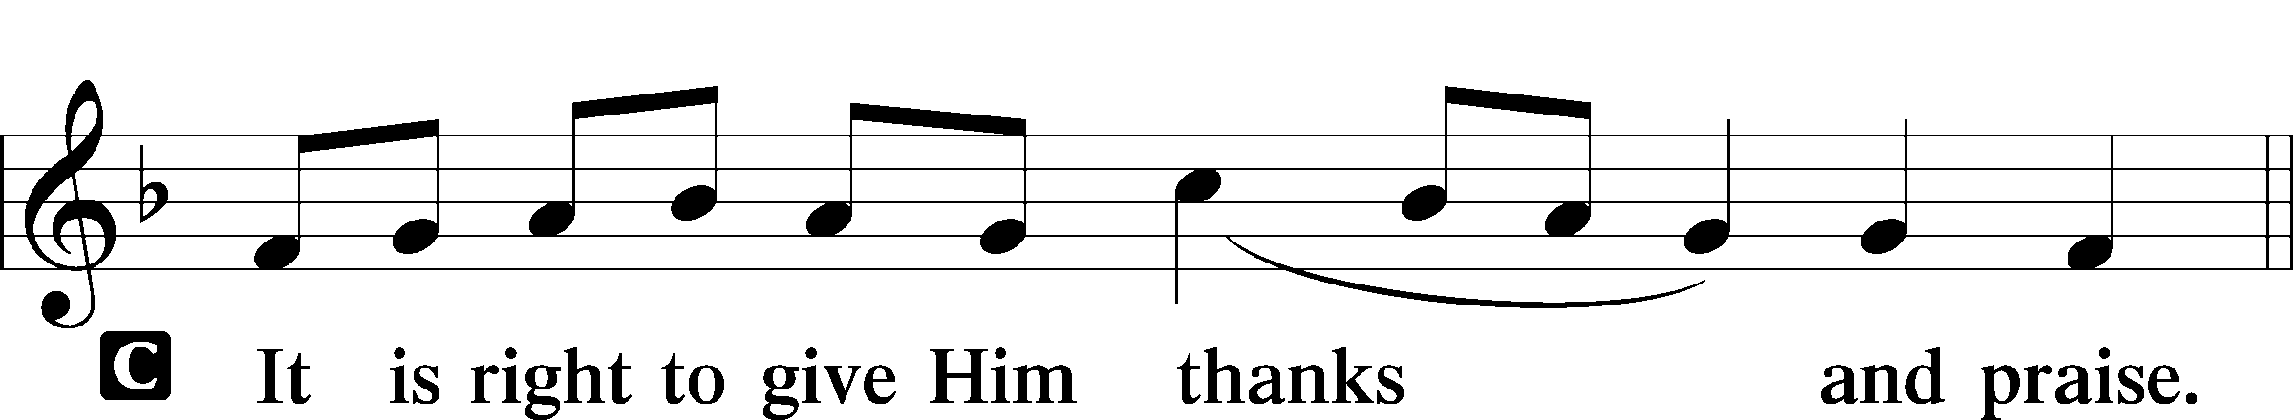

Proper Preface (Full)
P It is truly good, right, and salutary that we should at all times and in all places give thanks to You, holy Lord, almighty Father, everlasting God. And most especially are we bound to praise You on this day for the glorious resurrection of Your Son, Jesus Christ, the very Paschal Lamb, who was sacrificed for us and bore the sins of the world. By His dying He has destroyed death, and by His rising again He has restored to us everlasting life. Therefore with Mary Magdalene, Peter and John, and with all the witnesses of the resurrection, with angels and archangels, and with all the company of heaven we laud and magnify Your glorious name, evermore praising You and saying:

Sanctus LSB 161
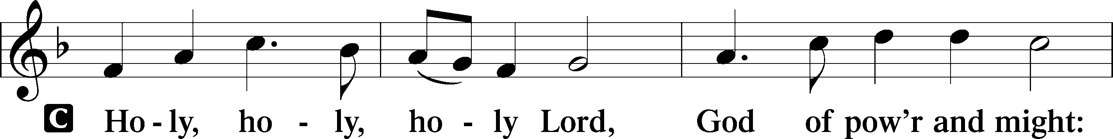
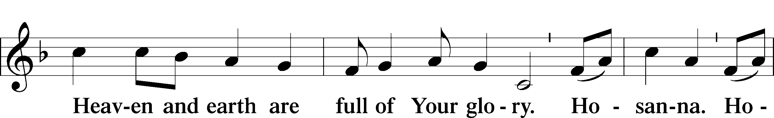
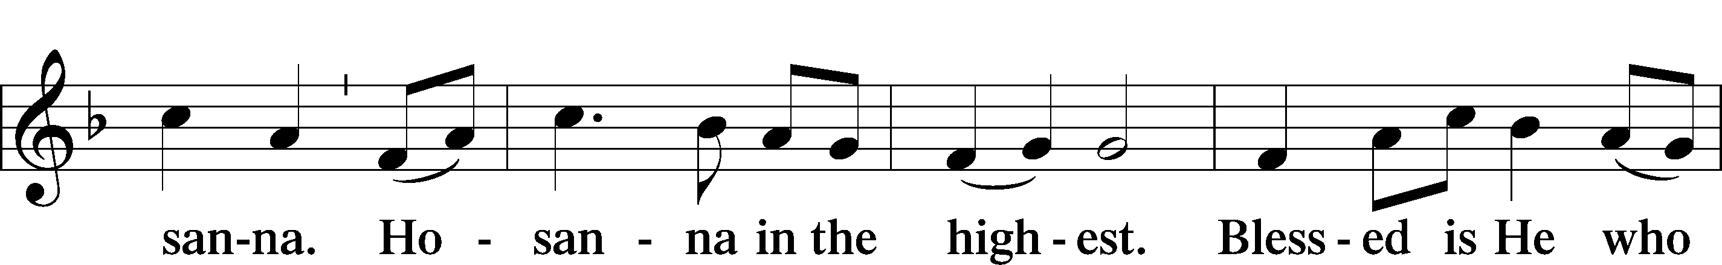
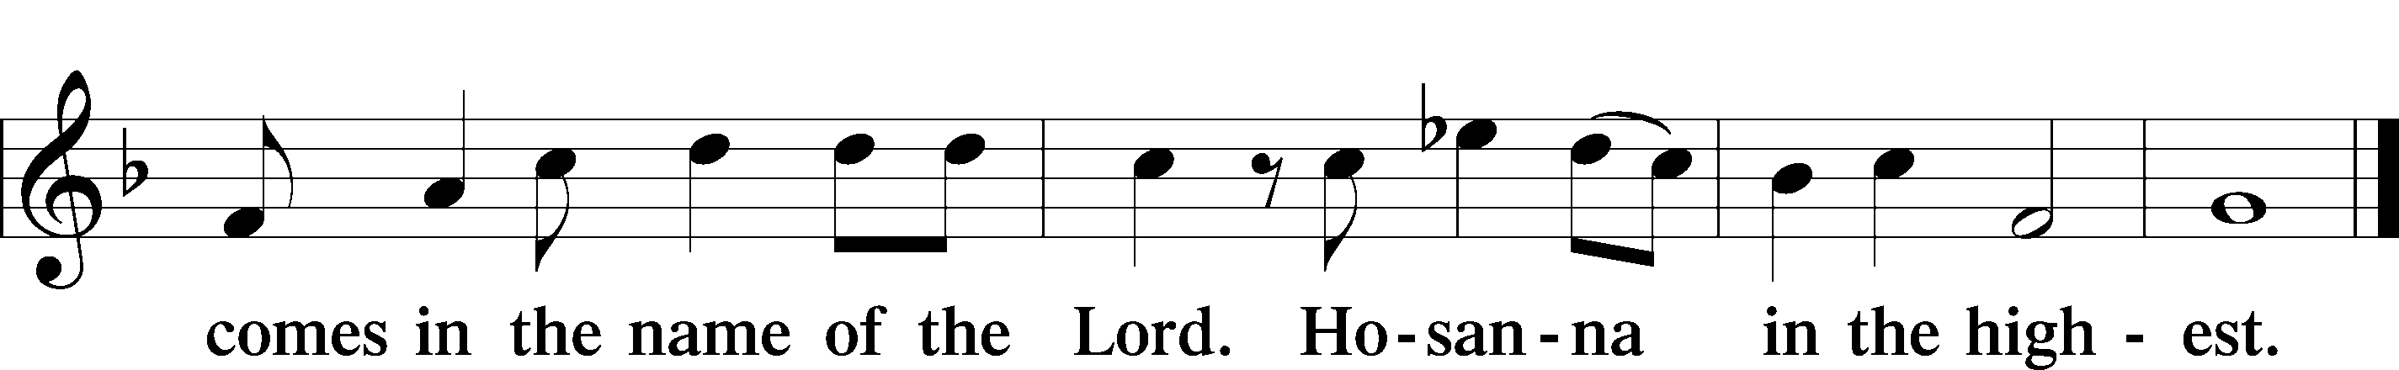

Prayer of Thanksgiving LSB 161
P Blessed are You, Lord of heaven and earth, for You have had mercy on those whom You created and sent Your only-begotten Son into our flesh to bear our sin and be our Savior. With repentant joy we receive the salvation accomplished for us by the all-availing sacrifice of His body and His blood on the cross.

Gathered in the name and the remembrance of Jesus, we beg You, O Lord, to forgive, renew, and strengthen us with Your Word and Spirit. Grant us faithfully to eat His body and drink His blood as He bids us do in His own testament. Gather us together, we pray, from the ends of the earth to celebrate with all the faithful the marriage feast of the Lamb in His kingdom, which has no end. Graciously receive our prayers; deliver and preserve us. To You alone, O Father, be all glory, honor, and worship, with the Son and the Holy Spirit, one God, now and forever.
C Amen.

The Words of Our Lord
P Our Lord Jesus Christ, on the night when He was betrayed, took bread, and when He had given thanks, He broke it and gave it to the disciples and said: “Take, eat; this is My T body, which is given for you. This do in remembrance of Me.”

In the same way also He took the cup after supper, and when He had given thanks, He gave it to them, saying: “Drink of it, all of you; this cup is the new testament in My T blood, which is shed for you for the forgiveness of sins. This do, as often as you drink it, in remembrance of Me.”

Proclamation of Christ
P As often as we eat this bread and drink this cup, we proclaim the Lord’s death until He comes.
C Amen. Come, Lord Jesus.

P O Lord Jesus Christ, only Son of the Father, in giving us Your body and blood to eat and to drink, You lead us to remember and confess Your holy cross and passion, Your blessed death, Your rest in the tomb, Your resurrection from the dead, Your ascension into heaven, and Your coming for the final judgment. So remember us in Your kingdom and teach us to pray:

Lord’s Prayer
C Our Father who art in heaven,
hallowed be Thy name,
Thy kingdom come,
Thy will be done on earth
as it is in heaven;
give us this day our daily bread;
and forgive us our trespasses
as we forgive those
who trespass against us;
and lead us not into temptation,
but deliver us from evil.
For Thine is the kingdom
and the power and the glory
forever and ever. Amen.

Pax Domini LSB 163
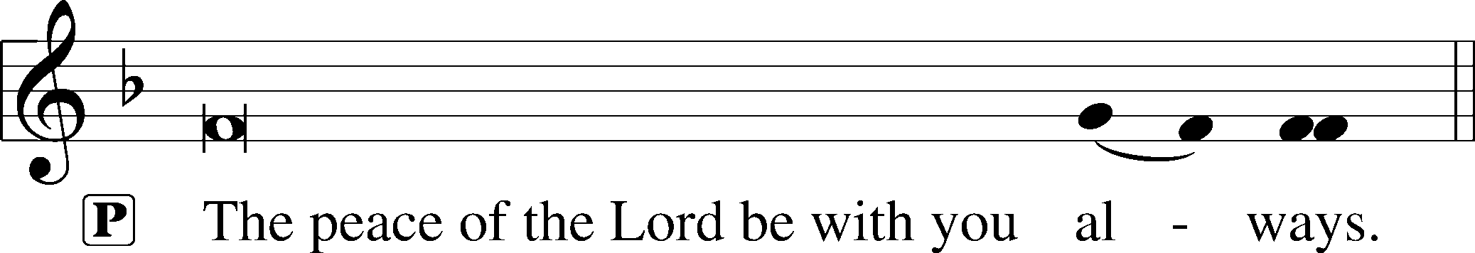

Agnus Dei LSB 163
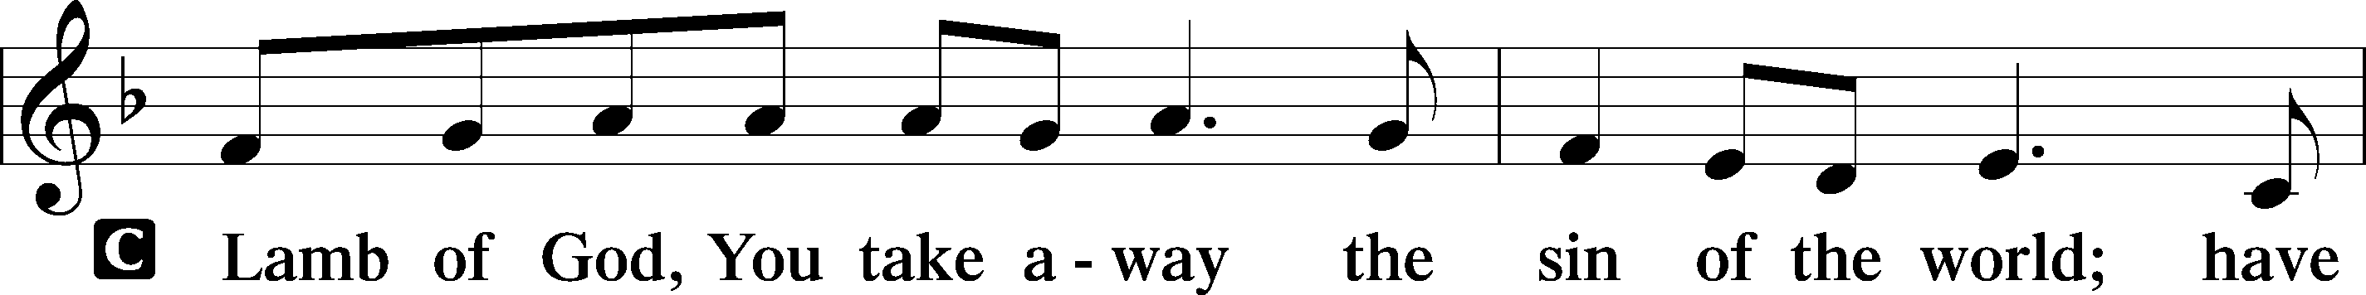
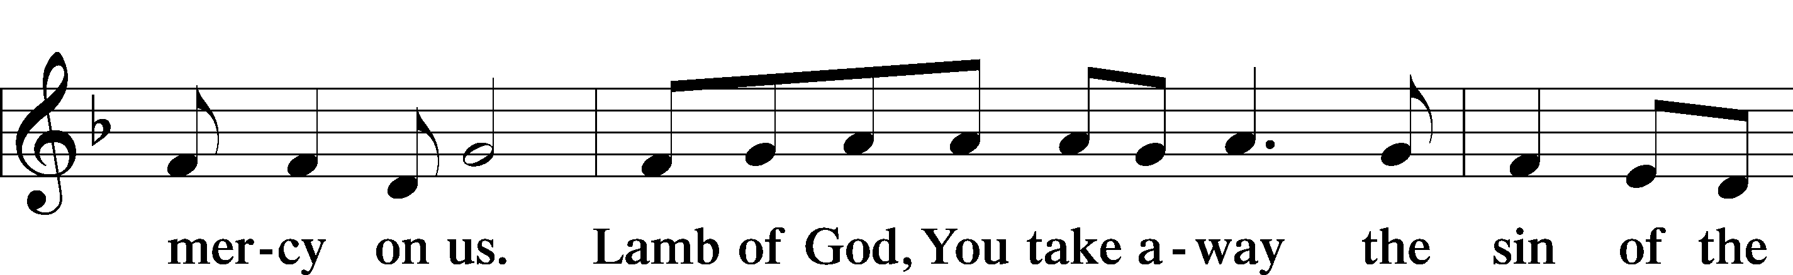
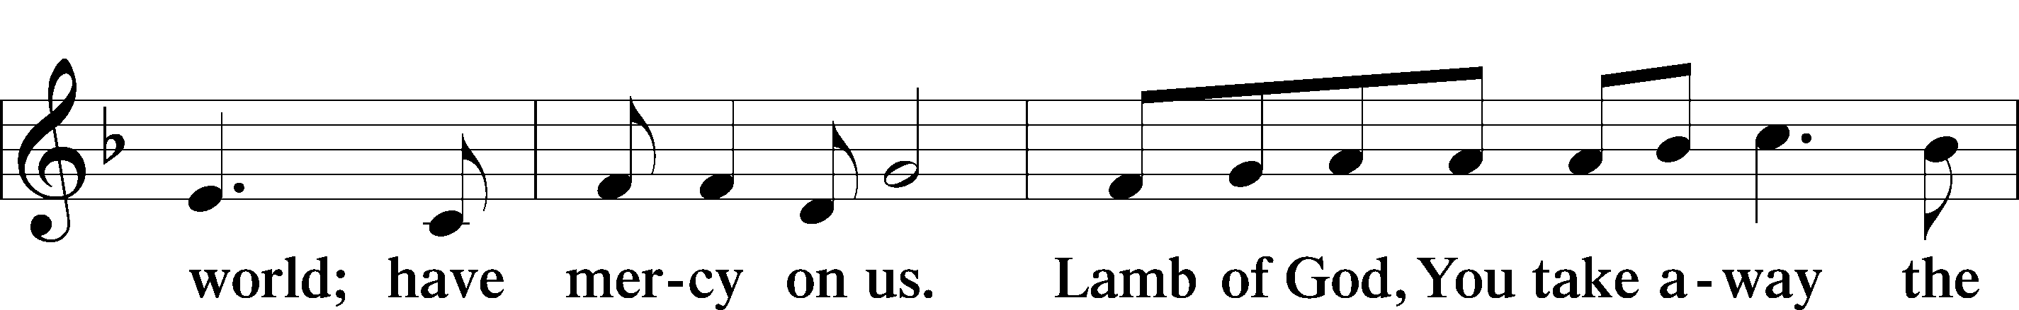
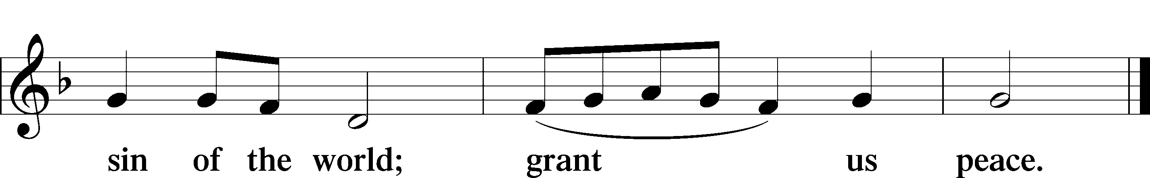

Sit

Distribution

633 At the Lamb’s High Feast We Sing
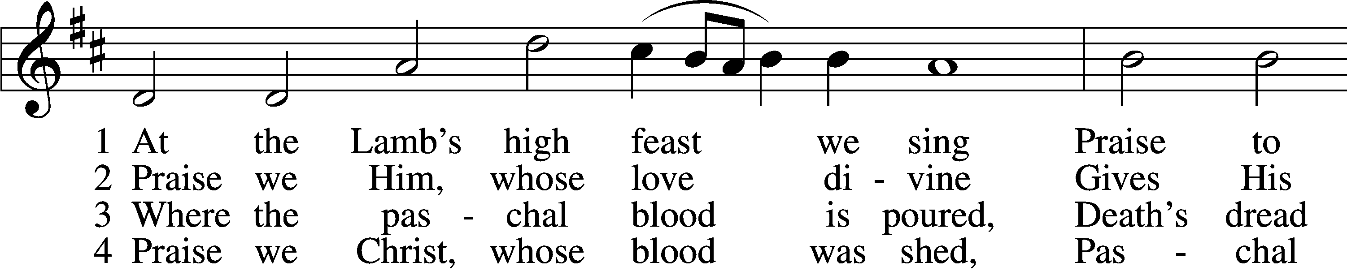
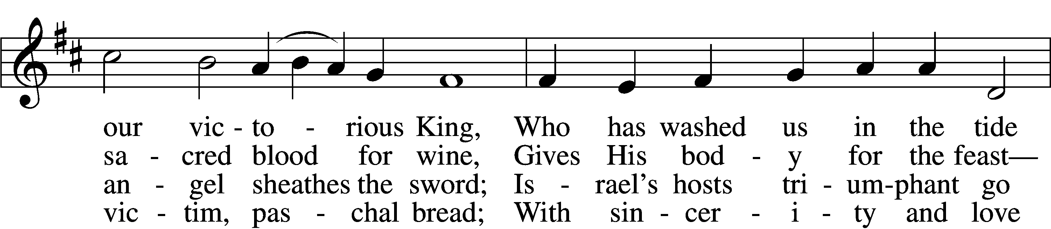
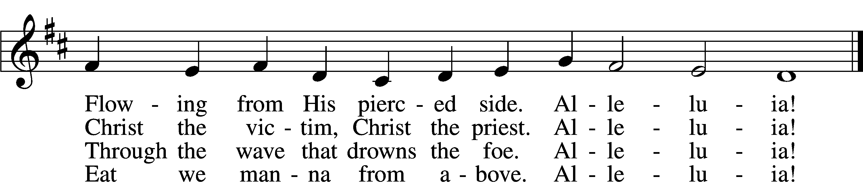

5 Mighty Victim from the sky,
Hell’s fierce pow’rs beneath You lie;
You have conquered in the fight,
You have brought us life and light.
Alleluia!

6 Now no more can death appall,
Now no more the grave enthrall;
You have opened paradise,
And Your saints in You shall rise.
Alleluia!

7 Easter triumph, Easter joy!
This alone can sin destroy;
From sin’s pow’r, Lord, set us free,
Newborn souls in You to be.
Alleluia!

D 8 Father, who the crown shall give,
Savior, by whose death we live,
Spirit, guide through all our days:
Three in One, Your name we praise.
Alleluia!
Text: Latin, c. 5th–10th cent.; tr. Robert Campbell, 1814–68, alt.Tune: Kirchengeseng, 1566, IvanciceText and tune: Public domain
466 Christ Has Arisen, Alleluia
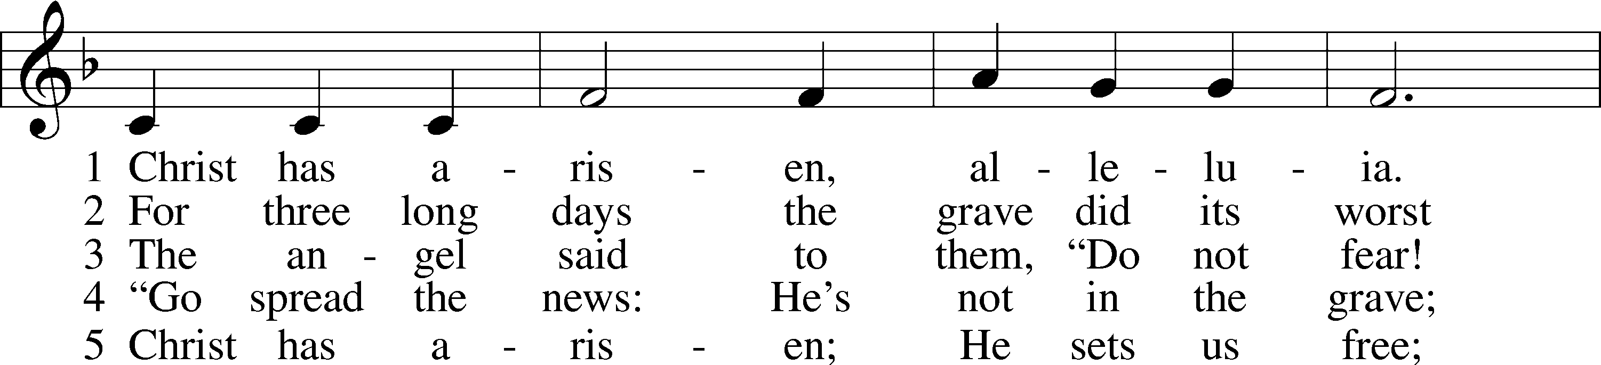
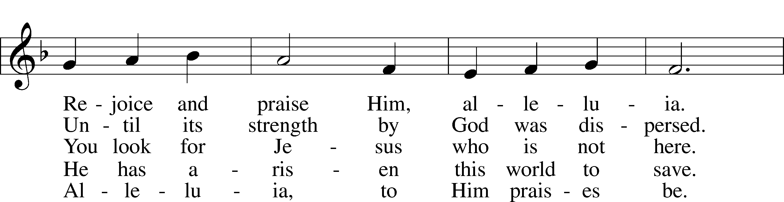
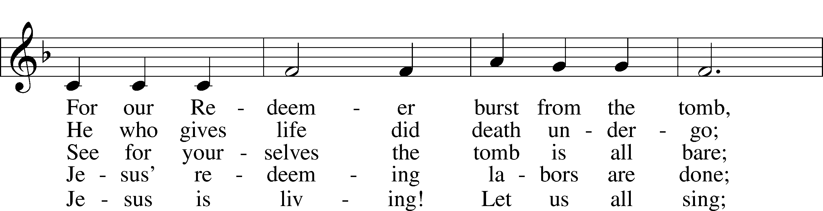
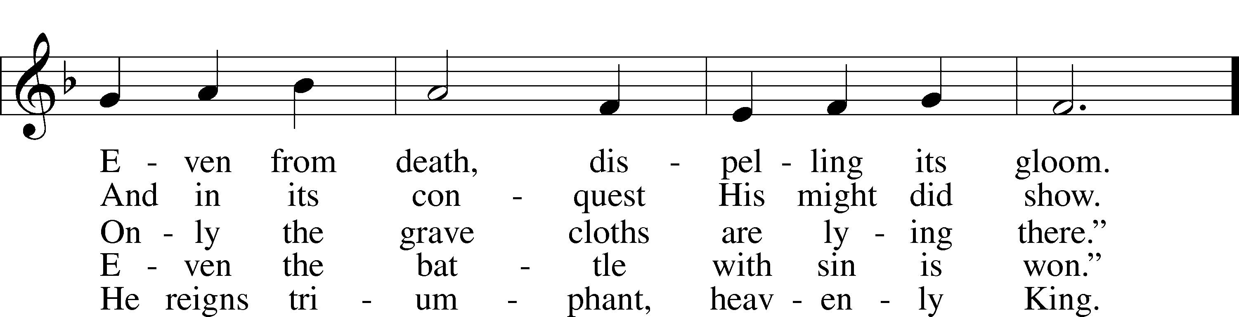
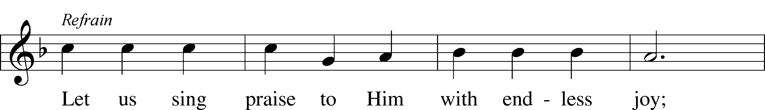
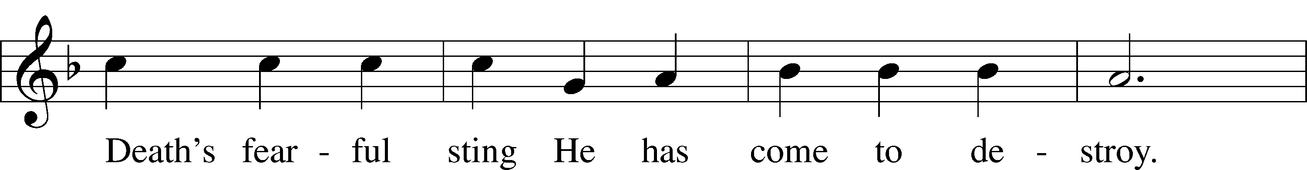
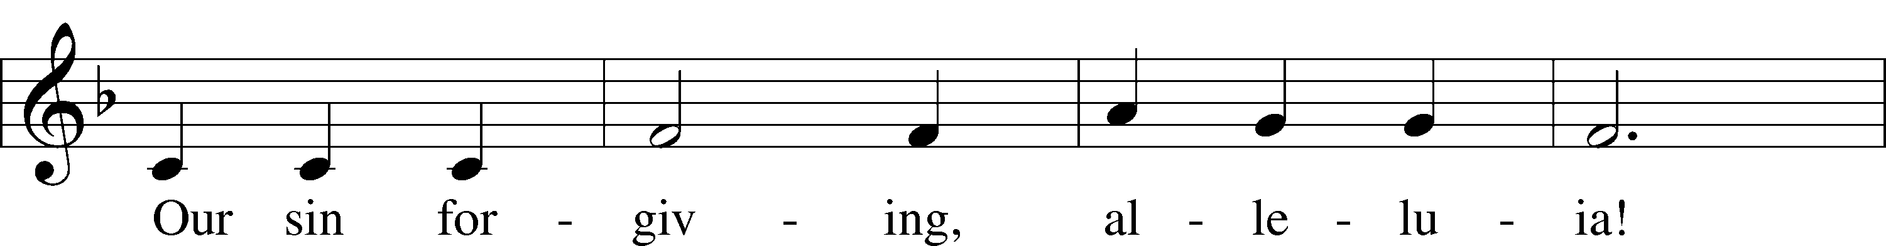
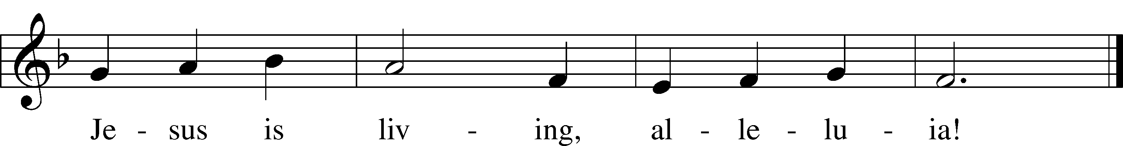
Text: Bernard Kyamanywa, 1938; tr. Howard S. Olson, 1922–2010
Tune: Tanzanian
Text: © 1977 Howard S. Olson. Used by permission: LSB Hymn License no. 110002831
Tune: Public domain

Stand

547 The Lamb
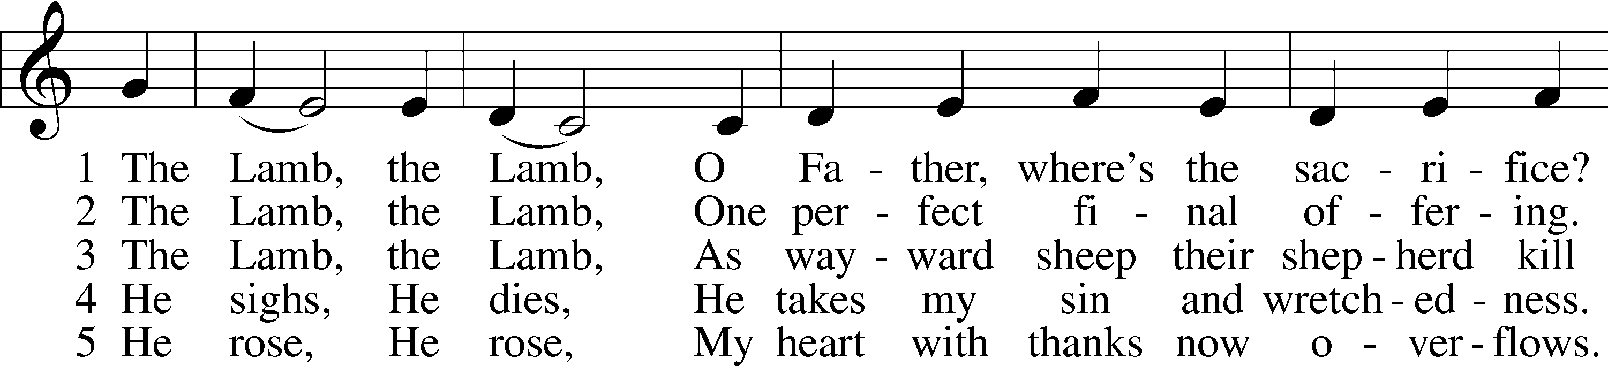
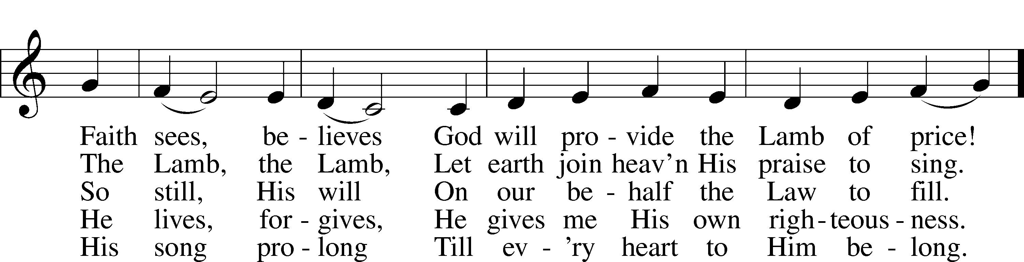
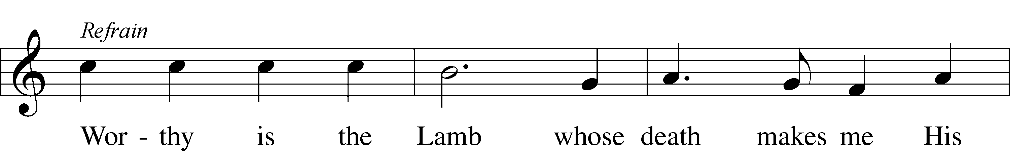
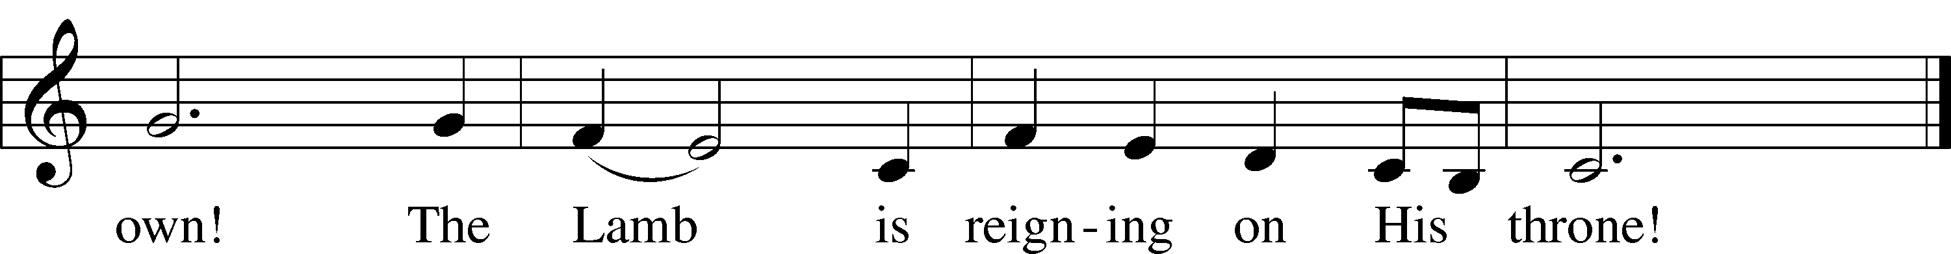
Text and tune: Gerald P. Coleman, 1953
Text and tune: © 1987 and 1997 MorningStar Music Publishers. Used by permission: LSB Hymn License no. 110002831

Thank the Lord LSB 164
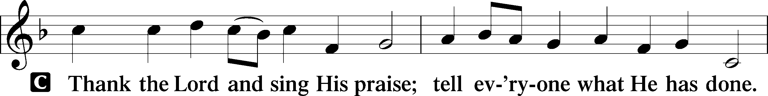
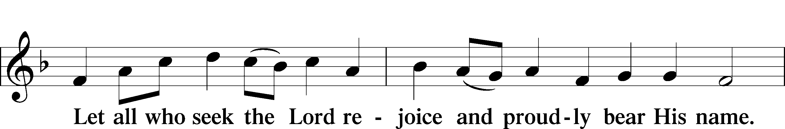
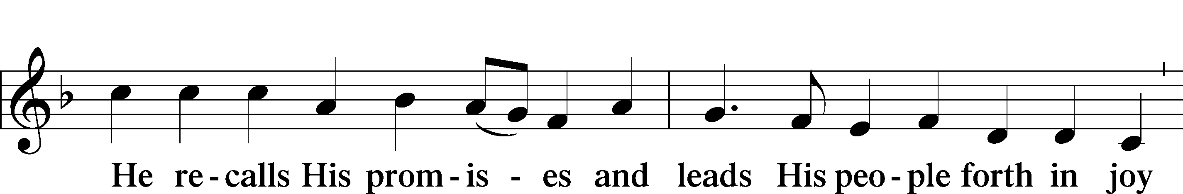
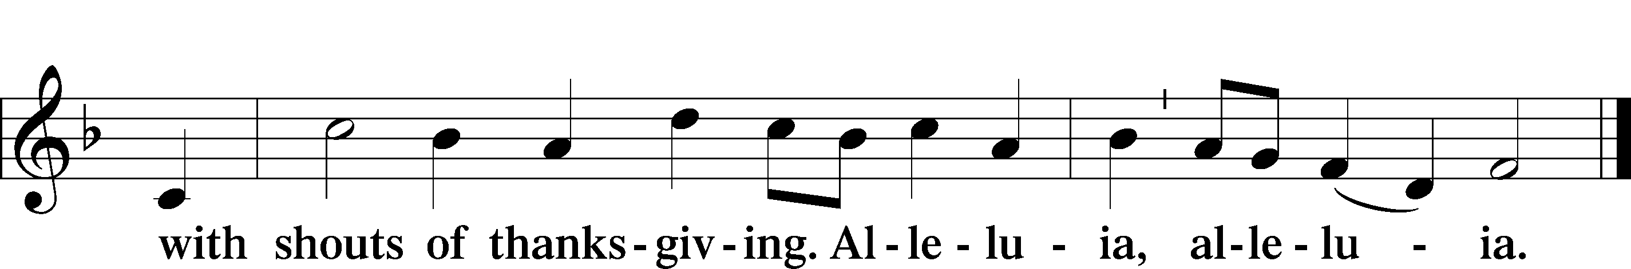

Post-Communion Collect
A Let us pray.
We give thanks to You, almighty God, that You have refreshed us through this salutary gift, and we implore You that of Your mercy You would strengthen us through the same in faith toward You and in fervent love toward one another; through Jesus Christ, Your Son, our Lord, who lives and reigns with You and the Holy Spirit, one God, now and forever.

Benediction LSB 166
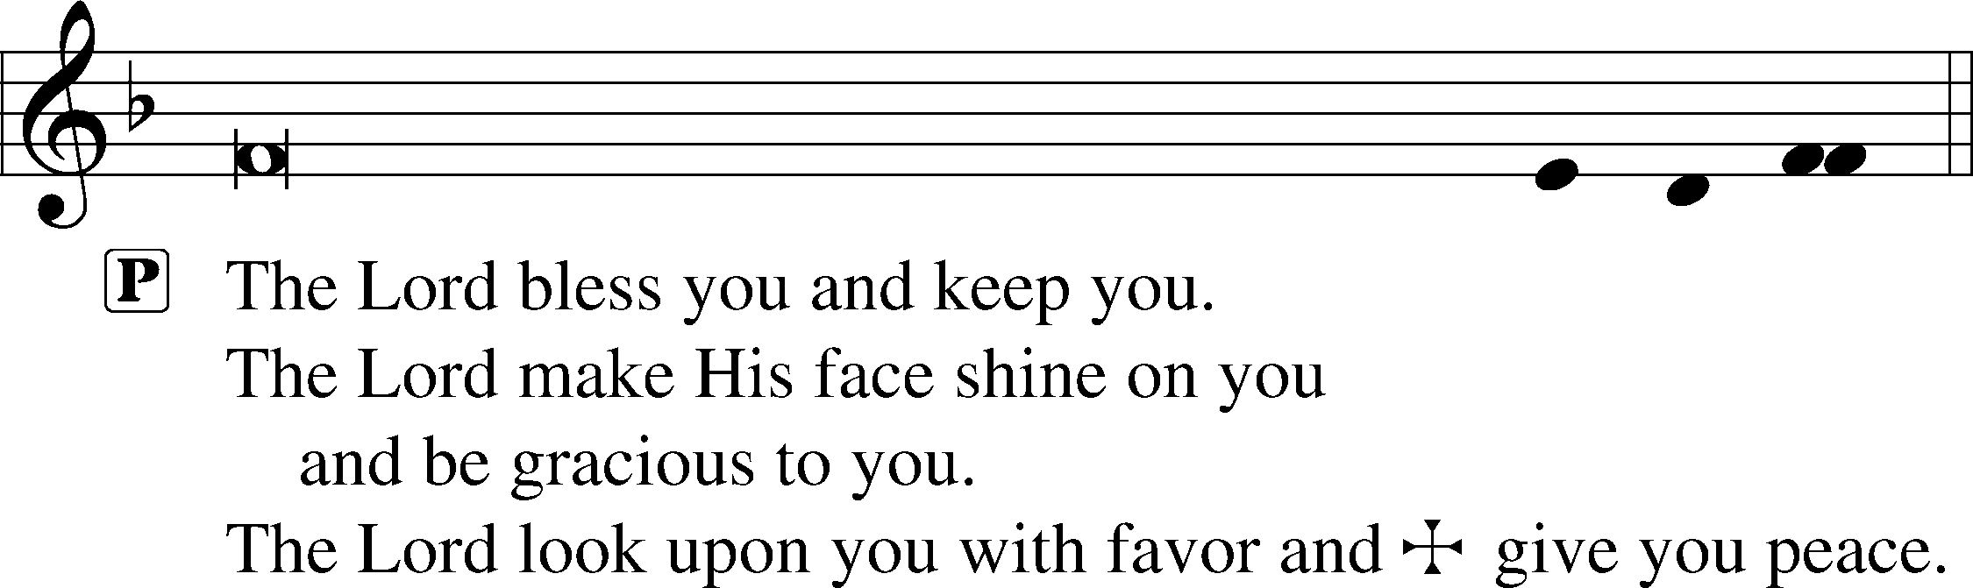

463 Christ the Lord Is Risen Today; Alleluia
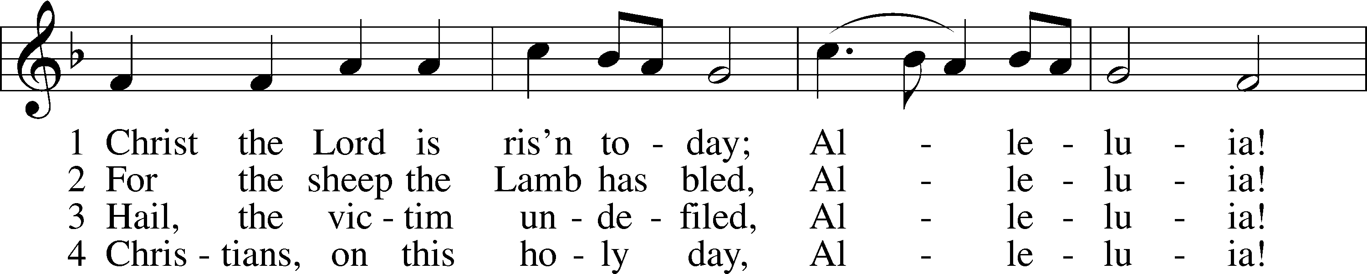
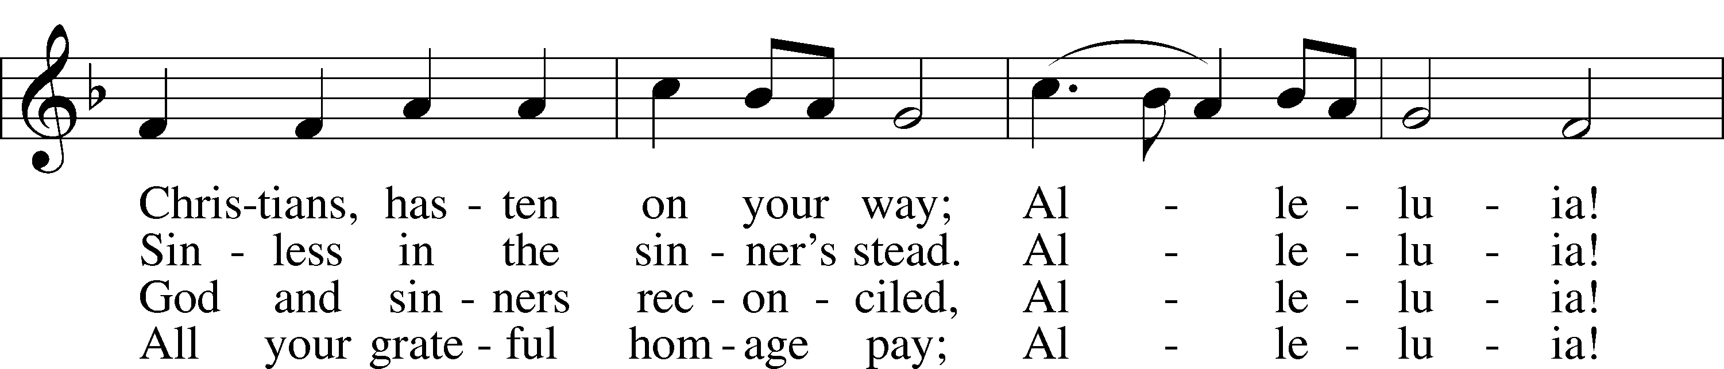
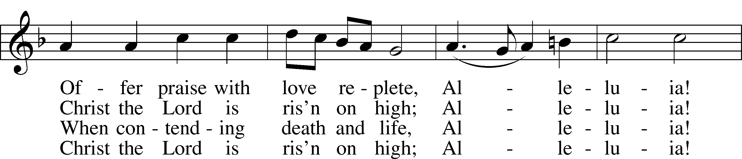
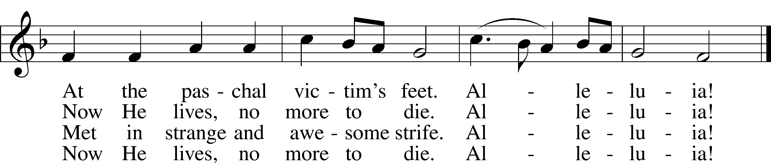
Text: attr. Wipo of Burgundy, d. c. 1050; tr. Jane E. Leeson, 1809–81, alt.
Tune: Robert Williams, c. 1781–1821
Text and tune: Public domain

Acknowledgments
Unless otherwise indicated, Scripture quotations are from the ESV® Bible (The Holy Bible, English Standard Version®), copyright © 2001 by Crossway, a publishing ministry of Good News Publishers. Used by permission. All rights reserved.
Created by Lutheran Service Builder © 2024 Concordia Publishing House.

