Third Sunday in Lent
Divine Service 1
March 2 & 3, 2024
St. Paul Lutheran Church

850 God of Grace and God of Glory
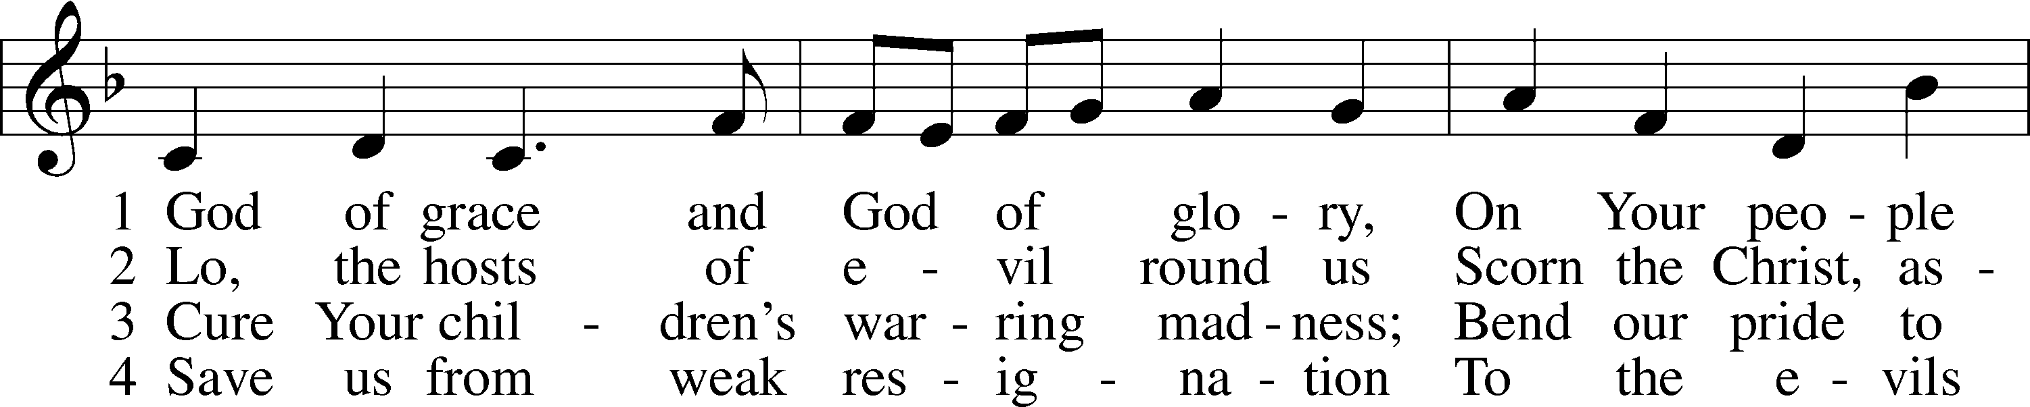
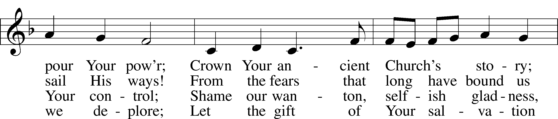
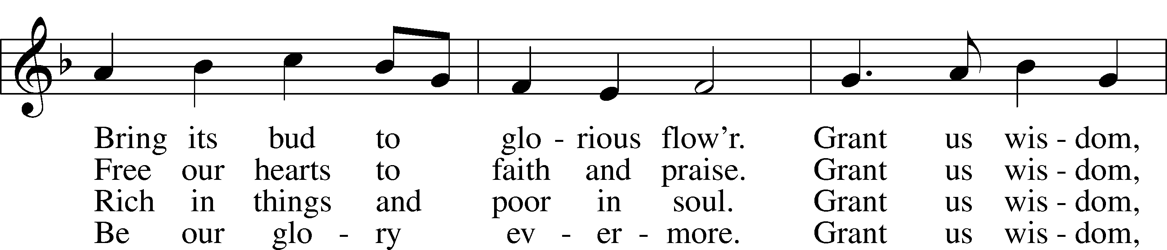
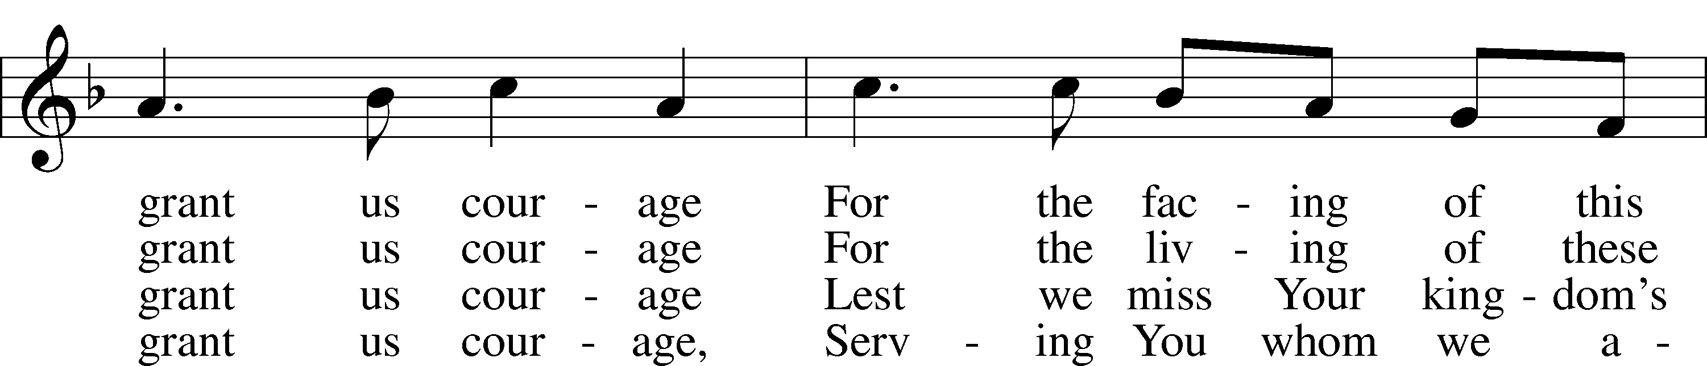
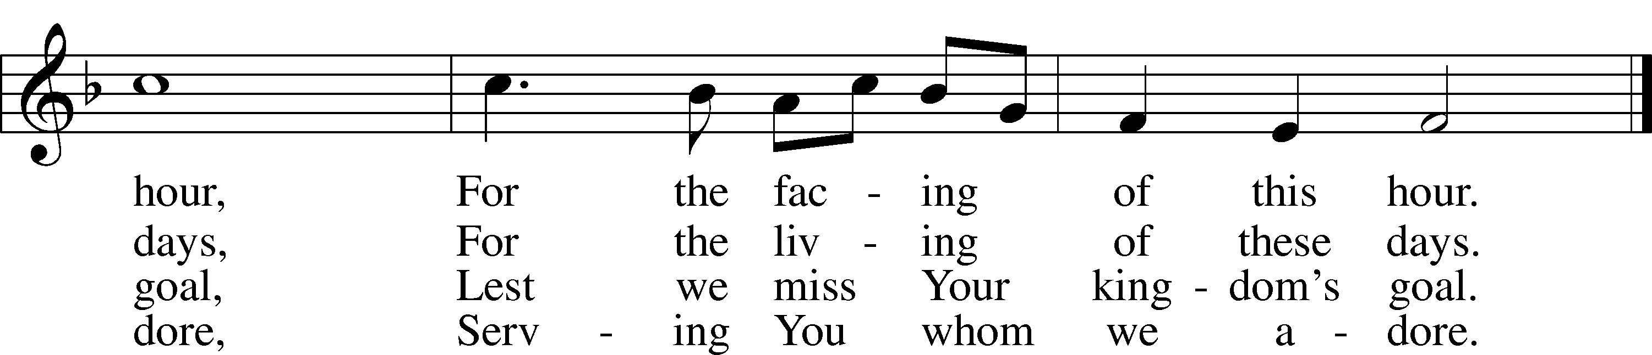
Text: Harry Emerson Fosdick, 1878–1969
Tune: John Hughes, 1873–1932
Text and tune: Public domain

Confession and Absolution

Stand

The sign of the cross may be made by all in remembrance of their Baptism.

Invocation
P In the name of the Father and of the T Son and of the Holy Spirit.
C Amen.

Exhortation LSB 151
P If we say we have no sin, we deceive ourselves, and the truth is not in us.
C But if we confess our sins, God, who is faithful and just, will forgive our sins and cleanse us from all unrighteousness.

Kneel/Stand

Silence for reflection on God’s Word and for self-examination.

Confession of Sins LSB 151
P Let us then confess our sins to God our Father.
C Most merciful God, we confess that we are by nature sinful and unclean. We have sinned against You in thought, word, and deed, by what we have done and by what we have left undone. We have not loved You with our whole heart; we have not loved our neighbors as ourselves. We justly deserve Your present and eternal punishment. For the sake of Your Son, Jesus Christ, have mercy on us. Forgive us, renew us, and lead us, so that we may delight in Your will and walk in Your ways to the glory of Your holy name. Amen.

Absolution LSB 151
P Almighty God in His mercy has given His Son to die for you and for His sake forgives you all your sins. As a called and ordained servant of Christ, and by His authority, I therefore forgive you all your sins in the name of the Father and of the T Son and of the Holy Spirit.
C Amen.

Stand

Service of the Word

PSALM Psalm 19
1The heavens declare the glory of God,
and the sky above proclaims his handiwork.
2Day to day pours out speech,
and night to night reveals knowledge.
3There is no speech, nor are there words,
whose voice is not heard.
4Their measuring line goes out through all the earth,
and their words to the end of the world.
In them he has set a tent for the sun,
5which comes out like a bridegroom leaving his chamber,
and, like a strong man, runs its course with joy.
6Its rising is from the end of the heavens,
and its circuit to the end of them,
and there is nothing hidden from its heat.
7The law of the Lord is perfect,
reviving the soul;
the testimony of the Lord is sure,
making wise the simple;
8the precepts of the Lord are right,
rejoicing the heart;
the commandment of the Lord is pure,
enlightening the eyes;
9the fear of the Lord is clean,
enduring forever;
the just decrees of the Lord are true,
and righteous altogether.
10More to be desired are they than gold,
even much fine gold;
sweeter also than honey
and drippings of the honeycomb.
11Moreover, by them is your servant warned;
in keeping them there is great reward.
12Who can discern his errors?
Declare me innocent from hidden faults.
13Keep back your servant also from presumptuous sins;
let them not have dominion over me!
Then I shall be blameless,
and innocent of great transgression.
14Let the words of my mouth and the meditation of my heart
be acceptable in your sight,
O Lord, my rock and my redeemer.
Kyrie LSB 152
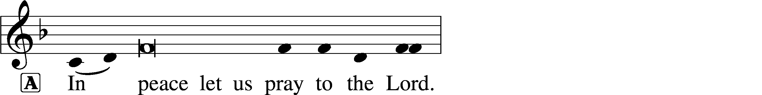
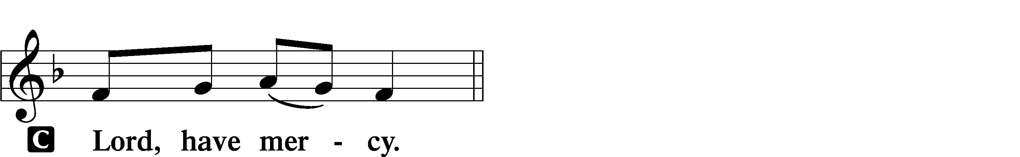

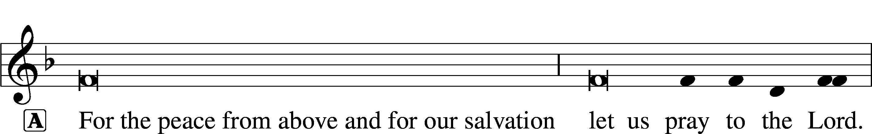
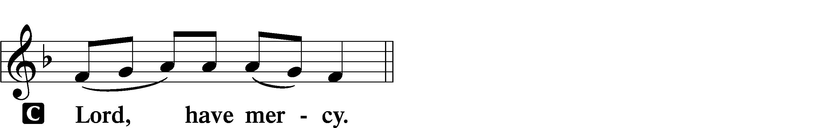

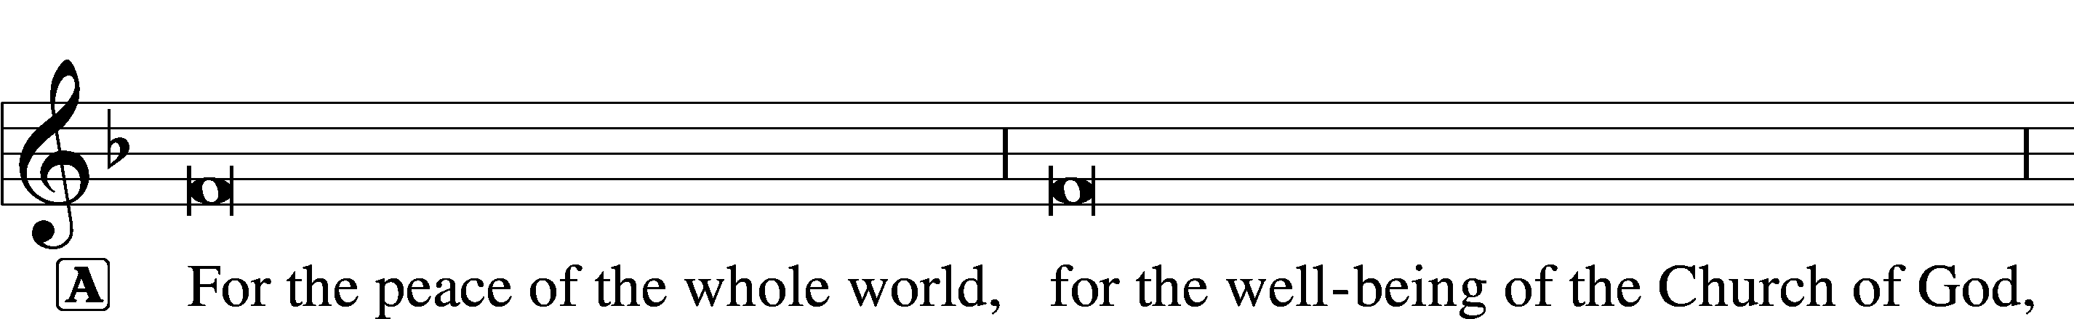
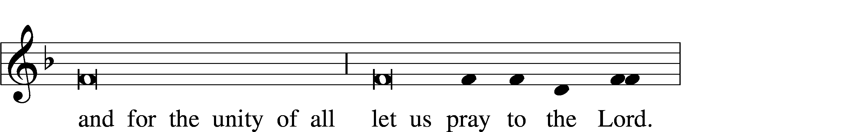
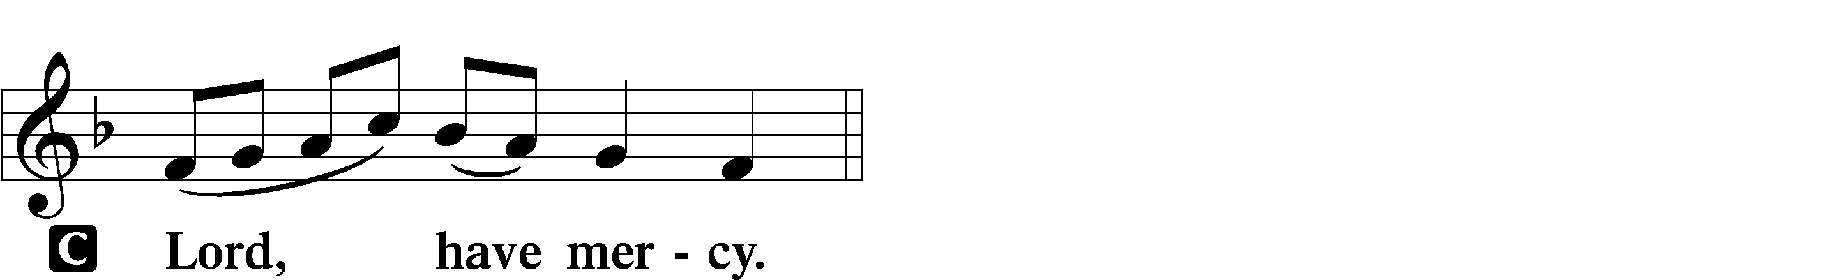

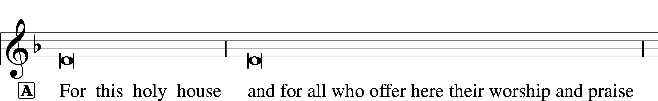
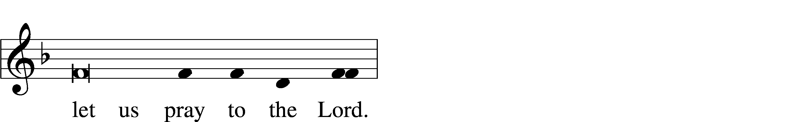
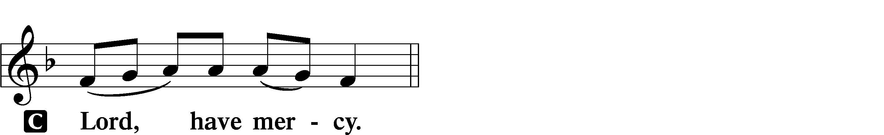

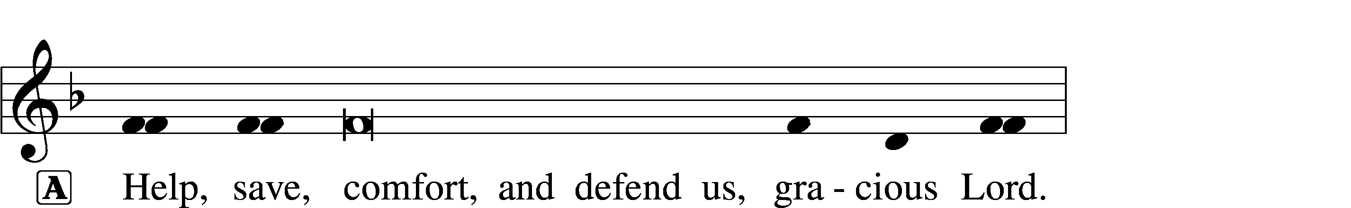
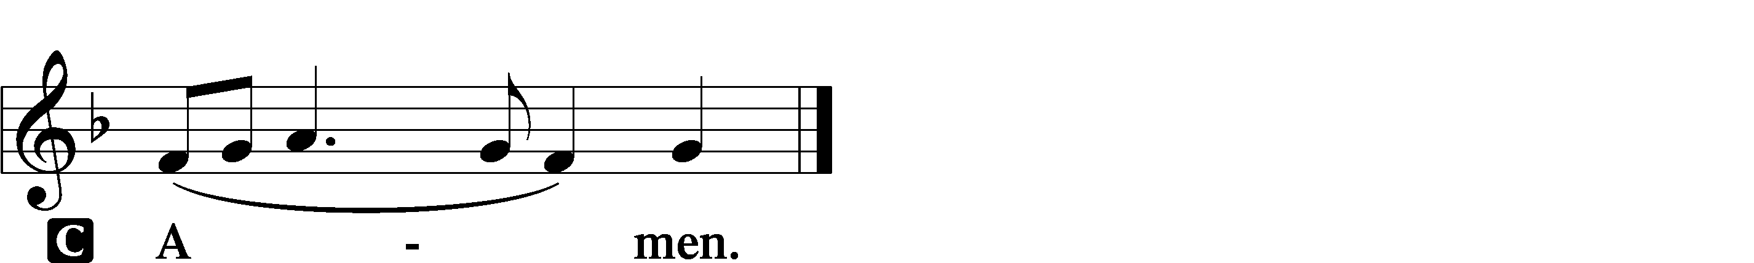

Salutation and Collect of the Day
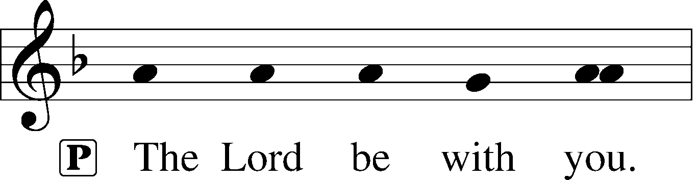
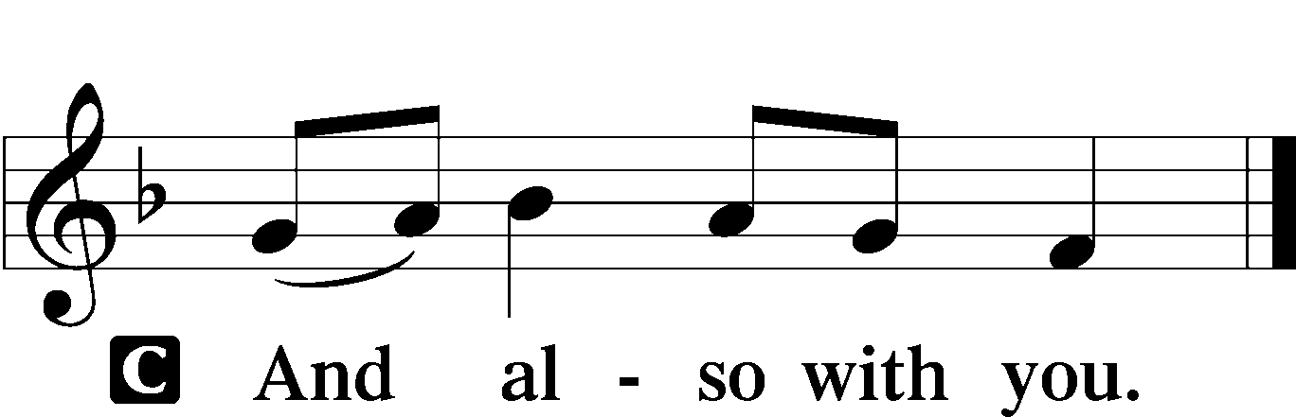

P Let us pray.
O God, whose glory it is always to have mercy, be gracious to all who have gone astray from Your ways and bring them again with penitent hearts and steadfast faith to embrace and hold fast the unchangeable truth of Your Word; through Jesus Christ, Your Son, our Lord, who lives and reigns with You and the Holy Spirit, one God, now and forever.

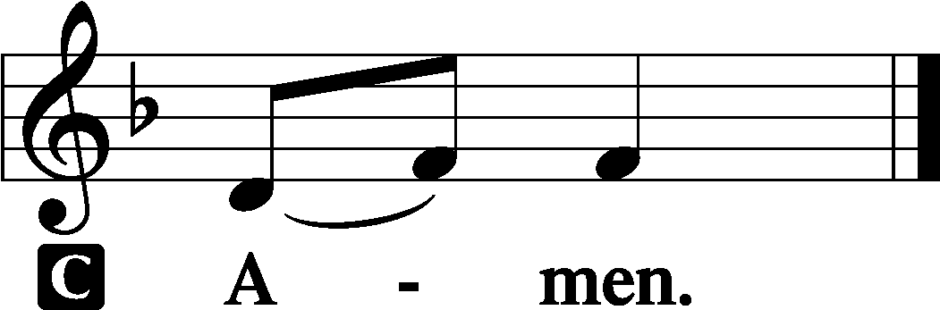

Sit

Old Testament Reading Exodus 20:1–17
1And God spoke all these words, saying,
2“I am the Lord your God, who brought you out of the land of Egypt, out of the house of slavery.
3“You shall have no other gods before me.
4“You shall not make for yourself a carved image, or any likeness of anything that is in heaven above, or that is in the earth beneath, or that is in the water under the earth. 5You shall not bow down to them or serve them, for I the Lord your God am a jealous God, visiting the iniquity of the fathers on the children to the third and the fourth generation of those who hate me, 6but showing steadfast love to thousands of those who love me and keep my commandments.
7“You shall not take the name of the Lord your God in vain, for the Lord will not hold him guiltless who takes his name in vain.
8“Remember the Sabbath day, to keep it holy. 9Six days you shall labor, and do all your work, 10but the seventh day is a Sabbath to the Lord your God. On it you shall not do any work, you, or your son, or your daughter, your male servant, or your female servant, or your livestock, or the sojourner who is within your gates. 11For in six days the Lord made heaven and earth, the sea, and all that is in them, and rested the seventh day. Therefore the Lord blessed the Sabbath day and made it holy.
12“Honor your father and your mother, that your days may be long in the land that the Lord your God is giving you.
13“You shall not murder.
14“You shall not commit adultery.
15“You shall not steal.
16“You shall not bear false witness against your neighbor.
17“You shall not covet your neighbor’s house; you shall not covet your neighbor’s wife, or his male servant, or his female servant, or his ox, or his donkey, or anything that is your neighbor’s.”

A This is the Word of the Lord.
C Thanks be to God.

Epistle 1 Corinthians 1:18–31
18The word of the cross is folly to those who are perishing, but to us who are being saved it is the power of God. 19For it is written,
“I will destroy the wisdom of the wise,
and the discernment of the discerning I will thwart.”
20Where is the one who is wise? Where is the scribe? Where is the debater of this age? Has not God made foolish the wisdom of the world? 21For since, in the wisdom of God, the world did not know God through wisdom, it pleased God through the folly of what we preach to save those who believe. 22For Jews demand signs and Greeks seek wisdom, 23but we preach Christ crucified, a stumbling block to Jews and folly to Gentiles, 24but to those who are called, both Jews and Greeks, Christ the power of God and the wisdom of God. 25For the foolishness of God is wiser than men, and the weakness of God is stronger than men.
26For consider your calling, brothers: not many of you were wise according to worldly standards, not many were powerful, not many were of noble birth. 27But God chose what is foolish in the world to shame the wise; God chose what is weak in the world to shame the strong; 28God chose what is low and despised in the world, even things that are not, to bring to nothing things that are, 29so that no human being might boast in the presence of God. 30He is the source of your life in Christ Jesus, whom God made our wisdom and our righteousness and sanctification and redemption. 31Therefore, as it is written, “Let the one who boasts, boast in the Lord.”

A This is the Word of the Lord.
C Thanks be to God.
Stand
Holy Gospel John 2:13–22
P The Holy Gospel according to St. John, the second chapter.

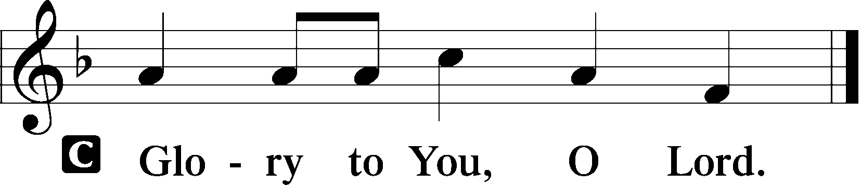

13The Passover of the Jews was at hand, and Jesus went up to Jerusalem. 14In the temple he found those who were selling oxen and sheep and pigeons, and the money-changers sitting there. 15And making a whip of cords, he drove them all out of the temple, with the sheep and oxen. And he poured out the coins of the money-changers and overturned their tables. 16And he told those who sold the pigeons, “Take these things away; do not make my Father’s house a house of trade.” 17His disciples remembered that it was written, “Zeal for your house will consume me.”
18So the Jews said to him, “What sign do you show us for doing these things?” 19Jesus answered them, “Destroy this temple, and in three days I will raise it up.” 20The Jews then said, “It has taken forty-six years to build this temple, and will you raise it up in three days?” 21But he was speaking about the temple of his body. 22When therefore he was raised from the dead, his disciples remembered that he had said this, and they believed the Scripture and the word that Jesus had spoken.

P This is the Gospel of the Lord.

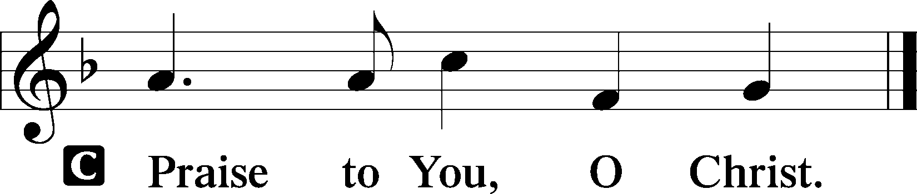

Sit

645 Built on the Rock
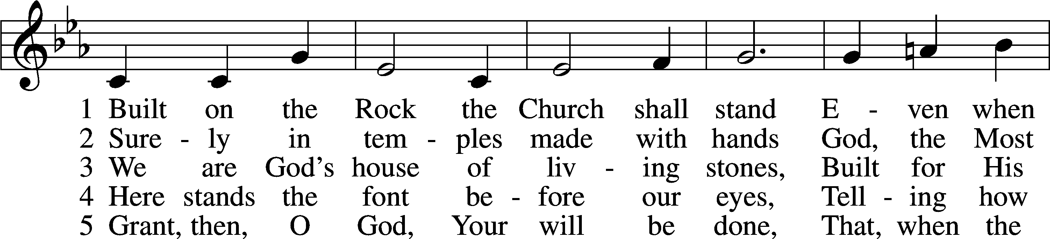
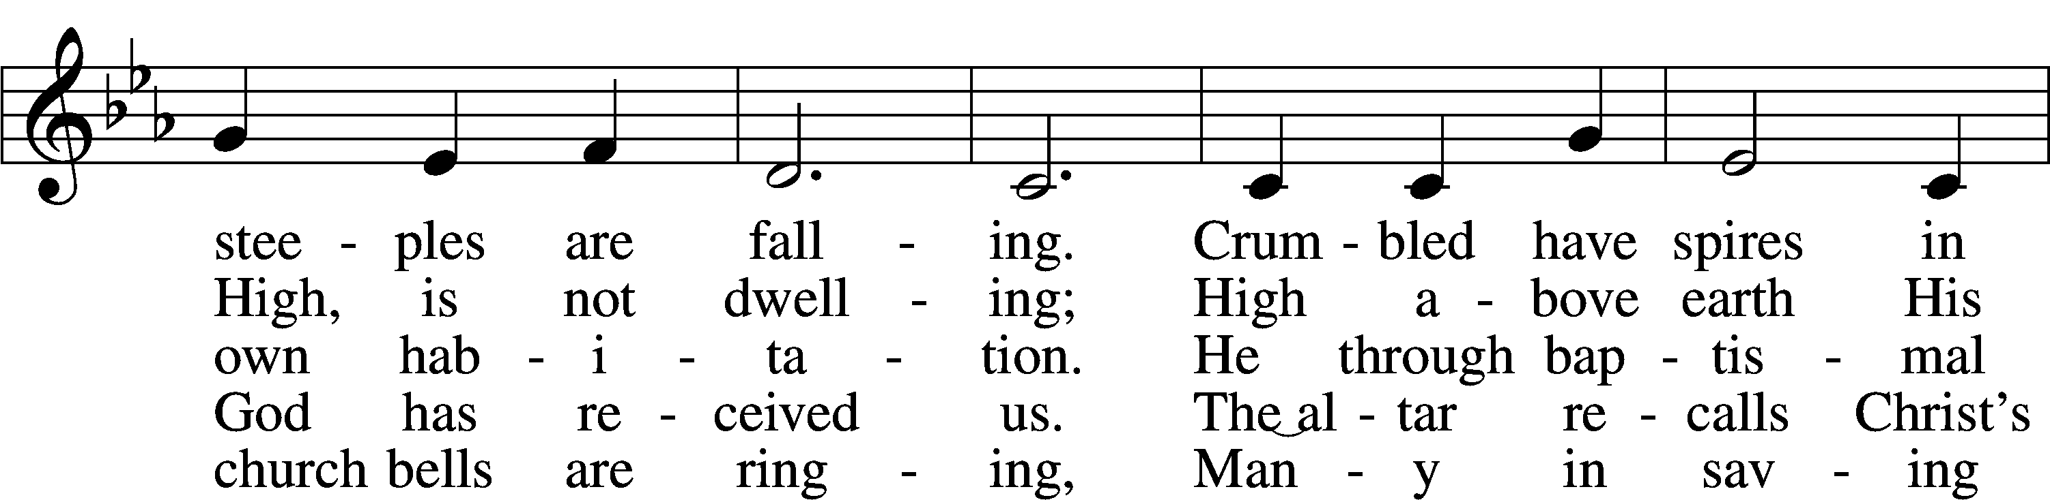
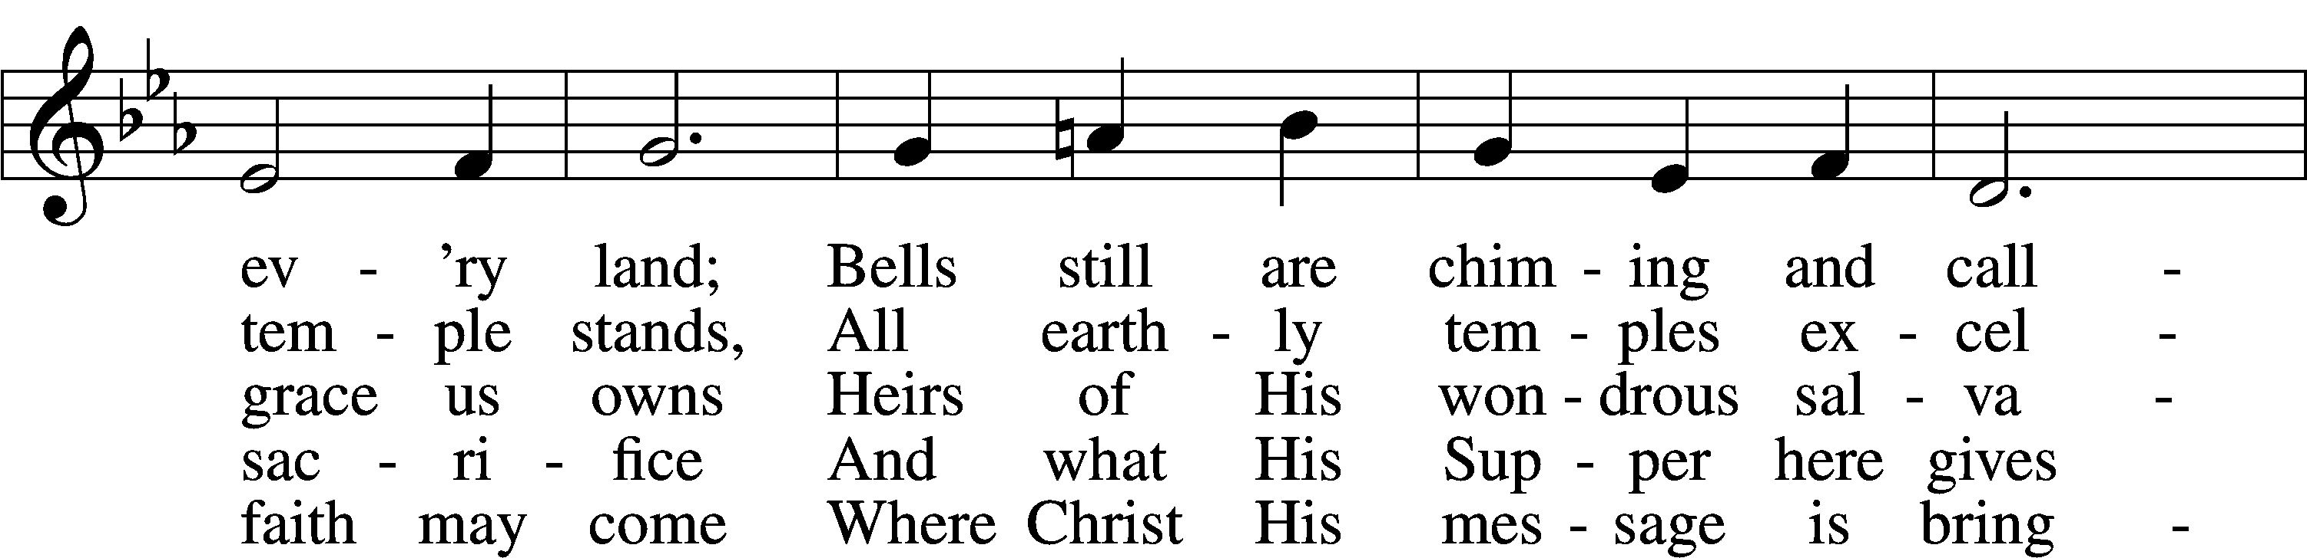
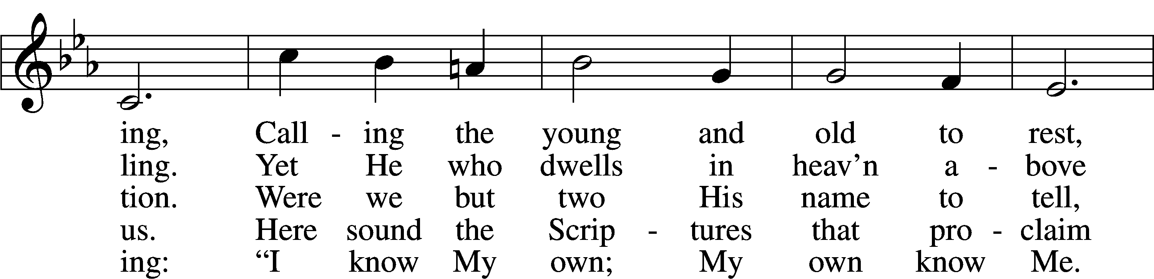
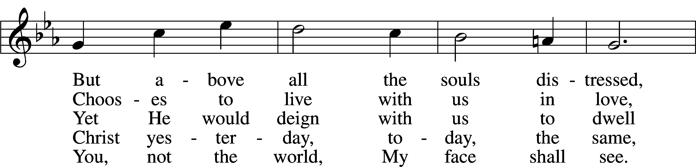
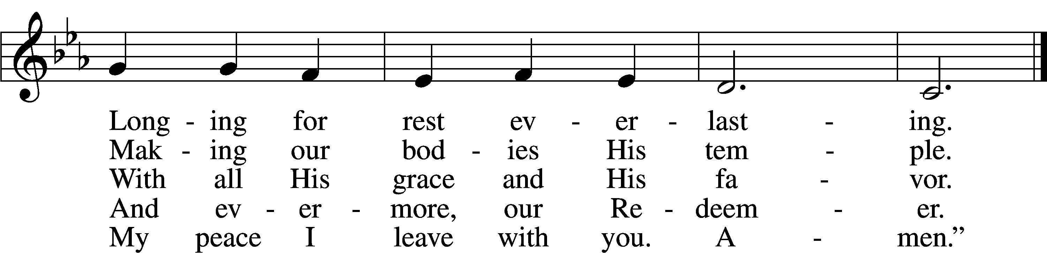
Text: Nikolai Fredrik Severin Grundtvig, 1783–1872, abr.; tr. Carl Döving, 1867–1937, alt.
Tune: Ludvig M. Lindeman, 1812–87
Text and tune: Public domain

Children’s Message
Sermon

Stand

Nicene Creed
C I believe in one God,
the Father Almighty,
maker of heaven and earth
and of all things visible and invisible.

And in one Lord Jesus Christ,
the only-begotten Son of God,
begotten of His Father before all worlds,
God of God, Light of Light,
very God of very God,
begotten, not made,
being of one substance with the Father,
by whom all things were made;
who for us men and for our salvation came down from heaven
and was incarnate by the Holy Spirit of the virgin Mary
and was made man;
and was crucified also for us under Pontius Pilate.
He suffered and was buried.
And the third day He rose again according to the Scriptures
and ascended into heaven
and sits at the right hand of the Father.
And He will come again with glory to judge both the living and the dead,
whose kingdom will have no end.

And I believe in the Holy Spirit,
the Lord and giver of life,
who proceeds from the Father and the Son,
who with the Father and the Son together is worshiped and glorified,
who spoke by the prophets.
And I believe in one holy Christian and apostolic Church,
I acknowledge one Baptism for the remission of sins,
and I look for the resurrection of the dead
and the life T of the world to come. Amen.

Prayer of the Church
P In peace, let us pray to the Lord:
C Lord, have mercy.

P That our jealous God would save the third and fourth generations who will come after us from His punishment, let us pray to the Lord:
C Lord, have mercy.

P For zeal this Lent, that following Christ we may cast every idol from our hearts and be devoted to Him alone, let us pray to the Lord:
C Lord, have mercy.

P For the continued proclamation of the cross’s power, that from this life-giving tree we would receive the gifts that preserve faith, let us pray to the Lord:
C Lord, have mercy.

P That our heavenly Father would preserve and bless all Christian households; that husbands and wives would live in love and service to each other; that fathers and mothers would diligently bring up their children in the fear of the Lord; and that children would honor their parents and be well equipped for service to their neighbors in this life, let us pray to the Lord:
C Lord, have mercy.

P That the Lord of the perfect Law would bless [__________] all who govern us; that He would make them wise in His ways and uphold justice; and that He would help us serve and obey them in accord with His will, let us pray to the Lord:
C Lord, have mercy.

P For [__________] all who suffer in our midst, that the flood may not sweep over them nor the pit close its mouth on them; and that God would deliver them in His steadfast love, granting them healing, comfort and peace, let us pray to the Lord:
C Lord, have mercy.

P That our Redeemer would declare us innocent in Christ of all hidden faults and keep us back from presumptuous sins, let us pray to the Lord:
C Lord, have mercy.

P For all who come before the Lord’s presence to eat Christ’s body and blood on this holy day, that we would boast not of ourselves but of Christ alone, let us pray to the Lord:
C Lord, have mercy.

P That our God, whose true temple was destroyed by wicked men yet raised up again after three days, would grant us and all the saints to share in the glory of His Son’s resurrection, let us pray to the Lord:
C Lord, have mercy.

P Hear us, heavenly Father, for the sake of Christ Jesus, our Lord, who lives and reigns with You and the Holy Spirit, one God, now and forever.
C Amen.

Sit

Offering

Stand

Offertory LSB 159
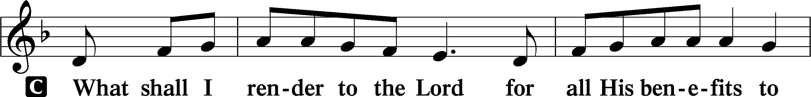
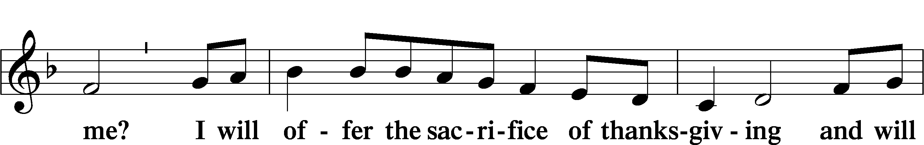
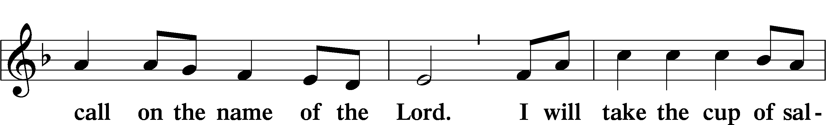
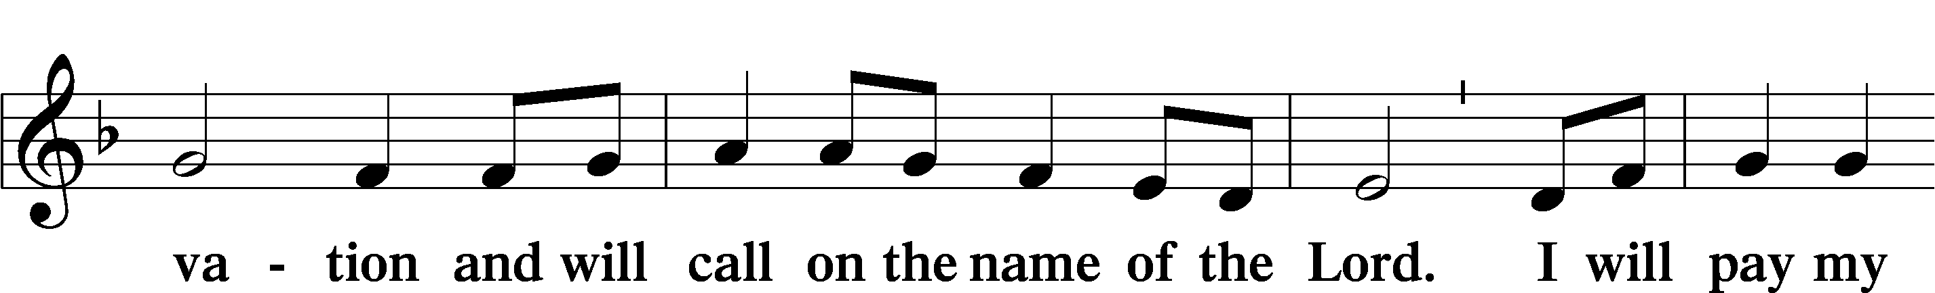
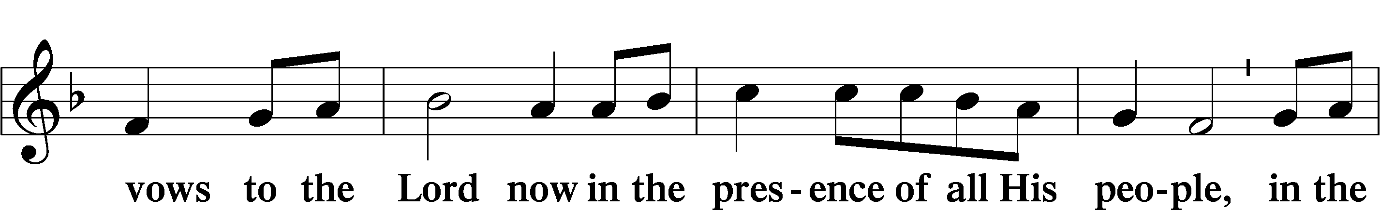
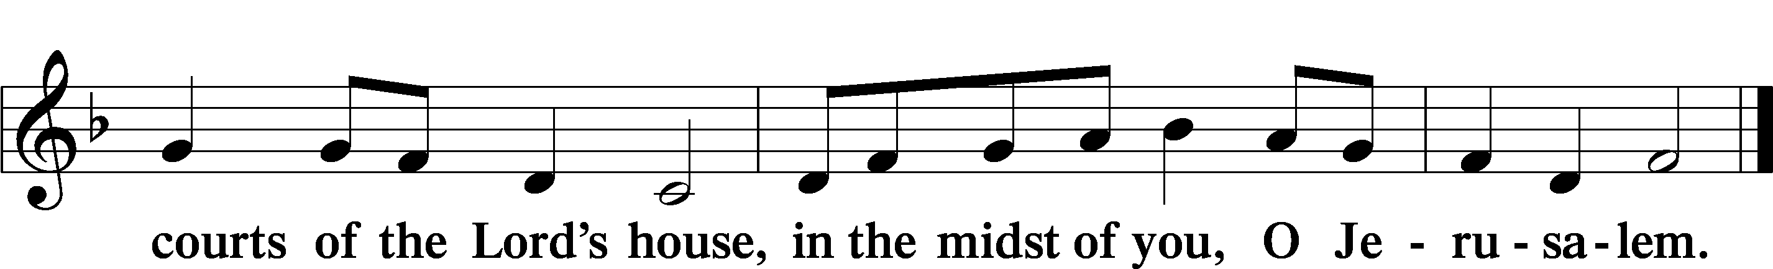

Service of the Sacrament

Preface LSB 160
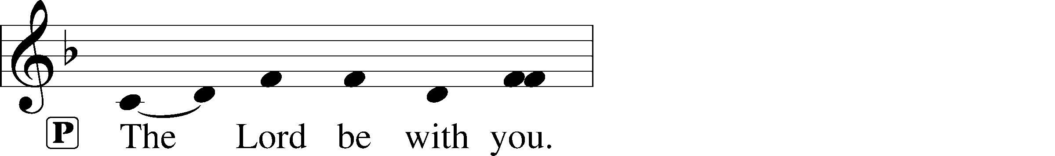
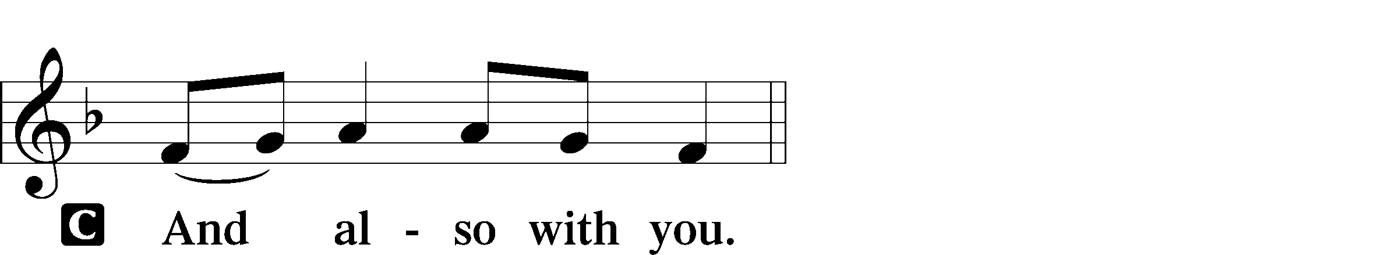
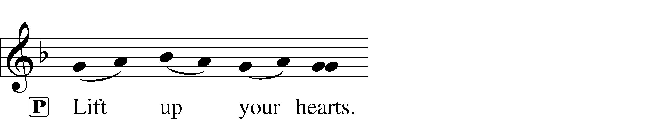
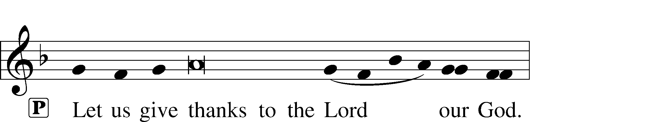
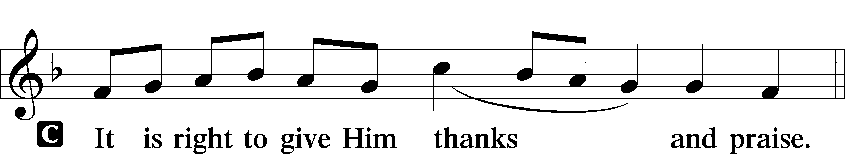

Proper Preface
P It is truly good, right, and salutary that we should at all times and in all places give thanks to You, holy Lord, almighty Father, everlasting God, through Jesus Christ, our Lord, who overcame the assaults of the devil and gave His life as a ransom for many that with cleansed hearts we might be prepared joyfully to celebrate the paschal feast in sincerity and truth. Therefore with angels and archangels and with all the company of heaven we laud and magnify Your glorious name, evermore praising You and saying:

Sanctus LSB 161
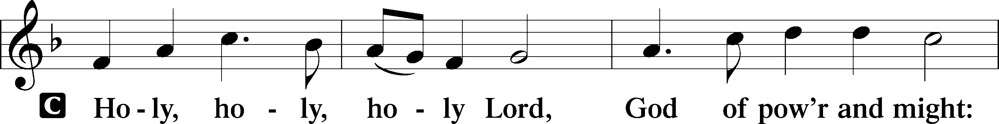
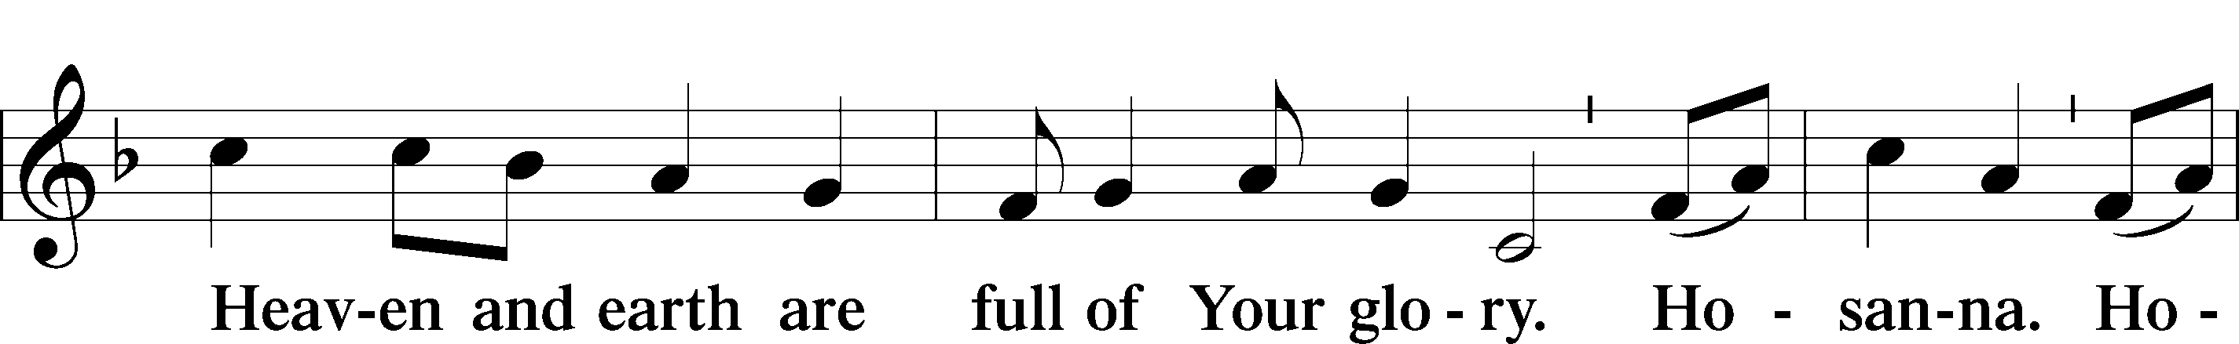
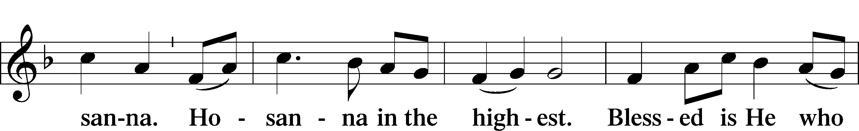
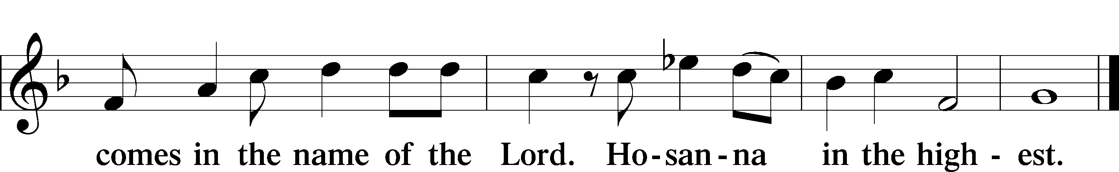

Prayer of Thanksgiving LSB 161
P Blessed are You, Lord of heaven and earth, for You have had mercy on those whom You created and sent Your only-begotten Son into our flesh to bear our sin and be our Savior. With repentant joy we receive the salvation accomplished for us by the all-availing sacrifice of His body and His blood on the cross.

Gathered in the name and the remembrance of Jesus, we beg You, O Lord, to forgive, renew, and strengthen us with Your Word and Spirit. Grant us faithfully to eat His body and drink His blood as He bids us do in His own testament. Gather us together, we pray, from the ends of the earth to celebrate with all the faithful the marriage feast of the Lamb in His kingdom, which has no end. Graciously receive our prayers; deliver and preserve us. To You alone, O Father, be all glory, honor, and worship, with the Son and the Holy Spirit, one God, now and forever.
C Amen.

The Words of Our Lord
P Our Lord Jesus Christ, on the night when He was betrayed, took bread, and when He had given thanks, He broke it and gave it to the disciples and said: “Take, eat; this is My T body, which is given for you. This do in remembrance of Me.”

In the same way also He took the cup after supper, and when He had given thanks, He gave it to them, saying: “Drink of it, all of you; this cup is the new testament in My T blood, which is shed for you for the forgiveness of sins. This do, as often as you drink it, in remembrance of Me.”

Proclamation of Christ
P As often as we eat this bread and drink this cup, we proclaim the Lord’s death until He comes.
C Amen. Come, Lord Jesus.

P O Lord Jesus Christ, only Son of the Father, in giving us Your body and blood to eat and to drink, You lead us to remember and confess Your holy cross and passion, Your blessed death, Your rest in the tomb, Your resurrection from the dead, Your ascension into heaven, and Your coming for the final judgment. So remember us in Your kingdom and teach us to pray:

Lord’s Prayer
C Our Father who art in heaven,
hallowed be Thy name,
Thy kingdom come,
Thy will be done on earth
as it is in heaven;
give us this day our daily bread;
and forgive us our trespasses
as we forgive those
who trespass against us;
and lead us not into temptation,
but deliver us from evil.
For Thine is the kingdom
and the power and the glory
forever and ever. Amen.

Pax Domini LSB 163
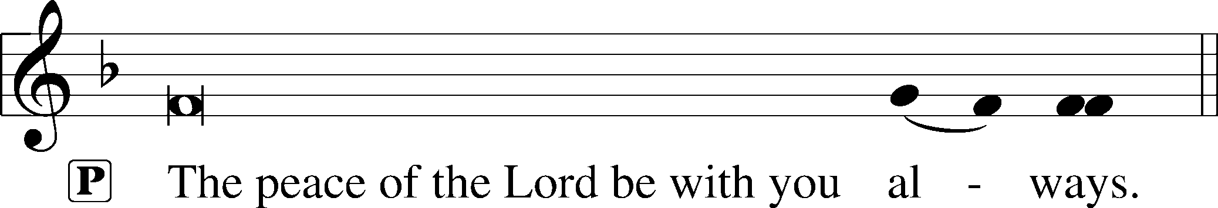
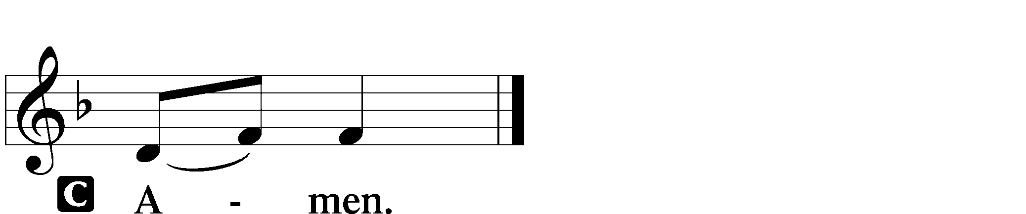

Agnus Dei LSB 163
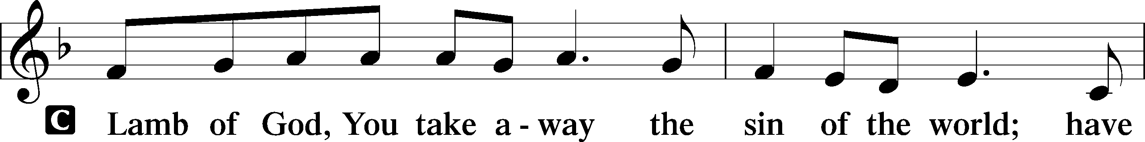
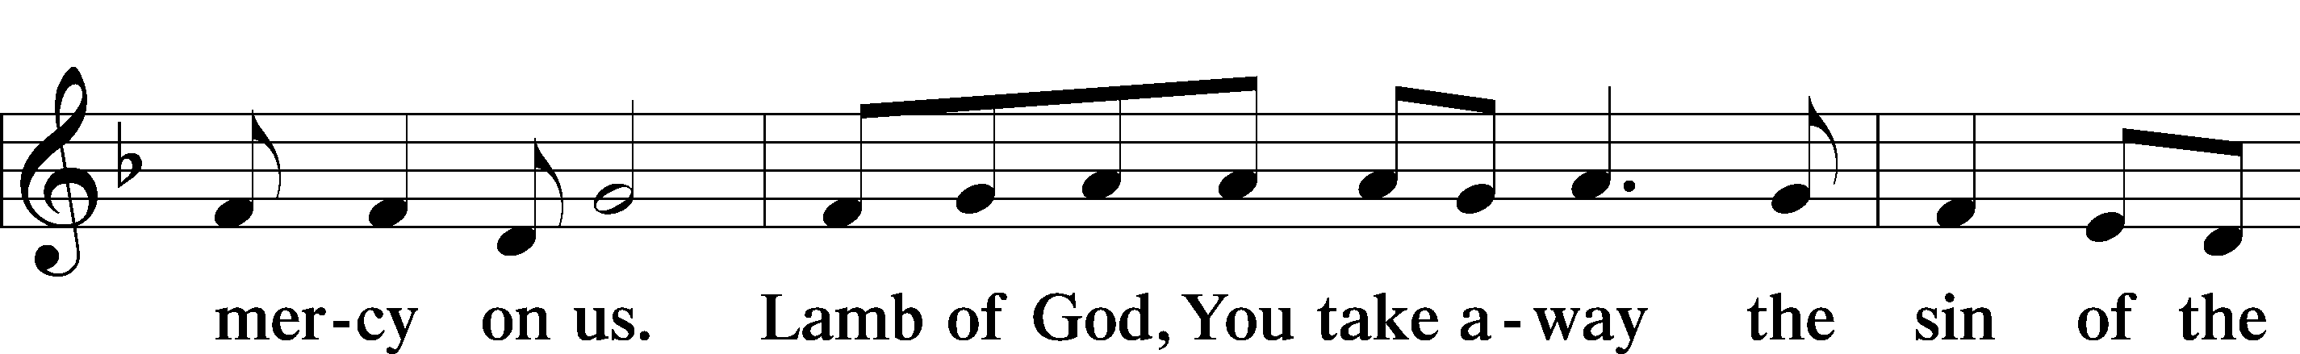
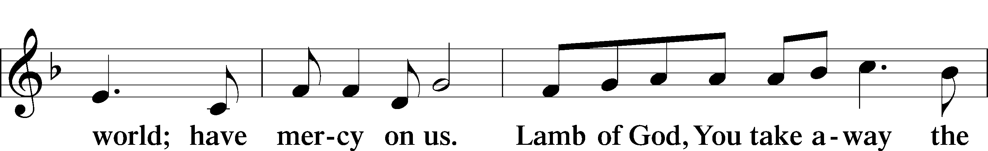
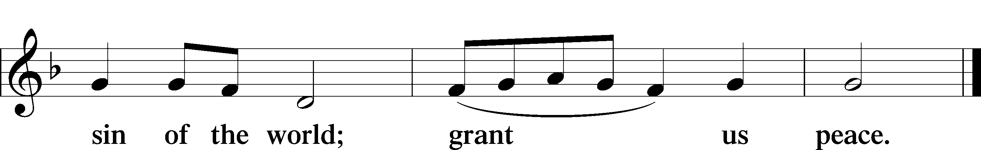

Sit

Distribution

563 Jesus, Thy Blood and Righteousness
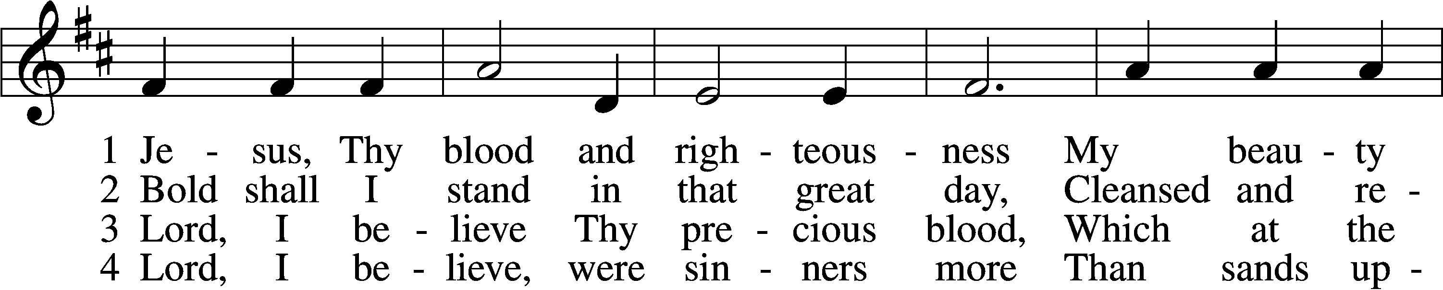
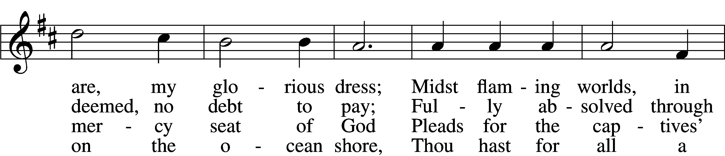
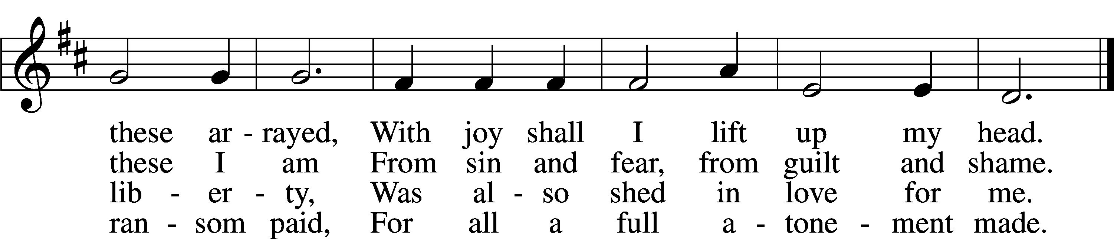

5 When from the dust of death I rise
To claim my mansion in the skies,
This then shall be my only plea:
Jesus hath lived and died for me.

6 Jesus, be endless praise to Thee,
Whose boundless mercy hath for me,
For me, and all Thy hands have made,
An everlasting ransom paid.
Text: Nicolaus Ludwig von Zinzendorf, 1700–60; tr. John B. Wesley, 1703–91, alt.
Tune: George J. Elvey, 1816–93
Text and tune: Public domain

425 When I Survey the Wondrous Cross
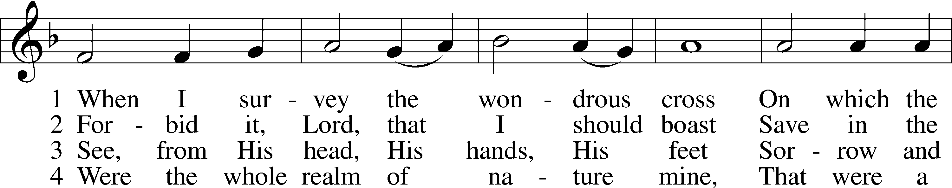
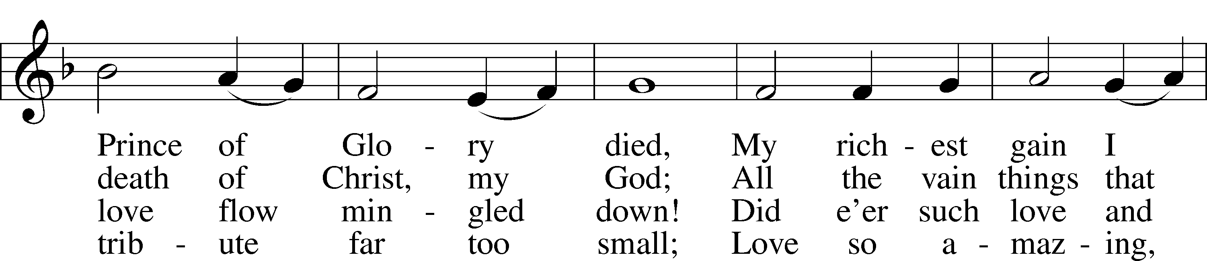
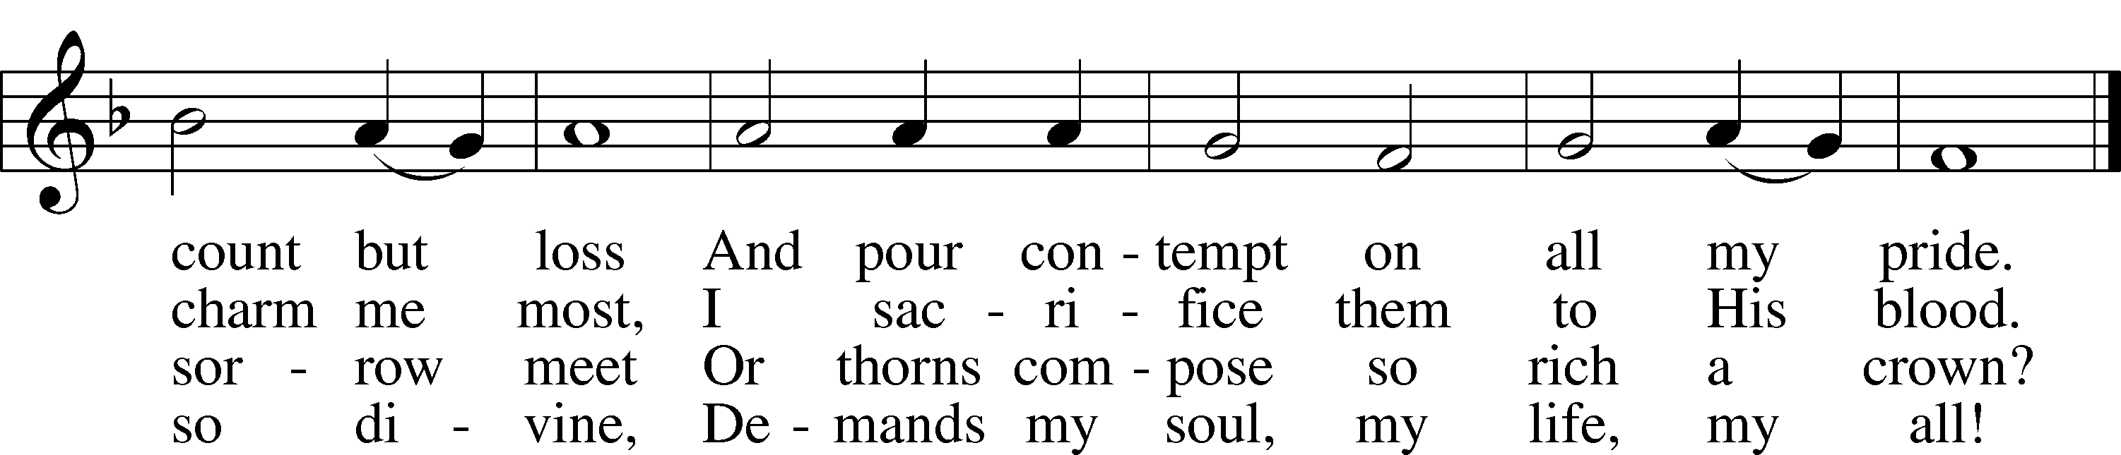
Text: Isaac Watts, 1674–1748
Tune: Lowell Mason, 1792–1872
Text and tune: Public domain

427 In the Cross of Christ I Glory
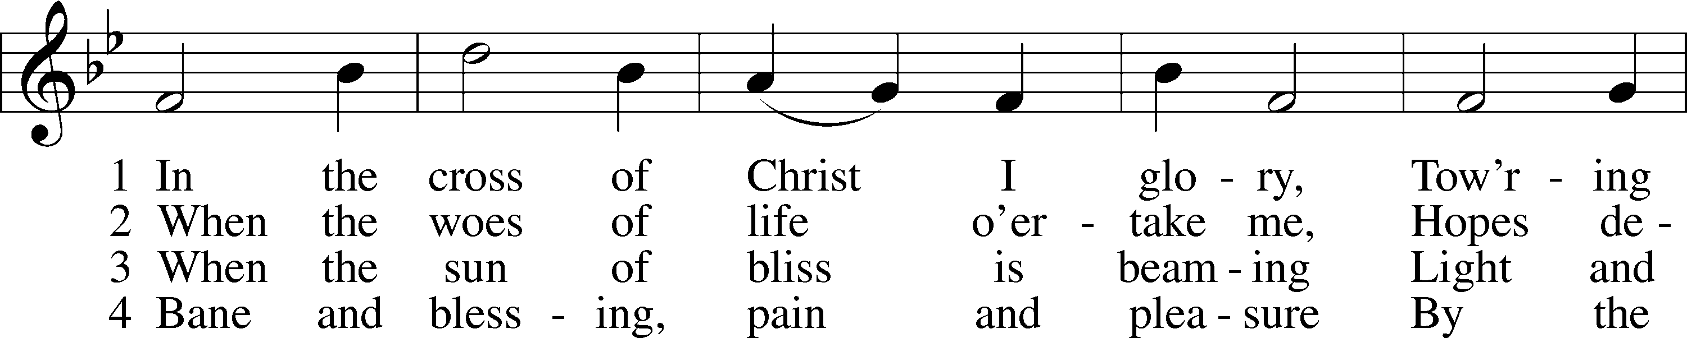
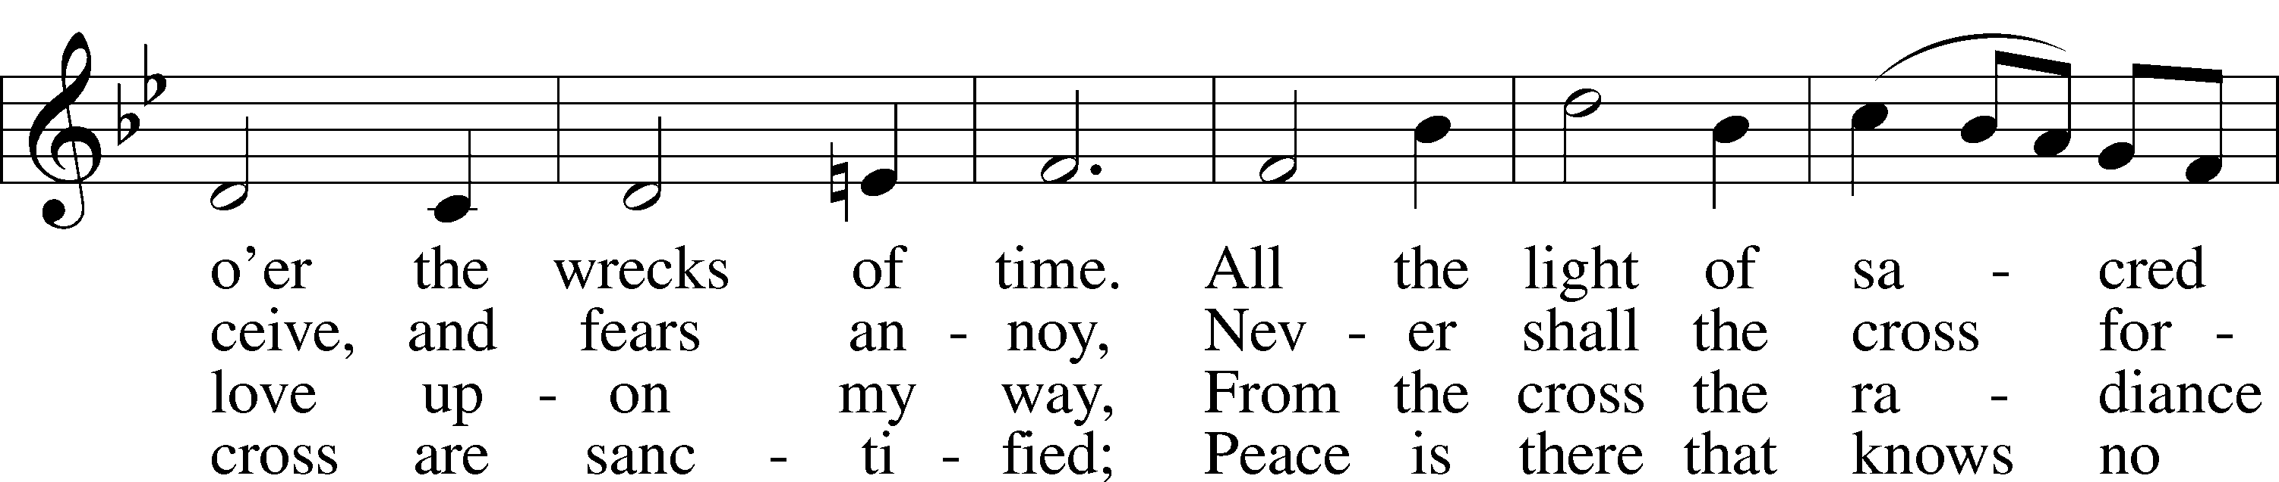
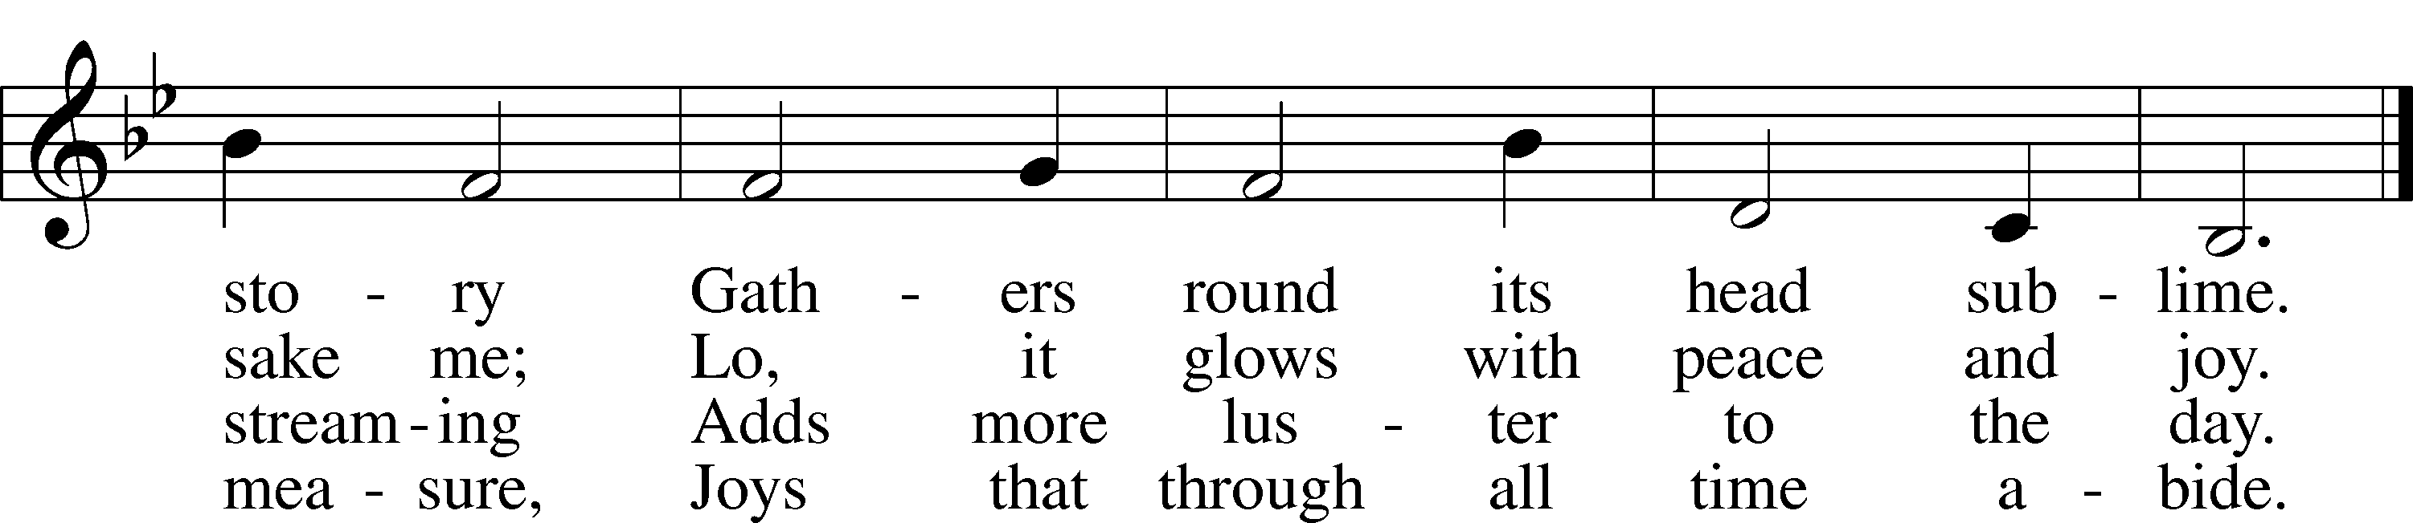
Text: John Bowring, 1792–1872
Tune: Ithamar Conkey, 1815–67
Text and tune: Public domain

Stand

Post-Communion Collect
A Let us pray.
We give thanks to You, almighty God, that You have refreshed us through this salutary gift, and we implore You that of Your mercy You would strengthen us through the same in faith toward You and in fervent love toward one another; through Jesus Christ, Your Son, our Lord, who lives and reigns with You and the Holy Spirit, one God, now and forever.

Benediction LSB 166
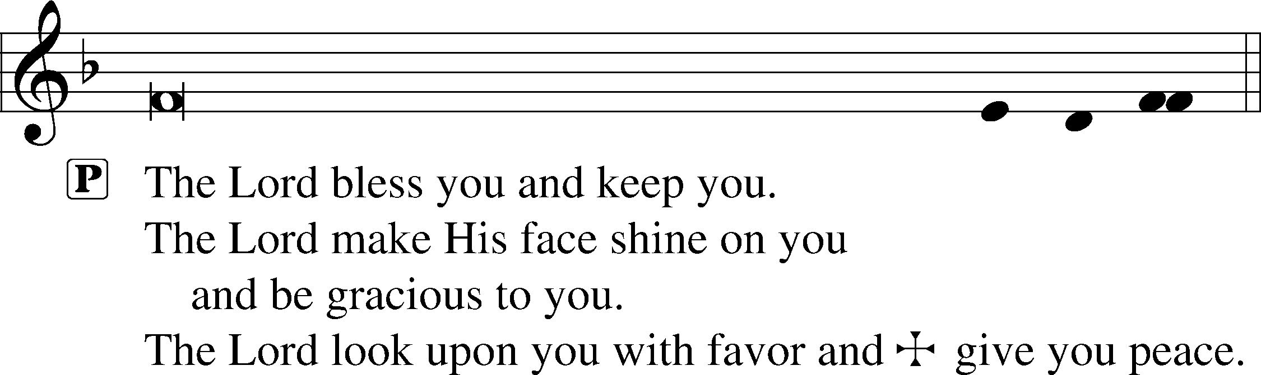
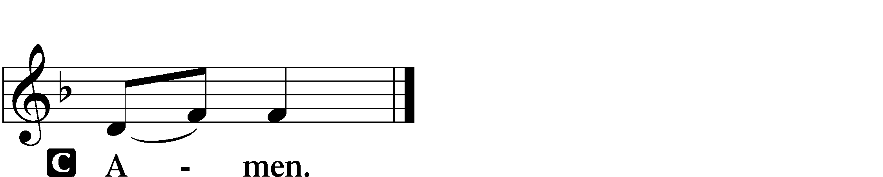

923 Almighty Father, Bless the Word
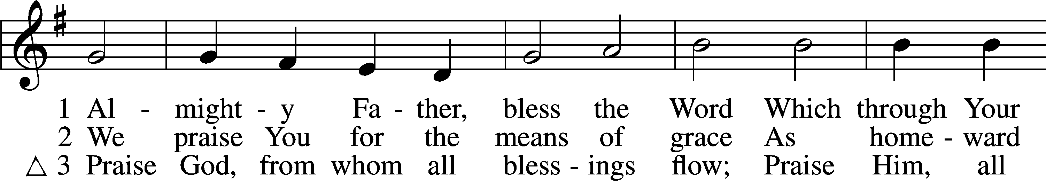
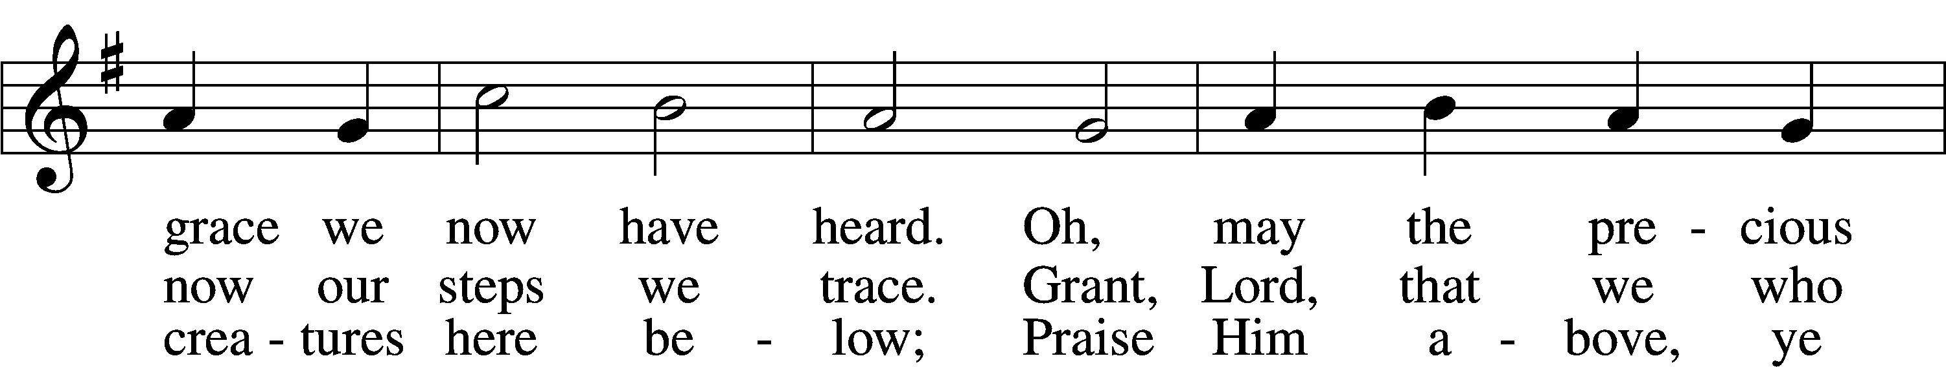
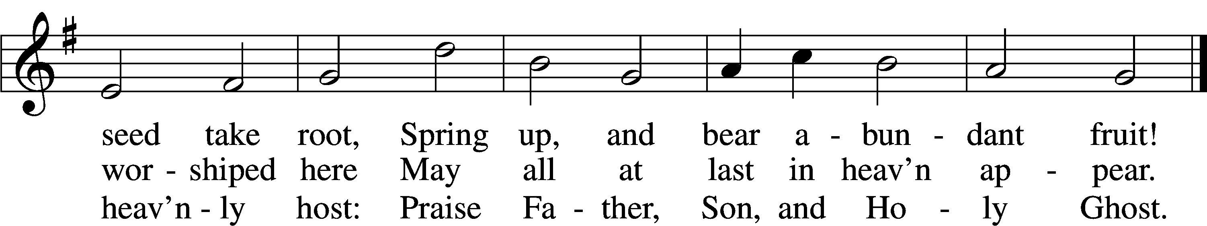
Text (sts. 1–2): Church Poetry, 1823, Philadelphia, alt.; (st. 3): Thomas Ken, 1637–1711
Tune: Trente quatre Pseaumes de David, 1551, Geneva, ed. Louis Bourgeois
Text and tune: Public domain

Acknowledgments
Unless otherwise indicated, Scripture quotations are from the ESV® Bible (The Holy Bible, English Standard Version®), copyright © 2001 by Crossway, a publishing ministry of Good News Publishers. Used by permission. All rights reserved.
Created by Lutheran Service Builder © 2024 Concordia Publishing House.

