Palm Sunday
Prayer and Preaching p. 260
March 23 & 24, 2024
St. Paul Lutheran Church

442 All Glory, Laud, and Honor
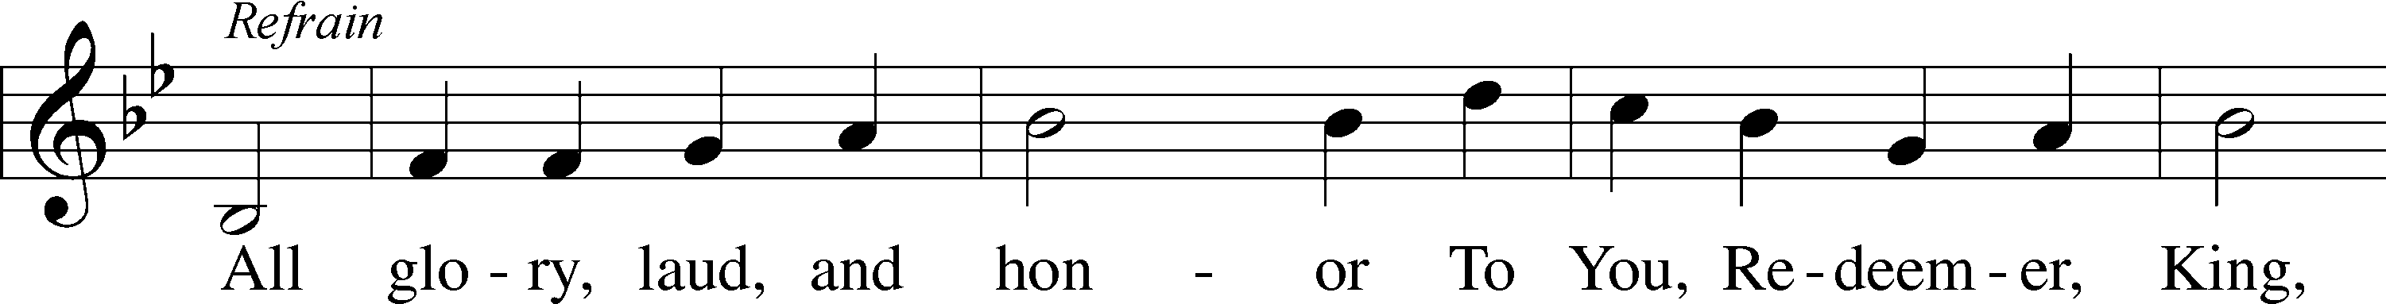
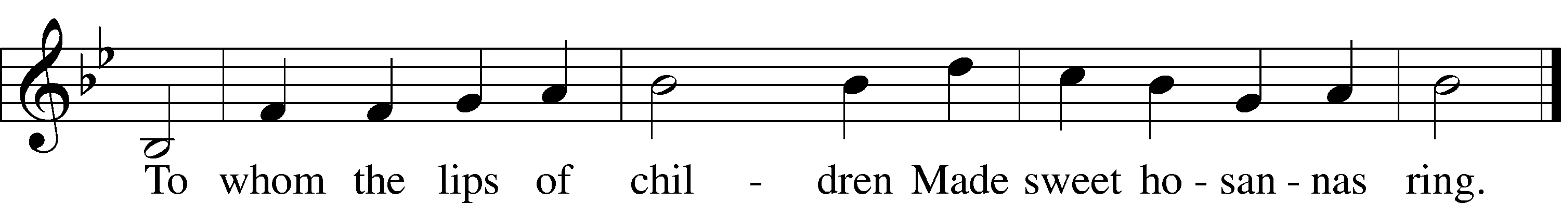
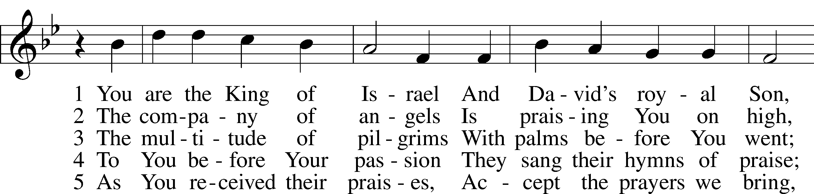
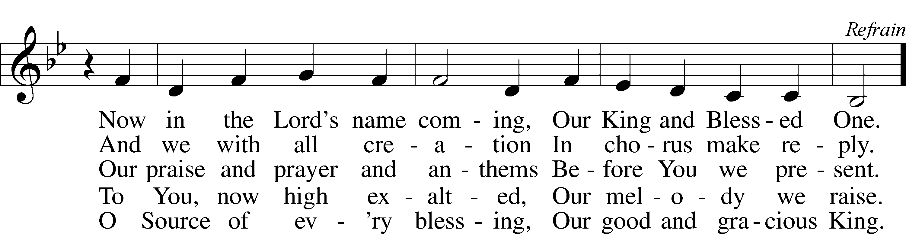
Text: Theodulf of Orléans, c. 762–821; tr. John Mason Neale, 1818–66, alt.
Tune: Melchior Teschner, 1584–1635, alt.
Text and tune: Public domain
Sunday: Procession of Palms
Special Music by the Sunday School Children

Opening Versicles
Lent LSB 260
L This is the day which the Lord has made;
C let us rejoice and be glad in it.
L From the rising of the sun to its setting,
C the name of the Lord is to be praised.

L Return to the Lord, your God, for He is gracious and merciful,
C slow to anger, and abounding in steadfast love, and repents of evil.
L Jesus said: If any man would come after Me,
C let him deny himself and take up his cross and follow Me.
L Christ was wounded for our transgressions.
C He was bruised for our iniquities.

L From the rising of the sun to its setting,
C the name of the Lord is to be praised.

C Glory be to the Father and to the Son and to the Holy Spirit;
as it was in the beginning, is now, and will be forever. Amen.

Old Testament Canticle LSB 261
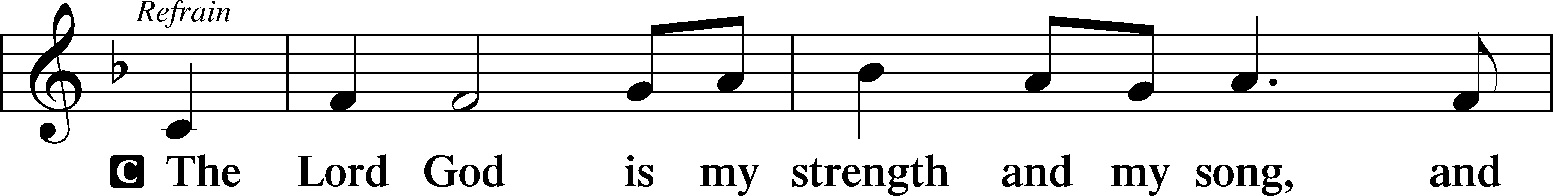
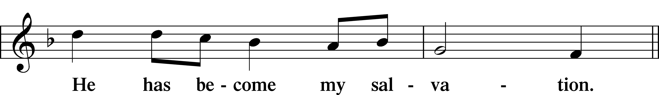
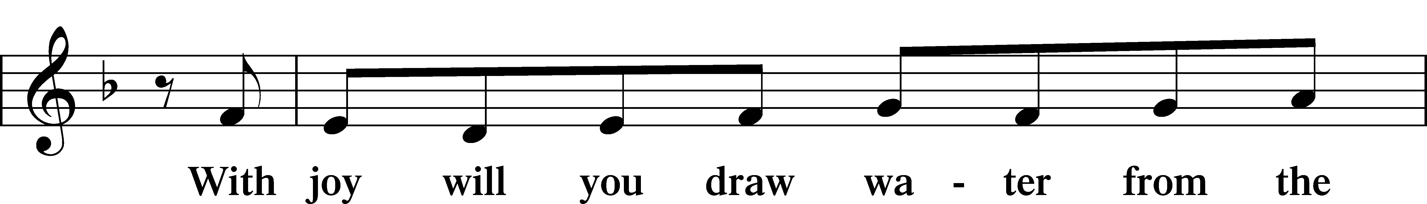
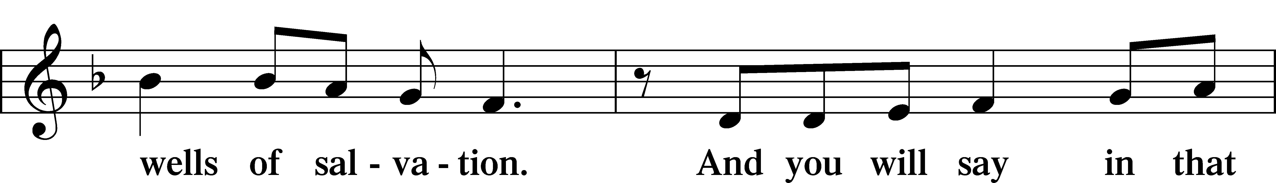
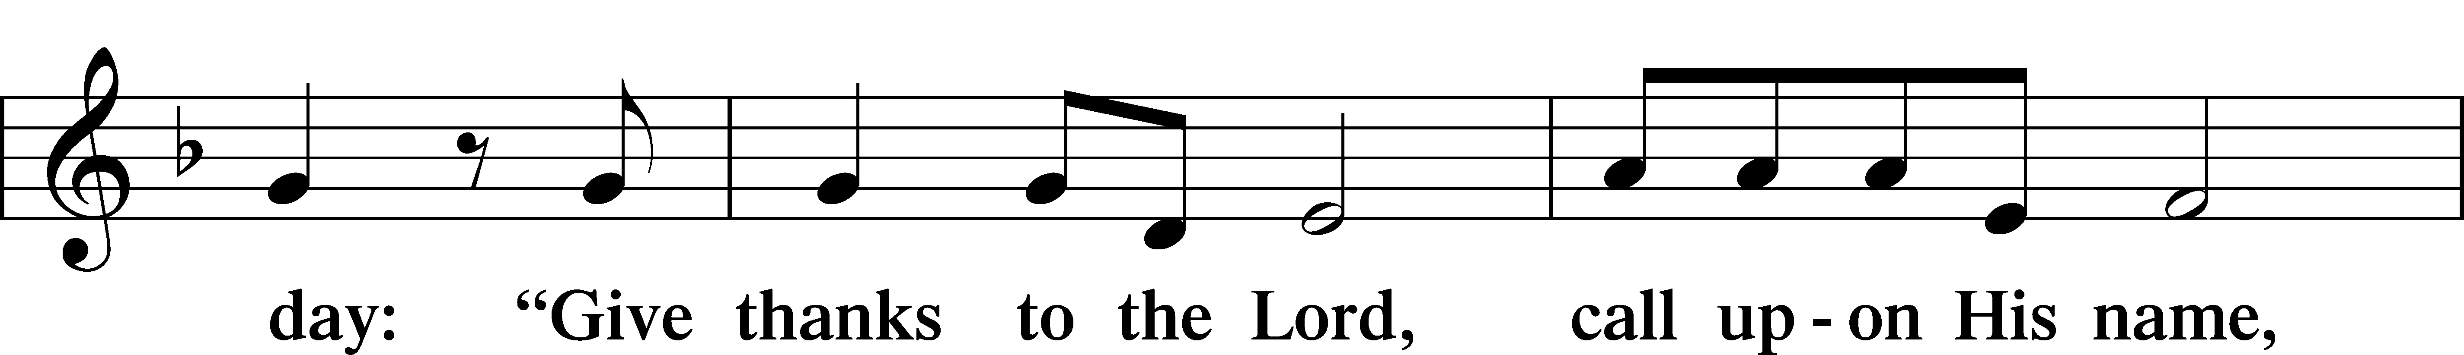
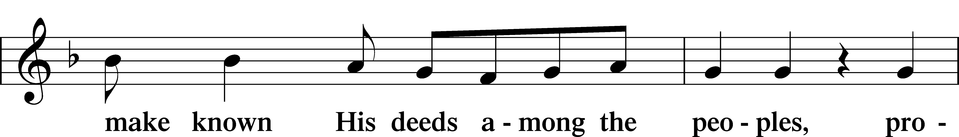
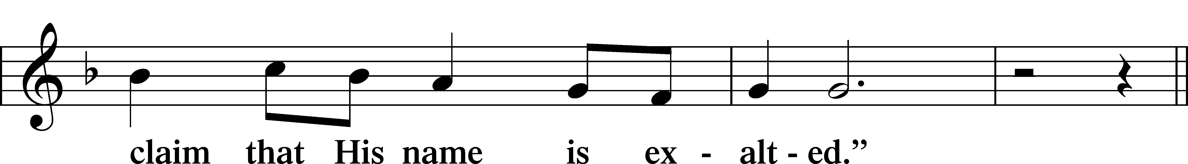
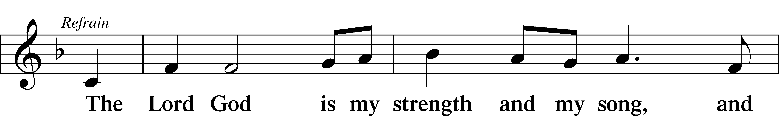
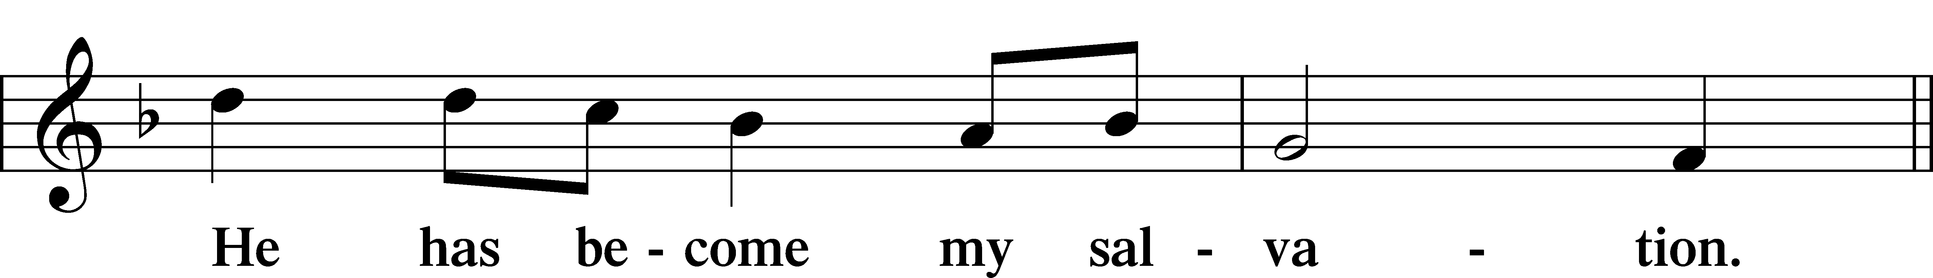
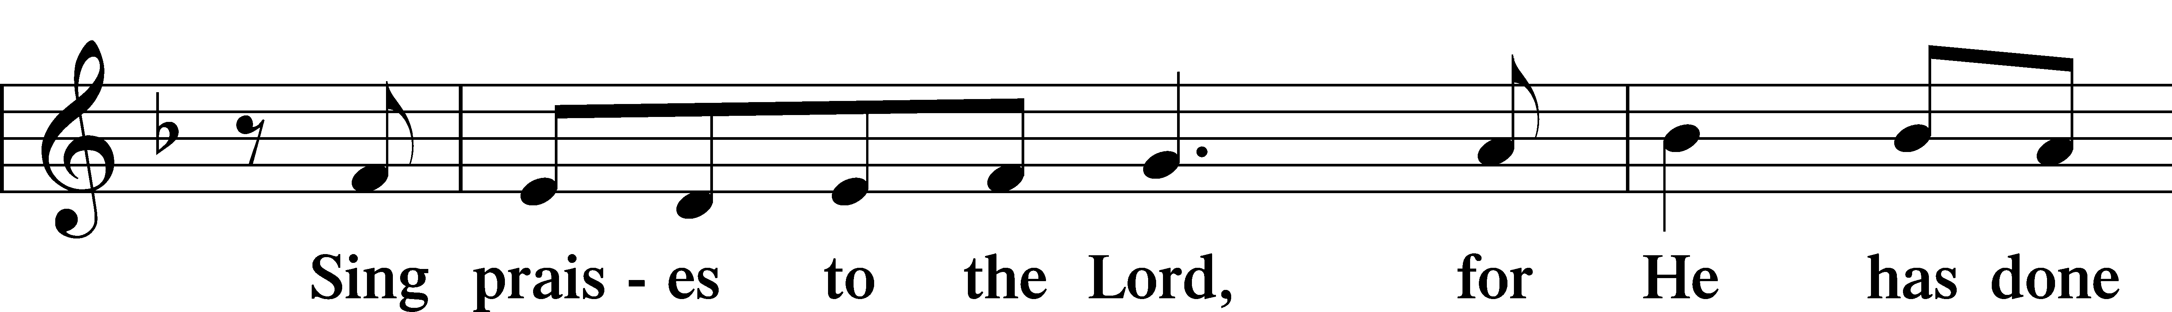
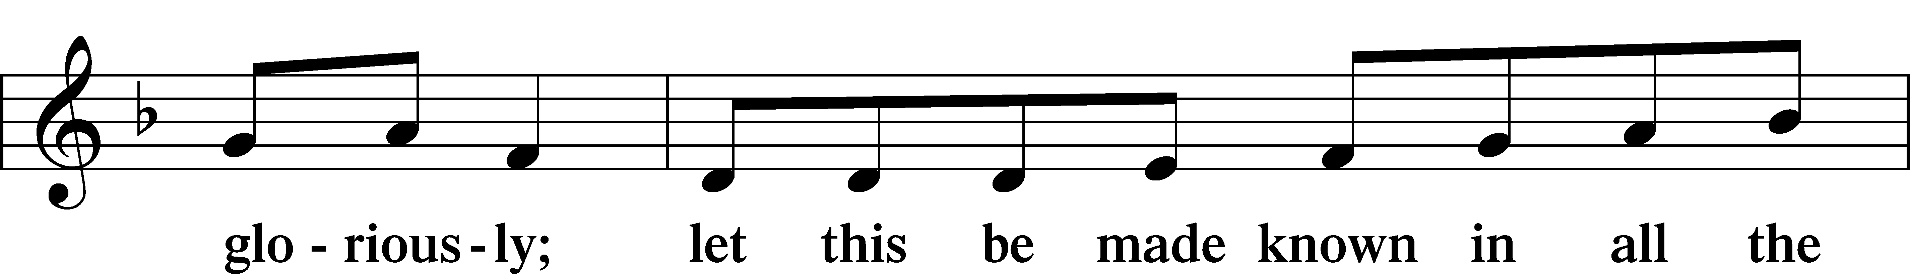
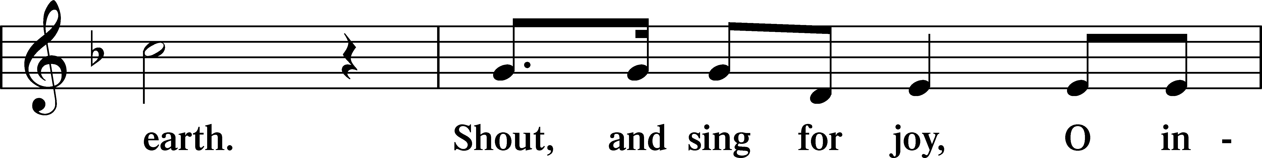
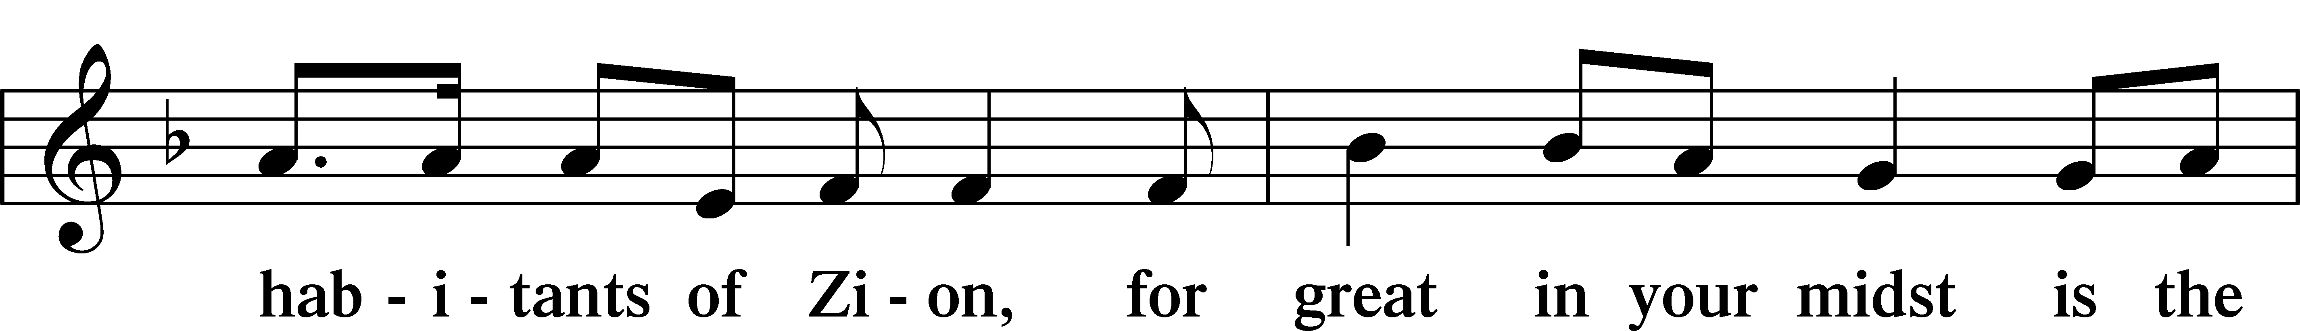
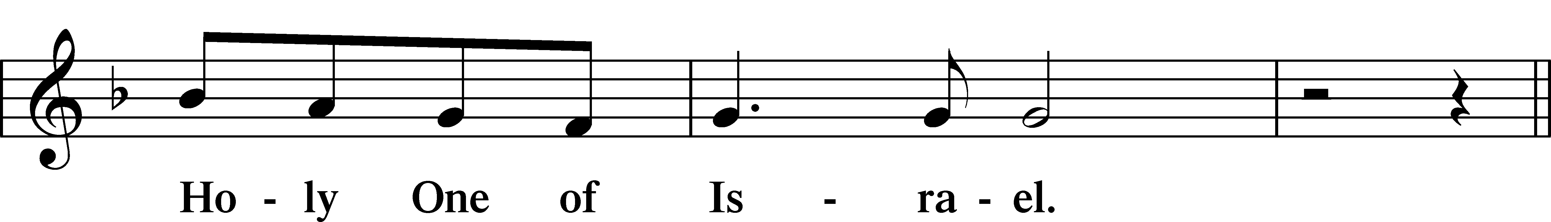
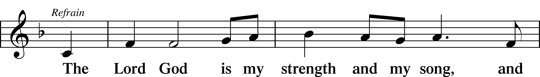
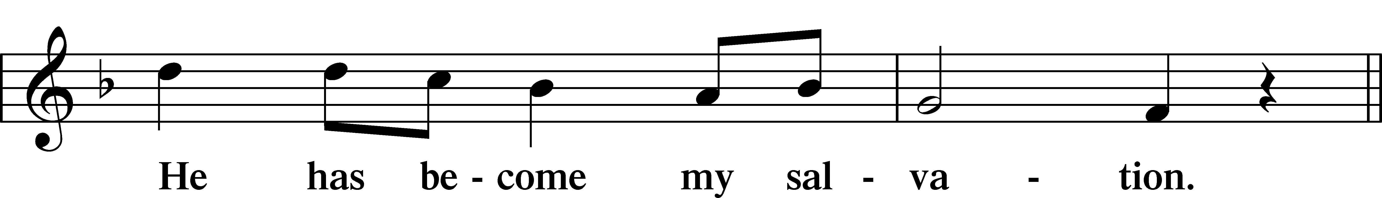
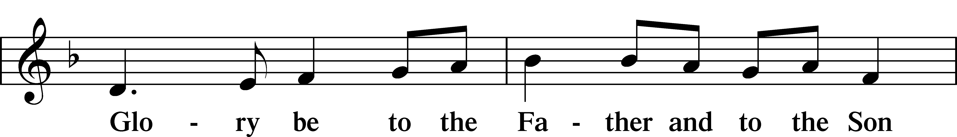
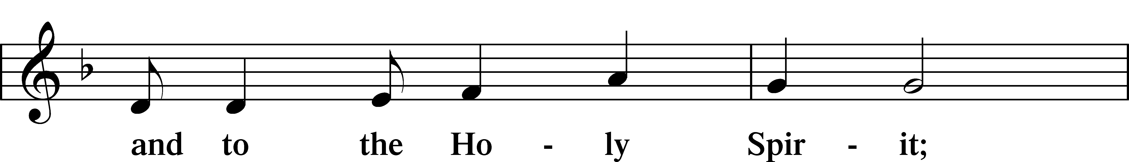
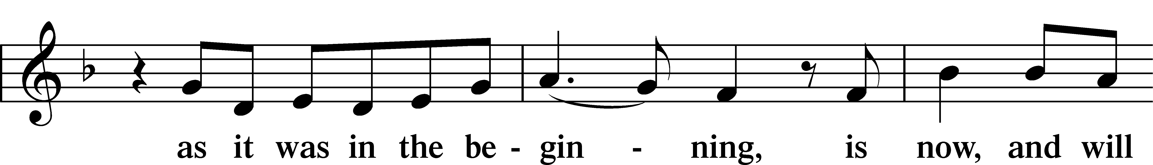
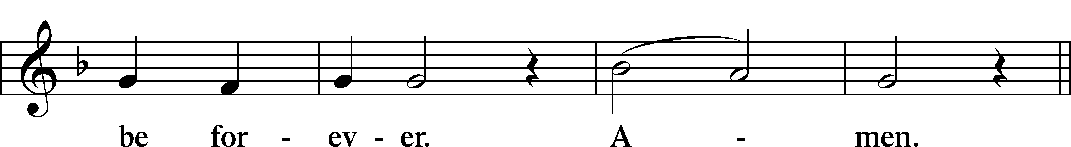
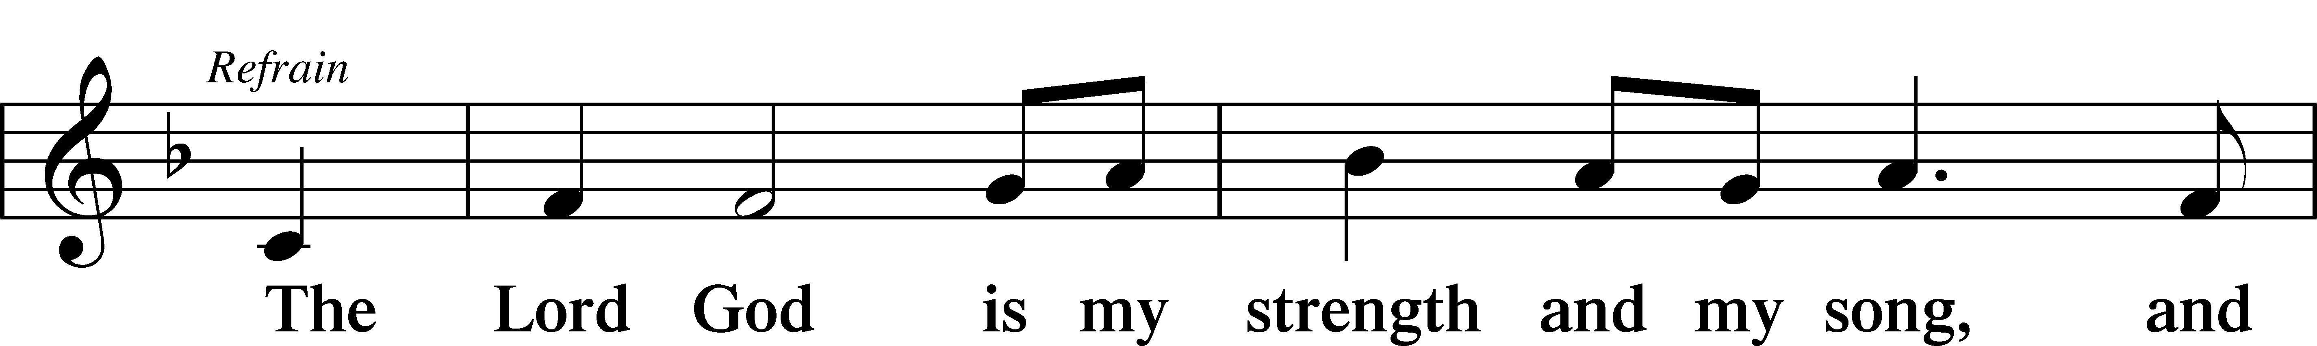
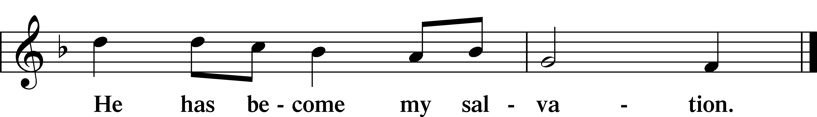

Readings From Holy Scripture
Reading Zechariah 9:9–12
L A reading from Zechariah, the ninth chapter.
9Rejoice greatly, O daughter of Zion!
Shout aloud, O daughter of Jerusalem!
behold, your king is coming to you;
righteous and having salvation is he,
humble and mounted on a donkey,
on a colt, the foal of a donkey.
10I will cut off the chariot from Ephraim
and the war horse from Jerusalem;
and the battle bow shall be cut off,
and he shall speak peace to the nations;
his rule shall be from sea to sea,
and from the River to the ends of the earth.
11As for you also, because of the blood of my covenant with you,
I will set your prisoners free from the waterless pit.
12Return to your stronghold, O prisoners of hope;
today I declare that I will restore to you double.
L This is the Word of the Lord.
C Thanks be to God.

Reading Philippians 2:5–11
⁵Have this mind among yourselves, which is yours in Christ Jesus, ⁶who, though he was in the form of God, did not count equality with God a thing to be grasped, ⁷but made himself nothing, taking the form of a servant, being born in the likeness of men. ⁸And being found in human form, he humbled himself by becoming obedient to the point of death, even death on a cross. ⁹Therefore God has highly exalted him and bestowed on him the name that is above every name, ¹⁰so that at the name of Jesus every knee should bow, in heaven and on earth and under the earth, ¹¹and every tongue confess that Jesus Christ is Lord, to the glory of God the Father.

L This is the Word of the Lord.
C Thanks be to God.

Reading John 2:12–19
¹²After this he went down to Capernaum, with his mother and his brothers and his disciples, and they stayed there for a few days.
¹³The Passover of the Jews was at hand, and Jesus went up to Jerusalem. ¹⁴In the temple he found those who were selling oxen and sheep and pigeons, and the money-changers sitting there. ¹⁵And making a whip of cords, he drove them all out of the temple, with the sheep and oxen. And he poured out the coins of the money-changers and overturned their tables. ¹⁶And he told those who sold the pigeons, “Take these things away; do not make my Father’s house a house of trade.” ¹⁷His disciples remembered that it was written, “Zeal for your house will consume me.”
¹⁸So the Jews said to him, “What sign do you show us for doing these things?” ¹⁹Jesus answered them, “Destroy this temple, and in three days I will raise it up.”

L This is the Word of the Lord.
C Thanks be to God.

Responsory
Lent LSB 263
L We have an advocate with the Father; Jesus Christ, the Righteous One.
C He was delivered up to death; He was delivered for the sins of the people.
L Blessed is the one whose transgression is forgiven, whose sin is covered.
C He was delivered up to death; He was delivered for the sins of the people.
L We have an advocate with the Father; Jesus Christ, the Righteous One.
C He was delivered up to death; He was delivered for the sins of the people.

Stand
Ten Commandments
C You shall have no other gods.
You shall not misuse the name of the Lord your God.
Remember the Sabbath day by keeping it holy.
Honor your father and your mother.
You shall not murder.
You shall not commit adultery.
You shall not steal.
You shall not give false testimony against your neighbor.
You shall not covet your neighbor’s house.
You shall not covet your neighbor’s wife, or his manservant or maidservant, his ox or donkey, or anything that belongs to your neighbor.

Apostles’ Creed
C I believe in God, the Father Almighty,
maker of heaven and earth.

And in Jesus Christ, His only Son, our Lord,
who was conceived by the Holy Spirit,
born of the virgin Mary,
suffered under Pontius Pilate,
was crucified, died and was buried.
He descended into hell.
The third day He rose again from the dead.
He ascended into heaven
and sits at the right hand of God the Father Almighty.
From thence He will come to judge the living and the dead.

I believe in the Holy Spirit,
the holy Christian Church,
the communion of saints,
the forgiveness of sins,
the resurrection of the body,
and the life T everlasting. Amen.

Lord’s Prayer
C Our Father who art in heaven,
hallowed be Thy name,
Thy kingdom come,
Thy will be done on earth
as it is in heaven;
give us this day our daily bread;
and forgive us our trespasses
as we forgive those
who trespass against us;
and lead us not into temptation,
but deliver us from evil.
For Thine is the kingdom
and the power and the glory
forever and ever. Amen.
Sit
343 Prepare the Royal Highway
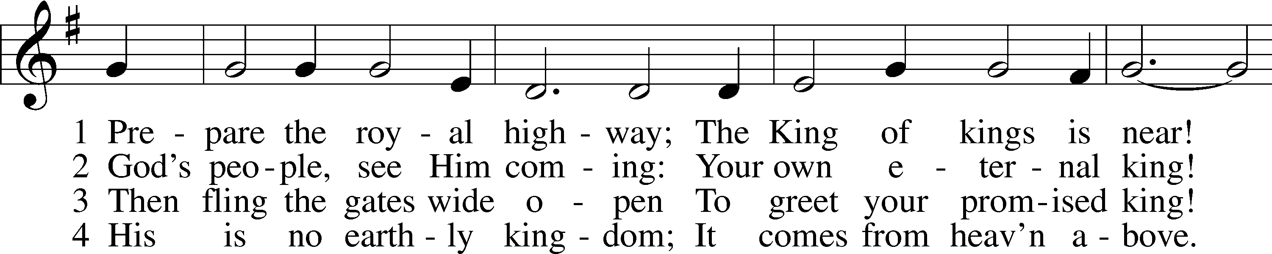
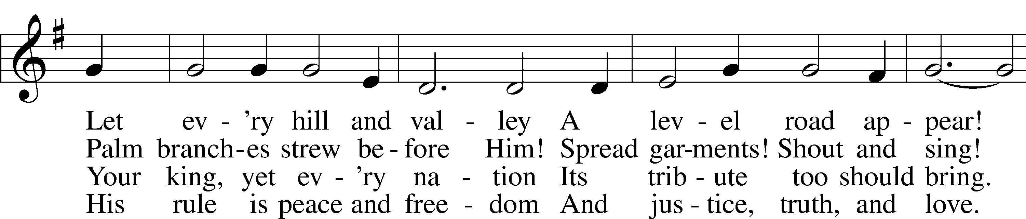
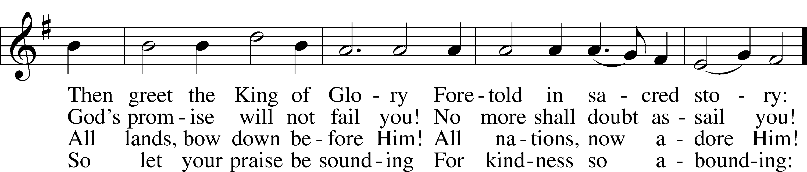
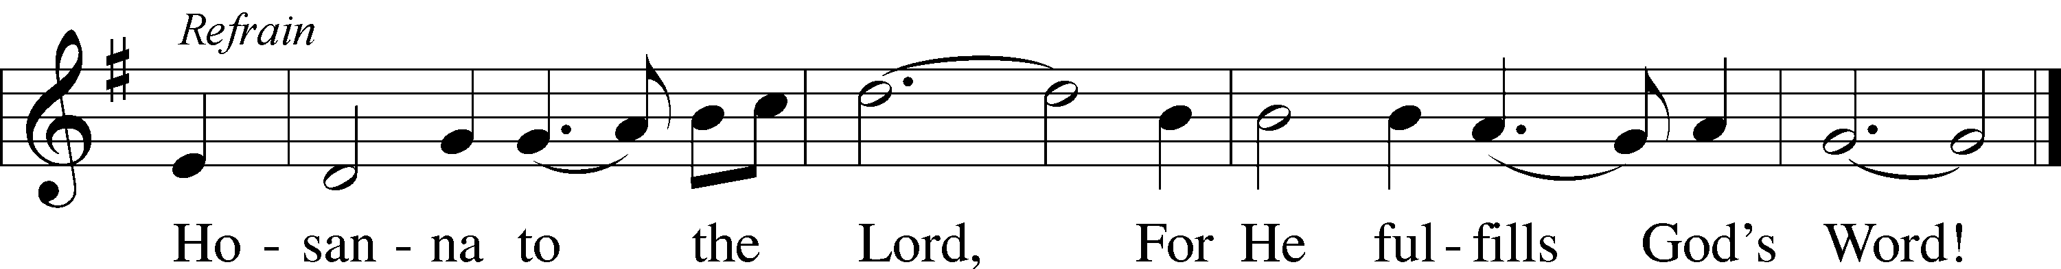
Text: Frans Mikael Franzén, 1772–1847; tr. Lutheran Book of Worship, 1978, alt.
Tune: Swedish, 17th cent.
Text: © 1978 Lutheran Book of Worship. Used by permission: LSB Hymn License no. 110002831
Tune: Public domain

Children’s Sermon
Sermon
Offering

Stand
Prayer
L In peace let us pray to the Lord:
C Lord, have mercy.
L For the gift of divine peace and of pardon, with all our heart and with all our mind, let us pray to the Lord:
C Lord, have mercy.
L For the holy Christian Church, here and scattered throughout the world, and for the proclamation of the Gospel and the calling of all to faith, let us pray to the Lord:
C Lord, have mercy.
L For this nation, for our cities and communities, and for the common welfare of us all, let us pray to the Lord:
C Lord, have mercy.
L For seasonable weather and for the fruitfulness of the earth, let us pray to the Lord:
C Lord, have mercy.
L For those who labor, for those whose work is difficult or dangerous, and for all who travel, let us pray to the Lord:
C Lord, have mercy.
L For all those in need, for the hungry and homeless, for the widowed and orphaned, and for all those in prison, let us pray to the Lord:
C Lord, have mercy.
L For the sick and dying and for all those who care for them, let us pray to the Lord:
C Lord, have mercy.
L For . . . [__________] . . . let us pray to the Lord:
C Lord, have mercy.
L Finally, for these and for all our needs of body and soul, let us pray to the Lord:
C Lord, have mercy. Christ, have mercy. Lord, have mercy.

Collect of the Day
L Almighty and everlasting God, You sent Your Son, our Savior Jesus Christ, to take upon Himself our flesh and to suffer death upon the cross. Mercifully grant that we may follow the example of His great humility and patience and be made partakers of His resurrection; through the same Jesus Christ, our Lord, who lives and reigns with You and the Holy Spirit, one God, now and forever.
C Amen.

Collect for the Word
L Blessed Lord, You have caused all Holy Scriptures to be written for our learning. Grant that we may so hear them, read, mark, learn, and take them to heart that, by the patience and comfort of Your holy Word, we may embrace and ever hold fast the blessed hope of everlasting life; through Jesus Christ, Your Son, our Lord, who lives and reigns with You and the Holy Spirit, one God, now and forever.
C Amen.

Morning Prayer
C I thank You, my heavenly Father, through Jesus Christ, Your dear Son, that You have kept me this night from all harm and danger; and I pray that You would keep me this day also from sin and every evil, that all my doings and life may please You. For into Your hands I commend myself, my body and soul, and all things. Let Your holy angel be with me, that the evil foe may have no power over me.

Evening Prayer
C I thank You, my heavenly Father, through Jesus Christ, Your dear Son, that You have graciously kept me this day; and I pray that You would forgive me all my sins where I have done wrong, and graciously keep me this night. For into Your hands I commend myself, my body and soul, and all things. Let Your holy angel be with me, that the evil foe may have no power over me.

443 Hosanna, Loud Hosanna
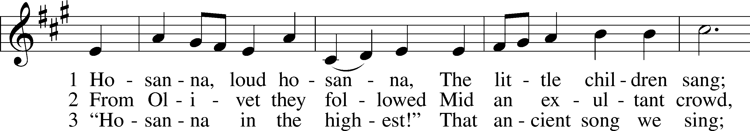
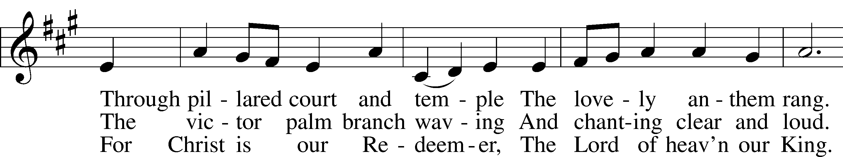
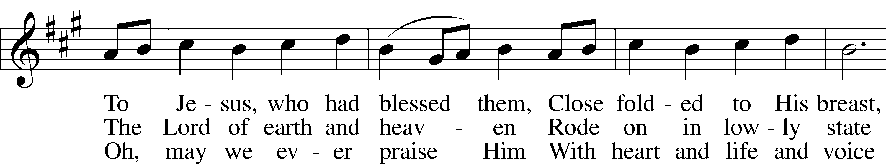
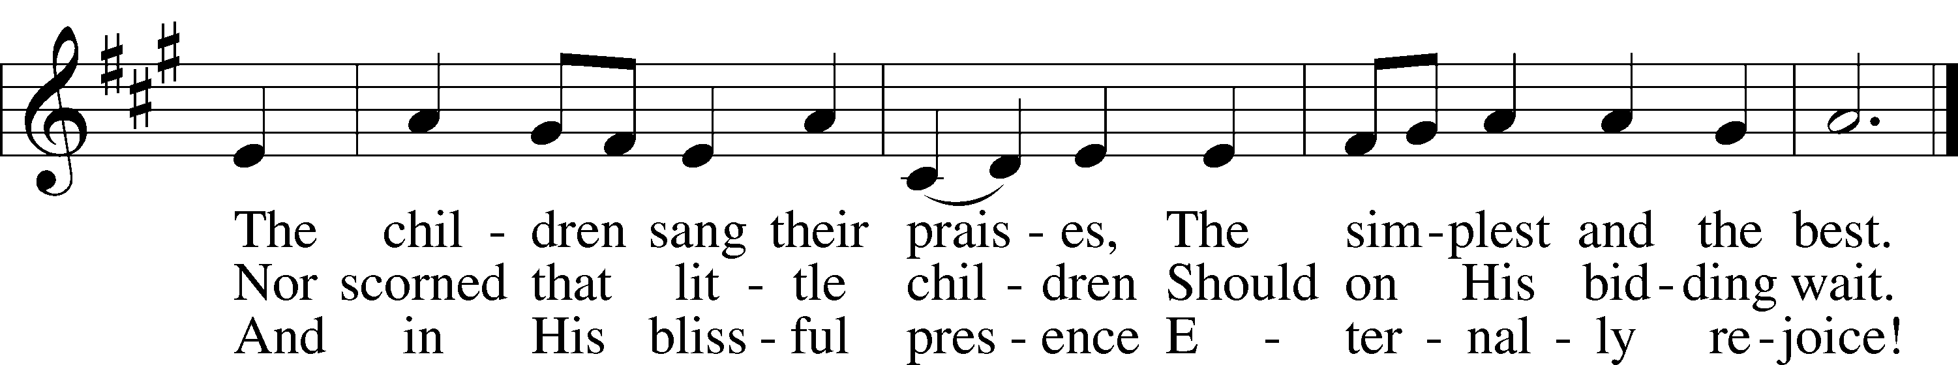
Text: Jeannette Threlfall, 1821–80, alt.
Tune: Gesangbuch der Herzogl. Hofkapelle, 1784, Württemberg
Text and tune: Public domain

Blessing

Benedicamus LSB 267
L Let us bless the Lord.
C Thanks be to God.

Benediction LSB 267
L The almighty and merciful Lord, the Father, the T Son, and the Holy Spirit, bless and preserve us.
C Amen.

837 Lift High the Cross sts. ref–6
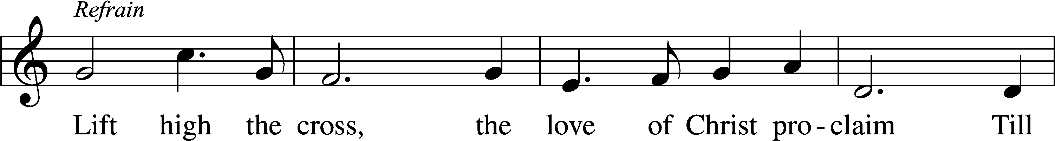
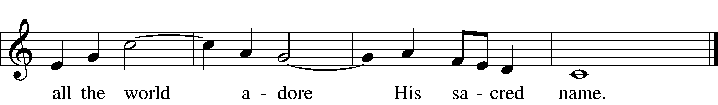
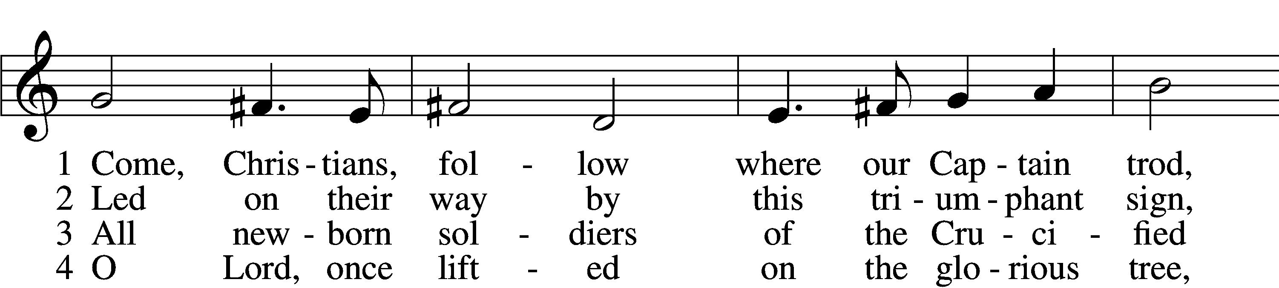
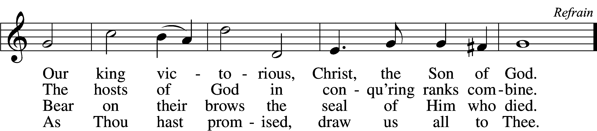

5 Let ev’ry race and ev’ry language tell
Of Him who saves our lives from death and hell. Refrain

6 So shall our song of triumph ever be:
Praise to the Crucified for victory! Refrain
Text: George W. Kitchin, 1827–1912; rev. Michael R. Newbolt, 1874–1956, alt.
Tune: Sydney H. Nicholson, 1875–1947
Text and tune: © 1974 Hope Publishing Co. Used by permission: LSB Hymn License no. 110002831

Acknowledgments
Unless otherwise indicated, Scripture quotations are from the ESV® Bible (The Holy Bible, English Standard Version®), copyright © 2001 by Crossway, a publishing ministry of Good News Publishers. Used by permission. All rights reserved.
Created by Lutheran Service Builder © 2024 Concordia Publishing House.

