Fourth Sunday in Lent
Prayer and Preaching p. 260
March 9 & 10, 2024
St. Paul Lutheran Church

825 Rise, Shine, You People
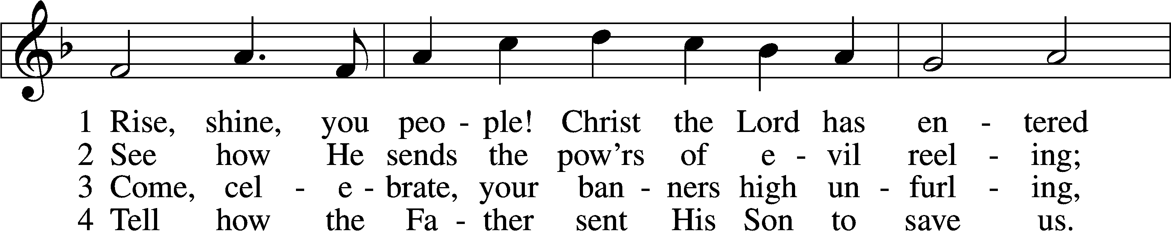
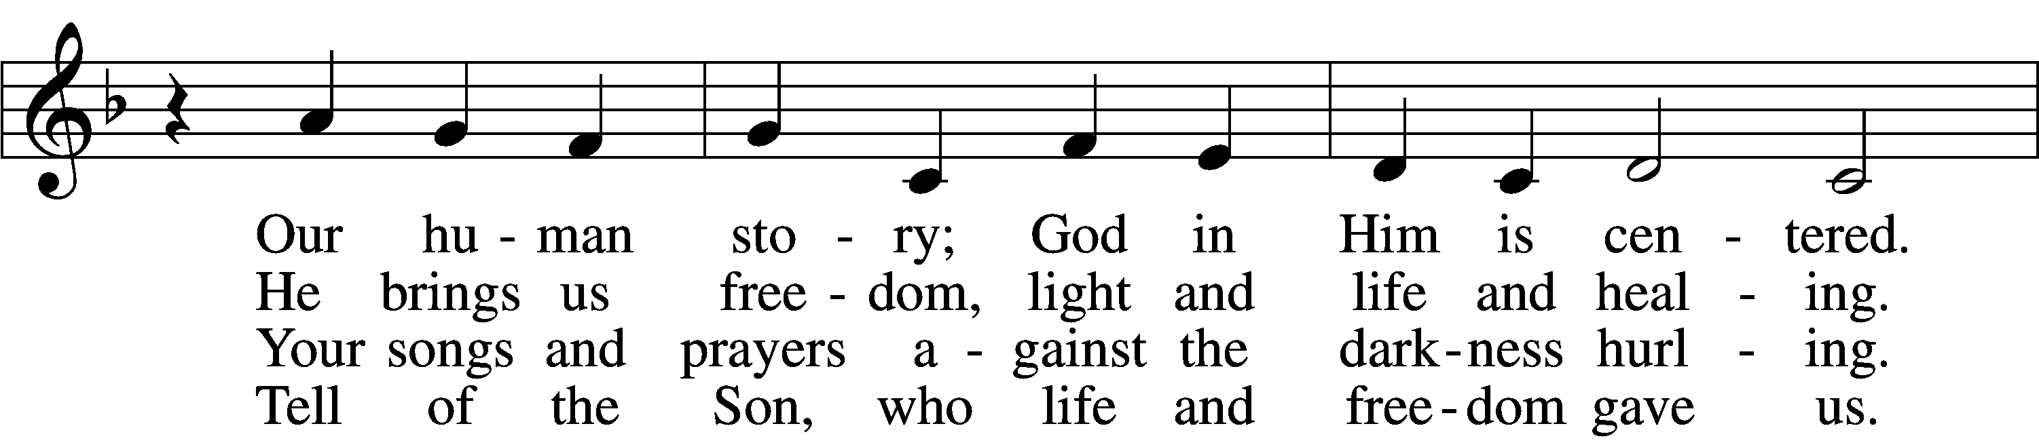
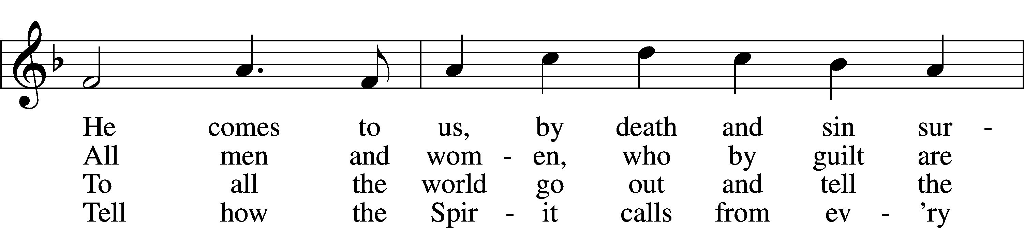
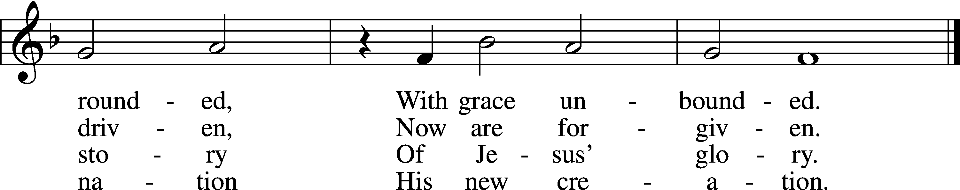
Text: Ronald A. Klug, 1939, alt.
Tune: Dale Wood, 1934–2003
Text and tune: © 1974 Augsburg Publishing House, admin. Augsburg Fortress. Used by permission: LSB Hymn License no. 110002831

Stand

Opening Versicles

Lent LSB 260
L This is the day which the Lord has made;
C let us rejoice and be glad in it.
L From the rising of the sun to its setting,
C the name of the Lord is to be praised.

L Return to the Lord, your God, for He is gracious and merciful,
C slow to anger, and abounding in steadfast love, and repents of evil.
L Jesus said: If any man would come after Me,
C let him deny himself and take up his cross and follow Me.
L Christ was wounded for our transgressions.
C He was bruised for our iniquities.

L From the rising of the sun to its setting,
C the name of the Lord is to be praised.

C Glory be to the Father and to the Son and to the Holy Spirit;
as it was in the beginning, is now, and will be forever. Amen.

Old Testament Canticle LSB 261
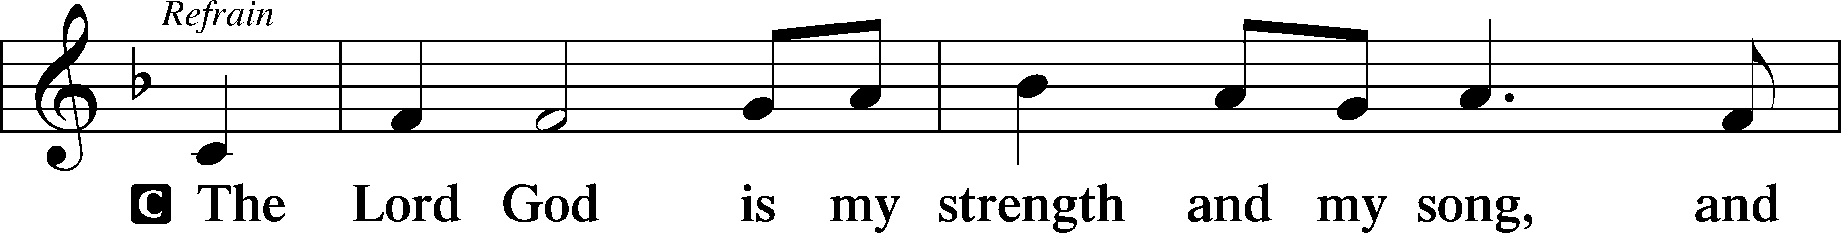
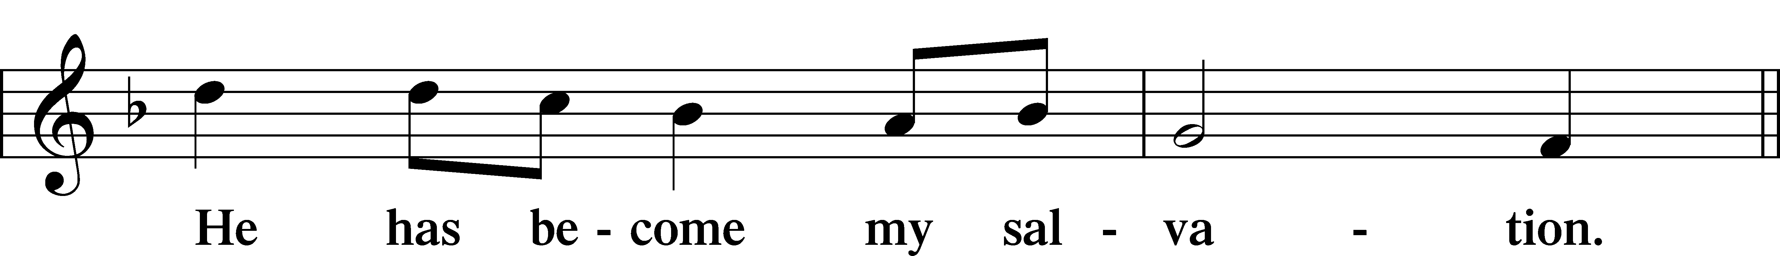
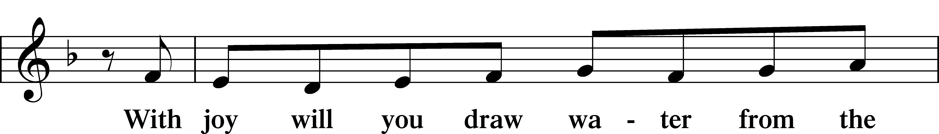
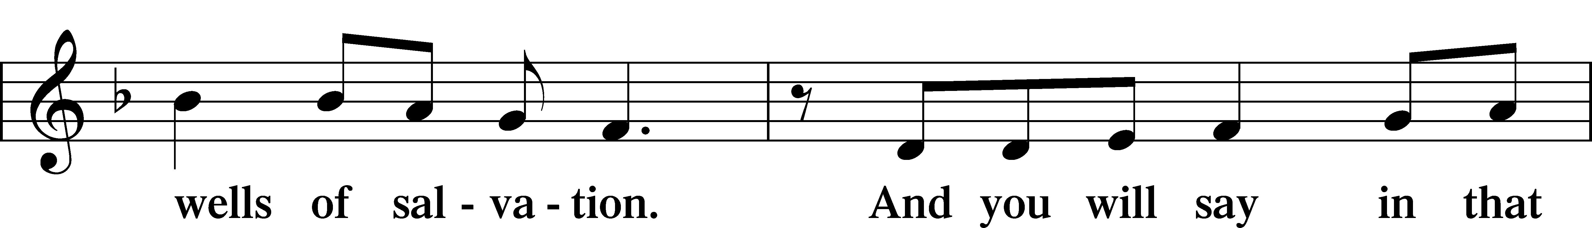
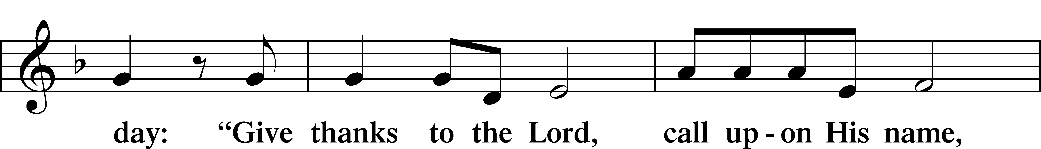
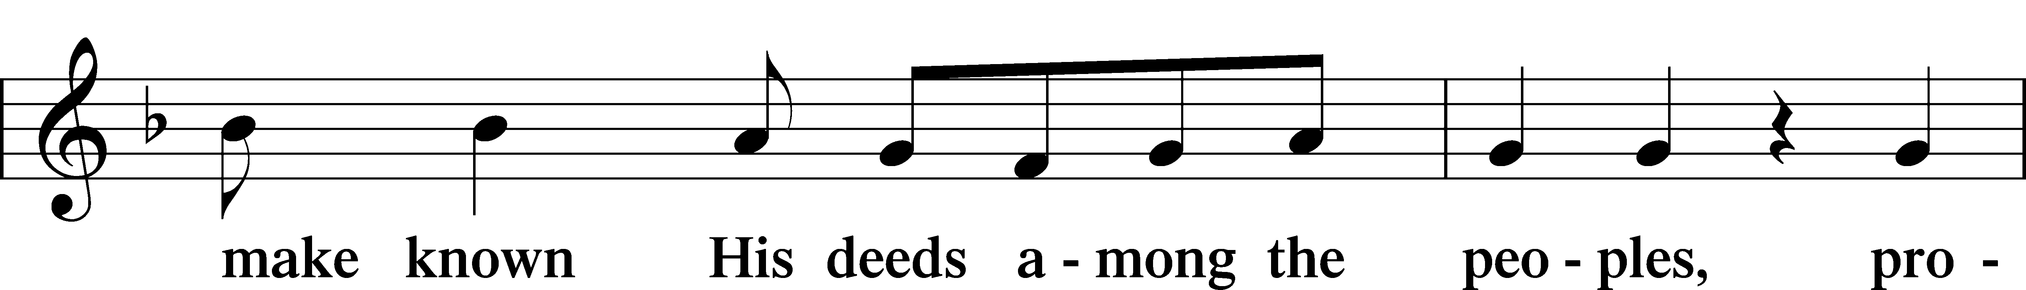
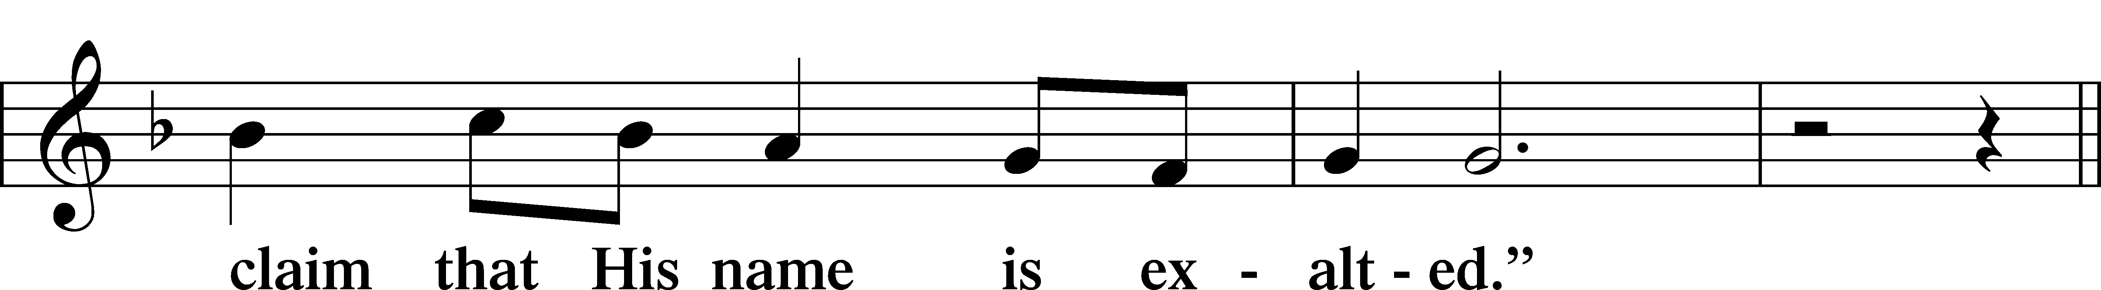
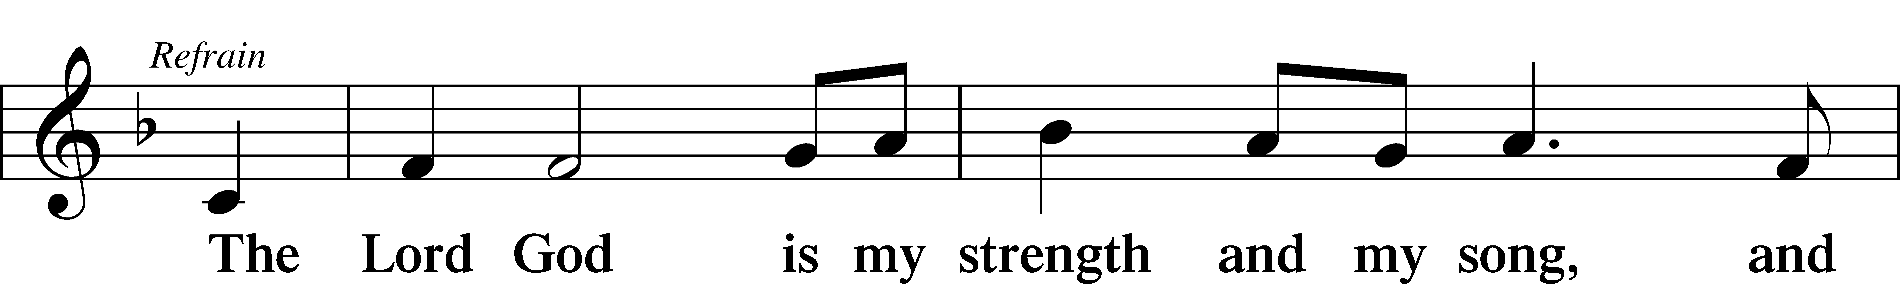
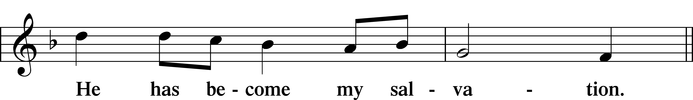
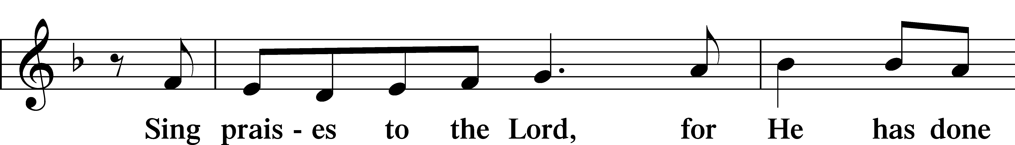
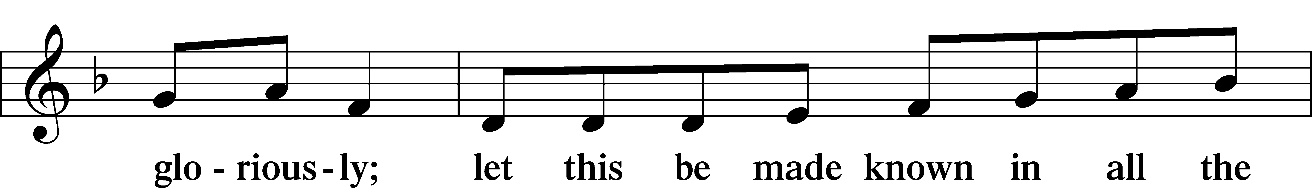
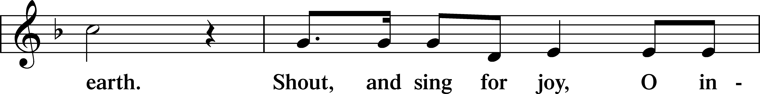
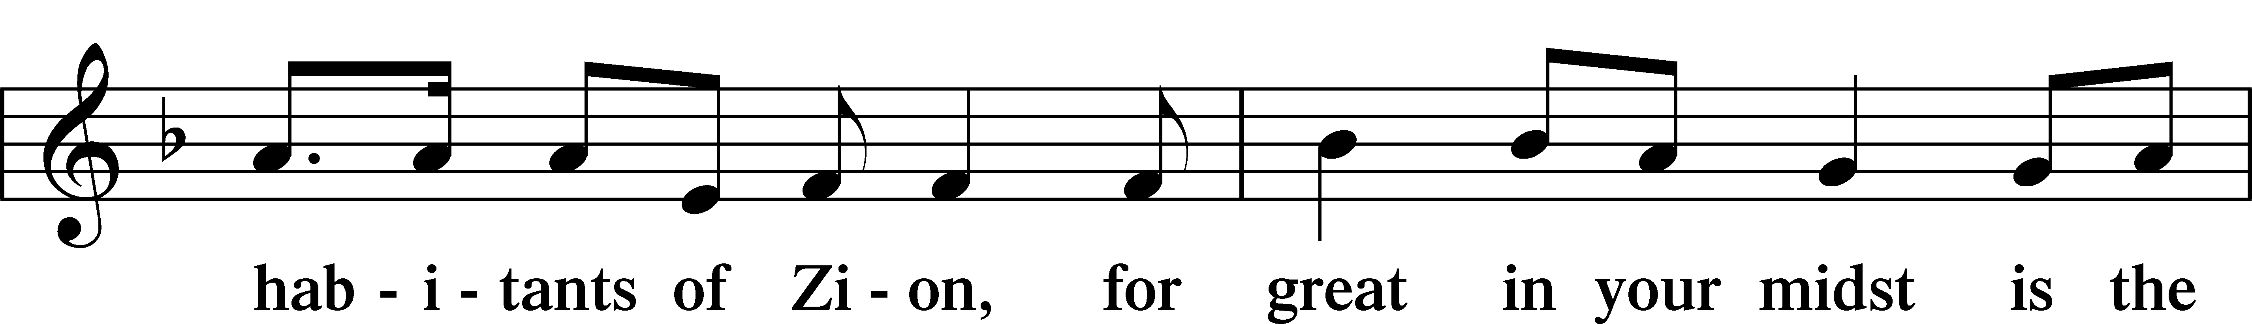
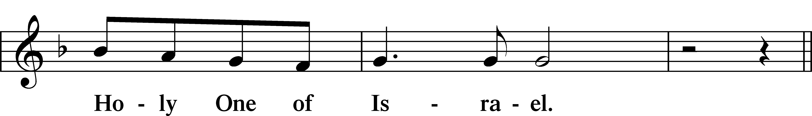
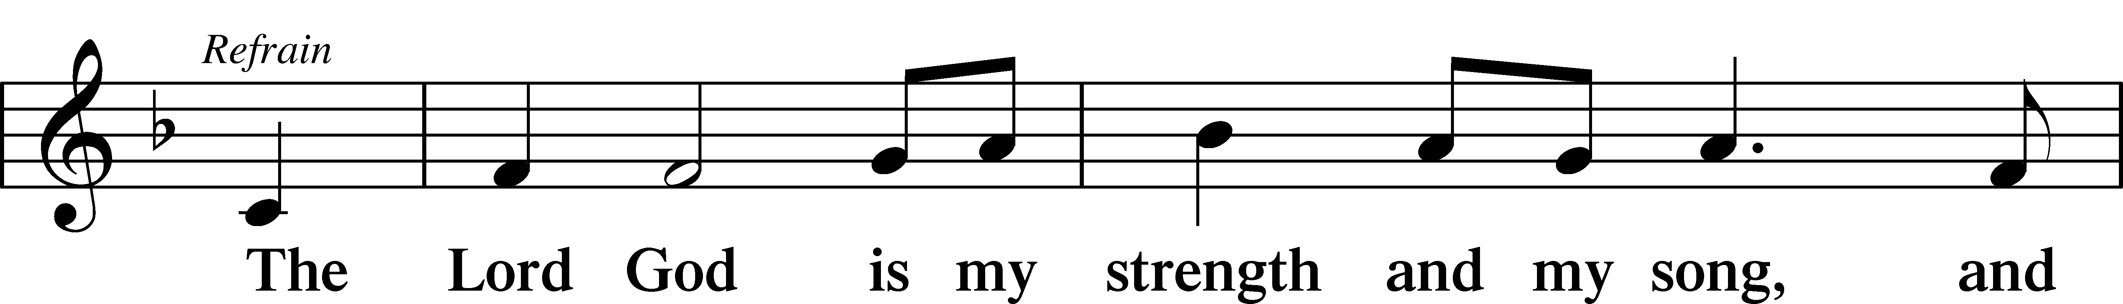
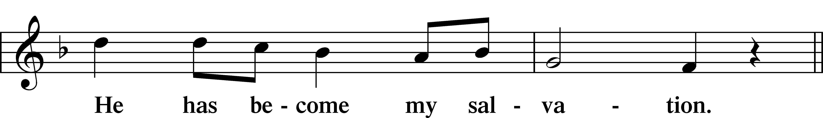
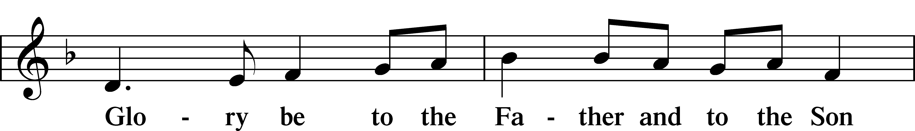
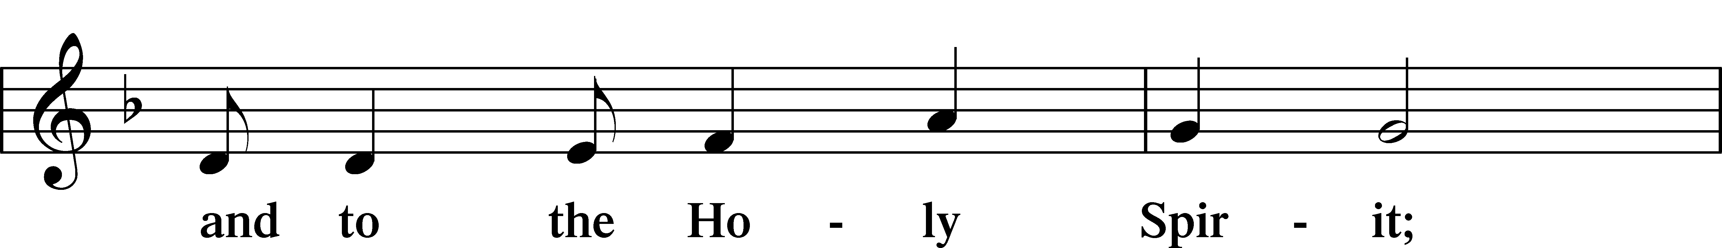
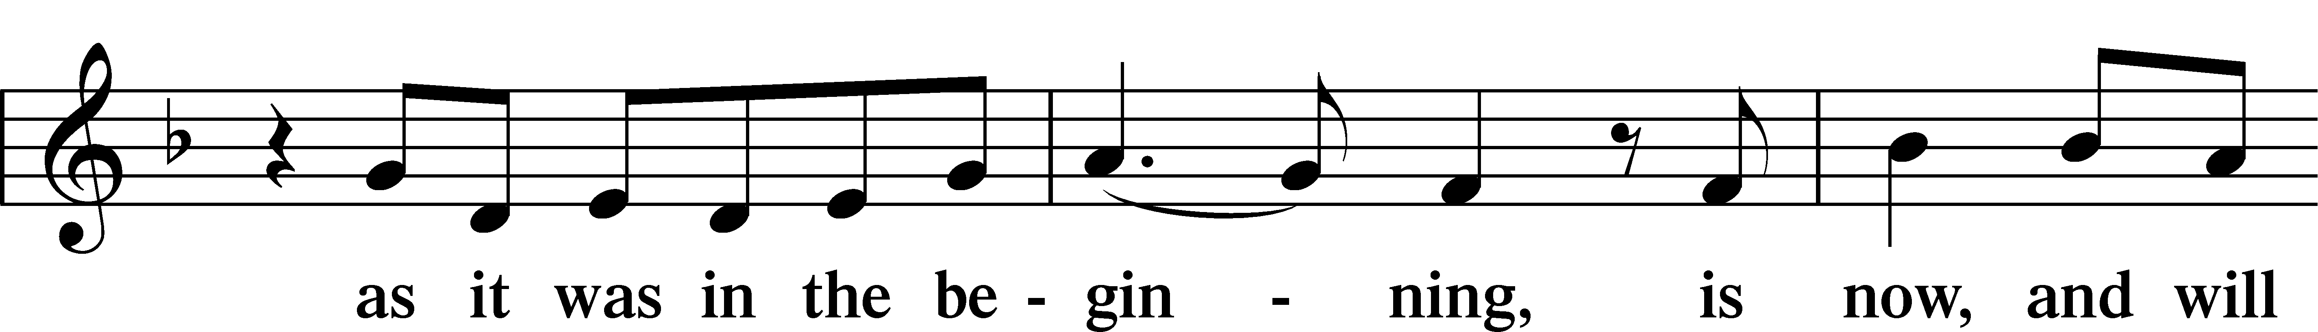
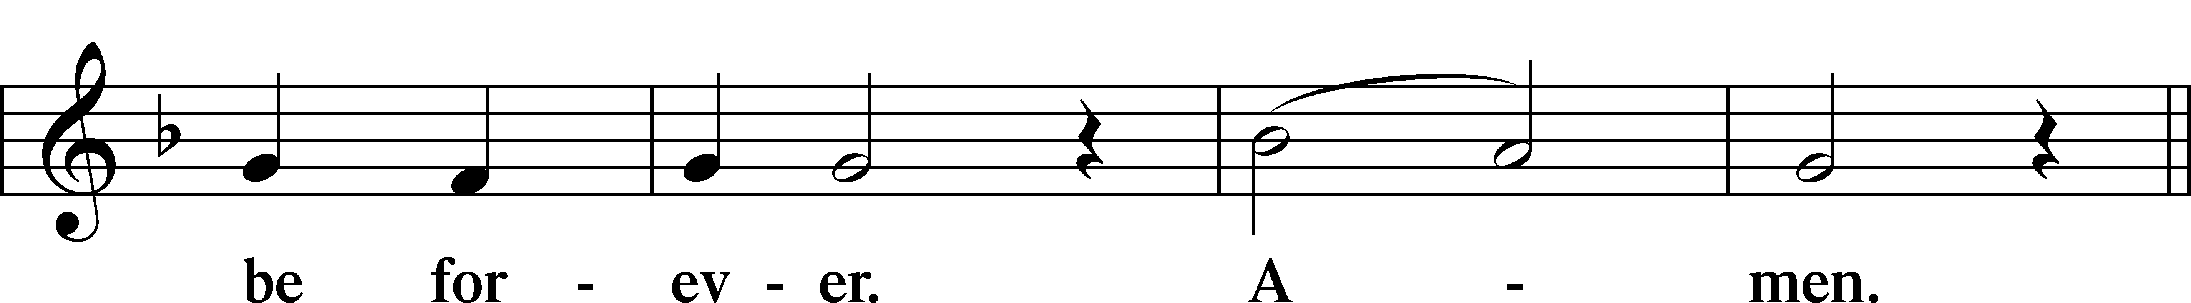
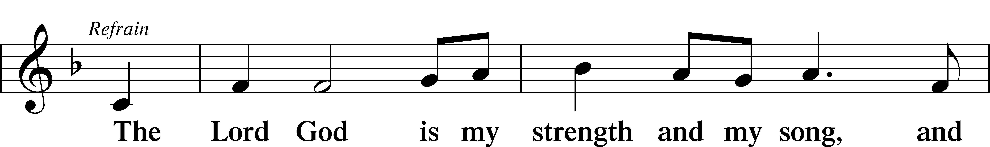
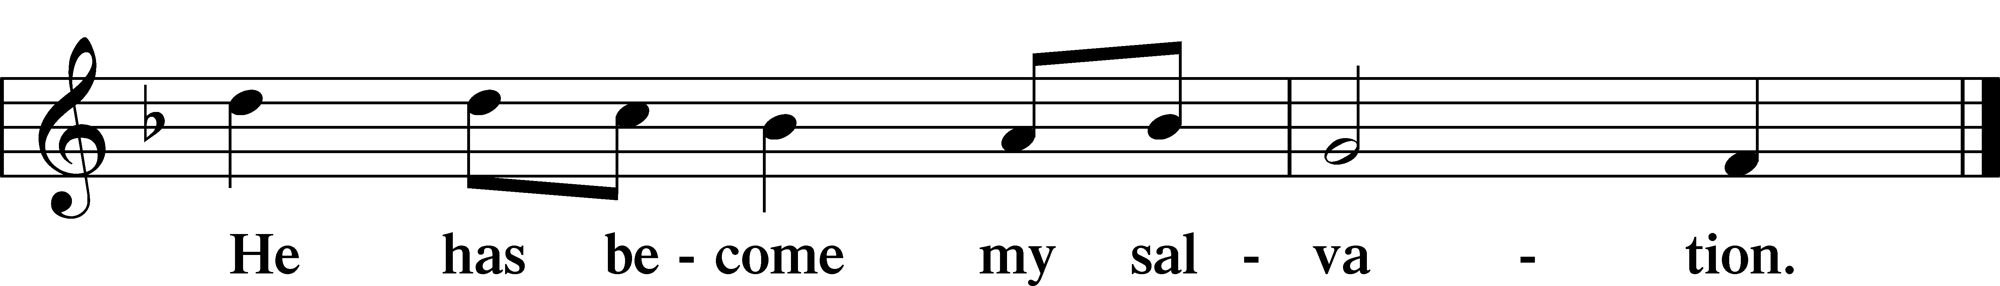

Sit

Readings From Holy Scripture
Reading Numbers 21:4–9
L A reading from Numbers, the twenty-first chapter.

4From Mount Hor they set out by the way to the Red Sea, to go around the land of Edom. And the people became impatient on the way. 5And the people spoke against God and against Moses, “Why have you brought us up out of Egypt to die in the wilderness? For there is no food and no water, and we loathe this worthless food.” 6Then the Lord sent fiery serpents among the people, and they bit the people, so that many people of Israel died. 7And the people came to Moses and said, “We have sinned, for we have spoken against the Lord and against you. Pray to the Lord, that he take away the serpents from us.” So Moses prayed for the people. 8And the Lord said to Moses, “Make a fiery serpent and set it on a pole, and everyone who is bitten, when he sees it, shall live.” 9So Moses made a bronze serpent and set it on a pole. And if a serpent bit anyone, he would look at the bronze serpent and live.
L This is the Word of the Lord.
C Thanks be to God.

READING Ephesians 2:1–10
¹And you were dead in the trespasses and sins ²in which you once walked, following the course of this world, following the prince of the power of the air, the spirit that is now at work in the sons of disobedience— ³among whom we all once lived in the passions of our flesh, carrying out the desires of the body and the mind, and were by nature children of wrath, like the rest of mankind. ⁴But God, being rich in mercy, because of the great love with which he loved us, ⁵even when we were dead in our trespasses, made us alive together with Christ—by grace you have been saved— ⁶and raised us up with him and seated us with him in the heavenly places in Christ Jesus, ⁷so that in the coming ages he might show the immeasurable riches of his grace in kindness toward us in Christ Jesus. ⁸For by grace you have been saved through faith. And this is not your own doing; it is the gift of God, ⁹not a result of works, so that no one may boast. ¹⁰For we are his workmanship, created in Christ Jesus for good works, which God prepared beforehand, that we should walk in them.
L This is the Word of the Lord.
C Thanks be to God.

READING John 3:14–21
¹⁴[Jesus said:] “As Moses lifted up the serpent in the wilderness, so must the Son of Man be lifted up, ¹⁵that whoever believes in him may have eternal life.
¹⁶“For God so loved the world, that he gave his only Son, that whoever believes in him should not perish but have eternal life. ¹⁷For God did not send his Son into the world to condemn the world, but in order that the world might be saved through him. ¹⁸Whoever believes in him is not condemned, but whoever does not believe is condemned already, because he has not believed in the name of the only Son of God. ¹⁹And this is the judgment: the light has come into the world, and people loved the darkness rather than the light because their deeds were evil. ²⁰For everyone who does wicked things hates the light and does not come to the light, lest his deeds should be exposed. ²¹But whoever does what is true comes to the light, so that it may be clearly seen that his deeds have been carried out in God.”
L This is the Word of the Lord.
C Thanks be to God.

Responsory
Lent LSB 263
L We have an advocate with the Father; Jesus Christ, the Righteous One.
C He was delivered up to death; He was delivered for the sins of the people.
L Blessed is the one whose transgression is forgiven, whose sin is covered.
C He was delivered up to death; He was delivered for the sins of the people.
L We have an advocate with the Father; Jesus Christ, the Righteous One.
C He was delivered up to death; He was delivered for the sins of the people.

Stand

Ten Commandments
C You shall have no other gods.
You shall not misuse the name of the Lord your God.
Remember the Sabbath day by keeping it holy.
Honor your father and your mother.
You shall not murder.
You shall not commit adultery.
You shall not steal.
You shall not give false testimony against your neighbor.
You shall not covet your neighbor’s house.
You shall not covet your neighbor’s wife, or his manservant or maidservant, his ox or donkey, or anything that belongs to your neighbor.

Apostles’ Creed
C I believe in God, the Father Almighty,
maker of heaven and earth.

And in Jesus Christ, His only Son, our Lord,
who was conceived by the Holy Spirit,
born of the virgin Mary,
suffered under Pontius Pilate,
was crucified, died and was buried.
He descended into hell.
The third day He rose again from the dead.
He ascended into heaven
and sits at the right hand of God the Father Almighty.
From thence He will come to judge the living and the dead.

I believe in the Holy Spirit,
the holy Christian Church,
the communion of saints,
the forgiveness of sins,
the resurrection of the body,
and the life T everlasting. Amen.

Lord’s Prayer
C Our Father who art in heaven,
hallowed be Thy name,
Thy kingdom come,
Thy will be done on earth
as it is in heaven;
give us this day our daily bread;
and forgive us our trespasses
as we forgive those
who trespass against us;
and lead us not into temptation,
but deliver us from evil.
For Thine is the kingdom
and the power and the glory
forever and ever. Amen.

571 God Loved the World So That He Gave
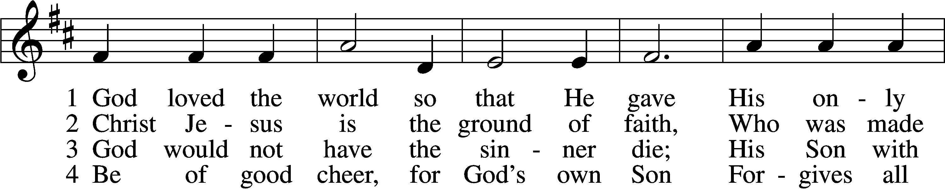
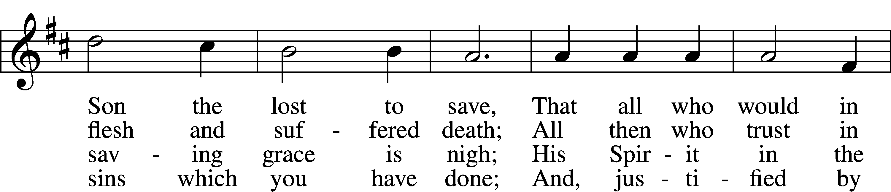
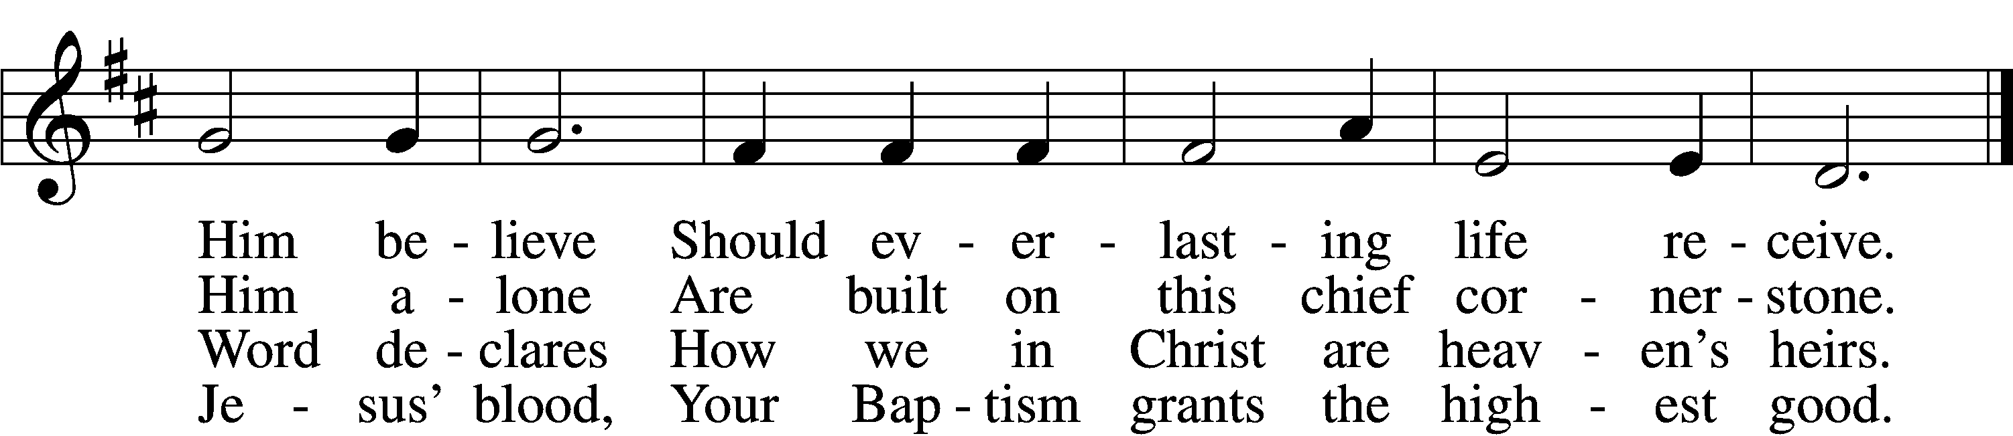

5 If you are sick, if death is near,
This truth your troubled heart can cheer:
Christ Jesus saves your soul from death;
That is the firmest ground of faith.

D 6 Glory to God the Father, Son,
And Holy Spirit, Three in One!
To You, O blessèd Trinity,
Be praise now and eternally!
Text: Heiliges Lippen- und Hertzens-Opffer, c. 1778, Stettin; tr. August Crull, 1845–1923, alt.
Tune: George J. Elvey, 1816–93
Text and tune: Public domain

Children’s Sermon
Sermon
Offering
Stand
Prayer
L In peace let us pray to the Lord:
C Lord, have mercy.
L For the gift of divine peace and of pardon, with all our heart and with all our mind, let us pray to the Lord:
C Lord, have mercy.
L For the holy Christian Church, here and scattered throughout the world, and for the proclamation of the Gospel and the calling of all to faith, let us pray to the Lord:
C Lord, have mercy.
L For this nation, for our cities and communities, and for the common welfare of us all, let us pray to the Lord:
C Lord, have mercy.
L For seasonable weather and for the fruitfulness of the earth, let us pray to the Lord:
C Lord, have mercy.
L For those who labor, for those whose work is difficult or dangerous, and for all who travel, let us pray to the Lord:
C Lord, have mercy.
L For all those in need, for the hungry and homeless, for the widowed and orphaned, and for all those in prison, let us pray to the Lord:
C Lord, have mercy.
L For the sick and dying and for all those who care for them, let us pray to the Lord:
C Lord, have mercy.
L For . . . [additional bids for prayer may be inserted here] . . . let us pray to the Lord:
C Lord, have mercy.
L Finally, for these and for all our needs of body and soul, let us pray to the Lord:
C Lord, have mercy. Christ, have mercy. Lord, have mercy.

Collect of the Day
L Almighty God, our heavenly Father, Your mercies are new every morning; and though we deserve only punishment, You receive us as Your children and provide for all our needs of body and soul. Grant that we may heartily acknowledge Your merciful goodness, give thanks for all Your benefits, and serve You in willing obedience; through Jesus Christ, Your Son, our Lord, who lives and reigns with You and the Holy Spirit, one God, now and forever.
C Amen.

Collect for the Word
L Blessed Lord, You have caused all Holy Scriptures to be written for our learning. Grant that we may so hear them, read, mark, learn, and take them to heart that, by the patience and comfort of Your holy Word, we may embrace and ever hold fast the blessed hope of everlasting life; through Jesus Christ, Your Son, our Lord, who lives and reigns with You and the Holy Spirit, one God, now and forever.
C Amen.

Morning Prayer
C I thank You, my heavenly Father, through Jesus Christ, Your dear Son, that You have kept me this night from all harm and danger; and I pray that You would keep me this day also from sin and every evil, that all my doings and life may please You. For into Your hands I commend myself, my body and soul, and all things. Let Your holy angel be with me, that the evil foe may have no power over me.
Evening Prayer
C I thank You, my heavenly Father, through Jesus Christ, Your dear Son, that You have graciously kept me this day; and I pray that You would forgive me all my sins where I have done wrong, and graciously keep me this night. For into Your hands I commend myself, my body and soul, and all things. Let Your holy angel be with me, that the evil foe may have no power over me.

744 Amazing Grace sts. 1–5
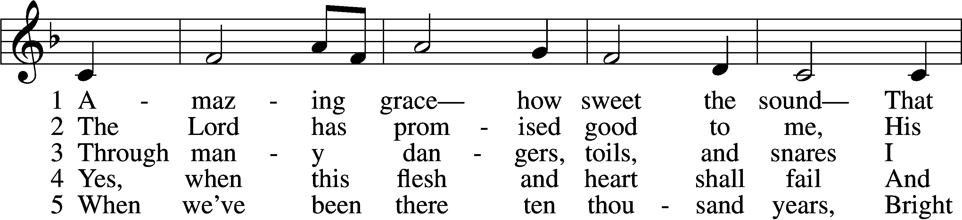
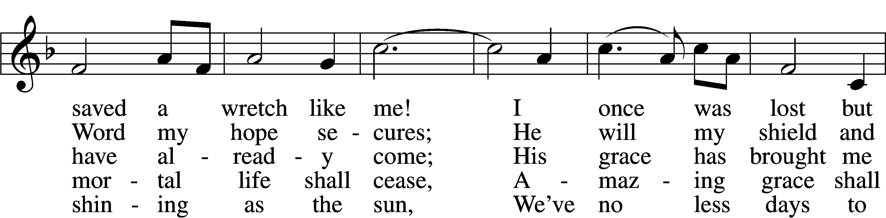
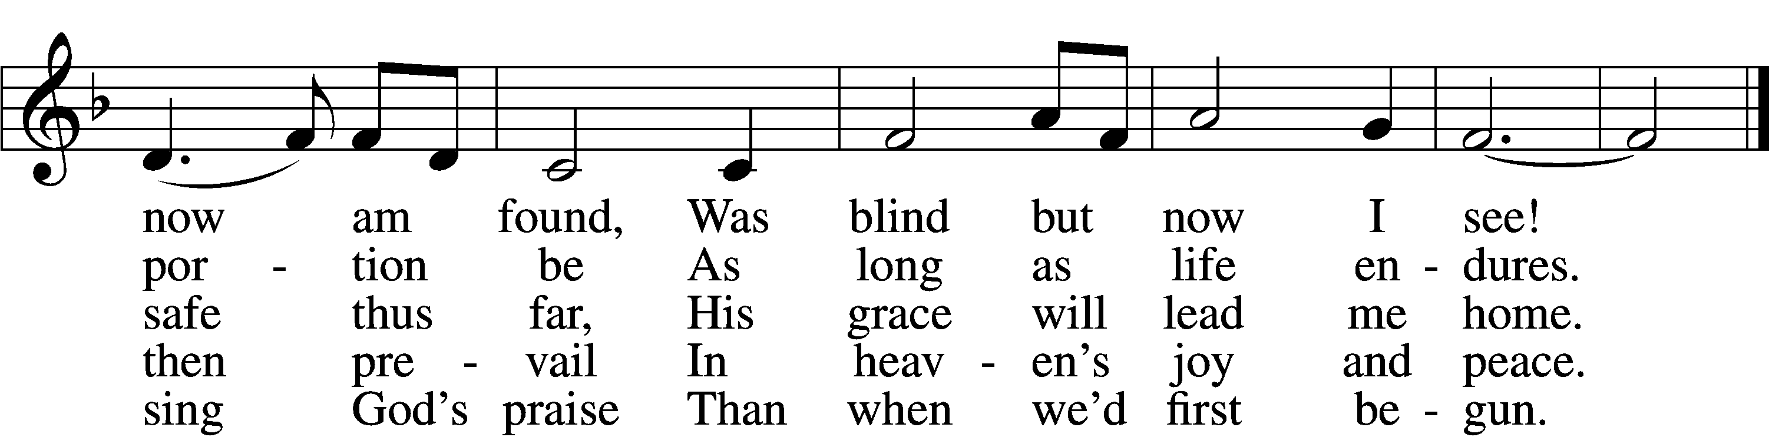
Text (sts. 1–4): John Newton, 1725–1807, alt.; (st. 5): A Collection of Sacred Ballads, 1790, Richmond
Tune: Columbian Harmony, 1829, Cincinnati
Text and tune: Public domain

Blessing

Benedicamus LSB 267
L Let us bless the Lord.
C Thanks be to God.

Benediction LSB 267
P The almighty and merciful Lord, the Father, the T Son, and the Holy Spirit, bless and preserve you.
C Amen.

420 Christ, the Life of All the Living
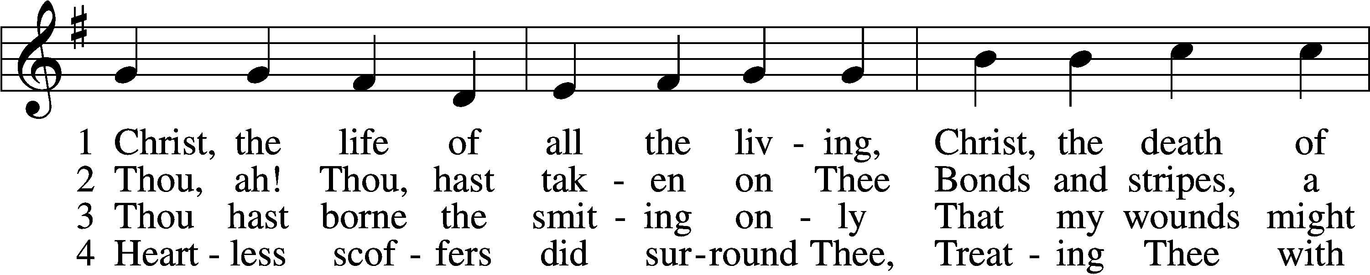
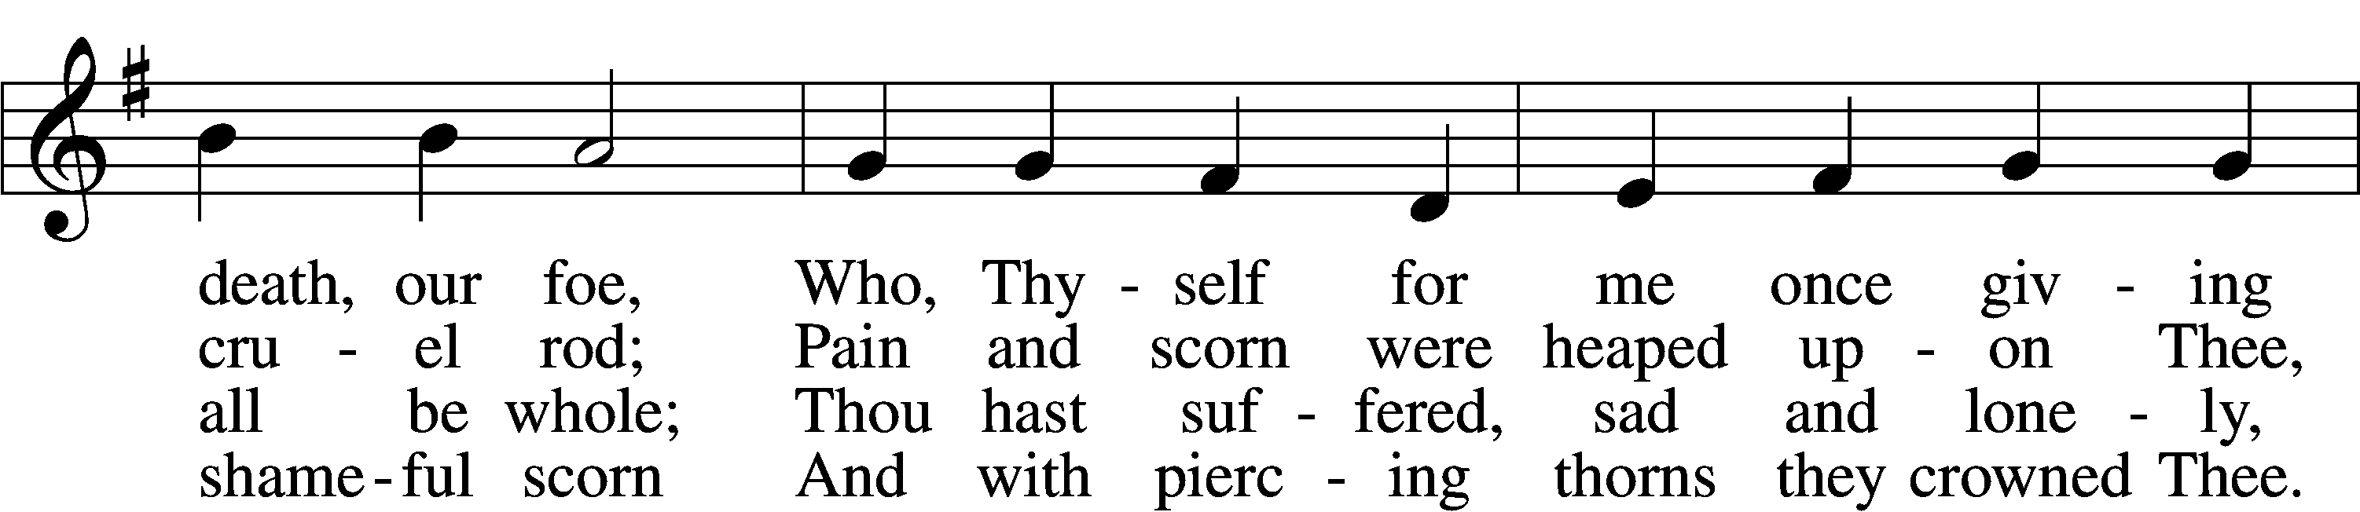
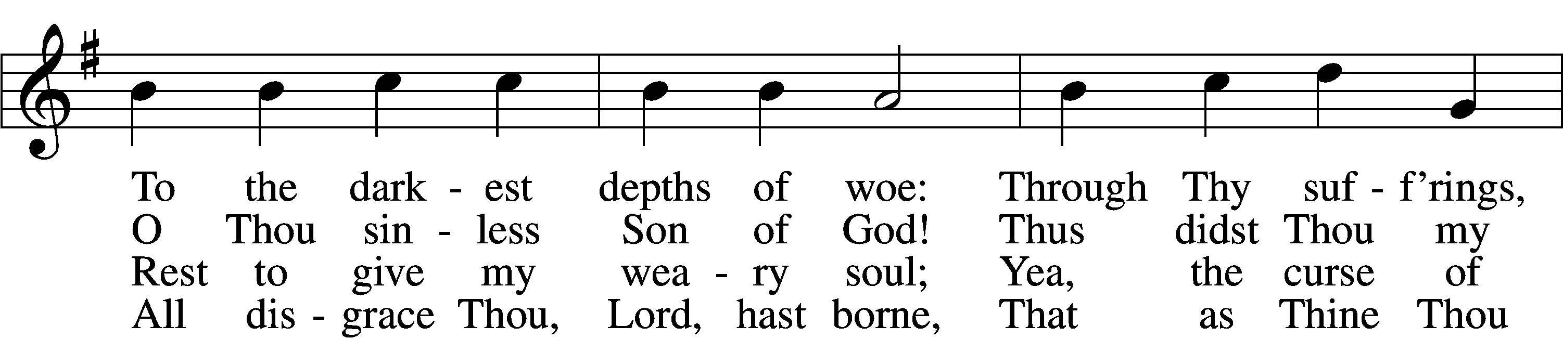
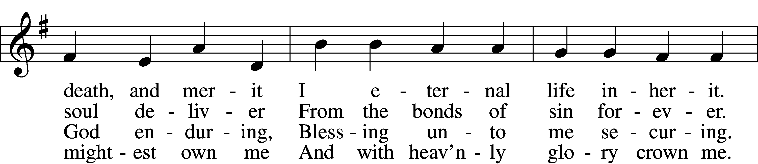
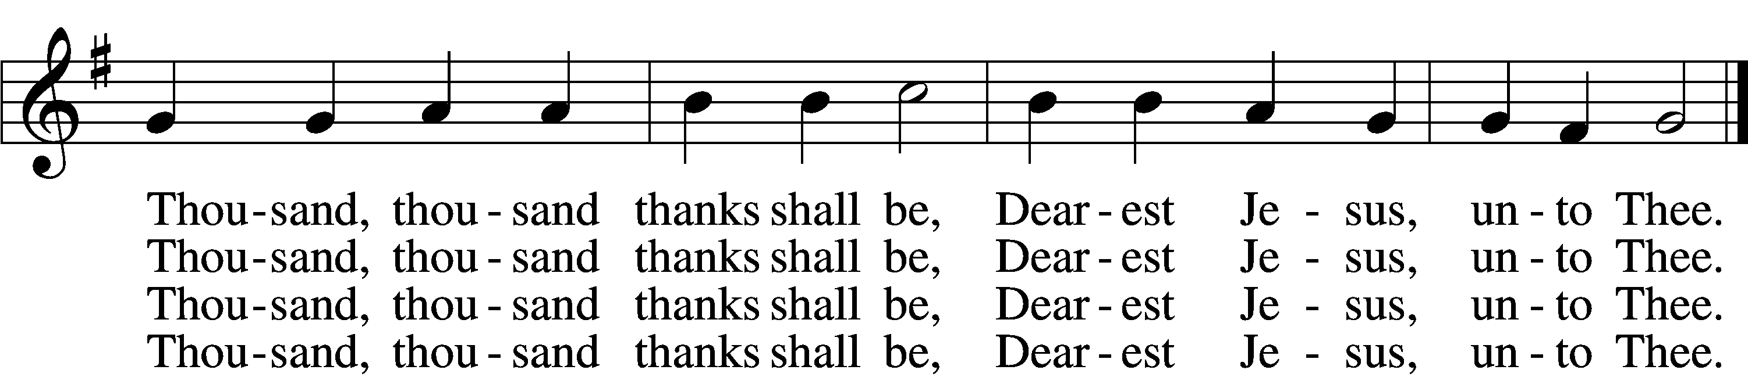

5 Thou hast suffered men to bruise Thee,
That from pain I might be free;
Falsely did Thy foes accuse Thee:
Thence I gain security;
Comfortless Thy soul did languish
Me to comfort in my anguish.
Thousand, thousand thanks shall be,
Dearest Jesus, unto Thee.

6 Thou hast suffered great affliction
And hast borne it patiently,
Even death by crucifixion,
Fully to atone for me;
Thou didst choose to be tormented
That my doom should be prevented.
Thousand, thousand thanks shall be,
Dearest Jesus, unto Thee.

7 Then, for all that wrought my pardon,
For Thy sorrows deep and sore,
For Thine anguish in the Garden,
I will thank Thee evermore,
Thank Thee for Thy groaning, sighing,
For Thy bleeding and Thy dying,
For that last triumphant cry,
And shall praise Thee, Lord, on high.
Text: Ernst Christoph Homburg, 1605–81; (sts. 1–2, 5, 7): tr. Catherine Winkworth, 1827–78, alt.; (sts. 3–4, 6): tr. Evangelical Lutheran Hymn-Book, 1912, St. Louis
Tune: Das grosse Cantional, 1687, Darmstadt
Text and tune: Public domain
Acknowledgments
Unless otherwise indicated, Scripture quotations are from the ESV® Bible (The Holy Bible, English Standard Version®), copyright © 2001 by Crossway, a publishing ministry of Good News Publishers. Used by permission. All rights reserved.
Created by Lutheran Service Builder © 2024 Concordia Publishing House.

