The Transfiguration of Our Lord
Prayer and Preaching
February 10 & 11, 2024
St. Paul Lutheran Church

873 Christ, Whose Glory Fills the Skies
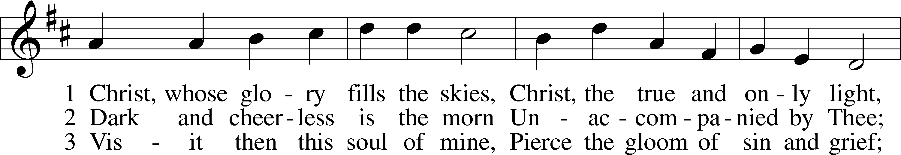
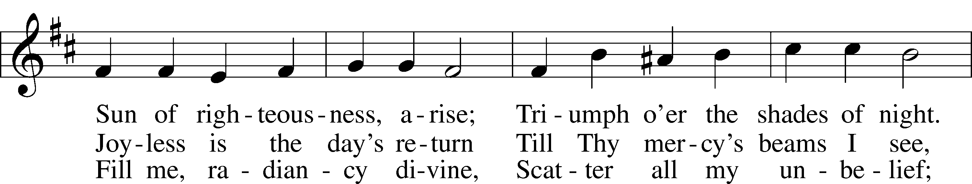
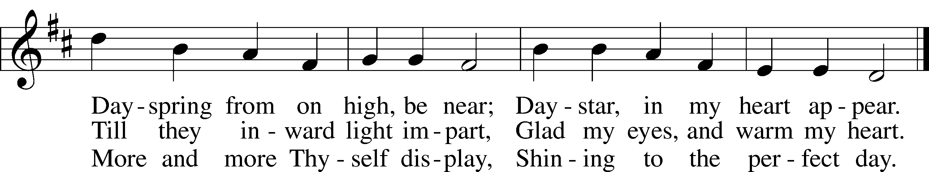
Text: Charles Wesley, 1707–88
Tune: attr. Johann G. Werner, 1777–1822
Text and tune: Public domain

Stand

Opening Versicles

Common LSB 260
L This is the day which the Lord has made;
C let us rejoice and be glad in it.
L From the rising of the sun to its setting,
C the name of the Lord is to be praised.

L Better is one day in Your courts than a thousand elsewhere;
C I would rather be a doorkeeper in the house of my God than dwell in the tents of the wicked.
L Make me to know Your ways, O Lord.
C Teach me Your paths.
L Sanctify us in Your truth.
C Your Word is truth.

L From the rising of the sun to its setting,
C the name of the Lord is to be praised.

C Glory be to the Father and to the Son and to the Holy Spirit;
as it was in the beginning, is now, and will be forever. Amen.

Old Testament Canticle LSB 261
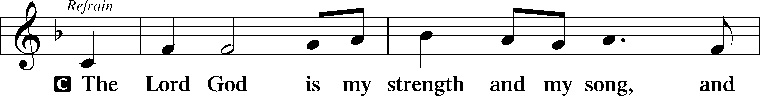
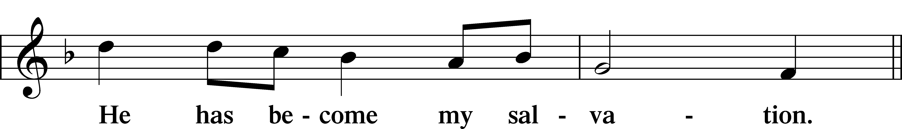
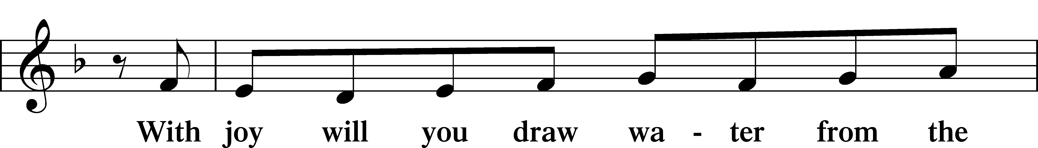
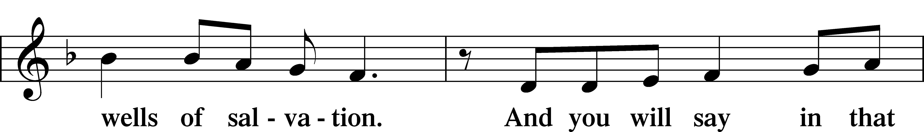
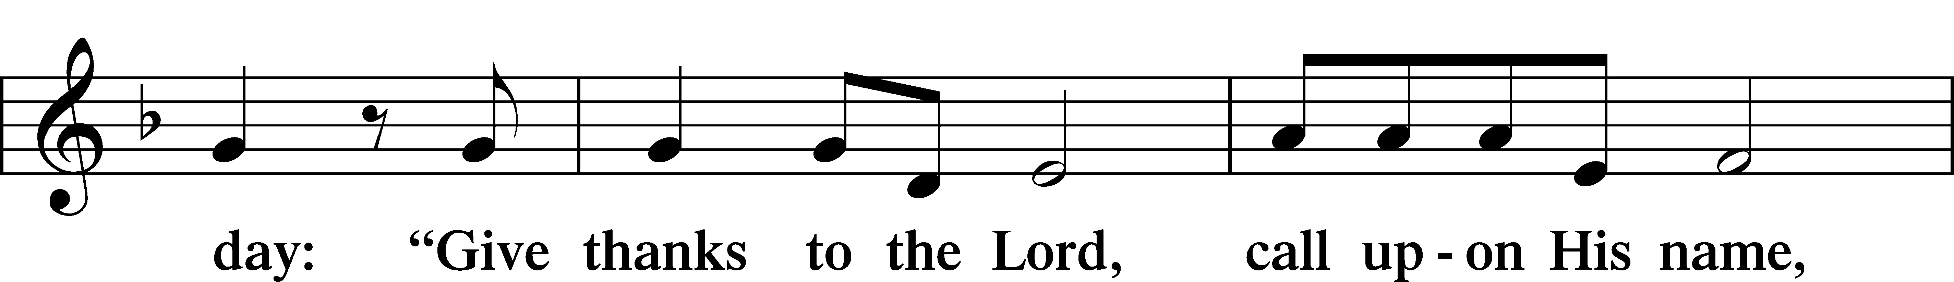
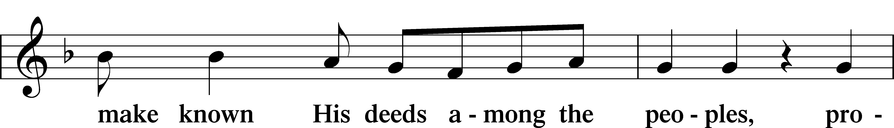
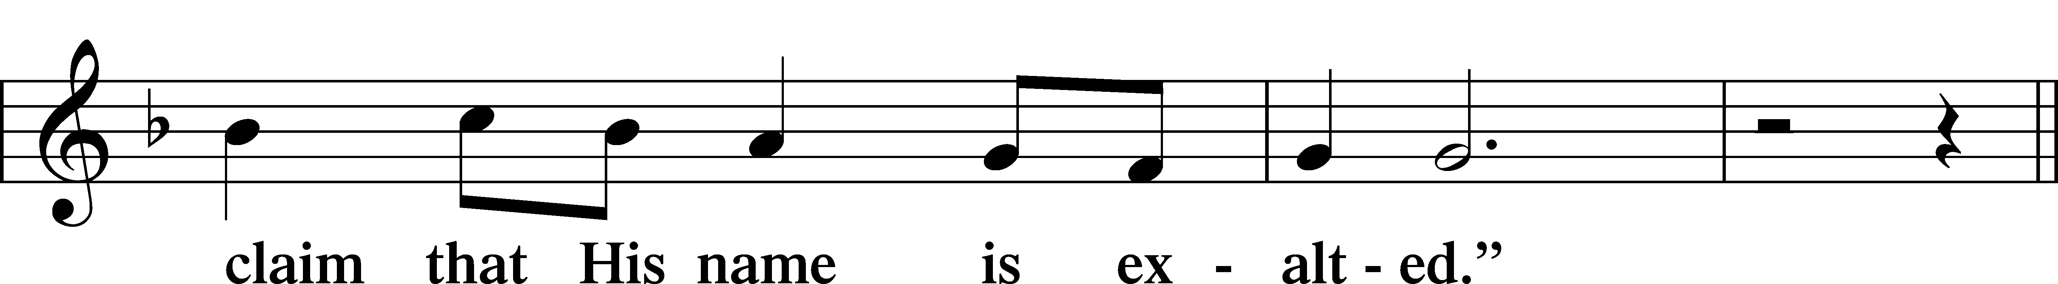
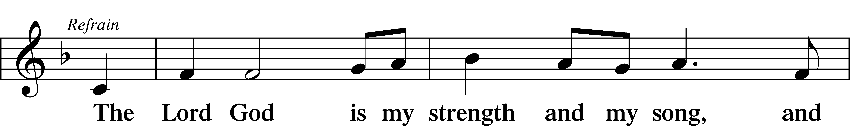
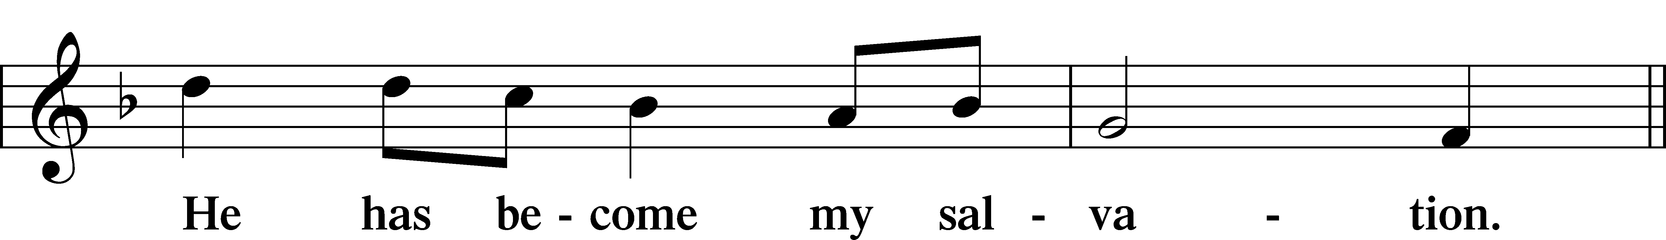
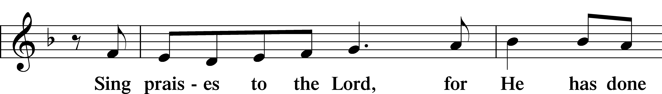
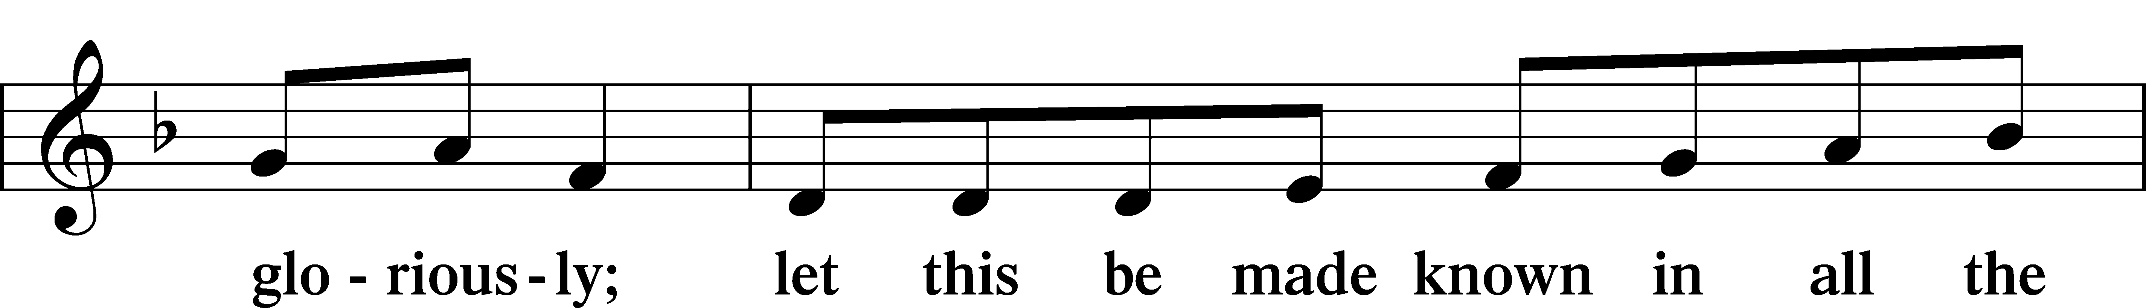
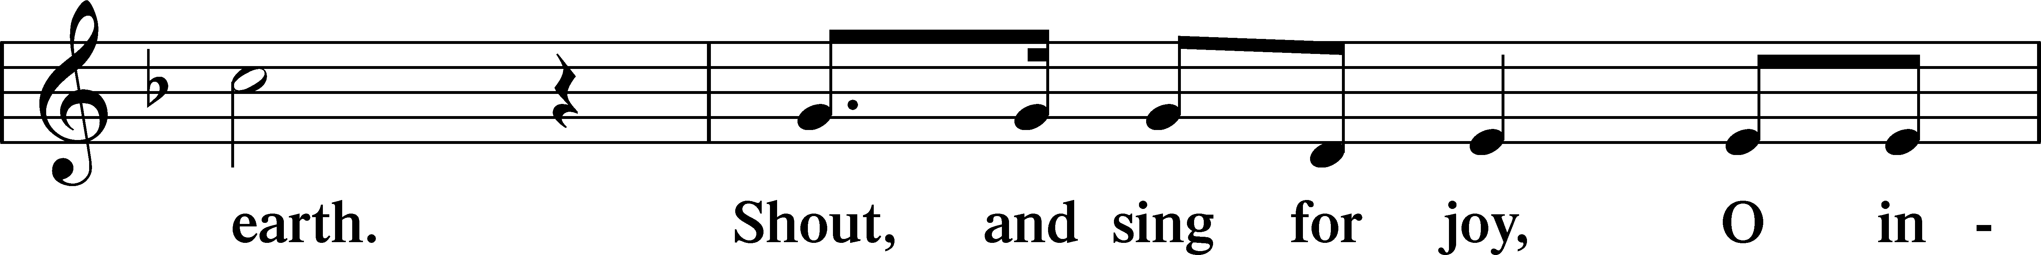
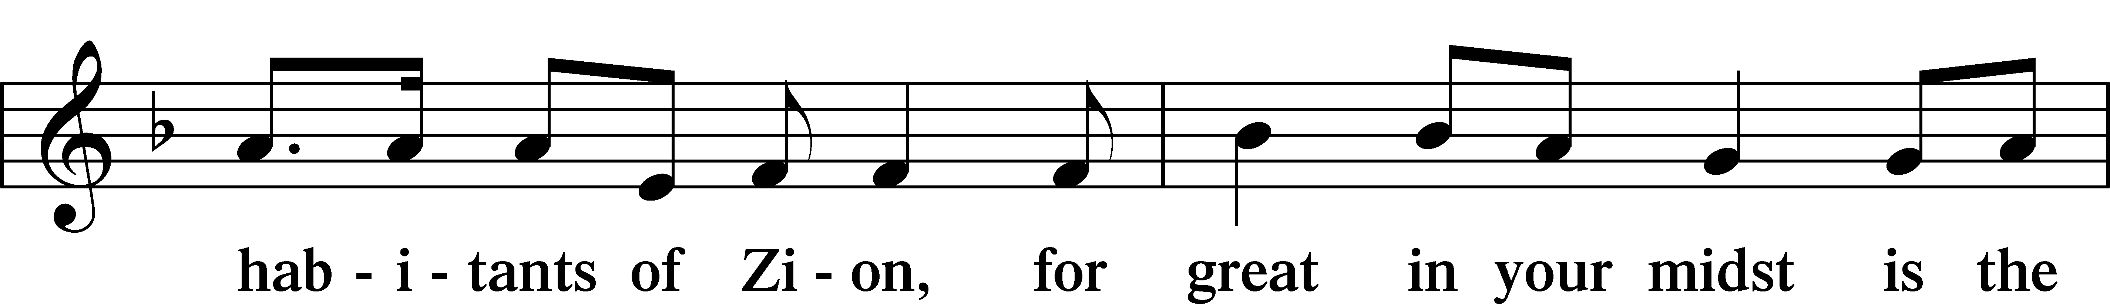
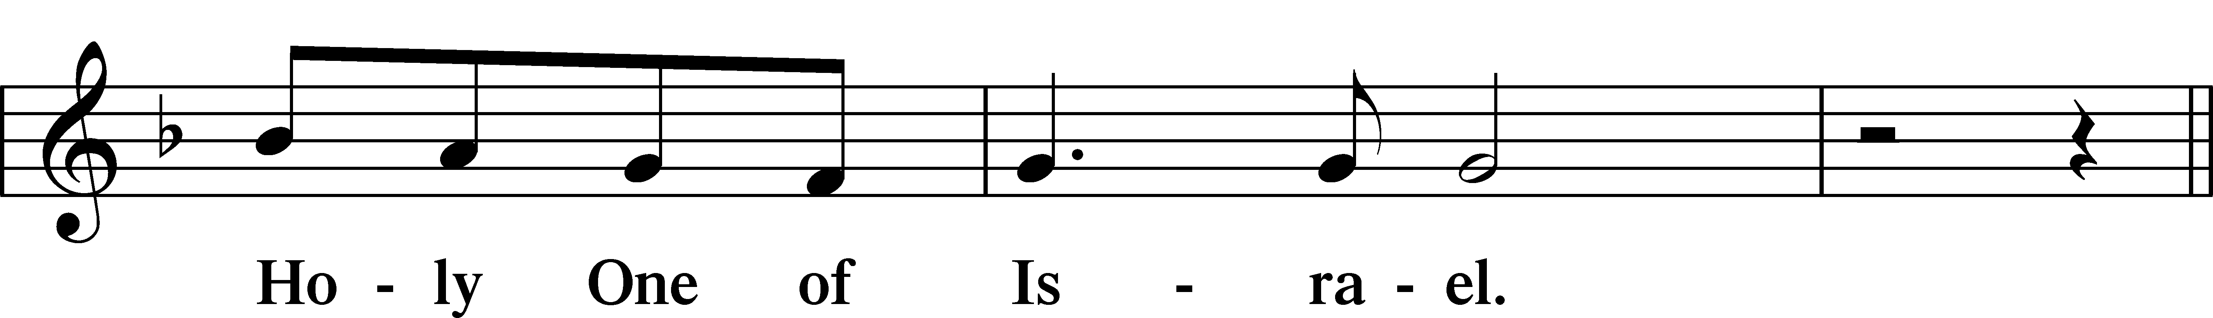
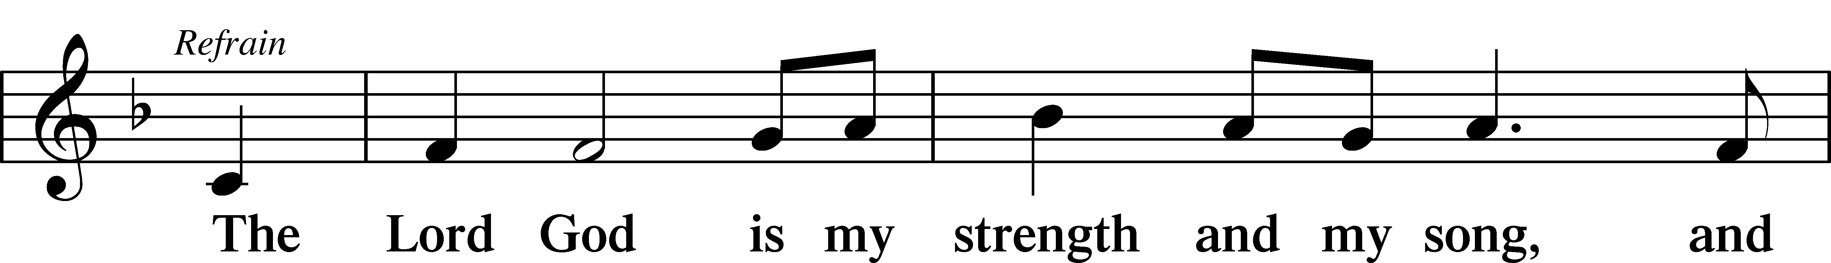
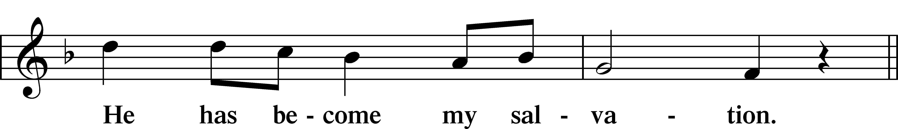
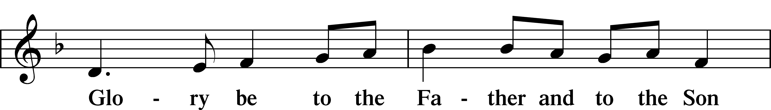
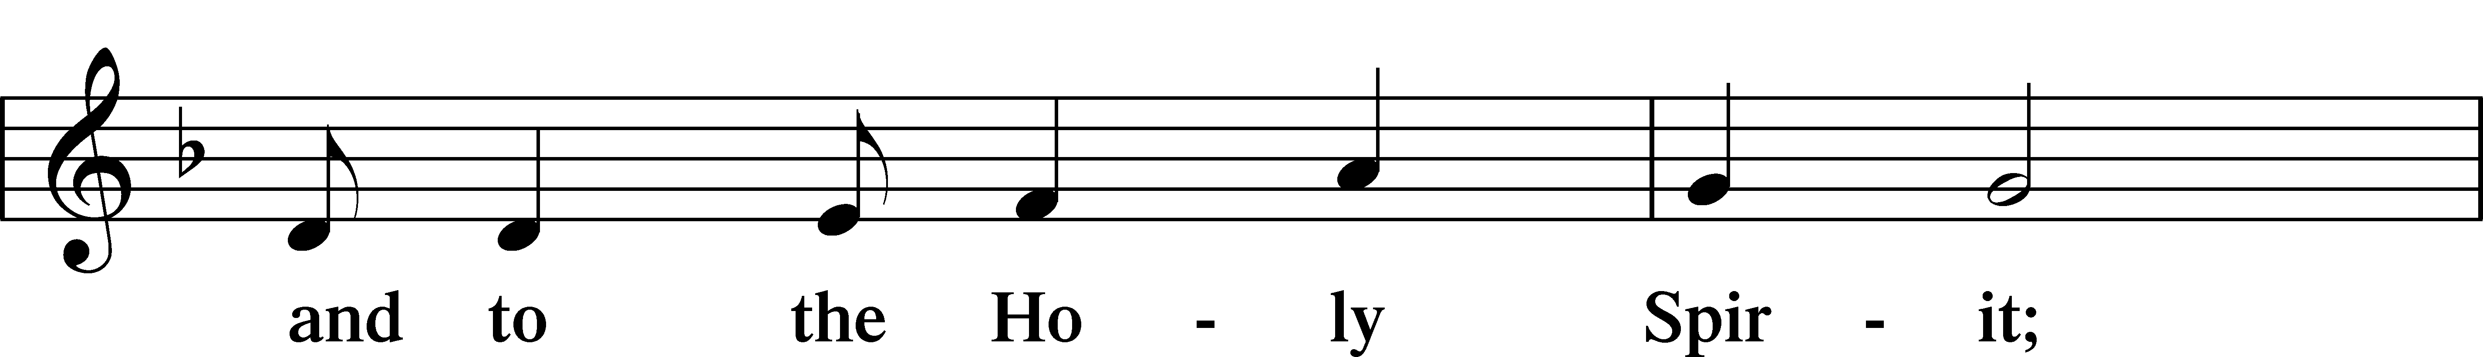
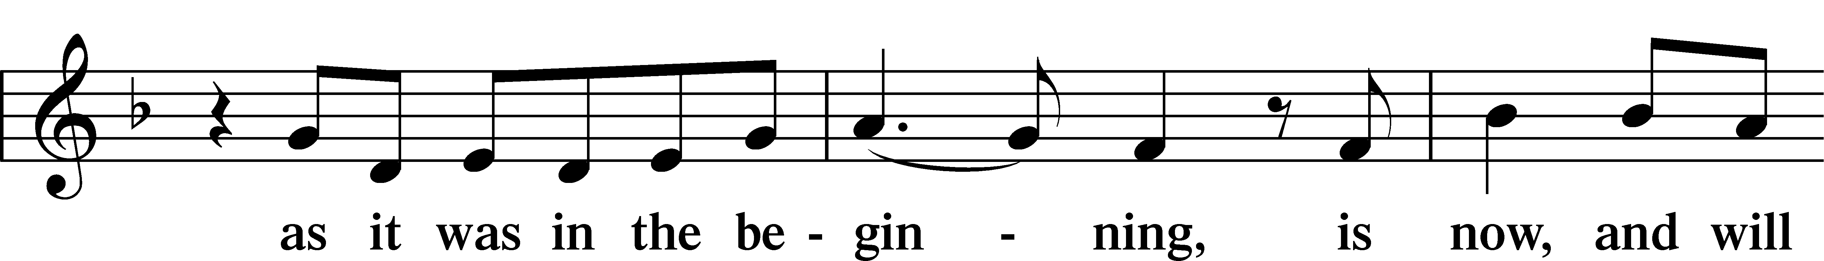
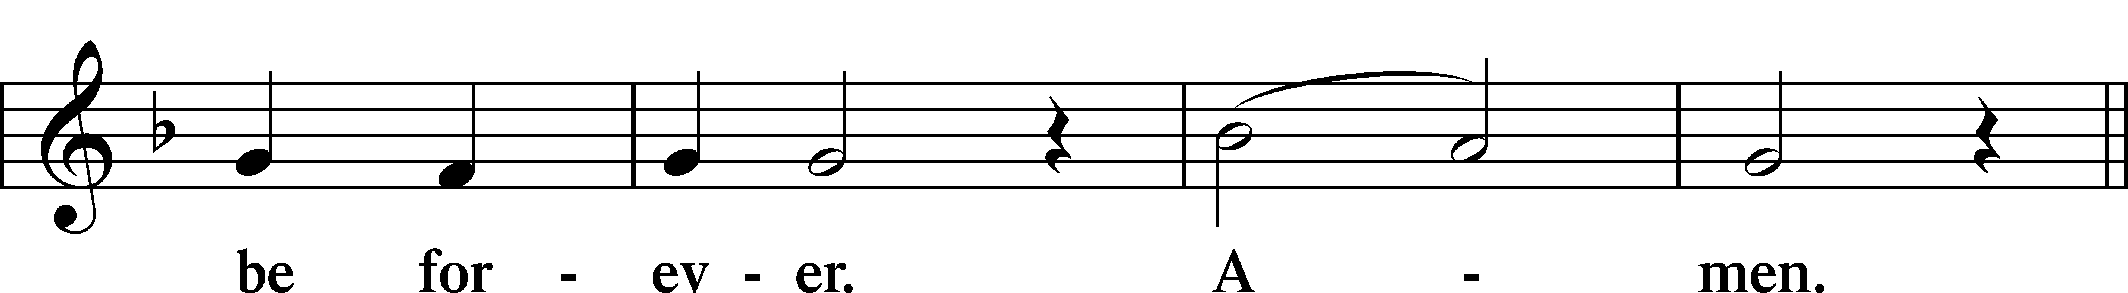
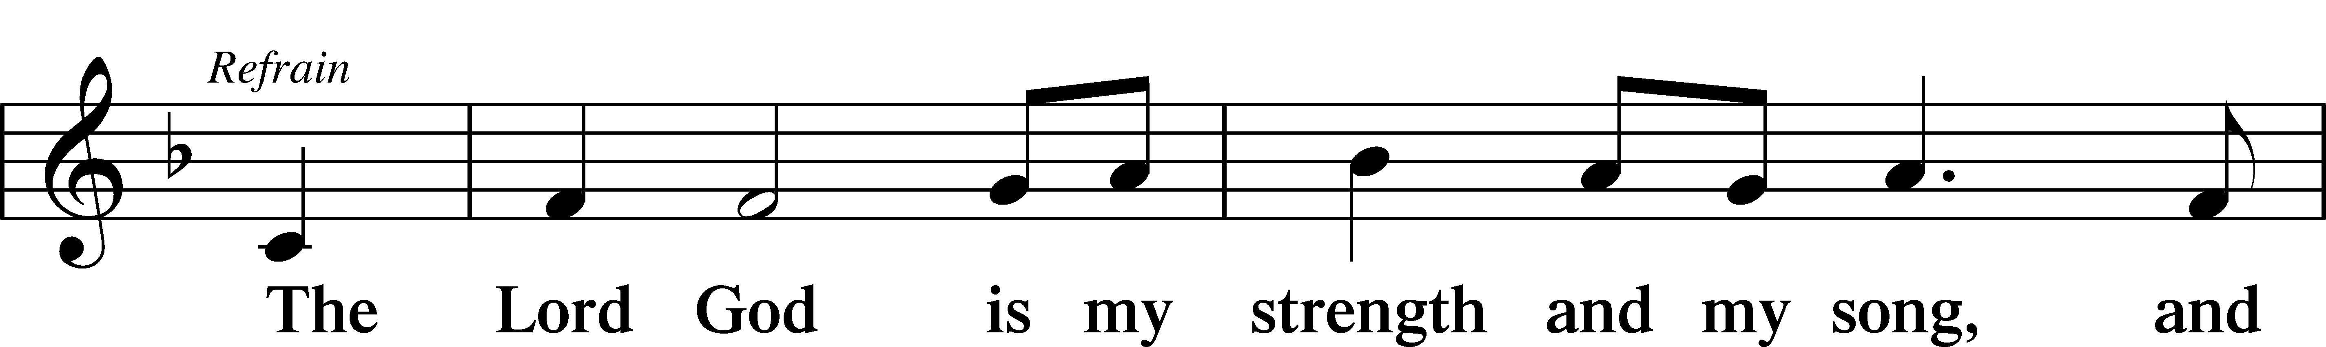
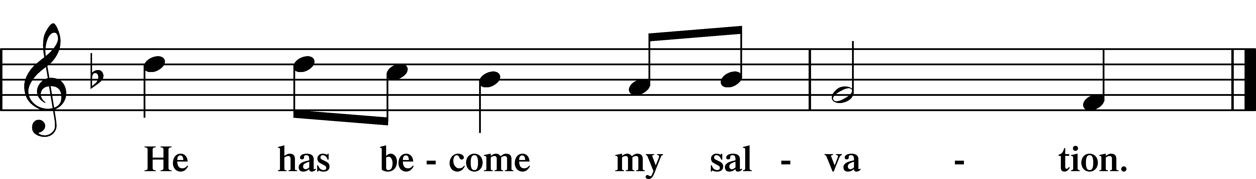

Sit

Readings From Holy Scripture

Reading Exodus 34:29–35
L A reading from Exodus, the thirty-fourth chapter.

29When Moses came down from Mount Sinai, with the two tablets of the testimony in his hand as he came down from the mountain, Moses did not know that the skin of his face shone because he had been talking with God. 30Aaron and all the people of Israel saw Moses, and behold, the skin of his face shone, and they were afraid to come near him. 31But Moses called to them, and Aaron and all the leaders of the congregation returned to him, and Moses talked with them. 32Afterward all the people of Israel came near, and he commanded them all that the Lord had spoken with him in Mount Sinai. 33And when Moses had finished speaking with them, he put a veil over his face.
34Whenever Moses went in before the Lord to speak with him, he would remove the veil, until he came out. And when he came out and told the people of Israel what he was commanded, 35the people of Israel would see the face of Moses, that the skin of Moses’ face was shining. And Moses would put the veil over his face again, until he went in to speak with him.

L This is the Word of the Lord.
C Thanks be to God.

Reading 2 Corinthians 3:12–18; 4:1–6
12Since we have such a hope, we are very bold, 13not like Moses, who would put a veil over his face so that the Israelites might not gaze at the outcome of what was being brought to an end. 14But their minds were hardened. For to this day, when they read the old covenant, that same veil remains unlifted, because only through Christ is it taken away. 15Yes, to this day whenever Moses is read a veil lies over their hearts. 16But when one turns to the Lord, the veil is removed. 17Now the Lord is the Spirit, and where the Spirit of the Lord is, there is freedom. 18And we all, with unveiled face, beholding the glory of the Lord, are being transformed into the same image from one degree of glory to another. For this comes from the Lord who is the Spirit.
1Therefore, having this ministry by the mercy of God, we do not lose heart. 2But we have renounced disgraceful, underhanded ways. We refuse to practice cunning or to tamper with God’s word, but by the open statement of the truth we would commend ourselves to everyone’s conscience in the sight of God. 3And even if our gospel is veiled, it is veiled only to those who are perishing. 4In their case the god of this world has blinded the minds of the unbelievers, to keep them from seeing the light of the gospel of the glory of Christ, who is the image of God. 5For what we proclaim is not ourselves, but Jesus Christ as Lord, with ourselves as your servants for Jesus’ sake. 6For God, who said, “Let light shine out of darkness,” has shone in our hearts to give the light of the knowledge of the glory of God in the face of Jesus Christ.
L This is the Word of the Lord.
C Thanks be to God.

Reading Mark 9:2–9
2After six days Jesus took with him Peter and James and John, and led them up a high mountain by themselves. And he was transfigured before them, 3and his clothes became radiant, intensely white, as no one on earth could bleach them. 4And there appeared to them Elijah with Moses, and they were talking with Jesus. 5And Peter said to Jesus, “Rabbi, it is good that we are here. Let us make three tents, one for you and one for Moses and one for Elijah.” 6For he did not know what to say, for they were terrified. 7And a cloud overshadowed them, and a voice came out of the cloud, “This is my beloved Son; listen to him.” 8And suddenly, looking around, they no longer saw anyone with them but Jesus only.
9And as they were coming down the mountain, he charged them to tell no one what they had seen, until the Son of Man had risen from the dead.
L This is the Word of the Lord.
C Thanks be to God.

Responsory

Common LSB 263
L Forever, O Lord, Your Word is firmly set in the heavens.
C Lord, I love the habitation of Your house and the place where Your glory dwells.
L Blessed are those who hear the Word of God and keep it.
C Lord, I love the habitation of Your house and the place where Your glory dwells.
L Glory be to the Father and to the Son and to the Holy Spirit.
C Lord, I love the habitation of Your house and the place where Your glory dwells.

Stand

Ten Commandments
C You shall have no other gods.
You shall not misuse the name of the Lord your God.
Remember the Sabbath day by keeping it holy.
Honor your father and your mother.
You shall not murder.
You shall not commit adultery.
You shall not steal.
You shall not give false testimony against your neighbor.
You shall not covet your neighbor’s house.
You shall not covet your neighbor’s wife, or his manservant or maidservant, his ox or donkey, or anything that belongs to your neighbor.

Apostles’ Creed
C I believe in God, the Father Almighty,
maker of heaven and earth.

And in Jesus Christ, His only Son, our Lord,
who was conceived by the Holy Spirit,
born of the virgin Mary,
suffered under Pontius Pilate,
was crucified, died and was buried.
He descended into hell.
The third day He rose again from the dead.
He ascended into heaven
and sits at the right hand of God the Father Almighty.
From thence He will come to judge the living and the dead.

I believe in the Holy Spirit,
the holy Christian Church,
the communion of saints,
the forgiveness of sins,
the resurrection of the body,
and the life T everlasting. Amen.

Lord’s Prayer
C Our Father who art in heaven,
hallowed be Thy name,
Thy kingdom come,
Thy will be done on earth
as it is in heaven;
give us this day our daily bread;
and forgive us our trespasses
as we forgive those
who trespass against us;
and lead us not into temptation,
but deliver us from evil.
For Thine is the kingdom
and the power and the glory
forever and ever. Amen.

Sit
414 ’Tis Good, Lord, to Be Here
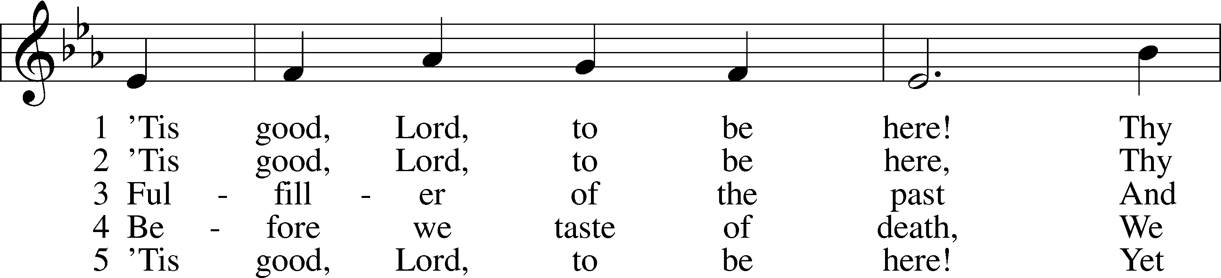
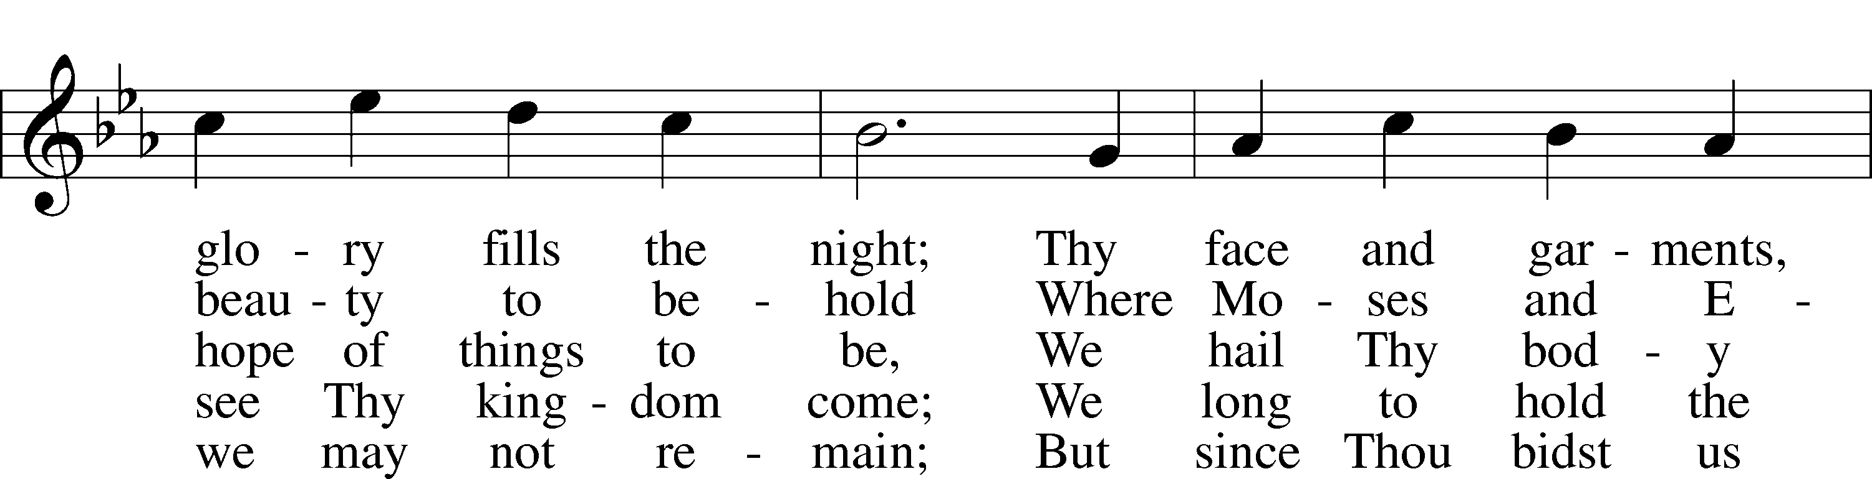
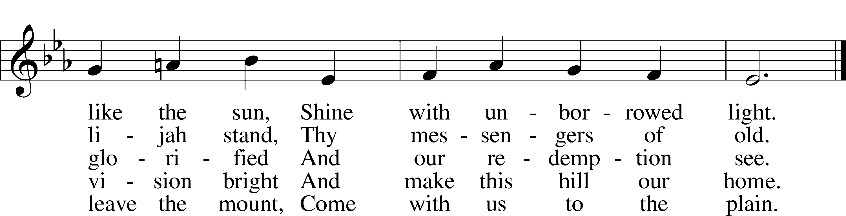
Text: Joseph A. Robinson, 1858–1933, alt.
Tune: Johann Sebastian Bach, 1685–1750, adapt.
Text and tune: Public domain

Children’s Message
Sermon

Offering

Stand

Prayer
L In peace let us pray to the Lord:
C Lord, have mercy.
L For the gift of divine peace and of pardon, with all our heart and with all our mind, let us pray to the Lord:
C Lord, have mercy.
L For the holy Christian Church, here and scattered throughout the world, and for the proclamation of the Gospel and the calling of all to faith, let us pray to the Lord:
C Lord, have mercy.
L For this nation, for our cities and communities, and for the common welfare of us all, let us pray to the Lord:
C Lord, have mercy.
L For seasonable weather and for the fruitfulness of the earth, let us pray to the Lord:
C Lord, have mercy.
L For those who labor, for those whose work is difficult or dangerous, and for all who travel, let us pray to the Lord:
C Lord, have mercy.
L For all those in need, for the hungry and homeless, for the widowed and orphaned, and for all those in prison, let us pray to the Lord:
C Lord, have mercy.
L For the sick and dying and for all those who care for them, let us pray to the Lord:
C Lord, have mercy.
L For . . . [________] . . . let us pray to the Lord:
C Lord, have mercy.
L Finally, for these and for all our needs of body and soul, let us pray to the Lord:
C Lord, have mercy. Christ, have mercy. Lord, have mercy.

Collect of the Day
L O God, in the glorious transfiguration of Your beloved Son You confirmed the mysteries of the faith by the testimony of Moses and Elijah. In the voice that came from the bright cloud You wonderfully foreshowed our adoption by grace. Mercifully make us co-heirs with the King in His glory and bring us to the fullness of our inheritance in heaven; through the same Jesus Christ, our Lord, who lives and reigns with You and the Holy Spirit, one God, now and forever.
C Amen.

Collect for the Word
L Blessed Lord, You have caused all Holy Scriptures to be written for our learning. Grant that we may so hear them, read, mark, learn, and take them to heart that, by the patience and comfort of Your holy Word, we may embrace and ever hold fast the blessed hope of everlasting life; through Jesus Christ, Your Son, our Lord, who lives and reigns with You and the Holy Spirit, one God, now and forever.
C Amen.

Morning Prayer
C I thank You, my heavenly Father, through Jesus Christ, Your dear Son, that You have kept me this night from all harm and danger; and I pray that You would keep me this day also from sin and every evil, that all my doings and life may please You. For into Your hands I commend myself, my body and soul, and all things. Let Your holy angel be with me, that the evil foe may have no power over me.

Evening Prayer
C I thank You, my heavenly Father, through Jesus Christ, Your dear Son, that You have graciously kept me this day; and I pray that You would forgive me all my sins where I have done wrong, and graciously keep me this night. For into Your hands I commend myself, my body and soul, and all things. Let Your holy angel be with me, that the evil foe may have no power over me.
New Testament Canticle LSB 266
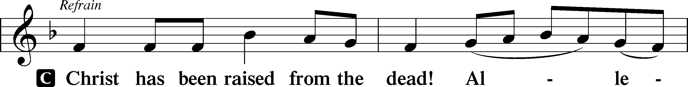
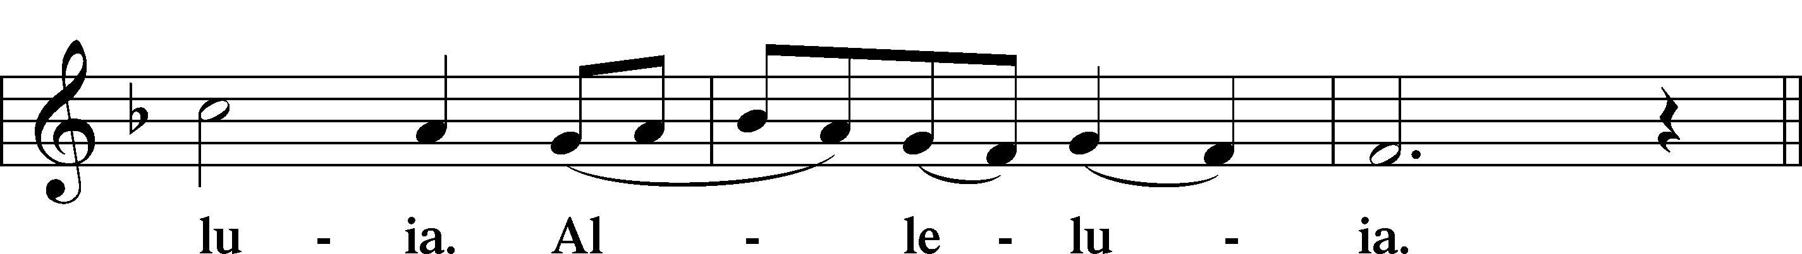
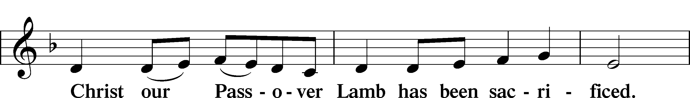
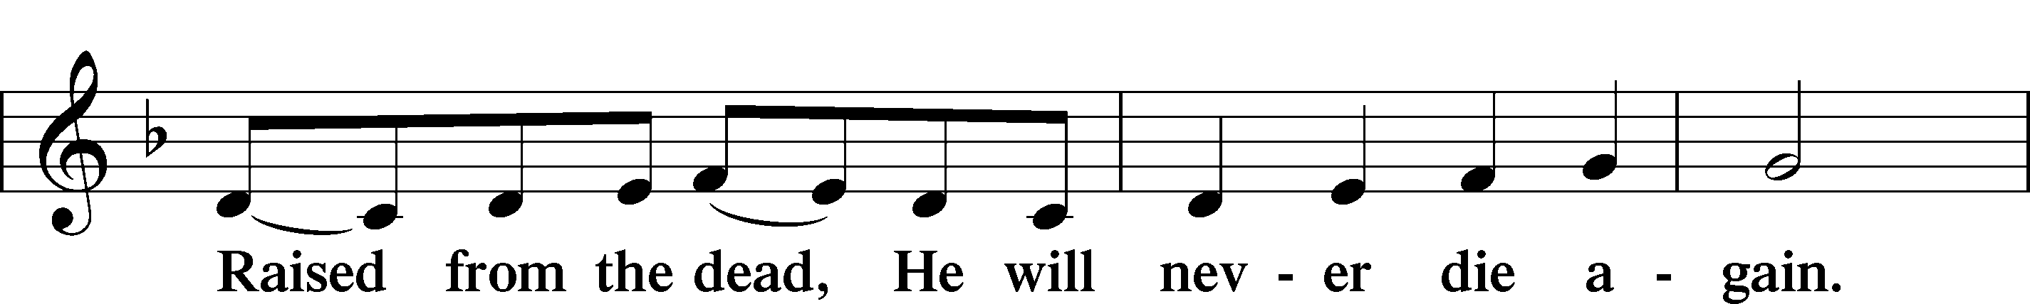
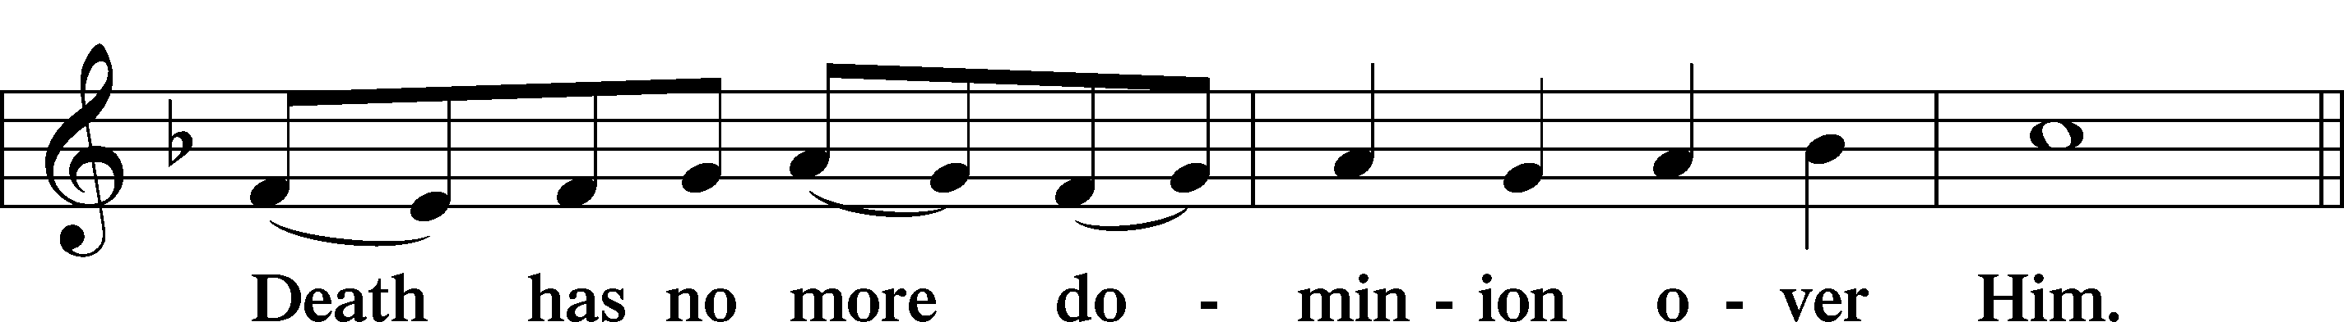
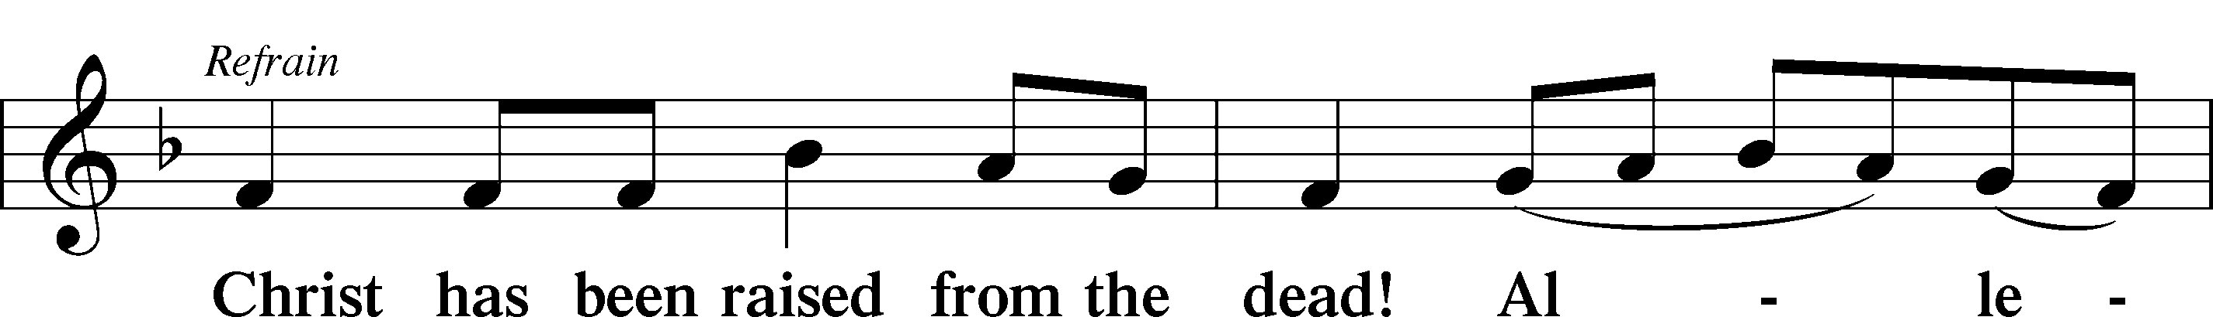
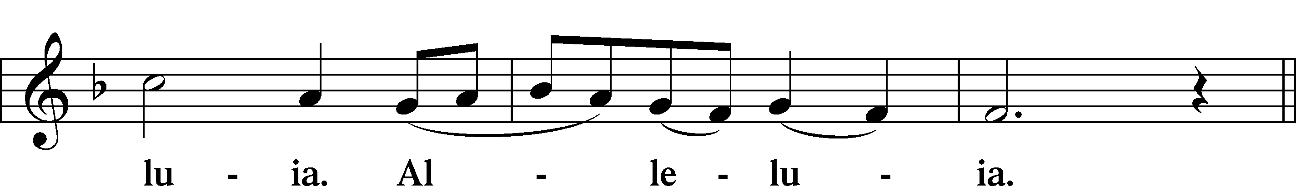
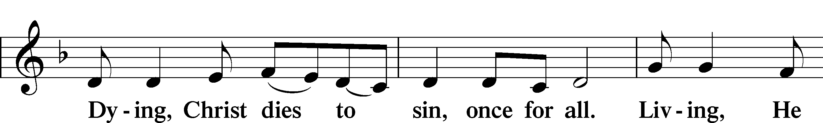
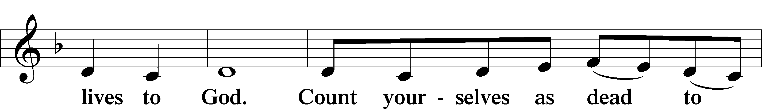
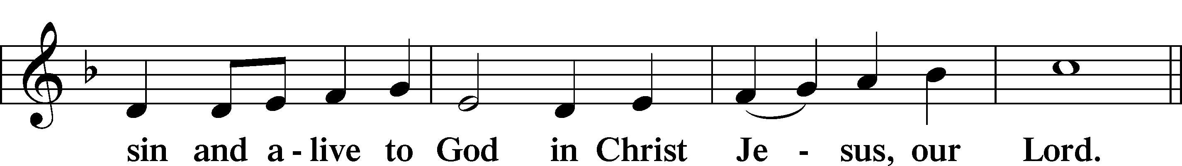
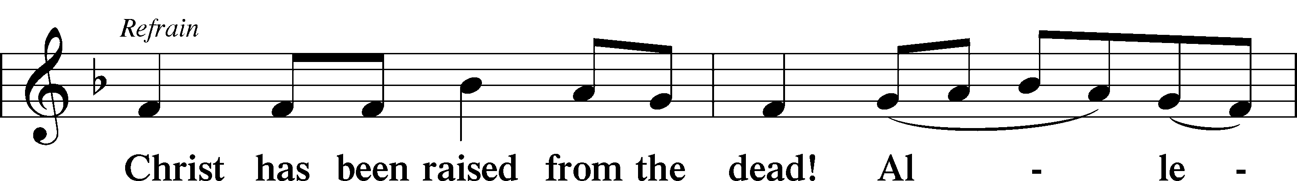
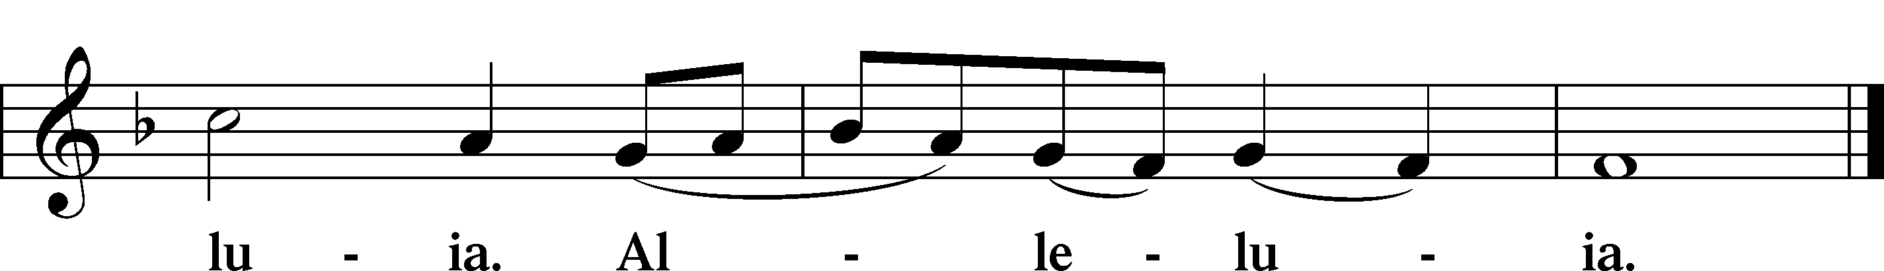

Blessing

Benedicamus LSB 267
L Let us bless the Lord.
C Thanks be to God.

Benediction LSB 267
L The almighty and merciful Lord, the Father, the T Son, and the Holy Spirit, bless and preserve us.
C Amen.

537 Beautiful Savior
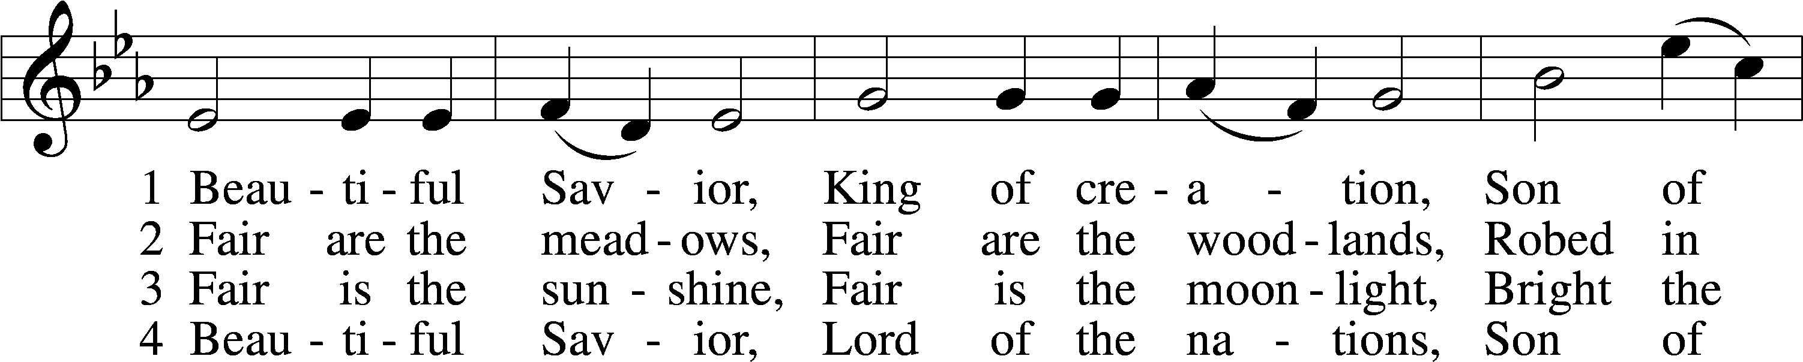
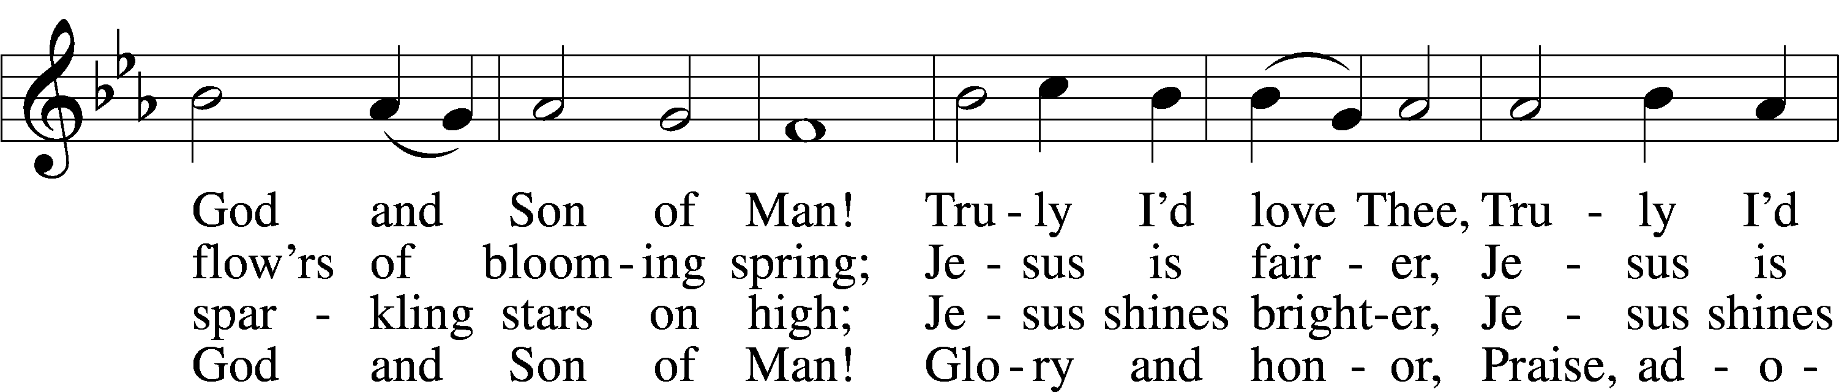
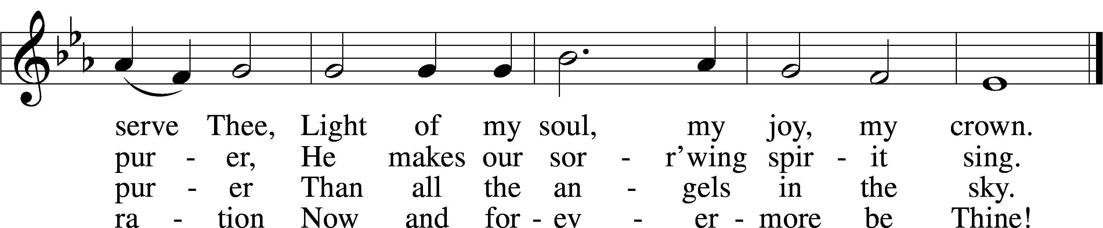
Text: Münsterisch Gesangbuch, 1677, Münster; tr. Joseph A. Seiss, 1823–1904
Tune: Silesian, 19th cent.
Text and tune: Public domain

Acknowledgments
Unless otherwise indicated, Scripture quotations are from the ESV® Bible (The Holy Bible, English Standard Version®), copyright © 2001 by Crossway, a publishing ministry of Good News Publishers. Used by permission. All rights reserved.
Created by Lutheran Service Builder © 2024 Concordia Publishing House.

