Second Sunday after Epiphany
Divine Service 3
January 13 & 14, 2024
St. Paul Lutheran Church
Confession and Absolution

807 When Morning Gilds the Skies
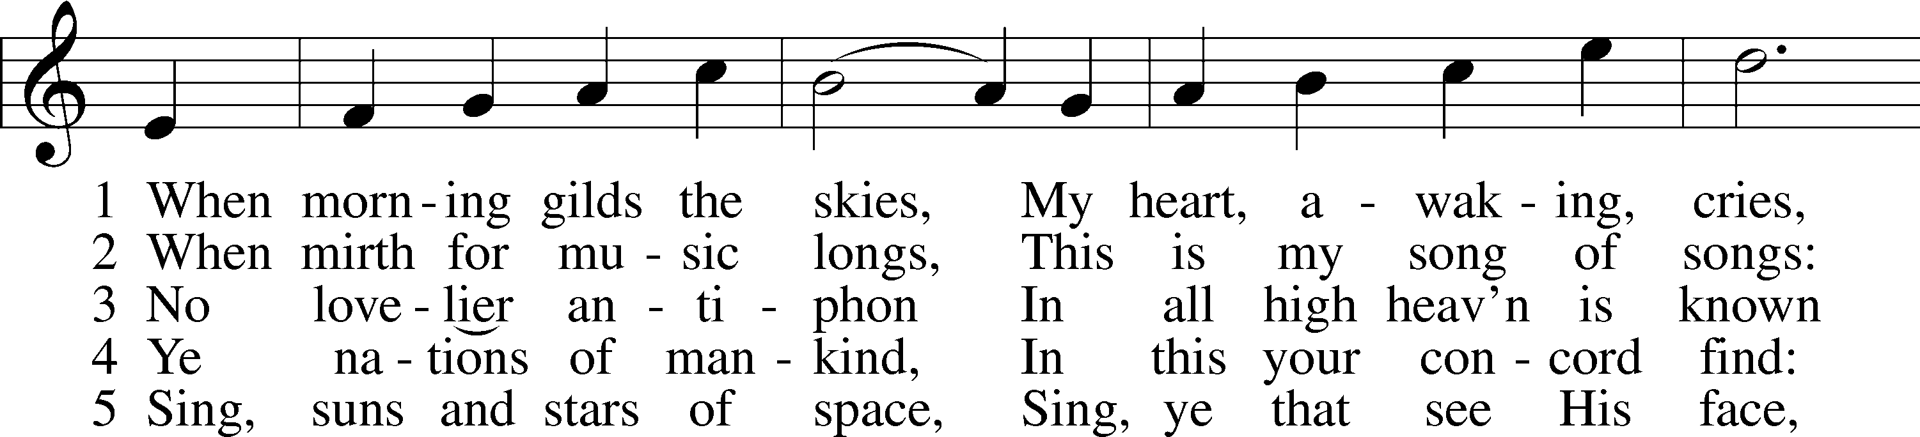
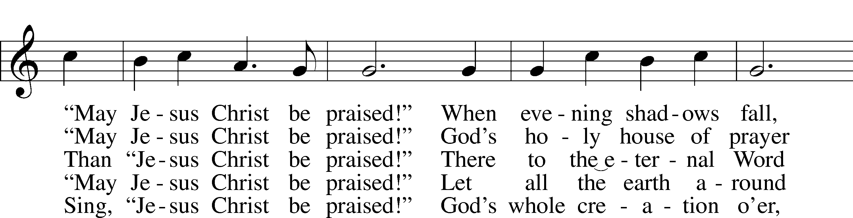
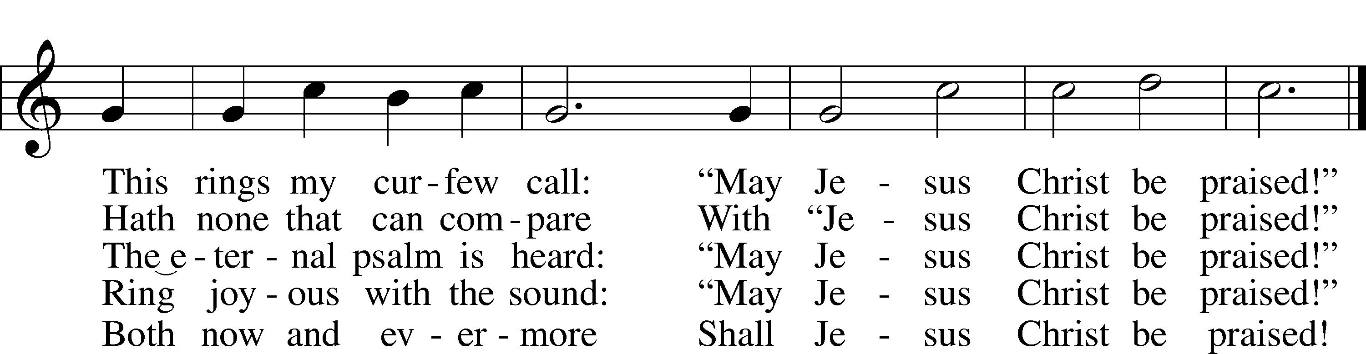
Text: Katholisches Gesangbuch, 1828, Würzburg; tr. Robert S. Bridges, 1844–1930, alt.
Tune: Joseph Barnby, 1838–96
Text and tune: Public domain

Stand

The sign of the cross may be made by all in remembrance of their Baptism.

Invocation
P In the name of the Father and of the T Son and of the Holy Spirit.
C Amen.

Exhortation LSB 184
P Beloved in the Lord! Let us draw near with a true heart and confess our sins unto God our Father, beseeching Him in the name of our Lord Jesus Christ to grant us forgiveness.

P Our help is in the name of the Lord,
C who made heaven and earth.
P I said, I will confess my transgressions unto the Lord,
C and You forgave the iniquity of my sin.

Kneel/Stand

Silence for reflection on God’s Word and for self-examination.

Confession of Sins LSB 184
P O almighty God, merciful Father,
C I, a poor, miserable sinner, confess unto You all my sins and iniquities with which I have ever offended You and justly deserved Your temporal and eternal punishment. But I am heartily sorry for them and sincerely repent of them, and I pray You of Your boundless mercy and for the sake of the holy, innocent, bitter sufferings and death of Your beloved Son, Jesus Christ, to be gracious and merciful to me, a poor, sinful being.

Absolution LSB 185
P Upon this your confession, I, by virtue of my office, as a called and ordained servant of the Word, announce the grace of God unto all of you, and in the stead and by the command of my Lord Jesus Christ I forgive you all your sins in the name of the Father and of the T Son and of the Holy Spirit.
C Amen.

Stand

Service of the Word

PSALM Psalm 139:1–10
1O Lord, you have searched me and known me!
2You know when I sit down and when I rise up;
you discern my thoughts from afar.
3You search out my path and my lying down
and are acquainted with all my ways.
4Even before a word is on my tongue,
behold, O Lord, you know it altogether.
5You hem me in, behind and before,
and lay your hand upon me.
6Such knowledge is too wonderful for me;
it is high; I cannot attain it.
7Where shall I go from your Spirit?
Or where shall I flee from your presence?
8If I ascend to heaven, you are there!
If I make my bed in Sheol, you are there!
9If I take the wings of the morning
and dwell in the uttermost parts of the sea,
10even there your hand shall lead me,
and your right hand shall hold me.

Gloria Patri LSB 186
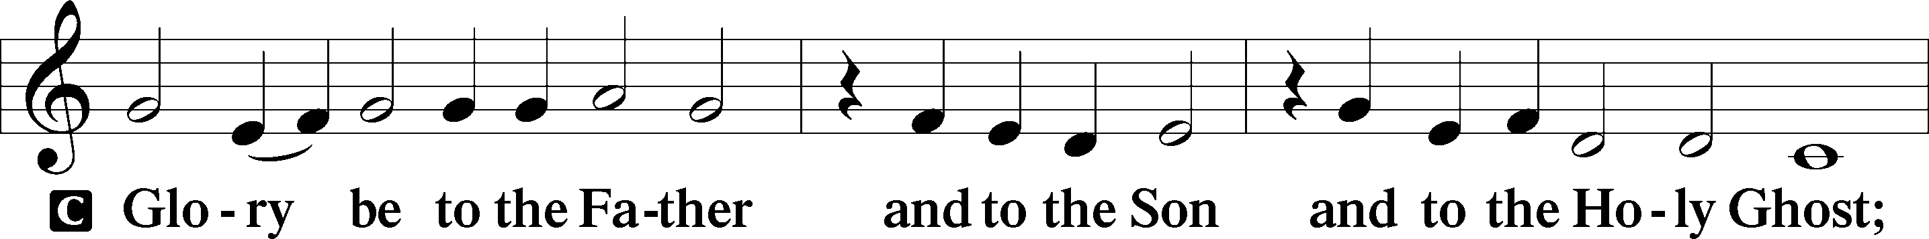
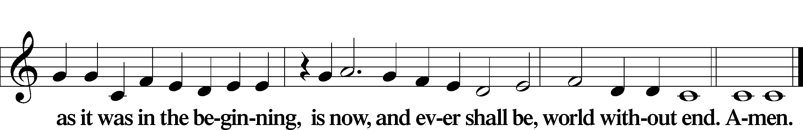

Kyrie LSB 186
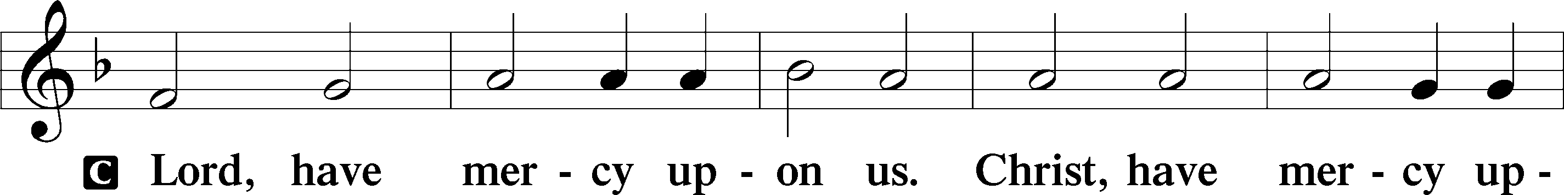
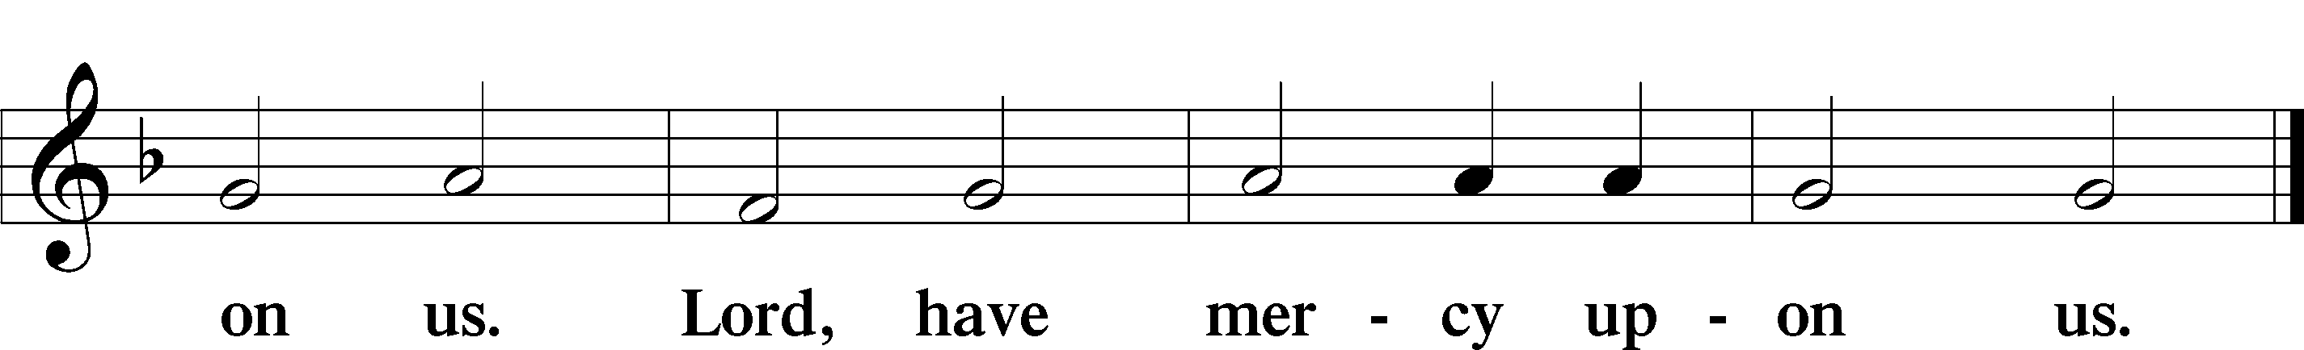

Gloria in Excelsis LSB 187
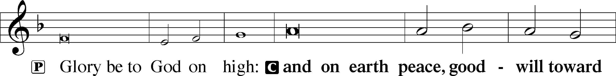
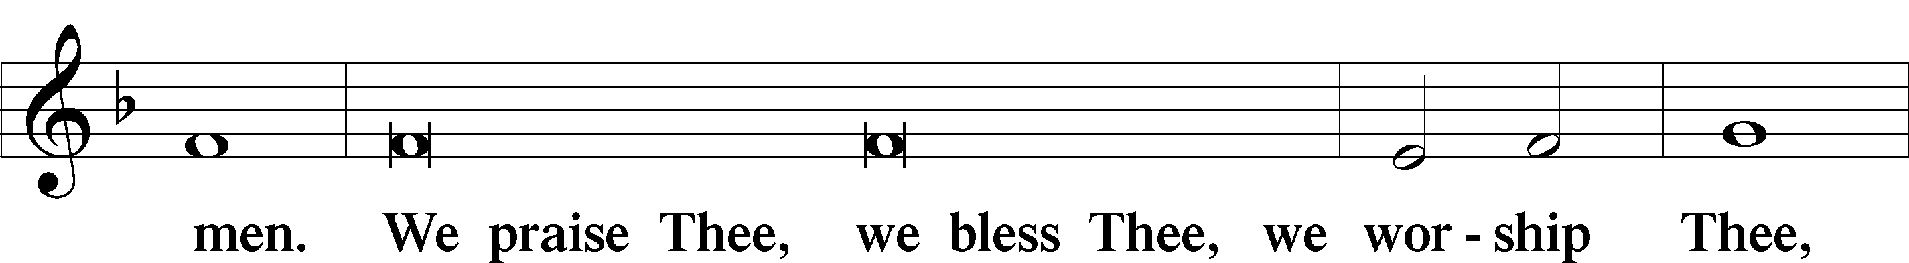
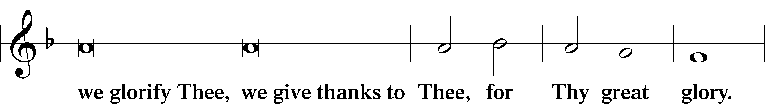
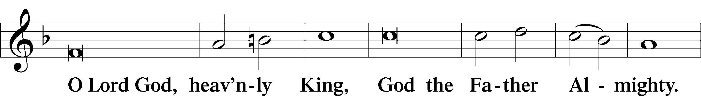
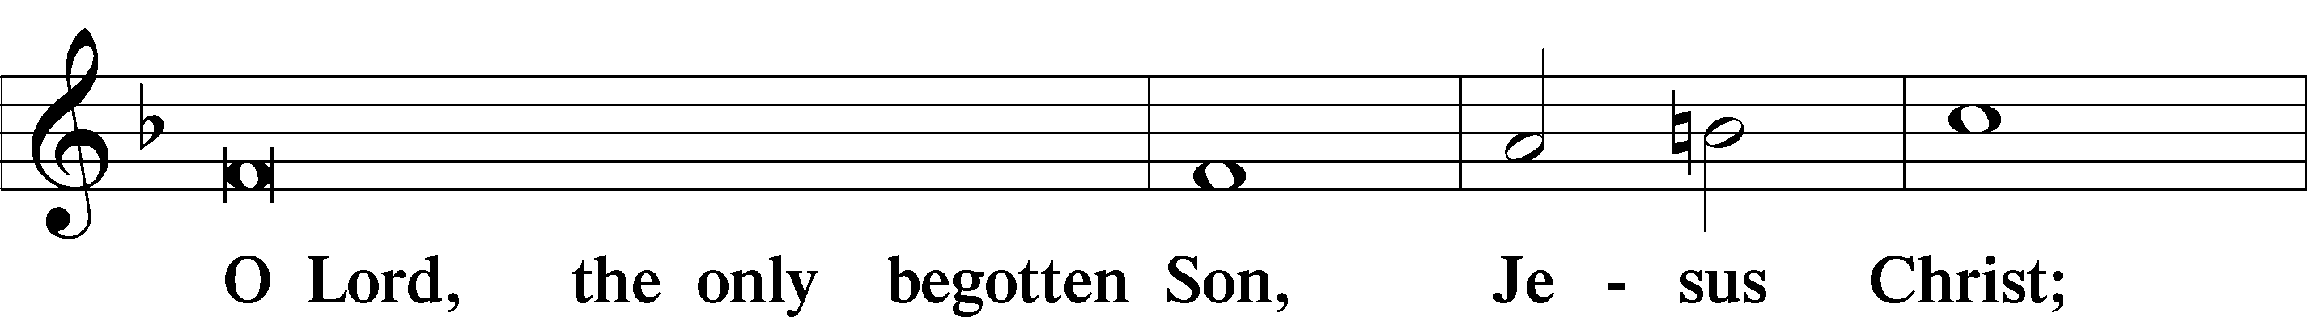
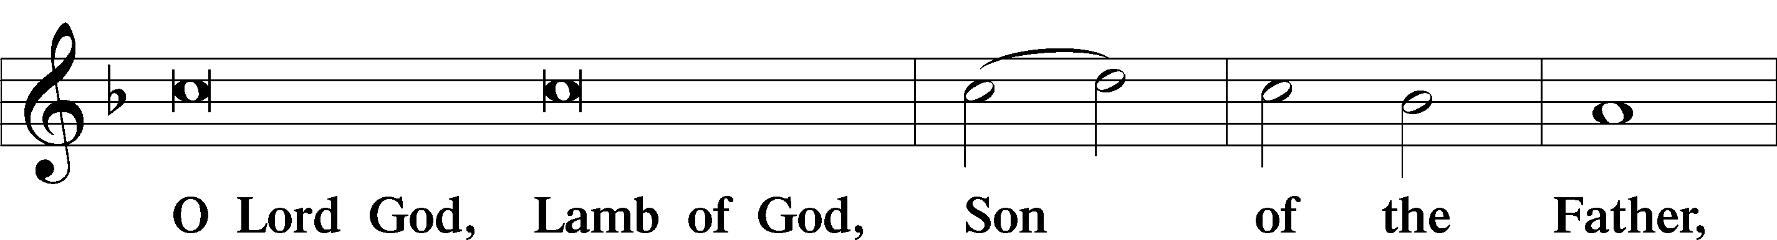
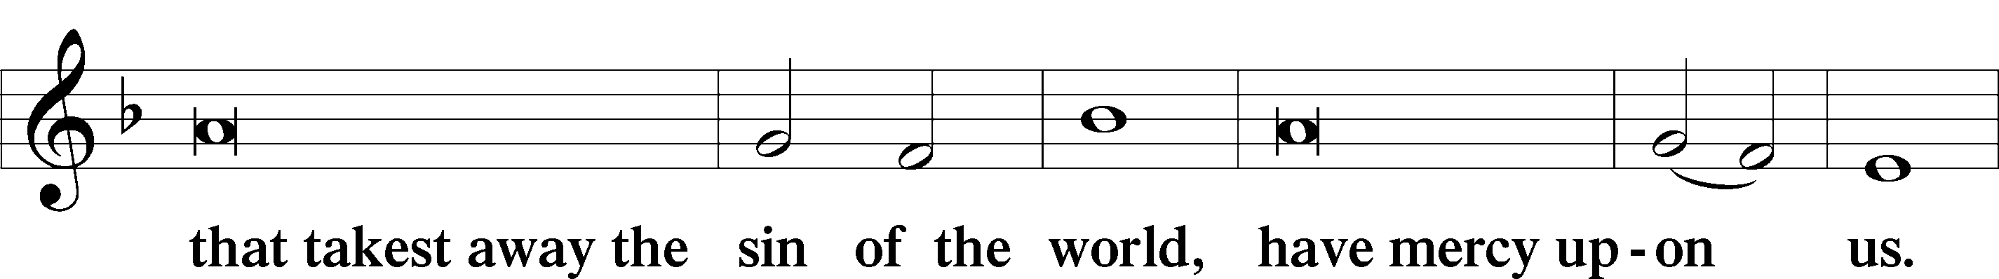
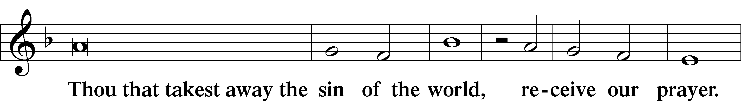
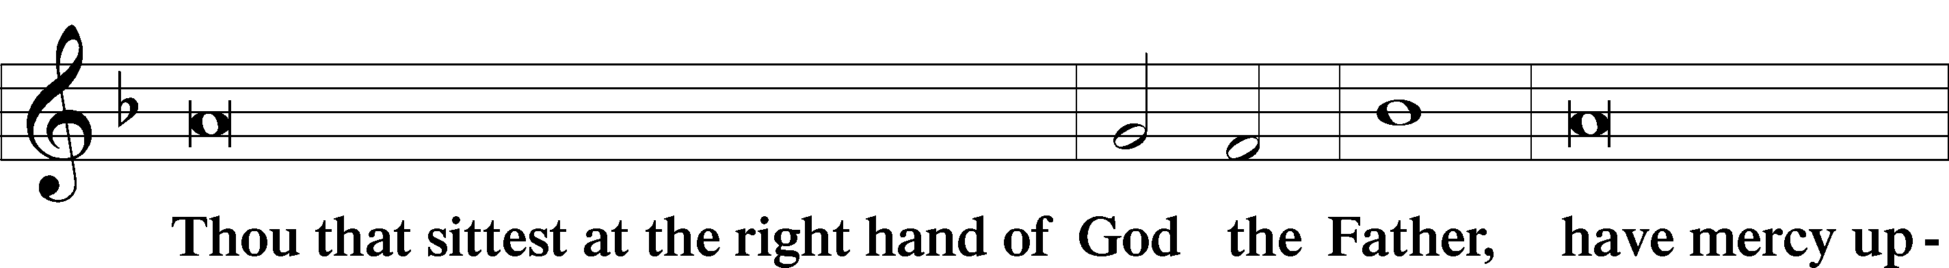
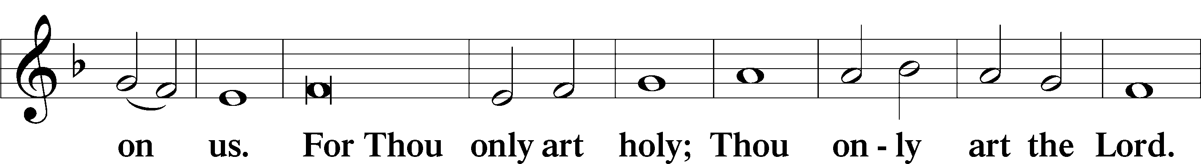
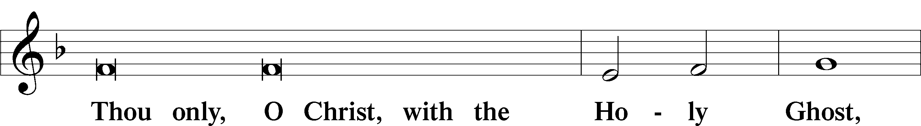
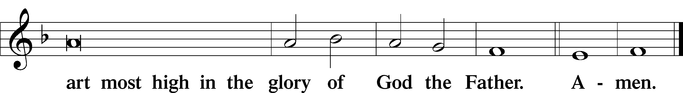

Salutation and Collect of the Day
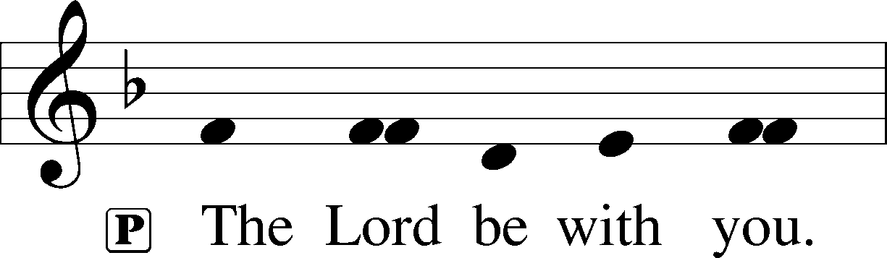
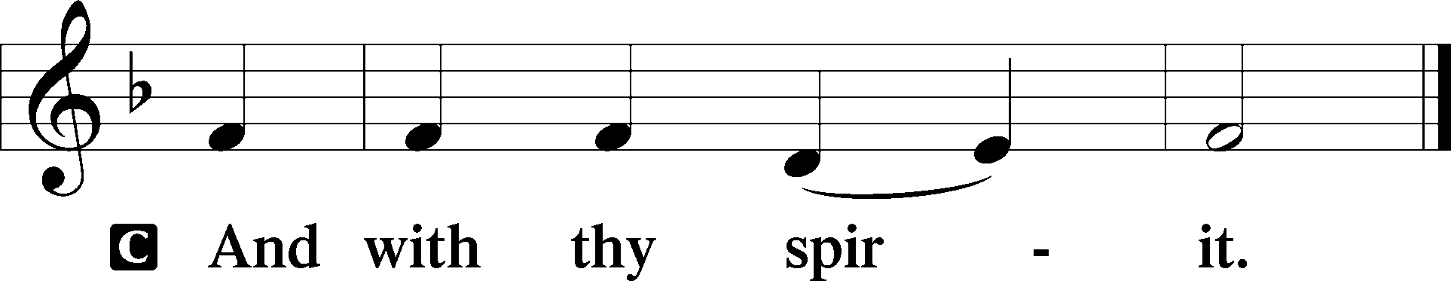

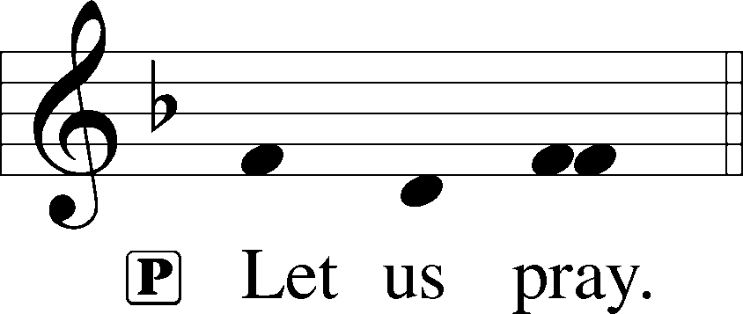

P Almighty and everlasting God, who governs all things in heaven and on earth, mercifully hear the prayers of Your people and grant us Your peace through all our days; through Jesus Christ, Your Son, our Lord, who lives and reigns with You and the Holy Spirit, one God, now and forever.

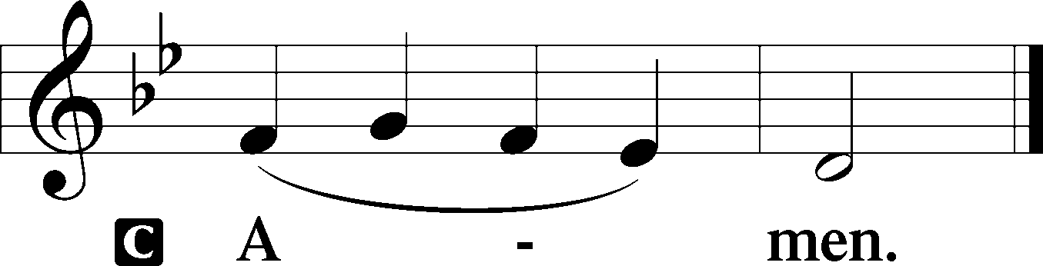

Sit

Old Testament Reading 1 Samuel 3:1–20
1The young man Samuel was ministering to the Lord under Eli. And the word of the Lord was rare in those days; there was no frequent vision.
2At that time Eli, whose eyesight had begun to grow dim so that he could not see, was lying down in his own place. 3The lamp of God had not yet gone out, and Samuel was lying down in the temple of the Lord, where the ark of God was.
4Then the Lord called Samuel, and he said, “Here I am!” 5and ran to Eli and said, “Here I am, for you called me.” But he said, “I did not call; lie down again.” So he went and lay down.
6And the Lord called again, “Samuel!” and Samuel arose and went to Eli and said, “Here I am, for you called me.” But he said, “I did not call, my son; lie down again.” 7Now Samuel did not yet know the Lord, and the word of the Lord had not yet been revealed to him.
8And the Lord called Samuel again the third time. And he arose and went to Eli and said, “Here I am, for you called me.” Then Eli perceived that the Lord was calling the young man. 9Therefore Eli said to Samuel, “Go, lie down, and if he calls you, you shall say, ‘Speak, Lord, for your servant hears.’” So Samuel went and lay down in his place.
10And the Lord came and stood, calling as at other times, “Samuel! Samuel!” And Samuel said, “Speak, for your servant hears.” 11Then the Lord said to Samuel, “Behold, I am about to do a thing in Israel at which the two ears of everyone who hears it will tingle. 12On that day I will fulfill against Eli all that I have spoken concerning his house, from beginning to end. 13And I declare to him that I am about to punish his house forever, for the iniquity that he knew, because his sons were blaspheming God, and he did not restrain them. 14Therefore I swear to the house of Eli that the iniquity of Eli’s house shall not be atoned for by sacrifice or offering forever.”
15Samuel lay until morning; then he opened the doors of the house of the Lord. And Samuel was afraid to tell the vision to Eli. 16But Eli called Samuel and said, “Samuel, my son.” And he said, “Here I am.” 17And Eli said, “What was it that he told you? Do not hide it from me. May God do so to you and more also if you hide anything from me of all that he told you.” 18So Samuel told him everything and hid nothing from him. And he said, “It is the Lord. Let him do what seems good to him.”
19And Samuel grew, and the Lord was with him and let none of his words fall to the ground. 20And all Israel from Dan to Beersheba knew that Samuel was established as a prophet of the Lord.

A This is the Word of the Lord.
C Thanks be to God.

Epistle 1 Corinthians 6:12–20
12“All things are lawful for me,” but not all things are helpful. “All things are lawful for me,” but I will not be enslaved by anything. 13“Food is meant for the stomach and the stomach for food”—and God will destroy both one and the other. The body is not meant for sexual immorality, but for the Lord, and the Lord for the body. 14And God raised the Lord and will also raise us up by his power. 15Do you not know that your bodies are members of Christ? Shall I then take the members of Christ and make them members of a prostitute? Never! 16Or do you not know that he who is joined to a prostitute becomes one body with her? For, as it is written, “The two will become one flesh.” 17But he who is joined to the Lord becomes one spirit with him. 18Flee from sexual immorality. Every other sin a person commits is outside the body, but the sexually immoral person sins against his own body. 19Or do you not know that your body is a temple of the Holy Spirit within you, whom you have from God? You are not your own, 20for you were bought with a price. So glorify God in your body.

A This is the Word of the Lord.
C Thanks be to God.

Stand

Alleluia LSB 190
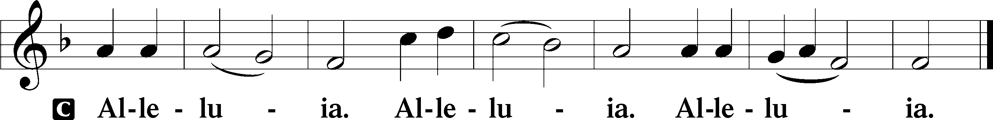

Holy Gospel John 1:43–51
P The Holy Gospel according to St. John, the first chapter.

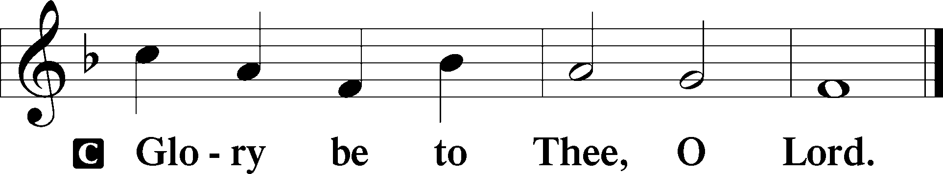

43The next day Jesus decided to go to Galilee. He found Philip and said to him, “Follow me.” 44Now Philip was from Bethsaida, the city of Andrew and Peter. 45Philip found Nathanael and said to him, “We have found him of whom Moses in the Law and also the prophets wrote, Jesus of Nazareth, the son of Joseph.” 46Nathanael said to him, “Can anything good come out of Nazareth?” Philip said to him, “Come and see.” 47Jesus saw Nathanael coming toward him and said of him, “Behold, an Israelite indeed, in whom there is no deceit!” 48Nathanael said to him, “How do you know me?” Jesus answered him, “Before Philip called you, when you were under the fig tree, I saw you.” 49Nathanael answered him, “Rabbi, you are the Son of God! You are the King of Israel!” 50Jesus answered him, “Because I said to you, ‘I saw you under the fig tree,’ do you believe? You will see greater things than these.” 51And he said to him, “Truly, truly, I say to you, you will see heaven opened, and the angels of God ascending and descending on the Son of Man.”

P This is the Gospel of the Lord.

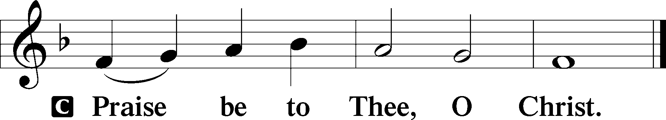

Apostles’ Creed
C I believe in God, the Father Almighty,
maker of heaven and earth.

And in Jesus Christ, His only Son, our Lord,
who was conceived by the Holy Spirit,
born of the virgin Mary,
suffered under Pontius Pilate,
was crucified, died and was buried.
He descended into hell.
The third day He rose again from the dead.
He ascended into heaven
and sits at the right hand of God the Father Almighty.
From thence He will come to judge the living and the dead.

I believe in the Holy Spirit,
the holy Christian Church,
the communion of saints,
the forgiveness of sins,
the resurrection of the body,
and the life T everlasting. Amen.
Sit

783 Take My Life and Let It Be
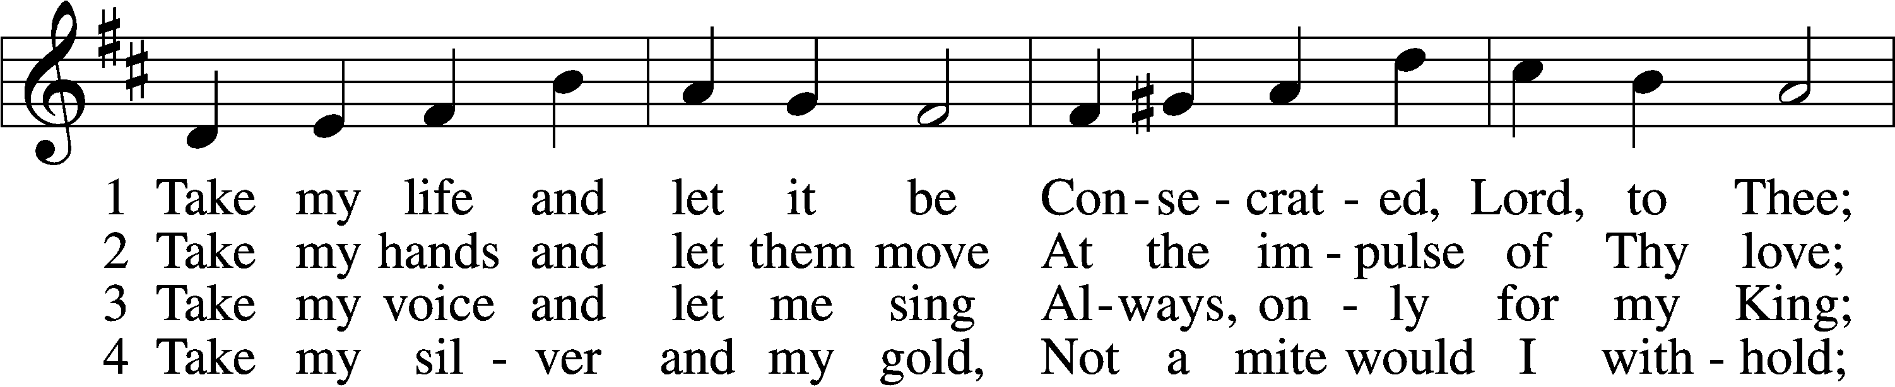
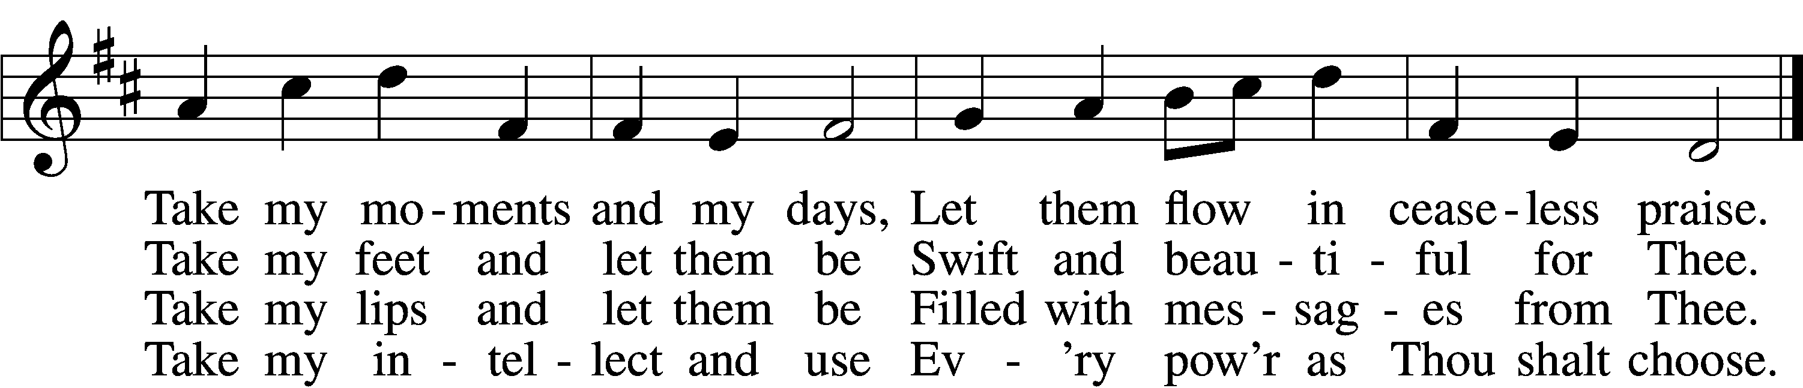

5 Take my will and make it Thine,
It shall be no longer mine;
Take my heart, it is Thine own,
It shall be Thy royal throne.

6 Take my love, my Lord, I pour
At Thy feet its treasure store;
Take myself, and I will be
Ever, only, all for Thee.
Text: Frances R. Havergal, 1836–79
Tune: William H. Havergal, 1793–1870
Text and tune: Public domain

Children’s Message
Sermon

Stand

Offertory LSB 192
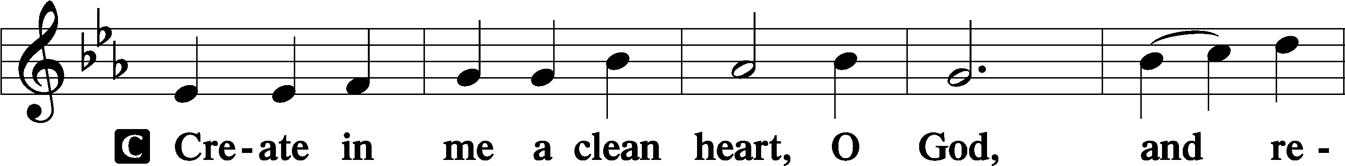
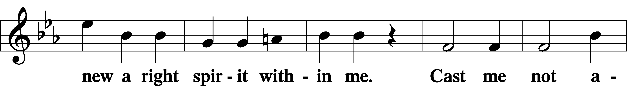
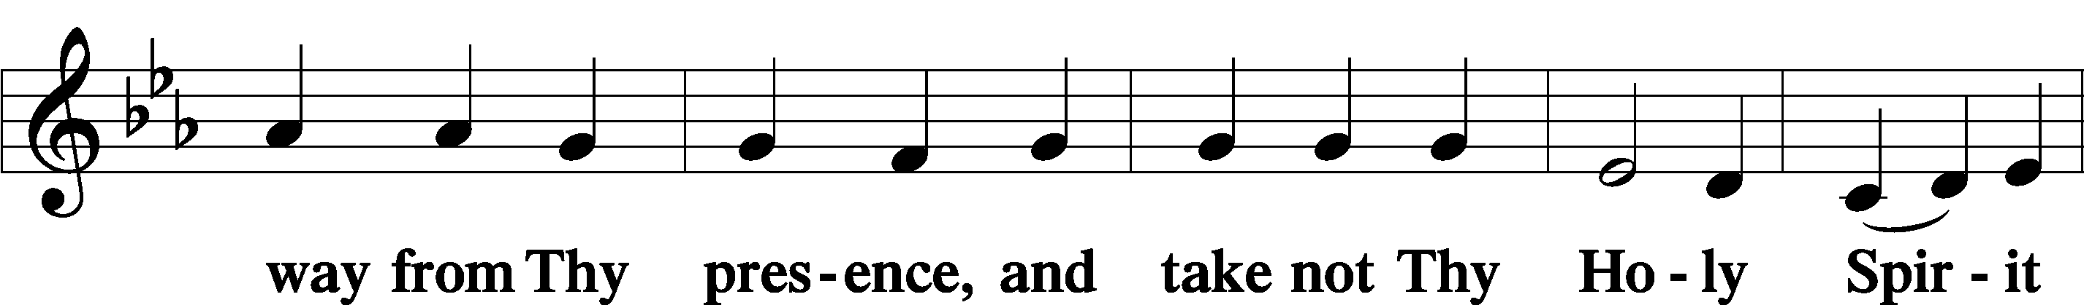
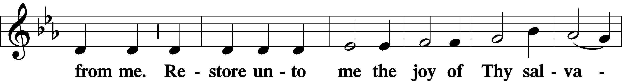
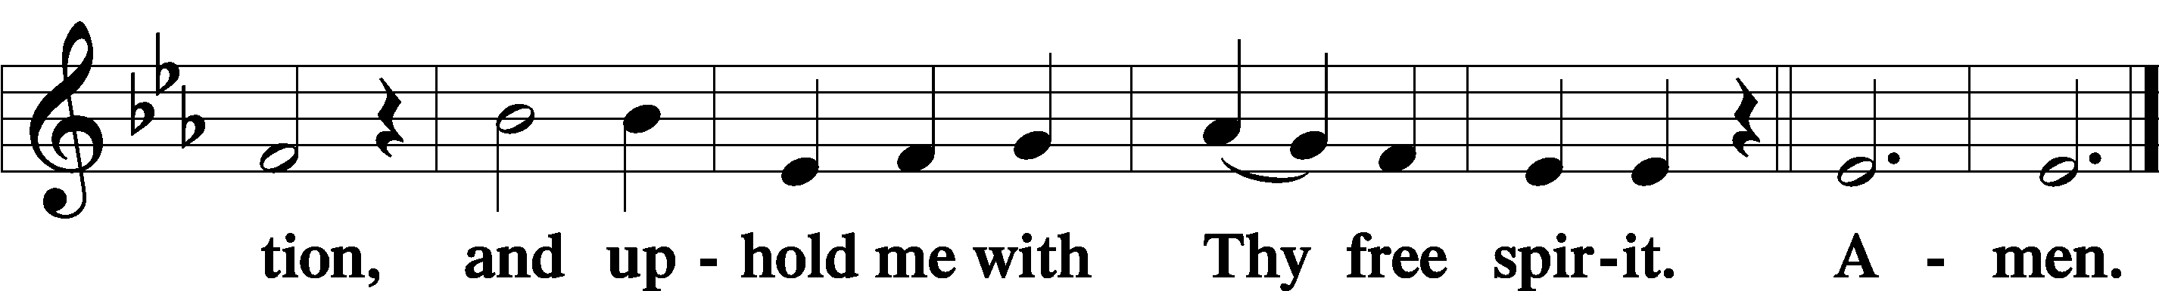

Sit

Offering

Stand

Prayer of the Church
P Let us pray for the whole Church of God in Christ Jesus and for all people according to their needs.
O Lord, put a new song in our mouths. Lead us out of all deceit and into the confidence of Your truth. Let us proclaim Your wondrous deeds of faithfulness and salvation in Christ without fear or hesitancy. Lord, in Your mercy,
C hear our prayer.

P King of Israel, as You once called Samuel, Philip and Nathanael into Your service, be pleased now to call men into Your holy ministry. Give them a delight in Your Holy Scriptures, that their witness would lead many to follow Jesus, the Son of God. Lord, in Your mercy,
C hear our prayer.

P O Lord, You call fathers, mothers and children to serve in their households. Let them serve eagerly, each according to their station, trusting that such love honors You. Lord, in Your mercy,
C hear our prayer.

P Almighty God, let all the nations and peoples of the earth ascribe to You the glory due Your name. Hear our prayers for all rulers and leaders, especially for Joseph, our president, and _____________, our governor, together with all legislators and judges. Direct them by Your Word and Spirit, and establish them in saving faith. Lead them in their offices to govern wisely for the good of their people. Lord, in Your mercy,
C hear our prayer.

P O God, behold in mercy all for whom we pray [especially _____________]. Bring healing, comfort, strength, patience and certainty to all in need. Receive our thanks for Your constant watch and merciful kindness. In every sorrow and every joy, do not let our eyes be drawn from the greater marvel of Your kindness in Christ Jesus, by whose grace and forgiveness alone we receive every blessing. Lord, in Your mercy,
C hear our prayer.

P Holy Lord, renew the gift of Your Holy Spirit to all who commune this day. Work in us true contrition to lament and abandon our sins, and so to come in confident faith to eat Your Son’s body and drink His blood, given and shed for the forgiveness of sins. Lord, in Your mercy,
C hear our prayer.

P Holy Lord, mighty God, You have shown us the face of Your mercy in Your Son, through whom all nations may find unity and life. Hear the prayers of Your people and grant what is needful to us and those for whom we pray, that trusting in Your mercy, our hearts may find perfect peace and rest; through the same Jesus Christ, Your Son, our Lord, who lives and reigns with You and the Holy Spirit, one God, now and forever.
C Amen.

Salutation LSB 201
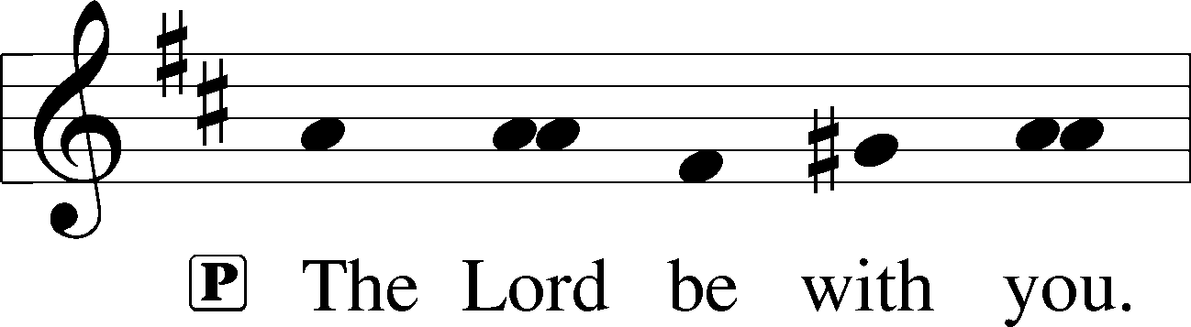

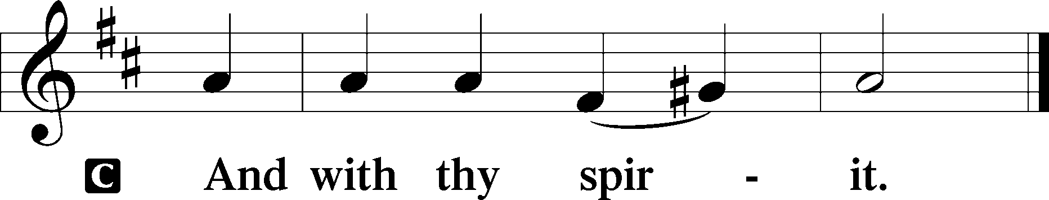

Benedicamus LSB 202
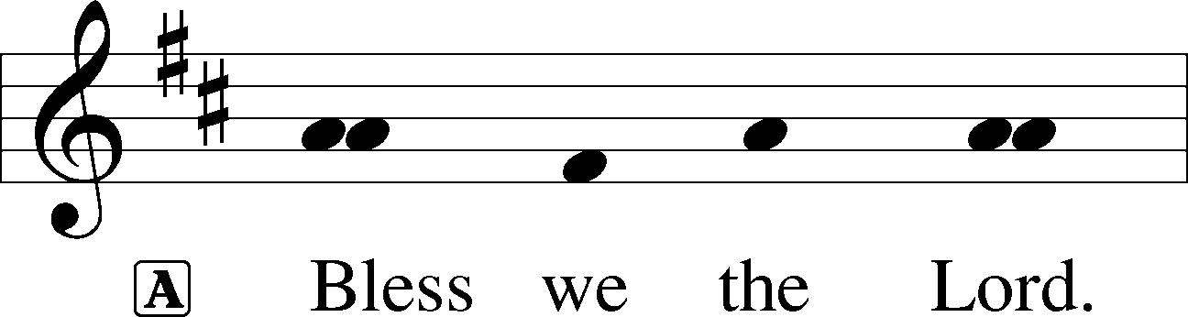

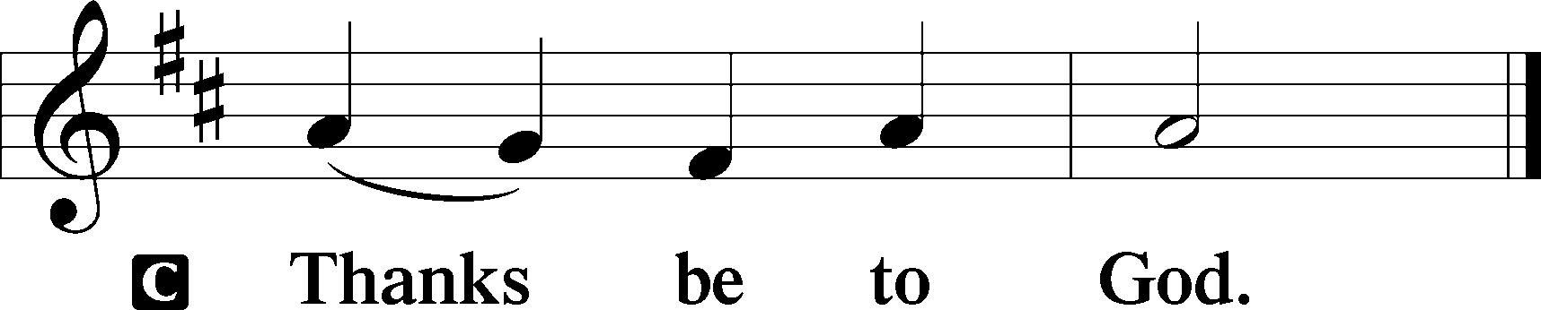

Benediction LSB 202
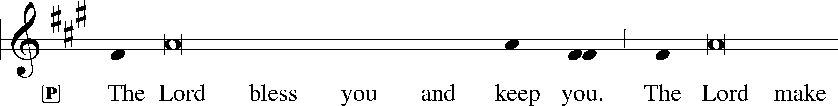
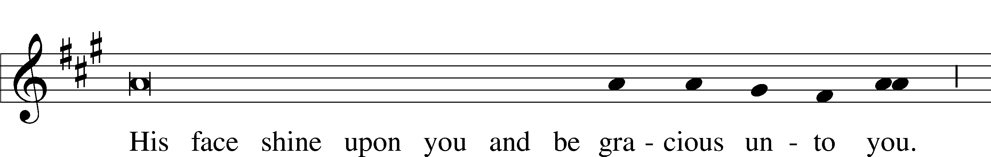
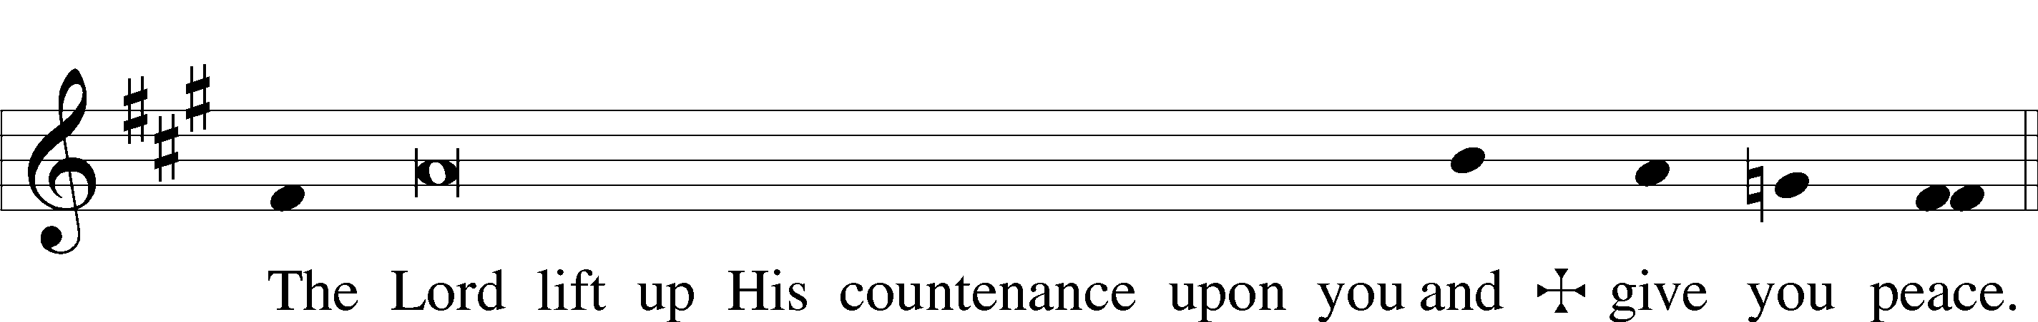

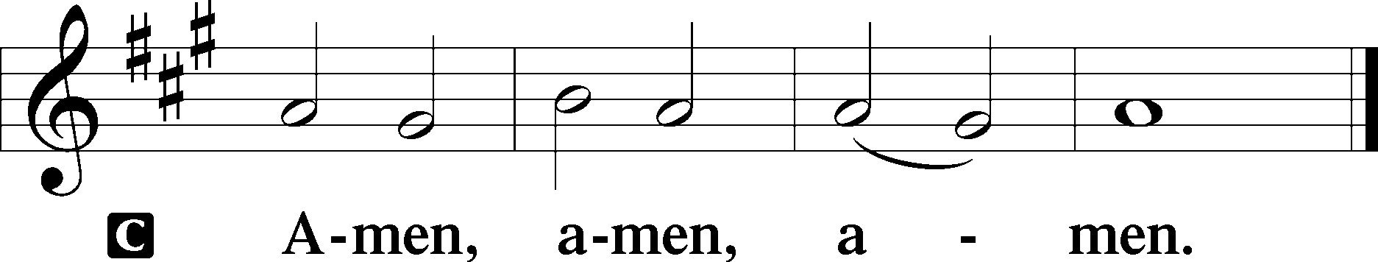

918 Guide Me, O Thou Great Redeemer
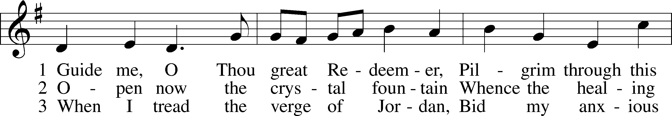
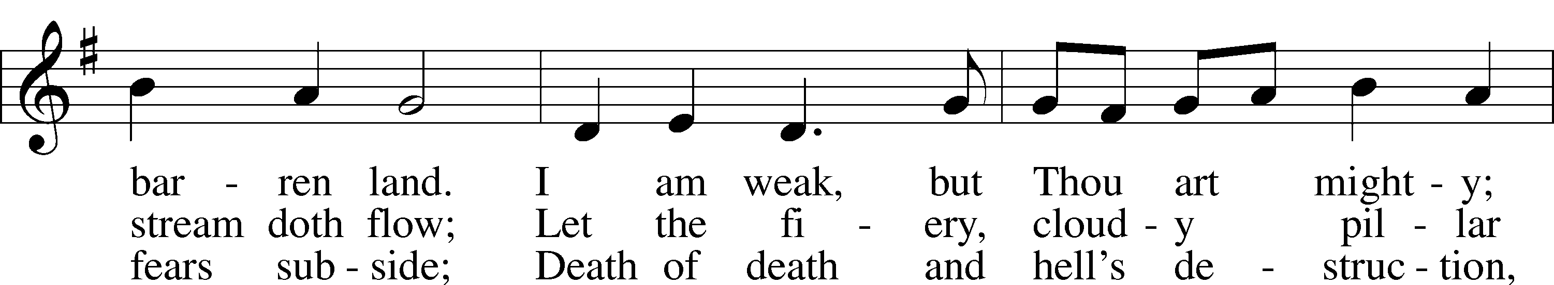
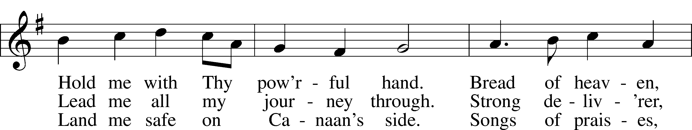
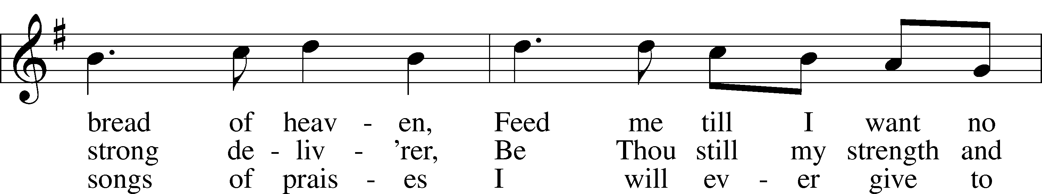
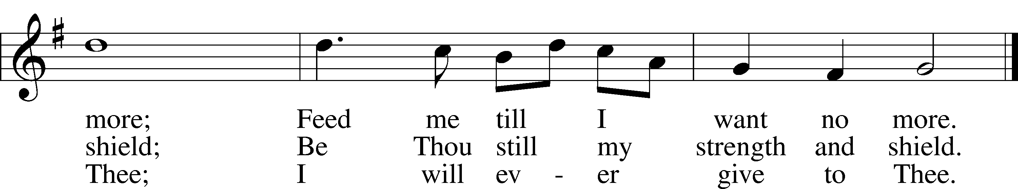
Text: William Williams, 1717–91, abr.; (st. 1): tr. Peter Williams, 1722–96, alt.; (sts. 2–3): tr. William Williams, 1717–91
Tune: John Hughes, 1873–1932
Text and tune: Public domain

Acknowledgments
Unless otherwise indicated, Scripture quotations are from the ESV® Bible (The Holy Bible, English Standard Version®), copyright © 2001 by Crossway, a publishing ministry of Good News Publishers. Used by permission. All rights reserved.
Created by Lutheran Service Builder © 2024 Concordia Publishing House.

